SAMEERAN RAVEENTHIRAN (2114454)

Network Operating Systems and Services
Assignment 2

Name of the Team:
Team Members
Student Name | Student ID
Sameeran raveenthiran | 2114454
maciek kucinski | 2003891
tony witter (unresponsive) | 2114134

Team Evaluation (Self Evaluate your Team)
 | Student 1 | Student 2 |  | Student 3 |  | Student 4 |  | Student 5
Student 1 | 5
Student 2 | 0
Student 3
Student 4
Student 5
Rate your Teams Contribution with a scale of 1 to 5 (1 No Contribution and 5 Excellent Contribution)
Add your comments on Team Evaluation: (Justify your evaluation)
Student 1: This student was able to share their knowledge and participate as a team upon completing the task ahead and provide useful information which benefitted me during the progress of completing the assignment.

Contents
Task 1: Managing and Maintaining Network Resources using Network Policy and Security Practices 3
Task 2: ROUTING AND PACKET FILTERING WITHIN CORE TCP/IP SERVICES AND CRITICAL FAILOVER/REDUNDANCY PRACTICES 9
IP Packet Filtering: 14
1. SOHO 16
2. Failover Clustering for high availability systems/services: 16
3. Draft a network policy for an Enterprise Network 18
4. Brief Reflection: 19
References: 20

Task 1: Managing and Maintaining Network Resources using Network Policy and Security Practices
Understanding NTFS and Share Permissions.
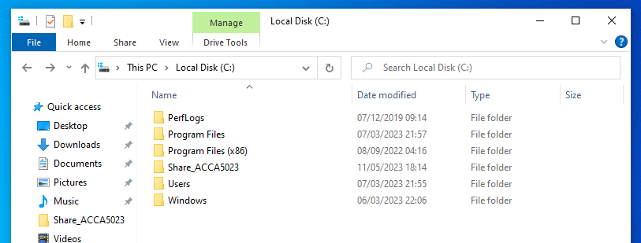
The user created a new folder within the C: named Share_ACCA5023 and within the folder a new text document was created named Confidential-File.

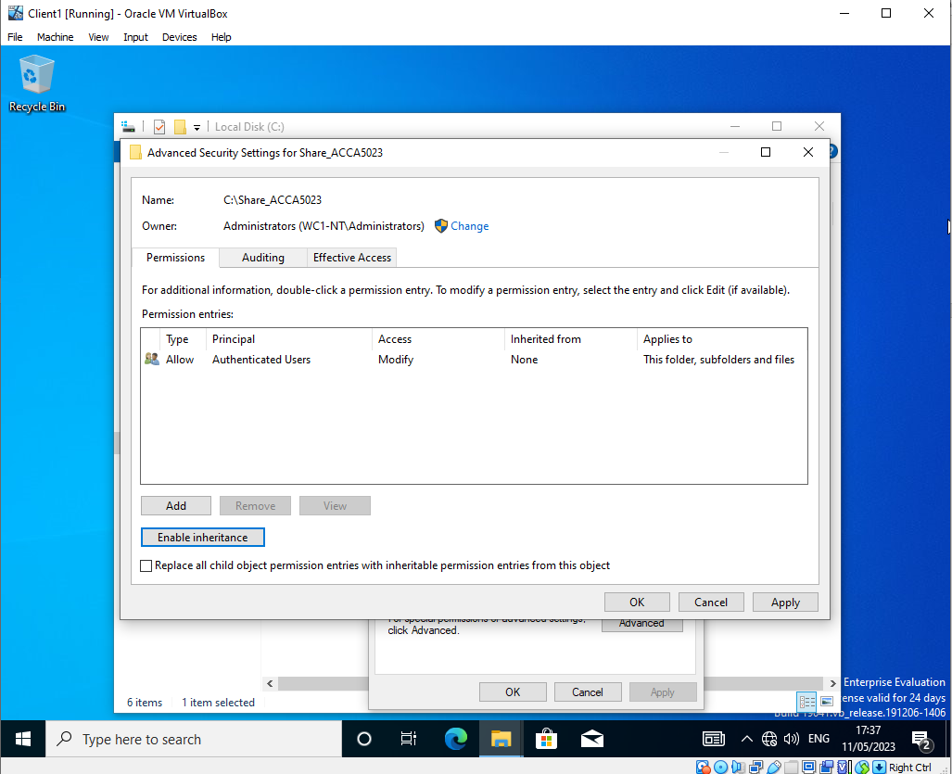

By restricting the permissions, the user deleted all the users and added a new user named administrator.

Share Permissions:
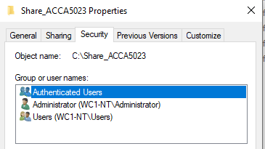

The administrator user has been given full permission to create changes and another user was created with a set of restricted permissions however this user also has full control checked.
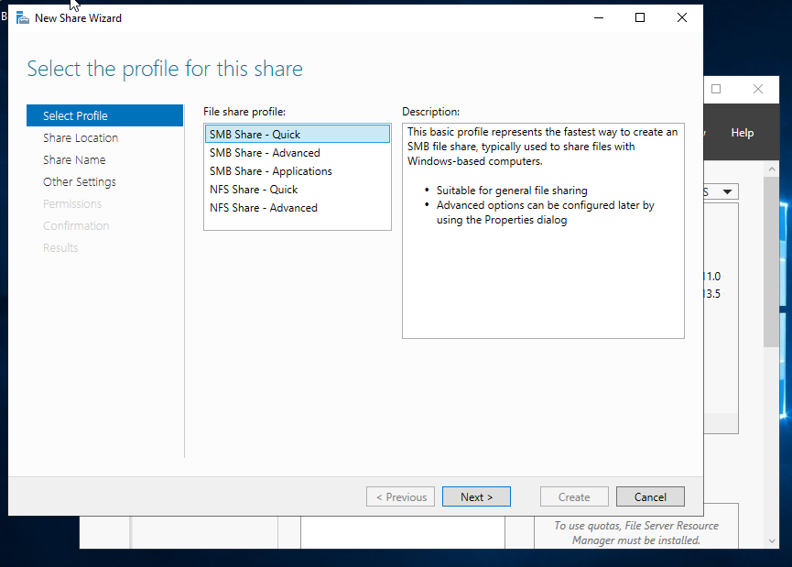
Within the share profile page, the user chose the suitable profile base which is “SMB share – Quick”.
At the Configure share setting window the user checked Enable access base enumeration and allow caching of share options. access base enumeration will only show the files and folders that a particular user has rights to access. Caching of share allows the users to view the files even if they are offline.
Within the Specify permission access screen, the user added the administrator that has full control with two members in the accatask.msft domain with the access of read and execute.
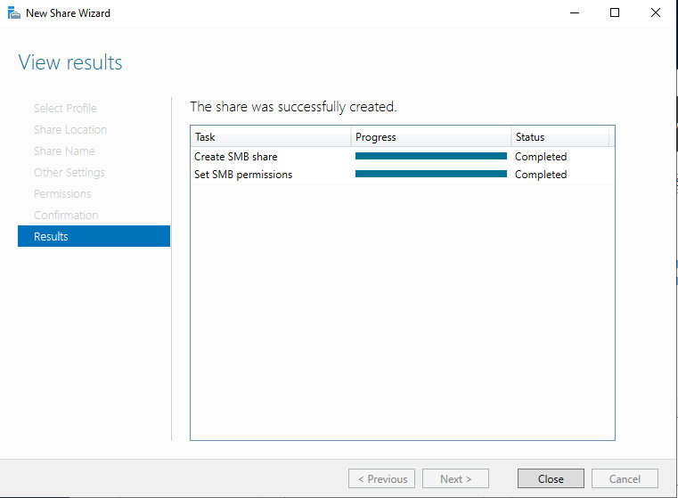

Accessing the file share/server over the network:
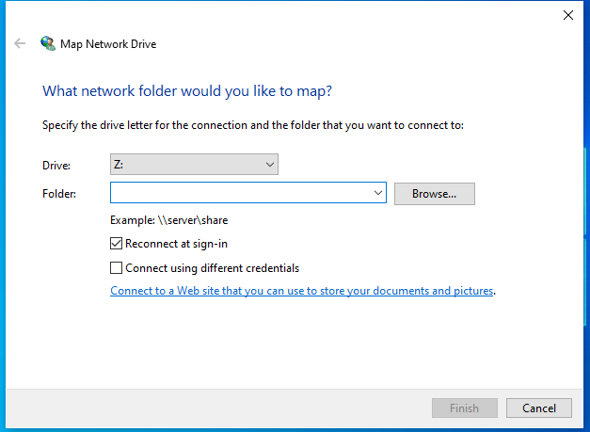

Within the Client 1 VM the user entered the name location of the folder “Share_ACCA5023$”. The purpose of this is to create a shortcut to share folders and resources.

Configuring User Environment and Computer Environment, ‘Network Group Policy Objects:
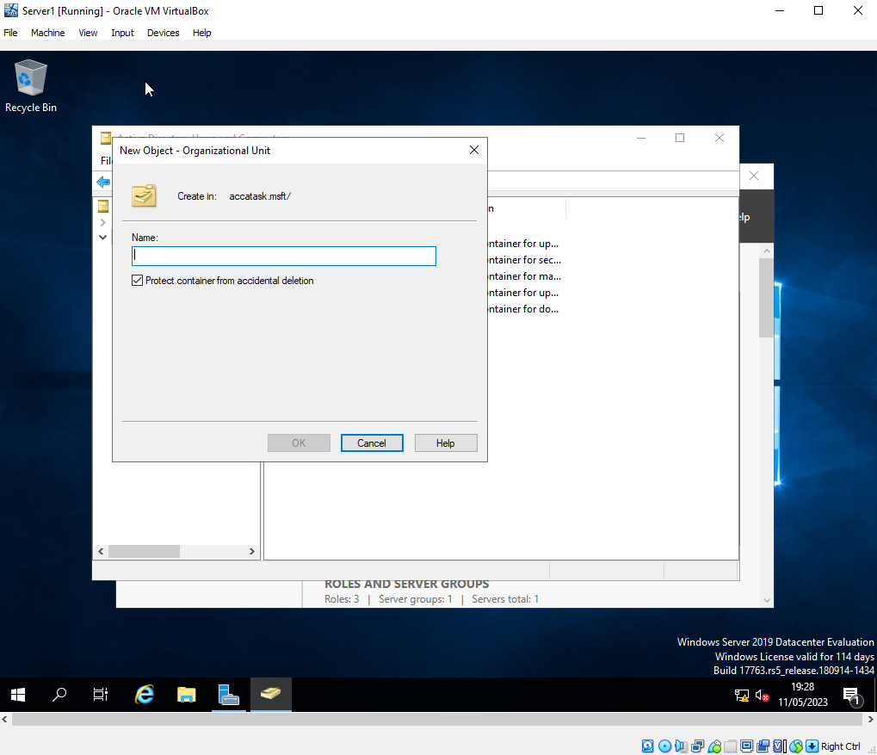

In Server 1 under active directory and computers the user right clicked on accatask.msft to get into the organisation unit and gave it a name as Non-admin users. The user gave the Non-Admin User a user with the Vin Shon.

Moderating Access to the Command Prompt:
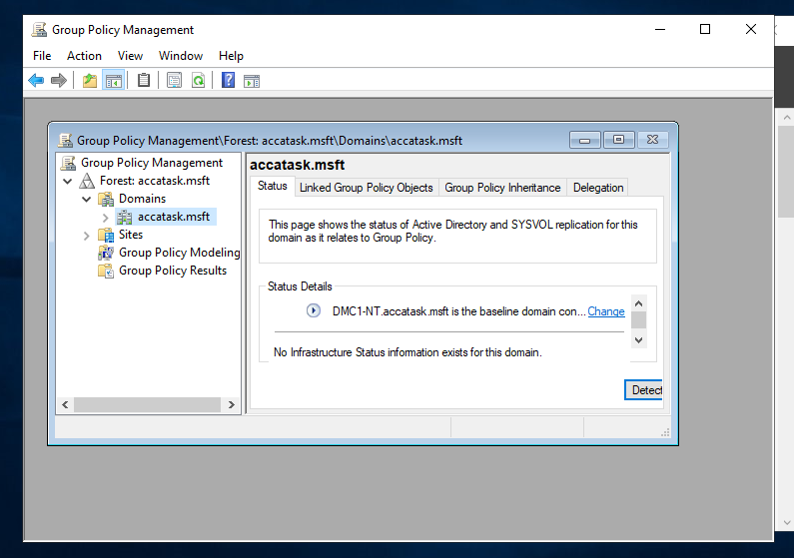
The user will need to test the policy if it is working by logging onto the workstation in the domain and verifying the policy works. The user created a new object under non-Admin users OU and called it “NoCtrlPanAccess”. The same steps will be repeated to create more objects. One of the objects created to remove access to the command prompt and it will be named “NoCmdPrmptAccess”, and the other object Restricts the access to removable media drives which will also be named “NoRemDriveAccess”.
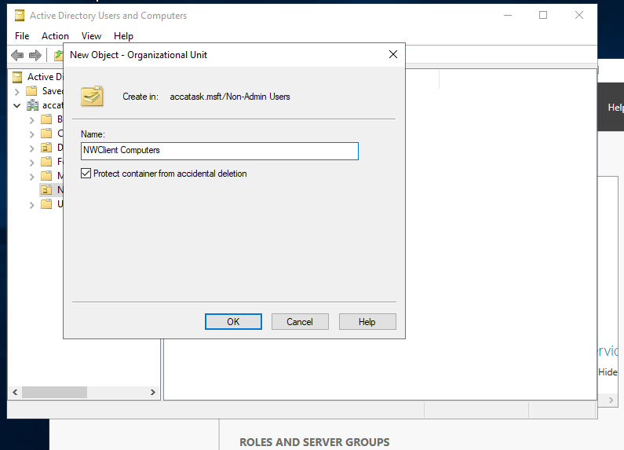
Restricting Software Installs:
The user created a new organisational unit under non-Admin users. The new OU will be name NWClient Computers, and by creating this will restrict the user from installing any softwares.

Task 2: ROUTING AND PACKET FILTERING WITHIN CORE TCP/IP SERVICES AND CRITICAL FAILOVER/REDUNDANCY PRACTICES
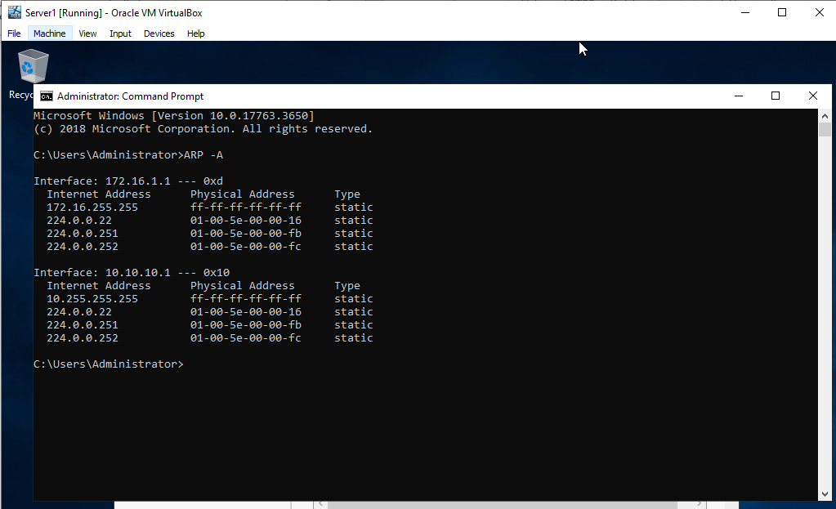
Utilising Arp and Routing Table:
The user ran command prompt on Server 1 and typed in “ARP -A”. This will display the NIC’s in your machine, the mac address of the NIC, and the internet address of the NIC. In addition to this the user also entered “route print” in command prompt, and this prints out the routing table information on your operating system. The information that gets displayed are the Netmask, Gateway, Interface, and Metric.
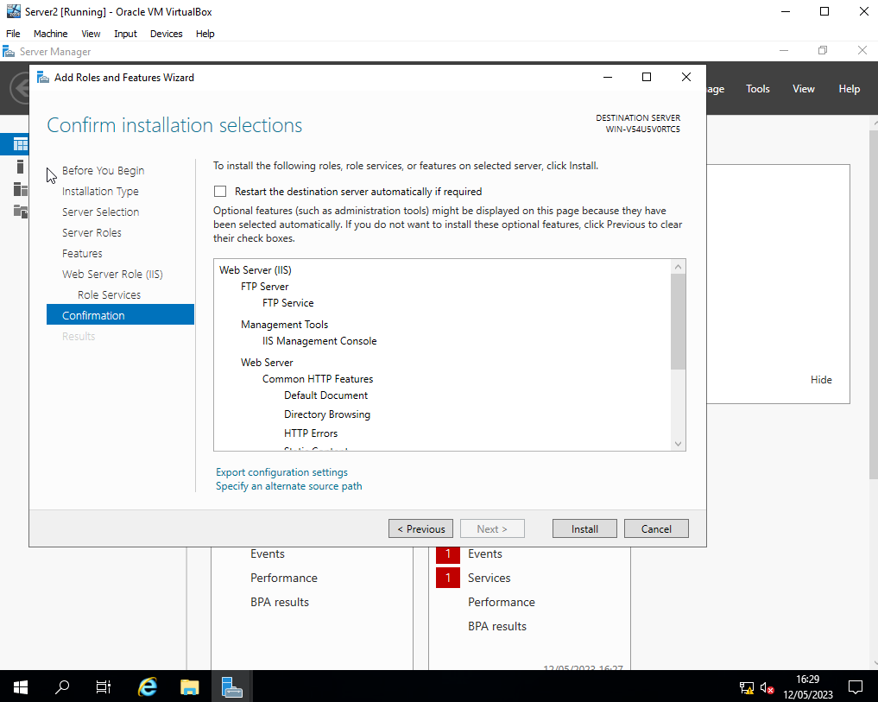
Deploy core services (FTP Server):

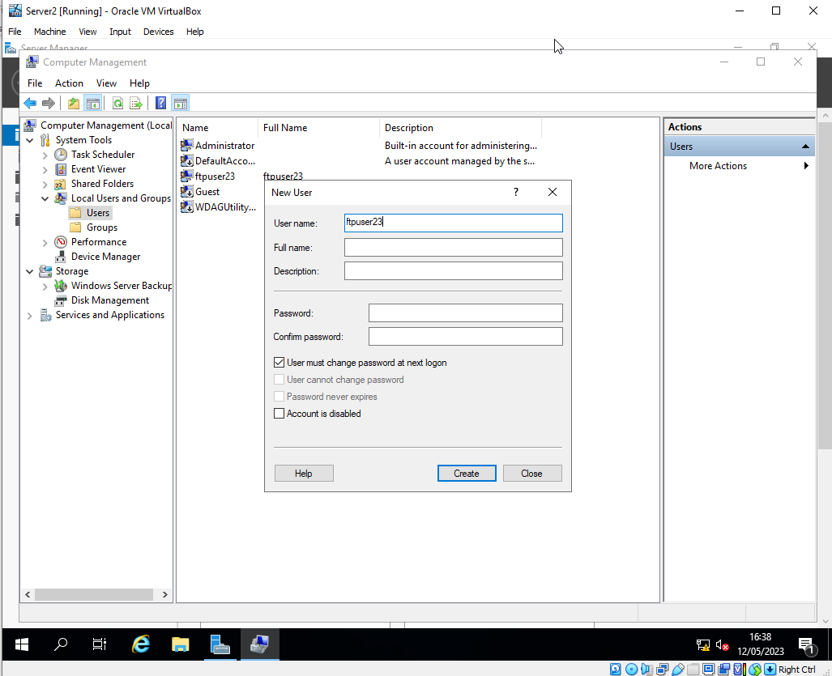

Created a new user by assigning a new username and password.
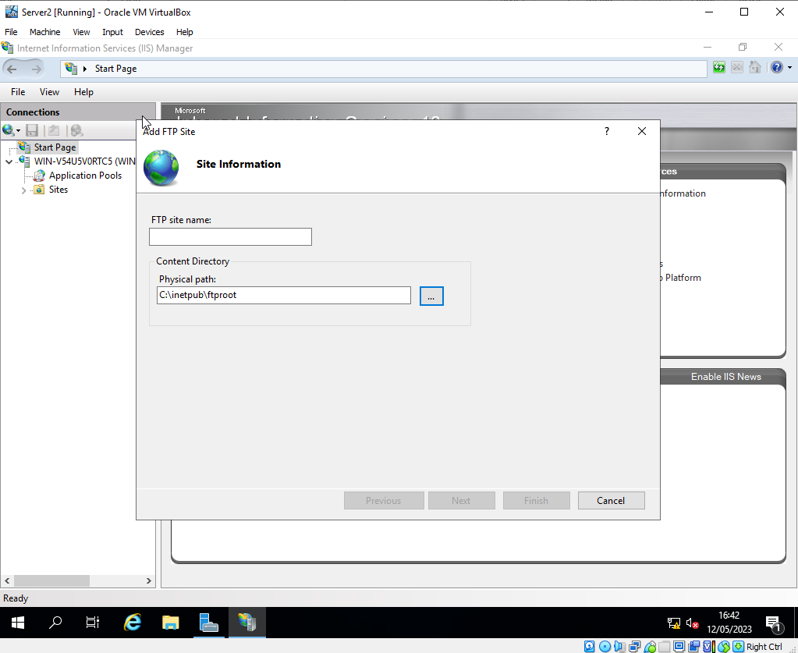

In server 2 VM the user installs the FTP server through the server manager option within the network. Currently on the client can be directly connected to the server and can be able to reach FTP service.

Set up Banners/Welcome greeting:
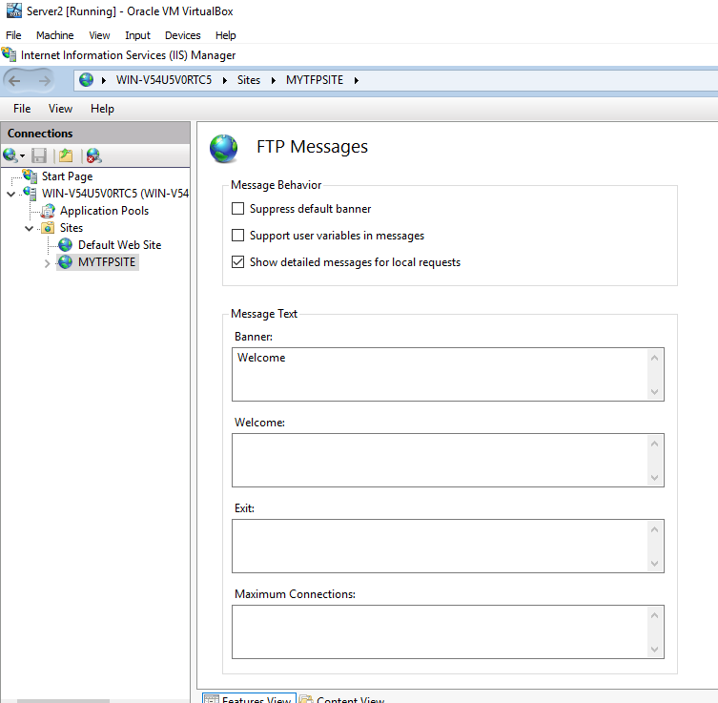

The user created an FTP site to check whether the user has permission to make changes. The user entered words under the banner and clicked on Apply. Furthermore, the user checked one last permission to make sure the use of FTPservices is okay. The user went into the C:/Inetpub and clicked on properties for ftproot.
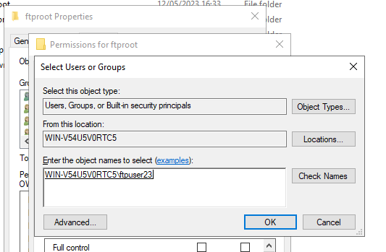

This implies that the FTP service is running on server 2

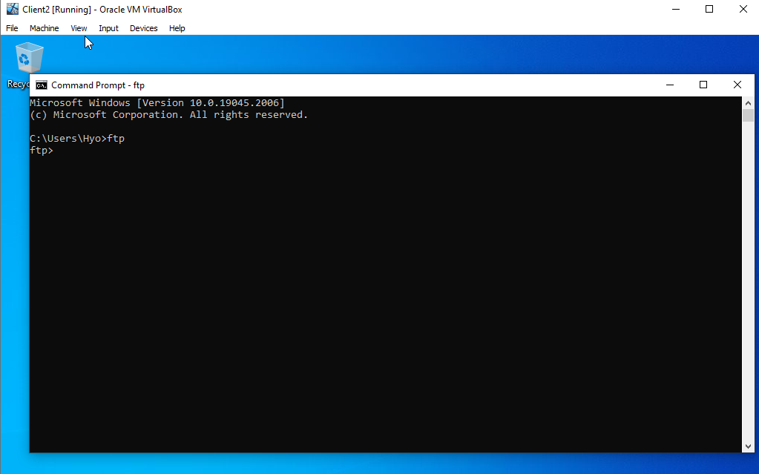
Within the Client 2 VM the user created a folder in the C: named “MYFTPFiles” and within the folder a text file named “myftpfile2upload.txt” has been created. In the command prompt the user wanted to be connected to the FTPServer which is detonated by an ftp prompt.
Installing and Configuring the Routing and Remote Access Service:
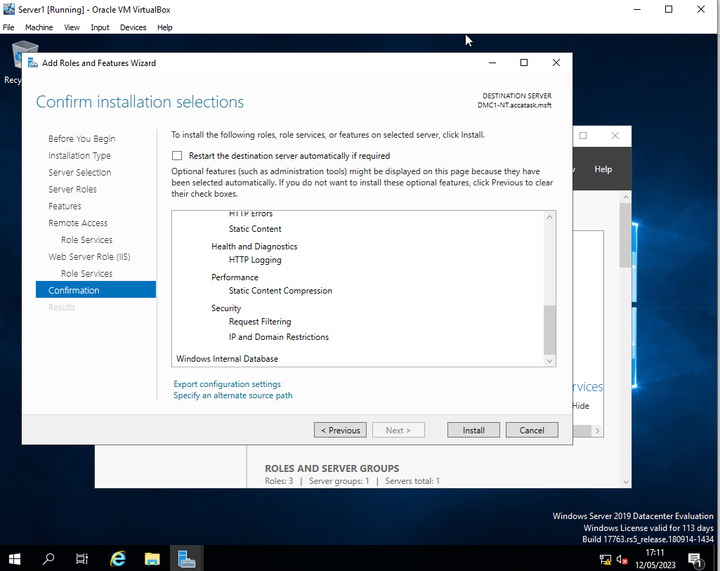
This is the process of expanding the initial network design and build two remotely connected local area networks.

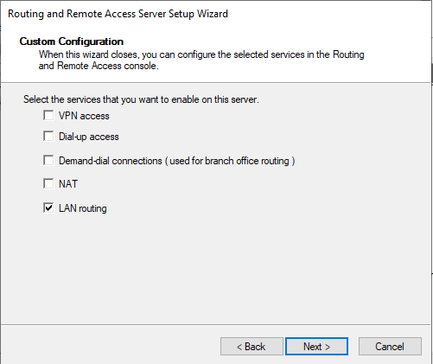

After this was done there was a link which said, “Configure Remote Access”. To confirm this works on the server icon there should be a green arrow next to it. This indicates that the service is running. Within the server icon the user right clicked on general under the IPV4 icon and chose RIP Version 2.
The purpose of this is to enable the routing protocols on the network interfaces in our networks. The reason for this is to allow the systems in our networks to learn about new networks.
These steps need to be repeated for Server 2 VM.
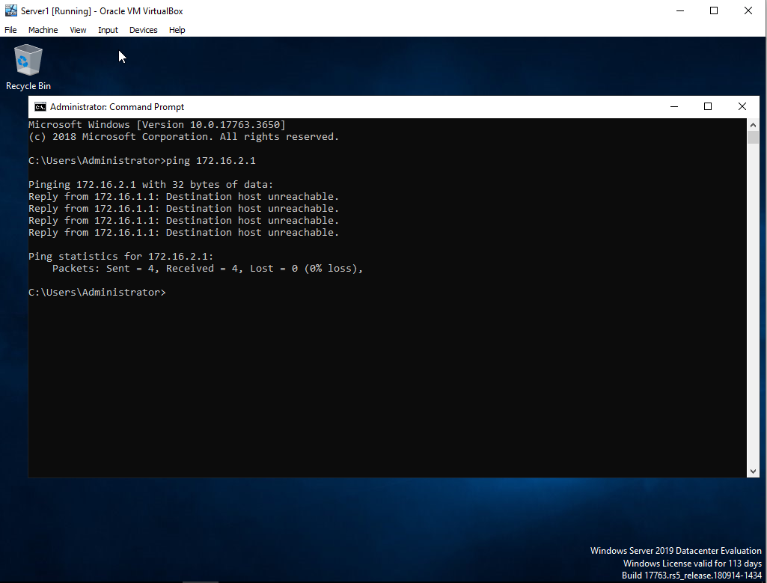

On server 1 the user verified the ping server on its PublicNet IP address and the same was repeated for Client 1 VM, as the user had to ping the Client 2 VM, on its PrivateNet2 IP address.

IP Packet Filtering:
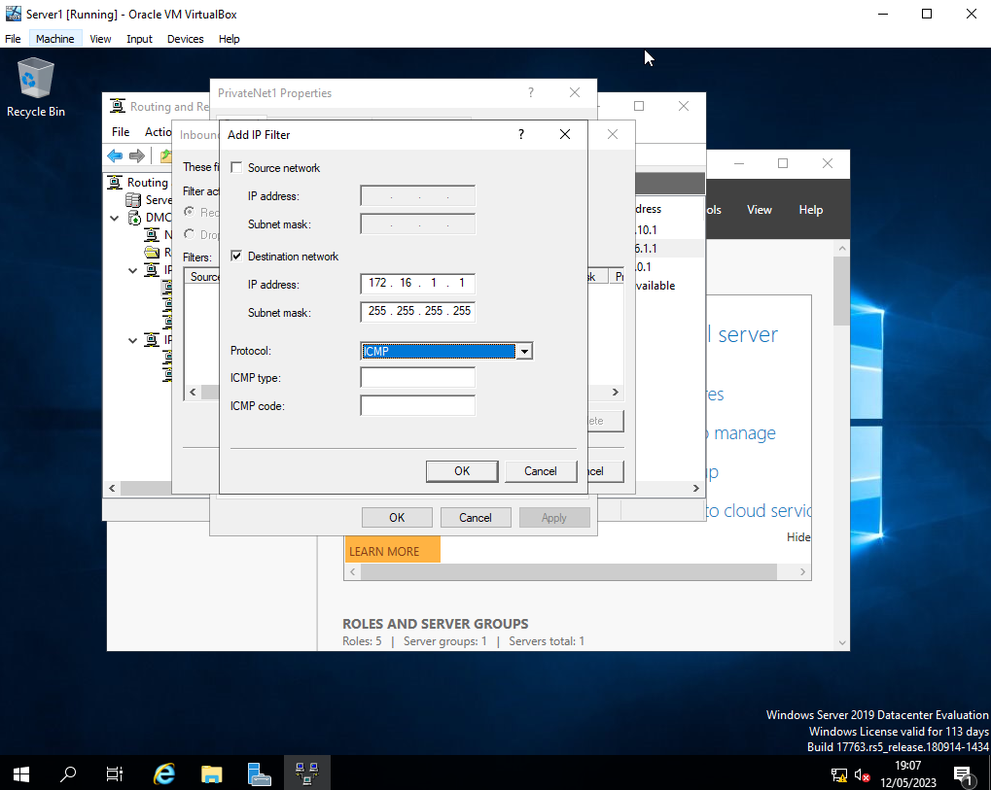
Filter 1: Stopping ‘anyone’ in PrivateNet1 from Pinging the Router Firewall Service

Filter 2: Restrict Access to FTP Service running on Server2 to only hosts in PrivateNet2
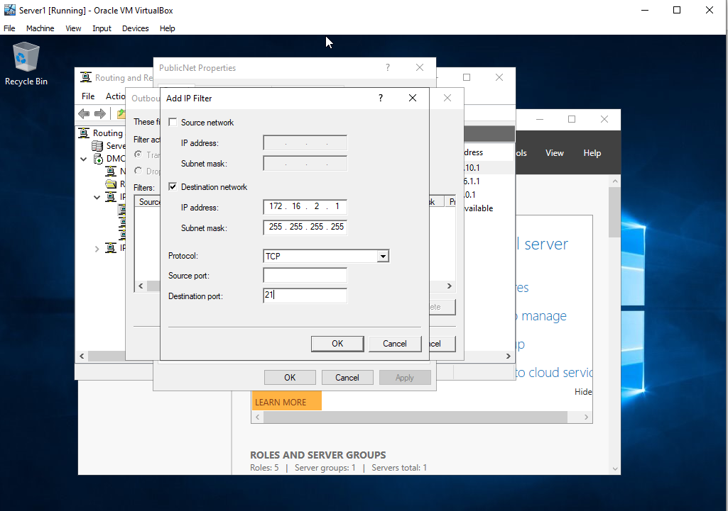

Filter 3: Only allow specific hosts in PrivateNet1 to access the FTPService running on Server
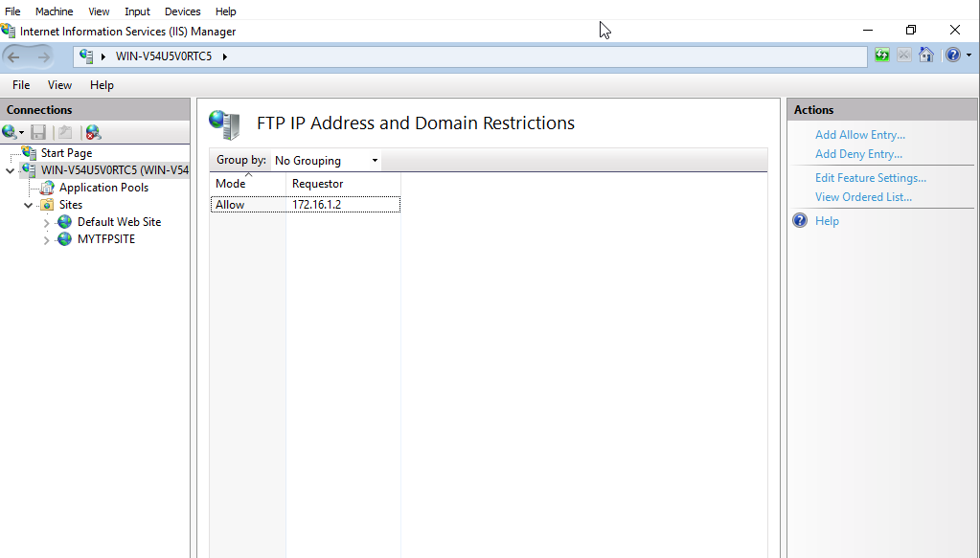
Under Internet information service (IIS) Manager, the user clicked on FTP IPv4 Address and Domain Restrictions and denied access to every unspecified client under “Edit Feature Setting”. Furthermore, the user allowed entry to only Client 1 VM. By doing so, the user inputted the IP Address of Client 1 under “Add Allow Entry”.
Task 3: Observational Tasks
On a SOHO (Small Office/ Home Office) Network, if you want to consider enhancing security, what actions could you do? Write on your own words in the context of your worksheet activities to demonstrate security policies.

SOHO
Securing a small office network is crucial to protect sensitive data and prevent unauthorized access to network resources. In this response, I will provide some actions that can be taken to enhance the security of a small office network.
Network Resources:
Access to network resources should be restricted to authorized users only. This can be achieved by implementing user authentication measures, such as passwords or biometric identification. Network resources should also be protected by firewalls to prevent unauthorized access or attacks [1,2].
Routing and Packet Filtering:
Routing and packet filtering can help to prevent unauthorized access to the network by blocking traffic from untrusted sources. This can be achieved by implementing access control lists (ACLs) on routers or switches. ACLs can be configured to block traffic based on IP addresses, ports, and protocols [2].
TCP/IP Services:
TCP/IP services should be secured to prevent attacks, such as denial of service (DoS) attacks. This can be achieved by implementing intrusion detection and prevention systems (IDPS) to monitor network traffic and detect any suspicious activity. Network devices should also be kept up to date with the latest security patches to prevent vulnerabilities from being exploited [3].
Critical Failover/Redundancy Practices:
Critical failover and redundancy practices should be implemented to ensure business continuity in the event of a network failure or disaster. This can be achieved by implementing redundant network devices, such as routers and switches, to ensure that network traffic can be rerouted in the event of a failure [3,4].
In conclusion, securing a small office network requires a combination of measures, such as user authentication, packet filtering, intrusion detection, and redundancy practices. By implementing these measures, small office networks can be protected from unauthorized access and potential attacks.

Failover Clustering for high availability systems/services:
When considering the usage of a failover cluster system, there are several concepts that need careful consideration to ensure that the cluster is configured correctly and can provide the desired level of high availability and fault tolerance. In this response, I will provide a detailed explanation of some of these concepts.
- Cluster Quorum:
Cluster quorum refers to the mechanism that determines which node in the cluster has the authority to make decisions in the event of a node failure. Careful consideration needs to be given to the selection of the appropriate quorum mode and the number of nodes required for a quorum. This is critical to ensure that the cluster remains available and operational in the event of a node failure [1].
- Storage Configuration:
The storage configuration of a failover cluster is critical to its availability and performance. The shared storage should be configured with redundancy to prevent a single point of failure and ensure data integrity. The storage should also be configured with the appropriate performance characteristics to meet the needs of the applications and services running on the cluster [1].
- Network Configuration:
The network configuration of a failover cluster is critical to its availability and performance. The network should be configured with redundancy to prevent a single point of failure and ensure connectivity between the nodes in the cluster. The network should also be configured with the appropriate bandwidth and quality of service (QoS) settings to meet the needs of the applications and services running on the cluster [1].
- Cluster-Aware Updating:
Cluster-aware updating is a feature that allows for the automatic updating of cluster nodes without causing downtime or service interruption. When using cluster-aware updating, careful consideration needs to be given to the update process and the impact it may have on the availability and performance of the cluster [1].
- Monitoring and Alerting:
Monitoring and alerting are critical components of a failover cluster system. A comprehensive monitoring and alerting system should be implemented to detect and notify administrators of any issues or failures in the cluster. This will allow for prompt remediation and minimize downtime [1].
Failover clustering is of critical importance because it helps to ensure business continuity by providing uninterrupted access to mission-critical applications and services. In the event of a server or hardware failure, failover clustering allows the workload to be shifted to another server without any disruption to end-users. This minimizes downtime, reduces the risk of data loss, and improves overall system reliability [2].
Failover clustering can be implemented in a variety of network environments, including on-premises data centres and cloud-based environments. In on-premises environments, failover clustering is typically implemented using dedicated hardware, such as a storage area network (SAN) or network-attached storage (NAS). In cloud-based environments, failover clustering can be implemented using virtual machines running on virtualization platforms such as Hyper-V or VMware [2,3].
In conclusion, failover clustering is a critical technology that helps to ensure business continuity by providing continuous access to mission-critical applications and services. By implementing failover clustering, organizations can minimize downtime, reduce the risk of data loss, and improve overall system reliability.

Draft a network policy for an Enterprise Network
Introduction:
The following draft network policy is designed for an enterprise network that operates in multiple locations and has critical business applications that require high availability and security practices. The policy outlines the architecture/topology of the network, network access, security team, enforcement of security policies, analysis of security risks, scope of security changes, monitoring security operations, and mitigation in the events of violation.
Architecture/Topology:
The enterprise network will consist of a hierarchical architecture with core, distribution, and access layers. The core layer will have redundant switches and routers, with multiple links to the distribution layer. The distribution layer will have multiple switches and routers, with redundant links to the core and access layers. The access layer will have switches that provide connectivity to end-user devices [1].
Network Access:
Access to the network will be controlled through user authentication and authorization. Users will be required to use multi-factor authentication to access the network. All access to the network will be monitored and logged [1, 2].
Security Team:
A dedicated security team will be responsible for monitoring and enforcing security policies. The security team will include personnel with expertise in network security, access control, and incident response [3].
Enforcement of Security Policies:
All devices connected to the network will be required to comply with security policies. All devices will be configured with the latest security patches and updates. Access to network resources will be restricted based on the user's role and level of authorization. All traffic on the network will be monitored and analysed for potential security threats [3].
Analysis of Security Risks:
Regular security audits will be conducted to assess potential security risks. The security team will use threat intelligence feeds to stay updated on the latest security threats. Any identified security risks will be addressed promptly [3].
Scope of Security Changes:
All security changes will be documented and reviewed by the security team. Any changes that may impact the network's availability or security will be tested in a lab environment before deployment [3].

Monitoring Security Operations:
All network devices will be monitored for potential security threats. Any detected threats will be analysed and responded to promptly. All security incidents will be logged, and incident response procedures will be followed [3].
Mitigation in the Events of Violation:
In the events of a security violation, the incident response team will follow established procedures to mitigate the impact of the incident. All incidents will be documented, analysed, and reviewed to identify areas for improvement in security policies and procedures [2, 3].
Conclusion:
The above network policy outlines the architecture/topology of the network, network access, security team, enforcement of security policies, analysis of security risks, scope of security changes, monitoring security operations, and mitigation in the events of violation. By implementing this policy, the enterprise network can ensure high availability and security practices for critical business applications.

Brief Reflection:
One of the most important learnings is the critical role that network policies and security practices play in maintaining the security and availability of enterprise networks. By implementing access controls, authentication mechanisms, and authorization policies, organizations can limit unauthorized access to the network and prevent security breaches. Additionally, routing and packet filtering within core TCP/IP services can be used to control the flow of network traffic and prevent malicious traffic from reaching the network.
Another key learning is the importance of implementing critical failover/redundancy practices to ensure that critical business applications are always available, even in the event of a failure. This includes implementing failover clustering and redundancy practices, which can automatically switch to a backup system in the event of a failure, thus minimizing downtime and ensuring business continuity.
Finally, IP filtering is another important tool for network security that can be used to protect against network attacks. By filtering incoming traffic based on IP addresses or ranges, administrators can restrict access to the network and protect sensitive data.
Overall, these learnings highlight the importance of implementing best practices for managing and maintaining enterprise networks. By doing so, organizations can minimize the risk of security breaches, ensure the availability of critical business applications, and protect against potential threats and vulnerabilities.

References:
SOHO:
- Cisco. (2021). Secure Your Network. Retrieved from https://www.cisco.com/c/en/us/products/security/secure-your-network.html
- Mell, P., & Grance, T. (2011). The NIST Definition of Cloud Computing. Retrieved from https://nvlpubs.nist.gov/nistpubs/Legacy/SP/nistspecialpublication800-145.pdf
- SANS Institute. (2021). Best Practices for Securing Small- and Medium-Sized Business Networks. Retrieved from https://www.sans.org/reading-room/whitepapers/smallbusiness/best-practices-securing-small-medium-sized-business-networks-35792
Failover Cluster:
- Microsoft. (n.d.). Failover Clustering Overview. Retrieved from https://docs.microsoft.com/en-us/windows-server/failover-clustering/failover-clustering-overview
- VMware. (n.d.). VMware High Availability (HA). Retrieved from https://www.vmware.com/products/high-availability.html
- Yu, C. (2019). High Availability in Azure Virtual Machines. Retrieved from https://docs.microsoft.com/en-us/azure/virtual-machines/windows/high-availability#understand-the-architecture-of-an-availability-set
Network Policy:
- Microsoft. (n.d.). Designing a Secure Network Infrastructure. Retrieved from https://docs.microsoft.com/en-us/windows-server/identity/ad-ds/plan/security-best-practices/designing-a-secure-network-infrastructure
- Cisco. (n.d.). Network Architecture and Design. Retrieved from https://www.cisco.com/c/en/us/solutions/enterprise/design-zone-networking/network-architecture-and-design.html
- SANS Institute. (n.d.). Incident Handling Step-by-Step. Retrieved from https://www.sans.org/security-resources/incident-handlers-handbook/incident-handling-step-by-step

