Student Name: Ayesha Khan
Student Number: 2129615
Module Code: LCHS4006
Module Name: Psychology in Health and Social Care
Lecturer Name: Dr Kennedy Obohwemu
Annotated Bibliography
Child Development and Psychology
Child development refers to the way a child grows and learns. It has four principles which are Physical, Social, Emotional and Cognitive development. Developmental psychologists aim to explain how thinking, feeling, and behaviors change throughout life.
Information Sources:

Authors: BEE, H. L.

The developing child. (9th Ed)

2000-Allyn and Bacon – Boston
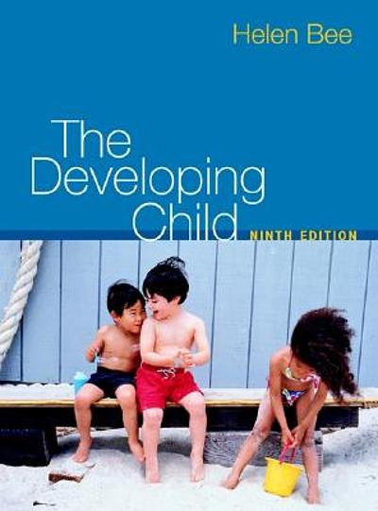
Bee Helen (1939) born in Tacoma, a psychologist and author of several books on the subject of human development, including both child and adult development. Bee Helen works on 119 in 664 Publications in 5 languages and 9,013 library holdings. Classifications: (BF721, 155.4). Publication Timeline (1960-2017). His book has defined it as the process by which a child changes over time. It covers the whole period of a human child to an adult. It is the 9th Ed book.
What is each source about?
It gives me much information & help regarding Lev Vygotsky’s theory.
I used this source to create my presentation. It will be useful for dependence to full independence.
- Author: BERK, L. E
- Child Development Book
- 2013- Pearson- Boston (9th Ed)
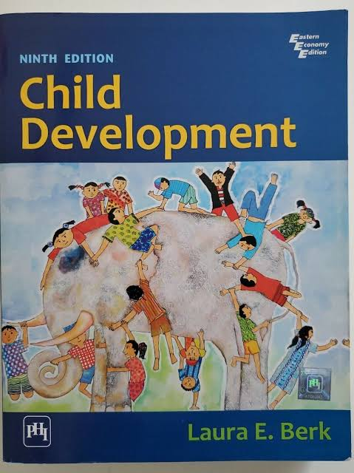
Laura E. BERK was born on Feb 17, 1962. She is a professor of psychology at Illinois State University, she has been a visiting Scholar at Cornell University, UCLA Stanford University and the University of South Australia. (Child Development Book) This is a research book where I search for knowledge for children of up to 1 year. It’s mostly about physical activity and motor skills proficiency with early childhood. It’s the 9th Ed and I get a lot of information about physical literacy and physical activities regarding child development.
- Author: AXLINE, V. M.
- Play Therapy (Book)
- 1979- Ballantine- New York
- Therapy 1st Ed.
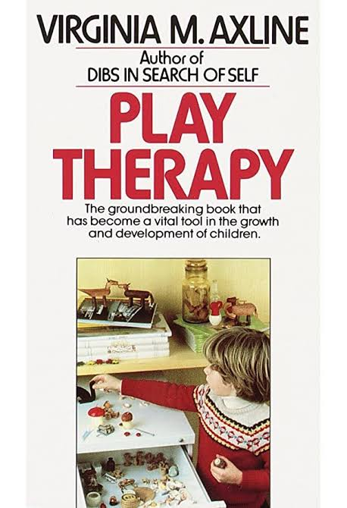
Virginia AXLINE (born on March 31, 1911) to March 21, 1988. She was a 20th Century Psychologist who Pioneered the use of Play Therapy Published in 1947. Play Therapy practice is still largely based on AXLINE’s. AXLINE attended graduate school at Ohio State University, also studied at Columbia University and completed her doctorate in education in 1950. Virginia AXLINE is the Author of this book. Play Therapy book is a Vital Tool in the growth and development of children, by this I found points with clarification which are given by 2 psychologists (Vygotsky & Piaget).

- Author: BARNES, M.
- The Healing Path with Children
- 2013 – The Play Therapy Press
- Limited- Eat Sussex. 1st Ed.
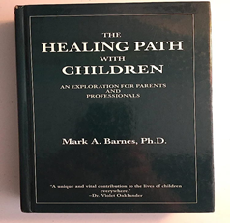
Mark A. Barnes was born in Dadeville. (Times 10 Publications, 2015). BARNES is an American attorney serving as partners in the Ropes and Gray Healthcare and life sciences practice based in Boston. He also has served as executive vice president of St. Jude Children’s Research Hospital and founded and directed the Harvard University. His book It’s an Exploration for parents and teachers. I had read this book to gain information of play therapy training, but very little evidence of theory has it with lots of personal opinions which are not so helpful.
- Author: Denise Boyd and Helen Bee
- Book Lifespan Development (7th Ed.)
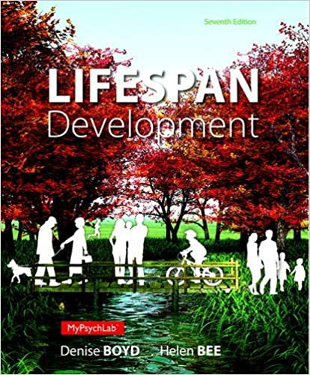
Denise G. Boyd was born on Jan 1^{st,} 1960. She has an associate degree. She received her Edu. D. In educational psychology from the University of Houston since 1988. She has Coauthored with Bee Helen. They also presented workshops for teachers whose students from preschool to college.
Lifespan development book is another useful book to gain information to do good presentation by reading this book. The thoughts of my mind are improved now & clear my doubts and no doubts that Lev Vygotsky and Jean Piaget are good psychologists and their discoveries regarding child development and child activities are the best way to guide parents and teachers.
According to Authors: Cognitive development refers to ‘how a person perceives, thinks, and gains understanding of his or her world through the interaction of genetic and learned factors. From sensory activities to discovery activities, all cognitive activities for Infants featured in books that are designed to provide the stimulation that will help to reach those important child development milestones.
Theories:
- Jean Piaget (1896- 1980)
- Swiss psychologist
- 20th Century, He was the first to make a systematic study of the acquisition of understanding in children.
According to Piaget: Cognitive Development was “A progressive reorganization of mental processes as a result of biological maturation and environmental experience”.
- Lev Vygotsky (1896-1934)
- Was a Soviet Russian psychologist
- 20th Century, He developed a sociocultural theory of child development designed to account for the influence of culture on a child’s growth.
According to Vygotsky: Cognitive Development was “A child’s cognitive development and learning ability can be guided and mediated by their social interactions”.
- Information Websites:
Froebel Foundation (2005)
‘Three Education Principles of Childhood’, Education Principles.
http://www.froebel.com/ [accessed 29th July 2022]
- Journal Article
Dryden, L., Hyder, T. and Jethwa, S. (2003)
‘Assessing individual oral presentation’. In Investigations in University of Teaching and learning’,
Vol. 1, issue 1, pp. 79-83.
http://ecrp.uiuc.edu/
Q. What is each source about?
Each source is about lifespan development. Child development or activities refers to the sequence of physical, language, thought and emotional changes that usually occurs in a child from birth to onwards. Each source is about child development, and I got many of research on psychologists, books, articles and other websites. These sources help me to get to know about the creche activities of children and awareness for the parents and teaching social interactions. From these sources I learn five stages of development which are from newborn, Infant, Toddler, Preschooler and school-age child.
Q. Why is each source credible and reliable?
There are many of sources that are credible and reliable like Vygotsky's theory taught us the accurate development of a child and their activities age by age same like that I get knowledge from different books and articles about children which are surely credible for each child because if the child will train by the correct and good way to start by his parents or teachers he will get the good development with healthy environment physically and mentally. Creche activities are the main thing to be active and develop an energetic child in a very good way and this is what everyone wants in the whole world.
Q. How did I use the sources to help me create the presentation?
I go through the sources from books, theories, articles and websites to gain my knowledge on this so to do my presentation I differentiate the Vygotsky’s theory and also inspired by it plus I read different books and articles on same topic to get main points which are reliable then I picked up all my research and use it as on my presentation and there are many similar points on each book and theory which are agreed by authors and writers also by psychologist which was very helpful and useful for me to create the presentation with clear points. That was a little bit tough but good and interesting.
References:

- Appel, M.H., & Goldberg L.S. (Eds.) (1977). Topics in cognitive development. Vol.1. Equilibration: Theory, research and application. New York: Plenum Press.

- Bjorklund, D.F. (1995). Children’s thinking: Developmental function and individual differences (2nd Ed.). Pacific Grove, CA: Books/Cole.

- Robson, S. (2006) Developing Thinking and Understanding in Young Children, London: Routledge
http://www.netlibrary.com [accessed 10th July 2012]

- Gopnik, A., Meltzoff, A., and Kuhl P. (2005). How Young Babies Think, London: Paul Chapman.

- S, D;Mello. Cognitive Disequilibrium Theory. Research Gate, Jan.2010, www.researchgate.net/figure/Cognitive-Disequilibrium-Theory_figl_215835874.

- M. Lally, and S,Valentine-French. Lifespan Development. Vygotsky’s Sociocultural Theory of Cognitive Development | Lifespan Development, courses.lumenlearning.com/suny-http://www.lifespandevelopment/chapter/vygotskys-sociocultural-theory-of-cognitive-development/.

- Ault, R.L. (1977). Children’s cognitive development. New York: Oxford University Press.

blank page ….

