{Developing a Research proposal}

Module code:BMSW5014
Lecturer:Jaliyah De-Silva
Student name: Aliaa Nabhan Danouni
Student ID:2309830

Table of contents
1-Introduction …………………………………………………………………..2
2-Rationale for the Study………………………………………………………3
3-Aim and objectives……………………………………………………………3
3.1Research questions………………………………………………………….3
4-Literature review……………………………………………………………….4
4.1 The Communication BetweenTheHead Teacher & Teachers………...5
4.2Motivation Strategies in Primary Schools………………………………...5
4.3Teacher productivity………………………………………………………….6
5 -The research Methodology…………………………………………………...6
5.1-Data Collection………………………………………………………………...7
6-Ethical Considerations, Reliability, and Validity……………………….7&8
7-References list……………………………………………………………….9&10
8-Appendix…………………………………………………………………….10&11

The Role of School Leadership in Motivating Primary Educators: A Study of Motivation Strategies and Their Impact on primary School Performance in Wales

Introduction

After working in a Welsh primary school, it will become clear how significantly leadership will influence the motivation and overall morale of teachers and teaching assistants. On certain days, simple expressions of appreciation such as "thank you" or words of encouragement from the headteacher will make a noticeable difference in how supported staff will feel, which in turn will enhance their performance in the classroom. On other days, many staff members will feel undervalued and unsupported due to a lack of clear communication or effective leadership.

Workplace motivation will continue to appear as a major issue within educational leadership, especially as teachers and support staff will have to meet consistently high standards while also facing increasing pressures such as larger class sizes, administrative responsibilities, curriculum changes, and the growing complexity of pupil needs. In this context, the ability of headteachers to motivate and inspire their teams will become more than just a managerial task, it will serve as a cornerstone of academic success.

Although a considerable body of research will exist on teacher motivation, much of it will tend to focus on secondary education or policy’s level perspectives, rather than on the lived experiences of staff teams within primary schools. Research into motivation and leadership will often overlook the role of teaching assistants (TAs), despite their essential contribution to student support.

This research proposal will aim to explore how headteachers in Welsh primary schools will inspire and motivate both teaching staff and teaching assistants. It will also examine how these efforts will affect individual productivity, team cohesion, and overall organisational outcomes (Jerrim, 2025) (Liu, Bellibaş and Gümüş, 2020).

Rationale for the Study.

The researcher has been at Holton Primary School inWales and has the first-hand experience of
observing how leadership styles of head teacher impacts staff motivation.

While supportive leadership fosters a sense of value and engagement among teachers and teaching assistants . On the other hand the lack of communication or recognition often leads to low morale and disengagement.Even though the teacher motivation has been widely studied, but most research focuses on secondary education or national policies, with limited attention to the specific context of Welsh primary schools.Teaching assistant experiences and viewpoints, in particular, are still under-represented. This study aims to close this gap by critically analysing the ways in which head teachers in Welsh primary schools motivate their teaching teams. Understanding these relationships is essential since employee motivation influences student outcomes, retention, teamwork, and performance. The purpose of this research is to offer useful data that will support the growth of beneficial and efficient leadership strategies proper for primary school settings in Wales.

Aim and Objectives overviews

Critically evaluate the strategies used by school principals to motivate staff in primary school settings.

●Objectives
1. Understanding the personal and professional needs of teachers and their assistants in primary schools, with the goal of creating a supportive and stimulating work environment.
2. Studying the impact of the motivating methods on employee morale, job satisfaction, and overall performance.
3. Gathering employee opinions on what truly motivates them and how leaders can motivate them to increase productivity.

●Questions

1. How do primary school principals in the UK motivate staff? How do these strategies affect staff morale and productivity?

2. What are the key personal and professional factors that influence staff motivation in primary school settings?

3. How can school leaders develop a more positive and supportive working environment that empowers staff and enhances their performance?

Literature Review

This literature review will explore three key concepts relevant to the research topic: the relationship between employees and school managers, employee motivation, and all productivity. These concepts will exam within the context of UK primary education will examine these themes through contemporary academic theories, focusing on their application and limitations in school environments. Moreover, this literature will critically assess how such concepts apply in school environmental (Clay,2021).

The Communication Between the HeadTeachers & Teachers

The communication between primary school’s headteacher and teachers will be viewed as a pivotal factor for both. For teachers, it will make them understand their roles in the school, enable them to seek support also share concerns as well as receive constructive feedback. For the school managers, it is learning to be more informed and effective decisions making, improving the work climate, and enhancing educational performance (Sofia, Syaidah and Shunhaji,2023).
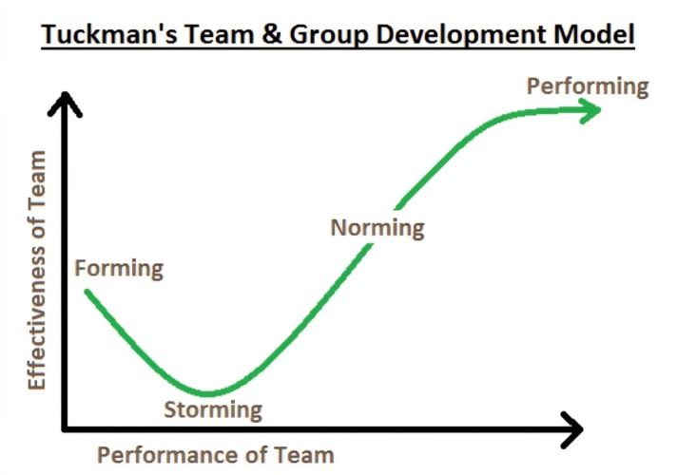
The research will adopt an approach based on Tuckman's model, which tells that work teams go through successive stages, starting with forming, brainstorming, normalising, and finally performing. Applying this theory to primary schools, we find that effective communication between headteachers and teachers at each stage can make a significant difference. For instance, during the forming stage, providing a straightforward vision and shared direction from the headteacher is essential for proving trust and understanding among teaching staff. On the other hand, the absence of this type of communication during the storming stage can lead to internal conflicts that negatively impact teachers' performance but,Tuckman's model is relying on a fixed plan for team development, which may not fully apply to a school environment that is significantly affected by external factors such as curriculum changes, increased student numbers, and ongoing performance pressures (Reinders, 2023)(zirar et al.,2023).

Motivation Strategies in Primary Schools:
Teacher motivation is essential for improving individual performance and the overall effectiveness of primary schools. Understanding teachers' motivational drivers enables school leaders to implement strategies that enhance engagement, satisfaction, and productivity.

▪︎Building a Positive School Culture
A positive work environment begins with transparent communication between school’s headteacher and teachers. When school leaders listen attentively to teachers' concerns, they will provide opportunities for valuable feedback, which fosters trust and mutual respect. Empowering teachers to take part in shaping school policies that will enhance their professional value. Regular social activities, such as field trips, camping, and parties, play a vital role in strengthening collegial relationships and fostering a sense of belonging. Showing appreciation and respect for teachers' time, effort, and ability significantly improves their overall morale (Collins,2024).
▪︎Supporting Professional Development
Continuing professional development will support through meetings, workshops, and training camps, which will play a key role in developing teachers' skills and competence. Furthermore, it will raise teachers' self-confidence. Moreover
recognising teachers' achievements and praising their efforts will foster a sense of professional satisfaction. Senior teachers, who will provide experience and guidance to new teachers, that will foster a sustainable collaborative environment in school (Vargo,2024).
▪︎Praise and Rewards Providing: Honest praise and public recognition at school conferences will rise teachers' morale. Recognising efforts reinforces their belief in the school's mission and motivates them to keep working the symbolic rewards (such as prizes or certificates of appreciation) will play an essential role in promoting a culture of gratitude and encourage teachers to continue committed to their duties (Arthur and Brandly,2023).
▪︎According to Herzberg's Two-Factor Theory, employee motivation factors redividing in
Hygiene factors, such as salary and environment, prevent dissatisfaction.
Motivators, such as recognition and development, promote satisfaction and achievement.
This theory reinforces school strategies by ensuring fair working conditions and providing opportunities for recognition and growth. However, it ignores individual differences, which may not be proper for diverse school environment (Nickerson,2025) (Stromberg,2018).

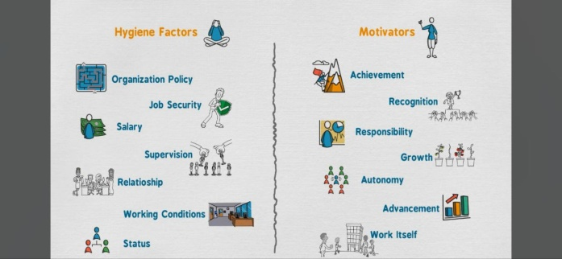
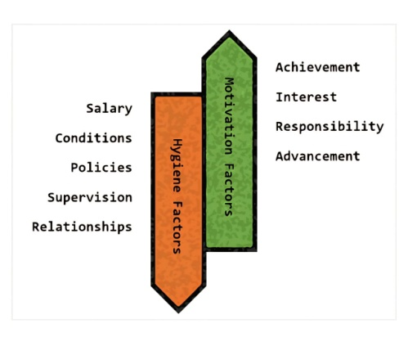
Herzberg's Two-Factor Theory

Teacher productivity
Teachers' productivity reflects their ability to perform educational and administrative tasks effectively. Studies have confirmed that intrinsic motivation and external factors, including recognition and training, are positively related to teacher performance.
On the contrary, poor communication and lack of motivation negatively change productivity. Therefore, investing in strategies that support teacher motivation is essential to improving school performance in the long term (Hua,2024).

Research Methodology
This research will adopt a qualitative approach, as its primary objective is to explore the feelings, experiences, and strategies used by managers to motivate employees in the primary school environment. Unlike quantitative approaches that focus on numerical data and statistical analysis, we found a qualitative approach more suitable for studying behaviours, emotions, and complex human relationships that cannot be fully understandable in closed-ended questionnaires alone (Bhandari,2020)(Bazen, Barg and Takeshita,2021).
Given the nature of the educational environment, choosing a qualitative approach is particularly proper, as it requires understanding the perspectives of teachers and managers. Furthermore, qualitative research tools are flexible and allow for in depth exploration of their opinions and experiences. Through direct interaction with participants, the researcher will be able to gather rich descriptive insights into how motivation is implemented and its impact on productivity in the school environment .on the other hand qualitative research’s findings are limited because it focuses on a specific context, the depth and detail it provides are crucial for this research, especially since the goal is to understand the "How are motivational practices done, rather than simply measuring their impact numerically. Furthermore, the qualitative approach allows for reflection and adaptation throughout the research process, which is essential in constantly changing social environments such as schools (Busetto, Wick, and Gumbinger, 2020).

Data Collection:

Qualitative Research Data Collection is the most popular techniques for gathering data in qualitative research are:
Structured, semi-structured, or unstructured interviews 2. Focus groups 3. Remarks 4. Analysis of documents (such as reports and policies).
The most suitable data collection strategy for this research will be semi-structured interviews, as they provide teachers with the flexibility to explore and articulate their individual experiences in depth. This method allows the researcher to ask follow-up questions based on participants’ responses, enabling a richer understanding of complex issues such as motivation. Given that motivation is often a sensitive and personal topic, one-on-one interviews are particularly effective, as they foster a more private and trusting environment in which teachers may feel more comfortable expressing their thoughts openly. but on the other hand, semi-structured interviews take time-consuming to sit down with respondents and conduct an open-ended interview. It requires extensive resources. In addition, it needs to interview enough people to draw conclusions and make comparisons (Youngwall, 2023) (Faulkner and Atkinson,2023).

Ethical Considerations, Reliability, and Validity.

Considering ethical issues in research is crucial to protecting the rights, safety, and dignity of study participants. Since this is a qualitative research method involving real people, such as teachers and school administrators in an educational setting, special attention will be to ensuring that everyone feels respected, safe, and comfortable throughout the research process.

Before any interviews, all participants will inform of the purpose of the research and the nature of their participation. Participants will sign a permission form confirming their knowledge of the study and their voluntary participation. In addition, they will have the right to leave at any time and for any reason. The final report will not include the names of participants or schools to protect privacy; codes such as "School X" or "Teacher A" will use. All interview data will be securelystored and used for academically purposes only (Bhandari,2022) (Akdemir,2020).

●Reliability

Semi structured interviews, which are ideal for qualitative research, will be the main research tool. They enable participants to go deeper into their opinions while keeping the motivational focus of the interview. All participants will be asked the same guiding questions to increase reliability. The researcher's particular views during analysis, particularly in open-ended responses, could be problematic. So, interviews will record carefully and subjected to members who check to avoid that (Christou,2025).

TheValidity
The research will ensure that the data are accurately and fairly as it represented by the voices of teachers and headteachers in primary schools. Since the research focuses on motivation, a highly personal and emotional topic, the questions that will used in the interviews must accurately reflect the purpose of the research and be based on realistic situations and pressures that teachers face in their daily work. In addition to use triangulation by interviewing staff from separate roles in the school. Thus, in turn, will help gather honest and meaningful insights into how school leaders motivate their staff.
It results will be support by interview questions and motivational theories, as Herzberg's two-factor theory, ensuring they relate to the research objectives.However, since motivation is a subjective experience, it will be important to critically consider how different participants interpret the same situation in separate roles, ages, and personalities, especially when their relationships with school leadership vary. Research accommodates this complexity, but the researcher must remain reflective and transparent throughout (Wingate, Bourdage and Steel, 2024).

Although this study offers valuable insights into the impact of leadership on staff motivation in primary schools in Wales, the research faced some limitations. The most significant limitations were time constraints, which made it difficult to access participants in addition to the limited sample size. This may affect the depth and generalisability of the findings. The availability of broader sources and the participation of a greater number of school staff would enhance the accuracy of the data. In future research, the sample size could expand to include multiple schools, providing a more comprehensive understanding. Despite the limitations of the research, it could stand for an important starting point for improving leadership practices and fostering a more supportive and motivating school environment for staff.

Reference list:

▪︎Akdemir, E. (2020) ‘The Determination of Teachers’ Motivation Based on Herzberg’s Motivation Theory’, TOJET: the Turkish online journal of educational technology, 19(4), p. 89.
▪︎Arthur, L. and Bradley, S. (2023) ‘Teacher retention in challenging schools: please don’t say goodbye’, Teachers and teaching, theory, and practice, 29(7–8), pp. 753–771. Available at: https://doi.org/10.1080/13540602.2023.2201423.
▪︎Bazen, A., Barg, F.K. and Takeshita, J. (2021) Research Techniques Made simple: an Introduction to Qualitative Research. Journal of Investigative Dermatology, [online] 141(2), pp.241–247. doi: https://doi.org/10.1016/j.jid.2020.11.029.
▪︎Bhandari, P. (2020) What Is Qualitative Research? | Methods & Examples. [online] Scribbr. Available at: https://share.google/pW30Q7eUJTEF0w1FR [Accessed 8 Jul. 2025].
▪︎Bhandari, P. (2022) Ethical Considerations in Research | Types & Examples. [online] Scribbr. Available at: https://www.scribbr.co.uk/research-methods/ethical-considerations/.
▪︎Busetto, L., Wick, W. and Gumbinger, C. (2020). How to Use and Assess Qualitative Research Methods. Neurological Research and Practice, [online] 2(1), pp.1–10. doi: https://doi.org/10.1186/s42466-020-00059-z.
▪︎Christou, P.A. (2025) ‘Reliability and Validity in Qualitative Research Revisited and the Role of AI’, Qualitative report, 30(3), p. COV1. Available at: https://doi.org/10.46743/2160-3715/2025.7523.
▪︎Collins, B. (2024) How Principals Can Foster a Positive School Culture. [online] Edutopia. Available at: https://www.edutopia.org/article/creating-positive-school-culture/.
▪︎Clay, R. (2021) Research guides: Library services for undergraduate research: What is a literature review? [online] libguides.wustl.edu. Available at: https://libguides.wustl.edu/our?p=302677.
▪︎Faulkner, S.L. and Atkinson, J.D. (eds.) (2023) Qualitative methods in communication and media. New York: Oxford University Press. Available at: https://doi.org/10.1093/oso/9780190944056.001.0001
▪︎Jerrim, J. (2025) The link between school leadership, staff job satisfaction, and retention. Longitudinal evidence from England. British Educational Research Journal, (https://bera-journals.onlinelibrary.wiley.com/doi/full/10.1002/berj.4134?utm_source=chatgpt.com). doi: https://doi.org/10.1002/berj.4134.
▪︎Liu, Y., Bellibaş, M.Ş. and Gümüş, S. (2020) The Effect of Instructional Leadership and Distributed Leadership on Teacher Self-efficacy and Job Satisfaction: Mediating Roles of Supportive School Culture and Teacher Collaboration. Educational Management Administration & Leadership, 49(3), p.174114322091043. doi: https://doi.org/10.1177/1741143220910438.
▪︎Nickerson, C. (2025) Herzberg’s two-factor theory of motivation-hygiene. [online] Simply Psychology. Available at: https://www.simplypsychology.org/herzbergs-two-factor-theory.html.
▪︎Hua, S. (2024) Teaching motivation, performance, and work productivity of higher education faculty in China: Basis for teacher development plan. International Journal of Research Studies in Education, [online] 13(7). doi: https://doi.org/10.5861/ijrse.2024.24633.
▪︎Hempel, S. (2020) Conducting your literature review | WorldCat.org. [online] Worldcat.org. Available at: https://search.worldcat.org/en/title/1105750134 [Accessed 7 Jul. 2025].
▪︎Reinders, H. (2023) Teacher Leadership - Communication | Cambridge. [online] World of Better Learning | Cambridge University Press. Available at: https://www.cambridge.org/elt/blog/2023/05/31/teacher-leadership-communication/.
▪︎Sofia, S., Syaidah, K. and Shunhaji, A. (2023) Principal’s Effective Communication and Teacher Performance: A Classroom Perspective. Kelola: Jurnal Manajemen Pendidikan, [online] 10(2), pp.101–114. doi: https://doi.org/10.24246/j.jk.2023.v10.i2.p101-114.
▪︎Stromberg, J.L. (2018) The impact of Herzberg’s motivational theory on elementary school teachers’ performance evaluations. [online] Digital Scholarship@UNLV. Available at: https://oasis.library.unlv.edu/rtds/2933/?utm_source=chatgpt.com [Accessed 7 Jul. 2025].
▪︎Vargo, L. (2024) Council Post: How Can Leaders Help Employees Achieve Professional Growth? Forbes. [online] 12 Aug. Available at: https://www.forbes.com/councils/forbesbusinessdevelopmentcouncil/2024/03/28/how-can-leaders-help-employees-achieve-professional-growth/.
▪︎Wingate, T.G., Bourdage, J.S. and Steel, P. (2024) Evaluating interview criterion‐related validity for distinct constructs: A meta‐analysis. International journal of choice and assessment, 33(1). doi: https://doi.org/10.1111/ijsa.12494.
▪︎Youngwall, V. (2023) A Quick Guide to Semi-Structured Interviews. [online] Fuel Cycle. Available at: https://share.google/wMePzv1NAnXlPPK0u [Accessed 9 Jul. 2025].
▪︎Zirar, A., Muhammad, N., Upadhyay, A., Kumar, A. and Garza‐Reyes, J.A. (2023) Exploring lean team development from the Tuckman’s model perspective. Production Planning & Control, 1(1), pp.1–22. https://doi.org/10.1080/09537287.2023.2275693.

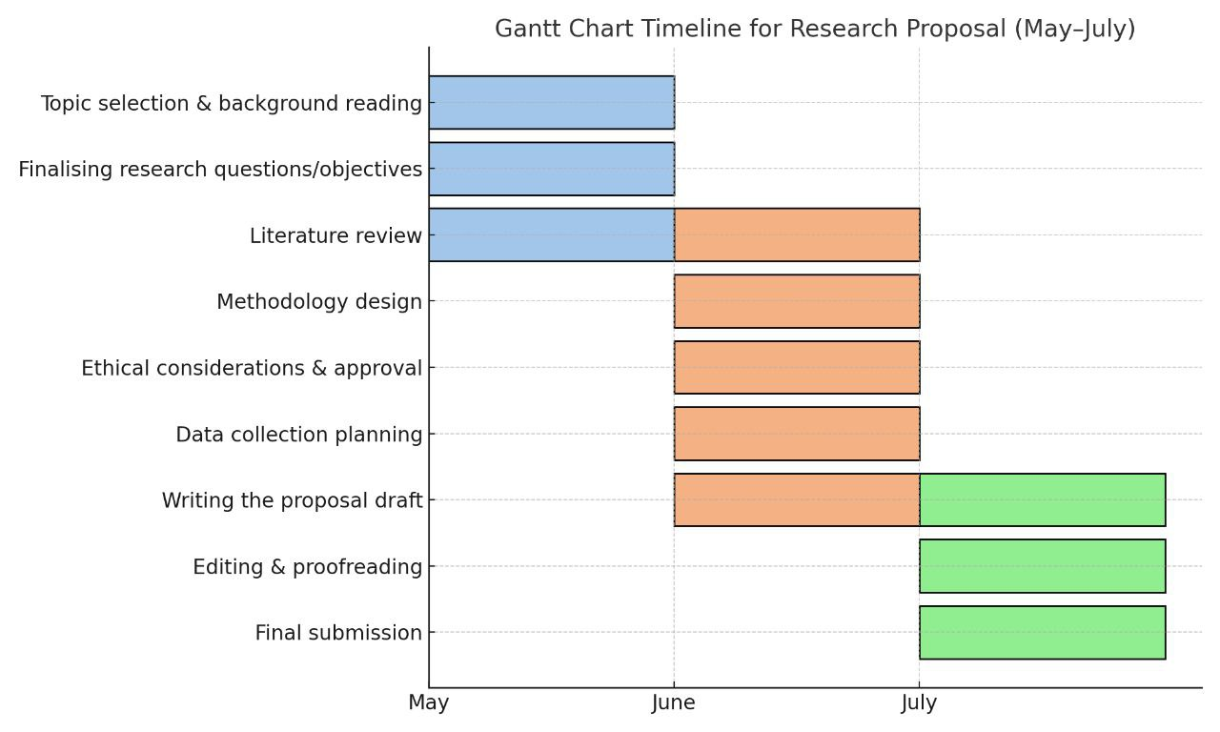
Appendix



