Knowledge and Information Management Skills
for Workplace
Submitted by- Sufian Thareque Immon
Student ID - 1706493

Contents
Introduction 1
Providing an evaluation of the concept and importance of knowledge management in the context of Round Cars 2
Explaining the relationship between data, information and knowledge 2
Explaining the relationship between individual knowledge and organisational knowledge 3
Applying analysis and modelling techniques to identify knowledge assets 4
Evaluating the actual and potential knowledge assets 5
Demonstrating an understanding of important knowledge management process in the context of Round Cars 7
Explaining what is required to create, store, apply and integrate knowledge 7
Considering the importance of intellectual property rights 9
Providing a framework for establishing knowledge management culture 10
Explaining the contribution knowledge management have on Round Cars 10
Evaluating the knowledge requirement for Round Cars 11
Evaluating the current knowledge sharing framework of Round Cars 13
Recommendation of the improvement of the current framework of knowledge sharing in Round Cars 14
Conclusion 15
References 16

Introduction
In this report, knowledge and information management skills in workplace will be discussed in the context of Round Cars. Round Cars is an online taxi booking services that has been offering its services since 2000 in London. In Round Cars I am working as a Finance manager. In the first section, the concept and importance of knowledge management for the organization will be discussed. Then, the knowledge assets of the organization including both actual and potential will be identified. The process of knowledge management of Round Cars will be discussed in the next section. After that the benefits of intellectual property rights will be evaluated. In the next section, I will evaluate the framework of knowledge sharing in my organization by making analysing of knowledge requirement as well. Finally, I will provide recommendation for improving the knowledge sharing framework in Round Cars.

Providing an evaluation of the concept and importance of knowledge management in the context of Round Cars

Explaining the relationship between data, information and knowledge
Data refers to the raw facts which are needed to be processed to create value for the organization (Dupuy, 2014). Same data can be very crucial to one party while the data may be useless to another party. We collect different types of data at Round Cars for different uses. Usually, in our organization we collect data regarding the car drivers, cars, customers, airport schedule and train schedule as well (Frappaolo, 2018). We collect the data of parcels very carefully giving high importance.
For example, in 21st March 2018, a customer named John took our online service to book taxi at 12:30 pm. Here the data are the name of the customer which is John, the date which is 21st March 2018 and the time which is 12:30 pm. We get thousands of this type of data every day. But to use the data, we need to make further processing.
Information refers to the data that is processed and create value for the organisations by helping in making decisions (Greseri, 2002). The users of the information can understand the meaning of the information and can use the information for their intended purpose. For example, in January 2019 we offer service to 3167 customers which is 2.67% lower than that of December 2018. So, the sales and marketing manager in our organization decided to improve the effectiveness of the marketing strategy of the organization.
We process data to create meaningful information for the managers at different departments using different ways. For example, we collect the customer data and categorize the data for different groups of customers. Moreover, we also categorize the data of online booking using different time slots to determine which slot is our peak slot. In addition, the income of the organization is averaged for the whole day. By using the information, the managers make plan, budget for the organization, monitor the activities of the employees and analyse their performance. Thus, using the information, the managers in our organization makes decisions to achieve organizational goals.
The information, experience and skills that a person get through learning is called knowledge. That’s why the relationship between data, information and knowledge is very strong and positive. The relationship can be explained using the DIKW model in Figure 1 below:
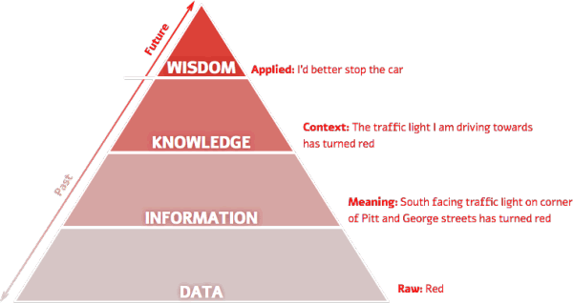
Figure 1: DIKW model
Source: ( Dupuy, 2014)
If the knowledge is applied in the practical life then this is called wisdom. We use the knowledge to make decisions in our organization. For example, in January 2019, the sales of the organization were £75000 and in February 2019, the sales of the organization decreases to £73000. So, I reported to the sales managers that the sales of the organization is decreasing constantly for the last two months based on my knowledge of organization’s sales.

Explaining the relationship between individual knowledge and organisational knowledge
Individual knowledge refers to the experience, skills and information obtained by individual at different stages of their life. Organizational knowledge is the paired knowledge of the individuals working the in the organization. When the knowledge of the employees in the organization is combined together then the knowledge is called organizational knowledge (Easterby-Smith and Lyles, 2003). For example, in Round Cards we work in different teams. We combine our knowledge and experience to solve the organizational problems and achieve the goals of the company. The culture of the organization affects the relationship between individual knowledge and organizational knowledge (Bergeron, 2018). For example, in our organization the culture is open culture thus we can share our knowledge with each other and the value of organizational knowledge is higher than the sum of the individual knowledge in our organization. But if the culture is closed then the opposite will happen.
To understand the relationship between these two types of knowledge we need to understand the sources of information in organization. The sources of information in an organization are:
- Formal communication
- Informal communication
Formal communication: The communication that occurs between the management and the employees of the organization through the formal organizational channel is called formal communication (Dau, Mungnier and Stumme, 2015). In formal communication the relationship between organizational and individual knowledge is not very strong as the employees are not free to share all of their ideas, knowledge and opinions with the management and the management cannot share their ideas and information with the employees as well.
Informal communication: The communication that happens among the employees and the management not through the formal organizational structure then this is called informal communication (Collinson and Parcell, 2004). In our organization, informal communication occurs more than formal communication as we complete most of our tasks in teams. Thus, we can share our information, knowledge and experience more and as a result, the value of organizational knowledge becomes higher. In our organization, the relationship between organizational and individual knowledge is very strong and positive as we focus on informal communication more.

Applying analysis and modelling techniques to identify knowledge assets
Knowledge assets of an organization refers to the accumulated intellectual assets of the employees working in the organization. In our organization, several techniques are used to identify knowledge assets. They are discussed in the following paragraphs:
Focus group: In order to identify the knowledge of the employees in Round Cards, the management has developed some focus groups. The members of the groups organize meeting occasionally to identify knowledge assets among the employees (Bergeron, 2018). In the meeting the ideas, opinions, knowledge and experience of the employees are shared and evaluated. Then the final ideas are evaluated by other team members and the team leader. Thus, our organization identify knowledge assets among the employees.
Structural change: Structural change means using the labour who are doing labour intensive work for doing capital intensive tasks. Thus, the employees will have diversified knowledge for completing different types of activities. As a result, new skills, knowledge and skills among the employees can be identified and as a result knowledge asset among the employees can be developed.
Information and communication technology: Using information technologies is the most effective way to identify knowledge assets among the employees in an organization. In our organization, we use an online platform to share our ideas, knowledge, skills and experience with other employees (Davenport and Prusak, 2000). The name of platform used in our organization is “IShare” which stands for idea sharing. The managers and the employees can freely share their ideas and opinions in the platform. Thus, the knowledge of any specific employee or any specific department can be identified easily and can be used by other employees in the organization. As a result, a better combined effort can be made to achieve the goals of Round Cars. Moreover, when a department or a team face a problem that they cannot solve individually they upload the problem in the online platform. Thus, the whole organization provide ideas and opinions to solve the problem and the problem can be solved more effectively.
Using these ways, Round Cars identifies the knowledge assets among the employees in the company.

Evaluating the actual and potential knowledge assets
There are existing knowledge assets in our organization that help us achieve the goals of Round Cars. But at the same time, the management identify some potential knowledge assets that can be used in the future to improve productivity, profitability and maximize the value of the organization (Collinson and Parcell, 2004). The actual and potential knowledge assets of Round Cars are discussed below:
Actual knowledge assets:
Human knowledge assets: The skills and abilities of the employees working in Round Cars are the human knowledge assets of the organization. The human resource department of the organization selects the best candidates, train them and motivate them so that they can develop their knowledge, skills and experiences and apply them for the organization.
Structural knowledge assets: The methods that our organization uses, the structure that it follows and the process of the organization are called structural organizational assets of our organization (Bergeron, 2018). We use patents to protect our brand name and software that we use. The patent is also the knowledge asset for us.
Market knowledge assets: Our management has better knowledge regarding the needs and demand of the customers, the market trends, the demand of the suppliers and the strategies followed by the competitors. The knowledge of our management regarding the market is called the market knowledge assets.
Potential knowledge assets:
There are some potential knowledge assets that our management can develop and use for achieving the goals of the organization. They are:
Innovation of the employees: Focusing on the innovation and creativity of the employees will motivate the employees to be innovative (Lehaney, 2014). Thus, they will develop new and effective process, methods, skills for completing organizational tasks. Our management should also employees to think outside the box.
Knowledge regarding the industry: Developing knowledge regarding online taxi booking industry in UK and in the world will help the management to determine our next area where we can expand our business.
Administrative systems: The system that is used for managing the employees is also needed to be improved. For improving the system, the management must have knowledge regarding the pros and cons of the system.

Demonstrating an understanding of important knowledge management process in the context of Round Cars

Explaining what is required to create, store, apply and integrate knowledge
The knowledge management cycle is used to show the relationship among the process of acquiring knowledge, retaining and transferring the knowledge and applying the knowledge in the job (Knowledge Management Systems, 2010). To explain the requirements for creating, storing, applying and integrating knowledge in the organization, the knowledge management cycle of our organization is needed to be explained, as shown in figure 2 below.

Figure 2: Knowledge management life cycle
Source: (Jones, 2001)
Knowledge creation: At first the employees in our organization learn the knowledge from learning and experience. Our organization focus more on creativity and innovation. The HR managers hire the best candidates so that they have the required skills and knowledge for performing the job (Ichijō and Nonaka, 2007). In addition, the department also offers training program to the employees so that they can develop new knowledge to perform their job more effectively. For example, in our finance department every year we participate a training program of one week to develop the skills required to perform activities and develop skills to cope with the upcoming change in the organization (Sanchez, 2003). Moreover, our employees also gain knowledge by taking help from other employees. As already mentioned, our organization has an online sharing platform which is “IShare” where employees can share their ideas and knowledge. The employees develop knowledge by learning from the online platform which is extremely helpful for them as they can learn the skills instantly required for performing their activities from the platform which is difficult to find through another ways.

Knowledge store: The knowledge of the organization needs to be protected so that the organization can have competitive advantages for the knowledge. In addition, the knowledge is also needed to be stored (Ichijō and Nonaka, 2007). In our organization, the knowledge that can be converted into quantitative form is usually stored in the database of Round Cars. For example, the knowledge regarding customers annual spending for our services, the average revenue per days and other numerical information are stored in the organisation’s database. The organization uses file database and relational database management system for storing data. Our organization also have a data warehouse in which huge historical and current data is stored. Round Cars use patents and trademarks to protect the brand name and software of the organization. The employees also store their personal information in their personal database.
Knowledge integration: The individual knowledge in our organization is integrated to create organizational knowledge in Round Cars. To integrate the individual knowledge, the knowledge among the employees is needed to be transferred. The employees in Round Cars transfer their knowledge through education, training and most importantly socialisation (Lehaney, 2014). Our organization has an online knowledge sharing platform where we can share our ideas and opinions and solve the problems of other employees through giving recommendation. Using the platform, the employees usually share their knowledge and their knowledge can be used together to achieve the goals of the organization. In addition, as we work in team, we can share our individual knowledge with other members in the team. Thus, all the team member’s knowledge is integrated and organizational knowledge is developed.
Knowledge application: In Round Cars, we apply our knowledge to achieve the objectives of our organizations. In addition, our management also use their knowledge to make decisions to implement organisational strategies (Sarngadharan and Minimol, 2015). To apply the knowledge of the employees and the management we use emergent, intended and deliberate strategies. For example, last month I found that the sales of our organization have decreased by 2.5%. then I reported to the management and the management improves the effectiveness of the marketing strategies to boost sales in our organization. This is how we apply knowledge in our organization.

Considering the importance of intellectual property rights
We can refer intellectual rights as patents, copyrights, trademarks and designation of origin that protects the brand, product, technologies, process and other development of the organization (Schwartz and Te’eni, 2011). By using intellectual rights, our management protects our brand and the software that our organization use from imitation by other organization. The management of our organization has taken trademarks for the software that we use to offer service and patents for the brand name for the following benefits:
Encourage innovation: The main reason for which intellectual rights were evolved to encourage organization to develop new products, process, methods, brand and other intellectual things through innovation (Sanchez, 2003). If the innovation of a person or an organization cannot be protected then the they will not be motivated to innovate new things. For this reason, Round Cars uses patent and trademarks for protecting and encouraging innovation.
Gaining competitive advantages: Using intellectual rights prevent the competitors to use the new and innovate process, products, technologies and other development developed by an organization. Thus, the organization which innovate the products or technologies can take the whole benefits of the innovation and they get competitive advantages over their competitors.
Benefits of the customers: The new products, technologies or process can be used to offer better quality products or services at comparatively lower prices as better products can be produced using the developed technologies or processes. As a result, the customers of the organization also get the advantages of innovation (Schwalbe, 2014). If the organization cannot protect their innovation through intellectual rights, they will not be able to offer better quality products to the customers at lower prices.
So intellectual rights offer benefits to the customers, organization and other stakeholders of the organization.

Providing a framework for establishing knowledge management culture

Explaining the contribution knowledge management have on Round Cars
The process through which the organization capture knowledge is called knowledge management for achieving the success of the organization. In addition, knowledge management also helps the management in ensuring that the employees have the required knowledge in their workplace so that they can perform their activities properly. In addition, knowledge management also plays significant role in increasing the productivity level of the employees and thus helping the organization is making higher returns. For the following reasons, knowledge management is important in our organization:
Access to information and knowledge: The making of better and effective decisions depends on having available knowledge to the managers (Lehaney, 2014). Knowledge management ensures that the managers of Round Cars have the required information available at the right time for making decisions. In addition, the database warehouse is made available to all level of managers. Thus, the managers from one department can have access to the information of another department. As a result, they have better access to information and knowledge of the organization which help them to make better decisions. As I am a finance manager of Round Cars, I need information regarding money requirement, working capital requirement, sales growth, interest rate and loan outstanding of the organization. Using the database warehouse, I have all the available information which helps me to make decisions regarding when to take loan, which interest rate to agree and when the repay the loan etc.
Promotion of innovation: In the online communication platform, that we use to share our knowledge and experiences we can also share our ideas. The employees who offer the best idea for solving the problem of the organization most effectively are awarded with incentives and rewards (Schwalbe, 2014). Thus, the employees become motivated to share their knowledge with other employees and their knowledge can be used in a combined way. As a result, the organization can use new and innovative ways to solve the problems and improve the operation of the organization. Using knowledge management, our managers promote innovation among the employees.
Improving efficiency and productivity: If our managers can properly manage the knowledge among the employees then it will increase the efficiency and productivity level of the employees. The employees will share their knowledge with other employees. In our organization, we share our knowledge with other employees through “IShare”. In addition, when an employee or a department faces a problem which they cannot solve individually, the whole organization’s employees and management share their knowledge and ideas to solve the problem (Wiig, 2013). Thus, the problem can be solved more effectively. So, knowledge management helps our employees to solve their problems and perform their activities more effectively and efficiently which increase their motivation.
Increase customer satisfaction: Our marketing department has all the required information regarding the needs and demand of the customers and trends in the market because our management ensure the proper management of knowledge in the organization. Thus, they can offer better services to the customers.

Evaluating the knowledge requirement for Round Cars
Our managers use knowledge need analysis to determine the requirement of knowledge in the organization. Knowledge need analysis refers to the process to identifying the knowledge requirement of the employees and the ways which can be used to achieve the required knowledge of the employees.
In order to determine the requirement of knowledge in our organisation, we make knowledge gap analysis which helps the managers in identifying the knowledge gaps among the employees. The knowledge gap analysis is presented in figure 3 below:
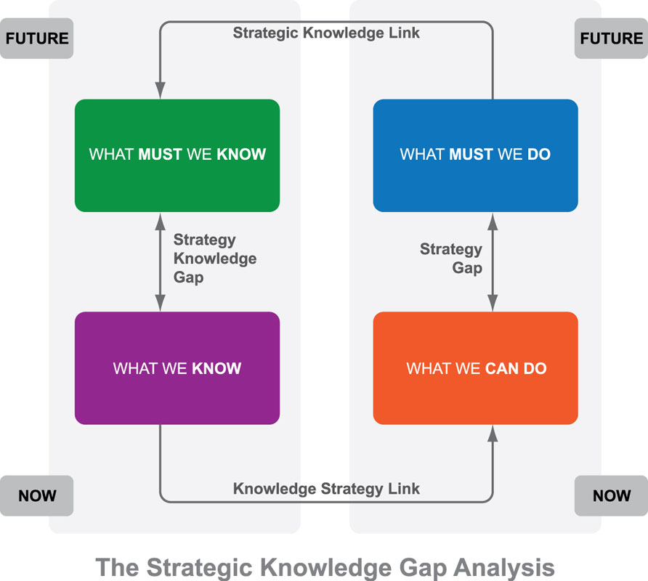

Figure 3: Strategic knowledge gap analysis
Source: (Tiwana, 2012)
What Round Cars must know:
As our organization has been offering online taxi booking services to the customers in London, the organization must have the knowledge on the following things:
- The managers must have deep knowledge regarding the online taxi booking industry in UK especially in London. Analysing the industry will help the managers to understand the future trend of the industry. Thus, they can prepare for the future condition on the online taxi services.
- Our managers must have better knowledge regarding the demand and needs of the customers in London. In addition, the new trends of the customers are also needed to be understood. So, they must have information regarding customers’ preferences.
- The social class of the customers who are taking our online taxi booking services must also be understood by our managers (Wiig, 2012). Having the information helps our manager in making pricing decisions for providing our services.
- Our organization offers high security of the customers’ and drivers’ information. So, the employees in Round Cars need to have better knowledge of data security.
What Round Cars knows
Our managers and employees have the following knowledge:
- The industry of online taxi booking service in UK is an industry of £700 million.
- There are 35 companies in UK which are offering this service around the country.
- The customers who usually do not have their personal cars are taking our services and they are taking our services during morning and afternoon.
- Our organization ensure security of the information of the customers and the drivers using firewall and password protected database management system.
Knowledge gap:
Rounds Cars has knowledge gap in the following areas:
- There are many reasons for which our customers are taking online taxi booking services. But our managers have identified few of those reasons. So, our organization can take the service of survey providing organization to understand the needs of the customers.
- Most of the employees in our organization does not have better idea regarding data protection. So, they need to develop the knowledge.

Evaluating the current knowledge sharing framework of Round Cars
In Round Cars we share the knowledge through teamwork and through our online knowledge sharing platform named “Ishare”. Using the framework, we can share our ideas, opinions and knowledge with others regardless of the level and position in the organization. The knowledge sharing platform in our organization is effective in solving problems and generating better ideas for competing the tasks efficiently.
The knowledge sharing platform in our organization is an informal communication platform. Thus, when any of our employees is having a problem, he or she can share the problem instantly in the platform. Thus, other employees from the same department or other department recommend solutions for solving the problem. Thus, the employee facing the problem can solve the problem easily using the knowledge sharing platform.
In addition, when any of the employees in our organization have an idea which can increase the current productivity level of the employees, the employees can share the idea easily in the platform. The other employees and the managers of the organization can evaluate the idea and then the final idea is selected for the organization. As a result, the idea of one employee which seems effective for the entire organization can be implemented in real time. As a result, Round Cars gets competitive advantages over other organizations.
Using the knowledge sharing platform one team can communicate with other teams if they think that taking ideas from other teams will help them in competing their activities effectively and achieve their goals (Jones, 2001). Thus, a combined effort for achieving the organizational goals can be ensured.
So, the online knowledge sharing platform “IShare” that we use to share knowledge and experience with other employees and managers is effective as it solves the organizational problem in real time and ideas can be implemented easily. In addition, the employees feel motivated to share their knowledge in the platform with other employees as they get the recognition for sharing information.

Recommendation of the improvement of the current framework of knowledge sharing in Round Cars
Although the online knowledge sharing platform that we use to share knowledge with other employees is effective, there are some rooms for improvement. In the knowledge sharing framework, the employees who share knowledge to solve the problem of other employees does not get any extra benefits for sharing the knowledge. So, the manager can introduce point system for sharing knowledge with others. That means, the employees who will share knowledge will get some points. Based on the points they achieved in a month the employees will be provided with some bonuses. The managers can also select members of the month to motivate the employees to share their knowledge with other employees.
There is no central monitoring on the knowledge sharing platform in our organization. The managers can appoint an executive to monitor the activities of the employees in the knowledge sharing platform. Thus, the conflicts among the employees can be minimized. In addition, the employees’ ideas can be recognized more easily and effectively. Using the central monitoring system, our managers can improve the effectiveness of the knowledge sharing platform.
In addition to improving the informal communication channel the managers must also the formal communication channel of Round Cars so that the employees also feel comfortable and interested to share their knowledge with other employees. To increase the effectiveness of the formal communication channel the managers can use democratic leadership style which will motivate the employees to share their ideas and opinions (Jones, 2001).
The security of our online knowledge sharing platform needs to be improved. Otherwise, if our competitors can have access to the platform, we will lose the competitive advantages. As a result, the profitability and growth of Round Cars will be hampered.

Conclusion
If the manager of an organization can manage the information and knowledge of the employees properly then they will be able to make better decisions and the individual knowledge of the employees can be converted to organizational knowledge. Through, using the knowledge sharing framework, the employees can share their knowledge with other employees and thus contribute much in achieving the goals and objectives of the organization.

References
Bergeron, B. (2018). Essentials of knowledge management. Hoboken, N.J.: J. Wiley.
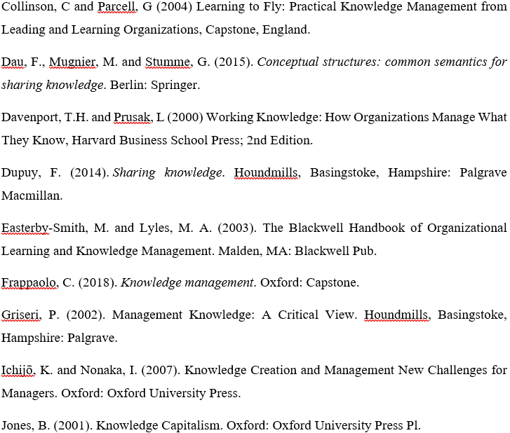
Knowledge Management Systems. (2010). Gardners Books.
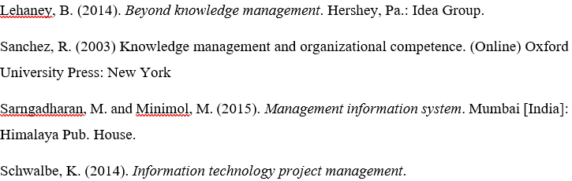
Schwartz, D. and Te'eni, D. (2011). Encyclopedia of knowledge management. Hershey, PA: Information Science Reference.
Tiwana, A. (2012). The knowledge management toolkit. Upper Saddle River, N.J.: Prentice Hall PTR.
Wiig, K. (2013). [Knowledge management]. Arlington, TX: Schema Press.

