Yohannes Zerzghi (P151368)

Managing a Hardware/Software Project for Disaster Recovery¬

Table of Contents
Introduction 1
Purpose of Risk Management 1
Scope of Risk Management 1
Risk Management 1
External risks 2
Internal risks 2
Risk Analysis Assessment 3
Qualitative and Quantitative Risk Analysis 5
Risk Matrix 6
Discussion 7
Sustainability 8
Sustainability Issues 8
Ethical and Legal issues 10
Quality Assurance Issues 12

Introduction
This report explains the risk management for the network disaster recovery of DVLA. The report provides information obtained through risk analysis assessment, regarding the probability of the risks and their impact or cost on to the project. In addition, the types of risks that are highly likely to happen to the project are identified using risk matrix. Moreover, the report looks into the sustainability issues of the project, in regard to the social, economic and the environment. Finally, the report explains the ethical and legal issues of the project after the Brexit and also the different quality metrics that are used to test the quality assurance of the project.

2.0 Risk Management
Risk management is a methodology of identifying, analysing the main risks of a project and uses different procedures to avoid or minimize their impact [1]. These risks are an indeterminate events or actions, which could hold back a company’s objectives or goals. There are many factors (risks) that can affect or disrupt business continuity of an organization or a company. These risks could be external or internal to the company [2].
There are many types of risks that can affect the online services of the DVLA. However; the type of risks that can affect the DVLA are classified external or internal.

2.1 External risks
External risks are events or actions that occur outside an organization’s control. Hence, the event or risk cannot be altered from happening, but its cost of influence can be minimized. Some of the external risks are natural disaster, man-made, political changes and so on [3]. Hence, the DVLA can be affected from these external risks.
The external risks that can affect the DVLA services are classified into the following four categories.
- Natural Disaster: These risks are external factors that could happen unexpectedly due to natural process of the earth. Some of the natural disasters that can affect the online services of a DVLA are floods, earthquakes, storms, tsunamis and so on.
- Man-made: These risk are made by humans. These risks could happen deliberately or due to human error. Some of the man-made risks that can happen to DVLA are terrorist attacks, fire, hacking and theft.
- Technological risks: These risks can happen due to hardware or software failure. Some of the technological risks that can happen to the DVLA are router or switch failure, operating system failure and so on.
- Internet service providers: These risks are related to internet service provider’s (ISP) failure. The DVLA service can be disrupted due to its internet service provider’s failure.

2.2 Internal risks
Internal risks are events that can occur within its organization. Some of the internal risks are man-made, technological and physical factors [3].
The following are internal risk factors to the DVLA.
- Power supply: services can be disrupted due to power cut or unregulated voltage within the DVLA.
- Telecommunication: good Implementation and design of the telephone architecture reduces chances of losing telecommunication services during the event of a disaster.
- Physical security: security cameras are implemented inside and outside the DVLA to monitor to any danger from unauthorized access to the building.

2.3 Risk Analysis Assessment
Risk assessment is a one of the steps that identifies risks in a risk management of a project. The risk assessment is based on the assumption of a risk likelihood to occur and the impact or cost it will have on an organization or a company [4].
As a result, the following formula is used to classify and identify the types of risks that can affect the online services of DVLA based on their threat occurrence and their magnitude of impact.
Risk factor = likelihood X impact [5].
The likelihood is based on the assumptions of a risk occurring on a scale 0 to 10 (where 0 means the risk will never happen and 10 means the risk will happen always). And the extent of impact is based on a scale 0 to 10 (where 0 means no damage at all and 10 means total loss of operations).

The table below shows the main risk factors for the disaster recovery of the DVLA.
Risks | Likelihood (0-10) | Impact (0-10) | Risk Factor ( Likelihood X Impact) | Strategies used to manage these risks
Earthquake | 1 | 7 | 7 | A remote server is implemented on the iCloud.
Flooding | 7 | 4 | 28 | Server room is on 2nd floor and an alternate remote server in Bristol.
Storms | 3 | 4 | 12
Hurricane | 3 | 6 | 18
Terrorism | 4 | 7 | 28
Cyber attack | 8 | 9 | 72 | Firewall is configured on the edge router and anti-virus is installed on all devices.
Water leakage | 5 | 7 | 35 | Alarms and notification technology is designed.
Router failure | 8 | 5 | 40 | A standby router is configured and a secondary link is configured in case the primary router fails, using HSRP protocol.
Power supply failure | 6 | 4 | 24 | A redundant UPS with auto standby generator is designed as a backup.
ISP failure | 8 | 8 | 64 | A secondary ISP provider is designed as a backup.
Table 1: Risk exposure analysis

2.4 Qualitative and Quantitative Risk Analysis
Qualitative risk analysis is a technique used to arrange risks for further analysis based on their chance of occurrence [4]. Risks are analysed into high, medium and low based on their likelihood of occurrence.
The following qualitative risk analysis are used to prioritize the risks that can affect the DVLA based on their chance of occurrence.

Likelihood of occurrence | Definition
High : < 5 > 10 | Extremely sure to happen.
Medium : > 2 < 5 | Somewhat an even chance to occur.
Low : < 2 | Almost sure not to occur
Table 2 : Qualitative assessment.

Quantitative risk analysis is a tool that analysis risks based on their magnitude of impact (cost) value to a project. For this report, the risks are grouped into high, medium and low based on their impact or effect to the online service of the DVLA.

Magnitude of impact | Definition
High : < 5 > 10 | Severe or catastrophic adverse effect on DVLA.
Medium : > 2 < 5 | Serious effect on DVLA services.
Low : < 2 | Limited effect on DVLA services
Table 3 : Quantitative analysis

2.5 Risk Matrix

The figure below explains the risk matrix of this project, where the risks with red colour are the most severe risks to the DVLA.

10
0.0
High
Low
Medium
Impact
Earthquake | Water leakage, Terrorism | Cyber-attack, ISP failure
 | Storms | Router failure
 |  | Flooding, Power supply failure
Medium
Low
High

10
0.0
Likelihood

2.6 Discussion
The figure from the risk matrix explains the types of risks and their impact to the project. The types of risks that can affect to the DVLA are both internal and external. According to the figure from the above, the line of no tolerance to DVLA are the risks in Red colour. These risks are types of risks to be considered highly as their impact is severe to the DVLA services.
Hence, to avoid or minimize their impact a risk strategy is designed to manage these risks (for risk strategy refer to the table of risk assessment from the above).

3.0 Sustainability
Sustainability is a field of study that associates the social science with the environment and the future technology of the world. Nowadays, new technologies are invented at a fast pace to provide a modern and simple life to the society. However, it is at the cost of all the natural resources of the environment. Hence, sustainability takes control of creating a mechanism that can protect the environment and health of the society.
The three main fields of sustainability are listed below.
- Economic development: deals with the economic aspects and legislative requirements of businesses, jobs and employability.
- Social development: is concerned about public health issues and regulations to protect the society from air or water pollution.
- Environmental protection: is concerned how to protect the environment from being damaged [6].

3.1 Sustainability Issues
One of the main sustainability issues to be addressed is the Impact of IT. Today’s information and communication is by using electronic equipment’s like computers, smartphones and the internet. As a result, the amount of energy and natural resources to be consumed will be massive. The impact of IT in sustainability are classified into first, second and third order according their effect to the environment [7].
For this project, the first order effect is the e-waste. The e-waste is a term that is used to describe when an electronic device is discarded or becomes out of use. These electronic devices could damage the environment when they are thrown away or used improperly [8]. The DVLA uses computers, routers, firewalls, switches, the internet and other devices to provide service to its customers. And these electronic devices consume huge amount of energy and they produce a large amount of heat to the environment. Hence, the company is designed with energy efficiency and cooling devices in order to reduce the effects to the environment and public health.
The second order effects is the result of the first order class applications that minimizes the risks to the environment, economic and social activities. These effects provide optimization, replacing the traditional methods with digital ones and so on [7]. One of the second order effects in DVLA is the introduction of online services. This online service protects the environment indirectly by using no papers or printers and providing economic benefit to the public as well.
The third order affects the environment, economic and public sector either directly or indirectly on a long-term structural and behavioural changes [7]. The DVLA introduces rules and regulations for its employees. One of the third orders for this project is to prevent employees not to use the DVLA computers for personal use.

4.0 Ethical and Legal issues
Nowadays, information and communication is through the internet, where organizations, small business companies and the public are benefiting from. However, the internet can be destructive, if it is used unethical and illegally. Hence, implementing ethical and legal standards is essential to the public and organizations [10].
Ethical standard are moral values based on human principles of good or bad. However, legal standards are executed by governmental laws [9]. It is important for organizations, public and governmental sectors to implement rules based on ethical and legal standards.
In this project, the ethical and legal standards is mainly concerned on data privacy, sharing, cyber-crime and the environment. These standards are based on the BCS and IEEE code of conduct. Some of the ethical and legal issues of this project are listed below.
- Data confidentiality must be maintained and protected.
- Protect all the data using digital data security by implementing firewall, password protection, strong encryption and virus protection from hackers.
- To provide employees courses, conferences and training in their professional development.
- To avoid discrimination against any person based on their race, age, religion and so on.
- To control and monitor employee’s from using the DVLA computers for personal use such as, Facebook, YouTube and online shopping.
- To protect the environment by implementing new technologies and innovations.
- To protect the safety and health of the public and also the environment by designing ethical and sustainable development.
- Avoid or reject that involves unethical issues such as, bribery, theft, dishonest and so on.

The impact of UK leaving the European Union (EU) on ethical and legal issues still remains uncertain. However, there are some issues to be considered. These issues could be modified or remain as it is. One of the issues to be affected after the Brexit is, the privacy and protection of data. Some of the ethical and legal issues after the Brexit are listed below.

- To develop a team to protect and share data on both sides. However, data sharing will be on request.
- To develop a team to tackle cyber-crimes on both sides [11].

5.0 Quality Assurance Issues
Quality assurance is a process of identifying the mistakes in a project and preventing them from happening [12]. The main quality assurance issues of this project are time and quality. One of the reasons that prevents this project from delivering its product is time. The reason is due to UWTSD staffs, lectures and project teams were on holiday time. Another, issue that hinders the project from its goals is lack of software and skilled team.
A packet tracer simulation is used to test the progress and quality of the project before handed to the project manager. The PING command along with the packet data unit (PDU) is used to test connectivity with each computers.

References

[1] | C. B, “risk management,” TechTarget, 1999. [Online]. Available: https://searchcompliance.techtarget.com/definition/risk-management. [Accessed 15 January 2019].
[2] | C. Systems, Disaster Recovery: Best Practices, San Jose: Cisco systems, 2008.
[3] | T. B, “Identify Internal vs. External Risks in Project Management,” Bright Hub PM, 25 March 2015. [Online]. Available: https://www.brighthubpm.com/risk-management/94946-internal-vs-external-risks-in-project-management/. [Accessed 13 January 2019].
[4] | D. A, “Types of Risk Assessment Reports for Documentation & Management,” brighthubpm, 24 April 2014. [Online]. Available: https://www.brighthubpm.com/risk-management/95799-reporting-on-risk-assessment-potential-impact/. [Accessed 16 January 2019].
[5] | K. P, “Disaster recovery: Risk assessment and business impact analysis,” ComputerWeekly.com, 22 April 2000. [Online]. Available: https://www.computerweekly.com/feature/Disaster-recovery-Risk-assessment-and-business-impact-analysis. [Accessed 14 January 2019].
[6] | “What Is Sustainability and Why Is It Important?,” EnvironmentalScience.org, 2019. [Online]. Available: https://www.environmentalscience.org/sustainability. [Accessed 15 January 2019].
[7] | A. G. Rudite C, “Information Technology Sustainability Problems and Possible Solutions,” Baltic J. Modern Computing, vol. I, no. 12, pp. 1-3, March 2017.
[8] | E. R. Corp, “what is e-Waste,” Electronix Rédux Corp, 2011. [Online]. Available: http://www.bostonelectronicwaste.com/go-green/what-is-ewaste. [Accessed 14 January 2019].
[9] | bcs, “BCS Code of Conduct,” BCS, 2019. [Online]. Available: https://www.bcs.org/category/6030. [Accessed 20 January 2019].
[10] | Y. Alcocer, “What is the Difference Between Legal & Ethical Standards?,” study.com, 2003. [Online]. Available: https://study.com/academy/lesson/what-is-the-difference-between-legal-ethical-standards.html. [Accessed 12 January 2019].
[11] | Bcs, “BCS on digital Brexit - get involved,” BCS, 12 October 2016. [Online]. Available: https://www.bcs.org/content/ConWebDoc/56850. [Accessed 15 January 2019].
[12] | simplicable, “7 Examples of Quality Assurance,” simplicable, 2002. [Online]. Available: https://simplicable.com/new/quality-assurance-examples. [Accessed 20 January 2019].
[13] | Z. X, W. N, L. H and Z. X, “Information security risk management framework for the cloud computing environments,” in IEEE, Bradford, 2010.

Appendices

SCHEDULE AND GANTT CHART

BEFORE
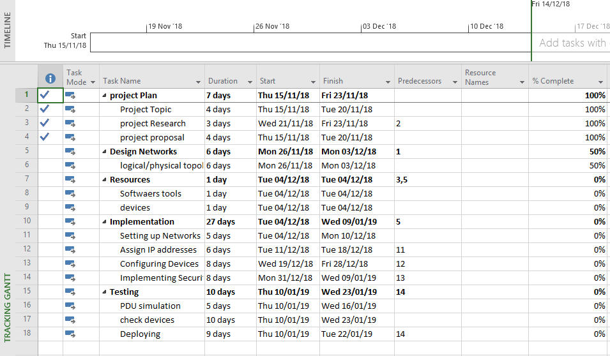

AFTER
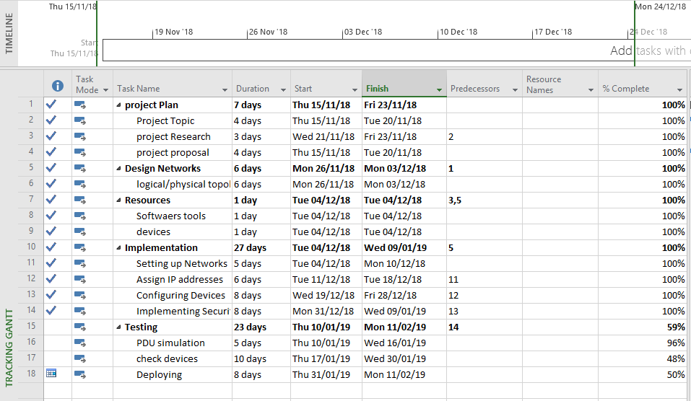

BEFORE
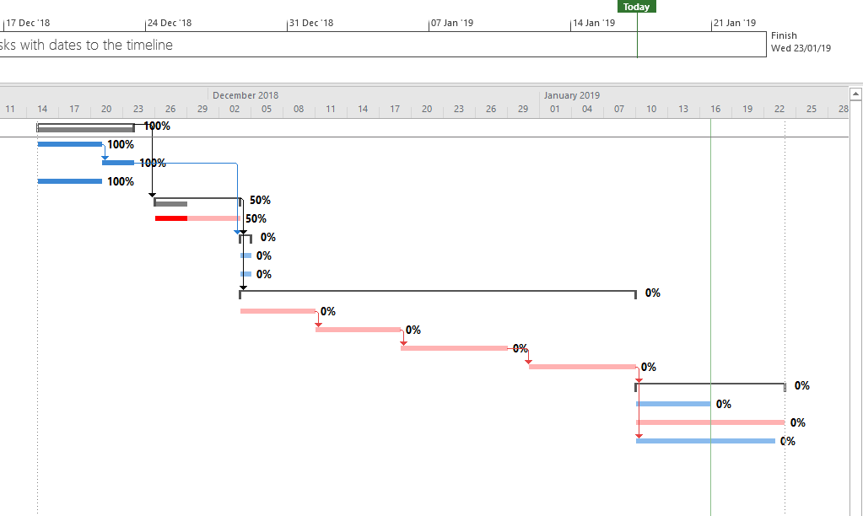

AFTER
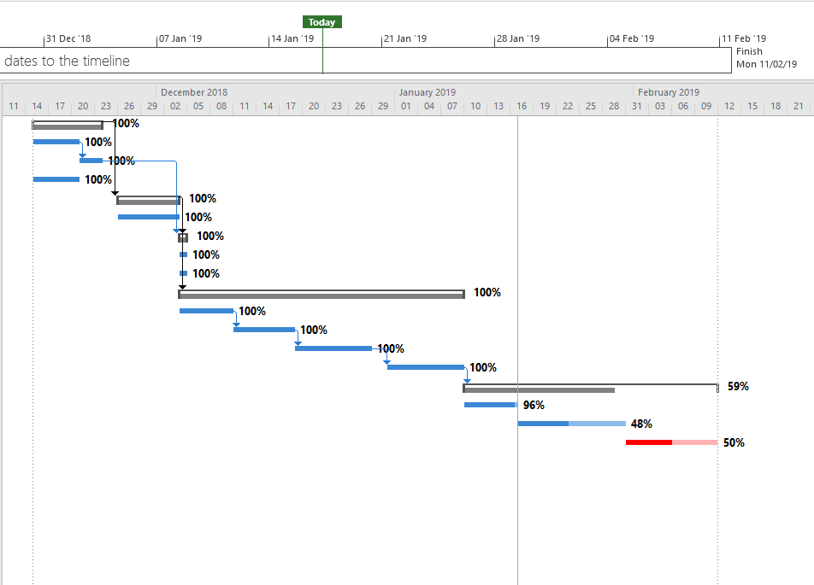

PROJECT RELATIONSHIP

BEFORE

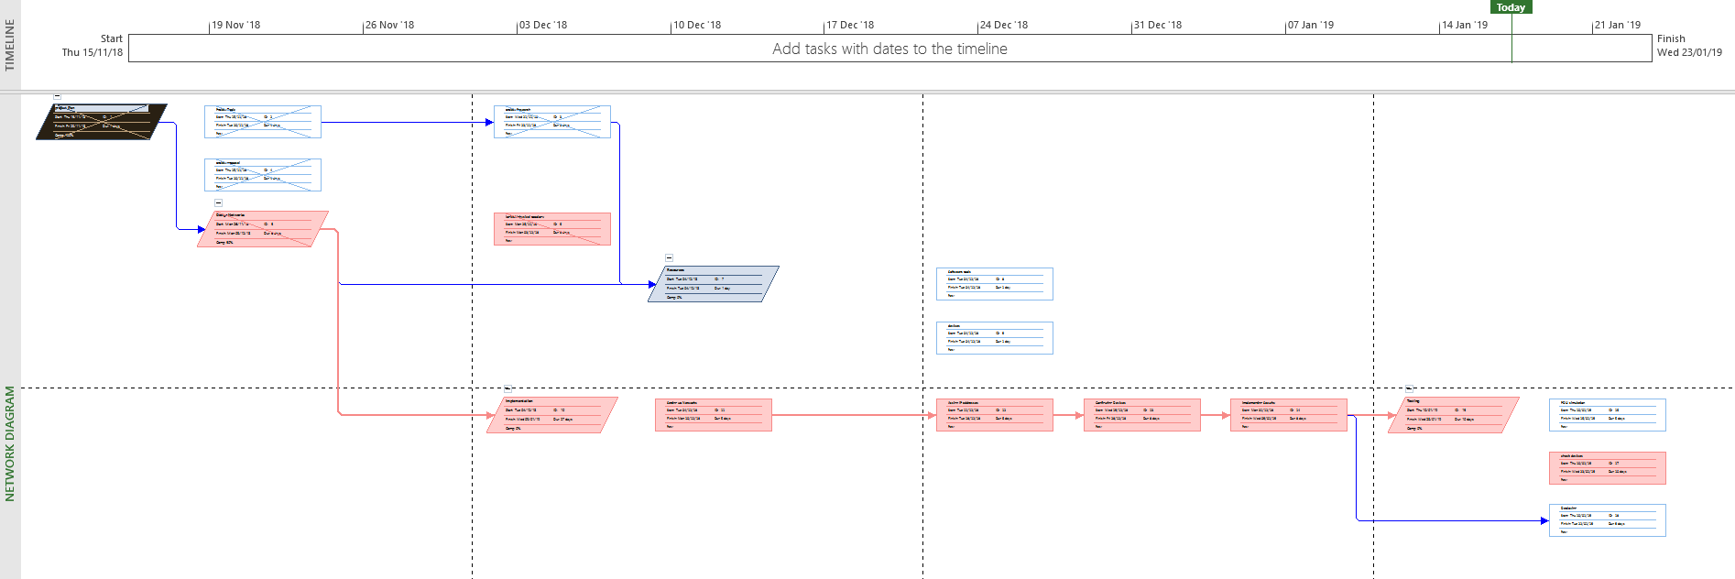

AFTER
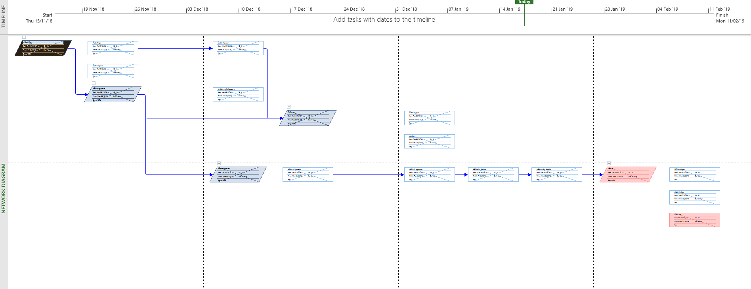

Packet tracer Simulation



