P126121
Group 1
WORD COUNT: 4782 words
School Development and pupil progress
‘Supporting pupil progress: a detailed analysis of one child’s holistic development, with justification for the next steps in learning.’

Student Self Evaluation Form

Common Assessment Criteria Applied
Common Assessment Criteria Applied | REFER |  | D |  | C |  | B | A
 | OUTRIGHT FAIL | UNSATISFACTORY | SATISFACTORY | GOOD |  | VERY GOOD |  | EXCELLENT
1. Subject Knowledge and Understanding (which includes using research-informed literature and knowledge and understanding of the subject)
 |  |  |  | X
2. Intellectual Skills (Analysis)
2. Intellectual Skills (Analysis) |  |  |  | X
3. Pedagogic and Professional Applications (Practical Application and Deployment)
 |  |  |  | X
4. Key Transferable Skills
4. Key Transferable Skills |  |  |  | X
PLEASE COMMENT ON AREAS IN WHICH YOU FEEL THAT YOU HAVE PERFORMED WELL | PLEASE COMMENT ON AREAS you feel that you need TO DEVELOP
I have included a lot of relevant research and think that my level of deeper understanding has improved. I think that I was able to address next steps well and to provide adequate strategies. | I think that I need more help with analysis and to make sure that I’m not just describing, but I am still getting better each essay. I am more confident with referencing but there is still some concern.
This section repeats in brief the common assessment criteria detailed on previous pages. The extent to which these are demonstrated by you determines your mark. Using these criteria, tick the box that best indicates the level of achievement you feel you have achieved with regard to each of them.
Southall (2013) suggests that despite how much research has gone into looking at the learning process of children, there is no definite answer on how children learn. The learning process is different for every child and the progressive steps that a child makes towards greater understanding within learning should be individualised towards that child’s needs. Southall (2013: 151) explains how important it is that we ‘help children learn for themselves” and using a holistic approach to look into next steps for a child’s learning progression gives the biggest opportunity for professional educators to do this.
To look at a learner holistically for progression of their personal development, it is important to consider all the environmental factors that influence their learning and experience within the school setting. Peterson and Warwick (2015: 5) address the issues that can concern a child’s learning experience, ranging from the languages spoken within the school to the ‘origin of the food they eat during the lunch break’. Therefore, it is important that the school itself is taken into consideration and how this could have an impact upon the learner’s progression.
The school is within a strong-knit community of different cultures on the outskirts of a main city, with many of the children within the school speaking English as an additional language as a large majority are from Bangladeshi backgrounds. The school is in a socially deprived area and has a Flying Start nursery embedded within the setting. There are strong links that have been developed with the nearby secondary school and there is a big emphasis on the ethos of creativity and imagination with the primary school. Each year group has one class per tier of education.
The learner that will be discussed is an eight year old boy from a Welsh background within a Year 4 class of 28 children. The class is an almost even split (13 girls and 15 boys) with many of the boys having behavioural and emotional issues leading to aggression. The learning, who will be referred to as Leo for anonymity and confidentiality, is one of the lowest attaining children within the class academically. He is a friendly, engaging child that has some issues with focus and speed of creating work, regardless of enjoyment of the lesson. There have been no issues of emotional distress or challenging behaviour in the weeks he was observed and the class teacher confirmed there have been no issues prior to this with Leo’s behaviour.
To fully be able to look at Leo on a holistic level for his development and further progression, the Mosaic Approach was used to collate and analyse data to guide his next steps within areas of the curriculum. The Mosaic Approach focuses on children and adults creating meaning together as collaborators. Clarke and Moss (2011: 2) describe this approach as combining ‘the visual with the verbal’ and focuses on the importance of young children being ‘listened to and responded to by adults.’ This approach gives both the student teacher and the learner the opportunity to reflect and challenge learning from more than one perspective. By collating data that is presented in more than one way, this gives more opportunities to view learning holistically and develop progressive steps whilst also considering the learner’s voice. Clarke and Moss (2011: 38) agree with this by stating that ‘combining […] these individual pieces brings a greater level of understanding about young children’s priorities’.
The data that was collated from Leo came from a variety of different methods and observations. As Clarke and Moss (2011: 15) suggest, putting together different combinations of data creates a ‘living picture’ of how the learner views the setting personally. The data itself was work that he had completed within class, work created individually with guidance from the student teacher, observations for next steps on assessment trackers and interviews on how he learns including a learning walk around the school from his first interaction with the student teacher. These give a small insight into how he views his own learning as well as how he compares from a teacher’s perspective and through government outcomes and levels. He was always given the opportunity to discuss what he thought his next steps should be and these were integrated into what next developmental progression would be suggested to further support and challenge his learning.
There are a number of strengths and weaknesses to using any method of collecting data, especially when the approach to the data is reliant on the learner’s voice. There is a heavy reliance upon the learner’s willingness to engage with the data within the Mosaic Approach and this can be seen as a strength when looking at how children learn. As Southall (2013) stated, each child’s learning journey is different, so by incorporating the child within the data collection and analyse through this approach, this offers the child the opportunity to become an active participant in their own reflective learning. Clarke and Moss (2011: 64) talk about how being engaged in the Mosaic approach can also have long-term benefits on the child and how they view themselves.
However, there is a limitation to having the learner at the centre of the data collection and reflection. The Mosaic Approach can cause a learner’s privacy to be invaded with the constant need for observation and listening to their opinions on their own learning, potentially causing discomfort and distress that will affect the child’s emotional wellbeing within the situation. This would then cause an issue with the reliability of the data that is being collected. This could also cause the learner to constantly be assessing their own work to a degree that is detrimental to their own understanding and enjoyment of the subject.
It is important to be ethically considerate whenever performing research that involves observational methods. This is especially important when the participant is a minor and their own rights should be respected as well as the rights of the adult who is responsible for the child at the time of the research, whether that is the class teacher, student teacher or parent. To make sure that all ethical considerations were taken, the child was asked to give assent for any recordings taken place as well as the class teacher having signed consent for the observations to take place which can be found in Appendix 1. Leo was made fully aware of the reason why he was being observed and what the research topic was, and verbal assent was asked for every time an interview or recording took place.
Anonymity and confidentiality have been considered within the research as an area of importance, with the school’s name being removed and Leo’s name being change to protect both identities. It was explained to Leo that his name would not be used within the research at any point and that he had the right to withdraw from being involved within the research at any time. He assented to being part of the research at each point that he was asked happily and understood why the research was taking place. For all the verbal recordings that took place, this was consented by the class teacher and Leo gave verbal consent as well as pressed the button to record his voice himself to give him the opportunity to withdraw. The recordings were transcribed for data collection and the digital files of voice recording were then deleted immediately after transcribing to keep confidentiality.
To analyse and reflect upon Leo’s learning, the data was collated and compared using a structural reflection model to help move forward his progression within learning. The model that was used to help support the analysis was Nottingham’s (2013) A.S.K. model. He used the A.S.K model to help review understanding after lessons through ‘three dimensions of learning’ he labelled as attitudes, skills and knowledge. This method helps to look at individual dimensions of learning for Leo and how those can relate to his developmental progression. Five areas of the curriculum were considered and analysed for Leo to help decide on his next steps for progression: literacy, numeracy, humanities, expressive arts and well-being.
Literacy
The major area of concern in regards to the curriculum for Leo is his progression and challenge with literacy. Leo’s attitude towards literacy is positive and he finds reading interesting, but finds that there are some issues with his understanding of words and how to use them. He stated that he sometimes wasn’t sure how to write the words down when creating written pieces of work and that the words can become jumbled up. ‘Difficulties with accurate and/or fluent word recognition and […] poor spelling and decoding abilities’ (Washburn et al, 2017: 171) is a characterisation of dyslexia and Leo had stated within his interview that he sometimes didn’t know how to write the words and became confused with how to do it. This could be a sign of Leo having dyslexia and further testing may need to be done to confirm this. Leo has shown a willingness to always try his best, but he can often be distracted by his peers that slows down his learning process.
One of the literacy lessons that was taught involved creating a plan for a diary recount. The lesson offered the opportunity to choose the differentiation level out of three levels and despite being a lower attaining child, Leo chose the middle level of differentiation that did not offer as much scaffolding support. He was able to complete this task and to link with his previous knowledge, but actually putting the ideas to paper was a struggle for him. His social skills of explaining what he wanted to write were extremely high but he found transferring this to the written element was difficult to do. Leo’s understanding of literacy from a verbal area is good and he is able to discuss his though processes with his peers and teachers. It is clear that his progression needs to be focused on the transference of verbal to written.
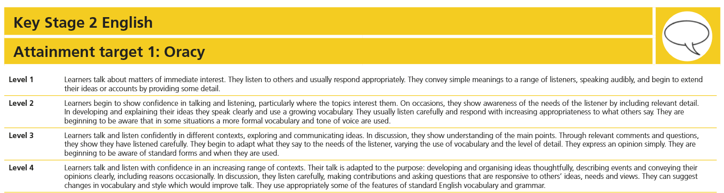
Leo has a lot of the knowledge to back up his understanding of literacy and where he needs to go to progress himself within this area of learning. He was aware of what he needed to include within the lesson on a diary recount, but the ability to write his work is where his major concern lies. His understanding and concepts for literacy lessons are developmentally higher than some of the more higher attaining children but his inability to be able to process this to paper causes some of his concepts to become lost.
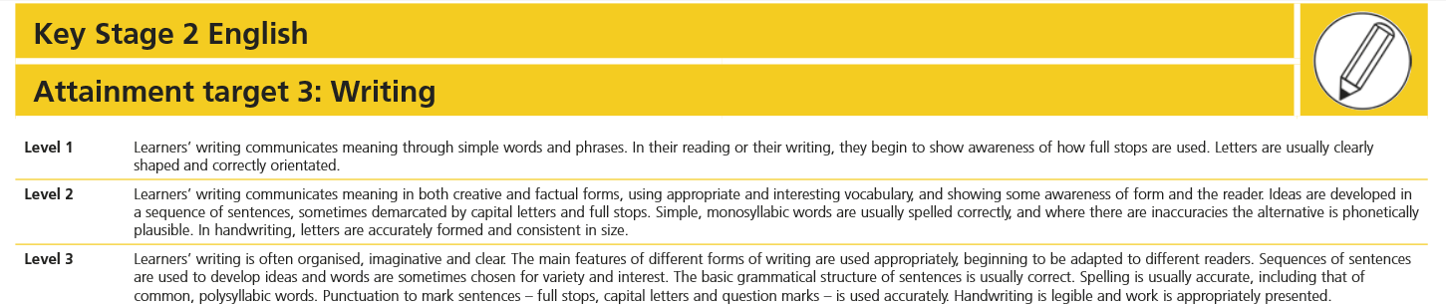
When considering attainment levels, his oracy attainment is a strong Level 3A, with a justification to move onto a Level 4 with some support with grammar and word choice. He has shown that he is able to display relevant thoughts and even within the interview, he showed good understanding of why it is important to learn certain subjects and could give justification for what his next steps should be. However, when looking at his written work and comparing this to the level descriptors, he does seem to be at a Level 1B. He has a lot of issues with his handwriting and understanding what has been written, as well as not always using full stops which can be seen in Appendix 2.
There is a lot of strength in this collation of data as there is the ability to compare his literacy work cross-curricular, especially when looking into his written work. However, the level of his literacy in the different areas of oracy and written is very much in contrast, causing difficulty in being able to give him a level that encompasses all of the data. As well, the level of his written work is difficult to understand due to his handwriting and letter formation, causing issues to be able to assess his writing accurately.
Numeracy
Leo has more confidence when assessing his numeracy abilities than with his literacy and is more willing to accept help with his numeracy work. He shows a willingness to challenge himself, choosing the more difficult tasks that are offered in differentiation, but when he is unable to overcome the challenge by himself, he can become quite unfocused and will talk off-topic with his peers rather than find another way to look at the challenge. He stated in his interview that support from teachers and teaching assistants help him to find the work less challenging, and that support from others is important to him to help progress his numeracy skills.
Leo is in the lower attaining bracket of his year group for numeracy and although he does show determination to try his best with his work, he can find issues comprehending instructions and explanations of tasks difficult once he is no longer with the person providing the support. In their current topic of time within numeracy, despite having examples and explanations of what he needed to do to overcome the challenge from both peers and teachers, he was unable to grasp the concept and how to apply that to what the work was doing.
Using his social skills within the numeracy concept did not show much improvement with the level and standard of his understanding of the tasks presented. He was still struggling with completing the tasks despite the direct help of a peer to help layout one of the problem solving tasks he had to perform. There was also the added concern of having to use his written literacy within the task that caused more challenge for Leo to overcome. There is an issue of his basic understanding of the topic of time and a need to further support his understanding of the skill in this area. Leo’s knowledge of time in general was limited and despite having done time in previous years, he was not able to transfer any prior knowledge to help with his lessons in numeracy. He wasn’t able to read the analogue clock or able to process the time shown, despite the amount of support his received.
Although the amount of data gathered in numeracy was quite limited due to having spent more time on literacy work, there is a clear concern with his numeracy development and a lot more support is needed to help his understanding. He is willing to learn and accept help from others, which could give an idea on how to further develop his understanding and learning. When looking at the level descriptors for numeracy, it is difficult to fully place him in any level as the data that has been gathered is limited to one area of the curriculum. There would need to be more evidence gathered to be able to level Leo accurately, but there is concern with his numerical development.
Humanities
Leo has shown a lot of curiosity towards the subject of humanities, particularly in the historical aspect of the topic that they are studying in class. The data presented for humanities is focused on the historical aspect of the curriculum and will reflect this in the analysis. Within his interview, he drew upon the importance of history and that they should learn about it within school. He always shows a willingness to become involved with each task presented to him within humanities and was immediately interested in the current theme of the Victorians due to having studied it in Year 3.
There was an improvement within his learning of humanities due to the different ways of presenting information in a variety of activities in the topic lessons. Leo was able to compare and contrast his ideas within history, but did show some reluctance to offer answers to the whole class unless prompted. This does seem to be a reoccurring theme for Leo within many of the lessons and could be based around not wanting to give answers that he believes could be wrong. Edwards and Springate (1995) suggest that the classroom should ‘reflect the adults’ encouragement and acceptance of mistake’ This could be a reason why Leo is not as quick to offer his own answers and that he does not feel the classroom offers him the opportunity to embrace mistakes. However, within his interview he claimed that he doesn’t feel bad about mistakes but that he felt he should have got it right the first time.
Within smaller groups, he has shown that he is able to understand the humanities tasks and has the ability to share his ideas, but can often be ignored by other members of his class due to having a quiet disposition. He was able to collaborate with others without issue and to help others when they were struggling with their words for the oracy task, but did get distracted by all the other activities and items that were around him.
Leo’s understanding of the topic that he is studying has some basis in previous knowledge due to having some experience with the theme last year. He felt that he was interested in finding out more from the work he has already done in this area. His grasp of some of the basic facts have helped with the understanding of his work. He could also understand the concepts being discussed and how that had an impact on the wider world.
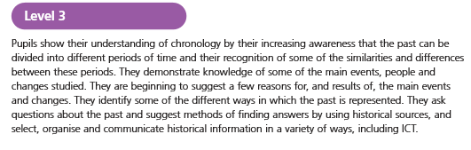
Although there is data collected for humanities, there is a strong emphasis on literacy within this theme that does cause some concern for Leo’s progression. Leo’s difficulties with writing and being able to process his ideas onto paper does hinder his developmental progression with humanities in some areas. The data does have weakness as a whole as there has been a lot of discussion within the class of key areas of the theme that have not be recorded as they have been oral-based.
When looking at the level descriptors for history, there is evidence for Leo to be firmly in Level 3, as he has shown within his work an understanding of chronology through a timeline as well as looking at Queen Victoria in detail using the support of historical sources on the internet as well as previous knowledge. He has also recently shown understanding in the differences of children now and children in Victorian times.
Expressive Arts
Although there were no directly taught lessons for expressive arts by the student teacher, it was used within the topic lessons and through a lesson developing on wellbeing. Leo showed a strong desire to draw and use his skills within drawing the further his development. He was given a task to draw what he thought of himself from the student teacher as part of the research which can be seen in Appendix 5. This was to look at how he saw himself and to look at his level of skills within art.
He took part in two lessons of drama that was focused on developing wellbeing within the class for collaboration, communication and concentration. He showed good understanding of what was expected and was willing to take part in all areas of the lesson. His attitude towards expressive arts in general was exceptional and he was willing to try out different kinds of activities, despite having communication issues with the other boys in the class due to their constant disruption. This is a reoccurring issue within expressive arts lessons, and Leo had spoken to the student teacher within a music lesson about wanting to become a girl so that he didn’t have to spend lessons with the boys.
Leo has a high ability with his social skills, always willing to talk with others and to create collaborative work. He has had no issues with any of the children within the class and will happily work with the students within his group, no matter who they are. He does offer his own opinions more willingly in expressive arts, but can still find his voice drowned out against the more vocal students.
He has the physical skills to be able to draw and colour in works of art that he can create from his own concepts. He was more than capable of using his body to work on his balance, creating still images and small roleplay scenes within drama. His physicals skills do have room for development, but his confidence is in place to be able to try more challenging physical feats.
Leo has been able to drawn upon his own ideas and concepts to create expressive works of art. His self-portrait that he created used his previous knowledge of anatomy and form to be able to draw successfully without a need for prompting with other instructions. He does have some issue with expanding past his basic understanding of ideas and does not always find it easy to think outside of the box.
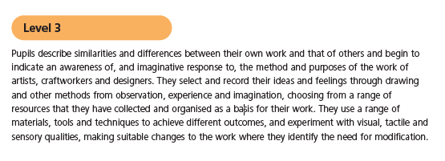
With expressive arts, it is difficult to be able to level a child on how they are progressing against a curriculum due to the subjective nature of art, drama and music. The amount of data collected for expressive arts is only based on the art area of the curriculum as it was not possible to gain physical data for music and drama. This causes another issue with trying to look at where Leo is in terms of progression and development.
When looking at the levels of art within the curriculum, however, it can be seen that he is able to show evidence for some of the level descriptors, though the different kinds of art he has created have been limited to just drawing. He is showing an increasing awareness of observation, experience and imagination as a way of creating a piece of work, therefore putting him in Level 3, but as other areas have not got evidence at this time, he would not be able to progress within Level 3.
Wellbeing
Leo’s wellbeing within school can best be analysed through conversations with him personally and looking into how he views school and subjects. The time spent with Leo on observations show that he is a very intuitive child when it comes to seeing how others interact around him and his own views on his friends. He can make decisions that are thoughtful and helpful to his friends, but does sometimes get distracted and disrupted by other people around him. This can have a detrimental effect on the level and consistency of his work, especially when the work is considerable slowed down when he is unfocused.
When asked how he feels about school in general, Leo stated that he didn’t like the school in Year 2 but started to like it more in Year 3. He stated that he liked school because it helped him to learn, let him do lots of different activities and that he got to meet new people. Within lessons, there have been no issues with his behaviour or any emotional upset, but he has spoken on occasion about the boys in his class and that he felt frustrated that the boys would not stop messing around. This does have an impact on his wellbeing and how he reacts in class, as he can become more withdrawn when the boys are causing disruption within lessons.
Data on Leo’s wellbeing comes from the interview completed with him and from how he interacts with his peers from observations. This does have some subjectivity on the data as there isn’t a lot of physical evidence to show how he is developing and progressing. However, wellbeing is in constant flux and needs to be addressed within the moment as issues can arise quickly in the school day that can affect Leo’s wellbeing.
To be able to look into Leo’s developmental progression within his learning, it is important to look at how he can further be supported and challenged with his understanding for the next step. When considering where Leo should progress to, pedagogical approached were considered as well as taking into account what Leo himself thought his next steps should be. This draws upon Southall’s (2013) idea that every child is individual and should have their learning addressed that way.
Two main areas of the curriculum were focused on for his next steps as they are the areas that need the most support and challenge to be able to further his understanding and progression within other areas of the curriculum. Leo’s major concern within his literacy is the emphasis on writing and his ability to transfer his ideas from verbal to visual. He also has difficulty with his handwriting and making the work legible to be able to develop his ideas even further.
A way to be able to address Leo’s handwriting would be to look into the differentiation of his letter heights, especially as most of his letters are all of the same height, regardless of what the letter is and whether it is a capital letter or not. A strategy to help with the formation of letters and differentiation of height would be the use of highlighted paper, an example of which can be seen in Appendix 6. This strategy has been used by a teacher within school to help students see the difference in the writing of letters and to help with understanding handwriting. Make, Take & Teach (2012) discuss how that you cannot see if a student has ‘fully mastered a phonics rule until you see him/her use it in writing’. Leo’s work causes difficulty being able to assess his understanding due to his sometimes illegible writing.
This strategy offers Leo the opportunity to see how to layout descending and ascending letters whilst keeping the small letters within the highlighted line. This would be used as scaffolding support to help him with his handwriting to being with but would gradually be taken away as he got more confident with his writing ability. This strategy could also be used within the class for other students with handwriting issues, but I feel that Leo would benefit particularly with a visual guide to follow.
When asked what he would suggest for his next step within literacy, Leo suggested that he would give himself more thinking time before writing the words down. This next step for progression was incorporated for his learning by using a mapping strategy to plan out his ideas before starting to write fully. This would give him the opportunity to put all his thoughts into a more cohesive view for himself and would work as a support to help his writing. This will also give him the opportunity to have more thinking time for his work, as well as giving him a structure to work from.
With numeracy, Leo’s major challenge is the ability to understand a concept and apply it to different activities. He particularly struggles with working on his own numeracy and finds that he prefers to be supported by teachers when needing an explanation on topics he finds difficult. To be able to progress further with his numeracy, Leo needs to be able to support himself with numeracy without needed 1-1 support.
A strategy that would help him with numeracy would be to use an ICT app to help him without the need for a teacher to be with him. The app, Explain Everything, would offer the opportunity for the teaching assistant or teacher to be able to record themselves demonstrating how to address a challenge and for Leo to take that recording with him to refer back to in a verbal and visual video. This would also give Leo the opportunity to create his own videos for explaining a challenge or task he’s managed to grasp to share with others.
It is clear that Leo’s progression should come for a collaboration of his own willingness to challenge himself, as well as teacher-led interaction and scaffolding strategies. Using both the understanding of Leo from the data and from interacting on a personal level, it is clear that there is a constant need for assessment for learning and that by analysing data, the best progression can be found to help the child move forward with their learning.
Being able to work with children on a collaborative level for their own leaving and taking into consideration their own opinion on how they could get better is a good tool for a teacher as feedback. This draws upon the idea stated before that learning is individual for everyone and a child’s next step should be individual to them too for their continual development. As a teacher, this experience of working on next steps collaboratively will further understanding of how best to teach a child and how their personal targets can impact on their progression. This will continue to develop through Donaldson’s (2015) idea of a collaborative, enterprising child and offer children the opportunity to shape their own learning and challenges.

References
- Clark, A. and Moss, P. (2011) Listening to Young Children, London: NCB, [e-book]. Available at: https://www-dawsonera-com.ezproxy.uwtsd.ac.uk/readonline/9781907969423 [Accessed on: 29th May 2018]
- Edwards, C.P. and Springate, K.W. (1995), ‘Encouraging Creativity in Early Childhood Classrooms’ [Online] Available at: https://www.ericdigests.org/1996-3/early.htm [Accessed on: 29th May 2018]
- Explain Everything (2018) ‘Explain Everything’ [Online] Available at: https://explaineverything.com/ [Accessed on: 29th May 2018]
- Make, Take & Teach (2012) ‘Strategies for Improving Handwriting’ [Online] Available at: http://blog.maketaketeach.com/strategies-for-improving-handwriting/ [Accessed on: 29th May 2018].
- Nottingham, J. (2013) Encouraging Learning. Abingdon: Routledge.
- Peterson, A. and Warwick, P. (2015) Global Learning and Education. Abingdon: Routledge.
- Southall, M. (2013) ‘How Do Children Learn?’, Childhood Education, 36, pp.151-152 [Online]. Available at: https://www.tandfonline.com/doi/abs/10.1080/00094056.1959.10727741?journalCode=uced20& [Accessed on: 29th May 2018]
- Think Literacy (Unknown Date) ‘Writing Strategies’ [Online] Available at: http://www.edu.gov.on.ca/eng/studentsuccess/thinkliteracy/files/Writing.pdf [Accessed on: 29th May 2018].
- Washburn, E., Mulcahy, C. and Musante, G. (2017) ‘Novice Teachers’ Knowledge of Reading-related Disabilites and Dyslexia’, Learning Disbailities: A Contemporary Journal, 15, pp.169-191 [Online]. Available at: https://web-a-ebscohost-com.ezproxy.uwtsd.ac.uk/ehost/pdfviewer/pdfviewer?vid=1&sid=5c4acce9-ebf6-4770-b82f-e2345ca4a87d%40sessionmgr4008 [Accessed on: 29th May 2018]
- Wyse, D., Selwyn, N., Smith, E. & Suter, L.E. (eds) (2016) The BERA/SAGE Handbook of Educational Research. London: Sage Publications Ltd.

Appendix
Appendix 1 – Consent Letter
Names have been mostly blocked out for confidentiality purposes. A copy of this letter can be accessed with full names if needed.
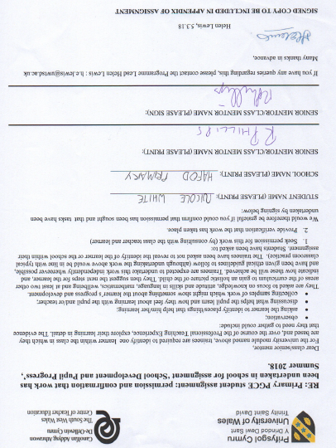

Appendix 2 – Leo’s Literacy Work
Recount Diary Plan
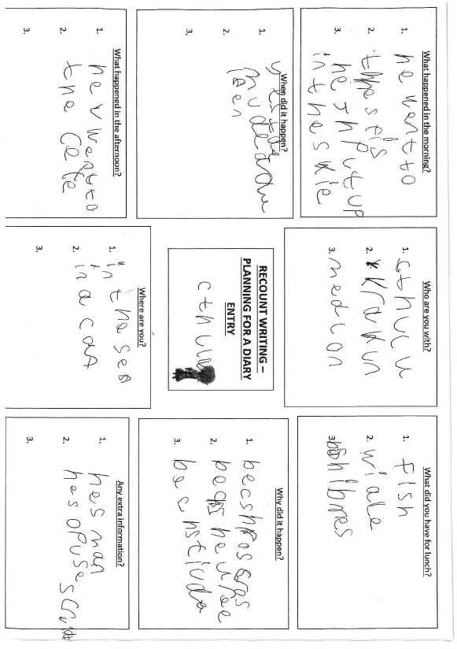

Appendix 3 – Leo’s Numeracy Work
Time Worksheet – Green pen written by student teacher
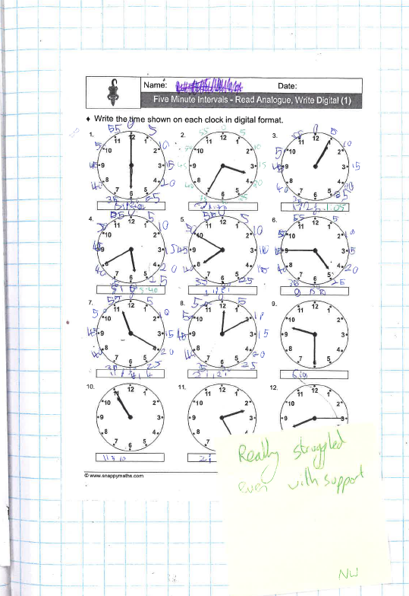
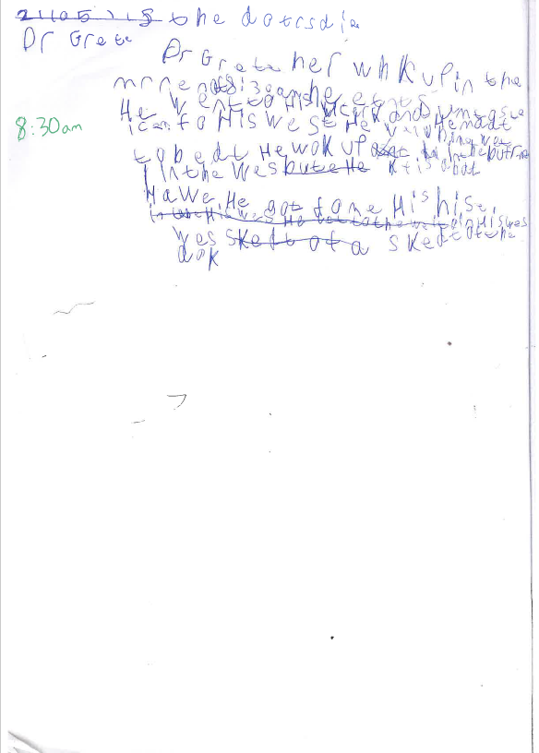

Appendix 4 – Leo’s Humanities Work
Victorian Comic Strip Timeline
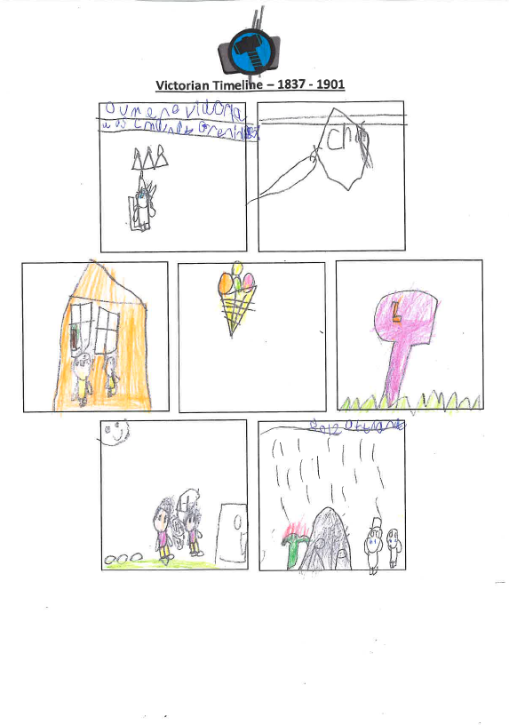

Queen Victoria Factfile

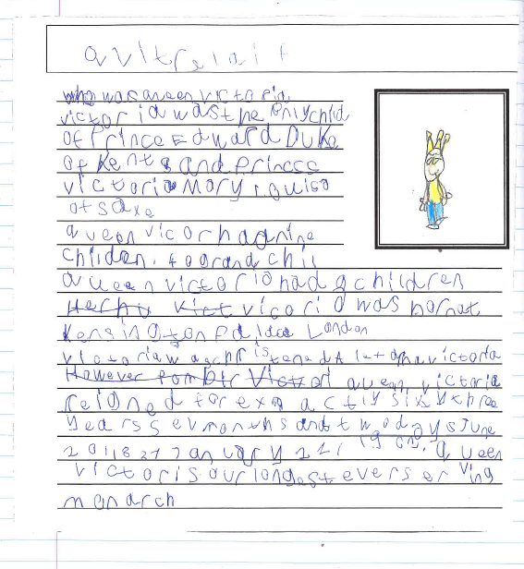

Appendix 5 – Leo’s Drawing of Himself
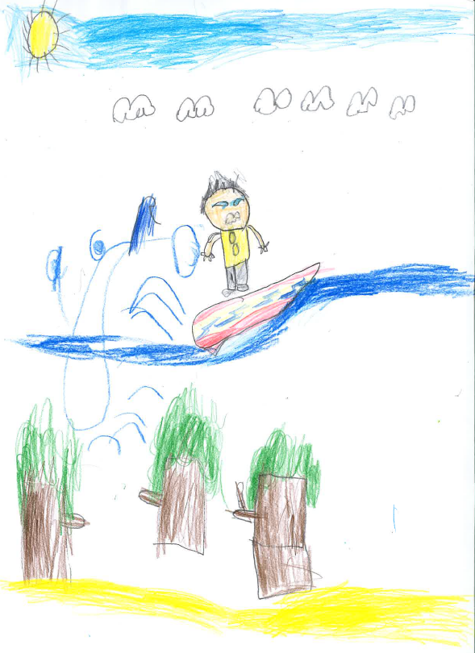
Appendix 6 – Example of Highlighted Paper Strategy
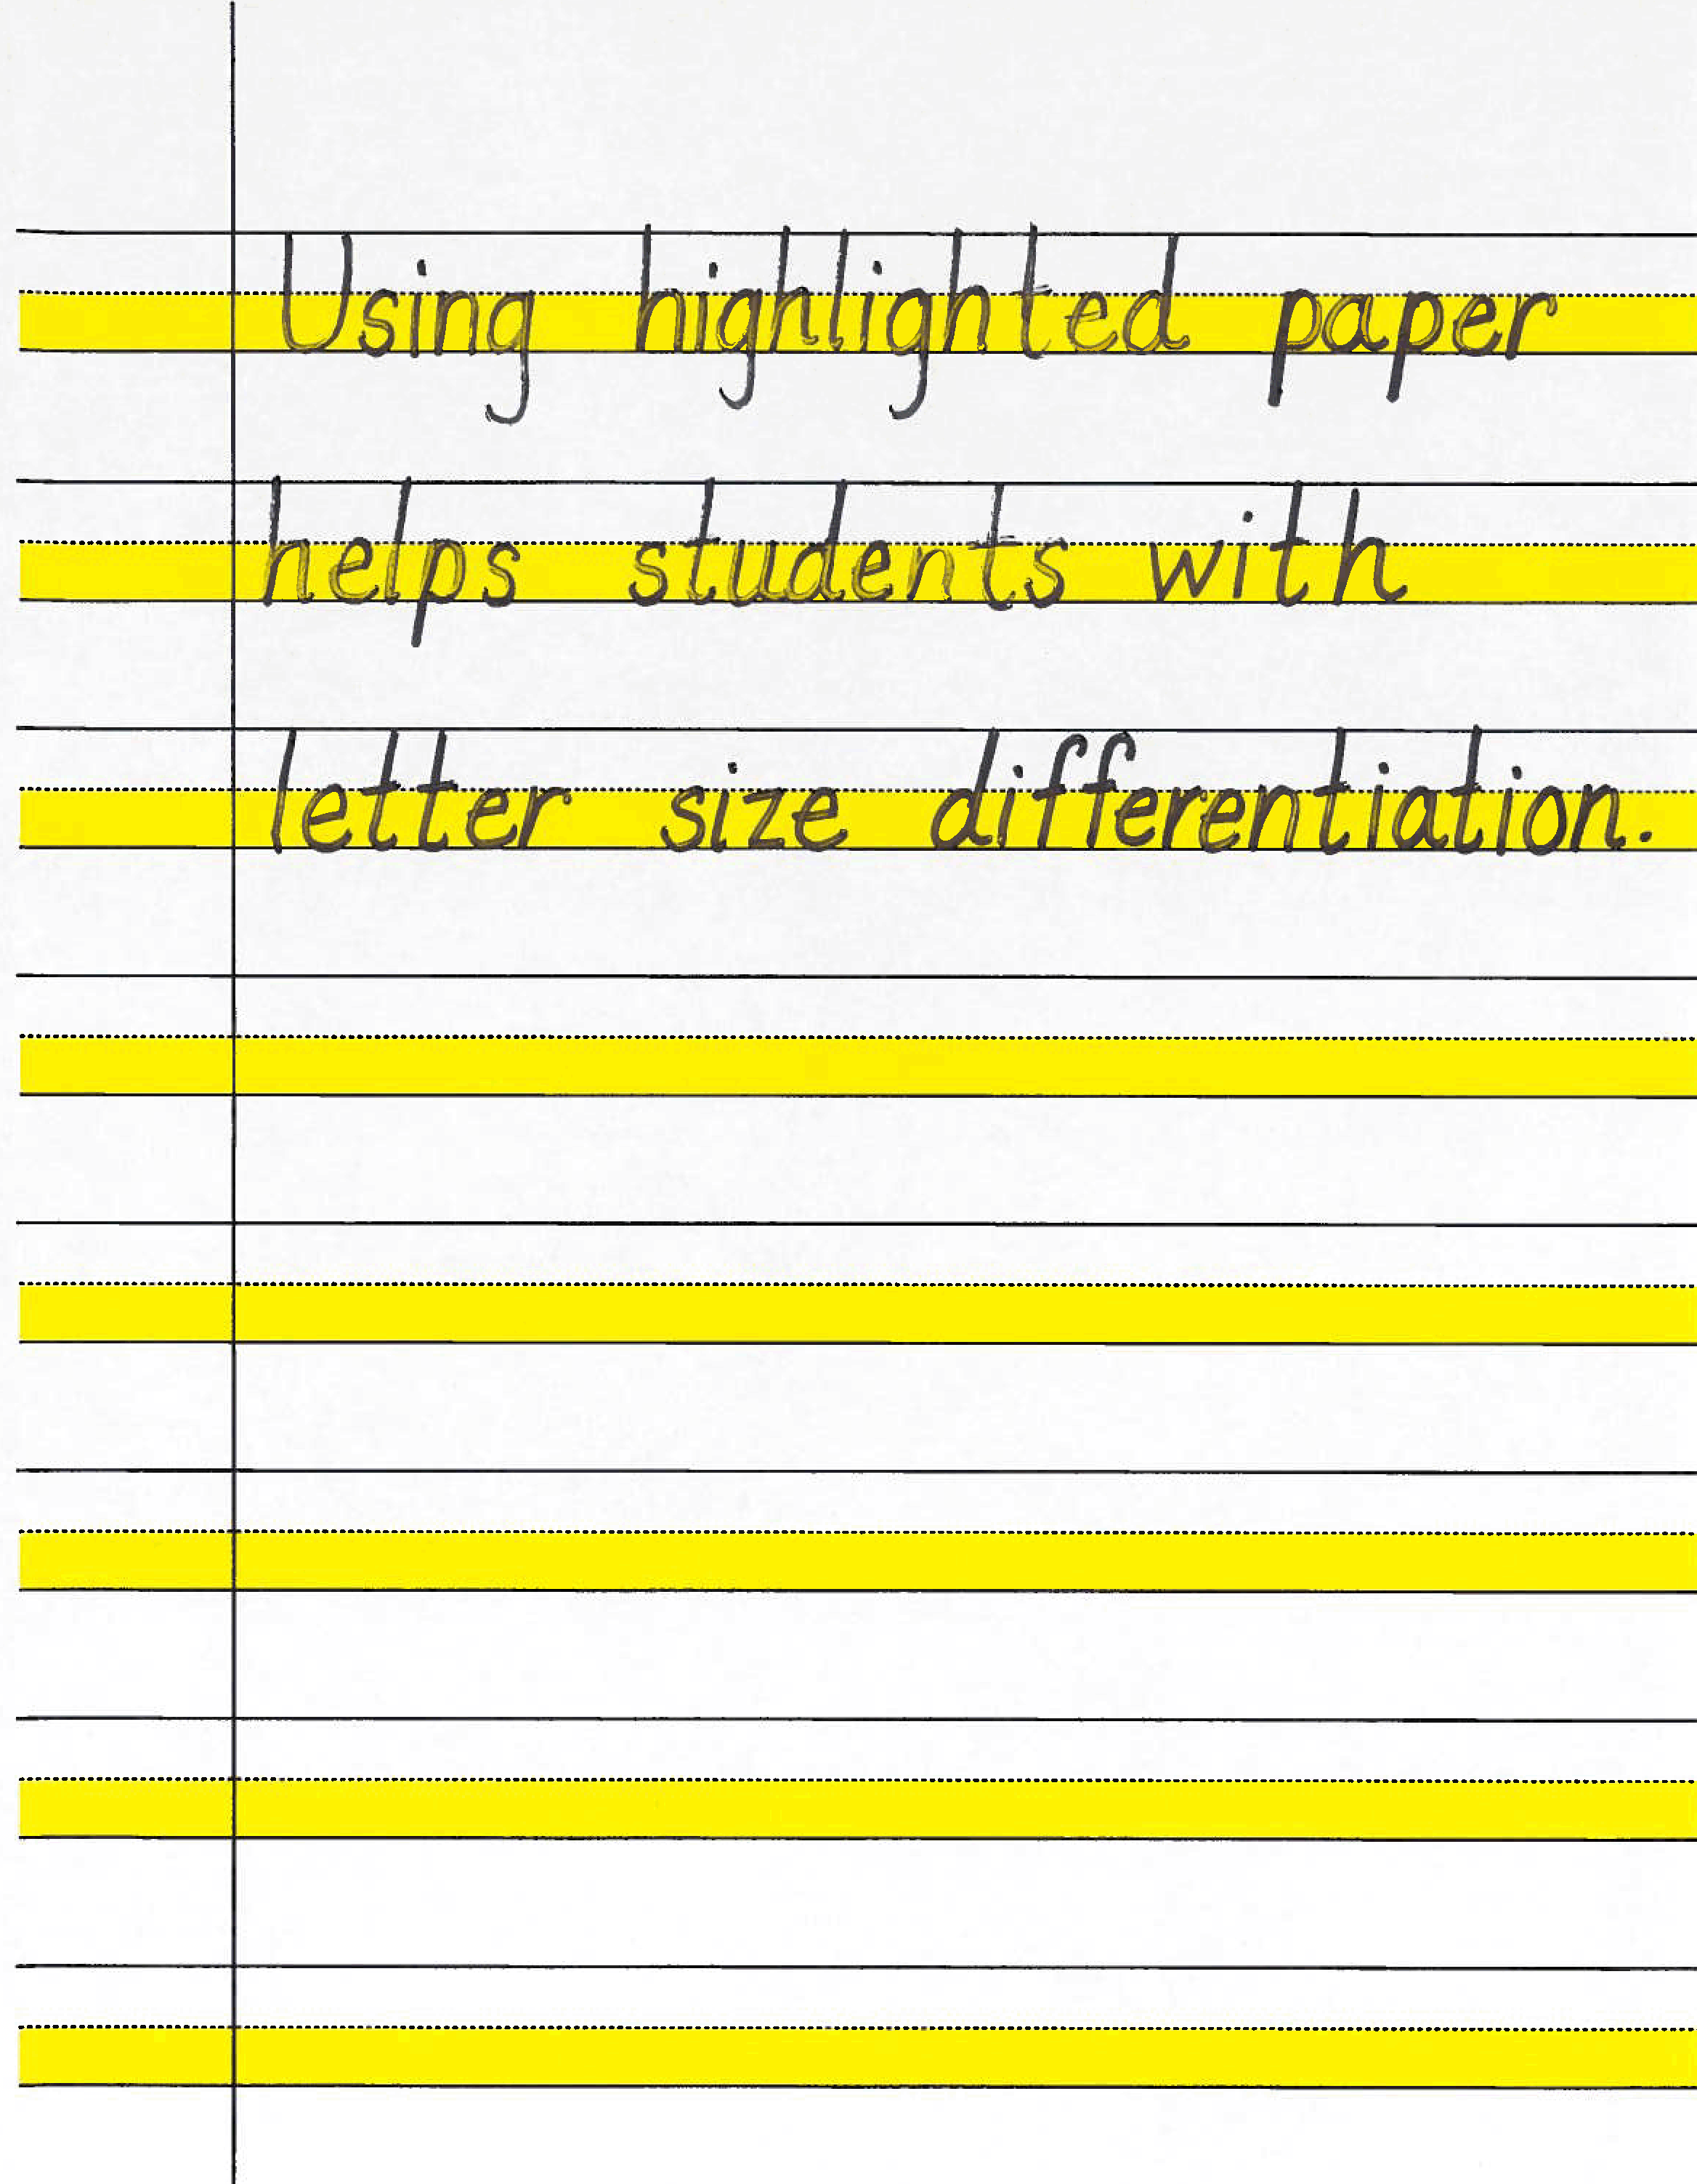

Appendix 7 – Example of Mapping Strategy
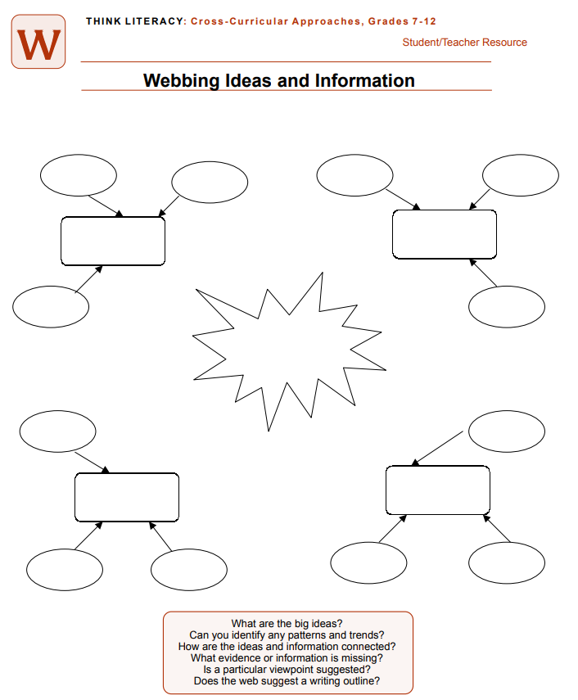

Appendix 8 – Transcript of Interview


