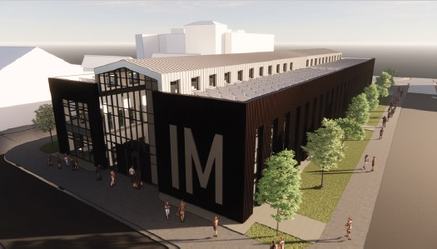

Case study; Innovation matrix centre
Dylan Samuel
12/12/2023

CONTENTS PAGE

- Introduction

- Groundworks and foundations
2a. foundation requirements
2b. site history
2c. chosen foundation
2d. what is a raft foundation?
2e. required excavation works

- Superstructure
3a. strength and stability
3b. fire resistance
3c. sustainability
3d. aesthetics

- Conclusion

- References

- INTRODUCTION
The aim of this piece of work is to;

- Analyse and discuss the foundation requirements of the building, primarily considering the location of the project.

- Estimate the excavation works required to construct the foundation of the project.

- Analyse and discuss the material choice for the superstructure considering design, structural strength, stability, fire safety, aesthetic and environmental impact and sustainability.

Introduction to the innovation centre
The innovation matrix centre is £9.3 million development located on the trinity saint David university campus on the Swansea docklands. The innovation matrix is planned to be the new home of many small scales, but growing local enterprises that are involved in developing the regions digital technology economy.
The Innovation Matrix and Innovation Precinct form part of a £175 million city deal project called Swansea City and Waterfront Digital District. The aim is to create the conditions and infrastructure for productive companies which generate well-paid jobs. (Reporter, 2022)
The 2000m2 building valuing at £9.3 million, is made up of a steel infrastructure providing 2 floors for optimal room and working space. The external finishes are made up of brickwork and metal sheeted cladding, providing a clean aesthetic look.

- Foundation requirements and estimated excavation works

To ensure the correct foundation type is used on a project like the sa1 innovation matrix, there are a number of factors that must be considered before finalising a decision;
- weight of the proposed structure
- purpose of the proposed structure
- the soil of the proposed site (soil mechanics)
- history of the proposed site
- cost feasibility
These factors listed above have a major impact on the chosen foundation therefore, the decision must be made by construction professionals with great knowledge in their fields.
From the information provided we are able to note the weight of the infrastructure is heavy in comparison to any timber frame structure, however it provides great stability and strength. The 2-story development will have a heavy load to bear on the ground below. With this in mind the load will need to be distributed as evenly as possible to ensure the building can stand.
The ground below the project must be tested to ensure all the correct information is taken to help assist with the decision of the foundations. A practical way of testing the ground is by using the bore hole method. Bore holes are a testing method used to collect accurate information on the soils and ground beneath. It can measure the maximum loading capacity. If the loading capacity of the ground below is lower than the weight of the complete structure above there is always a possibility that the structure above could collapse resulting In injuries or loss of life. The results must provide information to prove that the ground below can withstand the load of the project.
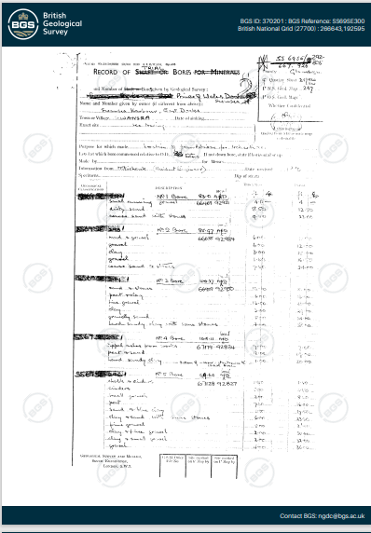
(mapapps2.bgs.ac.uk, 2023)
The above document shows a borehole survey taken place in close proximity to the sa1 innovation matrix. This is the first page of the 7-page document showing what was found at different levels below. As you can see from the document above; clay, sandstone and gravel are found during the survey. These 3 materials can be built on using a raft foundation.

2a. Site history
Swansea’s development as a major port began during the early part of the eighteenth century when a rapid expansion in local coal mining and iron production, together with the introduction of copper smelting and tinplate manufacture, resulted in the establishment of many new wharves along the banks of the River Tawe. (www.swanseadocks.co.uk, n.d.)
The large amount of traffic that used the Swansea docklands during this time would result in contaminated soils due to the number of hazardous substances produced from the traffic that continuously used the docklands. The potential contaminated soils that lay under the project will affect the choice of foundation. If contamination is found below the project. Additional tests and precautions will need to take place to ensure the safety of the surrounding environment. This will be at an additional cost to the current project’s valuation.

2b. Chosen foundation
With all the information above collected and considered, the foundation best suitable to this project would be a raft foundation. A raft foundation is the most appropriate choice considering the weight of the structure is heavy. A raft foundation is made up of a concrete slab base, reinforced using steel bars. The flat slab that is formed using concrete helps distribute the weight evenly from the above structure preventing the project from potentially sinking due to the soil conditions. Without the even weight distribution provided by a raft foundation, the above structure is liable to sinking due to the soil conditions below.

2c. What is a raft foundation?
A raft foundation is a concrete slab base reinforced using steel bars that supports columns or walls and transfer loads from the structure to the soil. Usually, mat foundation is spread over the entire area of the structure it is supporting. (Civiltoday.com, 2019)
Raft foundations are typically used to support residential or commercial buildings with underlying poor soil conditions. In this case, the innovation matrix centre. A raft foundation transfers the total load from the structure to the entire floor area, distributing the weight evenly through the foundation reducing the stress on the soil below. To calculate the amount of stress on the soil below, you must calculate the weight of both the structure and the foundations below and divide by the total area of the foundation it is covering.

Raft foundations are used when a condition below is met;
- The soil has a low bearing capacity.
- Load of the structure has to be distributed over a large area.
- Stress on soil needs to be reduced.
- There is a possibility of differential settlement in case individual footing is used.
- When soil strata are unpredictable and contain pockets of compressible soil.

In the case of the innovation centre all the condition’s above are met resulting in the choice of a raft foundation.

2d. Required excavation works
In order to construct the raft foundation that is required on this project, the method of works would be as followed;
- Excavate the existing ground until the required depth is met
- Compact the remaining soil
- Lay the waterproof membrane
- Lay reinforcement steel bars using appropriate spacers
- Pour required amount of concrete to meet foundation requirements

Due to the location of the project and the history of the docklands additional tests/surveys may need to take place to ensure there is no undiscovered contaminated ground and if so, it is dealt with appropriately. If the tests were to discover contaminated land it must be removed and documented safely and effectively.

- Superstructure
As previously mentioned, the superstructure of the innovation matrix centre is made up of a steel frame and finished with metal sheet cladding. The use of Steel frames within the construction industry is very high due to the long list of benefits that come with using the material, some of which include strength and stability, fire resistance, speed of the construction process and also sustainability.
The steel frame is finished with metal sheet cladding and low-level brickwork providing a modern finish to the project.

Many recognisable buildings use the method of a steel structure, one that stands out the most is the sears tower which is now known as the Willis tower. The 442m tall tower is located in Chicago, USA. The famous building was once given the title as the tallest building in the world in 1974. The steel frame is used in the concept of this building due to the strength and stability that a steel frame provides. The steel frame is split into section to help counter act the high wind speeds at such a height.
Willis Tower’s nine steel-framed tubes allowed it to reach its envisioned height with monumental efficiency, requiring only 33 lb of steel per sq. ft (the Empire State Building, in comparison, required 66 lb per sq. ft). Each tube has 75-ft-long sides, for a total of 225 ft on each side of the building. (www.aisc.org, 2023)

3a. Strength and stability
The strength and stability of a steel superstructure is unmatched in comparison to other materials available to the current construction industry. The properties of steel enable it to withstand heavy loads and extreme weather conditions at a lighter weight than a concrete superstructure for example. Its strength to weight ratio allows for the construction of towering structures without effecting the stability of the structure. The strength and stability that the material provides maximises the health and safety of all that use the building. Considering the location of the innovation matrix centre being located at the Swansea docklands where it is exposed to harsh weather conditions, including high wind speeds. Using a steel frame as part of the superstructure will benefit the project by making it safe and durable.
The project is metal sheet cladding on the external of the building providing it with an acting windshield. Metal cladding is incredibly strong and has a high resilience to water damage, electrochemical reactions and corrosion. The overall lifespan of metal cladding is long whilst requiring little to no maintenance at all.

3b. Fire resistance
The fire resistance of a steel superstructure is a key advantage of using the material. It ensures the health and safety of all that use the building and in the surrounding areas. Unlike wood, steel does not contribute to the spread of a fie. In fact, steel maintains it strength at temperatures as high as 1250 degrees Celsius making it highly resistant to any fire related damages. The fire resistance of steel can allow the public within the building extra time to evacuate a building in an event of a fire. Another advantage of using steel Is that it can be provided with fire resistance coatings to add additional protection and enable the material to withstand higher temperatures. As the innovation matrix centre is planned to house many businesses leading the local digital technology economy, it is important the building uses highly fire-resistant materials like a steel frame and metal sheet cladding due to the large quantity of electrical equipment that will be placed inside the building.

3c.Sustainability
Steel is an easily recyclable material, making it an eco-friendly choice for a construction project. Although steel has a very long-life span and can last for decades. Once the life of a steel structure Is coming to an end, it can be recycled and re used as part of another project. Reducing the need for raw materials and helping to minimise waste. As mentioned, steel has a long lifespan, this factor also contributes to a large part of the sustainability of steel. The long lifespan of steel reduces the need for frequent replacement or high levels of maintenance.
The building also has large amount of glass as part of the design, resulting in a lot of natural light. This will reduce the levels of electricity required to light up the main walking area of the building.
The innovation matrix also has several solar panels on the roof to help reduce the carbon footprint of the building. The solar panels will aim to provide energy to the building by using the daylight as a renewable source.
3d.Aesthetics
Steel structure buildings offer a modern look to any architectural design. The design flexibility that is offered by using steel allows for innovative and structural designs to be constructed. The strength and stability of steel allows for more complex deigns without the lack of ability to support it. Although the innovation matrix design isn’t very complex. The steel structure allows for a lot of open space giving the building an overall modern and spacious look.
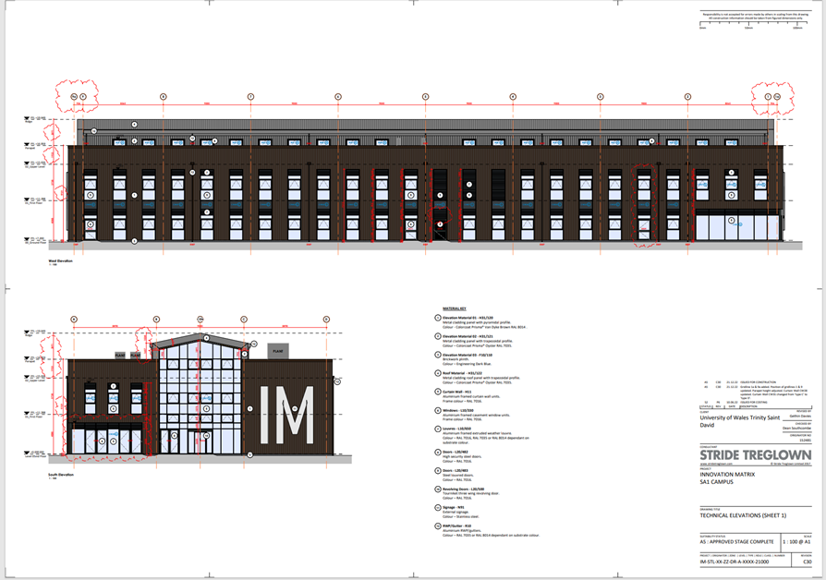
(Swansea Council, 2022)
The drawing shown above shows the external design of the building and the materials used. as you can see from the drawing, the overall aesthetic look is very pleasing to the eye. The design includes a lot of glass resulting in a lot of natural light entering the building.
The cladding choses provides a modern look to the building whilst also providing great strength and stability which will result in the long lifespan of the building. The large Volume of glass implemented into the design again, gives the innovation matrix a very modern look which is well suited to the use of the building. With the innovation matrix essentially being a hub for new business to establish and lead the digital technology economy I believe the use of the modern method of construction impacts the overall story and reputation of the building.

- Conclusion
In conclusion the innovation matrix project will reach high levels of sustainability using the materials as shown on the specification. The designers have ensured the overall look and feel of the building is modern, whilst ensuring the materials used are sustainable. The primary energy source of the building is supplied via the solar panels above which also adds high value to their sustainability rating. From the drawings, it clearly shows there is a large number of glass/windows within the building, allowing a lot of natural sunlight to also help reduce energy usage.

In conclusion this building met its prime goal of being sustainable and reducing embodied carbon. Though some of the design and material choices may prove to be expensive in the long run these will pay off. If all projects, go down this road the construction industry and see a drastic reduction on its impact on the earth. Though it is impossible for construction to have no impact on the environment this was an excellent go at it by using natural materials that have benefits such as good insulation really helped in the long run. One of the best decisions made was to use timber, to go further glulam and CLT which are very versatile, resistant and sustainable materials.

- References

Civiltoday.com. (2019). Raft Foundation - When to Use, Types, Construction - Civil Engineering. [online] Available at: https://civiltoday.com/geotechnical-engineering/foundation-engineering/167-raft-mat-foundation-use-types-construction.
mapapps2.bgs.ac.uk. (2023). GeoIndex - British Geological Survey. [online] Available at: https://mapapps2.bgs.ac.uk/geoindex/home.html?layer=BGSBoreholes&_ga=2.133086862.103622144.1703165767-619327034.1703165767 [Accessed 21 Dec. 2023].
Reporter, R.Y.-L.D. (2022). Plans unveiled for £9.3m Innovation Matrix at Swansea SA1. [online] Wales News Online. Available at: https://walesnewsonline.com/plans-unveiled-for-9-3m-innovation-matrix-at-swansea-sa1/ [Accessed 21 Dec. 2023].
Swansea Council (2022). 2022/0954/RES | Approval of all reserved matters in respect to the development of the Innovation Matrix Building (mixed Business B1 / Education D1 with ancillary A3) including associated landscaping and supporting infrastructure - Phase 1 Swansea Waterfront Innovation Quarter (Details of access, appearance, landscaping, scale and layout pursuant to conditions 08, 09, 15 & 20 of outline planning permission 2015/1584 approved 13th May 2016) | Plots Pc And Pj Land South Of Fabian Way And East Of River Tawe Swansea. [online] property.swansea.gov.uk. Available at: https://property.swansea.gov.uk/online-applications/applicationDetails.do?activeTab=documents&keyVal=RAOE1BEVLYQ00 [Accessed 3 Jan. 2024].
www.aisc.org. (2023). Modern Steel Construction. [online] Available at: https://www.aisc.org/modernsteel/news/2023/may/a-pioneer-in-bundled-tube-design-iconic-willis-tower-turns-50/#:~:text=Willis%20Tower%E2%80%99s%20nine%20steel-framed%20tubes%20allowed%20it%20to [Accessed 5 Jan. 2024].
www.swanseadocks.co.uk. (n.d.). Swansea and Port Talbot Docks Website. [online] Available at: http://www.swanseadocks.co.uk/docksnewsite/history.html.

