
Programme: Master of Business Administration
Student Name: Monika Singh
Student ID:250436
Module: International Marketing: Principles and Practices
Module code: LCMB7026
Lecturer’s Name: Tushara Balendran Dian Mayasari
Assignment Title: Assessment component 1: Individual report

Table of Contents
Section 1: Report 4
1. Introduction 4
2. Background of the Company: Louis Vuitton 4
3. Macro Environment Analysis 5
PESTLE 5
4. STP Analysis 9
5. International Marketing Mix (7Ps) 12
6. Directional Development Strategy 16
7. Ethical Issues 18
8. Recommendations 19
9. Conclusion 20
Section 2: Reflective Account 22
Reflective Account Using Gibbs Reflective Cycle 22
Description 22
Feelings 23
Evaluation 23
Analysis 24
Conclusion 24
Action Plan 25
References 27

Section 1: Report

1. Introduction
The present report provides a critical analysis of the international marketing of Louis Vuitton within two separate markets, which are India and the United Kingdom. Luxury brands have to juggle between standardisation and customisation to fit various economic climates, cultural demands and consumer habits that are being experienced in various nations in an ever-globalised business environment. This renders the study of the global marketing strategies especially important in relation to the competitiveness and sustainability of the global brands. This report aims at comparing and contrasting the macro-environmental forces that affect both markets using the PESTLE framework, with special preference in the social and cultural divergences with Hofstede’s Cultural Dimension Model that characterize consumer preferences.
In addition, the report assesses the segmentation, targeting, and positioning (STP) strategies of this brand as well as its extended marketing mix (7Ps), taking note of the main similarities and differences in how the brand is treated. The report also examines the strategic direction in which the brand is set to grow in a single market, and evaluates the possible ethical concerns that may arise in the marketing processes of the brand. Depending on the findings, practical suggestions are made that can help it improve its international marketing strategies used in both the developed and emerging markets. In the last, it will provide a Gibbs Reflective cyvke to analyse the learning experience that gained from international marketing module.

2. Background of the Company: Louis Vuitton
Louis Vuitton is an internationally reputable luxury brand with its headquarters based in Paris and specialises in high-quality leather products, fashion wearables, and accessories. It is made by a French Trunk-maker and the brand is created by his name in 1854 in Paris (Louis Vuitton (2026). The company functions within the framework of LVMH, the largest luxury organization globally, which takes care of a range of posh brands. The mission statement of this company is to be the global leader in luxary brand and provide product and services that meets the highest standards of ethical social, and, environmental standards (LVMH, 2026). Louis Vuitton is also characterized by high quality crafts, innovations, and exclusivity, which have made it have high brand equity in the international market (Liu, 2024). The brand has a selective distribution approach whereby the company has flagship stores and other upmarket retail outlets, where the clientele experiences a similar luxury experience. Its internationalization is an example of strategic compromise between preserving the heritage and adjusting to the varied foreign markets.

3. Macro Environment Analysis
The macro environment is a set of external forces that affect the operations of a company in terms of political, economic, social, technological, legal and environmental forces. Its analysis is significant since it assists companies to recognize opportunities and threats, effectively adjust strategies, and make wise decisions when they do business in various markets and countries.

PESTLE
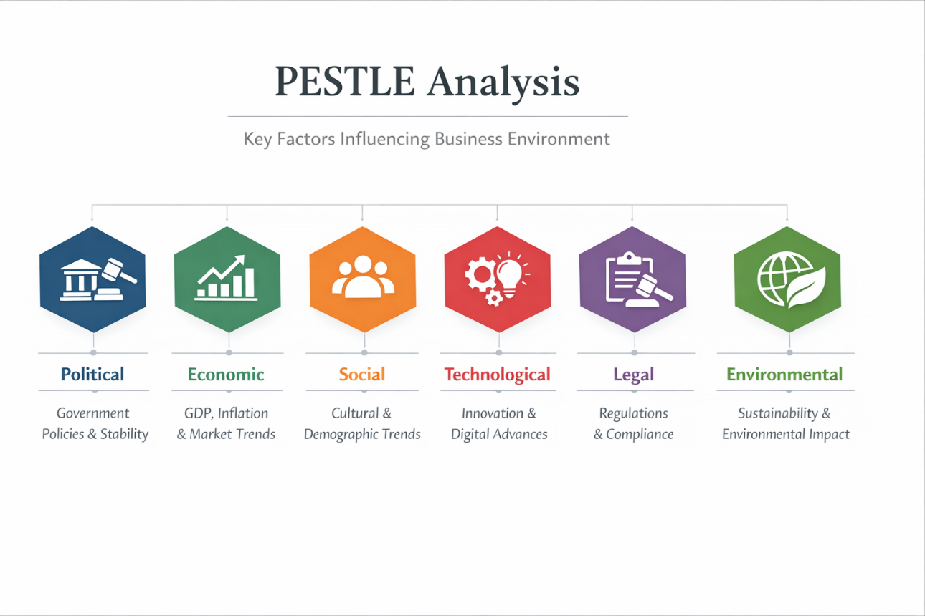
Figure 1: PESTLE Analysis
(Source: Self-Developed)
The macro-environmental factors affecting Louis Vuitton in India and the United Kingdom show a sharp difference between an established and stable luxury market and the one that is emerging but still has a high potential.
Political Factor: Politically, the United Kingdom offers a very stable and transparent business regulatory environment which facilitates business activities and long-term planning. Nevertheless, Brexit has added barriers to trade, which has increased the cost of imports and administrative complications (UK Government, 2024). Conversely, India allows 100% foreign direct investment (FDI) in single-brand retail (Department for Promotion of Industry and Internal Trade, 2023), which is good to enter the market. Nonetheless, bureaucracy and the delays in the approvals pose operational challenges, which makes the environment moderately favourable.
Economic Factor: UK is much more economically powerful and its GDP per capita is over $45,000, which allows people to consume luxury regularly and widely (World Bank, 2024). This provides a stable source of revenue to Louis Vuitton. On the other hand, the GDP per capita of India is at about 2,500, and this is restrictive to mass affordability. Nonetheless, the luxury market in the country is exhibiting an annual growth rate of 6-8 per cent due to a fast-rising affluent market. This means that the UK is a sure way to attain short-term profitability, but India is a long-term strategic growth.
Social Factor: The UK market can be described as having high brand awareness, fashion awareness, and growing focus on sustainability (McKinsey & Company, 2023). The consumers have been accustomed to luxury consumption, which increases the stability of demand. In India, status and prestige are the main attributes of luxury goods, especially in the case of urban elites. This generates high aspirational demand but the market is niche and focused.
The Hofstede Cultural Dimension Model

The Cultural Dimensions Theory developed by Hofstede can be regarded as an effective instrument to measure cultural variations as the determinants of consumer behaviour in India and the UK, applicable to the case of Louis Vuitton.
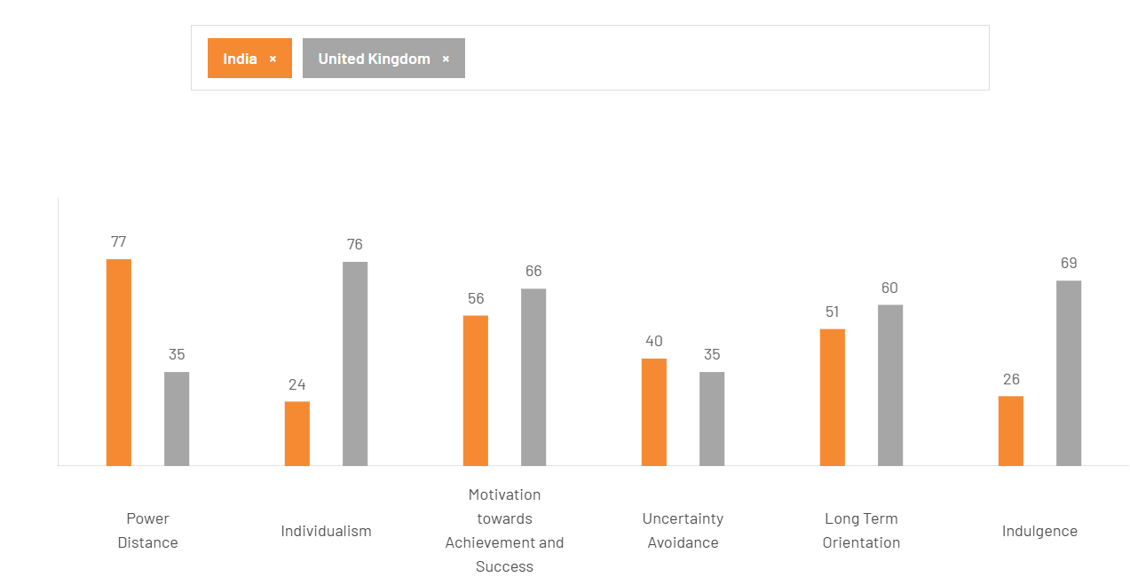
Figure 2: Hofstede Cultural Dimension Model
(Source: The Culture Factor Group 2026)
India ranks high in Power Distance, which implies that inequality and subordination are tolerated. This serves the luxury consumption, in which items such as Louis Vuitton are considered as a status symbol. Conversely, Power Distance in the UK is low, and the society is relatively more egalitarian, with luxury being used more as a source of satisfaction than as a status attribute. In India, power distance and collectivism are very high, thus the luxury consumption is socially motivated as the products of Louis Vuitton indicate the status and social acceptance. Individualism in the United Kingdom encourages self-expression as the consumers buy luxury as an identity. Therefore, social behaviour in the two markets is highly determined by cultural values and their impact on purchasing motivations.
The UK has a very high (approximately 76) score in Individualism, which indicates that consumers are self-focused and prefer their individuality. With a low score (approximately 24), India represents a more collectivist culture, whereby family and social groups have an influence on purchasing decisions. This has an effect on marketing because aspirational and family-oriented communication is better in India.
Uncertainty Avoidance aspect has a relatively low score in the UK, which implies that consumers are willing to adopt new trends and innovations, hence suitable for the fast-changing fashion cycles (Aoun, 2025) In India, moderation in terms of trust and brand reputation is stronger in the buying decision-making.
In regard to Long-Term Orientation, India is more pragmatic, which is reflected by the higher score, whereas the UK is more short-term oriented, which means that they pay more attention to immediate tendencies and consumption. This implies that Indian customers might attach more importance to durability and brand legacy.
Technological Factor: The UK has an advantage in terms of technological factors; the country possesses a high-level of digital infrastructure, which allows it to organize the omnichannel retailing and provide clients with flawless customer experience. Despite the fact that India has more than 700 million internet users (Internet and Mobile Association of India, 2023), the country is characterized by uneven internet penetration and logistic inefficiencies, which may compromise the quality of services.
Legal Factor: The UK provides an extremely favourable legal environment with a well-developed intellectual protection and stringent consumer laws that guarantee brand value protection (World Intellectual Property Organization, 2023). Conversely, India has a weaker intellectual property rights enforcement which is a risk factor to the counterfeit goods which threatens brand exclusivity.
Environmental Factor: The UK market is more pressure-inducing on the brands in terms of adopting sustainable practices which affect the purchases. Environmental awareness in India is developing, though it is not as influential, which is a moderately favorable factor.
Similarities and Dissimilarities
The two markets are good to Louis Vuitton and in terms of development and brand recognition as well as increasing digital adoption and changing consumer awareness. Nevertheless, major differences can be observed. UK is a developed, stable, and very favourable market, having high purchasing power and infrastructure compared to India which is a developing market, with low purchasing power but high growth potential. Also, the enforcement of the law and operational efficiency are much better in the UK, whereas the India poses relatively more risks because of the challenges related to regulations and infrastructure.
The Benefits of the Model
- Gives a systematic means of comparing cultures.
- Facilitates the adaptation of marketing strategies by businesses (Khalique et al., 2023).
- Applicable in the study of consumer behaviour in other countries.
The drawbacks of the Model
- Simplifies complicated cultures.
- According to old data may not capture the present developments (Sun et al., 2023).
- Ignorance towards regional differences within countries (in this case, mostly applicable to India).
On the whole, the model contributes to understanding the role of cultural differences in the luxury consumption; however, it has to be used carefully along with other models.

4. STP Analysis
The Louis Vuitton Segmentation, Targeting and Positioning (STP) is highly important towards retaining the global luxurious position and adjusting to local conditions within the United Kingdom and India.
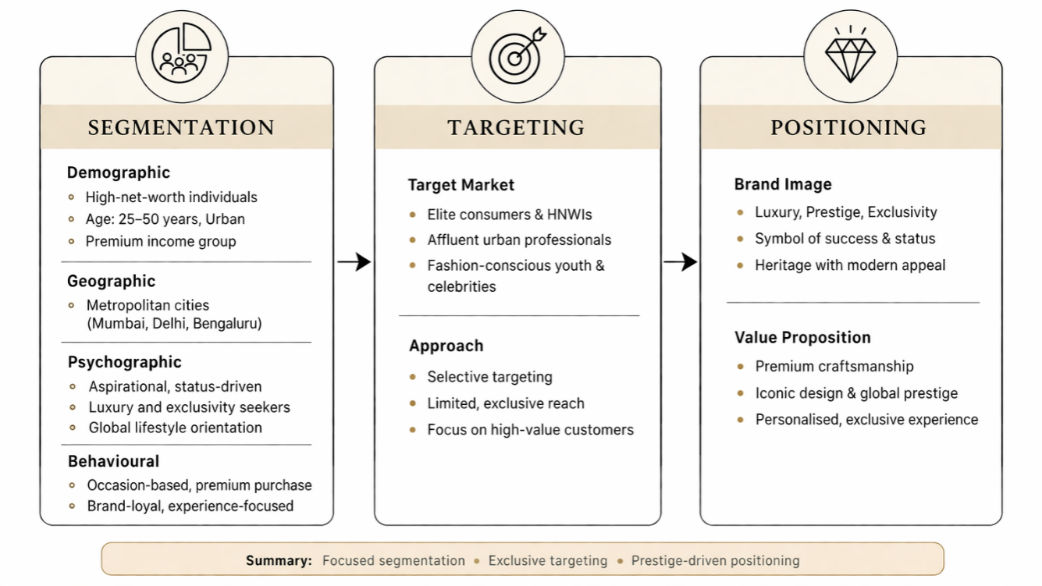Figure 3: STP Analysis of Louis Vuitton in India
(Source: Self-Developed)
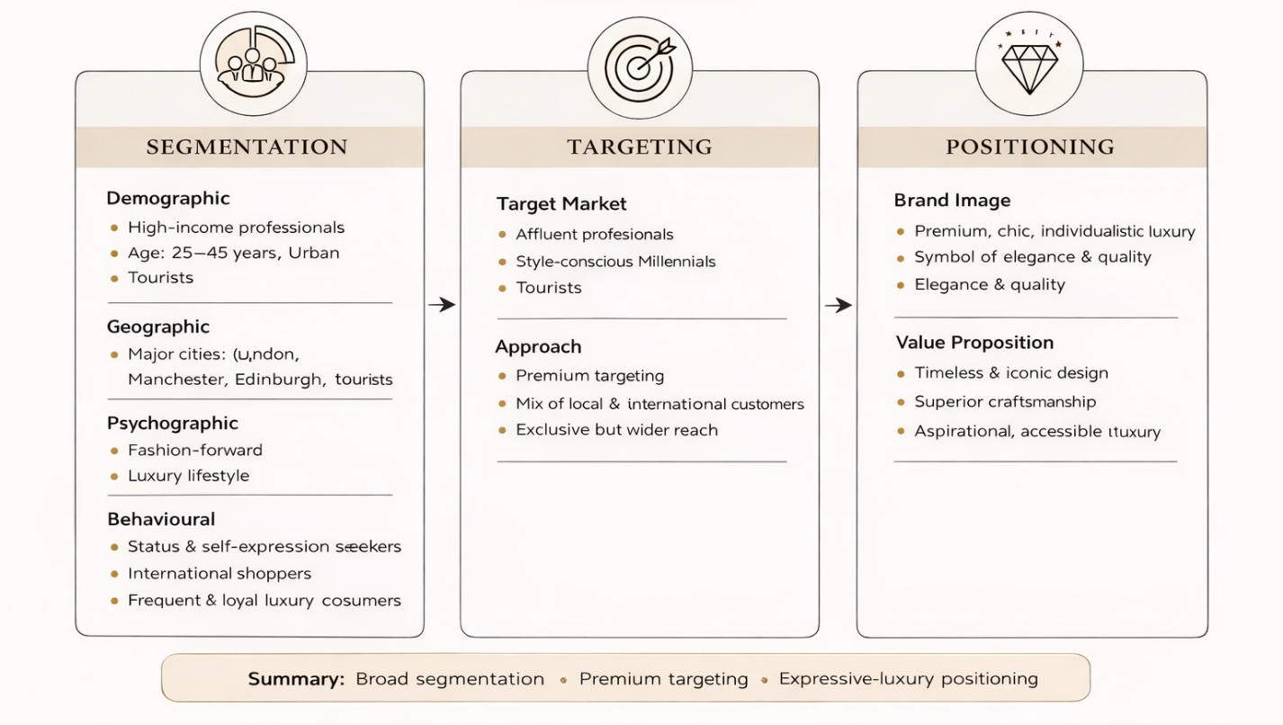Figure 4: STP Analysis of Louis Vuitton in UK
(Source: Self-Developed)
Segmentation
Louis Vuitton employs a multi-dimensional segmentation strategy of demographic, geographic, psychographic, and behavioural variables. In the UK, the brand communicates to a comparatively wide luxury consumer audience as well as includes people with high incomes, fashionable millennials, and foreign tourists (Chen, 2025). The market of luxury products in the UK is mature, and it is possible to segment by age group and lifestyle, and consumers are interested in both status and expression.
Contrastingly, the segmentation process in India is more focused and targeted, where their main target are high-net-worth individuals (HNWIs), celebrities, and the affluent urban consumer within the metropolitan cities like Mumbai and Delhi. Indian consumers have high aspirational behaviors psychographically, and they use luxury goods as a tool of success and social acceptance (Xiong, and Yuen, 2024). Behavioural purchases, as opposed to frequent consumption, are usually occasion-based, like weddings, social get-togethers, etc.
Targeting
Louis Vuitton adheres to both selective targeting in the two markets yet with varying levels of intensity. The brand will reach an expanded higher-end segment in the UK because of better disposable income levels and decades of luxury consumption habits (Wang, 2024). This comprises both the domestic customers as well as a large number of international shoppers and hence the market is very accessible.
In India, it is a more exclusive and targeting approach, which is done on a niche segment, which has a high purchasing power (Yuqi, 2022). The brand is also focused on the upper-end consumers who are less price-sensitive but more price-insensitive according to their brand appeal. This targeted market enables the exclusivity and profitability in the low-income elastic market.
Positioning
Louis Vuitton has a uniform positioning across the world as a symbol of luxury, legacy and exclusivity. Nevertheless, there are minor distinctions between the two markets. The brand has been placed as a high-end but affordable luxury brand in UK that competes with other luxury fashion houses, and targets customers who like style, quality, and independence.
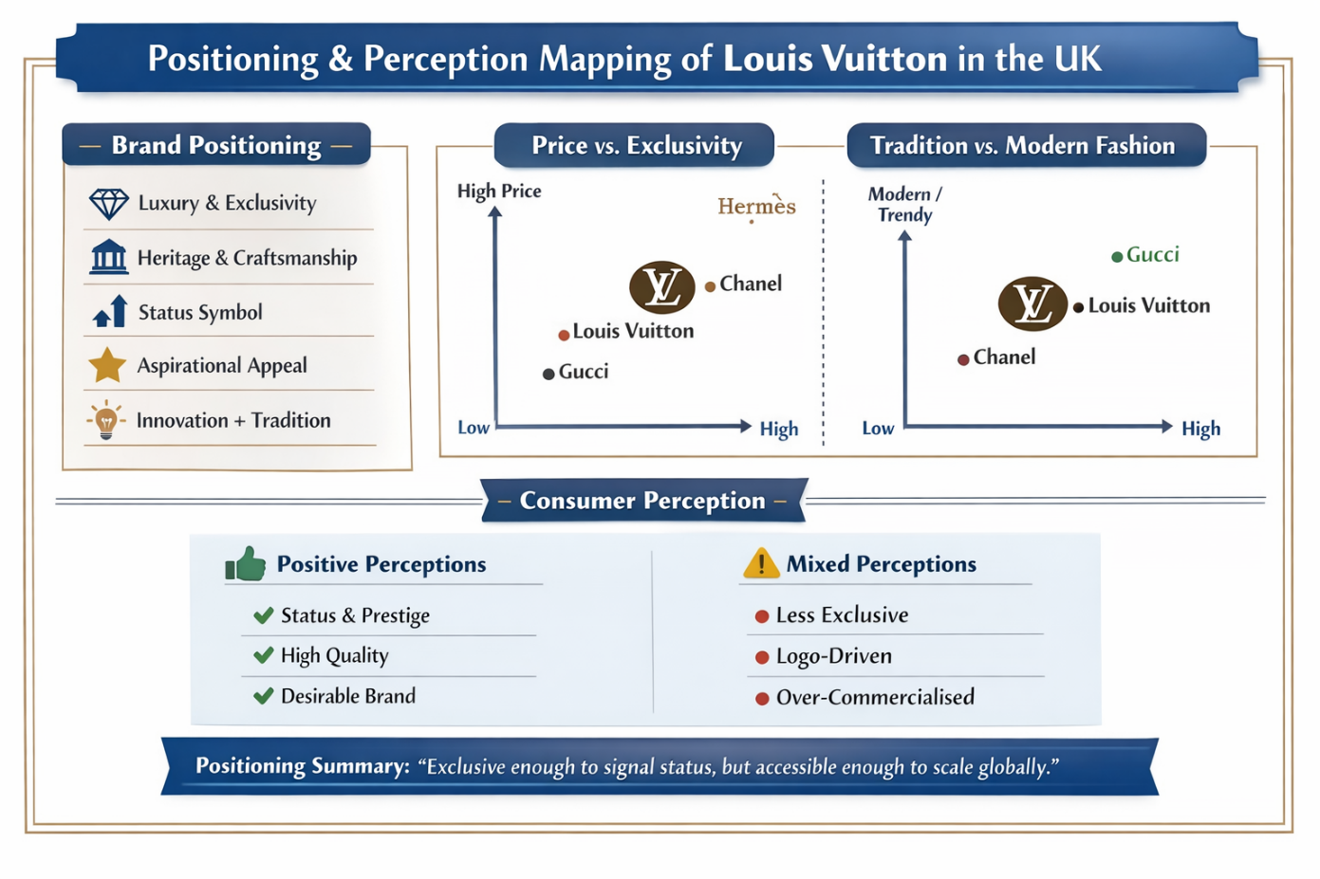
Figure 5: Positioning Map of Louis Vuitton in UK
(Source: Self-Developed)
According to the aforementioned figure, Louis Vuitton is positioned as a high-price, medium-high exclusive brand in UK that balances heritage and modern fashion. It highlights strong consumer perception status, quality, and desirability.
India is more of an aspirational status-oriented place, whereby the possession of the Louis Vuitton products is an aspect of affluence, achievement, and social status. The brand is viewed as an indicator of prestigious status, which boosts its attractiveness to wealthy consumers. This positioning is supported by a low number of store outlets, high cost and distributional control.

Comparative Insight
Louis Vuitton uses a standardised global brand image, but the company has adaptive elements through STP strategy. The UK enjoys market maturity which offers it broader segmentation and wider targeting whereas India is faced by concentrated segmentation and niche targeting situations based on economic and cultural aspects (Phung, 2025). Positioning has been similar between luxury and exclusiveness but it is different in consumer perception; functional and expressive in the UK and symbolic and aspirational in India.

5. International Marketing Mix (7Ps)
Introduction to 7Ps
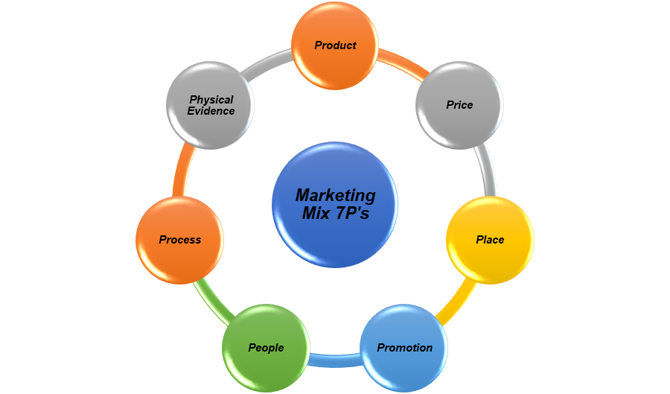
Figure 6: Factors of Marketing Mix (7Ps)
(Source: Self-developed)
Extended marketing mix (7Ps) is an integrated way of analysing how companies create value to the markets in a global context (Jain et al., 2022). The idea of standardisation in the global market and local accommodation is critical to luxurious brands such as Louis Vuitton. In India and the UK, cultural, income and infrastructure variations will have a great impact on the way each of the 7Ps is deployed in a strategic manner.
Product Strategy
The product strategy of Vuitton is based on high level of craftsmanship, tradition and exclusiveness and it provides products such as leather products, clothing and accessories that portray status and quality (Wang, 2024). Worldwide the brand enjoys stable design identity in its iconic monogram and limited edition lines, and adds value by its exclusivity. In the UK, products focus on innovation and sustainability, which is consistent with mature consumer demands. In India, on the other hand, products in the market have a great aspirational worth in that they are used as a symbol of the social status of wealthier consumers. Also, small luxury goods at the entry-level will appeal to small-scale appealing buyers in their middle-class market, as they adjust to the emerging luxury market in India without losing the primary brand identity.
Price Strategy
Louis Vuitton pursues the premium pricing policy that strengthens the luxury image and exclusivity. The brand does not use discounts very often and does not lower prices in the market. In UK, the purchasing power is high which sustains constant high-end prices, so the luxury products can be affordable to the wealthy customers (Pathak et al., 2025). In India, on the other hand, it is a much more expensive experience because import duties and taxes raise the perceived exclusivity but reduce access. Price is also used symbolically as a status symbol, and especially in India, where consumption of luxury is aspirational. Therefore, although pricing is standardised worldwide, differences in price perception arise in different markets owing to economic and cultural impacts.
Place (Distribution) Strategy
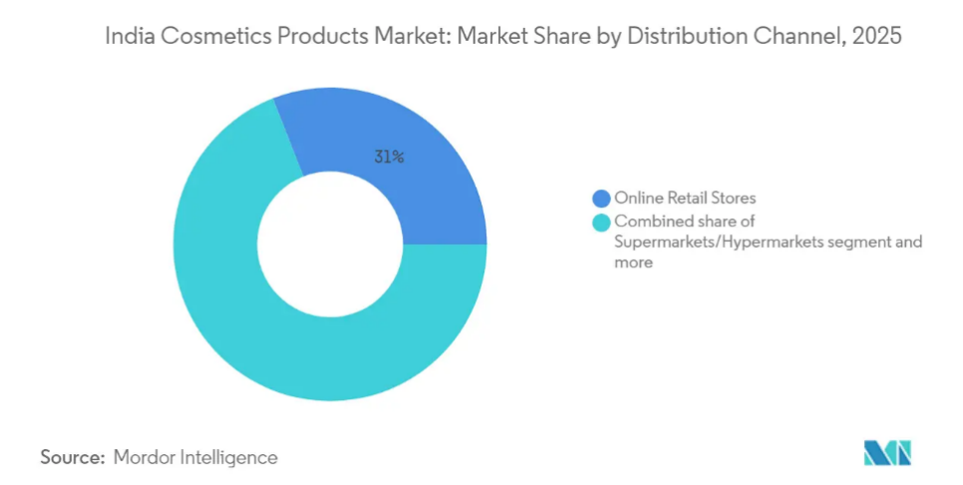
Figure 7: Distribution Channel Market Share of India’s Cosmetic Industry
(Source: Mordorintelligence, 2026)
Louis Vuitton uses the exclusive distribution channel, offering products exclusively sold by the company in its own stores and official online to retain brand control and authenticity. In the UK, the brand enjoys established retail network such as high-end shopping areas and heavy adoption of e-commerce (Matić and Bajs, 2022). India, by contrast, has constraints in the infrastructure of high-end retail, and there are very few luxury malls, which limit its physical growth. Louis Vuitton, therefore, selectively enters key metropolitan cities like Delhi and Mumbai. This identifies one of the main differences; the widespread accessibility in the UK and the controlled and limited distribution in India to enforce exclusivity.
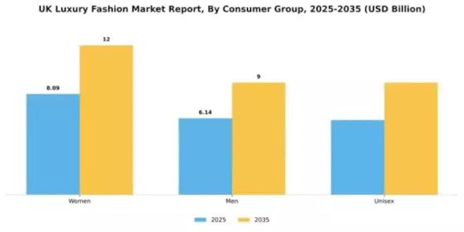
Figure 8: Distribution Channel Market Share of UK’s Cosmetic Industry
(Source: Marketresearchfuture, 2026)
Promotion Strategy
Louis Vuitton has an international promotional strategy which is centered on storytelling, heritage, and aspirational branding. The brand relies heavily on digital content, celebrity name drops, and high-profile partnerships to increase recognition and desirability. Promotion in the UK is about trends in fashion, sustainability, and online interaction with the younger generation (Del Olmo Arriaga et al., 2025). India is more aspirational in terms of its level of promotion; they use celebrities and influencers to support the idea of luxury as a status and success. Integrated Marketing Communication (IMC) can be defined as the strategic co-ordination of all promoting media and mediums (advertising, PR, digital media, sales promotion etc.) to present a consistent as well as coherent brand image to consumers (Einwiller et al., 2022). More than 10 years later, in the example of Louis Vuitton, IMC can be seen at work when the celebrity endorsement, the use of social media, and the unique in-store experience work as one to convey a standardized message of luxury, exclusivity, and heredity. The brand does not engage in direct advertising but instead aims at building emotional engagement and feeling of exclusivity, with uniformity in global communications and flexibility in communication styles as per the cultural orientation.
People Strategy
Customers are very important in the provision of Louis Vuitton luxury experience. The brand has highly trained employees who offer high quality and personalised customer service. In the UK, consumers desire professional, efficient and specialization in service offering in line with mature luxury. Relationship-building and personalised attention are especially vital in India, where luxury consumption is very much associated with social status and emotional values (Gupta et al., 2024). Moreover, brand ambassadors and the role of celebrities are effective influencers of consumer perceptions as influential people and reinforce aspirational value in both markets.
Process Strategy
The service processes of Louis Vuitton are highly standardised so that the luxury experience is consistent in all the markets around the world. The developed digital infrastructure in the UK enables smooth integration of the omnichannel, such as on-demand browsing, in-store delivery, and customized service. In India, the trend towards the digital adoption is on the rise, but the efficiency of the services may be influenced by the logistics and infrastructure issues (Sahu et al., 2022). Nevertheless, the brand has a high level of customer control, exclusivity, and quality. Both markets focus on appointment-based shopping, personalised services and after sale services to increase customer satisfaction and boost brand excellence. Unsatisfied customers always communicate their complaints to the customer service manager, or demand returns or repair, or turn to rival luxury brands, which may harm brand loyalty and renditions.
Physical Evidence
Figure 9: Website Link
(Source: Louisvuitton, 2026)
Physical evidence is critical towards supporting the luxury positioning of Louis Vuitton. Modern and minimalist design with sustainable elements of their stores tend to prevail in the UK, as customer values are changing. In India, shops are aimed at looking richer and more luxurious which is in line with the concept of luxury as a thing of image among the consumers (Shahid et al., 2023). The quality of packaging and iconic branding, as well as store ambience, give tangible indicators of exclusiveness, so that there is a uniform but culturally-adapted luxury experience between the two markets.

6. Directional Development Strategy
Ansoff Matrix
The Ansoff Matrix is a strategic planning tool that is used in identifying growth opportunities based on the products and the markets. In the present context, it will be used in the Indian Market to increase the adapbalitu of the products of Louis Vuitton.
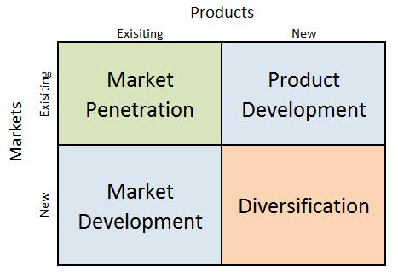
Figure 10: Ansoff Matrix
(Source: Roeraas, and Loranger, 2024)
Market penetration (Existing Products -Existing market)
Louis Vuitton wants to dominate the Indian market more by enhancing retail stores in places such as Mumbai and Delhi. It engages wealthy customers by addressing them with high-end in-store experiences, digital marketing, and expanding upon collaboration with influencers to drive repeat buying and brand loyalty.
Product Development (New Products -Existing Market)
The brand launches collections that are India-inspired, editions, and smaller accessories in order to target younger and aspirational consumers. It includes seasonal launches and personalization choices to increase the level of local relevance and remain global in terms of luxury.
Market Development Strategy
Louis Vuitton's core directional strategy in India is market building which is directed towards increasing visibility in a developing luxury market. Although the brand has been in existence in India over several years, it has not yet penetrated the market as compared to the developed markets (Morrison, 2025). Louis Vuitton plans to attract a larger share of the growing number of affluent Indian shoppers by expanding into new metropolitan destinations and increasing its retail presence in the country.
Diversification (New Products -New Market)
By entering hospitality, lifestyle products, and experience luxury in India, Louis Vuitton will develop new income streams and enhance brand prestige (Matić and Bajs, 2022). Louis Vuitton does not overexpose itself, unlike mass-market brands; this means that the demand will be higher than the supply and reinforce the premium image of the brand.
Strategic Evaluation
The directional development strategy of Louis Vuitton in India demonstrates a well-calculated growth and exclusivity strategy. The brand does not strive to grow aggressively to secure its luxury status, although it aims to tap into the market potential. The tactic works well in markets such as India, where the demand of luxury is on the rise but highly concentrated in a niche market.

7. Ethical Issues
The Louis Vuitton marketing mix in India poses various ethical issues, especially on sustainability issues, pricing systems and social responsibility.
Product and Environmental Concerns
One of the biggest ethical challenges is connected to the effects of luxury fashion production on the environment. Though Louis Vuitton focuses on durability and craftsmanship, the broader luxury sector promotes manufacturing that is resource-intensive, such as the consumption of leather and non-renewable materials (Machado, 2025). Whereas Louis Vuitton has been implementing sustainability efforts, critics believe that not all the efforts are transparent, which brings into question greenwashing (Armitage, 2023). In India, environmental issues are less in the consumer decision-making and this makes it easier not to place pressure on the brand, but that does not help to disregard the responsibility.
Pricing and Accessibility
Louis Vuitton adheres to a high-end pricing strategy to remain exclusive. Nevertheless, the Indians have high import duties and taxes, which push the price of their products very high and can be bought by only a small group, the elite (Holmqvist Adolfsson et al., 2023). This creates ethical dilemmas concerning inclusiveness and fairness since luxury branding tends to strengthen social disparities.
Promotion and Social Influence
The promotional strategy of the brand, based on the extensive use of exclusivity and aspirational images, might also become ethically questionable. Marketing in India, where status and social recognition are dominant, can enhance materialistic values and social comparison, especially in younger consumers.
Legal and Fraudulent Problems
Its major ethical and legal concern is counterfeiting, especially in India, where the intellectual property law is not enforced so strongly. The existence of fake products not only compromises the revenues of the brand but also makes ethical issues effectively deceiving consumers and using illegal production techniques of labour exploitation (Khattak and Khattak, 2024).
Overall Evaluation
Although Louis Vuitton has a strong brand name in the global market, India market faces more ethiucal issues as Sustainability and transparency are more emphasized in the UK, and accessibility and counterfeiting are emphasized in India. Considering such issues is the key to preserving long-term brand credibility and moral responsibility.

8. Recommendations
To remain competitive in the long term in many kinds of markets like India and the United Kingdom, Louis Vuitton would be well advised to follow a balanced approach combining global consistency with local lifestyle.
Improving Localised Product Strategies
Louis Vuitton ought to do more product localisation to mirror on the local preferences without losing its luxury foundation. This may include the use of culturally relevant designs, lighter materials, or clothes fit in the Indian climate, and collection-limited as dictated by the festivals or weddings (Sengupta et al., 2022). In the UK, one should continue with trend-based collections and diversify sustainable product lines to satisfy rising environmental demands.
Enhancing Online and Multichannel Care
The brand must also consider investing in superior omnichannel strategies, especially in India, where digital adoption is growing at a rapid rate. Improving the e-commerce systems, providing online shopping experience, and combining online and line services can work towards enhancing access and exclusivity (Lamba and Diwan, 2023). Customer engagement and loyalty can be enhanced in the UK by making use of data analytics and personalised digital marketing as a tool.
Gaining Market Access to Grow in Control
In India, Louis Vuitton ought to be selective in the type of expansion to Tier-1 and emerging Tier-2 cities, which have an expanding affluent population. Although growth should be kept within limits lest brand exclusivity be lost (Guntupalli et al., 2026). The UK market is also mature, and optimisation of the current networks of stores and providing customers with a better experience are more vital than driving excessive expansion, in that case.
Enhancing Ethical Transparency and Sustainability
Louis Vuitton needs to intensify sustainability and transparency in order to cope with growing global issues. Economic sourcing, reduction of carbon, and circular fashion practices in the UK can be communicated and contribute to brand reputation (Take, 2026). Awareness creation on the issue of sustainability in marketing efforts as a luxury brand can make the brand a responsible brand leader in India.
Fighting Fake and Securing Brand Equity
The company must invest in anti-counterfeit measures, like product authentication measures and electronic tracking in the market, like in India. Brand equity can be safeguarded by teaming up with the local authorities and educating the consumers on the dangers of counterfeit goods.
Improving Pricing and Value Perception
Raising the pitch is not the best choice but by offering exclusive services, customized experiences and limited-edition products, Louis Vuitton can increase perceived value even with premium prices. This would make sure that high prices will be warranted by excellent customer experience instead of mere brand name.

9. Conclusion
The comparison of Louis Vuitton in India and the United Kingdom demonstrates the significance of international marketing strategies in which consideration of local market layouts is significant. The United Kingdom is a stable, mature and highly favourable luxury market with high purchasing power and a well-developed infrastructure, which facilitates stable performance. Conversely, India has high growth opportunities, necessitated by an increasing class of the affluent, though its inhibiting factors are low purchasing power, regulatory complications, and infrastructure restrictions.
The study shows that although Louis Vuitton has a globally consistent brand image, strategic adjustment in segmentation, targeting, and marketing mix would be critical to success. Additionally, discussing the ethical issues like sustainability and fake products is important to the brand credibility in the long term. On the whole, global standardisation and local responsiveness are important instruments that will help Louis Vuitton to maintain a competitive lead in both developed and emerging markets.

Section 2: Reflective Account

Reflective Account Using Gibbs Reflective Cycle
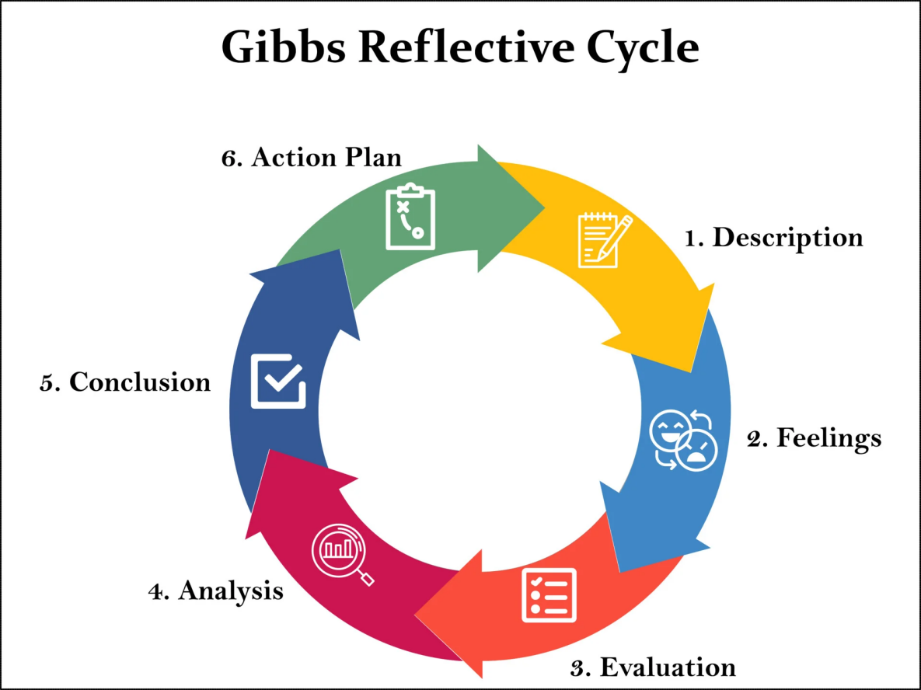
Figure 11: Gibbs Reflective Cycle
(Source: Simply Psychology, 2026)

Description
Under this evaluation, I worked on a major international marketing report, which is the analysis of Louis Vuitton in India and in the United Kingdom. It was done by macro-environmental analysis, the use of Hofstede cultural dimensions Model, and analysis of STP and directional strategies, which was done through the PESTLE model. Ethical issues and recommendations were also examined by me. I used a mixed research approach that comprised secondary research in academic journals, industry reports, and reputable institutional sources released after 2022.

Feelings
Initially, I was sure of having knowledge on marketing frameworks and a little bit unsure of the framework application in the comparative approach between the two totally distinct markets. As I prepared the PESTLE and cultural analysis, I felt more engaged and interested, particularly in determining the way cultural values affect the luxury consumption. In order to comprehend marketing mix of Louis Vuitton, I have analysed the global and local strategies of the company. I also had trouble with critical analysis and not the description of concepts, though. Later on, I became more confident in relating theory to practice. The completion of the ethical issues and recommendations sections has provided me with a feeling of achievement because I could consider a more critical and strategic approach.

Evaluation
The systematic use of proven marketing tools like the PESTLE and STP, which allowed my work to systemise occasionally complicated information and present it in a structured and logical way, is one of the greatest advantages of my work. These models allowed a comparative analysis of India and the United Kingdom based on their systematic relationship of macro environments such as economic development, social factors and cultural variations to consumer behaviour. The 7Ps model assisted me in the analysis of product, price, place and promotion in the two markets. The application of the Cultural Dimensions Model, created by Hofstede, also brought a lot of depth to the given analysis since it established a theoretical framework through which consumer drives and consumer purchasing behaviour can be viewed in both markets (Żemojtel-Piotrowska and Piotrowski, 2023).
Nevertheless, my approach had a number of limitations. At some stages, my writing became more descriptive than critical, especially in articulating theoretical concepts and not critiquing their applicability and weaknesses. Another difficulty that I encountered was the inability to balance between the concepts of global standardisation and local adaptation throughout sections of the report. Furthermore, controlling the word count while keeping analytical fluidity was hard, which is why not all of the sections will be as detailed and critical as I had planned them to be.

Analysis
This experience made me realise how critical thinking is in academic writing. Directly implementing structures does not work; there is a need to challenge the frames and restrictions (Nurlatifah et al., 2023). In order to illustrate, even though the Hofstede model was useful in explaining cultural variations, I came to know that the model might be simplistic in explaining diverse markets such as India, where differences between the regions are pronounced.
My source evaluation also got much better in the course of the research process. I made comparisons on how the elements of the marketing mix vary in the United Kingdom and India contexts. I realised that the decisions associated with international marketing are largely contextual, depending on the economic conditions, consumer behaviour and regulatory conditions. Furthermore, I came to know that luxury branding must strike a delicate balance in global consistency and adherence to local preferences. This was reflected in the positioning of the Louis Vuitton in India and the UK.

Conclusion
In general, it has been a very valuable experience in terms of learning new skills, as it has enabled me to build on my research, analytical, and critical thinking skills. The process has helped me have a better idea of how the marketing theory can be practically implemented in real-life situations, especially in development and emerging markets like the United Kingdom and India. This was another eye-opening experience as I got to realise the need to go beyond descriptive writing and into more critical and evaluative writing, which is necessary with scholarly work at higher levels.
When looking back at my performance, I understand that I can still improve. Assuming that I were going to carry out this task again, I would emphasise devising better critical analysis in all parts of the report. The next thing that I would consider would be to be more consistent in uniting theory and practical examples to support the wider argument. This enhanced my knowledge of luxury brands and their international adaptation of their marketing concepts.

Action Plan
Area for Improvement | Action to be Taken | Timeline | Expected Outcome
Critical analysis skills | Practice evaluating theories by identifying strengths, limitations, and real-world relevance | Next 4 weeks | Improved ability to write analytically rather than descriptively
Research quality | Use more peer-reviewed journals and recent industry reports (post-2022) | Ongoing | Stronger academic credibility and evidence-based arguments
Time management | Create a detailed schedule for each section of assignments | Immediate | Better organisation and reduced last-minute pressure
Application of theory | Link every framework directly to case examples during writing | Next assignment | Clearer connection between theory and practice
Writing clarity | Proofread and simplify language for better readability | Ongoing | More professional and coherent writing style
Depth vs word limit | Prioritise key arguments and avoid unnecessary description | Next assignment | Balanced and concise academic writing
Table 1: Action Plan
(Source: Created by the learner)
This is a reflection process, which has enabled me to understand my learning process and academic growth better. The process of critically evaluating my work has allowed me to define my strength points, which include the ability to structure and analyse properly and use the frameworks, and my points of weakness, which include the need to write more deeply and write less. It has also enabled me to be more aware of the significance of time management, the quality of the research and connections between theory and practice. In general, this reflection has given me succinct pointers on how to improve my academic performance and come up with more analytical, well-structured and quality work in future assignments.

References
Aoun, B.B., 2025. Cultural Dimensions and Their Impact on International Human Resource Management. Preprint). https://doi. org/10.20944/preprints202505, 1567, p.v1.
Armitage, J., 2023. Globalized luxury fashion is the crisis: Kanye West, a structure of feeling, and the case of Louis Vuitton. Luxury, 10(1-2), pp.7-21.
Chen, A.Y., 2025. A case study on Louis Vuitton’s global marketing strategy to promote corporate social responsibility in sustainability corporate communications. J Textile Eng Fashion Technol, 11(1), pp.30-35.
Del Olmo Arriaga, J.L., Pretel-Jiménez, M. and Ruíz-Viñals, C., 2025. From fast fashion to shared sustainability: The role of digital communication and policy in generation Z’s consumption Habits. Sustainability, 17(18), p.8382.
Department for Promotion of Industry and Internal Trade (2023) FDI Policy in India. Available at: DPIIT Official Website (Accessed: 31 March 2026).
Dhingra, A., 2024. The impact of digital transformation on luxury brand marketing and consumer experience. International Journal of Social Science and Economic Research, 9(10), pp.4108-4113.
Einwiller, S., Seiffert-Brockmann, J. and Ninova-Solovykh, N., 2022. Agile integrated communication: a content-based approach. In Research Handbook on Strategic Communication (pp. 400-415). Edward Elgar Publishing.
Guntupalli, S., Misra, R.K. and Agnihotri, A.K., 2026. Bridging Luxury and Culture: The Power of Cross-Cultural Marketing. In Technology-Driven Market Transformations for Digital Fashion and Smart Luxury (pp. 57-92). IGI Global Scientific Publishing.
Gupta, V., Hushain, J. and Mathur, A., 2024. The future of luxury brand management: A study on the impact of new technology and relationship marketing. In AI in Business: Opportunities and Limitations: Volume 1 (pp. 57-68). Cham: Springer Nature Switzerland.
Holmqvist Adolfsson, L., Johnsson Wallin, G. and Bergtoft, E., 2023. Collaborative Couture: Decoding Relative Pricing Strategies and its Impact on Brand Equity. SBM-Student Masters Papers.
Internet and Mobile Association of India (2023) Digital in India Report. Available at: IAMAI Official Website (Accessed: 31 March 2026).
Jain, R., Jain, S. and Jain, S., 2022. Analyzing and exploring the effectiveness of each element of 7Ps of marketing mix. International Journal of All Research Education and Scientific Methods (IJARESM), 10(1), pp.2455-6211.
Khalique, F., Madan, P. and Puri, G., 2023. Study of cultural dimensions in MNC subsidiaries in India. In Managing and Strategising Global Business in Crisis (pp. 22-35). Routledge India.
Khattak, K. and Khattak, J., 2024. Market positioning and competitive advantage: A case study of luxury fashion brands. Competitive Research Journal Archive, 2(02), pp.38-49.
Lamba, R. and Diwan, S.P., 2023. Consumer Brand Engagement Through Marketing 4.0: A Case of Indian Luxury Fashion Industry. JIM QUEST, 19(2), p.111.
Liu, X., 2024. Analysis Of Marketing Strategy of Age Z Luxury Group-----Take Louis Vuitton as An Example. connections, 37.
Louis Vuitton (2026) Louis Vuitton Official USA website | Louis Vuitton ®. Available at: https://us.louisvuitton.com/eng-us/homepage (Accessed: 17 April 2026).
Louisvuitton (2026), Crossbody & Shoulder Bags. . Available at: https://eu.louisvuitton.com/eng-e1/women/handbags/all-handbags/_/N-tfr7qdp (Accessed: 17th April 2026).
LVMH (2026) Our mission, LVMH. Available at: https://www.lvmh.com/en/our-group/our-mission (Accessed: 02 April 2026).
Machado, M.G.F.D.A., 2025. Consumer perceptions on how the luxury fashion industry is adapting to sustainability and ethical dilemmas.
Marketresearchfuture (2026), UK Luxury Fashion Market. Available at: https://www.marketresearchfuture.com/reports/uk-luxury-fashion-market-46362 (Accessed: 17th April 2026).
Matić, L. and Bajs, I.P., 2022. Specificity and development of distribution strategies of luxury fashion brands. Textile & leather review, 5, pp.540-563.
McKinsey & Company (2023) The State of Fashion. Available at: McKinsey Official Website (Accessed: 31 March 2026).
Mordorintelligence (2026), INDIA COSMETICS PRODUCTS MARKET SIZE & SHARE ANALYSIS - GROWTH TRENDS AND FORECAST (2026 - 2031). Available at: https://www.mordorintelligence.com/industry-reports/india-cosmetics-products-market-industry (Accessed: 17th April 2026).
Morrison, M., 2025. Strategic Excellence in Global Luxury: A Porter’s Diamond Model Analysis of Louis Vuitton. Available at SSRN 5315248.
Nurlatifah, L., Purnawarman, P. and Sukyadi, D., 2023, December. The implementation of reflective assessment using Gibbs’ reflective cycle in assessing students’ writing skill. In AIP Conference Proceedings (Vol. 2621, No. 1, p. 070006). AIP Publishing LLC.
Office for National Statistics (2024) Economic Indicators. Available at: ONS Official Website (Accessed: 31 March 2026).
Pathak, M., Creutzig, F. and Gupta, D., 2025. What has been done to reduce luxury consumption? A global review. Annual Review of Environment and Resources, 50.
Phung, N., 2025. Organisational structure of Louis Vuitton: the secret to Louis Vuitton’s success in the high-end fashion industry.
Roeraas, E. and Loranger, D., 2024. Living the dream: Executives’ strategic decision-making and the interdependence of ‘pure’luxury and masstige. Fashion, Style & Popular Culture, 11(3-4), pp.635-653.
Sahu, P.K., Pani, A. and Santos, G., 2022. Freight traffic impacts and logistics inefficiencies in India: Policy interventions and solution concepts for sustainable city logistics. Transportation in Developing Economies, 8(2), p.31.
Sengupta, A., Wesley, S., Cavender, R. and Lee, M.Y., 2022. Global vs local: Analysis of the consumer-brand relationships in India. International Journal of Retail & Distribution Management, 50(3), pp.361-376.
Shahid, S., Islam, J.U., Farooqi, R. and Thomas, G., 2023. Affordable luxury consumption: An emerging market's perspective. International Journal of Emerging Markets, 18(2), pp.316-336.
Shuo, Y., 2026. Luxury Digital Omnichannel Marketing: A Case Study of Louis Vuitton.
Simply Psychology, (2026). Gibbs Reflective Cycle. Available at: https://www.simplypsychology.org/gibbs-reflective-cycle.html. (Accessed: 2 April 2026).
Sun, J., Kim, S. and Zhao, F., 2023. Mathematical modeling of optimal allocation of remote workforce: an interdisciplinary investigation with Hofstede's cultural factors and managerial ability. Cross Cultural & Strategic Management, 30(2), pp.219-247.
Take, L.V., 2026, March. Research on Cultural Marketing Strategies of Global Luxury Brands in China. In Proceedings of the 2025 5th International Conference on Culture, Design and Social Development (CDSD 2025) (p. 292). Springer Nature.
The Culture Factor Group (2026) Country comparison tool. Available at: https://www.theculturefactor.com/country-comparison-tool?countries=india%2Cunited%2Bkingdom (Accessed: 31 March 2026).
UK Government (2024) Brexit Trade and Regulatory Changes. Available at: UK Government Website (Accessed: 31 March 2026).
Wang, S., 2024. A study on the impact of Louis Vuitton’s business strategy. Highlights in Business Economics and Management, 24, pp.1568-1575.
World Bank (2024) World Development Indicators. Available at: World Bank Data (Accessed: 31 March 2026).
World Intellectual Property Organization (2023) Global Intellectual Property Report. Available at: WIPO Official Website (Accessed: 31 March 2026).
Xiong, X. and Yuen, K., 2024. Building a Lead Luxury Brand through Unique Marketing Position and Marketing Strategies: A Case Analysis of Louis Vuitton. Finance & Economics, 1(6).
Yuqi, L., 2022. Brief Study on Marketing Strategies of French Luxury Brands in China-Taking Louis Vuitton as an Example. Academic Journal of Business & Management, 4(16), pp.58-65.
Żemojtel-Piotrowska, M. and Piotrowski, J., 2023. Hofstede’s cultural dimensions theory. In Encyclopedia of sexual psychology and behavior (pp. 1-4). Cham: Springer International Publishing.

