Topic: Consultancy Report (Revenue Increase)



Client Name: Hotel Brooklyn
Report Prepared by: Akm Baizidur Rahman Khan (Effectiveli Consultancy)
Report Handover Date: 06/12/22

 | 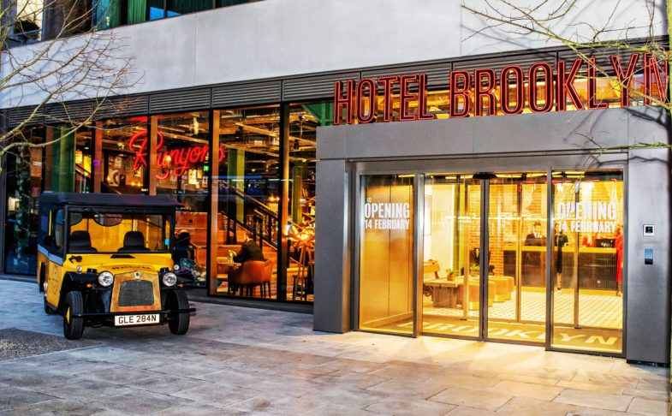
We believe in growth, together | Together with Hotel Brooklyn

Student Name: | Akm Baizidur Rahman Khan
Student ID: | 2013237
Module: | Organisational Consultancy (BMIH6005)
Programme: | BA(Hons) IHM (Level6), Swansea, UWTSD
Lecturer: | Gayathri Nadeeshani Senanayake Mudiyanselage
Submission Deadline: | 9th December 2022
Executive Summary
Hotel Brooklyn is a Manchester based hotel that resides at 59 Portland St, Manchester M1 3HP, United Kingdom. An understanding of how the hotel industry works is an important prerequisite for further upgrade of the organisation which can be done through research. In order to understand the insights of an industry, it was important for Effectiveli consultancy to have the general data that are available at first. It was also important for the firm to have analytical resources so that it can be used in the process of conducting research. In the case of Hotel Brooklyn, it was not entirely possible to do an analytical research regarding the working process of the hotel compared to the industry standards without having micro level data about Hotel Brooklyn and industry competitors. When research was conducted for the purpose of finding insights from the industry, it was important to consider that the organisation that would be using the insights from the report that would be prepared needs to be able to use the insights to adapt to their operational model. As the firm has essential project management skills that would help the process of completing the research and coming up with information that is relevant to the business that wants the research to be conducted As per the research, a few problems were addressed within the hotel and the synchronisation with the external environment was not stable as well. Hotel Brooklyn is a mid-tier hotel in the United Kingdom that is trying to improve its sales and marketing tactics along with time. The organisation has been operating for a long time in the United Kingdom. The organisation is not generating enough revenue along with time. The reason behind this situation is a weak leadership system, weak employee retention, not having enough amenities for modern day customers and unskilled staff. As a part of the solution, it is important for the organisation to improve its services over time and have a more expert marketing consultancy so that its revenue increases as well. Therefore, the organisation needed consultancy on what are amenities the organisation needs to improve and focus on over time and how the organisation can improve its marketing approaches to increase profitability over time. There are many rooms in the hotels that are left empty even in seasons when international tourists visit. Thus, the management of the organisation looked over the issue and hired a consultant to understand what are the pieces that were missing in the organisation in accordance with its external environment and what steps the organisation should undertake along with time to improve its overall situation. As a consultant, it was important to visit the hotel and see the overall internal situation of the management, the leadership practices and the amenities that the hotel used to offer to its clients. Furthermore, the online presence of Hotel Brooklyn was very low. Thus, there was a discussion with the marketing executives of the hotel on their activities and plans regarding having progress of the hotel’s sales activities. The sales team was also called upon for a meeting in order to understand what activities they do on a regular basis for the improvement of the total revenue of the company. After that, their field research was conducted upon what are the practical approaches to providing amenities to clients from similar-scaled other hotels that have the same capacity of investment and hotel space. After the research about their amenities. Sales strategy, marketing strategy, and management structure, there was clear evidence that the overall approach to the operation of Hotel Brooklyn was lacking in a lot of aspects. Thus, it was important for the hotel to improve its overall activities through a gradual process. As a consultant, it was important to inform the management about the micro-level and macro-level changes that were required within the organisation. The micro-level changes included changes in the team structure, management structure, leadership structure, sales methods, amenities offered, and marketing approach in the aspect of online marketing and offline marketing. After providing a clear and transparent idea of what the lacking are that the organisation has, it was clear and convincing for the management to implement the changes that were necessary to make. After the management got convinced, a timeline was set to ensure that the management understood the steps and the specific timelines that the organisation should stick to when making the changes internally. In the process of analysing what the changes that are required are, it was important to do a SWOT analysis and PESTLE analysis to understand the overall internal and external situation of the organisation. After the analysis, it was clear that the organisation lacked a lot in terms of its internal environment, and there was no upgrade of the organisation along with time in accordance with the external environment of the organisation. As a consultant, it is also important to provide a clear budget to Hotel Brooklyn on how their problems can be mitigated with a clear plan of action. The action plan would include the duration of each change, the timeline, the budget required for the change and the output that is desired to be prevalent through the change made. This way, it was possible for Effectiveli to provide a clear and transparent plan for Hotel Brooklyn on how they can improve their organisation's problems that circulate around their amenities, marketing approach and revenue. Furthermore, there is a set of recommendations for the hotel so that it can follow them, in the long run, to be able to understand how it needs to stay as a sustainable business in the future. For instance, it needs to focus upon increasing the amenities of the hotel, it needs to have regular training sessions for its employees, it needs to revamp its leadership practices within the organisation. These will help the hotel to become more effective in the future. The work done through the consultancy will be highly impactful for the brand.

Table of Contents
Introduction 4
Scope and Analysis 5
SWOT analysis of Hotel Brooklyn 5
PESTLE analysis of Hotel Brooklyn 7
Leadership Issue Within Hotel Brooklyn to Affecting Employee Retention 10
Increasing Employee Motivation 11
Implementing Technological Advancements 13
Employee Training Programs 15
Solve common complaints of Customers 15
Findings and Results 16
Increased Margin of Profitability 19
Action Plan 20
Recommendations 23
Conclusion 23
References 24

Introduction
The hotel industry is everchanging as there are lots of competitors that are working with similar kinds of services. In the saturated industry, it is important for hotels to stay updated on the action plans they have to improve and sustain in the industry. As a part of that, it is important for the hotels to conduct research that would help them to proceed with a clear vision. Doing internal analysis is highly important in the process of conducting research. Furthermore, a hotel has to also identify what the lacking that it has in order to understand what are the scopes of improvement that it has are. When a hotel understands its overall internal situation, conducting research on its external environment can help it to understand how the competitors are getting better results in some aspects using different strategies (Bastic, 2016). These strategies might be helpful for Hotel Brooklyn as well to integrate to solve the problem they are facing with marketing, sales, amenities and other issues. I have used SWOT analysis to understand the overall problems that Hotel Brooklyn is facing. Furthermore, the opportunities and threats analysis of the SWOT has helped me to understand what are the probable external environmental concerns that the hotel should have (Hailey and Wymer, 2017). It was important for the hotel to understand that the external environment of the hotel is not limited to the competitors it has, but many more issues that would impact and affect the operational process of the organisation. Thus, it was important to do a PESTLE analysis that gives an overview of how the organisation operates with certain external environment concerns in consideration, such as national politics, economic situation, technological aspects and much more. I was, therefore, able to come up with probable solutions and action plans for the brand to help it to mitigate the problems it was facing in the long run.

Scope and Analysis
The scope and analysis of the work are important to understand for the consultant in order to come up with viable solutions for the hotel. The hotel has a lot of information that should be considered when coming up with further research and action plans to support the hotel’s improvement. SWOT analysis and PESTLE analysis will help a lot in the process of understanding the scope of work for the hotel (Bernstein and Yuhas, 2016). The information that is represented in the SWOT analysis and the PESTLE analysis is collected through the survey, in-person interview and market visit/field visit.

SWOT analysis of Hotel Brooklyn
SWOT analysis of Hotel Brooklyn will be giving an overview of the hotel’s internal situation and its external situation (WARD, 2021). The strengths, weaknesses, opportunities and threats of the brand will be discussed here.

Strengths  - The organisation has a strong reputation in the local area.  - The organisation has loyal employees who were historically never accused of stealing.  - The food quality of the hotel is high. | Weaknesses  - Employee retention rate of the brand is low.  - The organisation does not have a strong organogram that fits the industry expectations.  - The marketing approaches of the brand are weak online and offline.
Opportunities  - The organisation has the opportunity to improve its marketing strategies.  - The hotel can improve its training session qualities and frequency to improve the staff quality.  - The hotel can add different services for the clients to improve its sales and revenue. | Threats  - The competitor brands of Hotel Brooklyn are getting technologically advanced.  - The prices of supplies that the suppliers are demanding are a concern for the brand.  - The marketing industry is everchanging, thus, this can be a negative aspect for the brand since their activities are not much highlighted.

There are many strengths of the brand that are amendable. The hotel is situated in Manchester, where it has a reputation for being one of the oldest hotels in the United Kingdom. It, therefore, has a strong reputation in Manchester for operating for a long time (Rahman, Abdullah and Awang, 2019). Because of the occasional corporate social responsibility campaigns that the brand has, it has a strong reputation for being a socially concerned brand in the United Kingdom. The employee base or staff base of the hotel is also loyal and honest.
As for the weaknesses, the brand has a low employee retention rate. Thus, it indicates that most of the employees of the brand are not satisfied with the working environment that the organisation has. In order to get more information on why it is happening, it was evident that the management of the organisation was not friendly with the staff of the organisation. Also, there was limited scope for growth since the leadership roles of the organisation were mostly filled by employees who were hired from other reputed hotels. The marketing approaches of the organisation were also not effective. Thus, it was not possible or the hotel to grow revenue or retain employees within the organisation.
The opportunities of the brand are also of high potential as it has the opportunity to improve its training sessions, which would lead to a higher employee retention rate and greater service to the clients of the hotel (Lindgren, 2012). The current amenities of the hotel can be improved with the help of overviewing the industry standard and by adding other additional services to the portfolio, such as gaming, improved machinery at the gym and much more. Moreover, the marketing strategies of the brand can also get improved with time so that the overall output of the efforts that the brand makes gets improved.
There are some threats associated with the brand as well that it needs to consider for its further growth time. As the brand is not technologically abled, the competitor brands of Hotel Brooklyn are progressing at a fast pace with different kinds of technological advancements that are helping their overall operations (James and Grahambel, 2020). As the marketing industry is changing at a fast pace, the hotel is not able to cope with the industrial marketing requirements, whereas the competing brands are. Thus, becoming obsolete in such a regard is another potential threat to the brand that needs to be paid attention to. The prices of the products or services of the organisation are also increasing, which is affecting the customers’ satisfaction. Thus, the organisation needs to change their suppliers over time to stay updated with the pricing.

PESTLE analysis of Hotel Brooklyn
PESTLE analysis of Hotel Brooklyn will help the brand to understand what is the situation of its external environment.
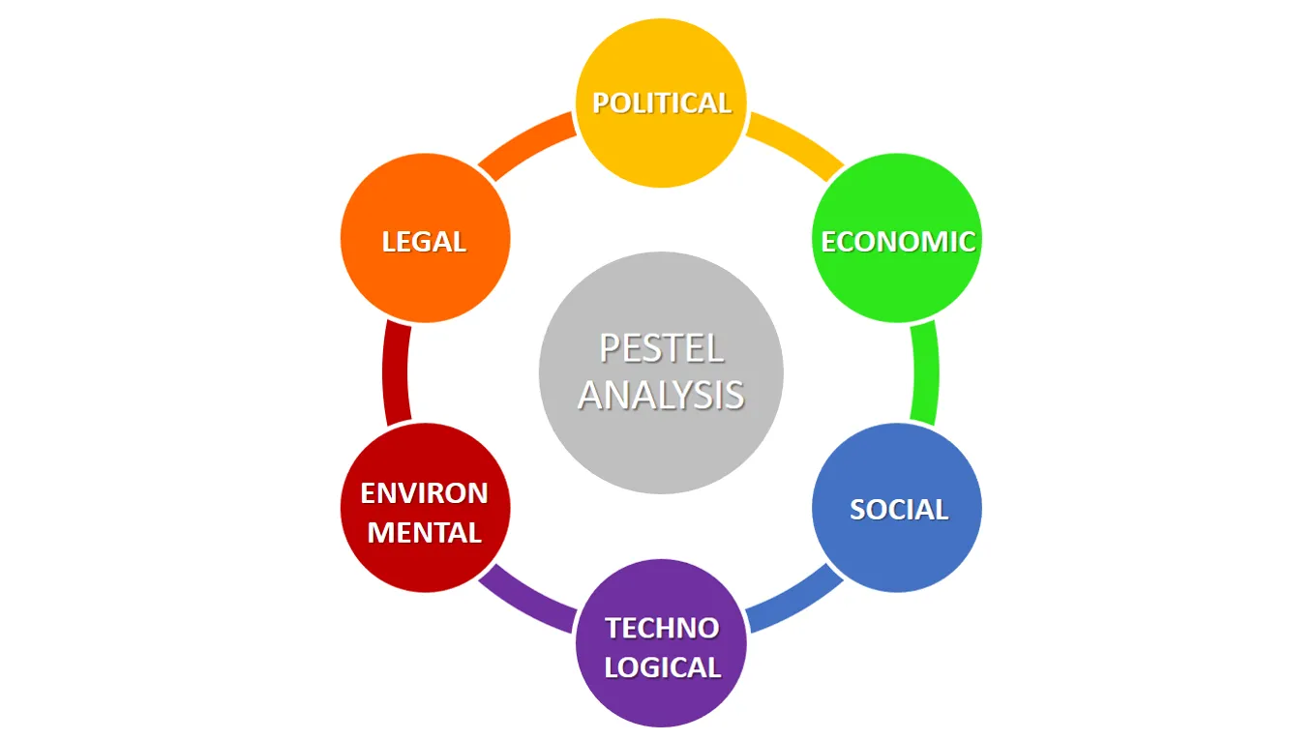
Figure: PESTLE Analysis (Jane, 2016)
This analysis will help the brand to analyse and understand its action plans for the future.
Political | The political situation of the United Kingdom is stable. Therefore, the organisation does not face any problems in the process of progress over time (Mehta, Kumar and Prasad, 2018). However, the organisation needs to observe and analyse the steps that are taken by the government to support the growth of SMEs or large businesses in periods of economic recession situations. During the Russia-Ukraine war, when the hotel industry was facing a lot of trouble, the government of the United Kingdom allowed hotels to import ingredients through suppliers with limited tariffs. However, the ones who applied for the process only got access to it. This is something that the organisation needs to consider overtime on observation and to take action quickly.
Economic | The economic situation of the United Kingdom is stable as of now. However, during the period of recession, the hotel did not shift its pricing strategy to adapt to the changes in the external situation (Laudon, 2019). In a period of economic downfall, it is important to adjust the prices like the competitor brands of the services the hotel provides in order to make the amenities affordable for clients.
Social | The social aspect of the United Kingdom’s Manchester is positive towards the hotel as it has been operational for a long time now (Mansour Ghazi, 2016). As the hotel has done many corporate social responsibility-related activities over time, this has helped the brand to gain a good reputation. however, in seasonal times, people from abroad or other states are the usual visitors to the hotel. Thus, gaining a good reputation across the United Kingdom is something that the organisation should target.
Technological | Modern-day clients are technologically advanced. In the process of booking a hotel, a usual client researches the hotel online. In order to find a hotel, people look on Airbnb or similar hotels to find services. Google is also a smart method to search for and book a hotel (Trumbauer, 2015). Since Hotel Brooklyn has limited technological presentation online, this has been a problem for the hotel.
Environmental | The environmental aspects of the hotel are also important to consider. There are some operations of the hotel that include the use of plastic-based materials such as coffee cups (Rahman, Abdullah and Awang, 2019). The brand needs to mitigate the use of plastic in order to become an environmentally sustainable brand which will create a good perception towards the clientele minds.
Legal | The legal aspects of the organisation are also important to consider as the brand has faced legal consequences quite a few times, which has harmed its reputation. The organisation was charged for its delivery men not having driving licenses. The hotel took a lot of time to resolve the legal issue that it faced. These problems have downgraded the reputation of the brand by a big margin over time.

Leadership Issue Within Hotel Brooklyn to Affecting Employee Retention
The leadership model that the hotel follows is not ideal considering its employee retention situation of it. The organisation follows the great man theory of leadership model for the leadership practices of the organisation. This is negatively impacting the overall progress of the organisation as employees are not motivated enough to work hard (Rosen and Brown, 2016). Thus, it is important for Hotel Brooklyn to understand what is the ideal leadership model that it should undertake in order to increase the employee retention rate and effectiveness of its working process.
The great man theory of leadership is not letting the junior employees of the organisation climb up the ladder with promotions from their work. The junior employees are, therefore not seeing any scope for growth within the organisation. This is a big problem for the hotel as the junior employees who are getting trained and learning how the works are to be maintained are switching to other hotels with time (White and Saunders, 2017). Thus, the leader recruitment process of the organisation should be changed over time. As a part of that, the hotel should adapt to the behavioural theory of leadership along with time so that the junior employees get a chance for growing their careers within the organisation.
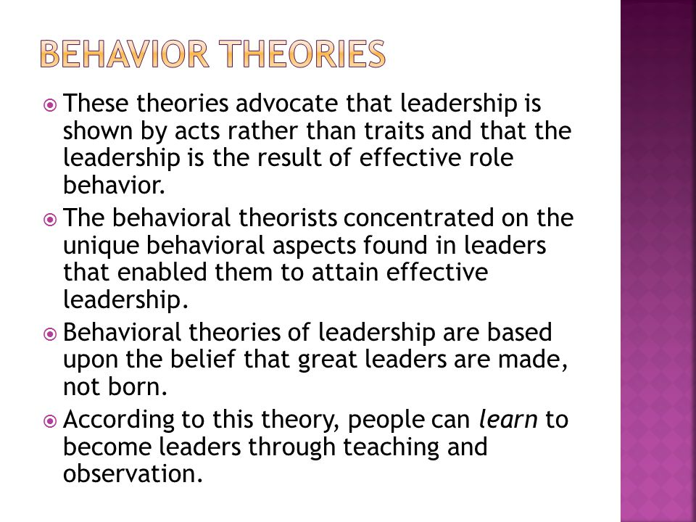
Figure: The behavioural theory of leadership (Tregaskis et al., 2012)
The behavioural theory of leadership suggests that employees can learn different aspects of leadership over time with learning. This theory believes that leaders are made, not born. When the leaders of the organisation teach other employees of the organisation how to show leadership skills, they improve over time. As a part of that, Hotel Brooklyn can take training sessions and provide one-to-one mentorship opportunities to the young employees to prepare them for the future. This way, the employee retention rate within the organisation will increase over time.

Increasing Employee Motivation
It is also important for Hotel Brooklyn to pay attention to the needs and motivational factors of the employees and staff. Therefore, following Maslow’s Hierarchy of needs will help the hotel to understand what are the steps it should undertake to improve the overall employee satisfaction level and increase the employee retention rate.
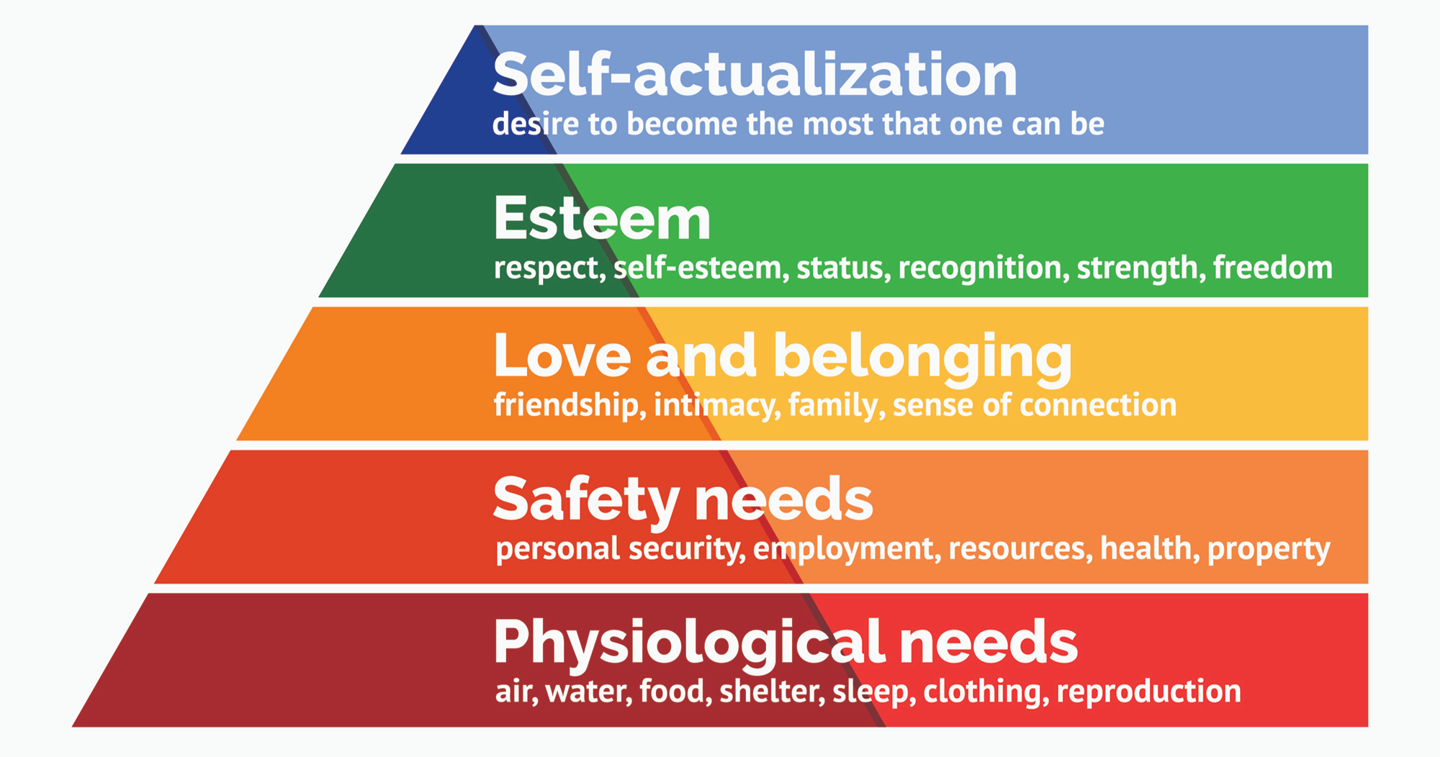
Figure: Maslow’s Hierarchy of Needs (Reddy, 2019)
The physiological needs and safety needs of the staff of the organisation are met by the management of the organisation. However, it is also important to ensure that the other needs of the employees are also met to increase employee satisfaction.
Love and belonging: The employees and staff of the organisation should feel like they belong to a family and the organisation cares for its employees. Setting up a friendly working environment is important therefore to make the working process more interactive and fun for the employees. Statista has shown an interactive and friendly work environment increases ownership of the employees to the organisation by 19% in most cases (Mehta, Kumar and Prasad, 2018). Thus, it is important to establish such a working environment through the human resource management of the organisation.
Esteem: Arranging different kinds of awards and programs where the employees are appreciated will help them to understand that they are valued within the organisation. This will be an important step for the organisation in the process of making the employees feel valuable to the organisation and contributing to the increase of employee retention rate.
Self-actualisation: Organising training sessions and employee benefit programs will help employees to feel more valued and self-actualised. This will help the employees to be more satisfied with the job they hold at Hotel Brooklyn.

Implementing Technological Advancements
Implementing different kinds of technological advancements within the organisation is also a very important step for the organisation. The hotel is not much technologically abled (Lonster, 2019). However, the PESTLE analysis indicates that the modern client base requires technologically abled services. Thus, there are a few steps that the organisation can adapt to in order to cater to this situation.
Digital payment options: Hotel Brooklyn does not accept debit cards, credit cards or mobile financial systems for payments to the customers. The customers of the hotel always have to pay with cash which is a burden for the clients. Therefore, it is important to ensure that the organisation is taking measures that will help the clients to pay the hotel via digital payment options that are available. The hotel should start accepting payments via cards (Lindgren, 2012). There are different kinds of visa cards, and master cards that people these days use in order to receive payment or send payment. Accepting payment from cards will be an important move that the hotel should undertake. Mobile financial services are also nowadays highly popular in the United Kingdom. Leopard and Monzo are some of the mobile financial services that are widely popular in the United Kingdom. It is important for Hotel Brooklyn to implement technologies in such a regard so that the payment option for the clients or the hotel gets enhanced. According to a report by Statista, 36% of generation Z customers are prone to paying via digital payment options. Thus, adapting to this service will help the brand to grow with time.
Online Booking Option: It is important for the hotel to ensure that the customers of the brand are able to book their hotels beforehand before coming to the hotel and checking in. Nowadays, it is possible for customers to book their desired hotels online with advanced payments. This way, the customers are able to book their hotels and check if their required hotel rooms are available for them. This makes the hotel booking process easy for the customers as they do not have to physically wait at the counter to check if their desired rooms are available. Moreover, the booking system and the payment system also get simplified if the booking process is shifted online as well. Therefore, it is important for Hotel Brooklyn to adapt to the online booking option as soon as possible, as it will help the brand target customers who order online.
Smart Room Card: Smart room card is important for hotels in order to ensure that the customers have a seamless experience. The use of keys is getting obsolete as there are now lock cards which help customers to open or lock their doors with the help of a card. When the residents get out of their rooms using the cards, the electricity of the rooms gets off, and when they come into the rooms and place the cards in the holders, the electricity for the room comes back. With this method, it is easy for hotels to save a lot of electricity (Johnson, Whittington and Scholes, 2011). The customers of the brand will also be able to have a solid experience that would simplify their residence at Hotel Brooklyn.
Sauna System: Sauna is an essential edition for Hotel Brooklyn to have at the moment. As the organisation has been operating for a long time now, it is now important for Hotel Brooklyn to add amenities that would satisfy the residents of the hotel over time. As a part of that, it is important to ensure that the guests at the hotel get access to the sauna for relaxation (Jane, 2016). This would be an important amenity for the hotel to add since most of the hotels nowadays which have good ratings add saunas next to their dedicated gymnasiums in order to increase relaxation scopes for their clients. 78% of the top tier hotels in Germany have a sauna system installed at their hotel at the level of the gym so that the guests can go to the sauna to relax their bodies right after a hefty workout session or shower (Kang and Yoon, 2018).
Hotel management software: Hotel management software can also help hotels to improve their customer service and overall operational experience. Hotel management software upgrades a hotel from being manual to auto in different aspects. For instance, when a guest tries to book a hotel, hotel management software can easily tell what rooms are available for the budget that the guest wants to spend. This way, the manual way of checking books can be avoided by using hotel management software (J. Turner, 2017). Moreover, room service can also be significantly improved with the help of this software as the software can easily tell what products or foods the guest is demanding in which room. With an integrated system, it will be possible to help the guests get their desired room service or, as they desire, more effectively and efficiently. Therefore, it is important for Hotel Brooklyn as well to integrate hotel management software to improve its services in many aspects along with time.

Employee Training Programs
Hotel Brooklyn should implement weekly employee training programs that would cover a lot of aspects of the training of the brands. As a part of the training program, the hotel can showcase how differently the staff of popular hotels around the world behave with customers, what the etiquette and other prospects of hotel management (Hailey and Wymer, 2017). The staff will therefore get to know about the steps they can undertake to improve their performance within the organisation. In such training programs, it will be possible for the management to communicate what are the expectations they have from the staff of the hotel. The staff will therefore be able to interact with the management and other colleagues and clear out their confusion and problems over time so that the coherence and coordination between the staff improve along with the time (Etzel, Walker and Stanton, 2017). The employee training programs will also enable the hotel to do research and, with discussion, upgrade their services for the betterment of profitability.

Solve common complaints of Customers
Along with taking measures to improve the amenities, it is also important for the hotel to take the complaints of the customers or guests of the hotel into consideration. There have been a few allegations from the customers of the hotel that the authority should take well care of.
- There were many complaints about Hotel Brooklyn about slow room service. Allegedly, when the guests call for room service, the management makes it late to send someone over. This is an aspect that needs proper care and consideration along with time.
- The food that is served in the rooms of the guests is allegedly stale sometimes. This is an issue that can spoil the reputation of the hotel. Thus, it is important for the hotel management to take this into consideration (Corallo, Passiante and Prencipe, 2017). However, the food that is served in the dining room has always been fresh for the guests.
- Increasing the instruments of the gym is also important for the hotel as there are many guests who have placed complaints regarding not having enough instruments. As per serving the requests, it is important for the authority to increase the instruments of the gym.
These are some of the methods of how hotels can increase their amenities and develop their services over time.

Findings and Results
There are different insights that can be derived from what the hotel is doing and what steps it needs to undertake. These insights will help the hotel to improve with time.

Some of the Issues and Remarks
Discussing a few issues and the analysis that will help Hotel Brooklyn to have some understanding of how the problems can be resolved.

Issue | Current State | Remark
Foodcourt management | There is a dedicated foodcourt/ dining room in the hotel, which a senior manager manages. There are 6 staff working with the management in total for the food court. | It is not important to engage more than 4 staff in the food court section outside of the kitchen. The staff are often unutilised as they keep standing. There are a few specific times when rush hour occurs. In rush hours, it is important for the hotel to be utilising the employees by adding additional employees in the rush hours. However, during regular hours, it is not important to engage more than 3 staff in the dining room/ food court.
Swimming pool management | The swimming pool is usually closed at the hotel unless the guests make a special request beforehand. This process makes it tough for the guests to enjoy the amenities that are to be offered. | Since the swimming pool often times remains closed, the guests have showcased annoyance due to this situation. Thus, it is really important for the hotel to make its The swimming pool open all the time. It will also be feasible for the hotel management to make a juice pool right across the swimming pool so that the guests who would be enjoying the swimming pool get to spend time at the swimming pool while enjoying juice. This way, the service of the swimming pool will be enhanced.
Room Renovation | The last time Hotel Brooklyn renovated their rooms is back in 2013. Since then, the hotel has not taken any measures to improve the quality of the rooms it has. Thus, many hotels have faded wall colours. Moreover, the interior decoration of the hotel is outdated and old-fashioned. The competing hotels in the area have, however, renovated most parts of their hotels once in 2017 or 2018. Thus, the interior decoration of the hotel sets a bad benchmark for the hotel. | It is important at this stage for Hotel Brooklyn to improve their interior decoration model. As the hotel has been operating for many years now, an obsolete interior design may make the customers or guests of the hotel feel unsatisfied with the amenities that are being offered. Thus, to avoid a bad impression, it is important for the hotel to have upgraded interior decoration along with time. This can be done with the help of having professional interior designers onboarded who can help with increasing the beautification for the guests of the hotel.
Trained Staff | The staff of the hotel are not upgraded with the new possibilities or benchmarks of customer service that can be offered to guests. Thus, although there has not been any specific or severe complaint, it is recorded that the brand still has scope for improving its customer a serving as the competitors in the industry have a much better approach to it. | It is important for Hotel Brooklyn to adapt to the industry standards of customer service. If the staff of the hotel are not well-mannered enough or do not understand modern-day etiquette, it would not be possible for the hotel to offer a pleasurable experience to the guests it will be having. Thus, it will be important to integrate different aspects of courtesy and etiquette training for the employees and staff of the organisation.

Increased Margin of Profitability
Hotel Brooklyn should have an increased margin of profitability so that new operations or projects can be undertaken to increase the profitability of the company. There are many scopes for the hotel to cut off expenses along with time. As per the survey with the kitchen staff of Hotel Brooklyn, it has been identified that so much food is wasted each day at the hotel due to sourcing and preparing food without a proper estimation (BBC, 2018). The kitchen team of the hotel do not have a pattern of data that would indicate how many customers they may encounter at what part of the day or part of the month (Coomber, 2017). As a result, due to cooking more than required, a lot of food is wasted each day at the hotel, which is hampering the profitability of the hotel by increasing the expenses.
It is quite understandable that in order to increase the profitability of a company, it is important to either cut down the expenses or increase the revenue of the organisation. However, cutting down expenses may hamper the quality of service that the organisation provides to its customers. Therefore, it is important for Hotel Brooklyn to increase its monthly revenue time by improving the services it already provides (Chiu, 2017). Moreover, as suggested, the hotel should have additional services offered to its customers and guests so that they become more interested to attend the hotel for their residing. As Hotel Brooklyn will add different services and improve the existing services it provides, the hotel will become more profitable along with time and the management will be able to operate more effectively.
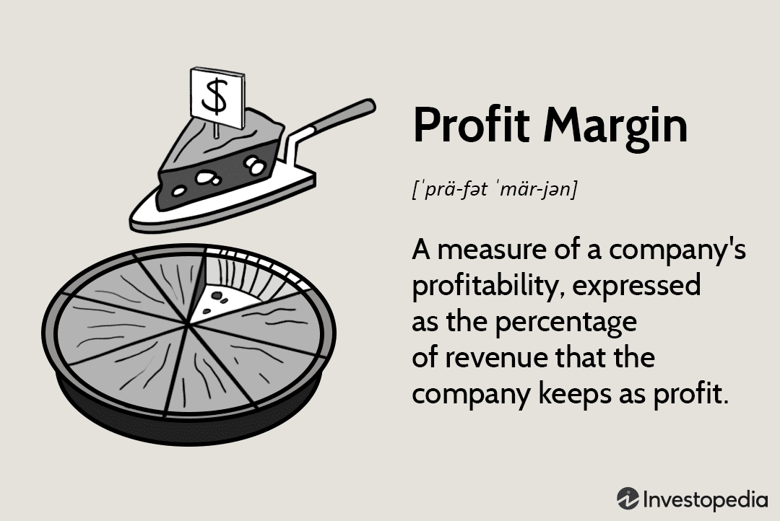
Figure: Profit margin of a company (Bastic, 2016)

This is something that the senior management should look into and solve. If not, it will not be possible to ensure the growth of the hotel as the board of directors would not be investing furthermore into the hotel because of lack of profitability. If the profit margin does not increase for the brand, it will also not be possible to sustain the brand for a long time as the employee salaries will also not increase because of this. When the organisation is able to increase its profitability without cutting expenses from the employee costs, it will be possible to generate more income for the employees and staff and make employee satisfaction level increase over time. This way, the business will be able to expand in the long run.

Action Plan
It is important for Hotel Brooklyn to set up a feasible action plan that would implement the changes within the hotel that are necessary. The action plan will include a list of actions that the hotel should undertake along with what would be the approximate budget that would be required in the process.

Number | Problem | Solution | Desired Outcome | Time Scale | Planned Budget
1 | No pre-booking system | The website of the hotel should include a booking system through which the guests will be able to book rooms. This will help the online users to find out what hotel rooms are available as per the budgets they have set. | After the integration of online booking system, it will be possible for the guests to book their hotels beforehand. Moreover, international travellers mostly book their hotels beforehand so that they do not have to take further hassle when they visit the country. This, will enable the hotel to reach out to and serve international guests more suitably. | 2 months | 1500 pounds
2 | Limited Online Advertisement | Hotel Brooklyn has not focused upon online advertisement till now. Therefore, since the organisation is not trying to reach out to potential customers online, generation z are mostly not being able to get to know about the amenities of the hotel. Thus, it is important to reach out to the young generation through the use of social media advertisement, which will be highly beneficial for hotels in the long run. A dedicated social media marketing team has to be set for the hotel that would be in charge of digital advertisement for the hotel. | Hotel Brooklyn will able to reach out to potential guests which will eventually help the brand to increase its revenue. | All time | 200 pounds per month
3 | Limitedamenities of the hotel | Hotel Brooklyn should develop different constructional amenities such as sauna, aesthetic interior and much more. | It will help the hotel to increase customer satisfaction along with time. | Subjective | Subjective

Recommendations
It is important for Hotel Brooklyn to improve in a lot of aspects. However, there are some actions of the hotel that is well appreciated by the guests and the other stakeholders. The company should be consistent in such a regard. For instance, the hotel has many corporate social responsibility activities that help it to reach further heights. Furthermore, it will be important for the hotel to add additional value to such activities to increase its positive social perception among the general public.

Moreover, it is important for the hotel to understand that the improvements that they are to make are to be done gradually on a linear basis. If the hotel tries to implement the changes all at once, it would not be possible to make successful changes and adaptations to the organisation (Armstrong, 2018). Training the employees and staff is also an important process that the organisation should take into consideration. Moreover, the changes within the organisation should follow Henry Fuyol’s change management model through which the management will be able to plan, organise, coordinate and control the changes that would happen within the organisation.

In since case, it will be important for the hotel to go through a trial-and-error phase where many steps will require close observations to make it successful.

Conclusion
In the process of conducting research, many insights have been presented that can help Hotel Brooklyn to solve the organisation’s existing problems and furthermore widen the opportunities for the hotel to increase revenue. As the world is getting technologically advanced, the suggestions regarding technological adaptations will help the hotel to achieve a lot in a short span of time. With proper technological adaptations, it will be possible for the hotel to attract customers from a young generation which will be a sustainable move for the hotel. As the development process starts, it will be important for the hotel to interact with the consumers before starting the initiatives to understand their perceptions about the changes that are to be made. Through a trial-and-error process, it will be possible for the hotel to make different kinds of changes and upgrade the hotel for better profitability. In the industry of hotel management, it is still important to do research and adapt to certain changes from time to time. Thus, it will be important for Hotel Brooklyn to look out for different opportunities and adapt to certain changes from time to time. This will help the hotel to become sustainable in the long run.

References
Armstrong, M.B. (2018) Gamification of employee training and development. International Journal of Training and Development, 22(2), pp.162–169. doi:10.1111/ijtd.12124.
Bastic, M. (2016) Environmentally Friendly Hotel Service as a Challenge for Innovations and Social Responsibility. Journal of Hotel & Business Management, 03(01). doi:10.4172/2169-0286.1000e110.
Baron, A. and Armstrong, M. (2007) Human Capital Management. London: Kogan Page.
BBC (2018) Tourism - Revision 3 - KS3 Geography - BBC Bitesize. [online] BBC Bitesize. Available at: https://www.bbc.co.uk/bitesize/guides/zqk7hyc/revision/3.
Bernstein, L. and Yuhas, C.M. (2016) How technology shapes network management. IEEE Network, 3(4), pp.16–19. doi:10.1109/65.34740.
Blake, R.R. and Jane Srygley Mouton (1977) The managerial grid: key orientations for achieving production through people. Houston, Tex: Gulf Pub. Co.
Brierley, E. (2006) Talent on tap: getting the best from freelancers, interims and consultants. London: Chartered Institute of Personnel and Development.
Burnes, B. (2014) 4th Edition, Managing Change, Great Britain, Prentice Hall.
Butaney, G.T. (2017) Commentary on ‘Business-to-Business Marketing Textbooks: A Comparative Review’. Journal of Business-to-Business Marketing, 14(4), pp.67–77. doi:10.1300/j033v14n04_04.
Buttrick, R. (2009) The Project Workout, London: Prentice Hall

Campbell, A. (2014) The Virtual Business: Creating the Effective Business Organization. Business Change and Re-engineering, 3(4), pp.45–53. doi:3.0.co;2-0">10.1002/(sici)1099-0828(199612)3:4<45::aid-bcr75>3.0.co;2-0.
Cateora, P.R. and Graham, J.L. (2020) International marketing. New York, Ny Mcgrawhill Education.
Chaffey, D. and Ellis-Chadwick, F. (2019) Digital Marketing: Strategy, Implementation and Practice. 7th ed. Harlow, England: Pearson.
Chiu, C.H. (2017) The effects of collaborative teamwork on secondary science. Journal of Computer Assisted Learning, 18(3), pp.262–271. doi:10.1046/j.0266-4909.2002.00238.x.
Coomber, S. (2017) TECH KNOW-HOW. Business Strategy Review, 25(2), pp.55–55. doi:10.1111/j.1467-8616.2014.01062.x.
Corallo, A., Passiante, G. and Prencipe, A. (2017) The digital business ecosystem. Cheltenham, Uk ; Northampton, Ma: Edward Elgar Pub.
Curseu, P.L. (2015) Team Performance Management – 2014. Team Performance Management: An International Journal, 21(1/2). doi:10.1108/tpm-01-2015-0002.
Dave, B. (2012) Board leadership. San Francisco, Ca: Jossey-Bass, Inc., Publishers.
Eriksen, K. (2012) Perfect phrases for creativity and innovation : hundreds of ready-to-use phrases for breakthrough thinking, inventive problem solving, and team collaboration. New York: Mcgraw Hill.
Etzel, M.J., Walker, B.J. and Stanton, W.J. (2017) Marketing. Maidenhead: Mcgraw-Hill Education.
Euromonitor Plc (2012) Global market share planner. Vol. 4, Major market share companies: the Americas. London: Euromonitor Plc ; Chicago, Ill.
Evans, V., Dooley, J. and Wright, S. (2015) Information technology. Newbury, Berkshire, United Kingdom: Express Publishing.
Fisman, R. & Sullivan, T. (2014) The Org: How the Office Really Works, Murray, London
Frazer, R. and Oswald, P. (2019) Teamwork! New York: Simon Spotlight.
Gabriel, K.K. (2015) Organizational Development, Organizational Culture and Organizational Change. SSRN Electronic Journal, 3(12). doi:10.2139/ssrn.2686104.
Griffin, R.W. (2017) Management. Boston, Ma: Cengage Learning.
Griffin, R.W., Ebert, R.J., Starke, F.A., Dracopoulos, G. and Lang, M.D. (2014) Business. Toronto: Pearson Canada.
Hailey, A. and Wymer, N. (2017) Hotel. London: Longman.
Harrington, H.J. and Lewis, R. (2014) Closing the communication gap : an effective method for achieving desired results. Boca Raton: Crc Press, Taylor & Francis Group.
Hill, C.W.L. and M, T. (2018) Global business today. New York, Ny Mcgraw-Hill Education.
Iverson, S. (2018) Team Performance Management. Team Performance Management: An International Journal, 15(5/6). doi:10.1108/tpm.2009.13515eaa.001.
J. Turner, M. (2017) Hotel Management Contracts: a Particularly Rich Research Context. Journal of Hotel & Business Management, 03(01). doi:10.4172/2169-0286.1000e107.
James, P.R. and Grahambel, J.L. (2020) International marketing. New York, Ny Mcgrawhill Education.
Jane, W. (2016) Team management. Melbourne, Vic.: Victoria University Of Technology, Research And Graduate Studies, Faculty Of Business.
Jansen-Verbeke, M. (2017) Cross-cultural differences in the practices of hotel managers: a study of Dutch and Belgian hotel managers. Tourism Management, 17(7), pp.544–548. doi:10.1016/0261-5177(96)89218-1.
Johnson, G., Whittington, R. and Scholes, K. (2011) Exploring corporate strategy : [text and cases]. Harlow: Financial Times Prentice Hall.
Johnson, M. (2005) The Independent Consultant’s Survival Guide, London, Chartered Institute of Personnel and Development.
Jones, P. and Comfort, D. (2021) Modern Slavery Statements and Leading UK Hotel Companies. ATHENS JOURNAL OF TOURISM, 8(3), pp.147–162. doi:10.30958/ajt.8-3-1.
Kai Hong Phua, Institute Of Policy Studies Singapore and Straits Times Press Pte. Ltd (2018) Healthcare. Singapore: Institute Of Policy Studies.
Kang, K. and Yoon, Y. (2018) The Effects of Corporate Ethicality, CSR Consistency, and CSR Fit on the Perception of CSR Authenticity : Focusing on the Moderating Effects of Anti-Corporate Sentiment. The Korean Journal of Advertising and Public Relations, 20(3), pp.5–34. doi:10.16914/kjapr.2018.20.3.5.
Labbaik, K. (2021) Hotel Maintenance Practices. Journal of Hotel & Business Management, 5(1). doi:10.4172/2169-0286.1000136.
Laudon, K.C. (2019) E-commerce : business, technology, society. Boston ; Columbus ; Indianapolis ; Munich Pearson.
Lindgren, P. (2012) Business Model Innovation Leadership: How Do SME’s Strategically Lead Business Model Innovation? International Journal of Business and Management, 7(14). doi:10.5539/ijbm.v7n14p53.
Lonster, J. (2019) British Steel - Building Stronger Futures with high-quality steel products. [online] British Steel. Available at: https://britishsteel.co.uk/.
Mansour Ghazi, K. (2016) Hotel Maintenance Management Practices. Journal of Hotel & Business Management, 5(1). doi:10.4172/2169-0286.1000136.
Mehta, P.L., Kumar, A. and Prasad, R. (2018) A Pragmatic Business Approach to a NovelAerial Radio Architecture, SIIARA. Journal of Multi Business Model Innovation and Technology, 4(3), pp.215–240. doi:10.13052/jmbmit2245-456x.433.
Nations, U. (2011) SWOT analysis and evaluation of the GEO-3 process from the perspective of GEO collaborating centres. Nairobi, Kenya: United Nations Environment Programme.
Noordzife, G. (2014) Project Management of Hotel Opening Processes: Exploring Better Ways to Manage New Hotel Openings, CreateSpace
Peng, M.W. (2017) Global business. 4th ed. Australia: Cengage Learning.
Rahman, R., Abdullah, N. and Awang, Z. (2019) A High Performing Group: Relationship between Group Cohesiveness and Work Performance. Archives of Business Research, 7(9), pp.1–4. doi:10.14738/abr.79.6718.
Reddy, S. (2019) Automation in buisness: uplifting the existing standards. Journal of Management and Science, 1(4), pp.289–294. doi:10.26524/jms.2020.35.
Rosen, R.H. and Brown, P.B. (2016) Leading people : the 8 proven principles for success in business. New York: Penguin Books.
Scotland. Scottish Executive (2015) National care standards : care homes for people with mental health problems. Edinburgh: Scottish Executive.
States., U. (2018) SWOT analysis : a tool for making better business decisions. Washington, D.C.: U.S. Dept. Of Agriculture, Risk Management Agency.
Tregaskis, O., Daniels, K., Glover, L., Butler, P. and Meyer, M. (2012) High Performance Work Practices and Firm Performance: A Longitudinal Case Study. British Journal of Management, 24(2), pp.225–244. doi:10.1111/j.1467-8551.2011.00800.x.
Trumbauer, L. (2015) Teamwork. Mankato, Minn.: Yellow Umbrella Books.
WARD, T. (2021) MANAGEMENT CONCEPTS. Management Decision, 1(4), pp.38–38. doi:10.1108/eb000817.
Watson, J. (2014) Special Issue Leadership Journal: Indigenous Leadership. Leadership, 10(2), pp.263–265. doi:10.1177/1742715014530196.
White, M.I. and Saunders, C. (2017) Leadership. Oxford: Oxford University Press.
Whittington, R. et al (2020) Exploring Strategy. Harlow: Pearson Education Limited.
Zedeck, S. (2019) Review of Intellectual Teamwork: Social and Technological Foundations of Cooperative Teamwork. Contemporary Psychology: A Journal of Reviews, 36(4), pp.346–346. doi:10.1037/029664.

