Module title: MANAGING PERFORMANCE
Module code: LCMB7013

Assignment title: APPLICATION OF CONTINGENCY APPROACH MODEL FOR ASSESSING STAFF PERFORMANCE MANAGEMENT



Student name: Rehnuma Dilavar Shaikh

Student code: 2239551

Word count: 5344

Date of submission:
Table of Contents
Introduction 3
Ways of implementation of the contingency approach model to support overall business strategy at each stage 3
Provide an organisation example for each stage and critically discuss how the organisation is/has implemented performance management 7
Explanation of Each stage 8
Evaluation of the application of Apple having personal management 12
Reflecting on the post-maturity stage 13
Reflection on the improvement of module learning practices 16
Recommendation 18
Conclusion 18
Reference list 19

Introduction
This report is going to shed light on the contingency approach model for managing the performances of employees in each stage of business. According to this theoretical model, it has been noted that the leader should be effective and apply certain strategies that fit the situation properly. Assessing the situation was extremely important for leaders in terms of enhancing the performance management of employees for each stage of business. A good leader’s effectiveness depends on the harmony between the situation at hand and the style of leadership. Apple is selected for this business report and the application of the contingency approach model will be effective to understand the performance management for each stage. A critical reflection on the Post-maturity stage will be provided along with suitable recommendations and a concise conclusion.

Ways of implementation of the contingency approach model to support overall business strategy at each stage
There are various ways present through which the contingency approach model can be implemented for the performance management of employees at each stage of business. In the very first stage or start-up conditions the leaders need to recognise the triggers which in turn influence performance management. In the primary stages of the startup phase, a leader has to recognize the needs and urgency of contingency planning for the performance management of employees. It has been difficult for the leader to predict certain things in terms of successful business progression for employee management (Ganegoda and Bordia 2019). The leadership style recognition and understanding of the team’s situation was extremely important for the leader to make further progress. Along with this, it can be said that the application of this model has been effective in understanding the need for leadership approaches. Application of the least preferred coworker scale or LPC was extremely necessary in the startup stages to highlight the essentiality of leadership approaches.
In the start-up stages, the determination of the LPC score was extremely important for a leader that helped in the identification of their approaches. This particular situation or condition has triggered the application of this leadership approach in the workplace to manage employee performance. A high score in the LPC (73 out of 100) has highlighted that the leader has relationship-oriented capabilities and that triggered the situation needs accordingly (McMullin and Raggo 2020). Employee management has been extremely necessary for the leader as it helped in the smoother start-up process for the business. However, the score remains 54 or below out of 100 which highlights the task-oriented quality of a leader. In this situation, the performance management of employees depended on their task performance or competition capabilities. During the start-up stages, the measurement of employee performance was extremely necessary as it highlighted their further progression opportunities (Baig et al. 2021). Assessing the situation in the start-up stages was essential for leaders and that allowed them to manage performances. In the further stages examination of the situation was extremely important for managers to enhance the performance management of employees.
Examining the situation was necessary for the leader to manage the performances of employees was the important thing. In a hypothetical situation, the leader needs to recognise an accurate aspect for incorporating performance management styles. Assessing and examining the situation will provide important categorical phases for them. The urgency or requirement of situational approaches in the management of employee performance was extremely helpful. The leader has made all the employees involved in each stage of business to improve the business growth (Khassawneh and Elrehail 2022). During the growth phase, it was beneficial for the leader to plan for delivering brainstorming responses. The disruption can occur in growth stages which might be mitigated through examination of the situation. Thus, it can be said that the application of employee management or performance assessment approaches in business growth stages was highly essential. Situational assessment in the growth phase of business is obligatory for smoother progressions.
Based on the contingency model approach it can be said that the examination of leader-member relations in terms of trustworthy and good conditions is compulsory. The leadership approach scores have determined the situation as it was poor and untrustworthy for employees or perfectly fitted. The clarity of tasks and structured perspectives have been the prerequisite for leaders to improve employee management in the growth stages of business. Moreover, the influences of leaders on employees with reference to assessing the situation were extremely important (Reams 2023). In the growth stages of business, a company distinguishes itself from its competitors in an intense marketplace. Owners tend to shed their focus on business expansion and growth significantly. In this perspective, the management of employee performances was extremely imperative for leaders. Therefore, the examination and assessment of the situation was highly responsible for a leader to enhance business performance and employee management approaches.
The business development stages have further expanded to maturity level and in that phase the application of the leadership process was necessary. The maturity stage of the business mainly consisted of dedicated employees and a strong management team. Annual growth of a business needs to be consistent and that triggered the leaders to make contingency planning to support business maturity. The quality of leaders depends on the perspectives and job structures in a business environment (Shala, Prebreza and Ramosaj 2021). High and low LPC has influenced the behaviour of leaders in the employee management process. The acquisitions and good business growth in maturity stages depended on employee performances and that in turn triggered the application of accurate leadership approaches. Based on the productivity level of employees a new product line can be developed by the management to improve business activities. Thus, it was extremely indispensable for the leaders to apply a contingency approach in business maturity stages.
A mature stage of business has highlighted steady and stable cash flow throughout the operations. The business has shown significant control over its customer base by effective management of product demands and productivity. All such factors highly influenced with performance management of employees and that in turn drove the business growth (Adeoye 2021). Based on the contingency approaches and planning from the business leaders it was ineluctable to plan the employee management accurately. The loyalty of employees was associated with the maturity stages of business. It has been helpful for the business managers to maintain the profitability level and secure cash flow.
The last stage of business progressions was the decline phase and that indicated strong leadership positions. Skills and leadership development of the managers in this phase was extremely vital as it recognised the turnover rates for employees. It was extremely necessary for leaders to monitor the turnover rate of employees as the decline stage tends to show a high employee turnover rate. This should be reduced and lowered by the leaders to mitigate the decline phases. Teams or employees have found it difficult to collaborate with other workers in terms of lowering employee turnover rates (McMullin and Raggo 2020). Based on the declining stages it was extremely obligatory for the managers or leaders to monitor employee performance. The level of employee productivity needs to be increased with accurate employee management approaches. The management needs to show innovative approaches, leadership processes, and organisational management to remove obligations. All such above-mentioned ways were important aspects for leaders to incorporate contingency planning and approaches.
Based on the above learning and application of contingency model approach, it has been noted that every company did not go through all the stages. Each of the stages in business cycle referred to as the maturity phases where they might suffer from several challenges. Hiring employees, delegating tasks and many other aspects are the important factor of business life cycle stages. Maintaining capital and accurate forecast development was the major aspects of business growths. In this particular report, apple company has been selected for evaluating and it was found that the company did not go through post-maturity stages.
Performance management cycle
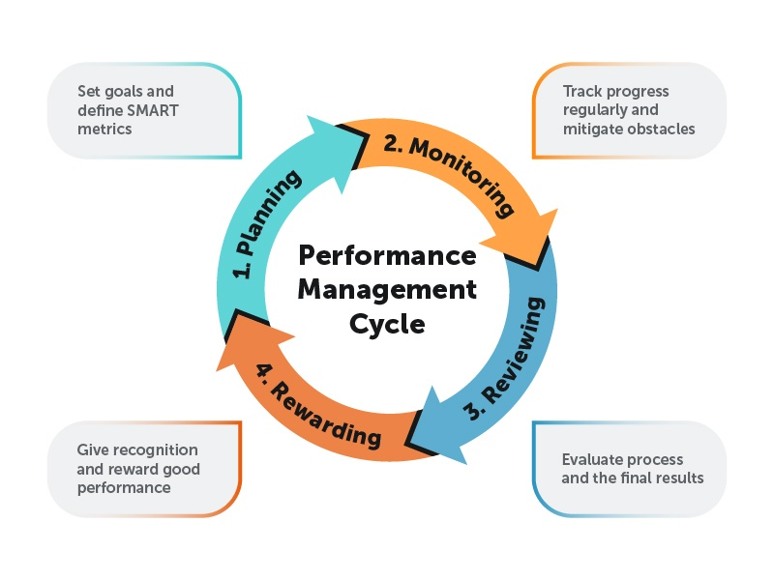
Figure 1: Performance Management cycle
(Source: Valamis 2021)

Planning
Apple started their company with working on understanding the goal that the organisation have. They had the idea that they would make a device that would help them to target the market who are in need of techs. They wanted to revolutionise the world by introducing Pcs that would have a good effect on the people (Podolny and Hansen, 2020). They started this to make sure that they are able to work on solving the problems that the people had in the absence of the personal computers.
Action
The company hired employees who would live their vision and make sure that they are supporting the cause of the company. They set their goals for the company which will help them to move forward in the market. The company have acted on the need of the product and made sure that it has a genuine value on the product. This have affected the people and made sure that they are able to make changes in the market (Umoh, 2019).
Monitor
In this case the company had to monitor the functions that are taking place and the way the people are working on the problems. The monitoring process is also done to understand the actions that they are taking (Perform, 2021). The company have appointed people to take a closer look into the market that they have. The company have monitored the customer thoughts on the products and they have acted wisely to take the feedback and apply them to their devices.
Review
The company have been asking the customer of the company about the products that they have. The company is focusing on learning the feedback that they have. This will be helping them to engage with the people. Also, it is important to make sure that they are applying the changes in the production process (Apple, 2021).

Provide an organisation example for each stage and critically discuss how the organisation is/has implemented performance management
The company that can be best used for the contingency approach explanation can be the company Apple. Apple has established their market for quite a long time and they have sold a lot of products that have changed the customer’s life with technology. The company have used the limitations of the society and create the products that they want. The company have changed a lot of skills and leadership to keep it stable in the market. The contingency approach model is used to understand how the company have gone through the stages of the model to build their market and make their own customer base. This will be helping them to work on the vision that they had for the company and make sure that they are creating products that would change the life of other people

Explanation of Each stage
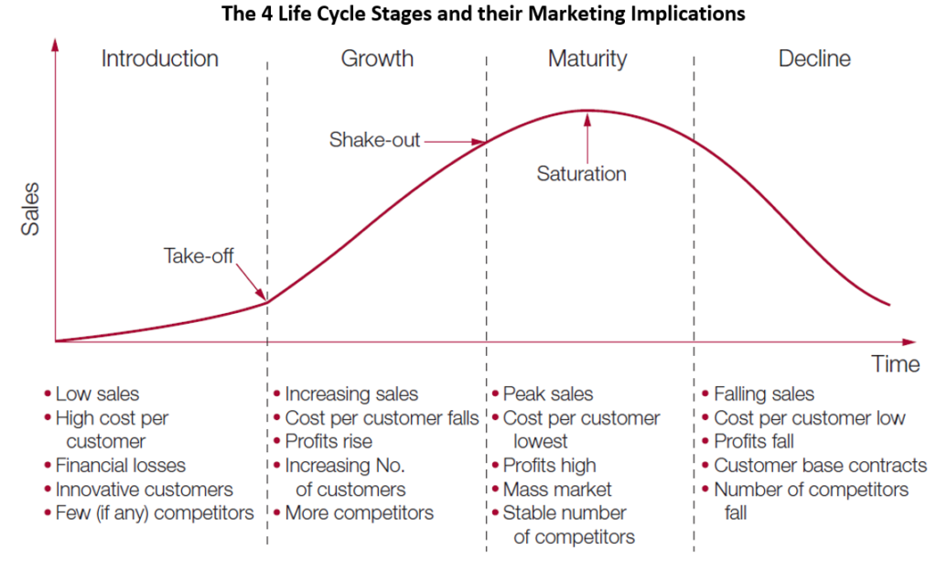
Figure 2: Apple product life cycle
(Source: Saxena, 2018)
Startup
Apple computer have started their company to sell the best PC in the market at the time when the best computer companies could not build that type of product. The company was totally focused on building. Apple has been dealing with the computers that they have built and they were trying to sell that to the customers. One of the major objectives was to make the people believe that the company can provide them with the good products in the market. Now the problem that took place was the customers were not able to buy the product because of the limited amount of product as it was the startup (Apple 2021).
Also at that time in the market they had IBM who was building new type of products. They had the largest base of customers. So it was tough to handle such things that would help them to work on the goal that they have. Also getting the customer base towards them was a tough work for them to do. So the company had low sales in the market, they also had to face high cost per customer in the market (Johansson 2021). This made the customer move away from the company. This has also affected the customer that they had leading to the loss of their financial growth.
In the beginning of the company Apple motivated their employees to work for them by telling them that how innovation can change their own life. Even Steve Jobs the owner of the company in the beginning offered them various positions in the company which also motivated the employees. there was a leadership quality in Steve Jobs that motivated the employees to work for him and create the best product (Penn 2021). Also the employees are Apple were given other facilities which help them to give the best to the company. The creativeness seen in the leader of Apple motivated the employees work for them properly.
Growth
After getting their product in the market Apple started to group big in the technology market and they started to present technology that and that time was not there in the market. The company was focusing on generating revenue from the innovating products and keep on innovating them to make the customers life easier. The companies changed its motto and made it a more customer based company (Greenberg 2019). This made the company increase their sales in the market every product of Apple was now selling in every store.

Figure 3: Explanation of each stage
(Source: Self-developed)
Also the profit of the company started rising in the market because they were no selling products that would help the customers to improve their own lifestyle. Also the company handed improvement in the customer base which have held them to sell their product in the market and also provide a good change in their life. This will help them to enhance the company market growth (Greenberg 2019). With this change now the company had more competitors in the market and now they had to think about improving the techs that they have been using. In this stage they had to make ideas that would help them to change the factors that they have in the market.
This is the stage where the company have been handling the employees in a proper way so that they can keep on creating good products for them. The company have been on covering the valuable inside which would help the employees to stay motivated on creating a certain product (Sauer 2022). Also the employees are given a lot of facilities and discount on the products that their creating. Also the employees have been trained to work on certain products which would help them to develop the ideas within the employees. Also they have to make sure that they are able to work on expanding their skill set in the market. Apple knows how to analyse the human behaviour and during the tough times. So that is the way they are working on motivating the employees by understanding the need that they have towards the company.
Maturity
This is a stage where the company have been focusing on increasing their market and creating new products that the competitors cannot imagine of. The company in this stage have been making the employees their family because they believe that they employees of the one who will create a major change in the market. The company never takes any kind of decisions alone in this stage because they think that the employees also a part of the company and the also have the right to take the decisions (Bloomberg 2019). Every decision that are made at the company are discussed by the employees then the final decisions are made. The company also feels good in their mind and in the body then they are working at Apple.
The reason behind this is the company is taking care of all the necessity that the employees demands and understand how the people can feel free in the company. This is the only way they can handle the employees and motivate them every day. Also there are certain facilities that the company can provide to the employees during this stage and these facilities will be much greater than the facilities provided to them in the previous stages. Alsothe employees that Apple feel good financially because they are offered a good amount of money for the services to the company. This is another way of motivating the employees in their company. So in the maturity stage it is all about making the employees believe that they can create a difference. The company did not go to the next stage of the market.The company have pulled them up in the market. This have made them train their employees in the market and make sure that they have employees with right number of skills. In this stage they have take various number of steps in the market.
The company might be training more employees to shop in the skills and make them learn skills that they are not interested at. This will affect their motivation and the same time they will lose the interest in creating new product. Also the company might be losing a lot of competitors in the market because the competitors might be innovating in a different way. Losing competitors does not always mean achieving success (Dogra 2019). The competitors might be managing their employees in different way which the work place culture of Apple.
The company is investing their money in other services which means the company is not taking so much time to train their existing employees they are also not willing to work on keeping their employees stress free at work. There working on various kinds of projects and they want their employees to give their best every time they start creating a certain product. Alsothey might be making the employees work forcedly on products which do not have value which might even drop their profit percentage in the market (Nicas and Browning 2021). So from all the stages it can be set that the employees are managed in different stages based on the situation that the company is facing.

Evaluation of the application of Apple having personal management
Apple Company has to focus on performance management to evaluate personal management in leadership management. Apple is focused on selective hiring to focus on the hiring process and aim for business connectivity. The factors need innovation and excellence in employment management (Baqutayan et al., 2018). The aspects of the Apple Company need training and development to invest in various training management for employees. Employees in the retail industry undergo significant training in interpersonal skills and product expertise. From the company perspective, apple has to focus on hiring employees and business management for an innovation corporation.
Apple Inc. performance appraisal to employees' growth and business motivation is related to the business management. Apple evaluates employee contributions using a performance assessment method. Employees receive frequent feedback, and performance assessments can impact promotions and pay hikes (Trivedi, 2019). The process of employee interaction has help to build employee motivation and support business motivation. The employee's engagement is creating effective encouragement for leadership development. Apple's performance management strategy is based on open communication in order to construct a picture of how each individual contributes to the business. This allows Apple to have a more comprehensive view of each person's performance, opening up new insights into how each individual affects the firm.
Apple's human resource management policies have multinational cooperation which is related to the employee's growth. The progress of professional development needs effective productivity in marketing development. The aspects of company policy need to build a business reputation to describe good job characteristics. Apple's trade policy and safety must motivate all workers (Nell, 2020). The employees intend to advance from their present level toward the next higher level. Every employee must aim to reach their position as their future anticipation. As a result, the personnel are working really hard. The employees' objective is to accomplish the expected post within six months, considering they are going to be executives in the Apple shop.
Apple's personal management has focused on the factors of employee leadership to increase marketing growth. The process of marketing makes good recognition to support business revenue and increase technological innovation. Sociocultural issues have a large impact on Apple's profitability. The technology component worldwide gives a significant number of chances for Apple, allowing the corporation to improve and develop improved services and products (Papierz, 2021). The aspects of company growth have to focus the business revenue and business services management. The prospective of the business innovation is needed technological support to increase business revenues and trade marketing.
Apple Company needs positive interaction to support marketing opportunity which includes trade policy and strategic marketing. Apple Corporation may improve worker productivity and work by recognizing failing issues, encouraging continuous communication, fostering a happy work environment, utilizing data and channels, and encouraging progress via managing performance (PerformYard, 2022). Apple Corporation may address inadequate results issues by first understanding the issues in order to better address them and provide opportunities for improvement.

Reflecting on the post-maturity stage
The post-maturity stage is related to the business relation to the focus on the failed response to grow competition and its losing market share. The factors are related to the business values and focus on the probability of successful appropriate planning and action (Yatsenko, 2021). The analysis is related to Apple Company and focuses on the factors of business growth. Business management is the relevant factor of the contingency approach to focus on staff performance monitoring. It entails investigating choices, whether they be family, company personnel, or third parties. It also entails creating finances and appraisals, doing investigations on prospective purchasers, and minimizing disturbance through a planned handover.
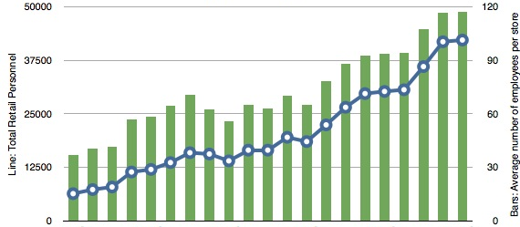
Figure 4: Employment growth rate of Apple Inc.
(Source: SHRM, 2019)
Renewal phase
In the renewal phase, it is related to the strategic alignment and focus on the organisational mission and vision. The approach of strategic alignment is related to the facts of performance management and team objectives (SHRM, 2019). The process of organisational connectivity needs business goals and focus on strategic directions. The process of the renewal phase depends on team objectives and business reassess for company growth. Operations that foster and oversee change should be included in managing performance.
Apple's product offers have regularly undergone renewal. Apple releases new or upgraded goods on a regular basis, like as iPod, iPhones, MacBooks, and Apple Watches. Each of these revisions marks a renewed effort to maintain market competitiveness. The Apple Company has effective services expansion which is making a strategic shift towards services in Apple products. In this phase, apple employees in terms of leadership can refer to the period of significant changes (Podolny and Hansen, 2020). This approach to leadership makes good growth and providing targeted leadership programs addresses skill gaps. To address the needs of changing business environments, apple's organisation need to adapt and improve its leadership renewal. It may be a significant aspect of the company's capacity to prosper in a competitive market.
This phase will help to encourage innovation and build creativity in business growth. The phase will effectively change the management of the company's growth. Metrics for performance ought to involve measurements of inventive considering, new product creation, and the capacity to react to shifting marketplace dynamics. Apple has to focus on promoting the leadership culture to build employees' motivation in innovation techniques. This is related to the facts of building diverse backgrounds and supporting networking facilities (Apple, 2022). The employee's leadership encourage a strategic refinement for the business performance.
Steady-state phase
In the steady-state phase performance management makes good emphasizes productivity and maintains the establishment of business standards. This is related to the key performance indicators to reflect priorities. The process makes effective productivity which is related to the factors of quality control (Carpi, Douglas and Gascon, 2017). It continuously improves quality control and builds effective standards for business growth. Performance management will help to ensure products or services build quality and customer satisfaction. In this stage, organisations need to analyse the goal alignment and focus on the factors of business performance. This is related to the training and development to build effective employee skills and adaptability.
In the phase of steady state phase, Apple Company focus on the various aspects of the supply chain and business operations. This has connectivity to build efficiency metrics to continuously improve manufacturing and optimise maximum profitability. The leadership approach of Apple creates a good relationship with the global world and builds a good nature about the company's talent management (Singh, 2022). This process is relatable to the partnerships and focuses on leadership management development. These factors help to generate innovation and focus employment growth in a business environment. This is related to the strategic evolving marketing demands and leadership management.
Apple has a relationship with employee engagement and focuses on creating a positive work environment for business value and motivation. The purpose is to conserve and expand on past triumphs during times of development or renewal, while simultaneously planning for future difficulties and possibilities (SHRM, 2019). Leadership methods must adapt to changing organizational demands while adhering to key standards for effective leadership. The process of the employee's development builds strategic objectives for employment growth. The employment strategy of Apple focuses on retaining key talent and reducing turnover. This is related to career progression and business opportunities.

Decline phase
In the decline phase, performance management should focus on streamlining processes and cost reduction. Employees might get demoralized during the decline stages. Activities aimed at promoting morale, controlling stress, and keeping important people should be included in performance management (St-Jean, 2023). The process of the decline phase has focused on developing and relating to strategies for business units or product innovation. This is important for the business foundation to focus on organisational constructions. The analysis is related to adapting business management to inform decisions and access employee relations. The objective of the decline phase involves data-driven employee relationships to require organisational growth.
Apple company employment leadership is related to the leadership responsibility to focus on change management. The approach of Apple Company needs change management to help maintain employee connections and reduce the necessary adjustments. It also gives organizations the opportunity to restructure them self and emerge stronger (Cherry, 2023). During this period, effective leadership requires a combination of strategic thinking, compassion, adaptability, and a commitment to steering the business through tough times while maintaining its fundamental principles and long-term goals. This is related to the deeper foundation of employee relationships in company growth and customer engagement. This is related to the long-term business development.
Apple's decline phase is related to the product cycle to international business innovation. The process of business decline phase is related to consumer market growth. The aspects of the company's growth depend on the business goals. Employees are also strengthening ties with the International Organization for Migration and the International Labour Organization, and are supporting their efforts to promote worker safety across industries (Saxena, 2018). In addition, we are collaborating with non-profit partners to implement best-in-class digital worker rights training across our supply chain. The process of organisational growth is focused on the business partnership and generated company growth and leadership management.

Reflection on the improvement of module learning practices
I have enjoyed the module learning throughout the semester on the application of contingency planning approaches. It has been better to develop my understanding and knowledge in each of the different areas of this module with reference to the ongoing thesis. It was highly beneficial for me to make suitable connections with the subject to deepen the discussion accurately. The module learning process as a whole has allowed me to look deeper insights of the specific areas. I have collaboratively worked with other classmates to monitor the lesson-learning programs distinctly. The collaborative process of learning has allowed me to enjoy the lessons and modules properly. We have provided encouragement and motivation for each other and that was extremely invaluable. I feel I have learned a lot from them as professionals, sharing ideas and thoughts about many different issues – seeing different perspectives and encouraging me to develop my thinking.
A lot of things were taught in the classroom during this semester and helped in the enhancement of the learning process. I have gained adequate knowledge about the contingency planning approach for further development of lesson learning. I decided to complete the tasks for several reasons. It helped me to improve my practical applications of the contingency approach for managing employee performance. A vast majority of tasks were performed and preferred by me during the module learning process. It will be valuable to input certain knowledge for practical purposes for better progressions. Lack of timing and various other hindrances were there which created certain challenges in the module learning process. I believed that it might be challenging for me in terms of not having much experience in those areas which in turn aided my professional development. Thus, it can be said that the learning process-related contingency approach was fruitful for my professional development.
I remember getting asked about the influence of the module on my learning and practical skills abilities. On reflection of this module learning process, I can say that it has a certain number of positive influences on me. I was able to gather a vast amount of knowledge, information and resources that in turn created confidence for me. The practices and learning procedures created opportunities for me to apply a contingency approach in practical workplaces. However, I felt certain challenges in managing the balance between module learning and practical applications. It was a huge area of curriculum that needed an adequate time to complete. I have made enormous efforts to ensure the quantity and quality of the module and applied it in practical fields. Extra activities were performed in the classrooms that I believed to be more effective for me professionally.

Recommendations
Apple has to focus on business investment to technological development. The employee's activity builds a good process for business interaction. To develop its parts, the corporation is continually developing new platforms and purchasing various sections of the supply chain. That method demonstrates Cook's foresight. The company's current reliance on iPhone sales is a clear concern since it accounts for more than fifty per cent of Apple's revenue and gross profit. The company need to focus on the employee's connectivity to reach global customers. These factors are relatable to business partnerships and leadership growth for the future.
The management of Apple Incorporation needs workers who really fit it’s the culture of the company along with their work experience; employees also need people who have to assess computer knowledge. The company are in need of both side equal opportunities for the employer and also to promote organisational diversity. The company offers compensation for competitive and a number of benefits to its employees.
Apple Inc. needs to focus on leadership management to build a stable foundation for business revenues and gross profits. Apple's leadership style is more imaginative and essential, and the leader must occasionally be involved to ensure that staff truly performs in accordance with the new aims. When Jobs elevated old technologies to new ones in order to improve achievement, the company used a transformational method. This included a shift in thinking processes and attitudes as well as a change in the knowledge, skills, and capacities of personnel. Employees who have been "transformed" grow more creative.

Conclusion
Based on the above analysis, it can be said that the application of the contingency approach in the employee management or performance management process was highly productive. Different ways and reasons for implementing contingency approaches in the workplace were discussed in this report. The interpersonal relationship between leader and employees was necessary for collaborating well in workplace activities have been elaborated. Along with this, the application of such a model in different business stages of Apple has also been discussed. A more comprehensive view of each person's performance, opening up new insights into how each individual affects the firm was critically discussed.

Reference list
Adeoye, M.A., 2021. Explanatory Remarks on Fiedler's Theory of Consequences. Indonesian Journal of Multidisciplinary Research, 1(2), pp.419-426. [Available at: https://www.researchgate.net/profile/Moses-Adeoye-3/publication/369588848_Explanatory_Remarks_on_Fiedler's_Theory_of_Consequences/links/6423571066f8522c38dc279d/Explanatory-Remarks-on-Fiedlers-Theory-of-Consequences.pdf]
Apple (2021). Careers at Apple: Explore benefits that make a difference. [online] Apple. Available at: https://www.apple.com/careers/ca/benefits.html#:~:text=At%20Apple%2C%20we%20approach%20everything [Accessed 16 Sep. 2023].
Apple (2021). How is employee performance measured? - Apple Community. [online] discussions.apple.com. Available at: https://discussions.apple.com/thread/7845007 [Accessed 23 Sep. 2023].
Apple (2022). Environmental Social Governance Report. [online] Apple. Available at: https://s2.q4cdn.com/470004039/files/doc_downloads/2022/08/2022_Apple_ESG_Report.pdf.
Baig, S.A., Iqbal, S., Abrar, M., Baig, I.A., Amjad, F., Zia-ur-Rehman, M. and Awan, M.U., 2021. Impact of leadership styles on employees' performance with the moderating role of positive psychological capital. Total Quality Management & Business Excellence, 32(9-10), pp.1085-1105. [Available at: https://www.researchgate.net/profile/Muhammad-Zia-Ur-Rehman-5/publication/335894965_Impact_of_leadership_styles_on_employees%27_performance_with_moderating_role_of_positive_psychological_capital/links/5ef445b44585153fb1b3b85b/Impact-of-leadership-styles-on-employees-performance-with-moderating-role-of-positive-psychological-capital.pdf]
Baqutayan, S., Jamaluddin, N., Omar, H., Hashmi Parvez, D., Sultan, J., Petra, Y., Kampung, D., Lumpur, K. and Persekutuan, W. (2018). Leadership Framework Intensifies Innovation Culture in an Organization. Journal of Advanced Research in Social and Behavioural Sciences Journal homepage, [online] 10, pp.33–49. Available at: https://www.akademiabaru.com/doc/ARSBSV10_N1_P33_49.pdf.
Bloomberg (2019). Chicago Tribune - We are currently unavailable in your region. [online] Chicagotribune.com. Available at: https://www.chicagotribune.com/business/blue-sky/ct-apple-china-workers-20180116-story.html [Accessed 16 Sep. 2023].
Carpi, R., Douglas, J. and Gascon, F. (2017). Performance management: Why keeping score is so important, and so hard | McKinsey. [online] www.mckinsey.com. Available at: https://www.mckinsey.com/capabilities/operations/our-insights/performance-management-why-keeping-score-is-so-important-and-so-hard.
Chamberlain, G. (2019). Apple’s Chinese workers treated ‘inhumanely, like machines’. The Observer. [online] 30 Apr. Available at: https://www.theguardian.com/technology/2011/apr/30/apple-chinese-workers-treated-inhumanely [Accessed 16 Sep. 2023].
Cherry, K. (2023). Transformational leadership. [online] Verywell Mind. Available at: https://www.verywellmind.com/what-is-transformational-leadership-2795313.
Dogra (2019). Tim Cook Reveals How Apple Takes Care of Its Employees With This One Simple Health Tip. [online] News18. Available at: https://www.news18.com/news/tech/tim-cook-reveals-how-apple-takes-care-of-its-employees-with-this-one-simple-health-tip-1779511.html [Accessed 16 Sep. 2023].
Evens (2022). Apple’s Product Development Process – inside the World’s Greatest Design Organization. [online] The Interaction Design Foundation. Available at: https://www.interaction-design.org/literature/article/apple-s-product-development-process-inside-the-world-s-greatest-design-organization.
Ganegoda, D.B. and Bordia, P., 2019. I can be happy for you, but not all the time: A contingency model of envy and positive empathy in the workplace. Journal of Applied Psychology, 104(6), p.776. [Available at: https://oveislab.com/s/Ganegoda-Bordia-2018-JAP.pdf]
Greenberg, G. (2019). Apple’s Corporate Culture Motivates Employees, Boosts its Stock Price. [online] TheStreet. Available at: https://www.thestreet.com/how-to/apple-s-corporate-culture-motivates-employees-boosts-its-stock-price-13314263 [Accessed 16 Sep. 2023].
Johansson, E. (2021). 5 problems facing Apple it won’t talk about at its April event. [online] Verdict. Available at: https://www.verdict.co.uk/5-problems-facing-apple-april-event/?cf-view&cf-closed [Accessed 16 Sep. 2023].
Khassawneh, O. and Elrehail, H., 2022. The effect of participative leadership style on employees’ performance: The contingent role of institutional theory. Administrative Sciences, 12(4), p.195. [Available at: https://www.mdpi.com/2076-3387/12/4/195]
McMullin, C. and Raggo, P., 2020. Leadership and governance in times of crisis: A balancing act for nonprofit boards. Nonprofit and Voluntary Sector Quarterly, 49(6), pp.1182-1190. [Available at: https://journals.sagepub.com/doi/full/10.1177/0899764020964582]
Nell, M. (2020). People and Environment in Our Supply Chain. [online] Available at: https://www.apple.com/in/supplier-responsibility/pdf/Apple_SR_2022_Progress_Report.pdf.
Nicas, J. and Browning, K. (2021). Tim Cook Faces Surprising Employee Unrest at Apple. The New York Times. [online] 17 Sep. Available at: https://www.nytimes.com/2021/09/17/technology/apple-employee-unrest.html [Accessed 16 Sep. 2023].
Papierz, M. (2021). (PDF) Apple Products: A Discussion of the Product Life Cycle. [online] ResearchGate. Available at: https://www.researchgate.net/publication/319199871_Apple_Products_A_Discussion_of_the_Product_Life_Cycle.
Penn (2021). Apple Computers, Van Halen, and Contingency Theory. [online] sites.psu.edu. Available at: https://sites.psu.edu/leadership/2020/06/06/apple-computers-van-halen-and-contingency-theory/ [Accessed 16 Sep. 2023].
Perform (2021). How Apple Does Performance Management (And Ideas for You to Consider). [online] www.performyard.com. Available at: https://www.performyard.com/articles/apple-performance-management#:~:text=set%20it%20apart%3A- [Accessed 23 Sep. 2023].
PerformYard (2022). How Apple Does Performance Management (And Ideas for You to Consider). [online] www.performyard.com. Available at: https://www.performyard.com/articles/apple-performance-management.
Podolny, J. and Hansen, M. (2020). How Apple Is Organized for Innovation It’s about experts leading experts. [online] Harvard Business Review. Available at: https://www.apple.com/jobs/pdf/HBR_How_Apple_Is_Organized_For_Innovation-4.pdf.
Podolny, J. and Hansen, M. (2020). How Apple Is Organized for Innovation It’s about experts leading experts. [online] Harvard Business Review. Available at: https://www.apple.com/jobs/pdf/HBR_How_Apple_Is_Organized_For_Innovation-4.pdf [Accessed 23 Sep. 2023].
Reams, L.C., 2023. Fred Fiedler’s contingency model revisited: 30 years later. Filosofiyaosvity. Philosophy of Education, 29(1), pp.111-124. [Available at: https://philosopheducation.com/index.php/philed/article/download/761/660]
Sauer, M. (2022). Tim Cook says there are 4 traits he looks for in Apple employees: ‘It’s been a very good formula for us’. [online] CNBC. Available at: https://www.cnbc.com/2022/10/02/tim-cook-says-there-are-4-traits-he-looks-for-in-apple-employees.html [Accessed 16 Sep. 2023].
Saxena, D. (2018). Product Life Cycle of Apple iPhone [E-Book] - Super Heuristics. [online] Super Heuristics. Available at: https://www.superheuristics.com/product-life-cycle-iphone/ [Accessed 16 Sep. 2023].
Shala, B., Prebreza, A. and Ramosaj, B., 2021. The contingency theory of management as a factor of acknowledging the leaders-managers of our time study case: The practice of the contingency theory in the company Avrios. Open Access Library Journal, 8(9), pp.1-20. [Available at: https://www.scirp.org/journal/paperinformation.aspx?paperid=111736]
SHRM (2019b). Developing and Sustaining Employee Engagement. [online] SHRM. Available at: https://www.shrm.org/resourcesandtools/tools-and-samples/toolkits/pages/sustainingemployeeengagement.aspx.
Singh, S. (2022). Apple’s Supply Chain : A Marvel. [online] www.linkedin.com. Available at: https://www.linkedin.com/pulse/apples-supply-chain-marvel-sushmita-singh.
St-Jean, E. (2023). 5 performance management challenges and how to fix them. [online] SearchHRSoftware. Available at: https://www.techtarget.com/searchhrsoftware/tip/5-performance-management-challenges-and-how-to-fix-them.
Trivedi, S. (2019). A Study on Development of Personal and Management Skills in Apple Inc. International Journal of Human Resource Development and Management, [online] 9(1), pp.1–9. Available at: https://www.ripublication.com/ijhrdm19/ijhrdmv9n1_01.pdf.
Umoh, R. (2019). The No. 1 reason Apple has been so successful can be traced to Steve Jobs. [online] CNBC. Available at: https://www.cnbc.com/2017/07/13/the-no-1-reason-apple-has-been-so-successful-can-be-traced-to-steve-jobs.html [Accessed 23 Sep. 2023].
Valamis (2021). Performance Management Cycle. [online] Valamis. Available at: https://www.valamis.com/hub/performance-management-cycle [Accessed 23 Sep. 2023].
Yatsenko, D. (2021). Maturity Stage of Product Life Cycle: How to Sustain Growth. [online] www.eleken.co. Available at: https://www.eleken.co/blog-posts/maturity-stage-of-product-life-cycle.
Zervas, S. (2021). Change in Leadership of Apple Inc. From Steve Jobs to Tim Cook. [online] Available at: https://www.researchgate.net/publication/356414493_Change_in_Leadership_of_Apple_Inc_From_Steve_Jobs_to_Tim_Cook.

