E-portfolio

Module code: ECPS4018

Contents page

Task one 4
Task two 6
Task three: Essay Plan 7
Library Search Screenshot 9
Summary of sources 10

AI Acknowledgement
I acknowledge the use of Grammarly (https://www.grammarly.com/ ) on 7th November 2024 to check my work using the prompt:
- Please check the following text for grammar.
I confirm that I have not presented any AI generated text as my own work. I confirm I have copies of my drafts, notes, and other resources I used before, and after the use of AI tools which I may be asked to provide in evidence.

I acknowledge the use of UWTSD library research assistant (https://librarysearch.uwtsd.ac.uk/discovery/researchAssistant?vid=44WHELF_UWTSD:44WHELF_UWTSD_VU1) on 28th, 29th October 2024 and 4th, 9th November 2024 to help research the essay plan question.
I confirm that I have not presented any AI generated text as my own work. I confirm I have copies of my drafts, notes, and other resources I used before, and after the use of AI tools which I may be asked to provide in evidence.

Task one
Article title: How does music make you feel?
Music can have a strong impact on people’s daily lives which can have an effect on their emotions and decisions. The author Zoe Nendick believed that certain things can influence how people feel about music (How Does Music Make You Feel?, 2022). These things can be in the form of different memories they have with a song or individual differences. Certain parts of the brain are linked to the enjoyment of music. Theses parts are the amygdala, ventral striatum, medial prefrontal cortex and the nucleus accumbens. The BRECVEMA framework which was created by Patrik Juslin (Juslin & Västfjäll, 2008; Juslin, 2013) looked at the complex interplay between the person listening and the music as well as the emotions in which have been induced by the music. Although music-induced emotions are being studied using the BRECVEMA framework, more research is required to fully comprehend the mechanisms and interactions. A persons emotional reaction to music can be influenced by a number of things such as the individual differences as well as their personality. It can also be influenced by Self-selected music as well as the social and physical surroundings in which the person is in. Self-selected music paired with the use of music streaming services has made music consumption more automated and personalised. However, this can have an effect on a person’s connection to the musicians. As music can induce different emotional reactions, music has been used as a form of therapy. It had been linked to reducing stress as well as the recall of memories. This has led to music being a great tool to help patients with Alzheimer’s disease. Overall music had been linked to inducing different emotional responses within a person. Due to this it has been used as a form of therapy in order to help patients reduce stress or recall certain memories (How Does Music Make You Feel?, 2022).

References
How does music make you feel? (2022, September 12). BPS; The British Psychological Society. https://www.bps.org.uk/psychologst/how-does-music-make-you-feel

Task two
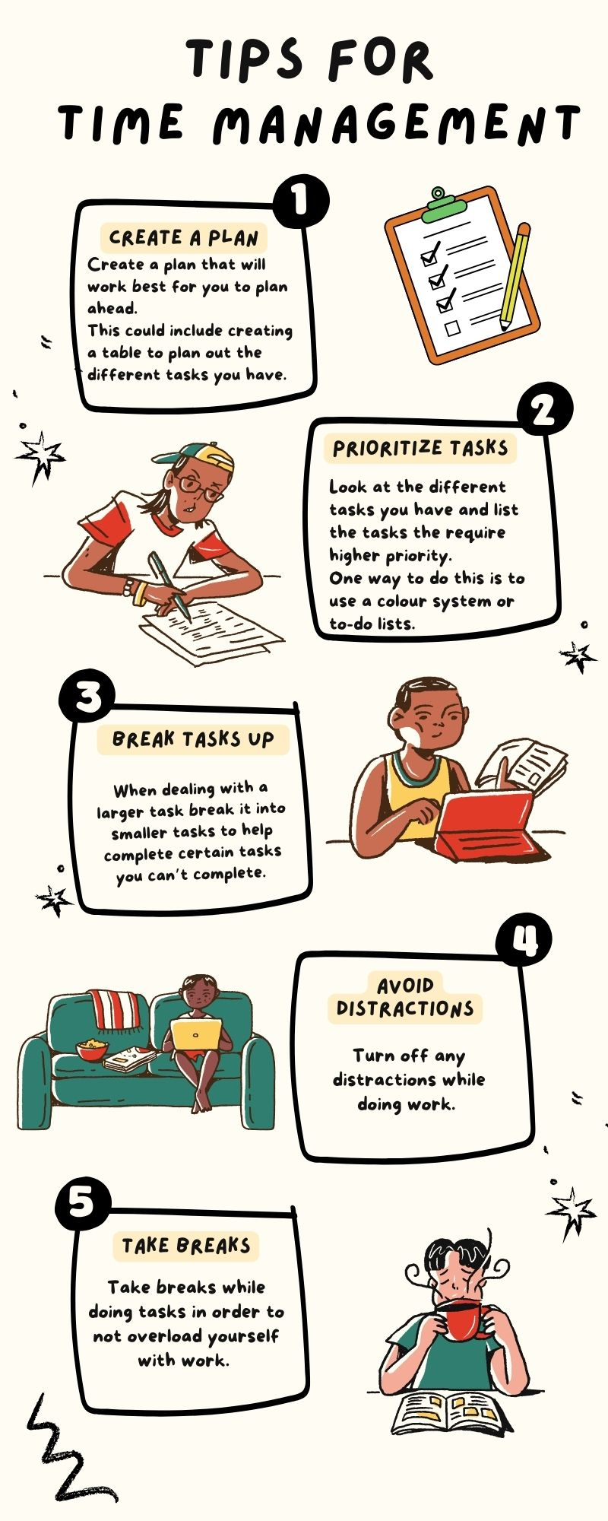
Infographic:

Task three: Essay Plan
Essay plan question: Describe and discuss the psychological, social and physical benefits of owning a pet.

Introduction | General  introductory  comments | Within the introduction paragraph it would have an generally statement of the topic in order to open the essay and then have a small summary of what the reader can expect to read within the essay.
Paragraph 1 | Topic sentence | Owning a pet can affect how experience situations as well as how they complete certain activities.
Paragraph 1 | Support | This paragraph would use this statement as an opening to the topic as looks at how owning a pet can had an affect on certain aspects.  Being a pet owner can effect a variety of performance activities and affective experiences, and it can be viewed as a type of occupation because it is full of social and personal meaning (Zimolag, Ulrike et al., 2009)
Paragraph 2 | Topic sentence | Owning a pet can help improve certain aspects such as a person’s well-being.
Paragraph 2 | Support | This paper looks at a which study conducted by (Meier & Maurer, 2022) within Switzerland. For this point it would look at what the study did as well as what the finding were.  This study looked at this and had found that pet owner's attitudes and feelings towards owning a companion animal were generally quite positive. This was shown on a on a five-point Likert scale. The positive statements about pet ownership generated significantly through higher levels of agreement than negative statements (Meier & Maurer, 2022.
Paragraph 3 | Topic sentence | Owning a pet has been linked to the reduced use of healthcare services.
Paragraph 3 | Support | Given that better health and wellbeing linked to pet ownership have been shown to lower the use of healthcare services, pet ownership may have an impact on the public budget and healthcare system (Smith 2012).
Conclusion | Concluding remarks/recommendations | As the concluding paragraph I would summarize the points in which I had found when researching the topic as well as summarize any studies that support the points.

References
Allen, K. M., Blascovich, J., Tomaka, J., & Kelsey, R. M. (1991). Presence of human friends and pet dogs as moderators of autonomic responses to stress in women. Journal of Personality and Social Psychology, 61, 582–589.
Meier, C., & Maurer, J. (2022). Buddy or burden? Patterns, perceptions, and experiences of pet ownership among older adults in Switzerland. European Journal of Ageing, 19. https://doi.org/10.1007/s10433-022-00696-0
Smith B (2012) The 'pet efect'—health related aspects of companion animal ownership. Aust Fam Physician 41(6):439–442. PMID: 22675689
Zimolag, Ulrike (Uli); Krupa, Terry. The American Journal of Occupational Therapy; Bethesda Vol. 63, Iss. 2, (Mar/Apr 2009): 126-37. DOI:10.5014/ajot.63.2.126

Library Search Screenshot

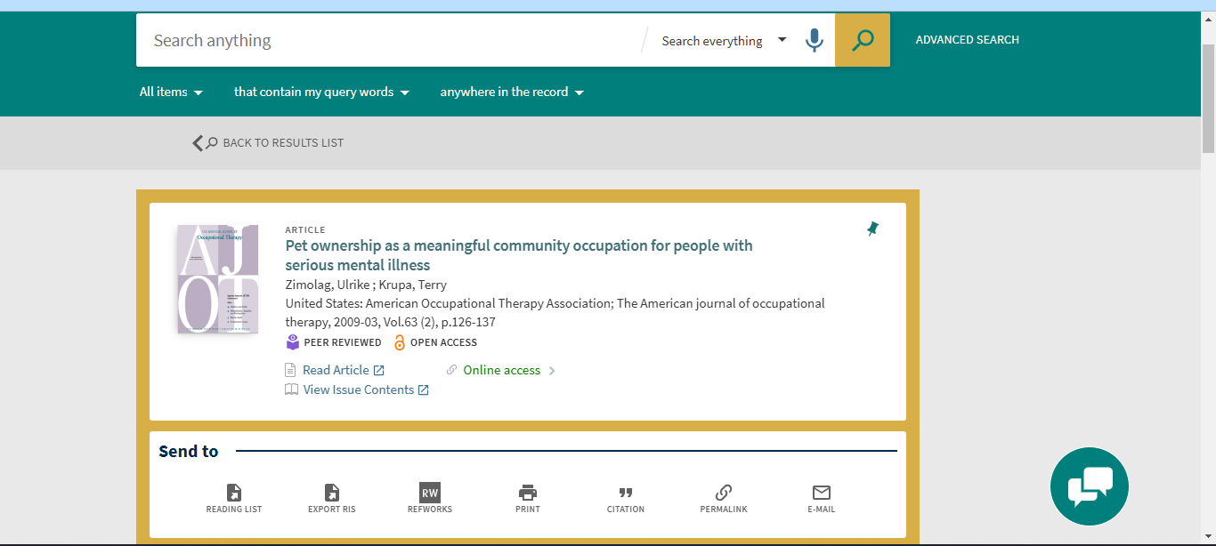

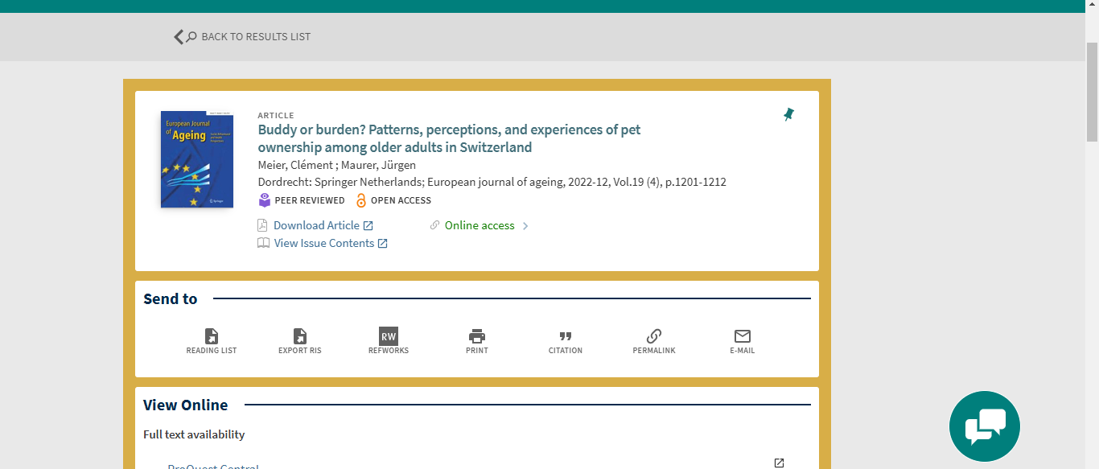

Summary of sources
These are the research articles in which I had found in order to complete the essay plan. The first I had used as it looked at how owning a pet can help people who suffer with mental illnesses. The second one looked at a study that was conducted to look at how pet ownership and mental reactions.

