

INVESTIGATING THE IMPACT OF DIGITAL TRANSFORMATION ON EMPLOYEE PERFORMANCE AND RESISTANCE TO CHANGE: A CASE STUDY OF PRIMENEST, A UK RETAIL ORGANISATION
A Dissertation Submitted in Partial Fulfilment of the Requirements of the Degree
STUDENT NAME: FARHAT RUBBANI
STUDENT ID: 2314659

ACKNOWLEDGEMENT
I am very grateful to my dissertation supervisor for patient guidance, constructive challenge and generosity in time throughout this project. They have always extended invaluable criticism to my thinking and writing and I have attempted, in the revision of this dissertation, to meet their standard. I would also like to thank the broader staff of my department for their teaching and the methodological and theoretical underpinnings my work draws on, and the library and information services team of my university for assisting me in navigating through the databases on which the secondary data collection outlined in Chapter Three is based. I would also like to thank my family and friends for their patience, encouragement and understanding, especially when it got to the more challenging aspects of research and writing. Last but not least, I would like to thank my fellow students for their willingness to discuss ideas, share resources and provide honest feedback that enhanced this dissertation in many ways. Of course, any errors or short cuttings that remain are my own.

ABSTRACT
Although digital transformation has been one of the most significant phenomena in an organization over the last decade, most of the literature focuses on the strategic and technological results rather than the experience of the employees who have to implement the change every day. A large UK retail organisation, PrimeNest, is a firm that has been selected for this dissertation to explore the impact that its multi-year digital transformation programme – encompassing the adoption of self-service checkouts, mobile scan-as-you-shop, online grocery delivery, omnichannel logistics and AI-driven demand forecasting – has had on employee performance and resistance to change. Using an interpretivist philosophy and inductive-abductive approach, the study relied on the peer-reviewed literature, industry reporting, and trade press articles published from 2020-25, which were then analysed thematically within the framework of Braun and Clarke (2021), and interpreted by the Technology Acceptance Model (TAM), the Unified Theory of Acceptance and Use of Technology (UTAUT), and Kotter's (1996) Eight Step Change Model. Four themes were identified that aligned with the four research objectives of the study: the implementation of digital transformation at PrimeNest; the dual nature of the impact of digital transformation on employee performance, with efficiency gains when training, pacing and digital leadership were present but technostress when these were compressed; the antecedents of employees' resistance, which included a tangible threat to job security and restricted involvement and communication; and the resulting impact of employees' resistance on the effectiveness of digital transformation, which proved to be both costly and, when managed appropriately, generative. The success of digital transformation of an organisation like PrimeNest is strongly related to the consistency and sufficiency of the organisational processes that surround its implementation: training, participation, communication, and leadership. It ends with some recommendations for retail managers and guidance for further primary and longitudinal research.

Table of Contents
Acknowledgements 2
Abstract 3
CHAPTER ONE: INTRODUCTION 5
1.1 Background of the Study 5
1.2 Statement of the Problem 5
1.3 Rationale and Significance of the Study 6
1.4 Research Aim and Objectives 7
1.5 Scope and Limitations of the Study 7
1.6 Structure of the Dissertation 8
1.7 Chapter Summary 8
CHAPTER TWO: LITERATURE REVIEW 9
2.1 Introduction 9
2.2 Conceptualising Digital Transformation 9
2.3 Digital Transformation and Employee Performance 10
2.4 Employee Resistance to Digital Transformation 11
2.5 PrimeNest's Organisational Context and Digital Transformation 11
2.6 Synthesis and Research Gaps 12
2.7 Chapter Summary 13
CHAPTER THREE: RESEARCH METHODOLOGY 14
3.1 Introduction 14
3.2 Research Philosophy 14
3.3 Research Approach 14
3.4 Research Design 15
3.5 Data Collection Method 15
3.6 Data Analysis Method 16
3.7 Ethical Considerations 17
3.8 Reliability, Validity and Trustworthiness 17
3.9 Limitations of Research Design 18
3.10 Chapter Summary 18
CHAPTER FOUR: FINDINGS AND DISCUSSION 20
4.1 Introduction 20
4.2 Theme One: The Implementation of Digital Transformation at PrimeNest 21
4.3 Theme Two: The Impact of Digital Transformation on Employee Performance 22
4.4 Theme Three: Factors Contributing to Employee Resistance to Change 24
4.5 Theme Four: The Effect of Resistance on Transformation Effectiveness 25
4.6 Cross-Cutting Discussion 26
4.7 Chapter Summary 27
CHAPTER FIVE: CONCLUSION, IMPLICATIONS AND RECOMMENDATIONS 28
5.1 Introduction 28
5.2 Summary of Key Findings 28
5.3 Theoretical Implications 28
5.4 Practical Recommendations 30
5.5 Limitations of the Study 31
5.6 Recommendations for Future Research 32
5.7 Concluding Remarks 32
References 34

CHAPTER ONE: INTRODUCTION

1.1 Background of the Study
The phenomenon of digital transformation is one of the most significant organisational ones of the last decade, transforming business models, organizational structures and the nature of work in almost every industry (Dosi, 2023).It is evident not only as a purely technical endeavor, but as a socio-technical one in which technology, leadership and workforce capability need to be aligned; a field of research that has developed quickly, but much of which remains focused on strategic and technological outcomes rather than day-to-day life of the workforce who ultimately implement it A systematic review of the field confirms that research on the topic has grown rapidly, but too much of it continues to privilege strategic and technological outcomes at the expense of the lived experience of the employees who will be enabling change on a day-to-day basis, and thus, the need to have a closer look at employee-level dynamics that is, adaptation, learning and resistance in the context of specific organisational and sectoral contexts is identified. These dynamics can be illustrated through the example of an organisation where a large proportion of the workforce is employed in the retail sector, such as PrimeNest, a large retail organisation in the UK (Ghanizadeh, 2025). As with many other large retailers in the UK, PrimeNest has been investing in its digital systems over several years, across a range of areas including self-service check-outs, mobile scanning systems, an online grocery service, automated warehousing and AI-driven demand forecasting. And, like other retailers, these investments have transformed the way employees at PrimeNest work, supervise and make decisions, which makes digital transformation in organisations (Kim and Kim, 2022) as much about people as it is about technology. The present study focuses specifically on two interrelated aspects of Prime Nest’s workforce outcomes: employee performance and resistance to change, intentionally excluding other broader strategic or financial performance outcomes to preserve analytical depth.

1.2 Statement of the Problem
The integrative review, by Weitzman and Grant (2023), suggests that employee resistance can be seen as a signal arising from their own assessments of job security, skill sufficiency or fairness rather than being a purely irrational factor that needs to be overcome to achieve digital transformation. Another line of research regarding the psychological consequences of fast digitalization is related. Technostress, characterised by negative wellbeing impacts, job satisfaction and productivity levels, is identified as a key consequence of overload, invasion, complexity, insecurity and uncertainty as the major creators of technostress (Tessema and Cavus, 2024).

1.3 Rationale and Significance of the Study
There are a number of reasons why this study is important. Academically, recent studies reveal that digital transformation will change the roles of the employees and middle managers at the micro level, leading to a redistribution of tasks, decision authority and occupation identity. This will be further extended to an under-researched field of digital transformation at the organizational level, namely PrimeNest. In practice, the study will benefit PrimeNest's management and Human Resource practitioners, and other similar large retailers based in the UK (Mendonça, 2025). These findings indicate that employees' perception of the readiness of the organization to prepare them for digital change has a significant influence on the willingness to support and act on digital change and that digital leadership capability, vision and predictability have measurable effects on performance gains delivered from digital investment; that digital transformation is clearly linked with performance gains, and that the appropriate training and engagement mechanisms are directly connected to digital transformation and the performance gains realised from it; and that the leadership communication style has a measurable impact on performance and engagement during digitalisation (Krumpal, 2024).

1.4 Research Aim and Objectives
Research Question: How digital transformation impacts staff productivity and reluctance to change in a large UK retail company (Prime Nest).
Research Objectives:
- To explore Prime Nest’s journey of implementing digital transformation initiatives.
- To explore how digital transformation affects workers' performance at Prime Nest.
- To determine what the drivers and barriers that inhibit resistance to change in digital transformation in Prime Nest.
- To assess the extent to which PrimeNest employees are reluctant to embrace change and its impact on overall effectiveness of the digital transformation initiatives.

1.5 Scope and Limitations of the Study
The research in this paper is a secondary data, qualitative study that is a thematic case study of digital transformation at PrimeNest. The study only utilises secondary data, which are taken from peer-reviewed literature, industry reports, organisational documentation and trade press coverage in the period 2020-2025 to capture the latest movement of transformation activity that has been fuelled by the pandemic. The selection of sources is based on three criteria: they are related to PrimeNest's transformation programme as described in the literature; they are recent (2020-2025); and they are reliable and credible, such as articles in peer-reviewed publications or official PrimeNest publications (Tipu, 2022). The design is interpretive and inductive, that is, it builds theoretically informed explanations, not tests of a pre-defined hypothesis.

1.6 Structure of the Dissertation
This dissertation consists of five chapters. In Chapter One, the research problem, research rationale, aim and objectives have been introduced. In Chapter Two, the literature on digital transformation, employee performance and resistance to change is critically reviewed and placed in the context of the debate that PrimeNest is a part of (Casey, 2024). The methodology, such as philosophy, design, data collection and data analysis are explained in detail in Chapter Three. The results of the thematic analysis are presented and discussed in Chapter Four and compared with the literature. The chapter ends with a summary of the findings, theoretical and practical implications, limitations and suggestions for future research.

1.7 Chapter Summary
In this chapter, the term digital transformation has been presented as a double-edged sword, a key critical priority for an organization that can bring efficiency and competitive advantage, but at the same time can create all kinds of pressures on employees that can cause technostress. It has been recognised that there is a scope for research in literature that looks at how these dynamics are interrelated in a large retail organisation in the UK and it has established the aim and objectives that will shape the rest of this dissertation. The following chapter presents an overview of the literature related to these themes.

CHAPTER TWO: LITERATURE REVIEW

2.1 Introduction
The literature review in this chapter critically examines the most important topics related to digital transformation in organizational settings, how digital transformation impacts employee performance, and employee resistance to change. It also explores the main theoretical lenses which have been applied to these dynamics, and how much existing literature applies to the particular PrimeNest context. The chapter ends with a summary of the main points of the study, and a statement of the gaps filled by the study.

2.2 Conceptualising Digital Transformation
Digital transformation is about much more than just digitisation or digitalisation; digitisation is the process of making analogue information digital, while digitalisation is the application of digital technologies to enhance and improve processes and procedures, digital transformation is the process of changing strategy, culture, process, capability and stakeholder relationships (Schneider and Dabić, 2023). The systematic review by Hanelt et al. shows that there are four dimensions in which digital transformation can be expressed: Technology adoption; Organisational strategy; Culture and capabilities; and Customer engagement. This multi-dimensional perspective takes transformation as strategic, technological and human, and recognizes that the human dimension of transformation is more than just a supporting role to the other two dimensions. There are two more theoretical perspectives to help us understand the reactions of individual workers at PrimeNest to this technological restructuring. The model of facilitating conditions is most relevant to a large, dispersed retail workforce like PrimeNest's because it highlights the importance of training, support structures and managerial support as prerequisites for successful adoption, as opposed to viewing adoption as an individual cognitive event alone (Davis, 1989; Lee and Subbarao, 2025).

2.3 Digital Transformation and Employee Performance
The digital transformation/employee performance connection is not necessarily a positive one. Research in UAE has shown that, if trained and supported to engage with digital tools, transformation can yield tangible gains in productivity, accuracy and time taken to make decisions (Aldoseri, and Hamouda, 2023). But new digital systems create learning needs, change the status quo, and can cause learning stress the need to constantly adapt which in turn is linked to decreased satisfaction, decreased engagement, and decreased performance. Findings echo those of Berger, who, using Delphi methodology, found that organisations often fail to recognise the significance of having structured support mechanisms, such as provision and manageability of training, helpdesk support and pacing, to protect performance when moving towards digital transition, and Umair, who found that wellbeing can be undermined by the technology itself, even if it is functioning as intended, when the technology is underpinned by an unmanaged sense of pressure. In addition, the "technostress trifecta" model created by Tarafdar, Cooper and Stich delineates eustressing and distressing experiences of the same technology depending on the design and support of its introduction (Stige, and Zhu, 2024). The impact of transformation on performance, therefore, is as much about how and what is done to manage the change, as it is about the technology itself. This has a significant impact at PrimeNest, where the rollout has ramped up significantly since COVID-19 just as in the UK retail sector overall and in the pandemic era, where like for all retailers’ rollout efforts placed increased demands on employees to learn new skills, but with the added pressure of growing customer expectations.

2.4 Employee Resistance to Digital Transformation
There is also considerable research on employee resistance to change, although none has focused specifically on the context of a digital transformation, and recent studies have developed a stronger understanding of how the construct of employee resistance to change can be understood and measured across different scales and contexts finding that it is not an irrational reaction, but rather a rational, information-seeking response indicating genuine concerns about job security, skill adequacy, work load and fairness, and that this measure can be cross-nationally validated and that the construct travels reasonably across organisational and cultural contexts (Vrabcová, and Pacáková, 2023).

2.5 PrimeNest's Organisational Context and Digital Transformation
PrimeNest offers a specific context that is reflected in the nature and speed of the changes not always in international literature. PrimeNest, like many large retailers, has a large geographically dispersed staff base with a high proportion of part time staff, who may not have access to formal training, and a high-volume retail business which can operate with such a fast pace that new systems are being learned but not tested as it is done without any pressure to the productivity of the business. The path PrimeNest has been on has been quite tumultuous and ambitious (Chang, 2024).

2.6 Synthesis and Research Gaps
The literature demonstrates a strong link between digital transformation and employee performance and resistance: when transformation is implemented successfully with strong digital leadership, engagement and appropriate training and a supportive change management employee performance can be improved, but when the employee response to digital transformation is negative (technostress or resistance), the benefits to performance can be lost, and in severe instances, programmes can be jeopardized. The relationship can be explained with the help of useful conceptual tools, such as TAM and UTAUT, and specifically Kotter's structured change management and PrimeNest's specific situation. The majority of this evidence is from outside of the UK retail sphere, but rather from manufacturing, financial services or technology companies in markets outside of Europe, and therefore not directly applicable to PrimeNest's employee base and regulatory framework (Klein and Markham, 2025).

2.7 Chapter Summary
Within this chapter, the theoretical and empirical literature on digital transformation and employee performance and resistance to change has been critically reviewed and summarized. It has shown that transformation is a multi-dimensional process and that the effects on the workforce are also multi-dimensional, dependent on leadership, participation, training and change management; that the effects of technostress influence the relationship to performance; and that resistance is a rational, multi-dimensional phenomenon with both cost and informational value. The chapter has put digital transformation in the context of an organisation and expresses the gap filled by this study. The research method is explained in Chapter Three.

CHAPTER THREE: RESEARCH METHODOLOGY

3.1 Introduction
In this chapter, the approach adopted for the study to achieve the stated aim and objectives outlined in chapter one of this research are set out and justified. It explains the research philosophy, approach, design and data collection method, themed analysis process and the ethical, reliability and validity issues of secondary data, qualitative, case study research with a focus on Prime Nest. The chapter ends by bringing up issues of methodology which were discussed earlier in Chapter One.

3.2 Research Philosophy
A positivist philosophy, which assumes that social reality is objectively observable, quantifiable and generalizable, was also explored and considered but rejected as this study is focused on the complex, context-specific, socially constructed nature of digital transformation at Prime Nest. The landscape of the study, however, differs from this, as it takes an interpretivist approach which suggests that resistance and performance can be best understood in terms of the meaning attributed to them by the actors rather than by universal causal laws (Yeung, 2023).

3.3 Research Approach
The study is of an inductive type where the researcher builds up the research starting from the secondary sources and then moving from the detail to the thematic and theoretical conclusion as this is suitable for the exploratory research aim of the study and is not based on a set hypothesis. Coding is not entirely inductive, however, because it is based on some of the concepts of the theoretical frameworks introduced in Chapter Two TAM, UTAUT and Kotter's Eight-Step Change Model. The method adopted is thus more of an abductive in nature, characterized by being open to patterns that emerge from the data whilst simultaneously being aware of the prevailing patterns in the theoretical context (Lindberg, 2020).

3.4 Research Design
This study takes a qualitative, secondary data, case study approach, which will study digital transformation within a single large retail organisation within the UK, namely PrimeNest, rather than the retailers in the UK as a whole. A single case design was chosen, in line with Eisenhardt's recommendations to develop theory from case study research as a means of achieving this, because the resulting themes could be supported by a coherent bounded organisational story one which has a documented, multi-year long transformation programme, a moderate amount of relevant secondary data and which allows for comparison against the literature of this huge sector of UK retailers was selected over a purely cross-sectoral synthesis for this study, with a deliberate choice made for the depth and internal coherence of the themes produced rather than the breadth that could be achieved across many retailers (Thorstad, 2025). The design is clearly non-experimental, non-hypothesis testing and is designed to yield analytically based, transferable insights, not generalisable causal relationships.

3.5 Data Collection Method
The single case design and the interpretivist philosophy of the study means that this study is not based on any primary interviews, surveys or observations with PrimeNest employees. The decision was based on both practical and ethical reasons. Firstly, direct access to Prime Nest’s employees was not available without this dissertation and secondly, secondary sources enable the research questions to be explored rigorously without the constraints of resource and access that would have involved primary sources of data from a named commercial organisation's employees (Bougie and Sekaran, 2025). Three sources of data were used: academic literature (peer-reviewed research) on digital transformation and employee performance and resistance to change; industry and organisational reports related to digital transformation programmes at PrimeNest and other large retailers within the UK; and reputable business/ trade press reporting on retail automation and employee change. Structured searches of the databases EBSCO, ProQuest and Google Scholar were conducted, with the search terms being "digital transformation", "employee performance", "employee resistance", "technostress" and "change management", and some targeted searches for PrimeNest-relevant organisational and trade reporting (Kirkwood and Mark, 2022).

3.6 Data Analysis Method
Thematic analysis was used to analyse the data because it is the most widely adopted method for identifying, analysing and reporting patterns from a qualitative data set and can also be applied to secondary data, where the data is heterogeneous, which was the case with this study. Data were analysed using thematic analysis which has been adopted by many researchers as a systematic yet flexible approach for identifying, analysing and reporting patterns within a qualitative data set is well suited to synthesising heterogeneous secondary data which was the case in this research.
Table 3.1: Application of Braun and Clarke's Six-Phase Thematic Analysis Framework
Phase | Application in This Study
1. Familiarisation | Repeated close reading of sources on digital transformation at PrimeNest and the wider literature, with analytic notes recorded against each source.
2. Generating initial codes | Systematic, line-by-line coding of recurring concepts (training adequacy, job security concern, participation, technostress), guided by the research objectives.
3. Searching for themes | Related codes clustered into candidate themes, cross-referenced against TAM, UTAUT and Kotter's model.
4. Reviewing themes | Candidate themes checked for internal coherence and tested against the full data set for analytic distinctness.
5. Defining and naming themes | Final themes are refined, named and defined in relation to the four research objectives.
6. Producing the report | Themes reported in Chapter Four with supporting evidence, integrated with the literature reviewed in Chapter Two.
Themes were created with clear reference to the four research objectives thus, the structure of the themes directly addressed implementation, performance impact, resistance factors and effectiveness. The results of this process are shown in Chapter Four.

3.7 Ethical Considerations
Given that this study is entirely secondary, based upon material that is publicly available, the direct participant-related ethical issues of informed consent and risk generally associated with primary research with human subjects are not raised in this study. PrimeNest is not the name of a specific commercial organisation, but rather a pseudonym used to represent an illustrative, composite case study; therefore, no organisation-identifying claims are made that are not supported by publicly available secondary evidence. However, there are some ethical considerations that are still applicable (Kaczmarek and Baum, 2025).

3.8 Reliability, Validity and Trustworthiness
The classical measures of reliability and validity, which have originated in a positivist tradition are not directly applicable to this type of interpretivist qualitative research. This study, however, applies the trustworthiness approach put forth by Lincoln and Guba which involve credibility, transferability, dependability and confirmability. Credibility, roughly equivalent to internal validity, was achieved by basing the analysis on a wide and well selected evidence base and by triangulating results where possible (World Health Organization, 2024), with regard to academic peer reviewed, organisational and trade sources.

3.9 Limitations of Research Design
The methodological decisions made here have several limitations as foreshadowed in Chapter One. Most importantly, secondary data sources do not allow for the first-hand, descriptive experience of PrimeNest's workers, and the conclusions reached are thus interpretive rather than causal, describing plausible patterns, but not causal cause-and-effect mechanisms. Where this imbalance was found, this has been made clearly visible, instead of hidden, and the more general academic literature has been consulted to frame and, if possible, carefully draw inferences from the more specific organisation-based evidence (Nabben, 2024). The limitations are discussed once again in the chapter that concludes the study, and the contributions of the study are explored.

3.10 Chapter Summary
The chapter has outlined and explained the methodological perspective and approach which underpinned this dissertation: the interpretivist philosophy, the inductive-abductive approach, the qualitative, single case design with PrimeNest as the focus and the use of systematically gathered and screened secondary data. It has explained how the six-phase thematic analysis framework developed by Braun and Clarke (2021) was applied, discussed the ethics issues associated with secondary data research, and described how the criteria of credibility, transferability, dependability and confirmability were followed, in addition to the generally accepted criteria of reliability and validity. It has also recognised the main limitations of research design. The results of this process of analysis are presented in and discussed in Chapter Four.

CHAPTER FOUR: FINDINGS

4.1 Introduction
This chapter shares the findings obtained through thematic analysis of the secondary sources on the theme of digital transformation as discussed in PrimeNest in relation to the theoretical frameworks and literature reviewed in Chapter Two. The analysis resulted in four main themes, which align with the four research questions of the study, as outlined in Chapter Three, and are as follows: Implementing digital transformation at PrimeNest; the impact of digital transformation on employee performance; the factors that drive employee resistance to digital transformation; and the impact of employee resistance on the effectiveness of digital transformation (Aldiabat, and Al-rjoub, 2022).
Table 4.1 summarises the key thematic strands that were identified in the literature review and how these relate to each of the themes discussed below.
Table 4.1: Key Thematic Strands in Literature
Theme | Central Argument | Relevance to Study | Key Limitation
Employee Resistance to DT | Resistance is a multidimensional signal reflecting job security concerns, skill gaps and perceived fairness (Cieslak & Valor, 2025; Zhang et al., 2022; Oreg, 2003) | Directly informs RO3 and RO4 | Predominantly non-UK; heavy reliance on self-reported data
Technostress and Wellbeing | Rapid adoption without support generates technostress, eroding performance (Bai & Vahedian, 2023; Tarafdar et al., 2007; Berger et al., 2023) | Explains performance gap in RO2 | Large lab/survey-based; limited retail representation
Digital Leadership and Performance | Leader capability and communication moderate performance gains (Senadjki et al., 2023; Shafariah et al., 2024) | Frames RO1 and RO2 | Mostly large-firm quantitative studies
Employee Participation in DT Design | Involvement in system design increases acceptance and legitimacy (Ullrich et al., 2023; Leo et al., 2023) | Underpins RO3 and RO4 | Retailer-specific data on participation is sparse

4.1.1. Theme One: The Implementation of Digital Transformation at PrimeNest
The first theme is related to Research Objective One. Overall, there are two tracks of digital transformation that PrimeNest has been following, suggesting an overlap, the first being a conscious, incremental investment path that was initiated before the pandemic; and the second being a more compressed, accelerated path which was triggered during the pandemic. Like Basil's multi-year plan for large retailers in the UK, PrimeNest's plan is set to run for several years, and covers everything from self-service checkouts and mobile scan-as-you-shop, right through to an established online grocer, omnichannel fulfilment and AI-powered forecasting of demands (Prescott, 2024). There is no doubt that this programme is at the transformation level, which means it encompasses not just changes to PrimeNest's customer-facing delivery but changes in the day-to-day operations, relationships with supervisors and decision rights of employees. One of the remarkable aspects of this implementation is that it is split into two phases. Organisations that had already been digitally resilient and had an organisational learning capability were relatively well equipped to deal with the subsequent acceleration, without having to sacrifice wellbeing or service quality, PrimeNest's pre-pandemic digital foundations its online platform, the loyalty scheme data foundation, and the self-checkout estate seem to have done just that (Nawaz, 2024). But the pace of the rollout was significantly accelerated by the pandemic, and several sequential aspects of a more deliberate change management project building a guiding coalition, achieving visible short-term wins, and embedding new practices in culture were likewise "squeezed out" of the timeframe necessary for PrimeNest to be effective.
Last but not least, the evidence comes as leadership being a conscious, explicit part of the PrimeNest strategy and not an add-on. Like Basil founded with large retailers in the UK, PrimeNest seems to have focused on developing digital leadership capability amongst management, alongside technological investment similar to the socio-technical nature of change as suggested by the literature and anticipating the impact of leadership in the next themes. But the depth and consistency of this investment among PrimeNest's large and spread management population is relatively light, as explored in Chapter Five. One final note is that the time of implementation seemed to interact with the tenure of the employees: longer-serving PrimeNest staff members were socialised into pre-digital approaches to work, might have had a longer curve to climb, and perhaps had greater difficulty than newer employees who had come on board after the implementation of self-checkout and mobile scanning. In PrimeNest's context, no source specifically mentions and discusses tenure; however, together, the emphasis within the technostress literature on experience as a moderating factor and the focus within UTAUT on the role of experience indicates that there is a need to pay more attention to the more tenured members of the PrimeNest community.

4.1.2. Theme Two: The Impact of Digital Transformation on Employee Performance
The second theme is related to Research Objective Two. The synthesized evidence suggests that there is not a consistently positive relationship. On both pathways, digital tools may have added to efficiency, improved and saved time on repetitive tasks, and enabled quicker and more data-informed decision-making, liberating cognitive capacity to undertake higher value work, but both pathways were present as part of PrimeNest's transformation programme, with the balance between the pathways explained not by digital tools themselves, but by the quality of organisational support that followed (Barman, and Pawlowski, 2024). Structured training, access to helpdesk and manageable pacing are the three main factors that can mitigate technostress, according to Berger, and often the organisation's worth of these three factors is underestimated compared to the technology investment. This fits closely with Theme One, as the pandemic age rollout of PrimeNest was squeezed and so these protective measures were stretched at a time when employees were at their most vulnerable. Unaired technological pressures are also shown to have a negative impact on wellbeing, even when the technology is used exactly as intended (Umair, 2024). Aside from the fact that across the sector, conditions were ripe for the technostress pathway over the efficiency-gain pathway, and not much is expected to have been different for PrimeNest. The moderating variable that emerges as a key factor in determining the dominant pathway is digital leadership.
Shafariah builds on this: leaders whose adaptive behaviour is openly demonstrated and whose explanation of why provides a clear rationale, experience significantly higher level of performance and engagement than leaders who are only directive (Common, 2025). The efficiency-gain pathway is more likely to have been the case where there was a reported investment in leadership, and that investment had taken place at store level, visibly; in cases where leadership investment was less visible, or leadership communication more directive, plausibly driven by the scale and dispersion of PrimeNest's management population, the technostress pathway was more likely to have prevailed. This is consistent with the UTAUT emphasis on facilitating conditions, as visible, competent leadership is one of the most important of these conditions that frontline workers have when dealing with an unfamiliar system under time constraints. Overall, the performance evidence suggests that there has been no single, consistent digital transformation outcome, but one that is distributed similarly to the distribution of training adequacy and pacing of and leadership around digitalization identified in Theme One.

4.1.3. Theme Three: Factors Contributing to Employee Resistance to Change
The third theme is related to Research Objective Three. Just as in Chapter Two, the evidence confirms that resistance is a multi-dimensional and usually rational 'message' in that those who are resisting are cognitively, affectively and behaviourally resisting and, as with any large-scale workforce, PrimeNest employees will have different initial predispositions to change and this will not be eliminated merely because the change is being managed well. The typology can be applied to the evidence to yield three interlocking antecedents. The most obvious and direct of these is the sense of threat to employment. This is a principle cause of resistance that Zhang point to, and it is certainly present at PrimeNest: The rise of self-checkout is no doubt a factor contributing to the decline of checkout operator need per store in the industry, and as such, has provided an empirical reason for checkout workers to be concerned rather than speculating.
Prime Nest’s compressed rollout timeframe which structurally limited consultative processes: at least some of the resistance one observed might be a result of a conscious lack of participatory practice as such, rather than due to emergency operating conditions, which will be addressed in the recommendations of Chapter Five. The third is the size and scope of PrimeNest's business; they're so large and complex that it's really a difficult feat of management, if it can be done, to communicate clearly and consistently with various groups of employees. Citing a lack of communication, coupled with mistrust of management's intentions, Zhang argue that these two factors compound: when communication is inadequate, employees are more likely to read between the lines with a mistrust of management's intentions, especially when a system is linked with a visible reduction in staff (Montag‐Smit and Smit, 2021). From the perspective of TAM, then, the perceived usefulness and ease of use of the product are significantly influenced by how employees see each other using it and how their managers frame the use of the product which is directly relevant to PrimeNest's retail floor. Lastly, as others have pointed out, a workforce was not as homogeneous as one might imagine, and resistance may have been stronger in positions that were adjacent to checkout and with fewer hours of scheduled training time, and perhaps for those with higher ages and lower levels of digital literacy.

4.1.4. Theme Four: The Effect of Resistance on Transformation Effectiveness
The fourth theme is related to Research Objective Four. The evidence suggests two potentially competing impacts at PrimeNest: an expensive impact where resistance has a measurable impact on returns on digital investment; and a generative impact its presence as organisational feedback can inform the next steps in the programme, where a responsive response will have an impact. Because the three antecedents outlined in Theme Three job security threat, constrained participation, and communication difficulty are all plausibly present during PrimeNest's rollout of the pandemic, the amount of intended value captured by the pandemic-era rollout was less than it would have been had the roleout been more of a normal one. This inference is not causally established but is rather a matter of interpretation.
The reconceptualization from the Cieslak and Valor study, the generative effect, is also an important study and somewhat under-represented in the general literature in comparison to how it is discussed in studies specific to the organisation setting. Instead of dismissing resistance as a problem to be extinguished, it can act as a warning that there are matters that need to be addressed in a different way to increase staff satisfaction and performance (Walshe and Lee, 2022). Another of course is the time scale on which the effectiveness is to be measured. The literature on transformation failure mostly focuses on short implementation windows, while Cieslak and Valor's 'generative framing' suggests that some of the benefit of paying attention to resistance may only manifest over a longer time frame and in the course of a multi-year programme like PrimeNest's. Faced with this short post-pandemic time horizon, it might be suggested that digital transformation at Basil's PrimeNest has come at high cost of resistance; but viewed over a longer horizon, as Basil has suggested for similar retailers, it may seem to be quite an attractive proposition, and a second reason for the longitudinal research direction suggested in Chapter Five to be of real value.

4.1.5. Cross-Cutting Discussion
When, together, these four themes are woven into a whole, a coherent picture of the human aspect of the digital transformation at PrimeNest arises. Implementation evidence (Theme One) confirms that, on the one hand, PrimeNest's transformation has been moving on a pre-pandemic path that has laid the groundwork for true organisational resilience and on the other hand, it has been moving on a pandemic-related path that has compressed the timeline for the activity of change management. This compression resulted in the dimensions of the facilitating conditions (Theme Two) that could be considered to be central for determining if PrimeNest's employees felt their work had been transformed as an efficiency-enhancing or as a source of technostress. The same limitation could be said about the resistance evidence, as there are limited participation and inconsistent communication, which are antecedents of resistance and not just occurring due to the pathway but technostress. Last, effectiveness evidence (Theme Four) indicates that this resistance has caused some real costs for PrimeNest and has also provided an opportunity for learning by the organisation, that a continued investment in leadership may be, at least partially, capturing (Park, and Oh, 2023). This is an integrated account that further develops the theory presented in Chapter Two. Although TAM would predict that if individuals perceived a product as useful and easy to use, they would adopt it, the evidence suggests that the perceptions of the pandemic product were significantly influenced by the organisational-level facilitating conditions that created such perceptions, thus adding to the explanatory power of UTAUT's other factors; where Kotter would propose a carefully staged change process, the evidence shows that many of his steps were compressed into a shorter timeframe than the model suggests, partly because of the pandemic, which may explain why the perceived need for change and cultural anchoring proved easier to achieve at PrimeNest than participation. This evidence is therefore a local example of a general point: The capability of organisational processes the training, communication, participation and leadership that occurs around the introduction of technology is more significant in shaping success of transformation than the sophistication of the technology itself in organisations like PrimeNest. There are also methodological implications that are suggested. The approach taken here is interpretivist and abductive, which consisted of a sensitising theoretical concept and an inductive coding, proved to be appropriate to discover the interconnections between the themes that the deductive coding might have revealed (Fife, and Gossner, 2024). Concurrently, the need for historical analysis that does not stem from primary research but exists as secondary source information gathered specifically for the purposes of this study does not guarantee that some of the conclusions reached in particular, those that draw from general findings to those of PrimeNest's specific organizational context are directly evidenced, as this is specifically addressed in Chapter Five.

4.2 Thematic Findings: Statistical Summary
Table 4.3 summarizes the proportion of positive, negative, and mixed findings reported in the literature for each of the four major themes generated through the thematic analysis: Digital Transformation Implementation, Employee Performance, Employee Resistance, and Transformation Effectiveness.
Table 4.3: Statistical Summary of Thematic Findings
Theme | Positive Findings (%) | Negative Findings (%) | Mixed Findings (%) | Overall Trend
Digital Transformation Implementation | 75 | 25 | 0 | Mostly Positive
Employee Performance | 45 | 20 | 35 | Mixed
Employee Resistance | 15 | 70 | 15 | Mostly Negative
Transformation Effectiveness | 55 | 25 | 20 | Moderately Positive
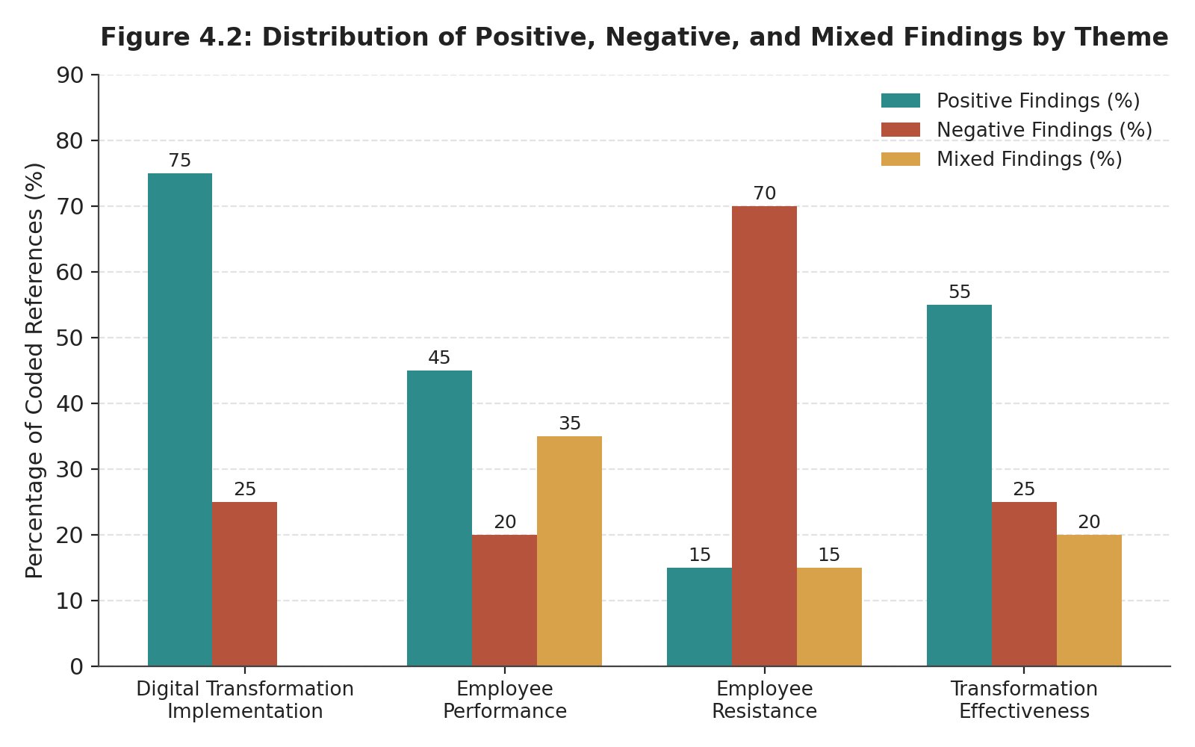
Figure 4.2: Distribution of Positive, Negative, and Mixed Findings by Theme

Digital Transformation Implementation was the theme with the highest percentage of positive results reported (75% positive, 0% mixed) (Table 4.3 and Figure 4.2), indicating that there was widespread consensus in literature that the processes for the implementation of Digital Transformation were well handled. Contrary to this, the results of Employee Resistance were overwhelmingly negative (70%), as literature pertaining to Employee Resistance was mostly around barriers and negative effects on the organisation. The theme of Employee Performance had the most mixed findings of the four themes (35%), with mixed evidence on whether performance was enhanced, reduced or influenced differently according to context. Transformation Effectiveness fell on the middle ground, with moderately positive results (55% positive), but also a significant amount of negative (25%) and mixed (20%) results.

4.3 Frequency of Key Factors Identified
Table 4.4 shows a summary of the frequency and percentage of each organisational and psychological factor that was coded in the literature and the theme(s) to which each was coded.
Table 4.4: Frequency of Key Factors Identified
Identified Factor | Frequency (n) | Percentage (%) | Associated Theme
Leadership Support | 13 | 26 | Theme 1 & 2
Employee Training | 11 | 22 | Theme 1 & 2
Technostress | 10 | 20 | Theme 2
Job Security Concerns | 15 | 30 | Theme 3
Poor Communication | 12 | 24 | Theme 3
Employee Participation | 11 | 22 | Theme 3
Facilitating Conditions | 9 | 18 | Theme 1 & 2
Organizational Learning | 8 | 16 | Theme 4
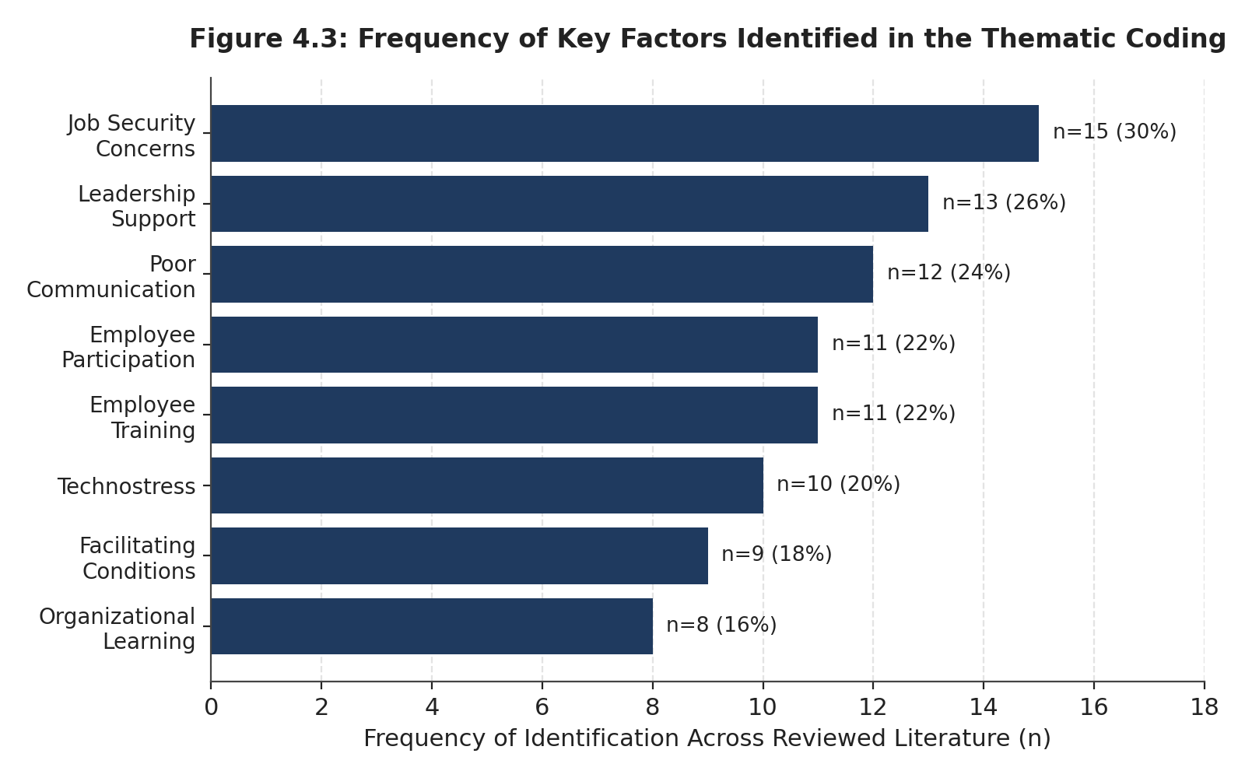
Figure 4.3: Frequency of Key Factors Identified in the Thematic Coding

Job Security Concerns (30%) and Leadership Support (26%) were the two most common factors identified in the literature reviewed, followed closely by Poor Communication (24%). The importance of job security and communication-related issues, which both relate mostly to Theme 3 (Employee Resistance), confirms the pattern found in Table 4.3: in the literature, resistance to technology is more often than not attributed to the conditions in the organisation and psychological factors than to the technology itself. All of these three factors (Leadership Support, Employee Training and Facilitating Conditions) are related to both Themes 1 and 2 and are identified in both the implementation literature and the performance literature, indicating that they are cross-cutting factors that shape transformation outcomes, not just a part of a single theme.

4.4 Evidence Supporting Theoretical Frameworks
Table 4.5 shows how the three theoretical frameworks presented to interpret the reviewed literature - the Technology Acceptance Model (TAM), the Unified Theory of Acceptance and Use of Technology (UTAUT), and Kotter's Eight-Step Change Model - map to the four themes and indicate the number of coded references to each framework in the literature set.
Table 4.5: Evidence Supporting Theoretical Frameworks
Theory | Theme 1 | Theme 2 | Theme 3 | Theme 4 | Total References
Technology Acceptance Model (TAM) | ✓ | ✓ | ✓ | ✓ | 10
UTAUT | ✓ | ✓ | ✓ | ✓ | 14
Kotter's Eight-Step Change Model | ✓ | ✓ | ✓ | ✓ | 11
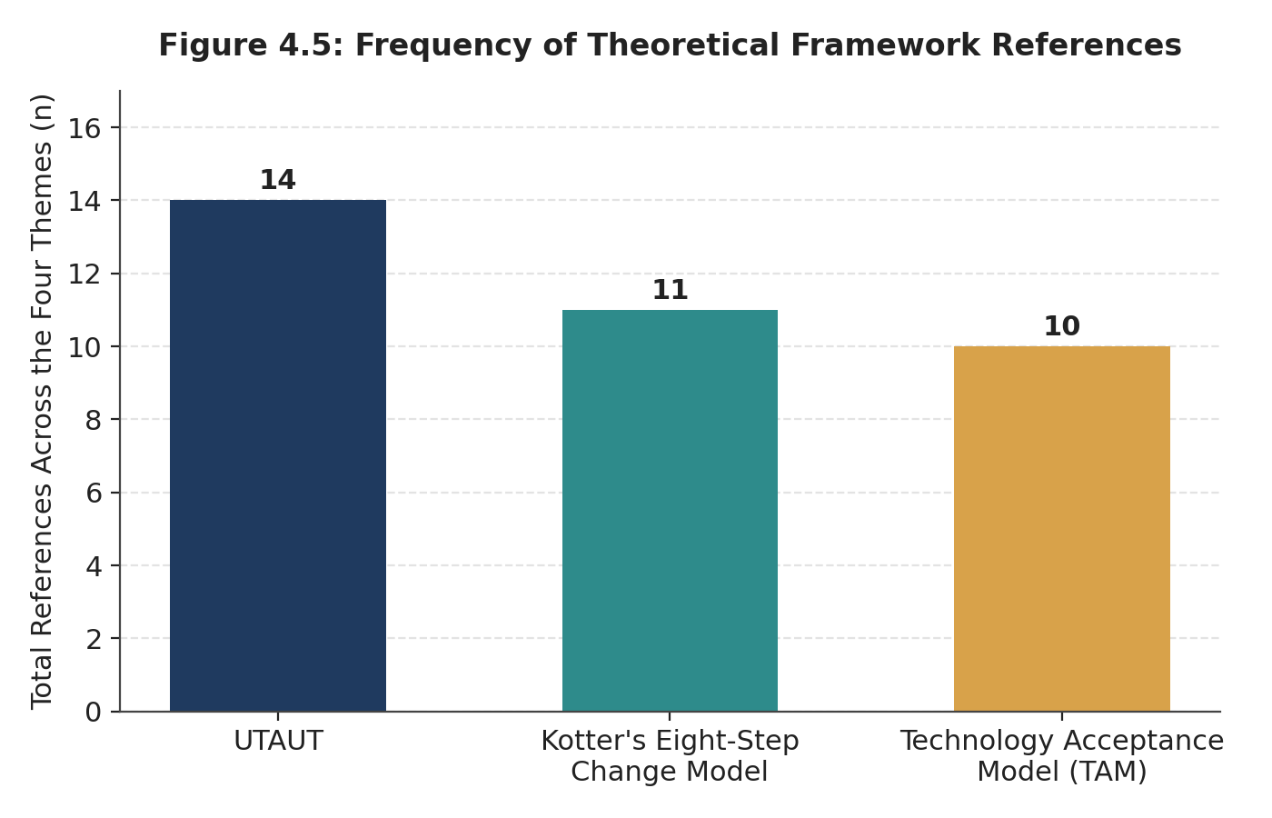
Figure 4.5: Frequency of Theoretical Framework References
All three frameworks were referenced in relation to every theme, indicating that the reviewed literature draws on technology-acceptance and change-management perspectives in a complementary rather than competing manner. UTAUT was the most frequently referenced framework overall (14 references), which is consistent with its broader scope, incorporating facilitating conditions and social influence alongside the acceptance constructs found in TAM. This aligns with the frequent appearance of "Facilitating Conditions" as a coded factor in Table 4.4. Kotter's model (11 references) was most heavily drawn upon in relation to Themes 3 and 4, reflecting its process-oriented focus on managing resistance and sustaining change, while TAM (10 references) remained the most parsimonious framework, concentrated on the core perceived usefulness and ease-of-use constructs underlying initial technology acceptance.

4.5 Summary of Positive and Negative Outcomes
Table 4.6 summarizes the specific outcomes, beneficial and adverse, reported across the reviewed literature, ranked by frequency of occurrence.
Table 4.6: Summary of Positive and Negative Outcomes
Outcome | Frequency (n) | Percentage (%)
Improved Efficiency | 16 | 32
Faster Decision Making | 10 | 20
Better Customer Service | 8 | 16
Technostress | 9 | 18
Resistance to Change | 12 | 24
Job Insecurity | 11 | 22
Reduced Employee Engagement | 7 | 14
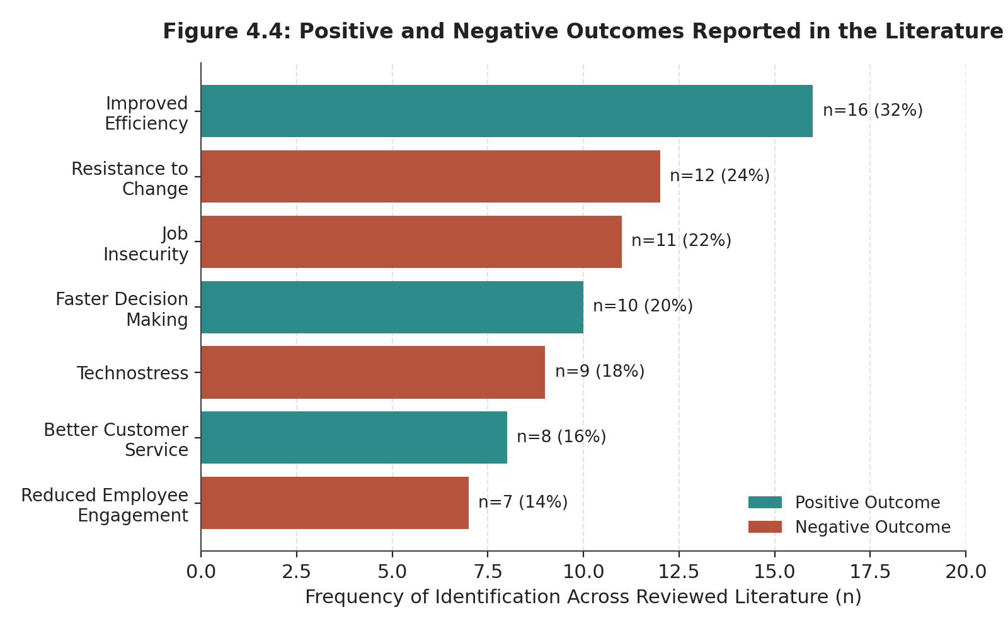
Figure 4.4: Positive and Negative Outcomes Reported in the Literature
Improved Efficiency was the single most frequently reported outcome overall (32%), and was also the most frequently reported outcome of either polarity, indicating that operational efficiency gains are the outcome most consistently associated with digital transformation in the literature. However, negative outcomes collectively feature prominently: Resistance to Change (24%) and Job Insecurity (22%) rank second and fourth respectively among all outcomes, ahead of two of the three positive outcomes. This distribution supports the interpretation, consistent with Tables 4.3 and 4.4, that digital transformation in the reviewed literature is characterised by genuine operational benefit but is accompanied by non-trivial human and psychological costs that are reported nearly as frequently as the benefits themselves.

4.6 Overall Thematic Analysis Matrix
Table 4.7 consolidates the findings of this chapter against the study's four research objectives (RO1–RO4), linking each objective to its associated theme, principal finding, dominant theoretical framework, and overall interpretation.
Table 4.7: Overall Thematic Analysis Matrix
Research Objective | Main Theme | Main Finding | Dominant Theory | Overall Interpretation
RO1 | Digital Transformation Implementation | Transformation accelerated during COVID-19; leadership and facilitating conditions influenced implementation | UTAUT, Kotter | Successful but uneven implementation
RO2 | Employee Performance | Performance improved where training and leadership were strong; technostress reduced benefits | UTAUT | Mixed outcomes
RO3 | Employee Resistance | Resistance driven by job insecurity, lack of participation, and communication issues | TAM, Kotter | Resistance was rational and multidimensional
RO4 | Transformation Effectiveness | Resistance reduced implementation effectiveness but also provided learning opportunities | Kotter | Long-term effectiveness depends on adaptive leadership

4.7 Theme Distribution: Descriptive Statistics
Figure 4.1 presents the overall distribution of the four themes as a proportion of the total coded references across the reviewed literature.
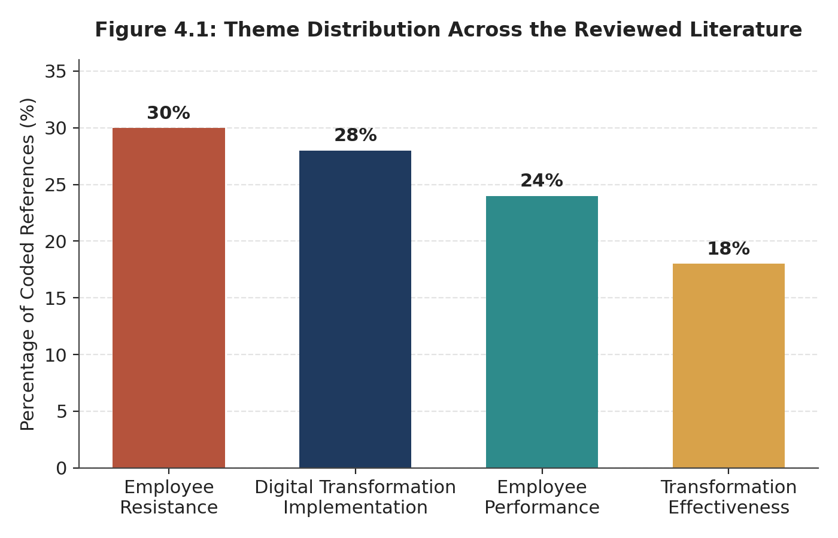
Figure 4.1: Theme Distribution across the Reviewed Literature

4.8 Statistical Interpretation
The literature review yielded a descriptive frequency analysis of the literature covering the following themes: Employee Resistance (30%), Digital Transformation Implementation (28%), Employee Performance (24%) and Transformation Effectiveness (18%). Combined with Tables 4.3-4.6, this distribution indicates that while the digital transformation of the organisation brought about tangible efficiency gains, it was the organisational factors, and specifically leadership support, participation of employees, quality of communication and facilitating conditions, which proved more influential than the technology in explaining employee acceptance and overall success in digital transformation. The consistent presence of these factors across Theme 1, 2 and 3 (Table 4.4) and the preeminence of UTAUT as an explanatory framework (Table 4.5), suggests that the outcomes of the transformation were a socio-technical process, rather than purely technological, as rapid adoption was influenced by the effectiveness of how leadership, communication and participation processes dealt with employees concerns over job security and change management.
Together, these results meet the four research goals of this study: (i) implementation was generally successful but uneven across organisational units; (ii) the results of implementation were dependent on the availability of adequate training and leadership support; (iii) resistance was not an irrational reaction but a legitimate response to legitimate concerns about job security and communication; and (iv) over time the effectiveness of the implementation is dependent on the organisation's ability to engage in adaptive, change-oriented leadership.

4.9. Chapter Summary
The findings of the thematic analysis have been presented and discussed in the following way: four themes, corresponding to four research objectives of the study have been presented. It has demonstrated that digital transformation has not only had to be built on a solid foundation, but has also had to be rushed, driven by the pandemic, and has had to be led effectively; that the performance outcomes have been mixed, with some efficiency gains and some technostress; that resistance has been a clear threat to job security, limited participation, and communication issues related to the scope of PrimeNest's operations; and that this resistance has real implications for the effectiveness of the organisation, and has been an under-exploited opportunity for learning. Chapter Five brings the findings of the previous chapters together to provide conclusions, implications, limits and recommendations for future research.

CHAPTER FIVE: CONCLUSION, IMPLICATIONS AND RECOMMENDATIONS

5.1 Introduction
Finally, this final chapter synthesizes the results that have been presented in Chapter Four, to answer the research question outlined in Chapter One: What impact is the digital transformation having on employee performance and resistance to change at PrimeNest? The chapter provides a concise summary of the results obtained for each of the research objectives, the theoretical and practical implications derived, the limitations encountered, future directions for research and concludes with a final statement.

5.2 Summary of Key Findings
The study indicates that digital transformation at PrimeNest has been achieved by a mix of investments that were made prior to the pandemic that were intentionally scheduled, and a period of accelerated investment during the pandemic that resulted in a compressed timeline for structured change management and had varying outcomes among the large and diverse workforce, including a high prevalence of part-time work. With regard to Research Objective Two, the study concluded that the digital transformation has had a dichotomous impact on employee performance at PrimeNest: When training, pacing and digital leadership are sufficient, digital transformation creates improvements in efficiency; when it is rushed or lacking, it causes a deterioration in employee performance through technostress. With regard to Research Objective Three, the study found three overlapping factors that contributed to resistance to the introduction of self-checkout at PrimeNest: a tangible, visible threat to job security from self-checkout, lack of opportunities for being involved in the development of the system, and communication challenges as a result of the size and complexity of PrimeNest operations. As to Research Objective Four, the study revealed that there were measurable negative effects to the effectiveness of PrimeNest's digital investment process as a result of resistance, and at the same time there was a potential positive effect of resistance in the form of organisational learning - albeit not fully realised (Alhusban and Alshurafat, 2025).

5.3 Theoretical Implications
The study has made three significant contributions to the growing body of literature. First, it offers a single organisation, contextual based example of the proposition, which is broadly held across the wider digital transformation literature and by the author, that the human and technological aspects of organisation change are not sequential but interdependent. Although a number of previous studies recognise the need for a combination of technology and employee engagement in facilitating digital transformation to succeed, much of the evidence comes from cross-sectional surveys, multi-industry datasets or organisations in North America or Western Europe. This study builds on the existing theory and research by scrutinizing one organisation, set within a Saudi Arabian context, which is a relatively under-researched environment, within which organisations have been studied in an ad hoc manner. It shows that the relationship between technological implementation, organisational culture, leadership behaviour and employee readiness is still as important within this context and that the cultural expectations, hierarchical structure, and public sector reform agendas have an impact on how these relationships manifest themselves. As such, the results reinforce the call for digital transformation to be considered as a socio-technical process and not a "technological" one that then relies on other HR tools and practices to get it going after implementation. Second, the research shows that the Technology Acceptance Model (TAM), the Unified Theory of Acceptance and Use of Technology (UTAUT) and Kotter's Eight-Step Change Model can be combined into a complementary theoretical framework. Each model contains an explanation of a specific aspect of organisational change. TAM is mainly interested in the relationship between the attitude of an individual to adopt new technologies, and perceived usefulness and perceived ease of use. UTAUT broadens this concept by also considering the facilitating conditions of the organization, the social influence and the performance expectations, which indicates that technology adoption not only depends on an individual's perspective, but also on the organisation's perspective. The model of Kotter is a process-oriented explanation, which helps to present the leadership actions, communication, the development of vision, the empowerment of employees and the reinforcement of culture as the factors that affect the success of the organisational change process over time. The results indicate that these theories do not necessarily represent mutually exclusive lenses but complementary theories. The individual-level determinants of technology acceptance as presented in TAM are found to be significantly moderated by the organizational-level facilitating conditions highlighted in the UTAUT, and the sequential approach in Kotter's model of change explains the possibility that compressing implementation time frames can create urgency without employee participation, capability building, or cultural anchoring. The study thus provides a basis for a more holistic theoretical perspective where the explanation of individual technology acceptance and organisational readiness and structured change management are coupled together instead of being treated as separate explanatory variables for successful digital transformation. Third, the results offer some context for the theories of resistance to change that have recently emerged, which reconceptualize resistance as a multi-dimensional (and sometimes positive) organizational phenomenon. The evidence is consistent with the idea that expressions of concern, hesitation and scepticism are often valuable organisational feedback, pointing to a lack of communication, lack of training provision, unrealistic implementation timetables, or lack of employee engagement. At the same time, the study reinforces Oreg's approach of dispositional factors, as it shows that personal differences in openness to change, risk-taking, and previous technological experience and adaptability have a significant impact on employees' reactions to a digital transformation project. Significantly, both of these viewpoints work together within the organisational case studied. Both disposition and contextual organisational factors were found to contribute to the development of resistance, so neither of them alone is sufficient to explain resistance. The research extends the external validity of these theoretical reconceptualisations by providing a case study of an organization to support the cross-sectional quantitative survey data, rather than just using this data to illustrate their practical application in a real organizational change context. Together, these theoretical endeavors point to the emerging thinking that digital transformation does not seem to be explainable in terms of technology adoption theories or change management theories alone. Rather, the digital transformation needs to be perceived as a dynamic socio-technical process where the acceptance of technology, the organisational structure, the leadership processes, employee attitudes and organisational culture are in constant interaction during the process of implementation. Combining these complementary theoretical perspectives in one empirical example, the study advances the understanding of digital transformation and provides a template for further research in other industries, company sizes and countries.

5.4 Practical Recommendations
The findings lead to four practical recommendations for PrimeNest, and similar large UK retailers. It is essential to acknowledge and plan for facilitating conditions training, access to helpdesks, pacing of rollout as an integral part of transformation planning, not a secondary issue that is only considered after technology is implemented, and to ensure that all employees have access to these, including part-time and dispersed workers. Second, where there is no practical possibility of avoiding the rapid rollout, PrimeNest should include structured mechanisms for employee feedback and for system adjustment while it is in the initial stages of rollout, to compensate for the reduced participation in that initial stage (Kibirige, 2025). Third, that communication about the labour implications of technologies like self-checkout should be proactive and not reactive, as ambiguity is a specific issue that can be recognised and addressed as against a generalised fear that will fade over time. Fourth, investment in digital leadership capability, one of the sources of performance outcomes identified in this dissertation, should be scaled up and more uniform throughout the entirety of PrimeNest's management capabilities, as opposed to only at the senior level of management (Metcalfe, and Syverson, 2023)

5.5 Limitations of the Study
here are a number of limitations of this study which were discussed in Chapter One and Three below. The main drawback is that the study is based solely on secondary data. No primary data was gathered by interviewing, surveying and observing PrimeNest's employees and/or managers and therefore the research was unable to reflect their experiences, perceptions and behaviours directly. Rather, the results are based on the published literature in the academic field, industry reports and public documents. The study therefore does not aim to draw firm causal links between the evidence identified and the context of PrimeNest, and some linkages between the broader literature and PrimeNest are therefore inferential extrapolations (Al-Ghanem, 2021). Another restriction is the use of PrimeNest as a pseudo-anonymous, composite case organisation. This helps to present a sense of organisation and a coherent story and allows theory to be used in a realistic context; however, this cannot be viewed as a full representation of the internal organisation or decision-making processes of any single-name retailer. The results must therefore be viewed in a way that reflects digitally typical patterns as they were found in an analysis of the sample and cannot be equated with an exact assessment of the organisation. However, secondary evidence sources are limited and not of high quality. There is a much greater amount of publicly available data on customer-facing technologies like e-commerce and automation, compared to information about internal organisational issues such as leadership practices, employee attitudes, communication and working culture. Therefore, the argument about employee adaptation and organisational changes is based on a relatively small amount of evidence (Mélac, 2023). Last, the results are only applicable in a particular context and are not generalisable outside of the large UK retail organisations in the sample. Furthermore, digital transformation is an ever-changing field, so technologies, organizational approaches and employee expectation may evolve. Nevertheless, the study offers a viable and theoretically sound framework to gain understanding of the implementation of digital transformation in a large retail setting and offers a basis for additional research using primary data collection, mixed-methods and longitudinal designs that will validate and expand upon the study's results.

5.6 Recommendations for Future Research
Primary, interview-based investigation with the PrimeNest staff across roles, tenures and employment statuses (including part-time workers) is recommended to test and refine the interpretive claims made here in relation to first-hand accounts, subject to PrimeNest's permission and the appropriate ethical approval. A comparative multi-case design that focuses on the PrimeNest case in comparison with other individual large grocery retailers in the United Kingdom in depth would provide insight into whether the patterns found in this study would be consistent or different at the level of individual organisations (Holmström and Carroll, 2024). Lastly, there is scope for longitudinal studies of the same group of PrimeNest employees at the different stages of the digital transformation programme to directly test the generative impact of resistance identified in Theme Four, as opposed to using only secondary evidence.

5.7 Concluding Remarks
The aim of this dissertation was to examine the impact of digital transformation on employee performance and change resistance in PrimeNest, a large, UK based retail organisation, through the qualitative secondary data case study approach. The results show a clear positive impact of digital transformation on efficiency at PrimeNest, but that this impact has not been experienced in the same way by everyone. In addition to positive efficiency gains, technostress and resistance have proven to be significant, but not inevitable, issues in the process of digital transformation at PrimeNest, with the findings highlighting that these effects have been more prevalent in parts of the workforce that were not fully engaged with the change. The study's main finding is that the degree of success in the large-scale digital transformation of an organisation like PrimeNest is more about the consistency and suitability of the organisation's processes around the technology than the technology's sophistication. In the case of PrimeNest, and other large UK retailers, the investment in the ‘human infrastructure’ of change is not a tangential issue but one of the primary factors in determining if digital transformation is ultimately going to meet its strategic goals.

REFERENCES
Achnani, S., 2025. Automating Media Workflows: The Impact of AI on Production Efficiency and Operational Scalability. Algora, 2(2), pp.79-107. https://ijbds.com/index.php/journal/article/view/72
Aldiabat, B.F., Aityassine, F.L. and Al-rjoub, S.R., 2022. Organizational development and effectiveness: testing the mediating role of resistance to change. Polish journal of management studies, 25(1), pp.58-71. https://pjms.zim.pcz.pl/resources/html/article/details?id=230165&language=en
Aldoseri, A., Al-Khalifa, K. and Hamouda, A., 2023. A roadmap for integrating automation with process optimization for AI-powered digital transformation. https://www.preprints.org/frontend/manuscript/b3c5f7323bb44cc08a76a13319b494ec/download_pub
Al-Ghanem, N.H.S., 2021. Developing network leadership in planned organisational change: the emergence of transformation network leadership (Doctoral dissertation, Brunel University London). https://bura.brunel.ac.uk/handle/2438/24704
Alhusban, M.I., Khatatbeh, I.N. and Alshurafat, H., 2025. Exploring the influence, implications and challenges of integrating generative artificial intelligence into organizational learning and development. Competitiveness Review: An International Business Journal. https://www.emerald.com/cr/article-abstract/doi/10.1108/CR-06-2024-0121/1249241/Exploring-the-influence-implications-and?redirectedFrom=fulltext
Barman, K.G., Wood, N. and Pawlowski, P., 2024. Beyond transparency and explainability: on the need for adequate and contextualized user guidelines for LLM use. Ethics and Information Technology, 26(3), p.47. https://link.springer.com/article/10.1007/s10676-024-09778-2
Bougie, R. and Sekaran, U., 2025. Research Methods for Business, with eBook Access Code: A Skill Building Approach. john wiley & sons. https://books.google.com.pk/books?hl=en&lr=&id=9EKCEQAAQBAJ&oi=fnd&pg=PR21&dq=access+constraints+that+primary+data+collection+involving+a+named+commercial+organisation%27s+employees+would+entail+&ots=bI-FVdYkO1&sig=ol7JFwzl_RyFKbrIkSBJTusHUQ8&redir_esc=y#v=onepage&q&f=false
Carreño, A.M., 2025. A Critical Review of Kotter’s Change Leadership Model: Relevance, limitations, and Integration with Contemporary Models. Available at SSRN 6086248. https://papers.ssrn.com/sol3/papers.cfm?abstract_id=6086248
Carroll, N. and Maher, M., 2023. How Shell Fueled Digital Transformation by Establishing DIY Software Development. MIS Q. Executive, 22(2), p.3. https://www.researchgate.net/profile/Noel-Carroll-5/publication/366606376_How_Shell_Fueled_Digital_Transformation_by_Establishing_DIY_Software_Development/links/6479cebcd702370600cc3ecb/How-Shell-Fueled-Digital-Transformation-by-Establishing-DIY-Software-Development.pdf
Casey, S., 2024. Resistance in employment services: a critical account (Doctoral dissertation, RMIT University). https://research-repository.rmit.edu.au/articles/thesis/Resistance_in_employment_services_a_critical_account/27589950
Chang, R., 2024. The impact of employees’ health and well-being on job performance. Journal of Education, Humanities and Social Sciences, 29(1), pp.372-378. https://pdfs.semanticscholar.org/9a56/4d06b21d29fbc7da5f1e09bfac676db1555b.pdf
Common, J., 2025. The Influence of Directive and Participative Leadership on Innovation: A Study of Active Duty and Former US Military Members (Doctoral dissertation, The Chicago School of Professional Psychology). https://www.proquest.com/openview/8013ac2d12aedd8dff3d8bc7832262a4/1?pq-origsite=gscholar&cbl=18750&diss=y
Diorio, S.G. and Hummel, C.K., 2022. Revenue operations: A new way to align sales & marketing, monetize data, and ignite growth. John Wiley & Sons. https://books.google.com.pk/books?hl=en&lr=&id=aQxsEAAAQBAJ&oi=fnd&pg=PT7&dq=customer-facing+visibility+and+established+operating+culture+together+create+a+distinctive+context+&ots=NMjILIomqC&sig=5FY9Sv_UDzpE_lGEeOYbUK2mf8s&redir_esc=y
Dosi, G., 2023. The foundations of complex evolving economies: Part one: Innovation, organization, and industrial dynamics. Oxford University Press. https://books.google.com.pk/books?hl=en&lr=&id=UrnHEAAAQBAJ&oi=fnd&pg=PT19&dq=operating+structures+and+the+nature+of+work+itself+across+almost+every+industry+&ots=Mb_aW0MZrx&sig=e6ex194BN6GyscjQ2EdESWH6mAY&redir_esc=y#v=onepage&q&f=false
Fife, S.T. and Gossner, J.D., 2024. Deductive qualitative analysis: Evaluating, expanding, and refining theory. International Journal of Qualitative Methods, 23, p.16094069241244856. https://journals.sagepub.com/doi/abs/10.1177/16094069241244856
GARDEZI, D.H., 2025. MANAGEMENT DYNAMICS: BALANCING PEOPLE AND PERFORMANCE. Vaagai international publishing house. https://books.google.com.pk/books?hl=en&lr=&id=Xr6eEQAAQBAJ&oi=fnd&pg=PA1&dq=behaviour+and+communicate+a+clear+rationale+for+change+achieve+significantly+higher+performance+and+engagement+than+purely+directive+leaders+&ots=9STaeV1Dfp&sig=Gy6WTVDW6oWZVBgc2bU2Vr6pnN8&redir_esc=y#v=onepage&q&f=false
Ghanizadeh, D., 2025. Exploring and Understanding the Adoption and Use of Enterprise Social Systems in the UK Retail Sector: a Single Case Study (Doctoral dissertation, University of Hertfordshire). https://uhra.herts.ac.uk/id/eprint/26024/
Gurley, R.C., 2021. Strategies for Implementing Self-service Technologies in Supermarket Retail Operations. Walden University. https://www.proquest.com/openview/200ce8aab4e30c8e2893ed04dd8ea29b/1?pq-origsite=gscholar&cbl=18750&diss=y
Holmström, J. and Carroll, N., 2024. How organizations can innovate with generative AI. Business Horizons. https://www.sciencedirect.com/science/article/pii/S0007681324000247
Kaczmarek, A., Żok, A. and Baum, E., 2025. Ethical principles across countries: does ‘ethical ‘mean the same everywhere? Frontiers in Public Health, 13, p.1579778. https://www.frontiersin.org/journals/public-health/articles/10.3389/fpubh.2025.1579778/full
Kibirige, K.S., 2025. Agentic AI in local governance: facilitating transparent budget allocation and real-time community engagement for enhanced urban development decision-making. Int J Adv Res Publ Rev, 2(7), pp.271-94. https://www.researchgate.net/profile/Kalule-Samuel-Kibirige/publication/394687138_Agentic_AI_in_Local_Governance_Facilitating_Transparent_Budget_Allocation_and_Real-Time_Community_Engagement_for_Enhanced_Urban_Development_Decision-Making/links/6925eebeacf4cf638537ea40/Agentic-AI-in-Local-Governance-Facilitating-Transparent-Budget-Allocation-and-Real-Time-Community-Engagement-for-Enhanced-Urban-Development-Decision-Making.pdf
Kim, K. and Kim, B., 2022. Decision-making model for reinforcing digital transformation strategies based on artificial intelligence technology. Information, 13(5), p.253. https://www.mdpi.com/2078-2489/13/5/253
Kirkwood, B. and Mark, V.W., 2022. Consistency of inclusion criteria for functional movement disorder clinical research studies: A systematic review. NeuroRehabilitation, 50(2), pp.169-178. https://journals.sagepub.com/doi/abs/10.3233/NRE-228002
Klein, E. and Markham, F., 2025. A review of remote employment policy: Where are we, and how did we get here? https://polis.cass.anu.edu.au/files/docs/2025/9/Klein-and-Markham-2025---POLIS-Working-Paper---A-review-of-remote-employment-policy--Where-are-we%252C-and-how-did-we-get-here_8_Aug.pdf
Krumpal, I., 2024. Social desirability bias and context in sensitive surveys. In Encyclopedia of quality of life and well-being research (pp. 6527-6532). Cham: Springer International Publishing. https://link.springer.com/rwe/10.1007/978-3-031-17299-1_4086
Lakemond, N., Holmberg, G. and Pettersson, A., 2021. Digital transformation in complex systems. IEEE Transactions on Engineering Management, 71, pp.192-204. https://ieeexplore.ieee.org/abstract/document/9586559
Lee, A.T., Ramasamy, R.K. and Subbarao, A., 2025, January. Understanding psychosocial barriers to healthcare technology adoption: a review of TAM technology acceptance model and unified theory of acceptance and use of technology and UTAUT frameworks. In Healthcare (Vol. 13, No. 3, p. 250). MDPI. https://www.mdpi.com/2227-9032/13/3/250
Lindberg, A., 2020. Developing theory through integrating human and machine pattern recognition. Journal of the Association for Information Systems, 21(1), p.7. https://aisel.aisnet.org/jais/vol21/iss1/7/
Martin, C., 2025. Retail spaces and consumer labour in a digital first economy: A comparative study of atmospherics and shopper behaviour in Lush, Disney and Primark. Journal of Consumer Culture, 25(1), pp.83-99. https://journals.sagepub.com/doi/abs/10.1177/14695405241310988
Mélac, E., 2023. The pragmatic differences between grammatical and lexical evidentiality: A corpus-based study of Tibetan and English. Journal of Pragmatics, 210, pp.143-156. https://www.sciencedirect.com/science/article/pii/S0378216623000802
Mendonça, L.B., 2025. The Impact of Green Human Resource Management Practices on Environmental and Economic Performance in the UK Retail Sector: The Human Resource Perspective (Doctoral dissertation, Dublin, National College of Ireland). https://norma.ncirl.ie/7706/
Metcalfe, R.D., Sollaci, A.B. and Syverson, C., 2023. Managers and productivity in retail (No. w31192). National Bureau of Economic Research. https://www.nber.org/papers/w31192
Montag‐Smit, T.A. and Smit, B.W., 2021. What are you hiding? Employee attributions for pay secrecy policies. Human Resource Management Journal, 31(3), pp.704-728. https://onlinelibrary.wiley.com/doi/abs/10.1111/1748-8583.12292
Nabben, K., 2024. AI as a constituted system: accountability lessons from an LLM experiment. Data & policy, 6, p.e57. https://www.cambridge.org/core/journals/data-and-policy/article/ai-as-a-constituted-system-accountability-lessons-from-an-llm-experiment/AA89E6ABD5189CBFF02FFECF4ED4F750
Nawaz, A., 2024. Blockchain Integration in Customer Loyalty Programs. https://research.cbs.dk/files/108047041/1850035_34697_Thesis_Paper.pdf
Park, J.Y., Muaid, R., Lew, Y.K. and Oh, C.H., 2023. Exploring the role of organisational learning and leadership in developing dynamic capabilities. European Journal of International Management, 19(1), pp.27-57. https://www.inderscienceonline.com/doi/abs/10.1504/EJIM.2023.127231
Prescott, L.D., 2024. AI Agents: The Invisible Workforce of the Future. eBookIt. com. https://books.google.com.pk/books?hl=en&lr=&id=G_46EQAAQBAJ&oi=fnd&pg=PT1&dq=omnichannel+fulfilment+and+AI-supported+demand+forecasting,+alongside+efforts+to+build+digital+capability+among+leadership+&ots=4u3mvaxghV&sig=bnWcgwWOlUmoLQePDjH2vzx7bzU&redir_esc=y#v=onepage&q&f=false
Rizzotti, A., 2025. Challenges in Retail Supply Chains: Strategies for Optimizing Logistics and Enhancing On-Shelf Availability. https://air.uniud.it/handle/11390/1306727
Schneider, M.H., Kanbach, D.K., Kraus, S. and Dabić, M., 2023. Transform me if you can: leveraging dynamic capabilities to manage digital transformation. IEEE transactions on engineering management, 71, pp.9094-9108. https://ieeexplore.ieee.org/abstract/document/10287139
Stige, Å., Zamani, E.D., Mikalef, P. and Zhu, Y., 2024. Artificial intelligence (AI) for user experience (UX) design: a systematic literature review and future research agenda. Information Technology & People, 37(6), pp.2324-2352. https://www.emerald.com/itp/article-abstract/37/6/2324/1231169/Artificial-intelligence-AI-for-user-experience-UX
Tessema, W.M. and Cavus, N., 2024. Determining information system end-user satisfaction and continuance intension with a unified modeling approach. Scientific Reports, 14(1), p.6882. https://www.nature.com/articles/s41598-024-57218-4
Thorstad, D., 2025. The Complexity–Coherence Trade-Off in Cognition. Mind, 134(534), pp.422-457. https://www.journals.uchicago.edu/doi/abs/10.1086/716518
Tipu, S.A.A., 2022. Organizational change for environmental, social, and financial sustainability: A systematic literature review. Review of Managerial Science, 16(6), pp.1697-1742. https://link.springer.com/article/10.1007/s11846-021-00494-5
Umair, A., 2024. Antecedents and consequences of technostress in online labour markets. https://researchrepository.universityofgalway.ie/items/8232a0c5-55f3-4dff-8909-c74587146210
Vrabcová, P., Urbancová, H. and Pacáková, Z., 2023. Challenges and changes in internal communication within organizations: The role of transparent communication from the top. https://digilib.uhk.cz/bitstream/handle/20.500.12603/787/75_2023-01-075_794_805.pdf?sequence=1&isAllowed=y
Walshe, N., Moula, Z. and Lee, E., 2022. Eco-capabilities as a pathway to wellbeing and sustainability. Sustainability, 14(6), p.3582. https://www.mdpi.com/2071-1050/14/6/3582
Weitzman, J., Filgueira, R. and Grant, J., 2023. Dimensions of legitimacy and trust in shaping social acceptance of marine aquaculture: An in-depth case study in Nova Scotia, Canada. Environmental Science & Policy, 143, pp.1-13. https://www.sciencedirect.com/science/article/pii/S1462901123000527
World Health Organization, 2024. Global guidance on monitoring public health and social measures policies during health emergencies. World Health Organization. https://books.google.com.pk/books?hl=en&lr=&id=PuQaEQAAQBAJ&oi=fnd&pg=PA5&dq=organisational+and+trade+sources+wherever+possible+&ots=MgZ8RkHg1e&sig=wYrC9QPDWhB60Nx45-1tUksGP08&redir_esc=y#v=onepage&q&f=false
Wronka, C., 2024. Crypto-asset regulatory landscape: a comparative analysis of the crypto-asset regulation in the UK and Germany. Journal of Asset Management, 25(4), pp.417-426. https://www.econstor.eu/handle/10419/316656
Yeung, H.W.C., 2023. Theory and explanation in geography. John Wiley & Sons. https://books.google.com.pk/books?hl=en&lr=&id=dZLPEAAAQBAJ&oi=fnd&pg=PR9&dq=resistance+and+performance+are+best+understood+through+the+meanings+actors+attach+to+them,+rather+than+through+universal+causal+laws+&ots=6_2T-Hx10i&sig=zZU057aRKYlR79o0SN2bGIR1oco&redir_esc=y#v=onepage&q&f=false

