William Edwards 2004219

Image 1 selected (coin with nero and Agrippina)
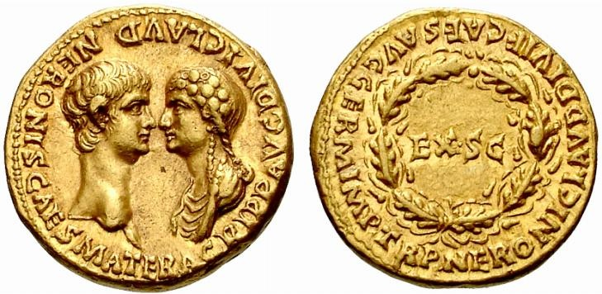

The coin was minted in the year 54AD, right at the beginning of Nero’s reign, as such, its symbology can be of great use to us in the identification of important notions of the time. For example, the obverse of the coin depicts Nero and Agrippina centrally with them facing each other, they are of the same size and prominence. This is weird, as it looks as though both Nero and Agrippina are of equal importance, prevalence and social stature. This is particularly weird if you take into account that Roman society was a male-led and male-dominant society, the act of placing both figures in equal proportions seems to lend either significant power to Agrippina or lessen the importance of the singular authority of Rome, Augustus, Nero.

The obverse also surrounds the figures with words. Of importance is the phrase “AGRIPP AVG DIVI CLAUDI” and “NERONIS CAES MATER”. The first part of the phrase is referring to Agrippina as the wife of the late Emperor Claudius, a figure who had been deified by the roman Imperial cult, this phrase is important because it highlights the link between the old Augustus and the new one, having her as a continuing theme through the two establishments as a remnant of the past. This can be useful as Claudius was generally liked by the people, due to his finishing of some Aqueducts, the conquering of Britain that not even Gaius Julius Caesar could do, and was generous in his gifts to the people by handing out bread and grain (Suet. Claud. 18-20). The deification that followed would have been of immense help to Agrippina in her quest to command Rome, for she was not only the wife of a god/demigod, but the mother of the son of a god/demigod, and it’s understandable that she would have wanted this conveyed and distributed to the public on their coins. It is also of use to Nero as the link to his adoptive father is his primary right to the office of principate, and using his mother as the link is a good inlet for his ascendancy.

The second phrase further emphasises the link between the old Augustus and the new. Although, it is of far more use to Agrippina as it places her as the mother and creator of the current Emperor. The popular theory that Agrippina poisoned Claudius may also be a reason for Nero’s allowance of this to be placed on the coin, as he has her to thank for not only getting Claudius to adopt him, but clearing his path to ascend to the Principate. The coin itself is a Gold Aureus, and this is quite a high value currency, and would most likely be prevalent in the purses of more wealthier citizens such as the Equites or the senatorial Patricians, and so, the contents of the reverse of the coin make much more sense. The reverse says “EX S C” in the centre, meaning Ex Senatus consulto. This means that the coins were struck by decree of the senate, this is very important as it shows that the Emperor, Nero, is reigning with approval of the senate, this would have put more credence to the idea of Emperor Nero as the Principate is allowed to rule by the people and the senate. It also represents a new era. As Claudius was not particularly popular with the senate, the official stamping and minting of coins of Nero with approval of the senate could mean the reparation of the rift between the Principate and the senate, but could also cement Nero as a different and new ruler of Rome, and that although he relies heavily upon Claudius to give credence to his rule, he wants to cement the idea that he is a different person, and that the Senate should treat him as such, and enforce a stable and prosperous rule under him.
The Ex Senatus consulto is also surrounded by an Oak wreath. It represents an act of saving a Roman citizen by killing a danger to that citizen/citizens, it is a high military honour and represents bravery and honour. It can be conveyed that the senate is placing this upon Nero and entrusting him with the protection and governorship of Rome. In a sense, it could also be conveyed as the death of a less-liked leadership under Claudius, And the hopeful ‘killing/elimination’ of Claudius’ style of governorship and legacy by Nero, hoped by the senate, as Claudius was, in a sense, an enemy of the Senate. A clean slate, as it were.

Surrounding the wreath is the writing “NERONI CLAVD DIVI F CAES AVG GERM IMP TR P”. These are the powers and position of Nero in the Roman government, the fact that his powers and titles appear on the reverse and not the obverse gives us the impression that Nero is almost secondary in status, the titles of Agrippina however, appear on the Obverse. Nero does appear on both sides of the coin, demonstrating his importance, but the placing of Agrippina on the obverse and her position and titles, sort of implies self-importance and the placing of herself above Nero. This does make sense if we take into consideration Agrippina’s lust for power, and putting herself on the coin, ahead of Nero, makes this blatant and obvious. The design and minting of these coins makes more sense when it is revealed who is managing the affairs of state “At first Agrippina managed for him all the business of the empire…” (Dio. 61.3), this sets a clear precedent for who is in charge, one as the figurehead, and one doing the behind the scenes work and puppeting him.

The minting of the coins in Lyon (Lugdunum) is interesting as there were mints active in Rome and the Latin and Etruscan regions of Italy at the time, the minting of the coins in Gaul could indicate that Agrippina wanted the wealthier Equites, governors and wealthy individuals outside the Italian peninsula to understand where she was positioned in the hierarchy, and to secure a power base in the outer regions of the empire, rather than the homeland. It may not seem suspicious to be doing this, but it could indicate sly political maneuvers on the part of Agrippina, with subliminal messaging about her position and showing where and with whom the true power lay in her eyes.

Agrippina’s position on the coin is indicative of her amount of power at the time, as in a few years, Nero’s and her face would appear on the coin in a jugate position with Nero in the foreground, overshadowing Agrippina, this is a physical representation and depiction of Agrippina’s power waning over time and her influence decreasing, until she is fully removed from the coin entirely. While in this coin, she is seen as almost an equal, this later changes as the dynamic shifts towards Nero as once supporters of Agrippina, Burrus and Seneca, tutor Nero to be independent and less reliant on his mother. As such, her prominence on the coin tells us that her position at this point was strong and arguably equivalent to Nero's.

Sources:
Cassius Dio, Historia Romana [book 61, 3.2]
Suetonius, The twelve Caesars, Claudius [18-20]

