

Student name: Luz Karina Barba Oliveira
Student ID: 2416438

Module name: Changemakers: Crteativity and Value Creation
Module code: BMHP5014
Lecturer name: Caroline Salami

Table of Contents

Poster……………………………………………………………………3
Introduction …………………………………………………………….4
Background ……………………………………………………………4-5
Innovation Description ………………………………………………..5-6
Impact on Health and Social Care…………………………………………..6
Public and Stakeholder Involvement …………………………………6-7
Policies, Services, and Professional Links ……………………………..7
Conclusion……………………………………………………………..7
References………………………………………………………8- 9-10

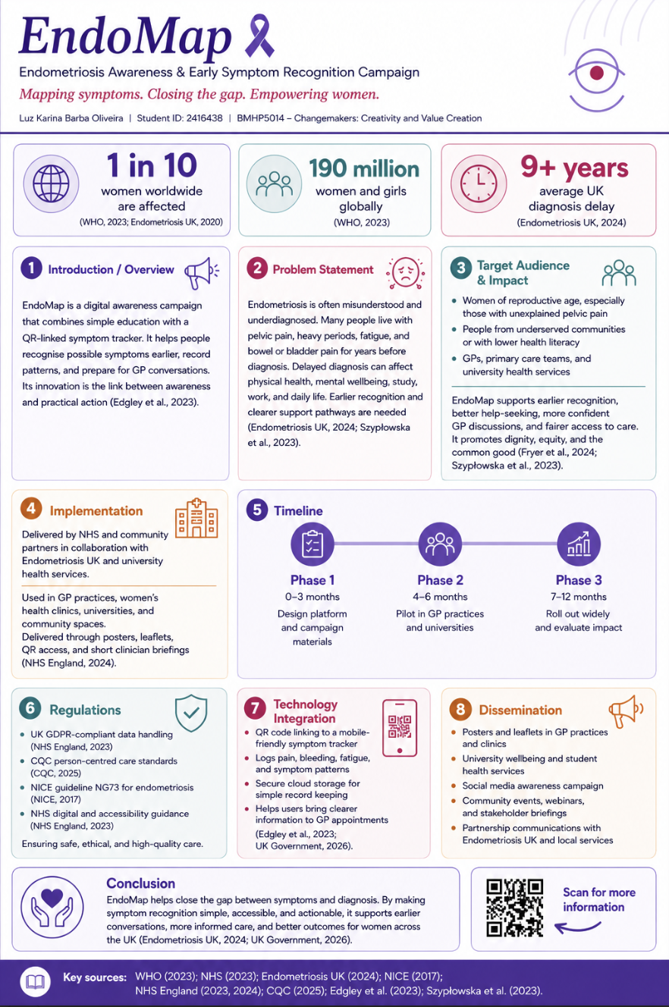
1. Introduction

Endometriosis is a chronic condition that affects approximately 1 in 10 women worldwide, representing a significant burden on individual and healthcare system (WHO, 2023; Endometriosis UK, 2020).
The management of endometriosis is often limited or inconsistent, with many women experiencing ongoing symptoms without a clear understanding or their condition.
To address this, EndoMap is a digital health awareness campaign designed to improve early recognition and understanding of endometriosis. The campaign will be delivered through accessible materials such as posters and digital media, incorporating QR codes that direct users to an interactive website.
What makes EndoMap innovative is its person-centred approach, combining awareness with a practical tool for personalised symptom mapping. In this way, the platform will allow individuals to track symptoms, identify patterns over time, and better understand their condition.
Unlike traditional campaigns that focus mainly on general information, EndoMap aims to bridge the gap between awareness and action by supporting users in recognising their own symptom patterns and facilitating more informed conversations with primary care professionals.

Background

Recent reports from Endometriosis UK (2024) indicate that the average diagnosis time in the UK has increased to over nine years, highlighting significant delays in recognising symptoms and accessing appropriate care.
Endometriosis affects an estimated 190 million women and girls globally (WHO, 2023). Although some progress has been made in awareness, diagnosis, and treatment, many individuals still experience delayed diagnosis and inadequate support, particularly in relation to mental health (Endometriosis UK, 2020; Szypłowska, et al., 2023).
Furthermore, it is now widely understood as a chronic systemic inflammatory disorder with immune dysregulation and metabolic effects, yet its exact causes remain unclear (The Lancet, 2025).
In addition, digital technologies such as apps and wearable devices show potential to improve symptom tracking and self-management in endometriosis but remains limited and under-research (Edgley, K. et al., 2023). This highlights the need for innovations like EndoMap to support earlier recognition and patient engagement.
Despite increasing awareness, public understanding remains limited, with many people unable to recognise key symptoms (Endometriosis UK, 2020).
Similarly, access to information remains limited, with only 8% of respondents reporting sufficient knowledge of gynaecological conditions such as endometriosis, and just 17% feeling informed about menstrual wellbeing (Department of Health and Social Care, 2022).
Moreover, many women report that their pain is often dismissed as “normal,” and diagnosis is frequently delayed despite multiple consultations over time (Department of Health and Social Care, 2022).
In addition, endometriosis significantly affects women’s physical, emotional, and social wellbeing, creating a long-term burden on both patients and healthcare services (Márki, G. et al., 2022).
Therefore, EndoMap is primarily aimed at women of reproductive age experiencing unexplained or recurring symptoms, as well as primary care professionals such as GPs and nurses.

Innovation Description
Endometriosis is most frequently diagnosed among women of reproductive age, with the highest incidence reported in the 20–24 age group globally (Zhang, J. et al., 2025), highlighting the early onset of the condition and the need for timely recognition and intervention.
To respond to this, the EndoMap awareness campaign will be developed in three key phases. Firstly, the development phase will focus on designing educational poster materials that promote awareness of endometriosis and introduce the EndoMap concept.
Secondly, a pilot phase will involve distributing posters in selected GP practices and university settings to gather initial feedback on clarity and engagement. Finally, the rollout phase will expand distribution across community health centres, educational institutions, and public spaces.
QR codes may be included as a future development to link users to a digital platform for further support and information. This approach aligns with NHS guidance on piloting digital technologies in health and care services (NHS England, 2024).
In addition, EndoMap will be delivered in partnership with the NHS and community health organisations, primarily within GP practices, women’s health clinics, and universities. It will also be accessible online through a dedicated platform.
Furthermore, the campaign will use posters, leaflets, and social media content to increase visibility and engagement.
Moreover, healthcare professionals can use EndoMap during consultations to support symptom tracking, improve communication, and encourage earlier recognition of endometriosis.
This also aligns with the NHS 10 Year Health Plan by promoting care closer to home and supporting personalised pathways, aiming to reduce variation in care and improve equitable access across England (NICE, 2026).

Impact on Health and Social Care

EndoMap primarily benefits women of reproductive age who experience unexplained pelvic pain, delayed diagnosis, or suspected endometriosis. It may also support individuals from underserved groups, including those who may struggle to understand health information or have limited access to specialist services.
In addition, the innovation improves access to healthcare by providing a simple digital tool for tracking symptoms and communicating concerns more clearly during consultations.
This can help patients present more structured information to healthcare professionals, supporting earlier recognition of symptom patterns and reducing diagnostic delays, which are currently a significant issue in endometriosis care (Endometriosis UK, 2024). As a result, patient experiences may become more validated and taken seriously within clinical settings.
Furthermore, healthcare professionals may benefit from clearer symptom histories, supporting more efficient consultations and better-informed clinical decisions. This could also improve referral accuracy and reduce unnecessary delays within primary care pathways (Fryer, et al., 2024).
Overall, EndoMap supports the common good by promoting fairness, dignity, and improved access to healthcare. It helps reduce inequalities in diagnosis and encourages a more person-centred approach to care. Ultimately, this contributes to better quality of life for patients and supports more equitable healthcare outcomes (Szypłowska et al., 2023).

Public and Stakeholder Involvement

Public and stakeholder involvement is essential to ensure that EndoMap is relevant, accessible, and responsive to user needs. The development of the campaign would involve collaboration with women affected by endometriosis, allowing lived experiences to inform content design and usability.
In addition, healthcare professionals such as GPs and nurses would contribute to ensure clinical relevance and support integration into practice. Engagement with organisations such as Endometriosis UK would further strengthen credibility and outreach.
Furthermore, ongoing feedback from users during pilot phases would support continuous improvement. This approach reflects national priorities for patient-centred care and co-production within health services (NHS England, 2024), ensuring that the innovation is shaped by both service users and professionals.

Policies, Services, and Professional Links

EndoMap will comply with key legal, ethical, and professional standards to ensure safe and responsible use. In terms of data protection, the platform will follow the UK General Data Protection Regulation (GDPR) to ensure that all personal and health information is stored securely and used with informed consent (NHS England, 2023).
In addition, it will align with Care Quality Commission (CQC) standards to ensure safe, effective, and person-centred care delivery where applicable in clinical settings (CQC, 2025).
Furthermore, the innovation will be guided by relevant NICE guidelines for endometriosis care, supporting evidence-based practice (NICE, 2017).

Conclusion

EndoMap addresses a significant gap in the early recognition and understanding of endometriosis, a condition that often leads to delayed diagnosis and reduced quality of life.
By integrating awareness with a simple digital symptom-tracking approach through a digital platform, it helps users to identify patterns earlier and communicate more effectively with healthcare professionals (UK Government, 2026).
Furthermore, this innovation promotes patient empowerment, and may improve emotional wellbeing, through better understanding of symptoms. Overall, EndoMap provides an accessible, practical tool that encourages earlier support, enhances clinical engagement, and contributes to more equitable healthcare outcomes for women.

References
CQC (2025). Regulations for Service Providers and Managers - Care Quality Commission. [online] Cqc.org.uk. Available at: https://www.cqc.org.uk/guidance-regulation/providers/regulations-service-providers-and-managers [Accessed 30 Apr. 2026].
Department of Health and Social Care (2022). Women’s Health Strategy for England. [online] GOV.UK. Available at: https://www.gov.uk/government/publications/womens-health-strategy-for-england/womens-health-strategy-for-england [Accessed 30 Apr. 2026].
Dyson, K. (2025). Misdiagnosed, dismissed, ignored: the women’s health crisis. The Lancet Obstetrics, Gynaecology, & Women’s Health, 1(3), p.e168. doi:https://doi.org/10.1016/s3050-5038(25)00115-3.
Edgley, K. et al., (2023). Symptom tracking in endometriosis using digital technologies: Knowns, unknowns, and future prospects. Cell Reports Medicine, [online] 4(9), pp.101192–101192. doi:https://doi.org/10.1016/j.xcrm.2023.101192.
Endometriosis UK (2020). Endometriosis Facts and Figures | Endometriosis UK. [online] Endometriosis-uk.org. Available at: https://www.endometriosis-uk.org/endometriosis-facts-and-figures [Accessed 1 May 2026].
Endometriosis UK (2024a). Change NHS: Help shape the future of the NHS | Endometriosis UK. [online] Endometriosis-uk.org. Available at: https://www.endometriosis-uk.org/change-nhs-help-shape-future-nhs [Accessed 30 Apr. 2026].
Endometriosis UK (2024b). Years of being ‘dismissed, ignored and belittled’: Endometriosis UK urges improvement to deteriorating diagnosis times | Endometriosis UK. [online] www.endometriosis-uk.org. Available at: https://www.endometriosis-uk.org/diagnosis-report [Accessed 29 Apr. 2026].
Fryer, J., et al., (2024). Understanding diagnostic delay for endometriosis: A scoping review using the social-ecological framework. Health Care for Women International, 46(3), pp.1–17. doi:https://doi.org/10.1080/07399332.2024.2413056.
Márki, G. et all., (2022). Challenges of and Possible Solutions for Living with endometriosis: a Qualitative Study. BMC Women’s Health, [online] 22(1). doi:https://doi.org/10.1186/s12905-022-01603-6.
Maulenkul, T. et al., (2024). Understanding the impact of endometriosis on women’s life: An integrative review of systematic reviews. BMC Women’s Health, [online] 24(1). doi:https://doi.org/10.1186/s12905-024-03369-5.
Missmer, S.A. et al., (2022). Impact of endometriosis on women’s life decisions and goal attainment: a cross-sectional survey of members of an online patient community. BMJ Open, [online] 12(4), p.e052765. doi:https://doi.org/10.1136/bmjopen-2021-052765.
National Health Service (2022). Endometriosis. [online] NHS. Available at: https://www.nhs.uk/conditions/endometriosis/ [Accessed 30 Apr. 2026].
NHS (2024). Piloting digital technologies in a health or care service - AI and Digital Regulations Service for health and social care. [online] AI and Digital Regulations Service for health and social care. Available at: https://digitalregulations.innovation.nhs.uk/regulations-and-guidance-for-adopters/all-adopters-guidance/piloting-digital-technologies-in-a-health-or-care-service/ [Accessed 30 Apr. 2026].
NHS England (2023). NHS England» Information governance and data protection. [online] www.england.nhs.uk. Available at: https://www.england.nhs.uk/long-read/information-governance-and-data-protection/ [Accessed 30 Apr. 2026].
NHS England (2024). Person-centred Care. [online] NHS England. Available at: https://www.hee.nhs.uk/our-work/person-centred-care [Accessed 1 May 2026].
NICE (2017). Overview | Endometriosis: diagnosis and management | Guidance | NICE. [online] Nice.org.uk. Available at: https://www.nice.org.uk/guidance/ng73 [Accessed 30 Apr. 2026].
NICE (2026). NICE recommends new dedicated fertility treatment pathway for endometriosis. [online] NICE website: The National Institute for Health and Care Excellence. Available at: https://www.nice.org.uk/news/articles/nice-recommends-new-dedicated-fertility-treatment-pathway-for-endometriosis [Accessed 30 Apr. 2026].
Paolanti, M. et al., (2020). Multidisciplinary Pattern Recognition applications: A review. Computer Science Review, 37, p.100276. doi:https://doi.org/10.1016/j.cosrev.2020.100276.
Royal College of Obstetricians and Gynaecologists (2026). RCOG responds to Endometriosis UK report showing rise in endometriosis diagnosis times | RCOG. [online] RCOG. Available at: https://www.rcog.org.uk/news/rcog-responds-to-endometriosis-uk-report-showing-rise-in-endometriosis-diagnosis-times/ [Accessed 29 Apr. 2026].
Szypłowska, M. et al., (2023). The impact of endometriosis on depressive and anxiety symptoms and quality of life: a systematic review. Frontiers in Public Health, 11(11). doi:https://doi.org/10.3389/fpubh.2023.1230303.
The Lancet Obstetrics, Gynaecology, & Women’s Health, T.L. (2025). Endometriosis: from awareness to action. The Lancet Obstetrics, Gynaecology, & Women’s Health, 1(3), p.e149. doi:https://doi.org/10.1016/s3050-5038(25)00122-0.
UK Government (2026). Embedding digital inclusion to make services accessible to all. [online] A roadmap for modern digital government. Available at: https://roadmap-for-modern-digital-government.campaign.gov.uk/join-up-services/digital-inclusion/ [Accessed 30 Apr. 2026].
World Health Organization (2023). Endometriosis. [online] World Health Organization. Available at: https://www.who.int/news-room/fact-sheets/detail/endometriosis [Accessed 1 May 2026].
Zhang, J. et al., (2025). Global, regional, and national burden of endometriosis among women of reproductive age, 1990–2021: Insights from the global burden of disease study 2021. PLoS ONE, 20(11), pp.e0337074–e0337074. doi:https://doi.org/10.1371/journal.pone.0337074.

