PROPOSAL
Financial Stress, Employee Wellbeing
and Organisational Support
in the UK Hospitality Sector

Student Details
Student Name: Sandra Peralta Galisteo
Student Number: 2008290
University of Wales Trinity Saint David
Module: Business Research

Table of Contents
1. Introduction 3
1.1 Research Context 3
1.2 Research Problem and Significance 3
1.3 Research Questions 4
2. Research Aim and Objectives 5
2.1 Research Aim 5
2.2 Research Objectives 5
3. Literature Review 6
3.1 Financial Stress and Employee Wellbeing 6
3.2 Financial Stress and Workplace Performance 9
3.3 Organisational Support and Financial Wellbeing 10
3.4 Hospitality Context and Research Gap 11
4. Research Methodology 13
4.1 Methodological Position and Research Design 13
4.2 Quantitative Method: Anonymous Online Survey 14
4.3 Qualitative Method: Semi-Structured Interviews 15
4.4 Analysis and Integration of Findings 16
4.5 Research Quality 17
5. Limitations 19
6. Project Planning 21
7. Ethical Considerations 22
8. References 24
9. Appendix 29
Appendix A: Anonymous Online Survey Questionnaire 29
Appendix B: Separate Interview Volunteer Form 33
Appendix C: Semi-Structured Interview Guide 34

1. Introduction

1.1 Research Context

Financial stress is a significant workplace concern because it is linked to employee wellbeing, behaviour and performance (De Neve and Ward, 2025). Financial wellbeing is more than income because it also concerns whether individuals feel secure and able to manage regular commitments (Prawitz et al., 2006; Powell et al., 2023).
The UK hospitality sector is an important context for this research because customer service relies on employees’ engagement, emotional energy and positive responses to customers (Boella and Goss-Turner, 2020; Aslam et al., 2020). Changing demand, operational pressure, flexible working patterns and historically lower median pay also create challenges for wellbeing, motivation and retention (Kusluvan et al., 2010; Department for Business, Energy and Industrial Strategy [BEIS], 2021). More broadly, work conditions can affect employee mental health and wellbeing, making organisational attention to workplace support important (Arnold et al., 2020; World Health Organization, 2024).
Financial pressure can reduce the emotional and psychological resources employees bring into work. For this reason, the research uses Conservation of Resources theory, the Job Demands–Resources model and Perceived Organisational Support theory to examine financial stress, wellbeing, workplace performance and organisational support (Hobfoll, 1989; Demerouti et al., 2001; Bakker and Demerouti, 2017; Eisenberger et al., 1986).

1.2 Research Problem and Significance

Hospitality research links engagement, emotional labour, commuting stress, wellbeing-oriented HR practices and psychological safety with employee behaviour and engagement (Aslam et al., 2020; Liu et al., 2024). These studies show that different pressures and forms of support shape employees’ workplace experiences. However, financial stress has received less direct attention than engagement, HR practices, workplace wellbeing and organisational support (Ngo et al., 2023; Rabiul et al., 2023).
This is important because financial stress is linked to wellbeing, concentration, motivation and emotional capacity, while organisational support shapes whether employees feel valued and cared for by their organisation (Hobfoll, 1989; Prawitz et al., 2006; De Neve and Ward, 2025; Kurtessis et al., 2017; Davidson, Timo and Wang, 2010; Eisenberger et al., 1986; Rhoades and Eisenberger, 2002).
This study addresses the gap through a small-scale explanatory sequential mixed-methods design, using an anonymous online questionnaire to identify patterns and follow-up interviews to explore them in more depth (Creswell and Plano Clark, 2018; Saunders, Lewis and Thornhill, 2019).

1.3 Research Questions

Main question: How do employees in the UK hospitality sector experience financial stress, and how do they perceive its effects on wellbeing, workplace performance and organisational support?
Supporting questions:
- What financial pressures do employees in the UK hospitality sector report?
- How do employees perceive financial stress to affect their wellbeing and workplace performance?
- How do employees evaluate the organisational support available to them when experiencing financial pressure?

2. Research Aim and Objectives

2.1 Research Aim

To examine how financial stress is experienced by employees in the UK hospitality sector, focusing on its perceived effects on wellbeing, workplace performance and evaluations of organisational support.

2.2 Research Objectives

The objectives of this study are to:
- Identify the financial pressures reported by employees in the UK hospitality sector.
- Examine employees’ perceptions of how financial stress affects their wellbeing.
- Explore employees’ perceptions of how financial stress affects their workplace performance.
- Evaluate employees’ perceptions of organisational support when experiencing financial pressure.
- Identify the forms of financial and wellbeing support that employees consider useful, accessible and meaningful.

3. Literature Review
Financial stress is increasingly recognised as more than a private financial concern because it can affect employees’ wellbeing, behaviour and capacity to perform effectively at work (Prawitz et al., 2006; De Neve and Ward, 2025). This review critically examines the relationship between financial stress, employee wellbeing, workplace performance and perceptions of organisational support, with specific attention to the UK hospitality sector. Rather than treating these themes separately, it considers how financial pressure may reduce employees’ psychological and emotional resources while also shaping how they experience support from their organisation.
The review draws on three theoretical perspectives: Conservation of Resources theory, the Job Demands–Resources model and Perceived Organisational Support theory. Together, these perspectives explain how financial stress may operate as a threat to personal resources, how it may interact with workplace demands, and why organisational support may influence employees’ ability to cope. This theoretical framing supports the rationale for a mixed-methods design, as both measurable patterns and employees’ own interpretations are needed to understand the issue.

3.1 Financial Stress and Employee Wellbeing
Financial stress refers to the pressure experienced when an individual feels unable to meet current or future financial obligations, such as rent, bills, debt, childcare, transport or unexpected expenses. Prawitz et al. (2006) distinguish financial wellbeing from income alone, arguing that it also concerns whether individuals feel secure, in control and able to manage their circumstances.
This distinction is important because employees on similar pay may experience financial stress differently depending on household commitments, income stability and wider responsibilities. Recent research also links perceived income adequacy with financial strain, reinforcing the importance of employees’ own views of financial security (Graham, Sinclair and Munc, 2026).
Powell et al. (2023) similarly show that financial wellbeing is connected to financial behaviour and the ability to manage commitments. However, it would be too narrow to frame financial wellbeing as only an individual responsibility. High living costs, low pay, limited progression and insecure hours can restrict financial security even where employees manage their finances carefully. This is particularly relevant to hospitality, where lower median pay and the need for improved progression have been highlighted (Department for Business, Energy and Industrial Strategy [BEIS], 2021).
Broader public-health research further shows that financial insecurity can have consequences beyond budgeting difficulties. Economic decline and policy responses have been linked with negative health outcomes, while financial stress and unemployment have been associated with serious mental-health consequences (Catalano et al., 2011; Stuckler et al., 2009; Roelfs and Shor, 2023). Even so this evidence is wider than the hospitality context, it supports the argument that financial stress should be treated as a wellbeing issue rather than only a private financial matter.
Conservation of Resources (COR) theory helps explain why financial insecurity can affect wellbeing. Hobfoll (1989) argues that people seek to protect valued resources, including money, time, health, energy and social support, and that stress occurs when these resources are threatened, lost or not restored. Financial stress can therefore be understood as a continuing threat to an employee’s sense of security, control and ability to cope with everyday demands.
In hospitality, this resource-based explanation is especially relevant. Employees may invest emotional and physical energy during long shifts while still struggling with essential living costs, irregular income or unpredictable expenses. Stress-management literature also emphasises that continuing stress can affect individuals’ ability to cope effectively with everyday pressures (Palmer and Cooper, 2007). Financial stress may therefore reduce the resources employees need to recover from work, maintain wellbeing and remain emotionally available during service interactions.
Maslow’s (1943) hierarchy of needs is also relevant because financial security is closely connected to physiological and safety needs, as shown in Figure 1. Although the model has been criticised as too linear, it helps explain why financially insecure employees may struggle to prioritise career development, training or longer-term organisational goals when more immediate needs feel uncertain.
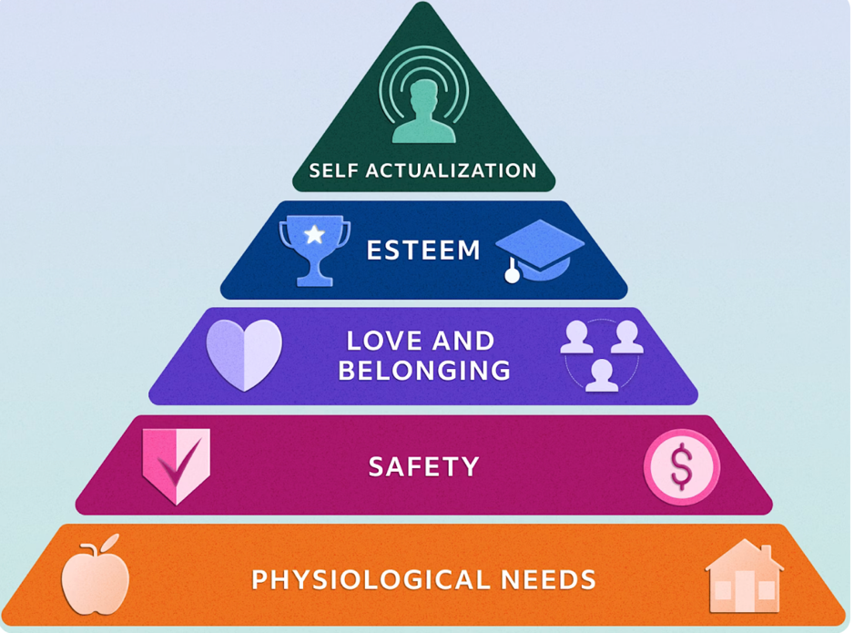

Figure 1: Maslow’s hierarchy of needs. Source: Indeed, Editorial Team (2026), adapted from Maslow (1943).

Employee wellbeing also has implications beyond the individual. De Neve and Ward (2025) argue that workplace wellbeing can influence organisational outcomes, including productivity, retention and performance. Financial wellbeing should therefore not be treated simply as a private issue that employees must solve alone. Organisations may need to consider whether employment practices, communication and support systems help employees manage financial pressure in ways that protect wellbeing.

3.2 Financial Stress and Workplace Performance
Financial stress may affect workplace performance because financial worries can compete with the resources needed for concentration, decision-making and emotional regulation (Hobfoll, 1989). This is relevant in hospitality, where employees serve customers and manage complaints.
The Job Demands–Resources (JD-R) model helps explain this relationship. Demerouti et al. (2001) distinguish between job demands, which require sustained physical or psychological effort, and job resources, which help employees achieve work goals and manage demands.
High job demands may contribute to exhaustion, while limited resources may contribute to disengagement. While financial stress is not part of the original model, it can be interpreted as an external pressure that affects the resources employees bring into work. Evidence about job control also relates limited control with anxiety, role overload and turnover intentions, suggesting that employees’ ability to manage demands is influenced by both work conditions and wider pressures (Jensen, Patel and Messersmith, 2013).
Figure 2 illustrates the original Job Demands–Resources model proposed by Demerouti et al. (2001).
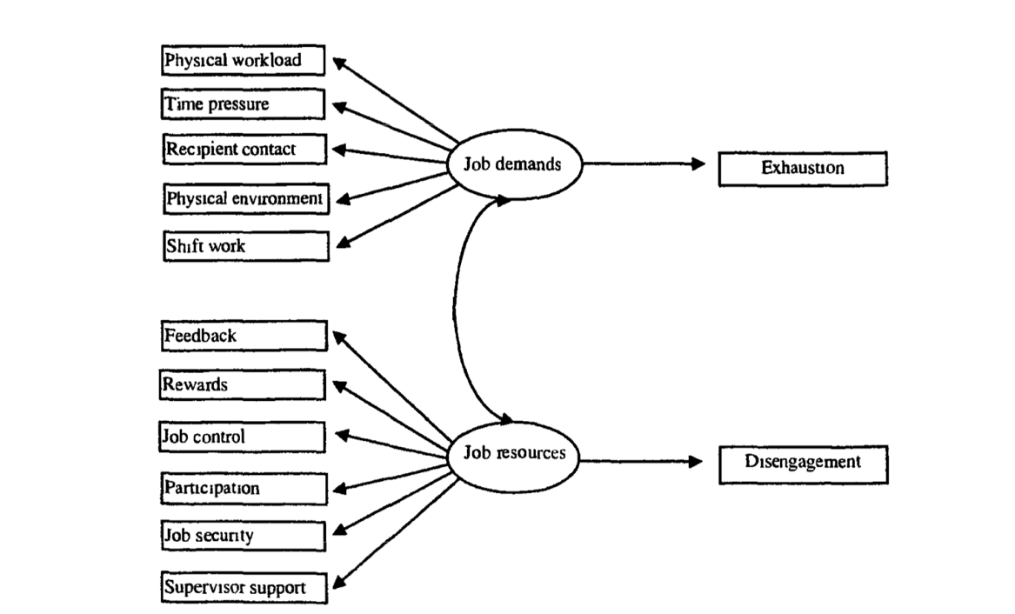

Figure 2: The Job Demands–Resources model of burnout (Demerouti et al., 2001, p. 502).
Demerouti et al. (2001, p. 510) argue that “to avoid employees’ exhaustion, specific job demands have to be reduced or redesigned. In addition, increasing job resources may enhance employees’ engagement.” From this perspective, worries about rent, debt or household bills may reduce the emotional energy and concentration available for customer interactions, decision-making and positive service behaviour.
Bakker and Demerouti (2017) argue that job resources can reduce the negative effects of pressure. In hospitality, supportive managers, predictable rotas and financial wellbeing support may help employees cope with demanding work. Nevertheless, the JD-R model mainly focuses on workplace demands and resources. As financial insecurity often comes from outside work, resource-based and organisational-support perspectives are also needed.
Hospitality research offers indirect rather than direct support for this relationship. Aslam et al. (2020) found that employee engagement and positive emotional labour were associated with proactive service performance among frontline hospitality employees, suggesting that employees need sufficient emotional capacity to respond effectively to customers.
Liu et al. (2024) similarly found that commuting stress affected work engagement among tourism and hospitality employees. The limitation is that neither study directly examines how financial stress affects hospitality employees’ wellbeing, performance or perceptions of organisational support, which reinforces the need for focused research.

3.3 Organisational Support and Financial Wellbeing
Workplace support may influence how employees cope with financial stress. Perceived Organisational Support theory, developed by Eisenberger et al. (1986), suggests that employees form beliefs about whether their organisation values their contribution and cares about their wellbeing. When employees feel supported, they may be more likely to show commitment, engagement and positive workplace behaviour. In the context of financial stress, support is therefore not only about whether formal initiatives exist, but also whether employees experience them as credible, accessible and safe to use.
Rhoades and Eisenberger (2002) argue that perceptions of support are shaped by factors such as fairness, supervisor support and organisational rewards. Kurtessis et al. (2017) similarly found that perceived organisational support is associated with positive employee outcomes, including job satisfaction, commitment and performance. This is particularly relevant in hospitality because organisations depend heavily on employees’ engagement, service behaviour and willingness to remain with the business.
Still, the existence of a wellbeing initiative does not automatically mean that employees experience the organisation as supportive. Support may have limited value if employees are unaware of it, cannot access it around irregular working hours or do not trust that their personal information will remain confidential. Financial wellbeing support should therefore be practical, accessible and clearly communicated. Relevant examples include clear information about pay, predictable scheduling, signposting to impartial financial advice, employee benefits, training opportunities and support with progression.
Line managers also shape employees’ everyday experience of organisational support. Kim and Beehr (2023) show that empowering leadership can strengthen employees’ psychological resources and encourage positive work behaviours. Although their study does not focus specifically on financial stress, it supports the view that managers can influence whether employees feel trusted, supported and able to manage pressure. Health-oriented leadership interventions are also relevant because leadership practices can affect employee health and wellbeing outcomes (Dannheim et al., 2022).
Similarly, Rabiul et al. (2023) found that hospitality HR practices were associated with employee engagement through psychological safety, availability and meaningfulness. This suggests that employees may be more likely to seek support when they feel safe discussing difficulties and believe that doing so will not affect their relationship with managers or future opportunities. The relevance to this study is that financial wellbeing support must be evaluated not only by its availability, but also by employees’ perceptions of trust, confidentiality and usefulness.

3.4 Hospitality Context and Research Gap
The hospitality sector is relevant because frontline employees work in fast-paced customer-facing settings, where wellbeing and behaviour shape service quality and organisational performance (Lashley, 1995). Hospitality HRM must balance changing demand and operational flexibility with employee wellbeing, motivation and retention (Boella and Goss-Turner, 2020; Kusluvan et al., 2010).
Financial stress is especially relevant because employees’ responsibilities and living circumstances differ. Irimiás and Michalkó (2016) illustrate why financial pressure cannot be understood only through job title or salary level. Lower median pay, limited progression and the need for practical workplace interventions further support attention to financial wellbeing (Department for Business, Energy and Industrial Strategy [BEIS], 2021; Rosemberg et al., 2022). Changing demand and operational flexibility can also make it harder to predict hours, organise childcare and manage household expenses, while wellbeing-oriented HRM research has not focused directly on financial stress as a workplace issue (Boella and Goss-Turner, 2020; Kusluvan et al., 2010; Ngo et al., 2023).
Financial pressure may affect wellbeing, concentration and emotional capacity, with implications for service behaviour, engagement and retention. This matters because staff turnover creates substantial costs for hospitality organisations (Davidson, Timo and Wang, 2010).
Although previous studies examine wellbeing, engagement, job demands and organisational support, they are often separate and mainly quantitative (Aslam et al., 2020; Liu et al., 2024; Ngo et al., 2023; Rabiul et al., 2023). They provide less insight into how employees interpret financial pressure and which support they find credible or useful.
There remains limited research on how UK hospitality employees connect financial stress to wellbeing, workplace performance and organisational support. The study aims to provide context-rich explanation rather than statistical representativeness (Flyvbjerg, 2006). The survey will identify patterns, while interviews will explore how employees explain them and what support they view as meaningful, accessible and trustworthy.

4. Research Methodology

4.1 Methodological Position and Research Design
This study will use a small-scale explanatory sequential mixed-methods design. Quantitative data will be collected and analysed first through an anonymous online survey, followed by qualitative interviews designed to explain, clarify and extend the initial survey patterns (Creswell and Plano Clark, 2018; Bryman, 2016). This design is appropriate because the research aims to identify broad patterns in employees reported financial stress while also understanding how employees interpret those experiences in relation to wellbeing, workplace performance and organisational support.
The methodological decisions are guided by the Research Onion framework, which links philosophy, approach, methodological choice, strategy, time horizon and data-collection procedures (Saunders, Lewis and Thornhill, 2023; Easterby-Smith, Thorpe and Jackson, 2012). Figure 3 shows the framework used in this study.

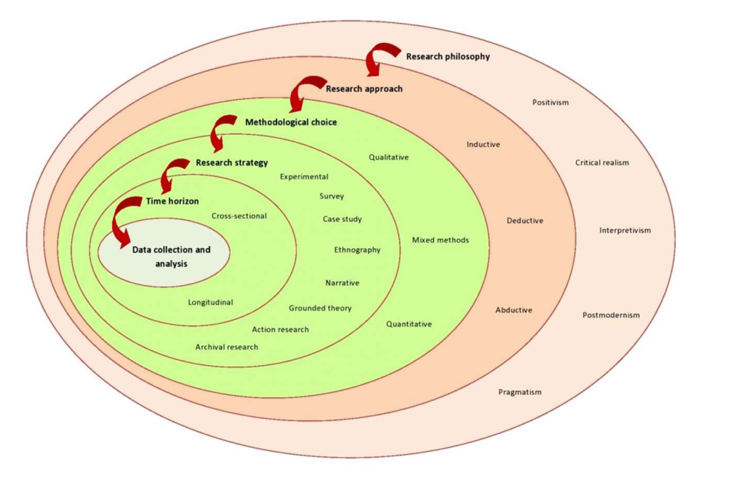

Figure 3: The Research Onion framework. Source: AESA Network (2020).

Ryan (2018) explains that researchers need to make their philosophical position clear because it shapes how they understand a research problem and choose their methods. This study adopts pragmatism because it focuses on a practical workplace issue and uses methods according to their usefulness for answering the research questions. Pragmatism is suitable here because financial stress can be examined through measurable survey patterns while also requiring qualitative insight into employees’ perceptions, meanings and experiences (Saunders, Lewis and Thornhill, 2023; Creswell and Plano Clark, 2018).
Ontologically, this project recognises that financial circumstances, income insecurity and unpredictable hours are real conditions affecting employees, while epistemologically it also recognises that employees interpret these conditions differently according to their responsibilities, employment circumstances and perceptions of support (Saunders, Lewis and Thornhill, 2023).
The study will adopt an abductive approach because it is informed by established theory while remaining open to explanations that emerge from the survey and interview findings. Conservation of Resources theory, the Job Demands–Resources model and Perceived Organisational Support theory will guide the interpretation of financial stress, wellbeing, workplace performance and support, while participants’ accounts will remain central to explaining how these issues are experienced in hospitality employment (Saunders, Lewis and Thornhill, 2023; Hobfoll, 1989; Demerouti et al., 2001; Eisenberger et al., 1986).
This research will also use a cross-sectional time horizon because data will be collected during one defined period, providing a snapshot of participants’ current or recent experiences of working in UK hospitality rather than examining changes over time (Saunders, Lewis and Thornhill, 2019).

4.2 Quantitative Method: Anonymous Online Survey
The first stage of the study will use an anonymous online questionnaire. Saunders, Lewis and Thornhill (2019) explain that surveys allow researchers to collect standardised information from a larger group of participants and present the findings in numerical form.
The target population will consist of adults aged 18 or over who currently work, or have worked within the previous 12 months, in the hospitality sector in England, Scotland, Wales or Northern Ireland. The study will aim to collect approximately 40–60 valid survey responses through voluntary purposive and snowball sampling. Purposive sampling will ensure that participants meet the eligibility criteria, while snowball sampling will allow eligible participants to share the survey voluntarily with other suitable hospitality employees (Bickman and Rog, 2009; Campbell et al., 2020; Saunders, Lewis and Thornhill, 2019). This sample size is suitable for a small-scale MBA proposal because the purpose is to identify indicative patterns rather than produce statistically representative findings.
Participants will be recruited through personal and former professional contacts, university and professional networks, LinkedIn and relevant online hospitality groups. No participants will be recruited through a manager, and the researcher will not invite direct reports or current colleagues over whom she has authority. Participation will be voluntary and unpaid.
The questionnaire will collect background information about hospitality setting, role, length of sector experience, contract type and predictability of working hours. It will also include five-point agreement-scale statements and optional open-text questions about financial stress, wellbeing, workplace performance and perceptions of organisational support. These areas reflect the concepts developed in the literature review, including financial wellbeing, job demands and resources, and perceived organisational support (Prawitz et al., 2006; Demerouti et al., 2001; Eisenberger et al., 1986).
The questionnaire will not be presented as a validated financial-stress scale because it has been designed specifically for this small-scale study. Its purpose is to identify patterns in participants’ reported experiences of financial pressure, wellbeing, workplace performance and organisational support rather than to produce a single validated measurement score.
The survey findings will be analysed using descriptive statistics, including frequencies, percentages, tables and charts. This is appropriate because the study uses a small voluntary non-probability sample and aims to identify patterns rather than make statistical generalisations. Inferential statistical tests will not be used because the study will not test causal relationships or make population-level predictions (Bickman and Rog, 2009; Saunders, Lewis and Thornhill, 2019). The descriptive results will instead be used to inform the focus of the follow-up interviews.

4.3 Qualitative Method: Semi-Structured Interviews
The second stage will involve three to four semi-structured interviews with eligible volunteers. Qualitative interviewing explores participants’ experiences, meanings and perspectives in depth (Brinkmann, 2023; Leavy, 2020). Semi-structured interviews use planned core questions with follow-up prompts, allowing participants to explain their views in detail (Kallio et al., 2016; Adeoye-Olatunde and Olenik, 2021).
The interviews will last approximately 20–25 minutes and will be conducted online or by telephone. They will explore financial pressures, perceived effects on wellbeing and workplace performance, and organisational support considered useful, realistic and trustworthy. Survey findings will guide follow-up questions so the qualitative stage can explain the most relevant patterns in greater depth.
Briggs (2007, p. 566) argues that interviewing forms part of the wider process of knowledge production within research. The interview guide therefore uses open questions and follow-up prompts to allow participants to explain their own experiences rather than limiting them to fixed survey responses. Silverman (2016) also highlights the value of allowing participants to describe their experiences in their own words.
Qualitative interpretation requires the researcher to make sense of participants’ accounts, which makes reflexivity important throughout data collection and analysis. Lichtman (2013, p. 21) states that “the qualitative researcher interprets and makes sense of the data.” Neutral interview questions, open follow-up prompts and reflexive notes will therefore be used to reduce the influence of researcher assumptions and ensure that participants can express differing viewpoints (Lichtman, 2013; Flick, 2023; Šimundić, 2013).

4.4 Analysis and Integration of Findings
The survey findings will first be presented through descriptive statistics to identify patterns relating to financial stress, wellbeing, workplace performance and organisational support. These findings will then inform the focus of the semi-structured interviews, while preserving the anonymity of questionnaire participants (Saunders, Lewis and Thornhill, 2019; Creswell and Plano Clark, 2018). For example, if many participants report that financial stress affects concentration, the interview stage can explore how and why this happens in everyday hospitality work.
Interview recordings will be transcribed and analysed using thematic analysis. Braun and Clarke (2006) and Fereday and Muir-Cochrane (2006) describe thematic analysis as a process of identifying, organising and interpreting recurring patterns of meaning across participants’ accounts. The analysis will examine themes relating to financial pressures, wellbeing, workplace performance and organisational support, while also considering experiences that differ from the most common patterns.
The final stage will integrate the descriptive survey findings with the interview themes to provide both breadth and depth when answering the research questions. The survey will show the patterns reported across the participant group, while the interviews will provide greater context about how employees experience financial stress and evaluate organisational support within hospitality employment. Integration will focus on where the two stages support each other, where interview accounts add explanation to survey patterns, and where unexpected differences appear (Creswell and Plano Clark, 2018).

4.5 Research Quality
Research quality will be considered differently across the quantitative and qualitative stages of this mixed-methods study. In quantitative research, quality is commonly linked to reliability, validity and generalisability, while qualitative research focuses more on the credibility, consistency and relevance of the researcher’s interpretation of participants’ accounts (Carrig and Hoyle, 2011; Leung, 2015). Lincoln and Guba (1985) describe trustworthiness as an important way of judging qualitative research quality.
For the survey stage, validity will be strengthened by designing the questionnaire around the research questions, the literature review and the key concepts of financial wellbeing, job demands and resources, and perceived organisational support. A small pilot will be completed before the survey is distributed to check that the questions are clear, relevant and easy to understand. The pilot will also check the order of the questions, the appropriateness of the response options and whether the survey can be completed within the expected time (Carrig and Hoyle, 2011).
Reliability will be supported by using the same anonymous online questionnaire, instructions and five-point agreement-scale responses for all participants. However, the questionnaire is researcher-designed for this study and will not be presented as a validated financial-stress scale. The survey will identify patterns in participants’ reported experiences rather than produce a validated financial wellbeing score (Carrig and Hoyle, 2011).
Generalisability will be limited because the study uses a voluntary purposive and snowball sample of approximately 40–60 participants. The quantitative findings will describe the experiences of the participant group and will not be used to make statistical conclusions about all UK hospitality employees (Carrig and Hoyle, 2011; Saunders, Lewis and Thornhill, 2019).
For the interview stage, quality will be supported through a semi-structured interview guide, neutral questions, audio recording with consent, accurate transcription and reflexive notes. These steps will help ensure that the analysis remains close to participants’ accounts rather than being shaped only by the researcher’s assumptions (Leung, 2015; Lichtman, 2013; Morse et al., 2002).
The interview findings will not aim to generalise to all hospitality employees. Instead, they will provide detailed context about how participants understand financial stress, wellbeing, workplace performance and organisational support, which is consistent with the explanatory purpose of the qualitative stage (Leung, 2015).
Finally, the survey patterns and interview themes will be compared during the final analysis. This will show where the two stages support each other, where they provide different insights and how the combined findings answer the research questions in more depth. This integration is important because the study is not only concerned with whether financial stress is reported, but also with how employees explain its effects and evaluate organisational support (Creswell and Plano Clark, 2018).

5. Limitations
This study has several limitations linked to its small-scale design, sampling strategy, data-collection methods and cross-sectional time horizon. These limitations do not undermine the value of the research, but they shape how the findings should be interpreted. The study is designed to generate context-rich insight into financial stress among UK hospitality employees rather than to produce statistically generalisable conclusions about the whole sector.
A first limitation concerns sampling. The study will use a voluntary purposive and snowball sample of approximately 40–60 survey participants. Because this is a non-probability sample, some groups of hospitality employees may be under-represented, particularly those with limited access to online networks or those who are less willing to discuss financial pressure. The survey findings will therefore be presented as indicative patterns within the participant group, not as statistically representative findings for all UK hospitality employees (Bickman and Rog, 2009; Saunders, Lewis and Thornhill, 2019).
A second limitation is that the questionnaire will be researcher-designed rather than a validated financial-stress scale. Although the questions will be informed by the literature review and aligned with the research questions, the survey will not produce a validated financial wellbeing score. This means that the findings can identify reported experiences and perceived patterns, but they cannot be treated as a formal psychometric measurement of financial stress (Prawitz et al., 2006; Carrig and Hoyle, 2011).
A third limitation is that both the survey and interviews will rely on self-reported accounts. Participants may choose not to disclose sensitive financial experiences, may interpret questions differently, or may provide answers they consider more socially acceptable. This is particularly relevant because financial stress can be a personal and potentially uncomfortable topic. The anonymous survey, separate interview-volunteer form, voluntary participation and reassurance that no employer will see individual answers will reduce this risk, but they cannot remove it completely (Šimundić, 2013).
A fourth limitation is the cross-sectional time horizon. Data will be collected during one defined period, so the study will provide a snapshot of participants’ current or recent experiences rather than showing how financial stress, wellbeing, performance or perceptions of organisational support change over time. This means that the study cannot establish causality or track whether organisational support has longer-term effects on employees’ financial wellbeing (Saunders, Lewis and Thornhill, 2019).
A fifth limitation concerns the qualitative stage. Three to four interviews will provide useful depth, but they will not capture the full diversity of experiences across the hospitality sector and will not be treated as evidence of data saturation. Guest, Bunce and Johnson (2006) show that saturation depends on the purpose and variability of interview data, so this study will use the interviews to add explanation rather than claim comprehensive coverage. In addition, because interview volunteers will provide contact details through a separate form, their interview accounts cannot be linked to individual anonymous survey responses. The interviews will therefore be used to explain and add context to the overall survey patterns rather than to trace the same participant’s experience across both stages (Creswell and Plano Clark, 2018; Leung, 2015).
Finally, the study will focus on employees’ perceptions rather than employer records, financial documents or objective performance data. This is appropriate for the research aim, which centres on how employees experience and interpret financial stress, but it means that the study cannot verify participants’ financial circumstances or directly measure workplace performance. The findings should therefore be understood as evidence of perceived effects and reported experiences rather than objective measures of financial hardship or performance outcomes.

6. Project Planning
The Gantt chart below summarises the planned research schedule from June 2026 to May 2027. Key stages include proposal submission, ethical approval, literature review development, methodology refinement, recruitment, data collection, analysis, dissertation writing, final editing and submission.
The study will use existing access to a laptop, internet connection, university library databases, Microsoft Forms, online meeting software and University-approved storage. No travel or participant-payment costs are expected.

Project Planning (Gantt Chart)
Planned Development / Target Date | Jun 2026 | Jul 2026 | Aug 2026 | Sep 2026 | Oct 2026 | Nov 2026 | Dec 2026 | Jan 2027 | Feb 2027 | Mar 2027 | Apr 2027 | May 2027
Submission of research proposal
Ethical clearance and permissions
Literature review
Research methodology
Participant recruitment
Online survey distribution and data collection
Preliminary survey analysis
Follow-up semi-structured interviews
Full analysis and integration of findings
Writing of draft chapters
Final editing and submission

Figure 4: Project plan (Gantt chart). Source: Researcher’s own development.

7. Ethical Considerations
This study involves sensitive topics because financial pressure and wellbeing are personal issues. Ethical safeguards will therefore focus on informed consent, voluntary participation, anonymity, confidentiality, secure data handling and participant wellbeing (Iltis and MacKay, 2024; Saunders, Lewis and Thornhill, 2019).
Data collection will begin only after ethical approval from the University of Wales Trinity Saint David (University of Wales Trinity Saint David, 2022). Participants will receive clear information about the study purpose, eligibility, voluntary participation, data use and their right to stop before submitting the survey, supporting UK GDPR principles of lawfulness, fairness and transparency (Information Commissioner’s Office, 2026).
The survey will collect only information needed for the research questions and will not ask for exact income, debt levels, bank details, financial documents, employer names or unnecessary personal details. Participants will also be asked not to name employers, managers, colleagues or identifiable locations in open-text responses, supporting UK GDPR principles of purpose limitation and data minimisation (Information Commissioner’s Office, 2026).
Survey participants may stop before submission. After submission, individual survey responses cannot be removed because no identifying information will be collected; this will be explained in the survey introduction.
Interview volunteers will provide contact details through a separate form that will not be linked to anonymous survey responses. They will receive separate information and consent materials and may withdraw within 14 days before recordings or transcripts are anonymised or analysed.
Because interviews may involve sensitive experiences, participants may refuse any question, ask for a break or end the interview at any time. The researcher will use neutral questions, avoid detailed private financial questions and stop the interview if a participant becomes distressed (Brinkmann, 2023; Briggs, 2007; Iltis and MacKay, 2024).
Interview contact details, consent forms, recordings and transcripts will be stored separately in password-protected, university-approved storage, with access limited to the researcher and authorised supervisor or examiner where required. Data will be retained only for the approved period and then securely deleted in line with University requirements and UK GDPR principles (Information Commissioner’s Office, 2026).
Findings will be reported anonymously. Names of employers, managers, colleagues and identifiable locations will be removed where necessary, and interview participants will be assigned codes during analysis and reporting.
Recruitment will not take place through managers, and the researcher will not invite direct reports or current colleagues over whom she has authority. Participation will be voluntary and unpaid. The researcher will not provide financial, legal, employment or health advice; survey and interview information will advise participants to seek independent support if needed.

8. References
Adeoye-Olatunde, O.A. and Olenik, N.L. (2021) ‘Research and scholarly methods: semi-structured interviews’, JACCP: Journal of the American College of Clinical Pharmacy, 4(10), pp. 1358-1367. Available at: https://doi.org/10.1002/jac5.1441
AESA Network (2020) ‘Blog 132—Research Onion: A systematic approach to designing research methodology’, 27 August. Available at: https://aesanetwork.org/research-onion-a-systematic-approach-to-designing-research-methodology/ (Accessed: 29 June 2026).
Arnold, J., Coyne, I., Randall, R. and Patterson, F. (2020) Work psychology: understanding human behaviour in the workplace. 7th edn. Harlow: Pearson.
Aslam, M.Z., Nor, M.N.M., Omar, S., Bustaman, H.A. and Foroudi, P. (2020) ‘Predicting proactive service performance: The role of employee engagement and positive emotional labour among frontline hospitality employees’, Cogent Business & Management, 7(1), article 1771117. Available at: https://doi.org/10.1080/23311975.2020.1771117
Bakker, A.B. and Demerouti, E. (2017) ‘Job demands-resources theory: Taking stock and looking forward’, Journal of Occupational Health Psychology, 22(3), pp. 273-285. Available at: https://doi.org/10.1037/ocp0000056
Bickman, L. and Rog, D.J. (eds) (2009) The SAGE handbook of applied social research methods. 2nd edn. Thousand Oaks, CA: SAGE.
Boella, M.J. and Goss-Turner, S. (2020) Human resource management in the hospitality industry: a guide to best practice. 10th edn. Abingdon: Routledge.
Braun, V. and Clarke, V. (2006) ‘Using thematic analysis in psychology’, Qualitative Research in Psychology, 3(2), pp. 77-101. Available at: https://doi.org/10.1191/1478088706qp063oa
Briggs, C.L. (2007) ‘Anthropology, interviewing and communicability in contemporary society’, Current Anthropology, 48(4), pp. 551-567.
Brinkmann, S. (2023) ‘Introduction to qualitative interviewing’, in Qualitative interviewing: conversational knowledge through research interviews. 2nd edn. New York: Oxford University Press. Available at: https://doi.org/10.1093/oso/9780197648186.003.0001 (Accessed: 29 June 2026).
Bryman, A. (2016) Social research methods. 5th edn. Oxford: Oxford University Press.
Campbell, S., Greenwood, M., Prior, S., Shearer, T., Walkem, K., Young, S., Bywaters, D. and Walker, K. (2020) ‘Purposive sampling: complex or simple? Research case examples’, Journal of Research in Nursing, 25(8), pp. 652-661. Available at: https://doi.org/10.1177/1744987120927206
Carrig, M.M. and Hoyle, R.H. (2011) ‘Measurement choices: Reliability, validity, and generalizability’, in Panter, A.T. and Sterba, S.K. (eds) Handbook of ethics in quantitative methodology. New York: Routledge, pp. 127-157.
Catalano, R., Goldman-Mellor, S., Saxton, K., Margerison-Zilko, C., Subbaraman, M., LeWinn, K. and Anderson, E. (2011) ‘The health effects of economic decline’, Annual Review of Public Health, 32, pp. 431-450. Available at: https://doi.org/10.1146/annurev-publhealth-031210-101146
Creswell, J.W. and Plano Clark, V.L. (2018) Designing and conducting mixed methods research. 3rd edn. Thousand Oaks, CA: SAGE.
Dannheim, I., Ludwig-Walz, H., Buyken, A.E., Grimm, V. and Kroke, A. (2022) ‘Effectiveness of health-oriented leadership interventions for improving health and wellbeing of employees: a systematic review’, Journal of Public Health, 30, pp. 2777-2789. Available at: https://doi.org/10.1007/s10389-021-01664-1
Davidson, M.C.G., Timo, N. and Wang, Y. (2010) ‘How much does labour turnover cost? A case study of Australian four- and five-star hotels’, International Journal of Contemporary Hospitality Management, 22(4), pp. 451-466. Available at: https://doi.org/10.1108/09596111011042686
De Neve, J.-E. and Ward, G. (2025) Why workplace wellbeing matters: the science behind employee happiness and organizational performance. Boston, MA: Harvard Business Review Press.
Demerouti, E., Bakker, A.B., Nachreiner, F. and Schaufeli, W.B. (2001) ‘The job demands-resources model of burnout’, Journal of Applied Psychology, 86(3), pp. 499-512. Available at: https://doi.org/10.1037/0021-9010.86.3.499
Department for Business, Energy and Industrial Strategy (BEIS) (2021) Hospitality strategy: reopening, recovery, resilience. London: Department for Business, Energy and Industrial Strategy. Available at: https://assets.publishing.service.gov.uk/media/60f14bd7e90e0764ca40656b/1200-APS-CCS0621819592-002-BEIS-Accessible2.pdf (Accessed: 28 June 2026).
Easterby-Smith, M., Thorpe, R. and Jackson, P. (2012) Management research. 4th edn. London: SAGE.
Eisenberger, R., Huntington, R., Hutchison, S. and Sowa, D. (1986) ‘Perceived organizational support’, Journal of Applied Psychology, 71(3), pp. 500-507. Available at: https://doi.org/10.1037/0021-9010.71.3.500
Fereday, J. and Muir-Cochrane, E. (2006) ‘Demonstrating rigour using thematic analysis: a hybrid approach of inductive and deductive coding and theme development’, International Journal of Qualitative Methods, 5(1), pp. 80-92.
Flick, U. (2023) An introduction to qualitative research. 7th edn. London: SAGE.
Flyvbjerg, B. (2006) ‘Five misunderstandings about case-study research’, Qualitative Inquiry, 12(2), pp. 219-245. Available at: https://doi.org/10.1177/1077800405284363
Graham, B.A., Sinclair, R.R. and Munc, A. (2026) ‘The relationship between dispositional affectivity, perceived income adequacy, and financial strain: an analysis of financial stress perceptions’, Psychological Reports, 129(1), pp. 415-439. Available at: https://doi.org/10.1177/00332941241239267
Guest, G., Bunce, A. and Johnson, L. (2006) ‘How many interviews are enough? An experiment with data saturation and variability’, Field Methods, 18(1), pp. 59-82. Available at: https://doi.org/10.1177/1525822X05279903
Hobfoll, S.E. (1989) ‘Conservation of resources: a new attempt at conceptualizing stress’, American Psychologist, 44(3), pp. 513-524. Available at: https://doi.org/10.1037/0003-066X.44.3.513
Information Commissioner’s Office (2026) A guide to the data protection principles. Available at: https://ico.org.uk/for-organisations/uk-gdpr-guidance-and-resources/data-protection-principles/a-guide-to-the-data-protection-principles/ (Accessed: 29 June 2026).
Indeed Editorial Team (2026) ‘Maslow’s Hierarchy of Needs: Applying it in the workplace’, Indeed Career Guide, 15 June. Available at: https://www.indeed.com/career-advice/career-development/maslows-hierarchy-of-needs (Accessed: 29 June 2026).
Iltis, A.S. and MacKay, D. (eds) (2024) The Oxford handbook of research ethics. 1st edn. Oxford: Oxford University Press. Available at: https://doi.org/10.1093/oxfordhb/9780190947750.001.0001
Irimiás, A. and Michalkó, G. (2016) ‘Hosting while being hosted: a perspective of Hungarian migrant hospitality workers in London, UK’, Tourism and Hospitality Research, 16(2), pp. 172-183. Available at: https://doi.org/10.1177/1467358415600211
Jensen, J.M., Patel, P.C. and Messersmith, J.G. (2013) ‘High-performance work systems and job control: consequences for anxiety, role overload, and turnover intentions’, Journal of Management, 39(6), pp. 1699-1724. Available at: https://doi.org/10.1177/0149206311419663
Kallio, H., Pietilä, A.-M., Johnson, M. and Kangasniemi, M. (2016) ‘Systematic methodological review: developing a framework for a qualitative semi-structured interview guide’, Journal of Advanced Nursing, 72(12), pp. 2954-2965. Available at: https://doi.org/10.1111/jan.13031
Kim, M. and Beehr, T.A. (2023) ‘Empowering leadership improves employees’ positive psychological states to result in more favorable behaviors’, The International Journal of Human Resource Management, 34(10), pp. 2002-2038. Available at: https://doi.org/10.1080/09585192.2022.2054281
Kurtessis, J.N., Eisenberger, R., Ford, M.T., Buffardi, L.C., Stewart, K.A. and Adis, C.S. (2017) ‘Perceived organizational support: a meta-analytic evaluation of organizational support theory’, Journal of Management, 43(6), pp. 1854-1884. Available at: https://doi.org/10.1177/0149206315575554
Kusluvan, S., Kusluvan, Z., Ilhan, I. and Buyruk, L. (2010) ‘The human dimension: a review of human resources management issues in the tourism and hospitality industry’, Cornell Hospitality Quarterly, 51(2), pp. 171-214. Available at: https://doi.org/10.1177/1938965510362871
Lashley, C. (1995) ‘Towards an understanding of employee empowerment in hospitality services’, International Journal of Contemporary Hospitality Management, 7(1), pp. 27-33.
Leavy, P. (ed.) (2020) The Oxford handbook of qualitative research. 2nd edn. Oxford: Oxford University Press.
Leung, L. (2015) ‘Validity, reliability, and generalizability in qualitative research’, Journal of Family Medicine and Primary Care, 4(3), pp. 324-327. Available at: https://doi.org/10.4103/2249-4863.161306
Lichtman, M. (2013) Qualitative research in education: a user’s guide. 3rd edn. Thousand Oaks, CA: SAGE.
Lincoln, Y.S. and Guba, E.G. (1985) Naturalistic inquiry. Beverly Hills, CA: SAGE.
Liu, X., Wu, L., Huo, Z. and Chen, Y. (2024) ‘The trip from home to work: exploring how commuting stress impacts on tourism and hospitality employees’ work engagement’, Current Issues in Tourism, 27(21), pp. 3557-3570. Available at: https://doi.org/10.1080/13683500.2023.2272019
Maslow, A.H. (1943) ‘A theory of human motivation’, Psychological Review, 50(4), pp. 370-396. Available at: https://doi.org/10.1037/h0054346
Morse, J.M., Barrett, M., Mayan, M., Olson, K. and Spiers, J. (2002) ‘Verification strategies for establishing reliability and validity in qualitative research’, International Journal of Qualitative Methods, 1(2), pp. 13-22. Available at: https://doi.org/10.1177/160940690200100202
Ngo, T., Le, D. and Doan, T. (2023) ‘“Are your employees mentally prepared for the pandemic?” Wellbeing-oriented human resource management practices in a developing country’, International Journal of Hospitality Management, 109, article 103415. Available at: https://doi.org/10.1016/j.ijhm.2022.103415
Palmer, S. and Cooper, C.L. (2007) How to deal with stress. London: Kogan Page.
Powell, R., Do, A., Gengatharen, D., Yong, J. and Gengatharen, R. (2023) ‘The relationship between responsible financial behaviours and financial wellbeing: the case of buy-now-pay-later’, Accounting & Finance, 63(4), pp. 4431-4451. Available at: https://doi.org/10.1111/acfi.13100
Prawitz, A.D., Garman, E.T., Sorhaindo, B., O’Neill, B., Kim, J. and Drentea, P. (2006) ‘InCharge financial distress/financial well-being scale: development, administration, and score interpretation’, Financial Counseling and Planning, 17(1), pp. 34-50.
Rabiul, M.K., Mohamed, A.E., Patwary, A.K., Yean, T.F. and Osman, S.Z. (2023) ‘Linking human resources practices to employee engagement in the hospitality industry: the mediating influences of psychological safety, availability and meaningfulness’, European Journal of Management and Business Economics, 32(2), pp. 223-240. Available at: https://doi.org/10.1108/EJMBE-12-2020-0347
Rhoades, L. and Eisenberger, R. (2002) ‘Perceived organizational support: a review of the literature’, Journal of Applied Psychology, 87(4), pp. 698-714. Available at: https://doi.org/10.1037/0021-9010.87.4.698
Roelfs, D.J. and Shor, E. (2023) ‘Financial stress, unemployment, and suicide: a meta-analysis’, Crisis: The Journal of Crisis Intervention and Suicide Prevention, 44(6), pp. 506-517. Available at: https://doi.org/10.1027/0227-5910/a000908
Rosemberg, M.-A.S., Granner, J.R., Li, W.V., Adams, M. and Militzer, M.A. (2022) ‘Intervention needs among hotel employees and managers’, Work, 71(4), pp. 1063-1071. Available at: https://doi.org/10.3233/WOR-205060
Ryan, G. (2018) ‘Introduction to positivism, interpretivism and critical theory’, Nurse Researcher, 25(4), pp. 14-20. Available at: https://doi.org/10.7748/nr.2018.e1466
Saunders, M.N.K., Lewis, P. and Thornhill, A. (2019) Research methods for business students. 8th edn. Harlow: Pearson.
Saunders, M.N.K., Lewis, P. and Thornhill, A. (2023) Research methods for business students. 9th edn. Harlow: Pearson.
Silverman, D. (2016) Qualitative research. 4th edn. London: SAGE.
Šimundić, A.-M. (2013) ‘Bias in research’, Biochemia Medica, 23(1), pp. 12-15. Available at: https://doi.org/10.11613/BM.2013.003
Stuckler, D., Basu, S., Suhrcke, M., Coutts, A. and McKee, M. (2009) ‘The public health effect of economic crises and alternative policy responses in Europe: an empirical analysis’, The Lancet, 374(9686), pp. 315-323. Available at: https://doi.org/10.1016/S0140-6736(09)61124-7
University of Wales Trinity Saint David (2022) Application for ethical approval: PG2/E1 form. Internal document.
World Health Organization (2024) Mental health at work. Available at: https://www.who.int/news-room/fact-sheets/detail/mental-health-at-work (Accessed: 20 June 2026).

9. Appendix

Appendix A: Anonymous Online Survey Questionnaire
This appendix contains the proposed anonymous online survey, the separate interview volunteer form and the semi-structured interview guide used to support the explanatory sequential mixed-methods design.
A1. Survey Introduction
This survey forms part of an MBA research project exploring financial stress, employee wellbeing, workplace performance and perceptions of organisational support among hospitality employees in the United Kingdom.

For the purpose of this survey, financial stress refers to worry or pressure relating to money, income or meeting regular living costs. The survey is anonymous and should take approximately 8–10 minutes to complete. Participants will not be asked to provide exact income, debt levels, bank details or financial documents.

Participation is voluntary. You may stop completing the survey at any time before submitting your answers. No payment or incentive will be offered for participation. Survey responses will be analysed and reported only in anonymised, grouped form.
Please do not include the name of your employer, manager, colleagues or any other identifiable person in the optional open-text responses.

A2. Consent and Eligibility

Question | Question wording | Response options / format
Q1 | I confirm that I am aged 18 or over. | Yes / No
Q2 | I confirm that I currently work, or have worked within the last 12 months, in the hospitality sector in England, Scotland, Wales or Northern Ireland. | Yes / No
Q3 | I understand that participation is voluntary and that the survey is anonymous. | Yes / No
Q4 | I consent to take part in this survey. | Yes / No

A3. Background Information

Question | Question wording | Response options / format
Q5 | What type of hospitality setting is or was your current or most recent UK hospitality role? | Hotel / Restaurant / Café / Bar / Events / Resort / Other / Prefer not to say
Q6 | What is or was your current or most recent UK hospitality role? | Front of house / Waiter or waitress / Bartender / Reception / Housekeeping / Kitchen or chef / Supervisor or manager / Other / Prefer not to say
Q7 | How long have you worked in hospitality? | Less than 6 months / 6–12 months / 1–3 years / More than 3–6 years / More than 6 years / Prefer not to say
Q8 | What type of contract does, or did you have in your current or most recent UK hospitality role? | Full-time / Part-time / Zero-hours / Temporary / Agency / Other / Prefer not to say
Q9 | In your current or most recent UK hospitality role, how predictable were or are your weekly working hours? | Always / Often / Sometimes / Rarely / Never / Prefer not to say

A4. Financial Stress

For Q10–Q27, answer about your current or most recent UK hospitality role; for Q10–Q26, use 1 = strongly disagree to 5 = strongly agree.

Question | Question wording | Response
Q10 | I worry about whether my income is enough to cover essential living costs. | 1–5
Q11 | Changes in my working hours make it difficult to plan my finances. | 1–5
Q12 | Financial pressure affects my stress levels. | 1–5
Q13 | Financial pressure affects my sleep or ability to relax outside work. | 1–5
Q14 | I feel or felt financially secure in my current or most recent UK hospitality role. | 1–5
Q15 | I find it difficult to stop thinking about financial worries while I am at work. | 1–5

A5. Wellbeing and Workplace Performance

Question | Question wording | Response
Q16 | Financial stress affects my mood at work. | 1–5
Q17 | Financial stress affects my motivation at work. | 1–5
Q18 | Financial stress affects my concentration during shifts. | 1–5
Q19 | Financial stress makes it harder to deal with difficult customers or stressful situations. | 1–5
Q20 | Financial stress affects my overall wellbeing. | 1–5
Q21 | When I experience financial stress, it is harder for me to perform well at work. | 1–5

A6. Organisational Support

Question | Question wording | Response
Q22 | In my current or most recent workplace, I feel or felt that my employer understands the financial pressures employees may face. | 1–5
Q23 | My current or most recent workplace provides useful support for employee wellbeing. | 1–5
Q24 | I would feel comfortable asking my manager for support if financial stress affected my work. | 1–5
Q25 | I know where to find support if I experience financial or wellbeing difficulties. | 1–5
Q26 | More support from employers could help hospitality employees manage financial stress. | 1–5
Q27 | Which types of support do you think would be most useful? | Clearer pay information; predictable rotas; financial wellbeing advice; confidential external support; mental health support; progression opportunities; training; employee benefits; flexible working; other.

A7. Optional Open Questions

Question | Question wording | Response options / format
Q28 | In your view, what are the main causes of financial stress for hospitality employees? | Optional open-text response
Q29 | In your view, how can financial stress affect hospitality employees at work? | Optional open-text response
Q30 | What could hospitality employers do to support employees better? | Optional open-text response

Appendix B: Separate Interview Volunteer Form

Volunteer Form

Completing this form is optional. Contact details will be collected separately and will not be linked to anonymous survey responses. Completing this form does not mean that a person has agreed to take part in an interview; it only means that they are willing to be contacted with further information about the follow-up interview stage.
Item | Form wording | Response format
B1 | I am willing to be contacted about a short follow-up interview. | Yes / No
B2 | Name | Short answer
B3 | Email address. | Short answer
B4 | Preferred interview format. | Microsoft Teams / Zoom / Telephone / No preference
B5 | Are there any preferred days or times for contact? | Short answer — optional

Appendix C: Semi-Structured Interview Guide

The interview will last approximately 20–25 minutes and will take place online or by telephone. Before the interview begins, participants will receive separate information and consent materials. Participants may refuse to answer any question, ask for a break or end the interview at any time without giving a reason.
Interview Questions

Question | Interview question | Purpose / possible probe
1 | Can you briefly describe your current or most recent role in the UK hospitality sector? | To understand the participant’s work context.
2 | From your experience or observation, what financial pressures can affect people working in hospitality? | Probe for common pressures such as pay, hours, travel, housing or living costs, without asking for private financial details.
3 | In what ways, if any, can financial pressure affect employees’ wellbeing outside work? | To explore perceived links between financial pressure, stress, sleep, recovery and general wellbeing.
4 | In what ways, if any, can financial pressure affect employees’ concentration, motivation or performance during work? | To explore perceived effects on workplace performance and service-related behaviour.
5 | What wellbeing, financial or workplace support is currently available in your current or most recent hospitality workplace? | To identify perceived existing support and whether employees know how to access it.
6 | What types of organisational support would feel useful, realistic and trustworthy for employees experiencing financial stress? | To explore support that participants consider meaningful, practical and credible.
7 | Is there anything else you think hospitality employers should understand about financial stress, wellbeing or support? | To allow participants to add any further views not covered by earlier questions.

