- The diagram below shows a box which is resting on an inclined plane. Forces F₁ and F₂ represent the component of weight which acts parallel to the slope and perpendicularly into the slope respectively.
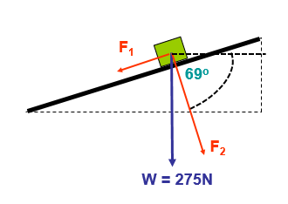

a) Given that g = 9.81ms⁻², and Weight = mass X gravity;
Calculate;
i) the magnitude of friction [2]

275cos(69degrees)=69.55N

ii) the angle between the direction of the force of friction and the vertical [2]

90-69=21degrees

iii) the normal reaction between the box and the plane [2]

275cos(21degrees)=256.73N

b) Newton’s second law states that the resultant force is proportional to the rate of change of momentum. Given that
Momentum = mass × velocity

i) Write out the above statement mathematically [2]
p=mv

ii) State the units of momentum, [2]
kqxm

c) Newton’s second law is commonly written as,
Resultant force = mass × acceleration or F = ma

i) Considering this, what would be the required magnitude of a force that pointed parallel to the slope, and in the opposite direction to F₁ so that the box would accelerate up the slope at 2.5ms⁻²
[4]
98.5x2.5=246.38N
ii) What would be the change in momentum between the moment just before the box began to move up the slope and when its velocity reached 7.5ms⁻¹ [2]
Just Before – 246.38x7.5=1847.85N
Just After – 1847.85-246.38=1601.47N

iii) Using the statement given in b) What resultant force would be required to increase the velocity of a 5kg box from rest to 12.5ms⁻¹ in 3.2s. [4]
3.2÷5=0.64N

- The circuit shown below shows a 12V battery connected to a combination of three resistors and a thermistor.
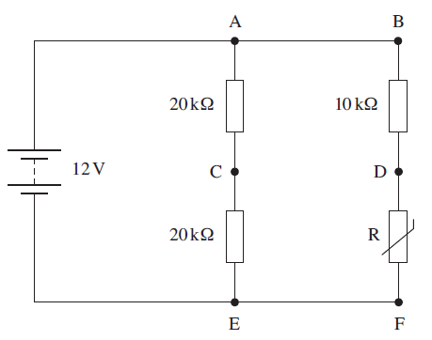

a)

When the resistance of the thermistor is 5KΩ

i) Calculate the total resistance of the circuit [4]

10000+5000=15000 20000+20000=40000

40000x15000=10909.09
40000+15000
ii) Calculate the current leaving the battery [2]

12 =0.0011A
10909.09
iii) Calculate the power used by each of the three resistors and the thermistor [8]

A-E – 0.0011²x20000=0.0242W

C-E – 0.0011²x20000=0.0242W

B-D - 0.0011²x10000=0.0121W

Thermistor - 0.0011²x5000=0.00605W

b) A voltmeter is used to measure the potential difference (PD) between points on the circuit. What PD would you expect to see between points:
i) A-C

0.0003x20000=6V

ii) D-F

0.0011 – 0.0003 = 0.0008x10000=8V 12-8=4V

iii) C-D [6]

0.0008x10000=8V 0.0003x20000=6V 8-6=2V

- a) Define the moment of a force about a point. [2]
b) The diagram below shows a ‘gripper’ used for hand strengthening exercises.

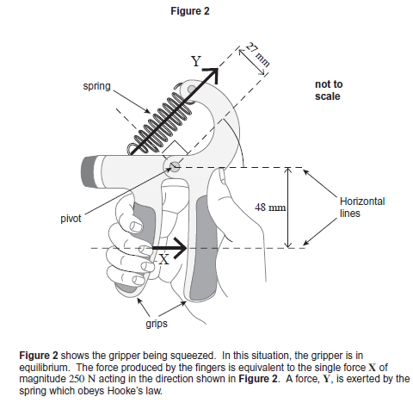

i) Calculate the moment of force X about the pivot. State an appropriate unit [3]

250x48=12000N

ii) Calculate the force Y [3]

15x27=405N

iii) The extension of the spring is 15mm. Given the fact that ‘Hooke’s Law’ states that the applied force is proportional to the extension, or;
F = kx

iv) Calculate the spring constant and state its unit. [4]

405=27

v) Given that;
Work done = Force × Distance

Calculate the work done on the spring to squeeze it to the position shown in figure 2. [3]

12000x15=180000

c) Given the definition, Power is the rate of working

i) Write down an equation for Power in terms of Energy and Time stating its units. [2]

P=Wd Power=WorkDone
T Time
ii) Assuming it takes 2.2s to squeeze the trigger, what is the power being applied. [2]

18000=91919.18J
2.2

d) If the total amount of energy that was used during the exercise session was 3.2kJ, how many times will the trigger be squeezed. [3]

