Marketing Fundamentals

Student Name: Ivan Todorov Todorov
Student ID: 2023561

Table of Contents
Introduction 3
Definition of Marketing 4
Importance of Marketing 4
The Marketing Process and its Main Stages 6 5
Mission Statement of the Company 6
Situational Analysis 6
Objectives 7
Strategy Planning 7
Implementation and Control 8
Segmentation, Targeting, and Positioning 9
Segmentation 9
Targeting 10
Positioning 10
The Marketing Mix 12
Conclusion 13
References 13

Introduction
The competition in the business world has grown a lot and innovative marketing can be the only solution to gain a competitive edge in the market (Strauss et al., 2019). In this report, starting from the definition of marketing, the importance of marketing and the entire process of marketing along with its stages have been discussed. In the later part of the report, STP Model (Segmentation, Targeting, and Positioning) and marketing mix have also been discussed along with industry examples to support the discussion.

Definition of Marketing
The definition of marketing states that marketing is considered as the set of activity, institutions, and all the processes that are involved in creating, developing communication, delivering, and creating exchange offer that provides value to the customers and the clients of the business (McCarthy and Perreault, 2017). In simple words, marketing is considered as the set of activities that are undertaken by the company to promote the buying and selling of their services. The core functions of marketing are to first focusing on a particular product or service and identifying the ideal group of customers to draw their attention towards the product or service.

Importance of Marketing
The importance of marketing for all organizations has been discussed below:
- Marketing helps to inform: Marketing is very important to effect in order to educate the customer as marketing effectively communicates the value proposition of the product or service to the customer.
- Marketing assists in equalizing: The modern tools of marketing such as social media platforms and email campaigns have made it easier for companies to reach out to their customers in a finances-friendly low (Kotler et al., 2010).
- Marketing builds sustainability: Marketing assists in building a sustainable presence of the company as it assists the business in maintaining a long-lasting relationship with their audience and this strategy helps them to flourish.
- Marketing engages: Customer engagement is one of the key elements of success for a company and marketing can help businesses to form a long-lasting relationship between their customers and the brand.
- Marketing drives sales: The bottom line of business is to generate sales and marketing helps in selling the product or service of the business. The channel of marketing helps to reach the end goal.
- Marketing helps the business to grow: Marketing not only helps to engage the current customers of the business but it can also play a role in expanding the customer base of the customers by spreading the word to new potential customers of the business.

The Marketing Process and its Main Stages
The process of marketing includes a number of steps that only help the business to identify the goals and generate business insights regarding what the customer needs are. In this way, it helps the business to generate products and services that can satisfy customer demands and along the way, help the business to achieve its goals.
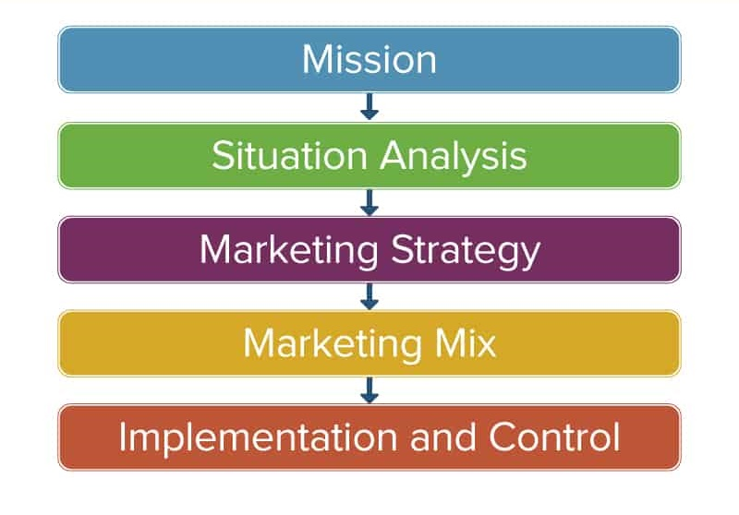
Figure: Marketing Process Overview (Kotler et al., 2010)

Mission Statement of the Company
The main reason why a mission statement exists is that it explains why the organization is in business and what value it can provide its customers. the mission statement of the company is aspirational to the authority and along with that it motivates the staff and inspires the customers. For example, the mission statement of Apple is that the company is dedicated to making innovative and high-quality products.

Situational Analysis
Situation analysis of the company is the process of evaluating the internal and external factors that affect the business and market. Conducting a situation analysis allows the business to identify its strengths and what sort of challenges the company can face based on the internal resources or external competition in the marketplace (Kotler, 2012). There are a number of ways in which situational analysis can be conducted and one of the most common ways to do that is the SWOT analysis. Each letter of the “SWOT” represents strengths, weaknesses, opportunities, and threats. In the analysis, strengths and weaknesses are often considered as the internal parts as they are well under the control of the company. On the other hand, the opportunities and threats are the external factors. The importance of conducting a SWOT analysis is that it helps the company to identify its strengths and weaknesses such as what are the factors that the company can control, what are the things that the company do well, what is the limitation of the company, in which sectors the company is underperforming. Again, the opportunity and threat analysis generate business insights such as what are the untapped markets or what are the obstacles and external factors that can cause a problem.
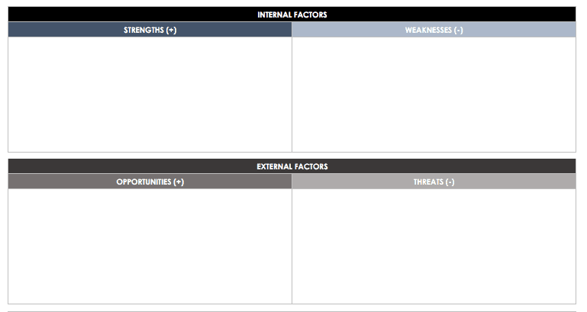
Figure: SWOT Analysis Template (Kerin et al., 2014)

Objectives
The objectives in marketing are defined as the defined goal of the brand. Marketing objectives play a great role in outlining the intentions of the team which acts as a clear set of guidelines for the team members to follow and for the executives, it serves as a measure of review and support (Kotler, 2012). It is normally considered as one of the pivotal parts of the marketing strategy as, without the defined goals and objectives, a brand will definitely struggle as there are no clear instructions on what the company wants to achieve. Some examples of marketing objectives can be generating leads, growing digital presence, targeting new customers, etc.

Strategy Planning
After conducting situational analysis and being clear about the marketing objectives, the strategic planning session begins. The first step of strategic planning is defining the target audience as it is not possible for the businesses to focus on the entire market and satisfy every need of the customers. the geographic, demographic, behavioral, and psychographic characteristics of the customers can be taken into account while identifying the target market.
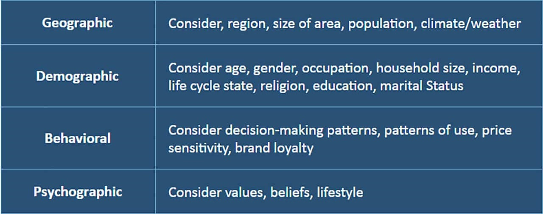
Figure; Segmenting Target Market (Armstrong et al., 2015)
The next step is setting SMART goals. SMART stands for specific, measurable, attainable, relevant, and time-bound. This will allow the company to identify their growth and progress such as how much they want to increase their sales or how much growth they want in a specific timeframe. The last step of strategic planning is to allocate the resources that will assist in turning the plans into action. the marketing budget will include the costs such as advertising cost, branding cost, public relations cost, staffing costs, etc.

Implementation and Control
Implementation means implementing the marketing plan such as identifying the customers' ad reaching out to them, persuading them about buying the product, allocating resources, organizing people, managing details for the goals, etc (McCarthy et al., 2019). Measuring and evaluating the results will allow the company to be in the controller seat as it will educate them regarding if they are achieving their goals or they need to adjust their tactics in order to achieve their expected results.

Segmentation, Targeting, and Positioning
Segmentation, Targeting, and Positioning create an STP model where there are three steps that allows the businesses to examine the products and services as well as communicating the benefits of the products and services to the target customers.
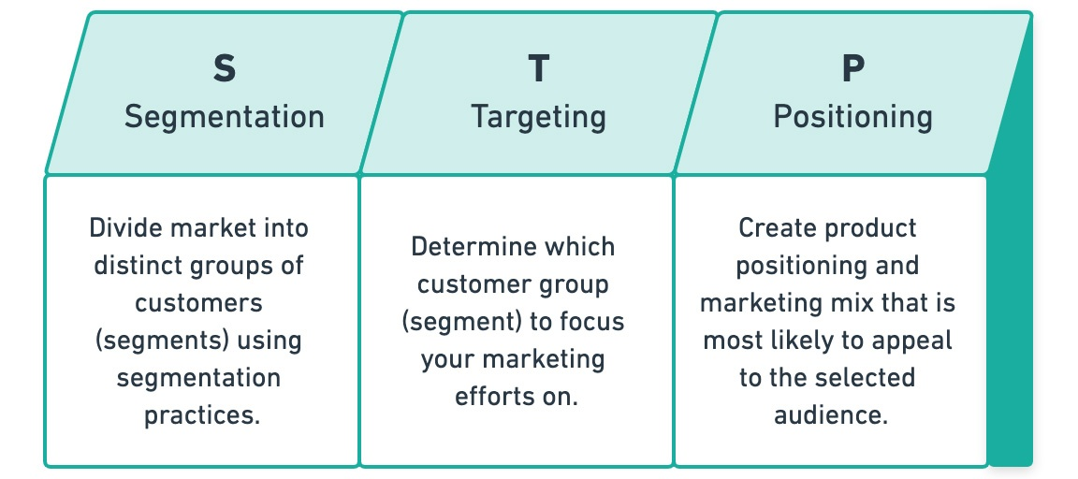
Figure: STP Model (Baker, 2012)

Segmentation
The first step of the model is segmentation which is about creating different customer segments based on the specific criteria and characteristics of the customers. Geographic segmentation is the process of dividing audiences into groups based on their location, such as their nation, city, state, or province. Demographic segmentation is the process of dividing the audience into groups based on factors such as age, ethnicity, educational attainment, profession, and gender. Behavioral segmentation is the process of dividing the audience into groups depending on how they engage with the company: what they purchase, how much they buy, what they browse, and so on. Psychographic segmentation is the process of dividing the audience into groups based on "who" your future customers are: Hobbies, sports, viewpoints, and so forth. For example, travel agencies normally go for couples and families who want an affordable, safe, and family-friendly environment.
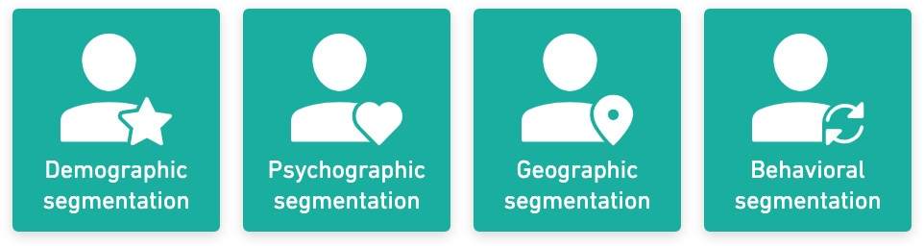
Figure: Segmentation (Foreman, 2013)

Targeting
Targeting is all about selecting which customer segment is more likely to generate the desired sales. When targeting a specific segment, the decision should be made on the size of the segment, the profitability of the segment, and the reachability of the segment.

Positioning
Positioning is all about setting the product or services of the company apart from the competition. There are a few positioning factors such as symbolic positioning where the self-image and ego of the customers are enhanced (Boone and Kurtz, 2015). Luxury cars can be a good example of this as even though normal cars serve the same purpose, luxury cars boost the self-esteem and image of the customers. other ways can be solving the problem of the customers which is named functional positioning. Experimental positioning is focusing on the emotional connection with the customers.
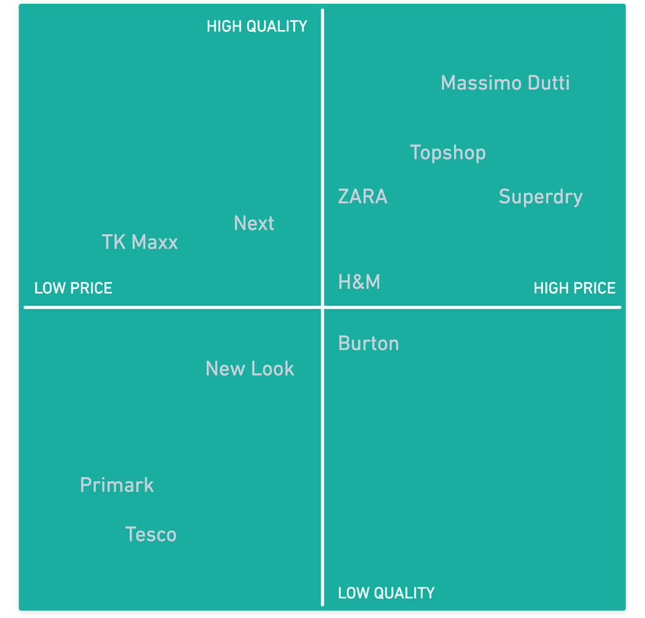
Figure: Example of Positioning (Kotler, 2012)

The Marketing Mix
The marketing mix is regarded as the set of marketing tools that are used by businesses in order to sell products or services to their target group of customers. There are four Ps in the marketing mix and they are product, price, promotion, and place (Van and Van, 1992).
Product: Product refers to the product or service that is being sold to the customers with a view to fulfilling existing consumer demand. For example, Apple’s iPhone is an example of a great product that provides great value to the customers.
Price: Price is the cost of the product or service that is paid by the customers in order to get their hands on the product or service. Before fixing the price, a link must be established to the product’s real value and perceived value. For example, the fashion brand of Japan, UNIQLO can produce high quality and innovative products which are sold at low price.
Promotion: Promotion refers to the actions that are involved in promoting the product or service such as advertising, promotional strategies, and public relations (Baker and Hurt, 2008). The main aim of promotion is to let customers know what value can the product add and why they should pay such a price for it.
Place: Place is referred to any location where the product or service can be used, accessed, or purchased by the customers. Examples of places are distribution centers, inventory decisions, franchises, etc. for example, Apple’s iPhone can be brought from both their online and offline stores.

Conclusion
The marketing process can allow the businesses to promote their brands to their intended customer segment with a defined plan. The concepts of the STP model and marketing mix can allow the business to thoughtfully target their audience and position their products accordingly in terms of place, price, and promotion.

References
Armstrong, G., Kotler, P. and He, Z., 2015. Marketing: an introduction.
Baker, M. and Hart, S., 2008. The marketing book. Routledge.
Baker, M., 2012. The marketing book. Routledge.
Boone, L.E. and Kurtz, D.L., 2015. Contemporary marketing. Cengage learning.
Foreman, S., 2013. Marketing. Henley manager update, 15(1), pp.10-19.
Kerin, R., Hartley, S. and Rudelius, W., 2014. Marketing. McGraw-Hill.
Kotler, P., 2012. Kotler on marketing. Simon and Schuster.
Kotler, P., Armstrong, G., Harker, M. and Brennan, R., 2010. Marketing: an introduction (Vol. 1). Englewood Cliffs, NJ: Prentice-Hall.
McCARTHY, E.J. and Perreault, W.D., 2017. Marketing. McGraw-Hill.
McCarthy, E.J., Shapiro, S.J. and Perreault, W.D., 2019. Basic marketing (pp. 29-33). Ontario: Irwin-Dorsey.
Strauss, J., Frost, R. and Ansary, A.I., 2019. E-marketing (Vol. 4). São Paulo: Pearson Prentice Hall.
Van Waterschoot, W. and Van den Bulte, C., 1992. The 4P classification of the marketing mix revisited. Journal of marketing, 56(4), pp.83-93.

