  Component One: Student Journal (learning log) 750 words +/- 10%  Contribution to Overall Module Assessment: 25% | Student No: | 2243878
 | Module Title: | Hotel Placement Operating Hotel Facilities.
 | Module Code: | BMIH4006
 | Lecturer: | Natalie Brailsford

1. Introduction
As stated by Raghubalan and Raghubalan (2016), housekeeping is referred to as one of the most significant departments of the hospitality industry that is especially responsible for cleanliness, and aesthetic upkeep of the rooms. The part depicts Gibbs's reflective model to analyse self-reflection on the working environment in the hospitality industry.
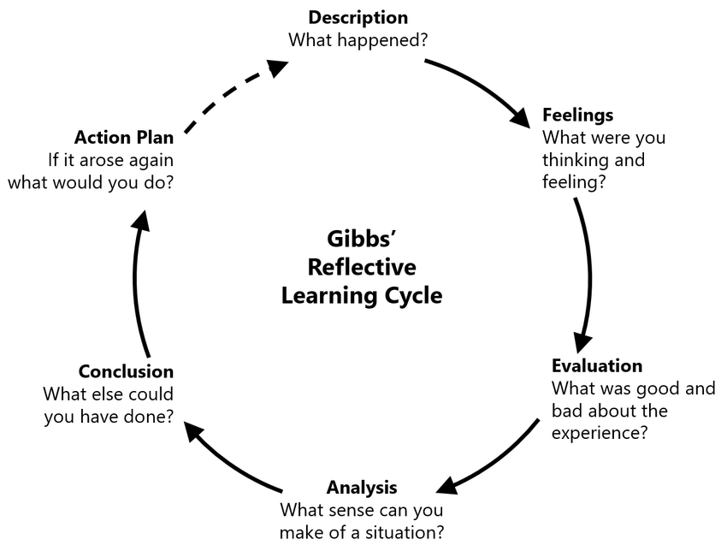
Figure 1: Gibbs Reflective Model
(Source: Harithuddin, 2021, p. 73)

2. Gibbs Reflective Model
Description
The Gibbs reflective model ensures that an experienced person can illustrate their experiences by using some steps (Williams, 2020). As an internship trainee in Missenden Abbey, I have attended “personal and vocational development” training sessions to identify the key trends within the hospitality industry. My role was internship trainee of housekeeping at the Missenden Abbey during the placement session. As a trainee, I collected and disposed of trash and notified the higher authority managers of necessary repairs. During the training period, I was responsible for cleaning and reporting any safety hazards to the manager in charge. By cleaning the rooms of the guests, I was able to influence guest's decision to return. The guest comfort rate of the hotel was in a good position after I cleaned the room through orderliness.
Feelings
My oral communication skills are in good condition which helps me to interact with guests and identify their requirements from the hotel industry. The brand reputation and customer satisfaction rate of the hotel industry have relied on the work of housekeeping workers. The study skill helps a person to elaborate their ideas in a particular matter (Cottrell, 2019). In addition, my judgemental skill helps me to clean the rooms and offer additional services based on the requirements of the guests. In spite of having good communication skills, I faced issues in the fast-paced working environment due to have lack of team working skills. As a trainee of Missenden Abbey, I identified that I was unable to complete the clean of the rooms at the scheduled time which was referred to as my weaknesses in the hotel industry. In this aspect, I try to develop my teamwork skills to collaborate with team members which would help me to meet deadlines for the cleaning works of the rooms.
Evaluation
My effective oral communication skill in this aspect helps me to understand the needs of the guests within the hospitality industry. I was able to keep the rooms organised by applying my problem-solving skills. I took feedback from the guests and managers to measure my performance rate as a housekeeper in the hotel. I was able to effectively interact with all administrative personnel and guests which helped me to identify their needs. Taking “operational tasks” within the leisure club and attending “maintenance and engineering” seminars helped me to develop my technical skills and oral communication skills. I have identified that I need to polish my team working skill and time management skills to complete the work of cleanness of the rooms in a unique way at the scheduled times.
Analysis
During the placement session, I collected information about the significance of the housekeeping work at the hotels. I observed that the guest satisfaction rate of the hotels totally relied on the work of the housekeeping staff. I worked closely with hotel management and the front office department in order to ensure all our work was carried out on time. My roles and responsibilities included preparing rooms between guests' stays. After cleaning the rooms with antibacterial detergent, the rooms were cleaned that help guests maintain hygiene in an effective way. This approach fostered the guest satisfaction rate of the hotel in an accelerated mode.
Conclusion
During the placement session, I identified that strong oral communication skill helps to communicate with the guests. It was also important to maintain teamwork skills and time management skills during the housekeeping work. I experienced that after the pandemic situation, most of the guests prefer hygiene in the hotel industry. Cleaning rooms and towels with antibacterial soaps help in this aspect to maintain the cleanliness of the rooms. The satisfaction rate of the guests encouraged me to carry on my work in a proper way within the hotel industry. My perception of maintaining hygiene and cleanliness as well as public speaking helped me to become a housekeeping manager in the future. My critical thinking skills have been developed after attending the seminar which would help in the future to meet the appropriate needs of the guests.
Action Plan
Objectives | Tasks required | Sources Required | Measurement style | Time Bound
Team working skill | Attending training sessions in "Conflict management" and using my active listening skills with the team workers to develop teamwork skill | I would read books regarding the team working skills and analyse the steps of improving the skill | I would take reviews from my team members to measure this skill | 3 months
Time management skill | I would use a “to-do-list” strategy at the workplace in order to improve my time management skill | Applying a “time-management” matrix would help me to identify how much I improve my time management skill | Taking feedback from the operational manager would help me to develop time management skill | 4 months

3. Conclusion
Gibbs's reflection model is important in order to make an analysis of past experience of a work. Attending workshops and seminars helps a person to develop the weak areas in a corresponding work. It is identified that the housekeeping department helps to increase the employee satisfaction rate in the workplace.

Component Two: Health and Safety Guide
Contribution to Overall Module Assessment: 25%

1. Introduction
As per the view of Leiter and Bakker (2010), exposure to chemicals in cleaning items, including skin reactions or any type of respiratory illness is regarded as a potential hazard to the workers during the housekeeping work. In addition, slip and fall accidents from cluttered surfaces are another hazard at the housekeeping work. The study demonstrates the potential challenges and collects information on hotel industry best practices and regulations related to housekeeping safety.

2. Main Analysis

2.1 Identify potential challenges, collect data on hotel industry best practices and regulations related to housekeeping safety
Hazards
“Repetitive strain injuries” are considered possible hazards for the housekeeping worker. For instance, the heavy physical workload as well as excessive bodily motions create a high risk of back injuries to the workers. In addition, skin and eye irritation issues are faced by the housekeeping workers during the time of washroom cleaning. Damaged electrics are one of the vital hazards in the workplace that may create life-threatening issues for housekeeping workers in the hotel industry.
Practices in the hotel industry
Hilton Hotels announced that the daily housekeeping would be performed based on the requests. Hilton housekeepers would clean rooms “automatically” on the fifth day of the guest’s stay (forbes.com, 2021). On the other hand, the Marriott International Hotel launched a “housekeeping Model” for housekeeping Stay over services. This hotel offers “basic safety training” and updated procedures to all the workers in order to avoid hazards in the workplace. Focusing and reducing the damaged electrics from the workplace in this aspect helps to avoid the chances of short-circuit issues from the workers.
Regulation
Hotel brands such as Marriott International, Hilton and Britannia Hotel follow the Health and Safety Act of 1974 to provide safety and mitigate the chances of “Repetitive strain injuries” among the workers. In addition, the Control of Substances Hazardous to Health Regulations (COSHH) is applied by the hotel industry of the UK to maintain a detailed inventory of all hazardous substances. On the other side, COSHH ensures the chemicals that are used at the workplace are not harmful to the housekeeping workers.

2.2 Precautions
Providing “safe lifting techniques” to all the housekeeping workers
The hotel brands offer a “safe lifting technique” to all housekeeping workers that helps employees avoid strain and injury at the workplace (Mullins and Dossor, 2013). Using long-handled tools like dusters and mops helps to avoid excessive stretching and crouching from the workers. In addition, applying lighter service carts with wheels helps housekeeping workers clean the floor in a shorter period of time.
Ensuring the correct labelling of chemicals
Hotel companies offer a "healthy precaution" strategy to the housekeeping workers that helps them to avoid the chances of skin irritation and eye irritation in a systematic manner. Considering the ventilation in an area where a cleaning item is being applied helps workers stop chemicals from being transferred to other surfaces or skin.
Applying safety regulations at the workplace
Reporting of Injuries, Diseases and Dangerous Occurrences Regulations 2013 is important in the hotel industry as it helps to reduce the chances of workplace accidents or hazards by guiding the owners about the situation. By applying this regulation, hotel owners get an idea to diagnose the causes of workplace hazards and mitigate these in a proper manner.

2.3 Procedures
Preparing the cleaning materials, chemicals and equipment
The housekeeping workers must carry cleaning materials such as vacuum cleaning machines and chemicals like antibacterial soaps before entering the rooms (Fallon and Rutherford, 2010). By using a vacuum cleaning machine, the employees are able to clean the rooms safely in a shorter period of time. On the other hand, using antibacterial soaps in the floor cleaning process helps to clean the rooms properly and helps workers stay safe at the workplace.
Using the “safe lifting technique” in the rooms
The housekeeping workers must use "safe lifting techniques" at the workplace to complete the cleaning work safely and efficiently. Applying this technique helps employees to overcome strain and injuries from their bodies. The long-handled dusters and mops help the workers overcome crouching and stretching issues in an effective way.
Entering the room with gloves and masks
Wearing gloves and masks helps employees avoid the chances of getting infected from dust allergies within the workplace. On the other hand, wearing gloves help employees to get protection from bacteria and spreading illness by which the employees are able to maintain a hygienic workplace within the hotel industry.
Maintaining “Healthy precaution” approaches while trashing wastes
The advanced waste management system must be applied by housekeeping employees while trashing wastes from the rooms. It is required to apply the “Reporting of Injuries, Diseases and Dangerous Occurrences Regulations 2013” to trash the wastes in an effective way.

2.4 Equipment
Protective gloves
The employees must use "Protective Gloves" at the workplace while cleaning the rooms of the guests (Ferdinand and Kitchin, 2017). Applying protective gloves helps employees to avoid the chances of bacterial infection. On the other side, this equipment helps to reduce the chances of infection spreading to a workplace which helps to maintain hygiene in an effective way.
Mops
Disposal mops could be applied by the housekeeping workers during the cleaning of the guests’ rooms. The "Shift lifting technique" through mops helps staff members clean the rooms by reducing the chances of coursing and stretching. In addition, a mop in this aspect helps to keep the rooms clean for a shorter period of time.
Absraves
In order to maintain hygiene at the workplace, housekeeping workers must apply Abrasives to clean metal surfaces of the washroom (Johnston et al., 2012). Absraves are helping in this aspect to reduce the chances of slipping hazards in the workplace. On the other side, wearing "anti-slippery shoes” could be used by the workers to keep the rooms clean by reducing the chances of slipping from floors (theguardian.com, 2020). Anti-slipper shoes could create great friction on the floor by which the employees could reduce the slipper situation in a proper manner. Applying upgraded Brooms technology in this situation helps to reduce the possibility of strain issues among the employees.

2.5 Hazard Mitigation
Hazards | Severity Rates (out of 10) | Solutions
Electric damages | 8/10 | The employers of Hotel brands must check the electric damages at the workplace and take action such as reducing waste and implementing a "strong miniature circuit breaker" system to avoid the chances of short-circuit issues in the workplace
Repetitive Strain Injuries | 7/10 | Repetitive Strain Injuries could be mitigated through applying "safe-lifting” approaches at the workplace. Applying lighter service carts with wheels helps to avoid the chances of workplace accidents.
Exposure to chemicals | 6/10 | Providing regular training and updating protocols on the identification of house cleaning materials helps in this aspect to reduce the chances of skin irritation issues among the workers.

3. Conclusion
The part demonstrates the effective strategies to mitigate workplace hazards in an effective way by using "safe lighting strategies" and offering "basic training" to the employees. The employees can reduce the chances of repetitive strain injuries by applying a lighter service cart at the workplace.

Reference List

Component 1
Cottrell, S. (2019). The Study Skills Handbook. 5th ed. London: Red Globe Press.
Harithuddin, A.S.M., (2021). A first experience of using failure report as a reflective tool in engineering education. International Journal of Emerging Technologies in Learning (Online), 16(18), p.23. https://www.researchgate.net/profile/Viorelia-Lungu/publication/356843846_Artic_Scopus_iJET_vol16_no18_2021_J_p69-84/links/61b05f3b68b5ed4ef5f08872/Artic-Scopus-iJET-vol16-no18-2021-J-p69-84.pdf#page=23
Raghubalan, G. and Raghubalan, S. (2016). Hotel Housekeeping - Operations and Management. 3rd ed. India: Oxford University Press.
Williams, K, Woolliams, M and Spiro, J. (2020). Reflective writing, Macmillan International, Oxford.
Component 2
Fallon, M. and Rutherford, D. (2010). Hotel Management and Operations. London: Pearson.
Ferdinand, N. and Kitchin, P. (2017). Events Management - An International Approach. 2nd ed. London: SAGE Publications Ltd.
forbes.com, (2021). As hotels like Hilton make daily housekeeping optional, will it damage the hotel product? Forbes. Available at: https://www.forbes.com/sites/michaelgoldstein/2021/07/19/hotels-like-hilton-drop-daily-housekeeping-will-it-annoy-customers/?sh=5f61b8b97205 (Accessed: January 29, 2024).
Johnston, R., Clark, G. and Shulver, M. (2012). Service Operations Management. London: Pearson.
Leiter, M. P. and Bakker, A. B. (2010). Work Engagement: A Handbook of Essential Theory and Research. Hove [England]: Psychology Press.
Mullins, L. and Dossor, P. (2013). Hospitality Management and Organisational Behaviour. 5th ed. Harlow: Pearson.
theguardian.com, (2020). “Cutting edge: Japanese paper art inspires a non-slip shoe,” The Guardian, 1 June. Available at: https://www.theguardian.com/technology/2020/jun/01/cutting-edge-japanese-paper-art-inspires-a-non-slip-shoe (Accessed: January 29, 2024).

