Web Development
Design Patterns in Web Development

Rhys Harding 1809709

Submitted in partial fulfilment for the award of the degree of
MSc (Hons)/PgDip/PgCert Software Engineering (Web Development)
University of Wales Trinity Saint David
April 2019

Contents

The use of Design Patterns in Web Development 2
Introduction – 2
LAP – 3
Model: 3
View: 3
Controller: 3
Object Relational Mapping – 6
Repository Pattern – 6
Unit of Work Pattern – 8
ORM with Repository and UoW Pattern – 8
Conclusion – 9
Bibliography 10

The use of Design Patterns in Web Development

Introduction –

Design patterns are commonly used techniques that a developer might include within their software system to overcome common or specialist encounters, which would otherwise hinder, or inefficiently affect the structure or implementation of a piece of code [1]. Design patterns can include but are not limited to the Singleton Pattern, Factory and Abstract Factory Pattern, Builder Pattern and Model View Controller Pattern. These patterns each carefully manipulate the way an Object Oriented Program (OOP) executes its classes and instances [1]. A variety of techniques are used, making use of interfaces, abstract classes, private or protected attributes, and others [1]. Many patterns can be used in conjunction with one another, or not at all, however they will not necessarily be implemented on the same functionality, rather multiple patterns combine together to fulfil business needs or idealistic approaches [1]. Each pattern is thought of as being the most efficient and desirable way of executing a particular piece of functionality, in such a way that certain strategies are encompassed [1]. For instance, the Model View Controller (MVC) Pattern is one that is sometimes used to attain layered architecture and is considered a Layered Architecture Pattern [2].

This report will investigate the use of Layered Architecture Patterns (LAP) and Object Relational Mapping (ORM) with Repository and Unit of Work Patterns; outlining their common usefulness in web applications. This report will further explore the benefits of using these techniques and will describe their necessity for particular programs, demonstrating their efficiency and productivity. In addition to this, the report will aim to identify any drawbacks that these strategies consequent and will aim to provide a critical analysis of these architectural and design patterns.

LAP –

A LAP is one that insists upon a certain way in which the architecture of a software program is designed [3] [4]. LAP describes that the modules of a software program should be separated into “layers”. These layers are designed such that they encapsulate different elements of a system [4]. They are considered as being isolate so that they deal with a specific task or concept [4]. The MVC pattern, for instance, is a version of layered architecture, which separates a program into the three layers that are model, view and controller.

Model:
The model layer is where the raw data object is created, or where the main components of an application are held [5]. This layer is purely for describing and holding the data of an application; it has no reference as to how this data is used, or any other logic concerning as to how it is presented to the user [5]. Therefore, it is completely isolate to the rest of the program and stands alone within the system, but will often contain the means to implement creation, change, deletion or extraction of the data being held [5].

View:
The view layer is entirely concerned with how the data and application is presented to the user [5]. It knows how to access the data, but it is not concerned with what can be done with said data, neither with what it means [5]. Generally, the view layer is where the presentation of the application is considered [5]. This is regarded an important factor as it is the design of the application which will become the first encounter for a user [5].

Controller:
Finally, the Controller layer is concerned with the functionality between the view and model layers [5]. This layer acts as the link between the two layers, representing the changes made in the view layer and reflecting and implementing them in the model layer [5]. This layer will task itself with directly working on the model data, creating and updating the data and so forth, and instantly echoing these changes to the view layer so that the user can be notified [5].

There exist many variations to the layered architecture approach, sometimes depending upon multiple layers, which is where LAP is often referred to as n-tier architecture pattern, however, the idea remains the same [6]. It is not uncommon to see, in such scenarios, additional layers, such as business, persistence and service layers [4]. These layers describe another way in which an application is structured, including where business logic is implemented and where the data follows a slightly different flow through the system, but likewise, there exists a presentation and database layer, and each layer remains isolated to one another [4]. However, there does exist a link between each layer for which the data is passed through. Each layer is connected to the next, often in a linear fashion although this is in many cases is an ideal and can be a well-designed system [7].

Following a linear design, all layers are considered as being closed. The concept of a layer being closed means that the flow of data moves from one layer to the next exclusively [7]. Conversely, the architecture of an application will not always include closed layers and may consist of a certain layer being open. An open layer indicates that the layer before is able to bypass that specific layer [7]. This is sometimes desirable when implementing a service layer when, for instance, logging or auditing, where you do not necessarily want the flow of data to have to pass through this layer, rather it is able to bypass it [7] as seen in Figure 1.
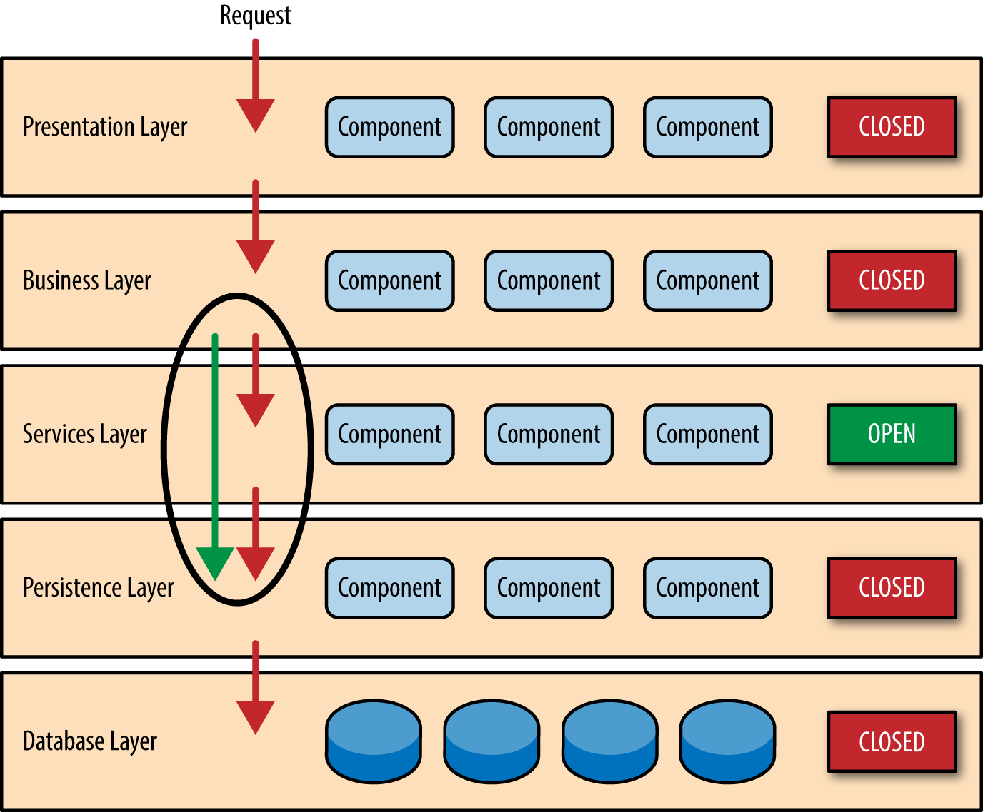

Figure 1. Layered architecture closed and open layers [4].

Layered architecture produces a carefully structured application that through the isolation of layers, becomes easy to design, in the sense that each layer is somewhat independent of the other layers, so much so that it is not required to develop any more functionality other than that of which is within the scope of that layer [4], [8]. It is left to only require the following layer to be able to communicate with the neighbouring layers [4], [8]. An advantage to this design, from a developmental perspective, is it becomes a lot easier to develop these layers since each layer does not wholly depend on the next [4], [8]. This way a layer can not only be created in parallel to other layers, but it can also be exchanged for a new or updated version of itself [4], [8].

For example, in the case of a database layer, a PostgreSQL database can be substituted for another database system without the expense of having to change what would be a rippling effect throughout the rest of the application [9]. As a consequence, maintenance of the code becomes cost effective since any changes can be easily contained. In addition, testing becomes easier and more effective as the application can test each layer independently of the surrounding layers with the aid of mocks and stubs to emulate any interactions between adjacent layers [4], [8].

Although layered architecture lends itself to high testability and development, LAP can often fall short when one considers how tightly coupled and sequential the layers are [4]. Due to this inter-dependent nature, the application can be difficult to scale, and performance can be hindered as a result of the sequential process, a business request for instance, may have to go through [4]. Furthermore, although each layer often remains isolated, the coupling between them can often result in timely efforts in order to change these ties between layers whenever a change to the application is needed, making the agility of the application quite poor [4]. Likewise, there is a possibility when deploying the code, that a specific change in code could result in the change in large proportions of the surrounding layers [4].

Object Relational Mapping –

Object Relational Mapping is a conceptual technique used for mapping data from objects in programming languages to databases which underpins the application the program is using [10]. An Object Relational Mapper (ORM), will automatically convert each entity within a relational database to an object in a program’s code, where the two systems would otherwise be incompatible [7], [11], [12]. The ORM makes use of its own library for developers to write queries within their language of choice [13]. It is often favourable for a developer to use such mappers when they tend to be more skilled in a specific language [13]. This way it is not needed to understand the querying language of a database, rather a developer can continue to use the language of choice and utilise the mapper to handle the querying to the database [13]. This is beneficial for instances when one database is substituted for another as the mapper abstracts away from the specific structured query language (SQL) of the interchanged database [14]. Furthermore, through using the ORM, any incompetence of the querying language is omitted [13]. Although one can avoid using database SQL, time is required to learn how to use the ORM and its libraries. Furthermore, abstraction from the querying language may mask a weakness in a developer’s skillset [4], [13].

Repository Pattern –

The Repository Pattern is one where a Repository layer acts as a mediator between a data source layer and a client business logic layer [15]. It is purely responsible for handling requests to the data source wherever the application requires and will usually contain an ORM to accompany and complete the task [15]. The Repository layer is a strategy in which the benefits of keeping all data source handling in one place, enables developers to easily maintain and test [15]. As opposed to being scattered throughout the application, the repository layer will contain all the necessary components in which to retrieve, create or change the data held in the data source [15]. The design of a repository is such that it can be used throughout the application by other layers without the need of knowing how the data source is queried [15]. This abstraction helps to keep this layer isolate, enabling the layer to stand independent of the others and also makes it easier for developer to test [15]. Testing can be done with far greater ease with the use of this pattern as the layer can be easily stubbed and mocked, in comparison to having to replicate the entire data source layer [15]. This layer will typically include basic operations such as the following [15]:

- public interface Repository<O> {
- void create(O item);
- void delete(O item);
- void update(O item);

- List<O> getAll();
- O getById(int id);
- }

These methods cover the basic operations that an application might want to utilise and constructs a template for a repository layer which will then derive how the data source is queried through each method, often with the use of an ORM [15].

Unit of Work Pattern –

The Unit of Work pattern (UoW) is one that works very closely with the Repository pattern. The UoW is used to track all the changes made to the data source in the repository layer within a single business transaction [16]. It does this by tracking an in-memory account of the updates in order to make sure that the correct changes are made, to then persist in the database [16]. Instead of committing each individual change to the database separately, the pattern utilises a way in which all changes are collated until after all requests have been made [16]. Once all requests of that particular business transaction have been made, the pattern then encapsulates all these ‘pieces of work’ into a unit, in preparation to make a single request to the data source [16]. This way, since only one request is being made to the data source, as oppose to multiple, the process can be completed a lot quicker as the data source will not have to queue multiple transactions [16]. Another advantage of executing the changes to the data source in this way, is that if a single operation fails then the entire transaction will also fail, making the transaction an atomic one [16]. Atomicity is one of the properties of ACID (Atomicity, Consistency, Isolation and Durability) transactions and is considered good practice for database systems [17]. The idea of the UOW pattern inducing atomic transactions means that the data source will be updated wholly or not at all, attributing to the data source remaining in a consistent state [17]. By the nature of this pattern, containing all changes and tracking them in one place means that it can be maintained easier.

ORM with Repository and UoW Pattern –

A repository layer is responsible for two particular tasks, data retrieval and data persistence. For retrieval the repository is responsible for taking the data from the data source and converting that data into an object [18]. Conversely, for persistence of data, the repository is responsible for taking the object and inserting any updates into the data source [18]. It is possible to do this with the use of an ORM. When one introduces an application with multiple objects, it is often the case where multiple subsequent repositories exist for each of these objects. A particular problem with this sort of structure is that often the application will have multiple repositories making separate updates to their respective data source structures at the same time [18]. Often, this can lead to inconsistencies in the data source, when for instance, one of two transactions fails to insert correctly. The use of a UoW pattern enables the application to bundle up the in-memory objects with their transactions and encapsulate them into a single transaction [18]. This way through the UoW pattern the transaction either fails entirely, and in the meantime the data source remains unchanged but consistent, or the transaction is successfully completed and again the data source is consistent hence preserving the atomicity of the data source [18]. On the contrary, it can be argued that the ORM can be said to be a replacement for the repository pattern, and that the use of both just adds an extra layer of abstraction that is unnecessary. Furthermore, the UoW and repository can often be used in such a manner that they become tightly coupled amongst themselves which can lead to difficulties in testing.

Conclusion –
This report has outlined the principle of layered architecture and analysed its utility in software development practices. Whilst the layered architecture pattern creates a structure that becomes easier to test and develop through layers of isolation, the layers and the surrounding layers are inter-dependent upon the next, resulting in a structure that can becomes difficult to scale and can create performance issues. This report has also outlined the use of an ORM, repository design pattern and the UoW, as well as the effectiveness of using them all in conjunction with each other. Independently, each of these concepts have their advantages and disadvantages, and when in conjunction with one another will likewise present benefits and drawbacks. Together an application can successfully connect with a back-end data source, consistently achieving atomicity in the transactions of the persisting data. However, it can be argued that the coupling can lead to excessive abstraction. The combination of these patterns and techniques are widely used in software development and it can be easy to adopt a pattern with the intention of creating a better system without knowing where and why it is best suited. This may lead to a design that unknowingly creates problems. Perhaps a developer should begin to question why they intend to use a specific pattern before doing so, instead of adopting them with the false pretences of improving their code.

Bibliography

[1] | A. Mansour, Building Scalable Web Applications: Researching Frameworks and Design Patterns., 2016.
[2] | V. Kumar, A. Kumar, A. K. Sharma and D. Singh, "Implementation of MVC (Model-View-Controller) design architecture to develop web based Institutional repositories: A tool for Information and knowledge sharing.," Indian Research Journal of Extension Education, vol. 16, no. 3, pp. 1-9, 2016.
[3] | A. H. Eden and R. Kazman, "Architecture, design, implementation.," Proceedings of the 25th International Conference on Software Engineering, pp. 149-159, 2003.
[4] | M. Richards, Software architecture patterns, O'Reilly Media, Incorporated, 2015.
[5] | A. Freeman, "The MVC Pattern, Projects, and Conventions.," in Pro ASP. NET Core MVC 2, Apress, Berkeley, CA, pp. 53-65.
[6] | B. D. Loyd and D. Kannan, "Identifying Design Patterns for Risk Management system using Big Data Analytics.," 2017 International Conference on Trends in Electronics and Informatics (ICEI), pp. 305-312, 2017.
[7] | A. Gerber, A. Barnard and A. Van der Merwe, Towards a semantic web layered architecture., 2007.
[8] | D. D. Clark and D. L. Tennenhouse, "Architectural considerations for a new generation of protocols.," ACM SIGCOMM Computer Communication Review, vol. 20, no. 4, pp. 200-208, 1990.
[9] | D. Dorofeev and S. Shestakov, "2-tier vs. 3-tier Architectures for Data Processing Software.," Proceedings of the 3rd International Conference on Applications in Information Technology, pp. 63-68, 2018.
[10] | E. J. O'Neil, "Object/relational mapping 2008: hibernate and the entity data model (edm)," Proceedings of the 2008 ACM SIGMOD international conference on Management of data, pp. 1351-1356, 2008.
[11] | R. Elmasri, Fundamentals of database systems, Pearson Education India, 2008.
[12] | M. R. Blaha, W. J. Premerlani and J. E. Rumbaugh, "Relational database design using an object-oriented methodology," Communications of the ACM, vol. 31, no. 4, pp. 414-428, 1988.
[13] | C. Xia, Y. Guangcan and T. Meng, "Efficient implement of ORM (object/relational mapping) use in J2EE framework: Hibernate.," 2009 International Conference on Computational Intelligence and Software Engineering, pp. 1-3, 2009.
[14] | M. Armbrust, R. S. Xin, C. Lian, Y. Huai, D. Liu, J. K. Bradley , X. Meng, T. Kaftan, M. J. Franklin, A. Ghodsi and M. Zaharia, "Spark sql: Relational data processing in spark.," Proceedings of the 2015 ACM SIGMOD international conference on management of data, pp. 1383-1394, 2015.
[15] | E. Hieatt and R. Mee, "MARTINFOWLER.COM," 2003. [Online]. Available: https://www.martinfowler.com/eaaCatalog/repository.html. [Accessed 30 March 2019].
[16] | Q. Liang, J. Y. Chung, S. Miller and Y. Ouyang, "Service pattern discovery of web service mining in web service registry-repository.," 2006 IEEE International Conference on e-Business Engineering (ICEBE'06), pp. 286-293, 2006.
[17] | S. Yu, "Acid properties in distributed databases.," Advanced eBusiness Transactions for B2B-Collaborations, 2009.
[18] | H. Dorfmann, "The Evolution of the Repository Pattern - Be Aware of Over Abstraction," 2016. [Online]. Available: http://hannesdorfmann.com/android/evolution-of-the-repository-pattern. [Accessed 30 March 2019].

marking criteria and Student FEEDBACK

This section details the extent to which the assessment criteria are demonstrated by you, which in turn determines your mark. The marks available for each category of skill are shown. Lecturers will use the space provided to comment on the achievement of the task(s), including those areas in which you have performed well and areas that would benefit from development/improvement.

Common Assessment Criteria Applied (Assignment 1) | Marks available | Marks  awarded
1. Engagement with Literature Skills

An excellent range of appropriate literature has been consulted and referenced in the work and the review and discussion of the literature is of a very good standard. (Grade mark: 80.00%) | 15 | 12
2. Knowledge and Understanding Skills

A very good overview of the layered architecture pattern with some good points discussed in the advantages and disadvantages section. A very good overview of ORM frameworks and the repository and unit of work patterns with some good points mentioned in the advantages section, but generally, I would have liked to see some more depth to your discussion. You do identify some of the criticisms of using the repository and unit of work patterns with ORM frameworks, but again, this section is too brief. (Grade mark: 72.00%) | 75 | 54
3. Cognitive and Intellectual Skills

4. Practical Application Skills

5. Transferable Skills for Life and Professional Practice

The report is well-written and presented. (Grade mark: 80.00%) | 10 | 8

Assignment Mark (Assessment marks are subject to ratification at the Exam Board. These comments and marks are to give feedback on module work and are for guidance only until they are confirmed. ) | Late Submission Penalties (tick if appropriate) |  | 74%
 | Up to 1 week late (40% Max) |  | 74%
 | Over 1 week late (0%) |  | 74%

