Student Name: Yousuf Mohammed
Student Number: 1713906
Module Code: BMSK4003
Module Title: Digital Skills and Research Methods
Module Lecturer’s Name: Mr Zee Zook

Contents
Introduction: 4
Evaluation of the effectiveness of the use of modern technologies within the workplace: 5
Office automation: 5
Database management system: 8
Vendor management inventory: 8
EDI: 8
Just-in-time inventory: 8
Automated order processing: 9
Exploring social media as a tool for marketing, information gathering, and communication 10
Social media as a marketing tool: 11
Social media as a tool for collecting information: 11
Social media as a tool for communication in the workplace: 12
Creating the professional online presence: 13
Conclusion: 16
References 17

Introduction:
The technological innovation and its involvement in the organization to minimize the cost of operation as well as maximize the productivity of the workforce have increased the demand for digital skill in the workplace. Digital literacy or the digital skill includes a continuous process of acquiring skill ranging from basic and operational skill to higher-order cognitive, social and attitudinal skills and abilities(Richardson & Bissell, 2017). However, the following assignment is going to focus on the evaluation of the effectiveness of the use of modern technologies in the workplace and exploring the social media as a tool for marketing, information gathering, and communication within the workplace. Lastly, the significance of creating a professional online presence to illustrate and evidence the research will be mentioned.

Evaluation of the effectiveness of the use of modern technologies within the workplace:
In the UK, almost 20% of the adults have a lack of basic online skill; among them 7.7 million are offline and 2.8 million are online. Nearly 77% of SME has the ensured the competency and application of the digital skill in their workplace(Corporation, 2018). Therefore, the requirement of the digital skill to recruit the new employee has become compulsory nowadays. However, the involvement of the modern technology in the workplace increases the efficiency of the workplace increases the office productivity and decreases the operational costs. However, the technology has contributed to almost every sphere of the organization from procurement to customer service.

Figure 1: the use of modern technology on the workplace of the UK
Source: (Spitz, 2004)
Office automation:
It contributes to improving the productivity of the operations in the organization with digitally creating, collecting, storing, and manipulating information needed in the administration and decision making process. It improves the speed and the accuracy of collecting data and information, processing them according to the requirement, storing them digitally and reducing the cost and labor of paperwork and human error also. The office automation tools contribute to marketing, office management, contact management, project management, and human resource management, employee training, and managing the office environment(Lieberman, et al., 2001). Here is a list of tools stratified with the fields below-
Table 1: a list of office automation tools in the different functional area
Source: (Ruprecht& Wagoner, 2003)

Database management system:
Database management system refers to the system software that helps to create and manage databases. It is computer application software interacts with the end users, other applications and the database itself to analyze and capture data. This system is used to assist the internal operations and to underpin the online interaction with the suppliers and the consumers of the organization holding administrative information and more specialized data. It helps to organize all kinds of data needed in the organization and customize them according to the necessity of the decision makers improving the analytical skill and promptness of decision making(Ramakrishnan&Gehrke, 2011).

Vendor management inventory:
It refers to a family of business models where the buyers provide the information of the products they need and the supplier fulfill that with the solutions taking full responsibility and the communication is ensured with a specialized software. It helps to improve the efficiency of the inventory management and reduce the rate of lost sale(Husack, 2001).

EDI:
The electronic data interchange refers to the exchange of business documents from computer to computer in a standard electronic format among the business partners. It helps to improve the business communication among the partners contributing to the investment decision, inventory management, purchase orders, invoices etc(Ongetta, 1995).

Just-in-time inventory:
It is inventory management strategies aims at increasing efficiency and decreasing the waste by providing the goods to the consumer only after the place the order or exposes their interest in purchasing. It contributes to minimizing the cost of operation and logistics with zero inventories, zero lead time, no failure, and no delay in order fulfillment. It is growing popular in spite of having a more complex and costly process system to imply(Christopher, 2016).
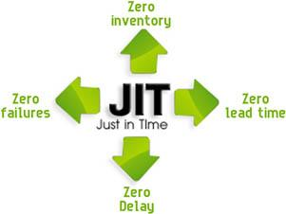
Figure 2: the JIT inventory
Source:(Kildow, 2011)

Automated order processing:
It is also specialized software that contributes to take the order and operate the total order fulfillment process automatically. Most of the online retailers are using this software to ensure the 24/7 service and reducing the cost of handling the order fulfillment process increasing the efficiency also as it manages multiple order at a time(Mentzer, 2001).
It is to say that the contribution of the modern technology in the business activity is decreasing the cost and labor in the different functional areas as well as ensuring the accuracy and speed of the activities. It also helps in decision making processing increasing the analytical skill and assessing the related data that results in the improvement of the effective decision making process.

Exploring social media as a tool for marketing, information gathering, and communication
Social media has created a revolution in communication system around the world and also become a medium of reaching a huge target market as well as creating an interactive communication. In the UK 42 million people actively use the social media like Facebook, Twitter, Instagram, Whatsapp, Snapchat etc. Among them 36.6 million people use Facebook and it is dominating with 75% of the market share of the social media; Twitter has a 10.79% market share("Home internet and social media usage - Office for National Statistics", 2018).
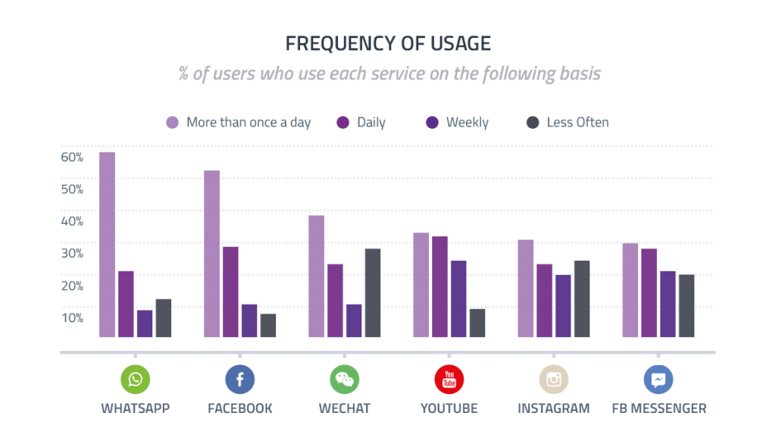
Figure 2: the frequency of using social media in the UK in 2017
Source:(Facts, 2018)

Social media as a marketing tool:
There has been emerged a new marketing term that is called the social media marketing that only focuses the social media to operate the marketing activities like informing the customers about the product, promotion, customer relationship management, customer service, review, and recommendation etc. 60% of the UK business organizations are using social media as a marketing tool especially the small and medium businesses. The global spending on the social media advertising in 2016 was $36.09 billion. However, in the customer relationship management, the interactive communication facility helps to make contact with the customers and answer their queries about the product and service before and after sales. The social media advertising enjoys the highest coverage because of the huge involvement of the prospects in the social media(Cohen & Zaidi, 2002). To collect feedback about the market offerings, the company can use this mode of communication along with engaging the customers in the decision making process to anticipate the demand on the market.

Social media as a tool for collecting information:
As it is a mode of interactive communication and the popularity of using social media is surging highly day by day, the company can cover a large share of the prospect while collecting the primary data through an online survey. The indifference of the prospect to provide their consent may hamper the data collection and authenticity but it is regarded as the most effective tool for data collection. The cost-effectiveness of the social media communication has contributed to the familiarity of using it as an information-gathering tool. However, the informal communication through social media can also help to oversee the market and evaluate the position of the company in the customer's mind. The company can encourage the participation of potential market in data collection arranging a competition and it can contribute to understanding the way the customers want to be served. However, it can be said that both the qualitative and quantitative data collection can be effectively performed using the social media. Collecting the review and the feedback from the customers using the rating system can help in estimating the brand equity of the company(TUTEN, 2018).

Social media as a tool for communication in the workplace:
Social media is mainly a platform for communication where people can share their views, activities, and opinions freely with minimum social restriction and be connected with a huge sum of people. it is building a complex web of communication connecting the individual with all the other members. However, to perform the internal communication within the workplace, the organization can maintain a group in the social media platform like Facebook, and Whatsapp and deliver the necessary formal and informal message there to inform the team members or take their opinion on a certain matter. It is quite impossible for the decision maker to collect the opinion of all the superiors and the subordinates at once in a formal meeting but he can make it possible using this platform as here the simultaneous presence is not mandatory. It can also contribute to creating a healthy, congenial, and cooperative communication within the workplace creating personal communication among the employees and the managers reducing the formal communication gap among them. The internal recruitment, hiring, and training process can also be developed using the social media(Barker &Gaut, 2002).

Creating the professional online presence:
The professional online presence refers to expressing the career interest and evidence in developing a career of the individual in the social media that creates his professional image. Nowadays, most of the multi-national companies follow the professional image of the applicants to evaluate their interest in the specific field and estimate his expertise and ability to add value. Here is a statistics of using the social media as a tool for recruiting the employees-
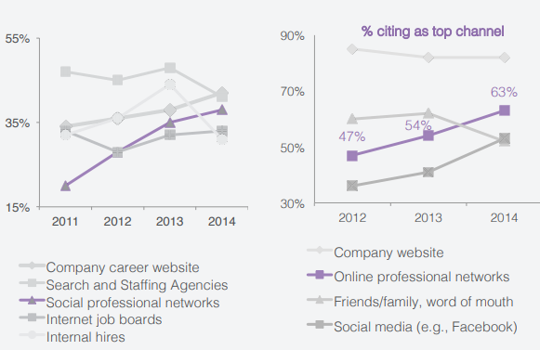
Figure 5: the social and online professional networks used for recruitment
Source:(facts, 2018)
The above chart shows that the role of the social professional network to collect is growing over the years and it was 37% and continues with the same growth in the successive years. Therefore, carefully building a professional image can help the fresher or the individual to expose his interest and expertise. The professional image can be built using a systematic process-
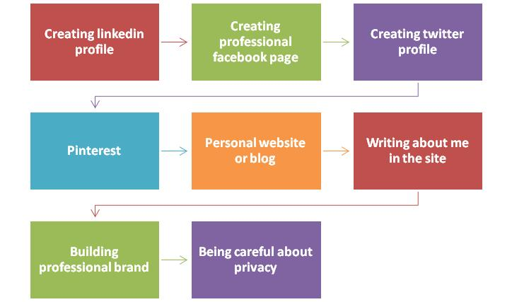
Figure 4: the process of creating a professional image in social media and ensuring the online presence
Source:(akyazı, 2018)
The process can be started with creating a LinkedIn profile and ended up ensuring the privacy of the information shared. A LinkedIn ID can help the candidates to update his achievements, activities, competencies, and thoughts using this profile and most of the employers oversee this professional ID to evaluate the intelligence of the employee and the level of his creativity. They select the employees that match their requirement and the skills that can contribute to the success of the organization to meet its vision. Then, he can create a Facebook page or profile with the same purpose but it can help him to share it not only to represent it to the professionals but also to share to the mass as it is the most popular social media around the world. The Twitter profile can be developed to follow the different successful personnel and also to express his views and interest like in the other social media. Pinterest can help to identify the jobs of the interests automatically. The personal blogs help to publish articles, career planning, and progress in development also. However, after completing the building of the social media platform, the applicants should write about his thoughts, his specifications, visions, views, and achievements that represent his intelligence and wisdom. The discussion on the different professional issues and factors can help the individual to build a professional brand image that can also contribute in getting preference while recruitment. And lastly, he must ensure the privacy of his personal data to avoid the risks of data manipulation and hacking. While building the professional image on the social media the individual should be careful about his behavior on the social platform(Stankiewicz&Bortnowska, 2016).

Conclusion:
The digital skill or the knowledge of using technology has become a primary requirement whole assessing the competencies of the employees as most of the functions of any business or non-business organizations are now depends on the technology. Though the UK is a developed country, it is facing a significant shortage of digital skill in their workforce and therefore, the government has started a lifelong learning process to overcome this crisis. The above discussion has proven that the digital skill is needed in managing the workplace using office automation, EDI, VMI, DBMS, and other tools that contribute to cost efficiency. It also contributes to data collection, communication, and especially in the marketing activities creating a platform to reach the highest amount of the prospects. The individual can create his or her professional image in the social media platform to create an online presence that can help him to ensure success in the career development process(akyazı, 2018).

References
akyazı, e. (2018). Social media as corporate reputation creating medium: A research on tour company’s social media accounts. Journal Of Tourism Theory And Research, 87-97. doi: 10.24288/jttr.415480
Barker, L., &Gaut, D. (2002). Communication. Needham Heights, MA: Pearson Professional Education.
Christopher, M. (2016). Logistics and supply chain management. Harlow (England): Pearson.
Cohen, M., & Zaidi, M. (2002). Global skill shortages. Cheltenham, U.K.: Edward Elgar.
Corporation, M. (2018). Digital Skills - Microsoft UK. Retrieved from https://www.microsoft.com/en-gb/athome/digitalskills/
facts, O. (2018). Topic: Online and social media recruiting. Retrieved from https://www.statista.com/topics/2727/online-recruiting/
Facts, S. (2018). Topic: Social media usage in the UK. Retrieved from https://www.statista.com/topics/3236/social-media-usage-in-the-uk/
Home internet and social media usage - Office for National Statistics. (2018). Retrieved from https://www.ons.gov.uk/peoplepopulationandcommunity/householdcharacteristics/homeinternetandsocialmediausage
Husack, G. (2001). Inventory management. Buffalo, N.Y.: Institute for Small Business.
Kildow, B. (2011). A supply chain management guide to business continuity. New York: American Management Association.
Lieberman, M., Selig, G., & Walsh, J. (2001). Office automation. New York: Wiley.
Mentzer, J. (2001). Supply chain management. Thousand Oaks: Sage.
Ongetta, S. (1995). Electronic Data Interchange — What are the security measures?. Network Security, 2009(8), 16-19. doi: 10.1016/1353-4858(96)89744-3
Ramakrishnan, R., &Gehrke, J. (2011). Database management systems. Boston: McGraw-Hill.
Richardson, L., & Bissell, D. (2017). Geographies of digital skill. Geoforum. doi: 10.1016/j.geoforum.2017.09.014
Ruprecht, M., & Wagoner, K. (2003). Managing office automation. New York: Wiley.
Spitz, A. (2004). Are Skill Requirements in the Workplace Rising? Stylized Facts and Evidence on Skill-Biased Technological Change. SSRN Electronic Journal. doi: 10.2139/ssrn.553883
Spitz, A. (2004). Are Skill Requirements in the Workplace Rising? Stylized Facts and Evidence on Skill-Biased Technological Change. SSRN Electronic Journal. doi: 10.2139/ssrn.553883
Stankiewicz, J., &Bortnowska, H. (2016). Professional image creation by students on social media sites (in the light of empirical research). Management, 20(1), 111-125. doi: 10.1515/manment-2015-0028
TUTEN, T. (2018). SOCIAL MEDIA MARKETING. [S.l.]: SAGE PUBLICATIONS.

Face book Profile:
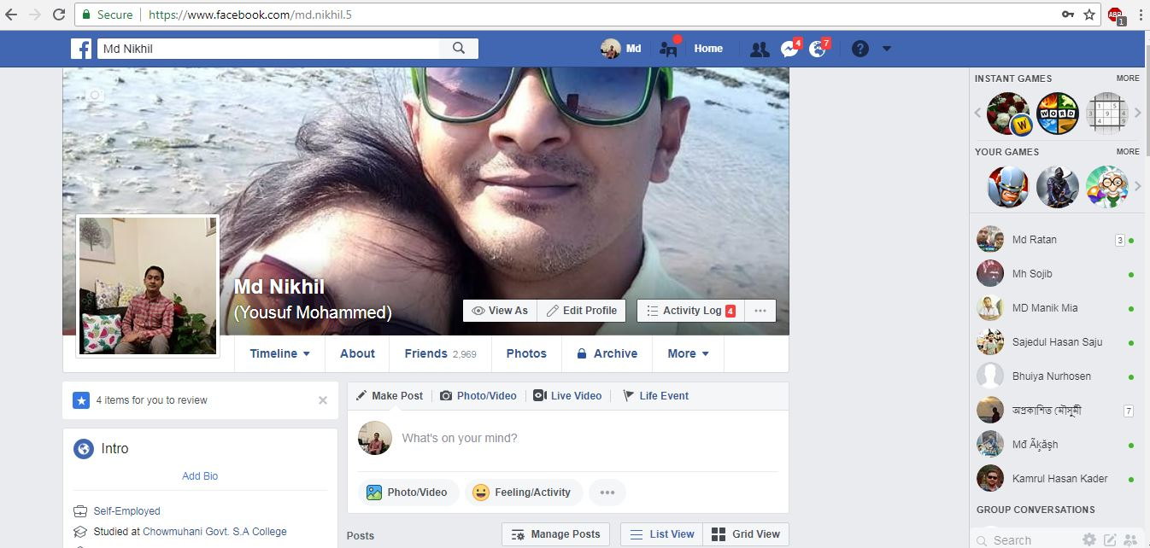
LinkedIn Profile:


