An Aesthetic Study of Chinese Animated movie characters from the Perspective of Semiotics

Manyu Tang

Abstract This study aims to find out the meaning of character aesthetics in Chinese animated films. Chinese animated film characters are an important carrier of Chinese film cultural symbols, with unique emotional beauty, formal beauty and image beauty. From the perspective of semiotics, the characters of Chinese animated films are an image expression of emotional concepts, which can satisfy the unique aesthetic taste of Chinese people under the influence of Chinese aesthetic culture. At the same time, as a kind of material existence of aesthetic object, it can lead people into an aesthetic state in the form of illusion, exaggeration and freedom. Chinese traditional aesthetics holds that beauty lies in images. Chinese animated film character designers form image shapes in their minds through the choice of body senses and creative imagination, and express them as concrete symbols through paintings or numbers, which can simulate, indicate and symbolize new meanings, and gradually form the unique aesthetics of Chinese animated film characters. Finally, Beauty is the essence of artistic existence. Under the background of today's aesthetic culture and consumption, the significance of artistic beauty needs to be re explored. I hope to find the deconstruction and construction process of artistic aesthetic significance in the current era by analyzing the aesthetic significance of Chinese animated film characters, and provide theoretical support for the future creation and development of Chinese animated film characters.
Keywords Semiotics；animation film；characters；Aesthetic

Contents
Abstract ..........................................................................................................................1
1.Introduction ................................................................................................................3
2. An overview of semiotic theory.................................................................................4
3. What is beauty? ..........................................................................................................8
4. Research Status of Animation Film Characters.......................................................13
5. Research Methodology............................................................................................14
6. Aesthetic Choices and Emotional Expectations in the Characters of Chinese Animated Films ...........................................................................................................15
7.Conclusion ..............................................................................................................19 8. Reference .................................................................................................................21

1.Introduction
Chinese animated films have gradually emerged in recent years, with good output and social impact, and are gradually gaining recognition from audiences. Overseas market expansion has also seen a sustained upward trend, playing a positive role in the promotion of China's cultural value system. The characters in an animated film are equivalent to the actors in a film, and are the subjects who perform in the form of life in animation, playing a crucial role in the success of an animated film. Aesthetic culture refers to the social sensual culture dominated by human spiritual experience and aesthetic view of forms. It is a special social activity in which human beings purposefully and consciously create beauty and enjoy it, and it is an artificial rather than natural aesthetic activity. （Lukács, G.1998）The aesthetic identity of the young generation of Chinese people has a "deficit" phenomenon, that is, more imported than local. For example, the young generation of Chinese audience to the animation character aesthetic more identify with the Japanese animation character modeling and art style, or Europe and the United States and other countries character modeling style. Therefore, thinking about how to create domestic animation film characters, constantly absorb the "Chinese meaning" of the cultural symbols, to create a unique aesthetic meaning, to maintain the diversity of animation character art style, build Chinese aesthetic culture system, to meet part of the national aesthetic psychology of identity play a positive role.
2.An overview of semiotic theory
Semiotics was born one hundred years ago as a relatively new field of study concerning the production, understanding, and operation of symbols in human society. It is internationally recognized that there are two sources of semiotics, one being the Swiss linguist Saussure and the other being the American mathematical logician and pragmatist philosopher Peirce. As the founder of modern semiotics, Saussure argued that ‘nothing is more appropriate than the study of languages to bring out the nature of the semiological problem' (De Saussure, 2011). The core of Saussure's semiotics was language. He proposed that the sign was a mixture of the referent and the referent and thought that linguistics was a kind of semiotics, highlighting the social and structural nature of language. It also had an impact on following developments like French structuralism and Russian formalism. Levi-Strauss' structural anthropology is one example of how it is comparable. Semiotics was used to examine literature and culture by structuralism supporter Roland Barthes. Literature, according to Barthes, is a body of symbols that all contribute to the meaning of the text in some manner. In culture, Barthes advocates the study of texts, arguing that to films, commodities, events and images are given meaning through their association with certain symbols. Other scholars influenced by semiotics include the philosopher Louis Althusser, Foucault and others. In his famous 1969 book on epistemology, The Archaeology of Knowledge, Foucault says: "We can call the whole knowledge of making signs 'speak' and developing their meaning hermeneutics; the whole knowledge of identifying signs and understanding the laws of connection, semiotics" (Foucault, M., 2013). Whitehead's opinion is similar to Foucault's: "Human beings seek symbols in order to express themselves; indeed, expression is symbolic."
Peirce's semiotic ideas are based on pragmatist philosophy, category theory and logic, and are not limited to language, but include the role of meaning in everything. The connection between symbols and human thought is highlighted, and the focus is on starting with meaning; one should look more at the final gain or effect. In his opinion, a sign, or represent a man, is something which s stands to somebody for something in some respect or capacity (Peirce, C.S., 1974). Peirce pointed out very clearly that there are three things in a symbol, the symbol itself, the object to which the symbol refers and the interpretative term of the symbol. Peirce focuses on the interpretative aspect of the sign, on the analysis of the consciousness of thought, and many of his studies are directed in a common direction, towards understanding the mechanisms of human thought, the inner properties and laws, through the apparent consciousness of thought.
Peirce started with meaning and bridged the link between meaning and thinking consciousness. He argued that human thought is a reflection of the objective world and that the aim of phenomenology is to explore the inner properties and laws through the apparent consciousness of thought. In this regard, Peirce introduced the concepts of firstness, secondness and thirdness. Peirce's first nature is an independent being, the second nature is the association and reaction between one thing and another, and the third nature is the interaction between one thing and another. Psychology describes these three properties also briefly as sensing, reacting and thinking. Peirce's theory of triplicity is primarily a response to nominalism. Nominalism holds that the world consists of individuals that exist individually without co-relation. Peirce disagreed with this claim and argued that things exist in relation to each other. Peirce's semiotic triad consists of: (i) the sign medium; (ii) the sign meaning; and (iii) the sign referring to an object or objects. In his book Principles and Inferences of Semiotics, Mr. Zhao Yiheng argues that the transition from firstness to thirdness is a kind of deepening process from representational perception to empirical understanding and then to abstract understanding. He argues that this progressive understanding of meaning is where semiotics and phenomenology come together. At this point, Peirce creates a unique semiotic triad based on the pragmatic 'effect-as-meaning' and the phenomenological 'triplicity', namely, the semiotic medium, the object and the interpretative item.
Then comes Morris, who was influenced by Peirce and proposed a scientific empiricism. His semiotics can be said to draw on the logic-based behaviorist semiotics with a pragmatic bent founded by Peirce. Morris sees symbols as having three types of relations, first, the relation of the symbol to a person or persons, second, the relation of the symbol to other symbols, and third, the relation of the symbol to the object. He focused on the analysis of meaning, distinguishing between denotative and affective meaning, and introduced the analysis of external environmental factors, arguing that in addition to the subjective world from thought to sign again, there is an objective external world from thought to denotative object.
There is still a lot of research on semiotics in the West, so I will briefly introduce the views of some scholars, and then look at the development of semiotics in China. Semiotics in China was first proposed by the scholar Zhao Yuanren in 1926 in a long article entitled "Outline of Semiotics", which appeared in the Shanghai journal Science, which he had helped to found. In this article, he pointed out that "symbols are very old, but to take all symbols as a subject and study their various properties and principles of usage is something that no one has yet done" (Wu Zongji, Zhao Xinna, 2002). Zhao Yiheng in 1993 defined semiotics as "the doctrine of the activity of meaning." and gave a definition of symbols. In his book "Principles and Derivations of Semiotics", Zhao Yiheng defines a "sign" as "a perception that carries meaning" (Zhao, Y, 2011). The interactive process of meaning cannot be separated from the perception and understanding of the subject. Because of China's rich heritage of cultural symbolic thought, semiotics China has seen a flourishing development, for example, the theory of formal culture, which starts from a discussion of the form of a text and explores the social and cultural workings behind the work. There have been many developments in classical Chinese semiotics, semiotic anthropology, semiotic communication, and so on.
Symbols, as the external form and material carrier of information, are essential elements in the production or dissemination of information, such as verbal symbols, pictorial symbols, etc. People today live in a world of symbols and use them or create them in order to fulfil the meaningful activities associated with them. Simply put, human beings use symbols for the expression of ideas or emotions and their related political and cultural constructions.
What is the connection between animated film characters and symbols? The animated film character exists as a form of sign, so we can understand and explain the ontology of the animated film character in terms of some theoretical principles of symbolic interaction theory, and the laws of interaction with people, the production of meaning, the energetic, referential and interpretative terms of the sign, etc.
3. What is beauty?
Aesthetics is not about dressing up, it is not about studying what is the standard of a painting? Is line, form, color the standard? It is not a study of what specifically looks good in a good-looking person. Rather, it is about finding out the logic behind these questions. The aesthetic question is: Are there standards for art? Are artistic standards possible? Can there be a standard for the appreciation of art or not? What should be the principles of this standard? The study of the 'question behind the question' and the 'standard behind the standard', the universal and fundamental questions of art and aesthetics. Aesthetics is a human science based on the inner experience of the aesthetic psyche and the understanding of the aesthetic psyche.
The research on the "aesthetic" of domestic animated film characters focuses on people's understanding of "beauty". "Aesthetics" can be understood as the characteristics of "beauty" of things, and " appreciate " is a verb, which reflects the subject's understanding or judgment of the "beauty" of objects or objects. What is beauty? The discussion of this issue has a long history. There are different opinions in China and the West. The Classical Chinese aesthetic view is relatively unified that beauty lies in whether the works have taste, romantic charm or artistic conception. Contemporary Chinese aesthetics has gradually developed into practical aesthetics. Li Zehou, as the founder of practical aesthetics, believes that aesthetics is a cognitive thesis topic and that the core issue is the sense of beauty, i.e. from the sense of beauty, from the analysis of man's perception of beauty（Li-yuan, Z.H.U., 2016）. In his book “Tan Mei”，Guangqian Zhu mentioned that beauty is a kind of image intuition or feeling of "non-utilitarianism" and "non-practicality"(Zhu,2012). He sees beauty as transcending practical considerations, beyond the limits of knowledge, a feeling of independent existence. Jiang Kong Yang believes that aesthetics studies all aesthetic phenomena or aesthetic activities that embody the aesthetic relationship between man and the world. He believes that beauty is the unity of non-utilitarianism and utilitarianism. (Jiang Conyang, 2006).
Western scholars have had their own views on the evaluation of beauty. Pythagoras considered beauty to be the harmony of numbers, and Plato in his "Great Hippias" proposed three definitions of beauty, namely "beauty is useful", "beauty is useful" and "beauty is the pleasure of seeing and hearing". "This is the view of the 'utility' of beauty.
Kant saw beauty as a judgement of aesthetic imagery in the form of 'purposeless purposefulness', and Hegel saw beauty as the sensual manifestation of an idea, which is the dialectical unity of concept and object（Mo land, L.L., 2019）.
The main scope of beauty is natural, social and artistic beauty. Truth and beauty, I believe, are what can satisfy the spiritual hunger of human beings，Existing as a spiritual need, this is similar to the human need for food, which is a survival need, a quest for meaning in existence. Beauty represents an important part of human emotion, reflecting people's perceptual perception of the existence of the world and their own existence. Beauty is a feeling; it is also an abstract concept that we can identify as a positive evaluation of something or someone, a feeling or emotion of pleasure.
The significance of studying beauty is that in new times, new practices arise, and new practices require new theories. For example, the impact of the virtual world of the internet on people in modern society has replaced the way people talk to each other face to face, so what is the new way in which animation should have a new meaning in this era. For example, the influence of the consumer aesthetic culture has many negative consequences for people. Works of art are manipulated by capital and the artist is not at the service of 'art' but of 'money'. Art has become a form of vanity decoration, with students taking out high-interest online loans to buy branded bags. Some people go for plastic surgery to become beautiful, some live behind social media videos of beautiful women or PS pictures, some dare not go out without make-up, some are discriminated against and not treated well in life because they are defined as ugly. Beauty has become a mask of "utilitarianism", representing the never-ending desire of human beings.
I think beauty is a process of human understanding of existence and then self-consciousness. What is the meaning of beauty for animated film characters? Or what does the beauty of animated film characters mean to human beings? Before answering this question, let's take an example. Nowadays, there are some virtual human internet idols on the domestic internet, fashion dressing blogger AYAYI, with a professional creation team, so that she has an identity, personality, taste, a personality that everyone likes and a flawless face. She is online and soon has more than 100,000 followers on Little Red Book, and big brands like Guerlain and LV invite her to endorse their products. And in fact, it is a hyper-realistic person pinched by metahuman software, and many netizens can't tell if she is a real person or an digital virtual human, such as figure 1.There is also the Beauty blogger on Tiktok, Yexi Liu, who has been described as a phenomenal avatar for 2021, with 3 million fans on Tiktok from just one video, such as figure 2. There is also a Lil Miquela on foreign networks, a 19-year-old outfit blogger with millions of followers, such as figure 3.
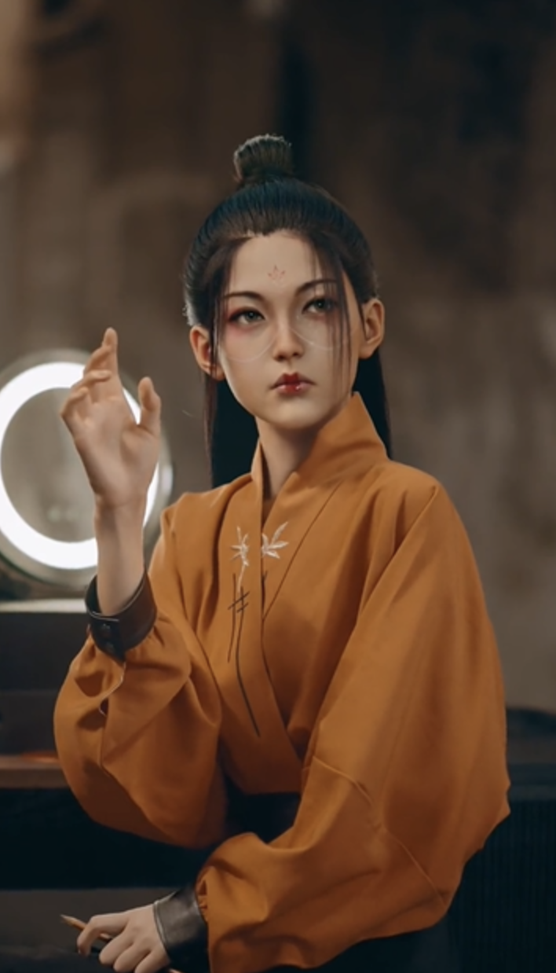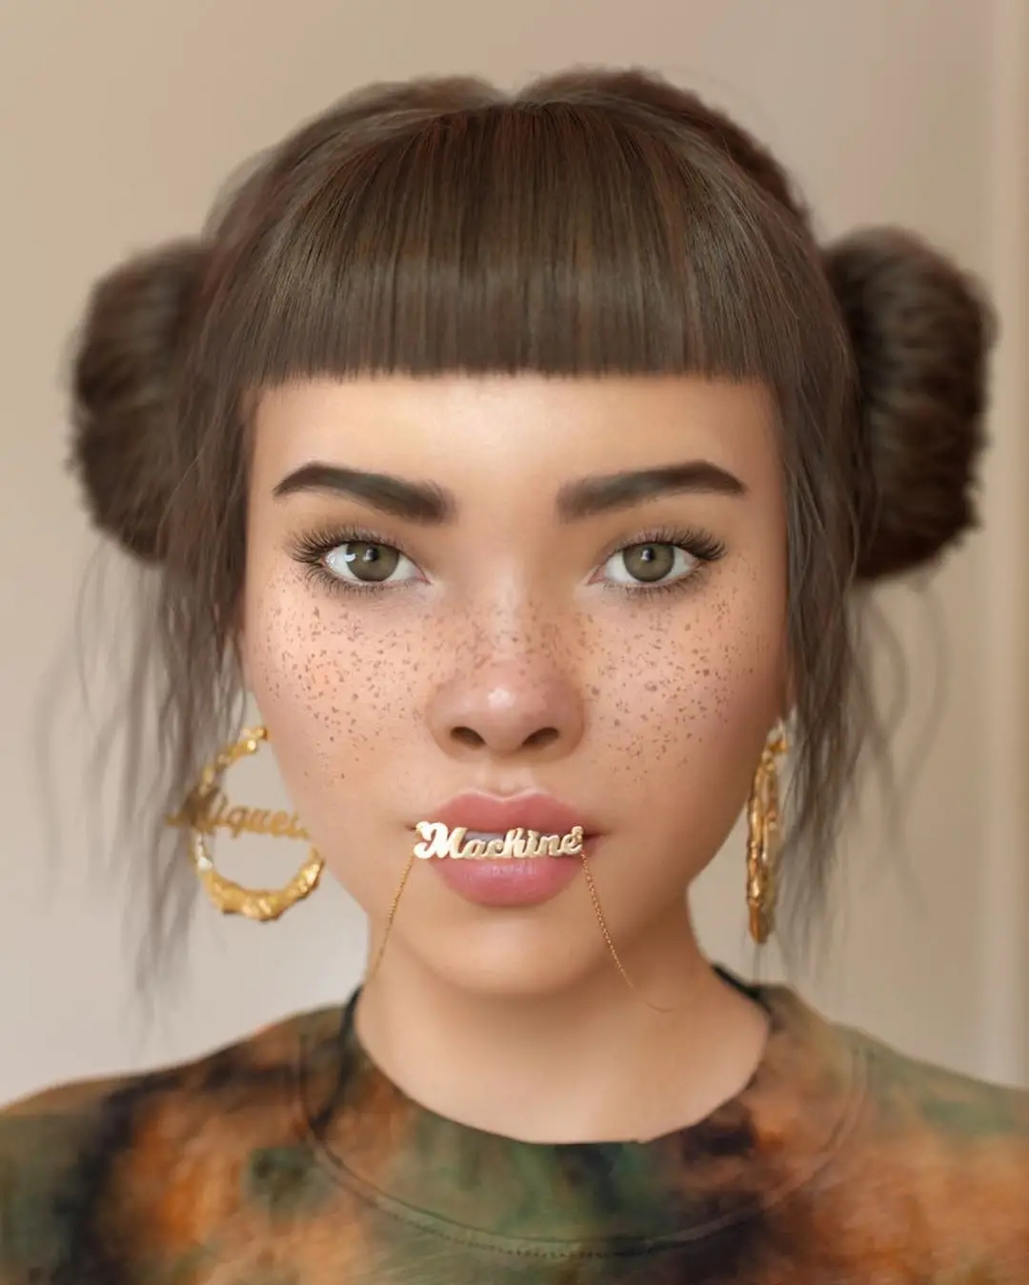
Fig. 1 AYAYI（2022） Fig. 2 Yexi Liu（2021） Fig. 3 lilmiquela（2022）
The existence of several virtual network celebrity reflects a phenomenon of aesthetic culture and aesthetic consumption in the current society. The essence is the aesthetic creation of human beings in order to satisfy their own pursuit of beauty. The constant pursuit of beauty has finally been satisfied in the world of fantasy, and their existence is partly satisfying the human pursuit of the perfect image.
The existence of these few online celebrity virtual person embodies a phenomenon of aesthetic culture and aesthetic consumption in contemporary society. Their essence is the aesthetic creation of human beings in order to satisfy their own pursuit of beauty. The constant pursuit of beauty is finally fulfilled in the world of imaginary, and their existence is a partial satisfaction of human beings' pursuit of a perfect image.
What do they have to do with animated movie characters? If they were to act in films, what is it? They are the stars in animated films, which is similar to why Chinese animated films continue to create classic mythological films, such as new stories of mythical characters such as Sun Wukong, Nezha and Yang Jian. Because many Chinese people know these "virtual" characters, they are similar to the existence of movie stars.
Some people will think that they are fictional characters after all, which fully meet the aesthetic requirements of the public? Just as an accessory of the public, without their own personal characteristics? What do you think? Will you pay attention to these virtual stars? If so, what do they mean to you? Good looking image? Fashion wear? Good character?
I think the existence of animation character art is to make people's images meaningful, or as a unit of meaning, to construct beauty, which is similar to the original natural scenery of the stars and the sea. You can make a video of nature and add music to make it have a special meaning. Such meaning will arouse some of your feelings or memories, or remind some people and things. At this time, you may say a "beautiful!" to express your feelings, so, the existence of art can partly meet the human pursuit of meaning and the pursuit of its own existence.
4. Research Status of Animation Film Characters
Animated characters are hypothetical images capable of conveying emotion and meaning, images that do not exist in real life and are created by artists, either as realistic characters, animals, plants, or inanimate objects (e.g. cars, toys, etc.), or even various fictional images of mythological origin (e.g. Sun Wukong, demons), etc.
In recent years, research on animated film characters, with the development of virtual simulation technology, foreign scholars would focus on the horror valley effect of the degree of anthropomorphic simulation of animated film characters, predicting that some realistic animated film characters would cause negative emotions in the audience（Kätsyri, J., Mäkäräinen, M. and Takala, T.）. There is also an exploration of the portrayal of character gender in Disney animated films Shaw croft, J.E., Coyne, S.M., Zurcher, J.D. and Brubaker, P.J.）This is because the gender portrayal of characters in animated films plays a role in the gender socialization of child audiences.
In contrast, domestic studies on animation film characters are mostly case studies analyzing film character building studies, with the main research issues in visual modeling, performance characteristics (Ni Han, 2021), (Yuan Jiaxi, 2022). There are also interpretations of the aesthetic characteristics of Chinese mythology-themed animated films, explaining the educational significance of animation for children in terms of character modeling, scene design, and color conformity, respectively, but still only a preliminary exploration of mythology-themed animated films from an aesthetic perspective, without fully exploring the profound cultural connotations in such films (Kang Wanhua, Zhou Yongxing , 2016). There are also in-depth investigations into the reasons for character metamorphosis in China's animation films from the perspective of national aesthetic psychology. (Zhou Yan Zhang Zhiyang, 2021).
From the perspective of film semiotics, Liu Xun analyzed the nationalized narrative expression of domestic animation films by using the concept of signifier and signified in film semiotics (Liu Xun, 2020). Zhang Bo took the film of Japanese animator Jin Min as an example to analyze the role of color symbols in its animation role shaping, lens artistic conception rendering, film narrative, story theme expression, etc., and put forward the problems and solutions of domestic animation in color application (Zhang Bo, 2017). Wang Lulu believes that the ideology and culture of different regions can be easily understood and accepted by more people after being symbolized. The article discusses the code creation of European animation films with the example of The Secret of the Kyle Sutra (Wang Lulu, 2016).
However, it rarely talks about the aesthetic meaning of Chinese animated film characters from the semiotic perspective. From the causes of aesthetic meaning in aesthetic phenomena, to the changes of aesthetic meaning in different times, to new media technology, new cultural context, new national aesthetic orientation in Chinese animation film characters, there is still room for in-depth analysis.
5. Research Methodology
This is because the main data types are currently mainly textual data, animated character image data. Later on, we may continue to collect some interview data, observation data, statistical data, for example, to design questions for semi-structured interviews to understand the subjective aesthetic feelings of domestic university students after they have watched Chinese animation film character images.
Literature analysis and induction. Search the related literature of semiotics, film semiotics, animation characters, aesthetics, etc. through Google, CNKI and other databases to understand the relevant theories required by this study and sort out the basic context of the paper.
Case analysis. This paper analyzes many animated characters in 51 Chinese mythological animated films, such as Sun Wukong, White Snake, Nezha and Yang Jian, and studies the characteristics and implication of their role symbols.
The study of the aesthetics of animated film characters is an important part of the study of video aesthetics. As an important method for the study of video aesthetics in the era of visual culture, semiotics plays an important role in, firstly, the study of video ontology and, secondly, the "meta" interpretation of video.
6.Aesthetic Choices and Emotional Expectations in the Characters of Chinese Animated Films
Aesthetic choice is the judgment and pursuit of beauty based on people's own feelings, "it is people's choice of the object of aesthetic experience. (Melchionne, K., 2017.)
The existence of the phenomenon of image selection and the reasons for specific preferences in the aesthetic process of people's characters in animated films should be related to their own emotions. In recent years, the influence of domestic animation films has gradually gained public attention and recognition. Many audiences are also impressed by some excellent domestic animated film characters, as if enumerating one's family valuables. For example, the image of Monkey King in the animated film "The Return of the Great Sage", the image of Nezha in "The Devil Child of Nezha Comes into the World", the image of Bai Suzhen in "White Snake: Origin" and so on. When audiences watch the characters in these animated film stories, they will have an unexpected but reasonable feeling. In the animated film "Luo Xiaohei's Battle Records", there was a scene in which Nezha teased his own image. In the film, Nezha takes the two buns off his head, and the other characters in the film ask, 'Who are you?' They have to put them back (as shown in Figure 1), Therefore, the two buns with meatballs have become the symbolic shape of Nezha's image. If Nezha does not have a bun, we may doubt that he is still Nezha. This shows that people have an aesthetic choice and expectation of emotional concept for the role modeling in their hearts.
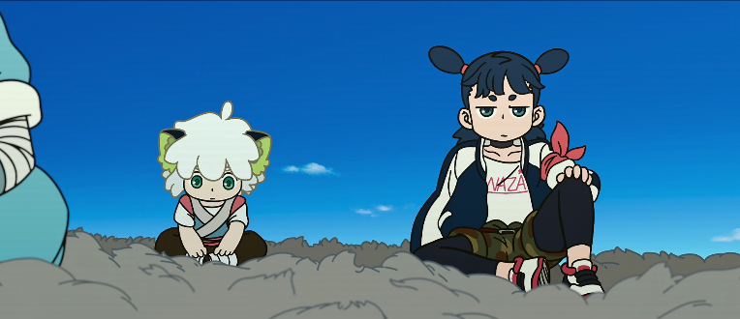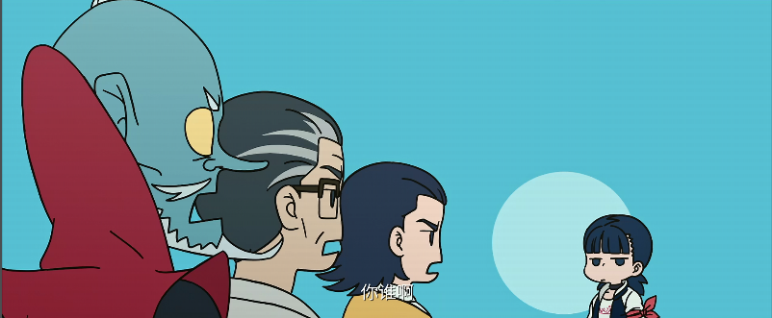
Fig. 4 The Legend of Hei (2019)
6.1 Aesthetic Choice of Animation Film Characters
Zhu Guangqian mentioned in his book "Tan Mei" that the pursuit of beauty is one of the important signs that human beings are different from other animals. For example, if a cup can hold water, why should we care about its color and style? Similarly, if a movie character can tell stories, why should he ask for a beautiful character? And people's preference for different styles of beauty is often changing at any time and anywhere. How to grasp the common aesthetic taste of the public? In fact, aesthetics is a matter of art appreciation. Your appreciation of a work of art is often related to a series of knowledge base. For example, your appreciation of the image beauty of an animated film character is not only about what you see and your cognitive ability, but also about your understanding of the background, form, structure, production process and other information of the character's creation, and even whether you have similar experiences with the story character. Therefore, you can understand the meaning and artistic characteristics contained in the role, and then trigger personal aesthetic judgment and emotional resonance. On the contrary, if people hope to obtain aesthetic pleasure in things, they will intuitively judge and choose the image of things, and choose the image that can express or stimulate aesthetic feelings.
When creating the character image of animation film, the creator will refer to many classic artistic images of different styles, as well as their colors, lines, forms and other elements. Gombrich mentioned various styles of reproduction in Art and Illusion - Psychology of Picture Reproduction, because artists can not avoid imitating the image formula when describing visual reality.( Gombrich ,2012). Susan Langer also pointed out that "art represents a universal human emotion that artists recognize. It is a concept of emotion, separated from personal emotion, and is a universal human emotion."(Langer,1953). Therefore, people can engage in artistic creation by mastering general emotional concepts. For example, when designing animated characters, looking for materials for reference is to understand what kind of image symbols can express human universal emotions. To give a simple instance, a female student asked her male classmate, "What kind of girls do you boys generally think are good-looking?" The boy replied that there are three kinds, one is "handsome", one is "fairy" and one is "sweet". Because of the subjective particularity of aesthetics, the boy's answer may not be universal, but it can provide us with a way of thinking. He put forward three concepts that he thinks are "handsome", "fairy" and "sweet". If "handsome", " fairyism" and "sweet" are universally shared emotional concepts of beauty, then the schema that can express the same emotional concept can meet people's expectations for beauty. Such images will be considered as beautiful, and as Hegel said, beauty is the manifestation of "ideas" in some things.
6.2 Expectation of Character Sharing in Animation Films
Human emotions are endless, and so is creation. As the creation of human emotional symbols, animated film characters' image reproduction can be based on shared expectations. Shared expectations refer to a collective consciousness that transcends individual consciousness and exists in people's subconscious, a consciousness that is implicit in the process of socialisation. This consciousness creates a hidden order in social life and people follow it naturally. The appreciation of artistic beauty, is an emotional expectation. It can also be understood as a process of socialisation of an emotional concept, a general emotion that is generally shared. For example, we generally believe that girls who are thin and white are beautiful. When people see images that conform to such characteristics, their subconscious will directly give a judgment on whether they are beautiful or not. Shared expectation is a consensus on the judgment of "meaning", which is the purpose, goal, emotion, etc. that precedes each of our actions. Meaning exists in three forms, the conscious state, the subconscious state and the cultural state, of which the term culture has been interpreted more often. The emphasis here is on it being shared meaning, an objectified meaning that transcends individual ideas. For instance, when the creator of an animated film character considers how to design the character, he or she considers what others think, what others expect of the character, and acts on that expectation. And this expectation is the shared meaning, which comes from the process of socialisation, an aesthetic culture shared by the majority. The creators of animated characters can meet emotional expectations by understanding schemas that have 'shared meaning' and incorporating them into the creation of their characters. In Roland Barthes' theory of intersubjective interaction of symbolic meanings, he refers to the same cultural groups, the "commonality and sharing of the mind", which allows the perception of the meaning of symbols not to vary from person to person (Carey, J.W., 2008) . Gestalt psychology also suggests that the "isomorphism" of the mind is an important reason why people derive beauty from objects. Thus, recognisable animated film characters represent a concept that reproduces the complexity and concord of the human heart, playing the role of emotional symbols. Thus, recognisable animated film characters represent a concept that reproduces the complexity and concord of the human heart, Plays the role of an emotional symbol.
7.Conlutions
What theoretical research can give to practitioners is not a guide to practical action, but knowledge of principles, those of social frameworks, social mechanisms, social trends. For example, in the design of animated characters there is a process of subjective human judgement and selection, a criterion of beauty, an aesthetic mechanism, and an understanding of the perception of beauty, the universally shared emotional meaning, that can guide our practice and action.
Know the Machine，There are two realities in our society: the human reality, which is characterized by 'agency', that is, the ability to set goals and take action to achieve them, and the social reality, which provides a Structure for human behavior, which both enables and constrains people. The state, the corporation, marriage, language, etc. are all social frameworks. Man creates the social framework, but the structure itself is not man and has no agency. The social structure is there, and man's action either consolidates it or changes it. At the same time, the social structure is a prerequisite for human action; it provides support for human action and sets limits to it. For each of us, our perceptions and reflections on the social framework also extend to the individual level, i.e. our perceptions; what we think in our heads and whether there are 'misconceptions' and 'prejudices' that have been formed within the social framework. Without reflection, individuals will only think they are right about everything and rarely realize that their perceptions are 'misconceptions' and 'prejudices'. In explaining social phenomena, we must focus on the ideas of the people involved, their opinions and beliefs. Social science can identify which ideas people have that are in fact 'misconceptions' and 'prejudices', based on truths or values. Thus, in explaining social phenomena, there is automatically a criticism of social frameworks because they create 'misconceptions' and 'prejudices'; they need to be discarded or transformed so that they no longer create misconceptions and prejudices, or create more correct ideas.
Knowledge can "liberate" us from ourselves. Ignorance is bondage, and in the realm of ignorance, stereotypes, dogmas and fallacies take control of our lives and suppress possibilities. Learning reduces ignorance and frees us from the "bondage of ignorance".
Finally, to borrow a famous quote from Peirce, Do not block the path of inquiry.

List of Illustrations
Fig. 1 AYAYI. (2019) [Film still, online] At: http://xhslink.com/mx9NIm. (Accessed21 /12/2022).
Fig. 2 Liu yexi. (2021) [Film still, online] At: https://www.douyin.com/video/7025168734767631629.In Now, the world I see, you can see it too. Beijing, China: TikTok.
Fig. 3 lilmiquela. (2022) [Photo, online] At: https://www.instagram.com/lilmiquela/. (Accessed21 /12/2022).
Fig. 4 Nezha's hair. (2019) [Film still, online] At: https://www.iqiyi.com/v_19rtszgos4.html?vfm=2008_aldbd&fc=828fb30b722f3164&fv=p_02_01.In The Legend of Hei. Beijing, China: IQIYI.COM.

Bibliography
Lukács, G. (1998) Aesthetic culture. The Yale Journal of Criticism, 11(2), pp.365-379.
De Saussure, Ferdinand. (1960) Course in General Linguistics. 1916; rpt. London: Peter Owen.
Peirce, C.S. (1974) Collected papers of charles sanders peirce (Vol. 5). Harvard University Press.
Barthes, R. (1964) Éléments de sémiologie. Communications, 4(1), pp.91-135.
Foucault, M. (2013) Archaeology of knowledge. routledge.
Wu, J. Zhao, X.吴宗济, 赵新那. (2002)Zhao Yuan Ren Yu Yan Xue Lun Wen Ji赵元任语言学论文集Shang Wu Yin Shu Guan.pp.178.
Zhao, Y.赵毅衡 (2011)Fu hao xue:yuan li yu tui yan符号学:原理与推演. Nanjing: Nanjing University Press. pp. 1-2.
Li-yuan, Z.H.U. (2016) A Brief View of Practice Ontology Aesthetics in the Context of Contemporary China. Journal of Literature and Art Studies, 6(6), pp.647-656.
Yuan J.X. (2022) Research on the Animation Character Shaping of Journey to the West: the Return of the Great Sage from the Perspective of Film Semiotics. China academic. journal electronic publishing house.
Wang L.L. (2016)Cong ‘kai er jing de mi mi’ kan ou zhou dong hua fu ma chuang zuo从《凯尔经的秘密》看欧洲动画符码创作. Movie Literature. Jiling: Film Group Journal Publishing Co., Ltd. pp.110-112.
Liu.X. (2022).Dian ying fu hao xue shi yu xia ‘shi qi nian’ zhong guo dong hua dian ying min zu hua xu shi biao da电影符号学视域下“十七年”中国动画电影的民族化叙事表达. Movie Literature. Jiling: Film Group Journal Publishing Co., Ltd. pp.127-131.
Zhang, B. (2017) Se cai fu hao zai dong hua dian ying zhong de ying yong de yan jiu色彩符号在动画电影中的应用研究. Northeast Normal University.
Zhou, G.朱光潜(2012) Tan mei谈美.Shanghai: East China Normal University Press. pp.6.
Melchionne, K. (2017) Aesthetic choice. British Journal of Aesthetics, 57(3), pp.283-298.
Langer, S.K. (1953) Feeling and form (Vol. 3). London: Routledge and Kegan Paul. pp. 10-13.
Gombrich, E. H. (1977) Art and illusion: A study in the psychology of pictorial representation (Vol. 5). London: Phaidon. pp. 15-16.
Carey, J.W., 2008. Communication as culture, revised edition: Essays on media and society. Routledge.
Cassirer, E. ( 2021) An essay on man. Yale University Press.
Bell, C. (1916) Art. Chatto & Windus.

