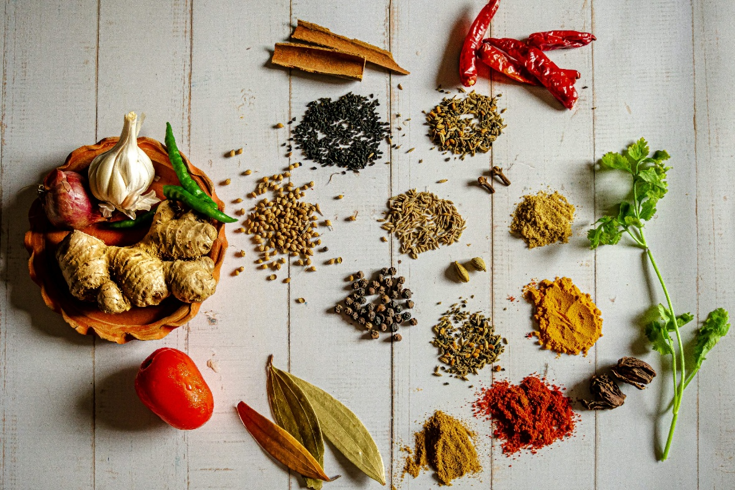
Master of Business Administration
STUDENT ID: 2335398
NAME: ARCHI JASOLIYA
Research Proposal for Opening a Food business (SpiceNest) in India
Table of Contents
List Of Tabulations and Figures 1
1. Introduction 2
2. Aim, Objectives, Research Questions and Hypotheses 3
2.1. Aim 3
2.2. Objectives 3
2.3. Research Questions 3
2.4. Hypothesis 3
3. Methodology 4
3.1. Research Approach 4
3.2. Data Collection Methods 4
3.3. Justification for the Selected Approach 4
3.4. Data Analysis methods 5
4. Literature review 5
4.1. Consumer Behavior in the Food Sector 5
4.2. Franchising Development in India 5
4.3. Innovative Strategies in the Food Industry 6
4.4. Satisfaction of customers in the Food Sector 6
5. Limitations 7
6. Ethical Considerations 8
7. Time Frame 9
8. Conclusion 10
References 11

List Of Tabulations and Figures
Figure 1 Gantt Chart 10

Table 1 Project Timeline 9

Introduction

The purpose of this proposal is to describe the recommended steps which include a survey based primary analysis for the launching of a modern restaurant called SpiceNest located in Mumbai India with hopes of it growing further as a franchise and chain store across the country. Rampant urbanization and the ever increasing consumer demand provides an underlying reason for the sustenance of growth of Indian food industry. The anticipated growth of SpiceNest will be driven by its unique offering of Indian cuisines that are authentic and also include New Age Indian cuisines that have many modern amalgamations (NAWANGSARI et al., 2023).
Understanding competitors and analyzing market trends relevant to the consumers is necessary. This proposal outlines how every single aspect from the core of the business market upto its scope of feasability will be tackled. This includes Analysis of the food business of Mumbai, selection of target zones, determination of brand equity, and level of pricing designation. Moreover, the scope of the franchise effectiveness for operational and supply chain capture efficiency, as well as expansion difficulty estimation, was also (Panda et al., 2023).
This proposal further strives to capture all primary and secondary data through surveys, and interviews with experts in the field, and through analysis of existing food chains.
Combining legal and economic transformation, as well as online marketing strategies, is the goal of this proposal while establishing SpiceNest as a household name in the Indian food business, which is growing rapidly, while at the same time ensuring customer satisfaction.

Aim, Objectives, Research Questions and Hypotheses

Aim
The research was conducted to assess the feasibility and market prospects for a food business, SpiceNest based in Mumbai, India, and evaluate its growth potential in order to convert it into a franchise and chain store business.

Objectives
The research will achieve the above goal through listed objectives:
- To complete food industry segmentation in SpiceNest’s target market, Mumbai, within the next six months and identify target audience, their preferences, and competitors.
- To gather and analyse over 200 responses from consumers through interviews and surveys in a period of three months to asses consumer behaviour and demand for new food products.
- To put together a strategic business plan, including but not limited to price strategy, brand image, and site, within six months after the results of the research are available.
- To draft a franchise expansion plan detailing operational and financial aspects within a year after the first outlet is opened.

Research Questions
The research questions for the research are as follows:
- Which factors have the most impact on consumer choices in the food sector of Mumbai?
- In which areas should SpiceNest focus to create strong brand equity and distinguish itself from competitors?
- What plans will guarantee the effective scalability of SpiceNest franchises throughout India?

Hypothesis
The research hypotheses are as follows:
H₀ (Null Hypothesis): The qualitative market research data has no correlation with the successful franchise expansion of SpiceNest.
H₁ (Alternative Hypothesis): Qualitative market research and strategic approach will improve the scalability and success of SpiceNest within the Indian food industry immensely.

Methodology

Research Approach
The study will take a quantitative research approach; the primary method for collecting data will be through surveys. The goal here is to capture the overall consumer preferences and market possibilities of SpiceNest in Mumbai. A clearly defined mechanism in form of a structured set of questions will be designed with an intention to have a clear uniformed data collection process so as to establish trends and patterns in relation to consumer habits (Ghanad, 2023).

Data Collection Methods
A sample survey will be administered to a minimum of 200 respondents across the categories of working class, students, families, and food lovers to ensure range. The survey will be made available online and offline on Google Forms and social media (Instagram, Facebook, LinkedIn), as well as in person at shopping malls, corporate offices, and universities. To enhance the survey, the questionnaire will be created with multiple choice, Likert scale, and closed-ended questions that help to easily formulate concise structured responses for easier quantitative analysis (Kotronoulas et al., 2023)
The survey will target areas such as consumption patterns about cuisine preference, dining frequency, price range, and expectations from a new food label. It will also capture brand attitude, openness to a new food chain, and knowledge of competitor brands (Fischer et al., 2023). Furthermore, the investigation will focus on online engagement with ordering and mobile applications, as well as participation in loyalty programs, to determine ways technology can be exploited for customer grab and retention purposes.

Justification for the Selected Approach
The approach that has been selected is a survey because it enables the collection of uniform responses from a large population in a relatively short period of time. The quantitative nature of surveys helps to track shifts in attitude and consumer behaviour patterns, which is helpful for decision making (Ghanad, 2023). In view of the fact that the sector is highly customer-oriented, the direct answers from target customers will help SpiceNest to make the right choices in service offering in order to match market expectations and to position the company competitively.

Data Analysis methods
The obtained survey data will be analysed through statistical methods to detect trends and correlational outcomes. Answers will be stored in predefined groups and analysis results will be applied in graphs, charts, and tables for faster comprehension (Ghanad, 2023). These findings will be instrumental in directing SpiceNest’s pricing policies, prospective menus, expansion strategy, and entry into India’s market and further growth in the future.

Literature review

Consumer Behavior in the Food Sector
Trust in the brand, social media marketing, and new and innovative ways to engage customers are some of the reasons that influence consumer purchase decisions within the food industry. As Hanaysha (2022) points out, informativeness and interactivity are greatly important factors when it comes to consumer purchase decisions within the fast-food industry. Brand trust also has a mediating effect.
As seen from the above literature, it is evident that digital marketing plays a central role in influencing consumer behaviour. Additionally, the emerging popularity of online food delivery services has changed the way consumers think. Dsouza and Sharma (2020) suggest that food quality, safety, and customer relations are among the most important constituents of a customer's loyalty in the online food delivery market. This demonstrates that there is a need for digital marketing programs to attract customers using online engagement tools among food business providers.

Franchising Development in India
The franchise business, especially in the food sector has grown at a rapid pace in India. Due to rise in income levels, increased urbanization coupled with growing Government Intervention, the Indian franchising industry is expected to cross INR 10.5 trillion by 2022 (Sebastian & Kalavathy, 2023). This sharp increase suggests growth of the industry but the lack of proper franchise regulations, laws, and limited enforcement of contract terms serves as a major bottleneck to growth.
Sebastian and Kalavathy (2023) claim that in India, laws pertaining to franchising such as the Competition and Trade Marks Acts offer some franchisee protection, but the overall regulatory framework is inadequate. This emphasizes the necessity of tailored franchise contracts to protect the rights of both franchisors and franchisees. Marketing Through the Use of Social Media in the Food Sector Social media has become one of the most useful tools to influence consumers’ buying decisions.
As per Hanaysha (2022), the study validates that social media marketing's two-way communication and informativeness is essential to the brand trust and purchase behaviour. Whars surprising, content that is entertaining has no impact on the few purchasing decisions in the fast-food sector, meaning that the consumers are more inclined to interact with companies who provide them value instead of trivial advertisement. Moreover, social media marketing has increased customer engagement and brand loyalty. Companies using customized digital marketing strategies get higher consumer engagement and increased sales conversions.

Innovative Strategies in the Food Industry
In the food industry, new development is crucial for sustaining competition. As noted by Manhas et al, (2022), innovations in QSRs serve customer satisfaction and retention purposes which highlights the need for better service delivery,more innovative modernization of menus, and technology integration.
In contrast, AI customer insight tools, digital ordering, and sustainable packaging in the hospitality industry were observed to enhance customer experience as with many other things (Manhas et al., 2022). This is vital for firms that want to establish themselves in the competition dominion..

Satisfaction of customers in the Food Sector
Customer satisfaction is perhaps the most important indicator of success in the food industry. Studies show that food quality, service delivery, and cleanliness or sanitation greatly influence customer loyalty. In addition, Dsouza and Sharma (2020) claim that creating a reliable governance structure for food sourcing and active quality control will generate trust from consumers and more brand loyalty over time.
To summarize, the literature provided demonstrates the linkages between consumer behaviour, franchising law, the use of social media as a marketing tool, innovation, and customer satisfaction in the food industry. This clearly paves way for further investigation on the competitive advancement in the food industry in India, especially pertaining to the franchising model.

Limitations

Although this research will attempt to analyse the feasibility and market scope of SpiceNest in Mumbai, there are many limitations that may narrow the breadth and depth of the study. Given the vast scope of consumer behaviour, business strategies, and marketing strategies, some issues such as deep longitudinal econometrics and granular competitor in-depth case studies will not be dealt with in detail.
Another limitation stems from the sample size of 200 respondents for the survey. With the target sample size, the study will gain valuable information about the population, but it will not be able to represent the diversity found in the food market in Mumbai (Giner-Sorolla et al., 2024). Although a larger sample size would render more robust results, tight temporal and financial resources will render achieving this goal impossible within the allotted research duration timeframe. Furthermore, the study will be conducted in urban Mumbai, which will render the results useless for suburban or rural areas with differing eating patterns and socio-economic factors (Lakens, 2022).
As for the limitations regarding the scope of data collection, the consumer surveys are going to be self-reported, which comes with biases such as social acceptance or even misremembering one’s expenses (Maxwell, 2021). Also, other external variables like certain seasons, changing economies, and the policies of the food industry will affect the market, but do not fall within the boundaries of this research.
Lastly, the research intends to look into the level of scalability SpiceNest can achieve as a franchise, but further development of the business will be subject to operational constraints, which are impossible to simulate within a research environment. Regardless of these limitations, the analysis will enable SpiceNest to strategically launch and scale its operations throughout India.

Ethical Considerations
Ethical policies will be enforced in this study in relation to the integrity, confidentiality, and voluntary participation of respondents for ethical considerations. Primary data collection through surveys forms the basis of this study, so the ethical aspects of participant rights and standards of research will be met during the research process.
Survey participation will be on a voluntary basis, so no respondent will be obligated to take part in the survey. Participants will be provided with a clear explanation of the study’s purpose, objectives, and how the collected data will be used prior to completing them most (Verbeke et al., 2023). Anonymous and confidential results will be ensured meaning no personally identifiable information will not be shared or disclosed. All respondents along with informed consent for the study shall be free to withdraw from the study at any point without consequences.
The research intends to make sure that the questions formulated in the survey are non-leading, non-discriminatory, and courteous, steering away from delicate or invasive issues that may pose discomfort to participants (Hwang, 2023). The collection of information will abide by ethical principles of preventing effacement and falsification of data. Moreover, only people actively participating in the research will be granted the data, and response files will be kept in a safe place to restrict access to other unauthorized persons.
Since the study includes market analysis as well as behaviour analysis, care should be taken not to raise undue hopes among research participants about starting the business. The research will be very open and no false advertisement will be made regarding the results of the business opening.
In addition, to secure non-plagiarism, all industry reports and case studies will be cited as secondary data sources (Nneoma et al., 2023). Insofar as any other sources are used to support the findings, such documents will be issued in accordance with ethical standards of research unrestricted by GPR.
By following these ethical guidelines, the proposed research will be credible, respectful, and fair while collecting sensitive data from participants. The result will ensure it does not breach ethical guidelines.

Time Frame
The research will be held from March to May of 2025 which allows 3 months of orderly data gathering, analysis, and reporting. Survey drafting and pilot survey testing will occur in April after the literature review, topic finalization and research methodology design. After data collection towards the end of April and beginning of May, the data will be analysed and cleaned. The report will be created, then edited, reviewed, and finalized before submission in May. This approach ensures that efficient workflow is established along with some room to make adjustments if need be. The following tabulation and chart show the stages of the research along with the timeline.
Table 1 Project Timeline
Task | Start Date | End Date | Duration (Days)
Topic Finalization & Proposal Writing | 01-03-2025 | 10-03-2025 | 10 days
Literature Review | 05-03-2025 | 25-03-2025 | 21 days
Research Design & Methodology Planning | 15-03-2025 | 05-04-2025 | 22 days
Survey & Questionnaire Development | 01-04-2025 | 10-04-2025 | 10 days
Pilot Testing & Refinement | 11-04-2025 | 20-04-2025 | 10 days
Data Collection (Survey Responses) | 21-04-2025 | 10-05-2025 | 20 days
Data Cleaning & Organization | 11-05-2025 | 15-05-2025 | 5 days
Data Analysis & Interpretation | 16-05-2025 | 30-05-2025 | 15 days
Drafting Research Findings | 01-05-2025 | 10-05-2025 | 10 days
Final Report Writing | 11-05-2025 | 20-05-2025 | 10 days
Review, Proofreading & Editing | 21-05-2025 | 25-05-2025 | 5 days
Final Submission | 30-05-2025 | 30-05-2025 | 1 day

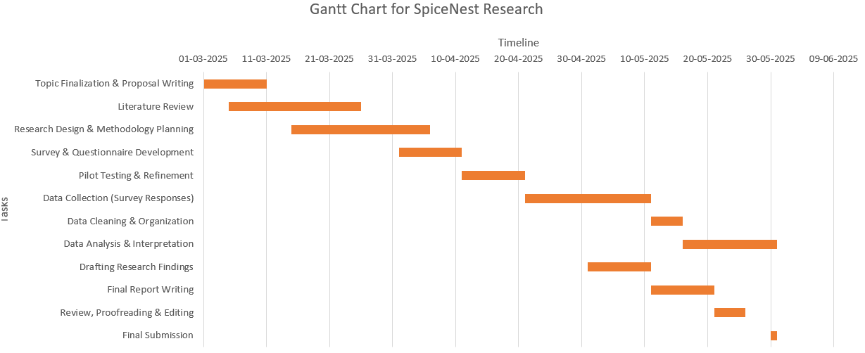
Figure 1 Gantt Chart

Conclusion
I decided to look into the feasibility and scalability of SpiceNest in Mumbai as well as its expansion as a franchise throughout India because comprehending consumer behaviour and strategic market segmentation in the food business is imperative for long-term sustainability. Given the pace at which the world is changing in terms of consumer tastes, digital participation, and competition, this study will be relevant to how a new food brand can position itself in a highly competitive and saturated market.
This research will be of a quantitative nature mostly focused on surveys to study in detail the purchasing behaviour of consumers, their brand perception, and the influence of social media marketing on consumer participation of the brand. This is primary data, which adds value to the research unlike previous research which used generalized information and market trends, adding very little value to the real-world problem.
This research is expected to yield an elaborate business plan for SpiceNest, which will cover pricing, branding, and even scope of expansion. The study seeks to provide a comprehensive framework that will assist in the optimal launch and progressive operational difficulties and market entry plans challenges evidence basis consolidation business expansion endeavour. The conclusion will be useful for subsequent research on franchising in the food industry while at the same time providing some insight into the growing body of literature on SMEs in the Indian cuisine industry.

References
Dsouza, D. and Sharma, D., 2021. Online food delivery portals during COVID-19 times: an analysis of changing consumer behavior and expectations. International Journal of Innovation Science, 13(2), pp.218-232. < http://dx.doi.org/10.1108/IJIS-10-2020-0184 >
Fischer, H.E., Boone, W.J. and Neumann, K., 2023. Quantitative research designs and approaches. In Handbook of research on science education (pp. 28-59). Routledge. < https://doi.org/10.4324/9780367855758 >
Ghanad, A., 2023. An overview of quantitative research methods. International journal of multidisciplinary research and analysis, 6(08), pp.3794-3803. < https://doi.org/10.47191/ijmra/v6-i8-52 >
Giner-Sorolla, R., Montoya, A.K., Reifman, A., Carpenter, T., Lewis Jr, N.A., Aberson, C.L., Bostyn, D.H., Conrique, B.G., Ng, B.W., Schoemann, A.M. and Soderberg, C., 2024. Power to detect what? Considerations for planning and evaluating sample size. Personality and Social Psychology Review, 28(3), pp.276-301. < https://doi.org/10.1177/10888683241228328 >
Hanaysha, J.R., 2022. Impact of social media marketing features on consumer's purchase decision in the fast-food industry: Brand trust as a mediator. International Journal of Information Management Data Insights, 2(2), p.100102. < https://doi.org/10.1016/j.jjimei.2022.100102 >
HWANG, H.J., 2023. The importance of anonymity and confidentiality for conducting survey research. Journal of Research and Publication Ethics, 4(1), pp.1-7. < https://doi.org/10.15722/jrpe.4.1.202303.1 >
Kotronoulas, G., Miguel, S., Dowling, M., Fernández-Ortega, P., Colomer-Lahiguera, S., Bağçivan, G., Pape, E., Drury, A., Semple, C., Dieperink, K.B. and Papadopoulou, C., 2023, April. An overview of the fundamentals of data management, analysis, and interpretation in quantitative research. In Seminars in oncology nursing (Vol. 39, No. 2, p. 151398). WB Saunders. < https://doi.org/10.1016/j.soncn.2023.151398 >
Lakens, D., 2022. Sample size justification. Collabra: psychology, 8(1), p.33267. < https://doi.org/10.1525/collabra.33267 >
Manhas, P.S., Sharma, P. and Sarangal, R., 2022. Assessing the impact of innovative practices on customer experience satisfaction and loyalty: A study on quick-service restaurants in North India. International Journal of Hospitality Management, 51(1), pp.29-40. < https://doi.org/10.5614/ajht.2022.20.2.06 >
Maxwell, J.A., 2021. Why qualitative methods are necessary for generalization. Qualitative Psychology, 8(1), p.111. < https://psycnet.apa.org/doi/10.1037/qup0000173 >
NAWANGSARI, L.C., SISWANTI, I. and SOELTON, M., 2023, November. Human Resources Management Strategy For Business Sustainability In Msmes. In ICCD (Vol. 5, No. 1, pp. 514-518). < https://iccd.asia/ojs/index.php/iccd/article/download/599/536 >
Nneoma, U.C., Udoka, E.V.H., Nnenna, U.J., Chukwudi, O.F. and Paul-Chima, U.O., 2023. Ethical publication issues in the collection and analysis of research data. Newport International Journal of Scientific and Experimental Sciences (NIJSES), 3(2), pp.132-140. < https://www.researchgate.net/profile/Kiu-Publication-Extension/publication/372420175_Ethical_Publication_Issues_in_the_Collection_and_Analysis_of_Research_Data/links/64b66d0fb9ed6874a52c6fe7/Ethical-Publication-Issues-in-the-Collection-and-Analysis-of-Research-Data.pdf >
Panda, S., Pandey, S.C., Paswan, A.K. and Pelton, L.E., 2023. Opportunism in an emerging market–franchisee perspective. Journal of Business & Industrial Marketing, 38(10), pp.2092-2106. < https://doi.org/10.1108/JBIM-06-2021-0297 >
Sebastian, B. and Kalavathy, M., 2023. AN OVERVIEW OF THE EXISTING FRANCHISING LAWS AND PRACTICES: SCOPE OF FRANCHISING IN INDIA. Estudios Italianos, 10(2), pp.300-308. < https://gvgvc.ac.in/iqac/aqar2024/criterionIII/3.4.3/3.4.3-26.Dr.M.Kalavathy.pdf >
Verbeke, K., Krawczyk, T., Baeyens, D., Piasecki, J. and Borry, P., 2023. Informed consent and debriefing when deceiving participants: A systematic review of research ethics guidelines. Journal of Empirical Research on Human Research Ethics, 18(3), pp.118-133. < https://doi.org/10.1177/15562646231173477 >

