UNIVERSITY OF WALES TRINITY SAINT DAVID

BMSW4004: PROBLEM SOLVING AND DECISION MAKING

LECTURER: MUSHFIQUR RAHMAN

ANGELO FIERRO 1909472

TASK 2: 2000 WORDS INDIVIDUAL REPORT

Introduction:
In this report I talk about the problem of stress in the workplace in the UK. It is a big problem that affects the majority of the population, and as many as 79% of people reported in a survey that they commonly experienced workplace stress, and of these 55% said that they feel anxious because of it, and 43% even lose sleep because of the stress they feel at work. (The 2020 UK workplace stress survey | Perkbox, 2020)
I think that stress is a big problem and actually, one in five companies don’t even have ways of addressing it among their workers, which can have many negative consequences both for the workers themselves and the company, so it is a problem that needs to be solved, and really, there are already studies that discuss potential solutions to this.

Defining the complex problem of workplace stress
The problem of stress in the UK is old but in many ways ever changing, and even if companies take action to combat one cause of stress and anxiety, others still exist or may even be made from the company’s policies in combating the other one, with the example of the stress causer of long hours as number one in 2018 but in distant 7 in 2020.
The problem of stress is comprised of multitudes of policies, environmental factors, employee traits, etc. that cause the feelings of anxiety, pressure and stress among the employees of a company. For example a big part of stress can be caused by the effects of uncertainty in the work that is required of someone which has a large impact on the wellbeing of the employee, as without clear and defined objectives it is harder to understand what one should do and if the work one does is acceptable. Related to this is also the problem of role ambiguity which makes workers feel like they have the responsibilities of multiple jobs in one and making it harder for the to cope with the workload. (Schmidt, Roesler, Kusserow and Rau, 2012)
Another example of a cause can be a trait specific to some employees which is perfectionism which makes people unable to accept a reasonable standard of quality for their work, and while some might consider this to be a positive trait that makes people more interested in self improvement it also causes long term dissatisfaction with the rising standard, stress and burnout in employees. (Childs and Stoeber, 2012)
Of course there are many more causes, like office politics, lack of communication, tensions with managers, but it is also important to know the reason this is a problem which involves the effects of stress: more mistakes in the workplace (Johnson et al., 2014), less productivity, burnout, and even health problems like mental illness, a weaker immune system (Eddy et al., 2016) and so on.

Analysing information on the identified problem
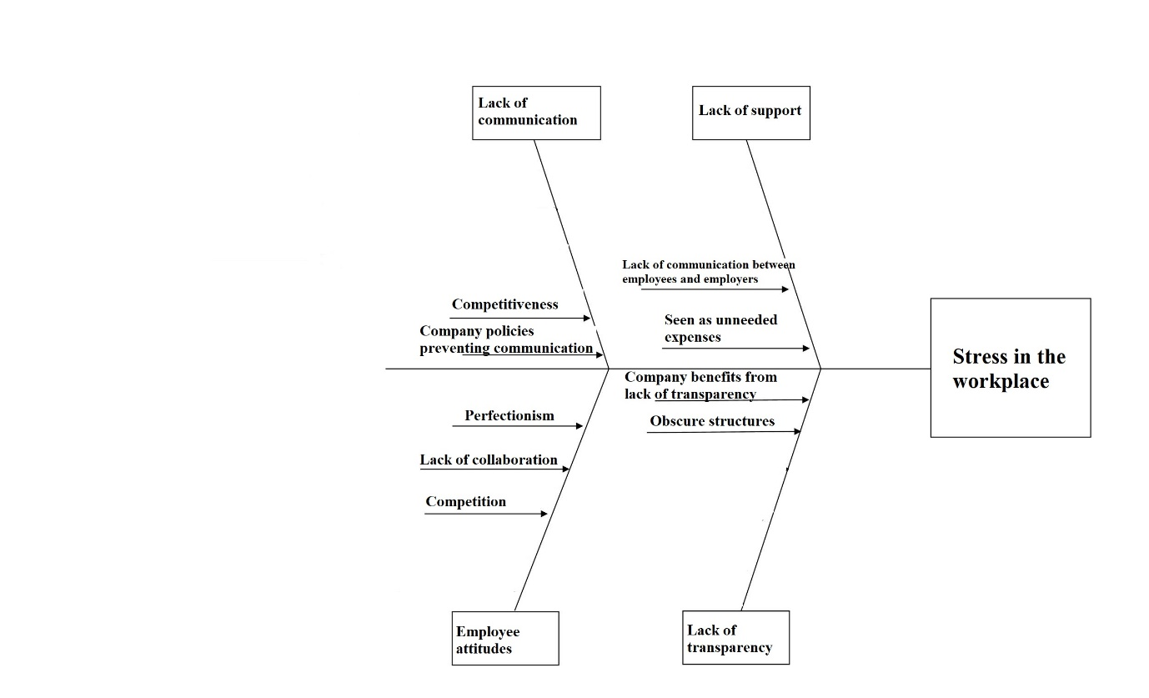
The underlying causes of work stress are mostly the attitudes of employees and company policies which can, whether or not by design cause stress to the employees. Many such policies come from the view of increasing productivity but are many time counter-productive to it by causing unnecessary stress, like, for example giving an employee more general and nebulous roles and instructions in order to have them work in more tasks, but this can cause confusion and stress.
Attitudes from employees affect the problem as well, for instance competitiveness can have a big effect on the employees who feel left behind by their peers, or perfectionism can cause them to feel that their work is inadequate and is yet to be fully finished, both of which can cause stress in the workplace and at home, along with anxiety about keeping the job in the future or being promoted.
Environment plays a role too, as some workers might feel their environments to be too dull, and they might not have a good place to relax at.
Possible solutions:
There are many solutions proposed to combat the stress in the workplace.
There are solutions that address the stress itself and there are those that are focused on negating the reasons that cause it in the first place
For example some workplaces offer yoga courses to their employees to relieve stress after work or on specific hours, and this has been proven to have a good effects on stress, as well as other positive mental health effects like more confidence, energy, satisfaction, and an overall improvement in the feeling of life purpose. (Hartfiel et al., 2010)
Another example of a stress relief solution is mindful meditation which some companies promote to their employees. This type of meditation has been proven to reduce the amount of stress hormones in the body and bring about other good health improvements as well, like an improvement in immune response to viruses. (Heckenberg, Eddy, Kent and Wright, 2018)
The solutions that involve preventing the causes of stress include the change of company policies regarding communication between workers and management, as well as interdepartmental communication. Also there is a more proactive approach of management to find the problems of the employees so the company can address them better and to give employees a feeling of being appreciated and cared for by the company and a feeling of more control over their situation.
A solution that can both prevent and relieve stress is the improvement of the environment. A stress-causing environment can be a cause and a reason for the perpetuation of stress for workers. On the other hand and environment that contains green and open spaces for relaxation is a good way to relieve stress for workers, (Lottrup, Grahn and Stigsdotter, 2013), and a more beautiful working environment can stop workers becoming stressed as easily.

Use a decision-making technique
Choosing which solution or group of solutions is the most efficient it is important to keep in mind the costs of many of these solutions and the effects that they have for the company. Of course things like yoga and meditation require expert instructors for the most effect and can be expensive if offered to all workers, though their effects in improving the overall health of the workers and the psychological effects of giving the opportunity to the workers in the first place will improve their opinion of the workplace and as such increase their loyalty and motivation. The stress relieving effect of these procedures are also demonstrable and can probably offset the costs in productivity rises alone.
Policies in the company and their replacement to more worker-oriented ones are mostly based on each company’s circumstances, so a generalized solution among this that is not just providing information on the effects of these policies is not possible to be implemented.
Implementing a space for relaxation that is filled with greenery and landscapes is not possible for most companies, especially those in crowded areas, but an improvement in the office or work space is possible for most at a low cost but with many benefits for mood and worker wellbeing outside of stress management.
So, a complete solution will be one that has environment improvement, the policy changes based on the circumstances and giving workers stress relief classes that could involve yoga and meditation with a good implementation and good information access, especially to those who will be directly affected by this.

Developing a plan for implementing the solution
Currently there is a big productivity loss for companies because of high stress of the employees, and many of the employees can develop mental illnesses such as depression or anxiety following this which will plunge them deeper into misery and diminish productivity even more, or lead to people leaving the company.
The transition to a better system will of course cost money and time in order to implement the solutions, since any changes take time and money to be implemented, but with proper management it can be implemented at a reasonable time frame and price, starting from improving the work environment which takes the least investment, then to seeking and proposing workers the stress relief classes and finally to change policies, which might require either just informing those implementing them or a complete retraining program.
Nevertheless, the result of this will be a far more loyal and productive workforce, a better company reputation which might attract new talent, and all with costs that are less than the benefits it brings.

Identifying stakeholders and communicating the plan
The people affected by this problem are primarily the workers which have to live with the effects of stress both in the workplace and, many at home and in their relationships. Still this problem also affects the businesses because of lower productivity and bigger risk of employees leaving their positions. The people who can provide services for helping with stress like yoga and meditation instructors are also an interested party in the solving of the problem. All of them will benefit from a good implementation of the solutions to this problem.
Monitoring the future for potential regression
In order to not fall back into rising stress it is important to have a way to get workers opinions transparently and to always be on the lookout for possible stress causes in new policies that are implemented. This could be quite costly as it would sometimes require expert opinions in this field.
In order to keep the loyalty of the workers it will also be important to compare the benefits to other companies.

Conclusion:
In conclusion the problem of stress is big and caused by many things from the environment that one works into the co-workers and their own mindset, and to the ways in which the company does business. This can lead to a variety of negative consequences for the workforce and company, from lower productivity to health problems. Still, as with most problems with enough research there are solutions that can be implemented to combat this and in tandem bring a better environment and a better way of life for those involved, resulting in profit for the company and society as a whole.

Reference list
Childs, J. and Stoeber, J., 2012. Do you want me to be perfect? Two longitudinal studies on socially prescribed perfectionism, stress and burnout in the workplace. Work & Stress, 26(4), pp.347-364.
Eddy, P., Heckenberg, R., Wertheim, E., Kent, S. and Wright, B., 2016. A systematic review and meta-analysis of the effort-reward imbalance model of workplace stress with indicators of immune function. Journal of Psychosomatic Research, 91, pp.1-8.
Hartfiel, N., Havenhand, J., Khalsa, S., Clarke, G. and Krayer, A., 2010. The effectiveness of yoga for the improvement of well-being and resilience to stress in the workplace. Scandinavian Journal of Work, Environment & Health, 37(1), pp.70-76.
Heckenberg, R., Eddy, P., Kent, S. and Wright, B., 2018. Do workplace-based mindfulness meditation programs improve physiological indices of stress? A systematic review and meta-analysis. Journal of Psychosomatic Research, 114, pp.62-71.
Johnson, S., O'Connor, E., Jacobs, S., Hassell, K. and Ashcroft, D., 2014. The relationships among work stress, strain and self-reported errors in UK community pharmacy. Research in Social and Administrative Pharmacy, 10(6), pp.885-895.
Lottrup, L., Grahn, P. and Stigsdotter, U., 2013. Workplace greenery and perceived level of stress: Benefits of access to a green outdoor environment at the workplace. Landscape and Urban Planning, 110, pp.5-11.
Perkbox. 2020. The 2020 UK Workplace Stress Survey | Perkbox. [online] Available at: <https://www.perkbox.com/uk/resources/library/2020-workplace-stress-survey> [Accessed 19 August 2020].
Schmidt, S., Roesler, U., Kusserow, T. and Rau, R., 2012. Uncertainty in the workplace: Examining role ambiguity and role conflict, and their link to depression—a meta-analysis. European Journal of Work and Organizational Psychology, 23(1), pp.91-106.

BMSW4004: PROBLEM SOLVING AND DECISION MAKING

LECTURER: MUSHFIQUR RAHMAN

ROLE PLAY

ANGELO FIERRO 1909427 LINE MANAGER

ROMULO SANTILLAN 1906875 EMPLOYEE

Good morning everyone, I am Angelo Fierro and my class partner is Romulo Santillan.
In this role play I will be performing as line manager of Romulo who will perform the part of unhappy employee based in the U.K.

Angelo:
Good morning Romulo, how are you?
Romulo:
Good morning Angelo, I’m not so good and that is the reason why I wanted to speak with you.
Angelo:
I’m sorry to hear that, please tell me what’s troubling you.
Romulo:
I’m keep getting the feeling of being overwhelmed with work, I seem to worry a lot about finishing all the work and on time.
Angelo:
Is it in terms of organising the workload? Have you tried setting a task schedule to help you organise what needs to be done and by when?
Romulo:
There is a high workload, but I believe that I that it is not just down to the organisation of it. There are often other factors that are involved.
Angelo:
Sure, I understand. You’ve been a loyal employee here for four years now, so I’m sure you are clear as to how to prioritise the work. What other factors are causing a problem?
Romulo:
Thank you, I do but it’s difficult when other employees are coming to me asking to help them with their tasks. I get distracted and do what I can to help them or advise them, but then I’m left to continue my work alone and often behind schedule. For this reason, I’m regularly staying later than I’m supposed to.
Angelo:
I see. So, are you feeling overwhelmed because you’re helping others, or you’re feeling overwhelmed because you’re working late? How long extra do you stay?
Romulo:
I’m happy to help the others and I’m proud that they turn to me for advice. I’m staying on average 1-2 hours longer each day, which doesn’t sound like so much, but then to travel home from work takes almost another hour and my evenings are lost.
Angelo:
By staying an extra 2 hours each day, you are working a whole day more per week. We appreciate the extra effort but of course if this is a regular occurrence then over time this will take its toll on you. Also, as much as I understand why other employees would ask you for help, they should be responsible for their own work and know how to get it done themselves.
Romulo:
It is not my place to tell them that. I often feel bad not to help, but then the longer I stay for extra hours, the worse I feel.
Angelo:
Of course, for this reason the board of directors have agreed that we should not pay our staff for overtime as a deterrence for anyone to do this because we want to prioritise the well-being of our employees.
Romulo:
But what can I do? If I have to finish my work, it feels like the only way I can do this is if I have to stay late. I don’t want to risk losing my job because I’m not performing, but even my wife is complaining to me that we don’t spend enough time together and that I’m always tired. It is starting to affect my life.
Angelo:
First of all, I will speak with the board and arrange some extra training for the staff to ensure that everyone knows what they are supposed to be doing and how they should do it. Secondly, I can’t give you marriage advice, but hopefully after the training sessions you can avoid the additional hours and have more time to spend as you wish.
Romulo:
Thank you, Angelo, that sounds like it could help the situation.
Angelo:
And Romulo, we really appreciate your dedication, support and hard work and I want you to know that we understand that you are a valued member of staff. I will put your name forward for a promotion.
Romulo:
Thank you very much!
Angelo:
No, thank you. Please come to me if you have any other problems. I would also like to speak with you again to see if this situation has improved.

