Module: LCBB5014
DATA HANDLING & BUSINESS INTELLIGENCE
Component 1: Coursework: Individual Report

Student Name: Xenia Costea
Student ID: 2422705
Executive Summary
This report focuses on the concept of "Business Intelligence (BI)", "Data Warehousing (DW)", and "Data Mining (DM)", and the way these aspects could support strategic decision-making within Pall-Ex. It has examined some key technologies, which consist of cloud-based data warehousing, real-time BI systems, and predictive analytics tools, such as Power BI, RapidMiner, SPSS, and Excel.
The findings of the report at present have indicated towards integration of these aforementioned technologies as they can enhance operational efficiency, alongside making required improvements in the performance related to delivery and enabling decision-making to be data-driven.
Accordingly, the report has proposed recommendations in context of adopting cloud-based infrastructure for BI, while implementing predictive analytics for the purpose of accurate demand forecasting and equally strengthening governance of data and measures for security. That is also for the purpose of ensuring performance to be sustainable and to achieve ultimate competitive advantages for Pall-Ex in UK logistics sector.

Table of Contents
Introduction 4
Trends in BI, DW, and DM 4
Data Warehousing in the Organisation Applications 6
Data Mining Techniques 7
Predictive Analysis 8
Ethical and Data Security Considerations 10
Reporting and Dashboard Solutions 11
Conclusion 11
Reference List 13

Introduction
The report at present would focus on organisation, namely Pall-Ex, which is a UK-based medium-sized distribution organisation, operating mainly in the logistics sector of UK. The specialising of the organisation in this context is seen to be its palletised distribution of freight through certain network model (pallex.co.uk, 2026).
Accordingly, it can be said that the purpose of the report is to evaluate the way Business Intelligence (BI), as well as Data Warehousing (DW) and Data Mining (DM), can enhance its core operational efficiency and ensuring strategic decision-making process.
Significantly, the report is anticipated to outline key trends, proposed solutions as data-centric, and simultaneously examine ethical and security considerations. That is also by providing practical recommendations for Pall-Ex to implement predictive analytics and reporting tools in real-time in the organisation.

Trends in BI, DW, and DM
BI, DW, and DM
The term Business Intelligence (BI) refers to the technologies as well as related processes that can transform raw data into certain actionable insights at core for the purpose of making strategic decisions (Machireddy, 2024). On the other hand, Data Warehousing (DW) is seen to involve centralised storage of data integrated. Furthermore, Data Mining (DM) is observed to be focusing on extraction of patterns and related knowledge from larger datasets.
Current Trends
Significantly, in this accordance, the current trends in context of Pall-Ex would highlight the shift towards real-time BI. That would certainly enable the organisation in analysing its data related to logistics and freight operations instantly, as well as respond to operational events with minimal latency (Meda, 2023). This, in turn, is considered to be enhancing agility within environment of logistics sector. In addition to this, it is also required to be noted that cloud-based data warehousing would ensure support towards scalability and ensuring cost-effectiveness. That can further allow logistics organisations like Pall-Ex to manage larger datasets without heavy investment in the infrastructure (Katasani, 2025). Moreover, it can be viewed that integration of AI alongside machine learning into the systems of BI would further ensure enhancement in predictive capabilities as well as automated insights at core.
Data Warehouse Supporting Data Consolidation and Decision-Making Enhancement
Following the discussion above, it can be implied that data warehouse would be supporting decision-making through consolidation of data from several sources into particular repository in unified manner (Nookala, 2023). Therefore, it would make improvements for Pall-Ex in the data quality of logistics operations and core accessibility for further analyses. In this significance, the implication of theoretical underpinning of Kimball Dimensional Model has shown emphasis on structured as well as business-centric data designs (Bussa, 2023).
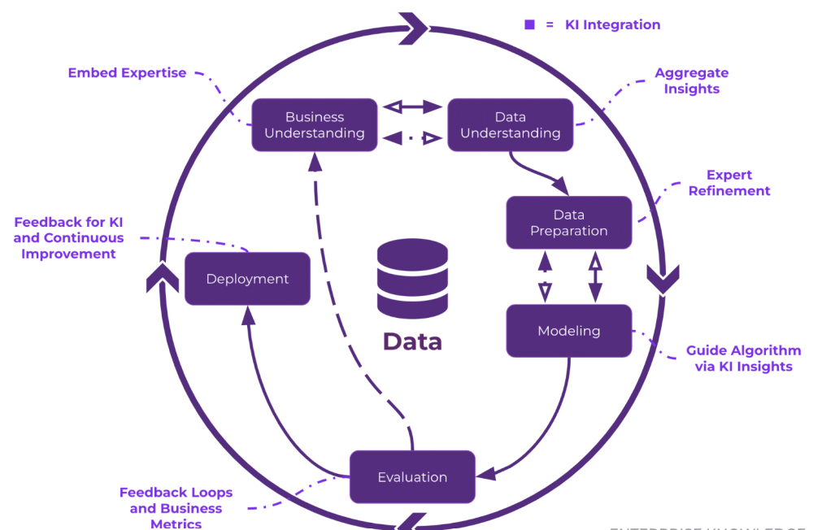
Figure 1: CRISP-DM Framework
(Source: enterprise-knowledge.com, 2026)
For Pall-Ex, this implication is further attributable to enhancing usability at core alongside reporting. On the other hand, CRISP-DM framework is attributable to provide certain systematic approach in case of Pall-Ex for data mining, from having authentic understanding of business operations to deployment (Hamdani et al. 2024). Altogether, these frameworks are considered to ensure effective implementation of BI strategies at Pall-Ex, enhancing operational efficiency and strategic planning at core of its logistics operations.

Data Warehousing in the Organisation Applications
Data Warehousing
The term Data Warehousing or DW refers to the process of collecting, as well as integrating and also storing larger volumes of data in a structured format from several operational sources into certain repository in centralised manner for the purpose of analysis and reporting (Batarlienė and Jarašūnienė, 2024). In case of Pall-Ex, this is considered to involve data from the depots alongside transportation system, orders from customers, and also the platforms to track delivery.
DW to Improve Data Access and Efficiency
Accordingly, it is to be stated that DW would majorly improve accessibility to data as well as operational efficiency through elimination of data silos across the distributed network of Pall-Ex. Significantly, in this correspondence, it can be said that by consolidating data into particular single system, employees would be able to retrieve quickly accurate information that is also in consistent manner (Anwar et al. 2022). That is further by decreasing manual processing alongside errors. For example, it can be seen that warehouse managers of Pall-Ex can have access to inventory levels in real-time. On the other hand, the logistics coordinators could be monitoring statuses for shipments without depending on systems that are fragmented.
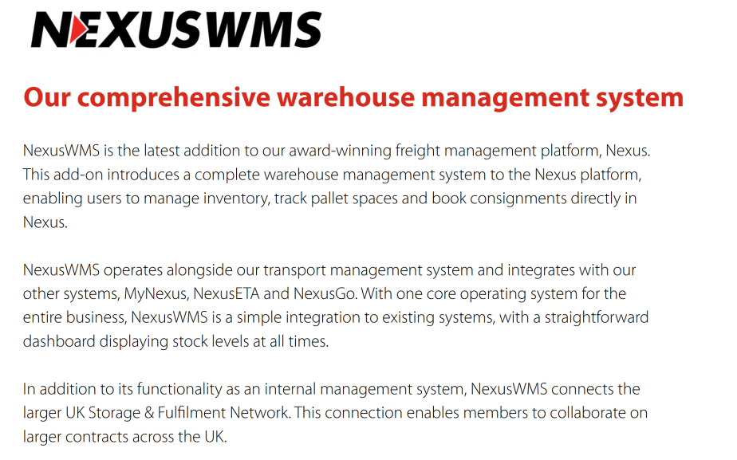
Figure 2: Current Warehouse Management System of Pall-Ex
(Source: pallex.co.uk, 2026)
DW to Support Strategic Decision-Making
Furthermore, on critical note, it can be said that data warehouse would be supporting strategic process of making decisions. That is also by enabling real-time and historical analysis (Enache, 2023). Accordingly, Pall-Ex could be analysing trends in the performance related to deliveries, identifying shortcomings in particular regions, and equally optimising the planning for routes. For example, it can be seen that consolidated supply chain data process of Pall-Ex would be allowing the management for ensuring evaluation performance of depot and allocate resources more effectively during the peak periods of demand (Boujarra et al. 2024). In addition to this, it is also required to consider that sales alongside customer data should be analysed for the purpose of identifying clients of higher value and making improvements in the offering of services.

Data Mining Techniques
Two techniques: Identification and Explanation
In Pall-Ex, it can be stated that there are two key data mining techniques, namely, clustering and regression analysis.
- Clustering is considered an unsupervised learning method, which groups similar data points based on the shared characteristics (Oyewole and Thopil, 2023). In the context of logistics, it could be classified as the customers, delivery zones, as well as shipment patterns under different circumstances.
- Regression analysis is contrarily considered as a predictive technique that examines relationships between variables through which outcomes can be forecasted, such as delivery times or levels of demand.
Their Relevance to the Data and Goals of Organisation
It should be noted that clustering is highly relevant to Pall-Ex as it allows efficient segmentation of delivery routes and categories of customers, which further improves optimization of the route and allocation of resources. This supports the organisational goals of reducing the operational costs while enhancing the delivery efficiency. By grouping the similar delivery locations and needs of customers, Pall-Ex could streamline logistics operations, while minimise fuel consumption and transit time (Aguilar Colmenero and Portela Garcia-Miguel, 2024).
On the other side, regression analysis helps predict delivery delays and demand fluctuations by evaluating some variables, like traffic, weather, and order volume. This allows proactive planning, improves the reliability of the services, and increases customer satisfaction. Along with this, it supports workforce scheduling in a better way, along with inventory management. It ensures that resources are allocated effectively to meet the changing demand patterns.
Tools or Platforms to Support These Techniques
For Pall-Ex, following tools have effectively supported the clustering and regression techniques, such as
Tools/Platforms | Discussion
Microsoft Excel | It offers basic statistical analysis and regression modelling, appropriate for smaller datasets (Kumar, 2023).
Power BI | It enables advanced data visualisation and integration with real-time logistics data for actionable insights.
RapidMiner | It provides more sophisticated machine learning capabilities, which consist of automated clustering and predictive modelling (Andryet al. 2022). It allows the organisation, like Pall-Ex, to evaluate the complex datasets while enhancing decision-making efficiency.
Table 1: Chosen Tools and Platforms

Predictive Analysis
Predictive Analysis Tools Suitable for Recommended
Following the discussion above, it can be recommended that predictive analysis tools such as Power BI, as well as Microsoft Excel, alongside IBM SPSS and RapidMiner, be used.
- Power BI, accordingly, is seen to be ideal for interactive dashboards as well as related forecasting (Shaharudin et al. 2023).
- Excel, on the other hand, would ensure support for basic predictive analysis
- SPSS would enable advanced modelling of statistical parameters
- RapidMiner would further offer capabilities of machine learning for complex data of logistics (Booker et al. 2024).
These tools, collectively and in integrated manner, would be aligned with the needs of Pall-Ex's logistics forecast demands, predicting delays in delivery and equally optimising routes.
Features, Usability, and Integration with Organisational Systems for Comparison
Accordingly, the features as well as usability and integration with systems of organisations are compared and discussed below:
Predictive Analysis Tools | Key Features | Usability | Integration
Power BI | Forecasting and visual analytics. | Moderate | Stronger with ecosystem of Microsoft.
Microsoft Excel | Regression and trend analysis (Brusco, 2022). | Easy | High compatibility.
SPSS | Advanced models of statistics. | Complex | Moderate.
RapidMiner | Machine learning and automation (Shmueli et al. 2023). | User-friendly | Integration of cloud and big data.
Table 2: Comparative Aspects of Predictive Analysis Tools
Reporting Automation or Forecasting Capabilities to Discuss
Now, in comparative parameters, it can be implied that these tools would enable automated reporting and related forecasting for Pall-Ex. Accordingly, Power BI is seen to be providing dashboards with updated, automated data in real-time (Hartzel and Ozturk, 2024). On the other hand, Microsoft Excel is perceived to support trend forecasting for Pall-Ex. Furthermore, RapidMiner would allow Pall-Ex to automate predictive modelling, while SPSS would offer statistical forecasts in detail. This, in turn, is subject to enhancing logistics decision-making proactively alongside bringing operational efficiency.

Ethical and Data Security Considerations
GDPR and Other Legal Compliance Aspects
It can be stated that, for Pall-Ex, compliance with the “General Data Protection Regulation (GDPR)” is necessary while managing the customers and delivery data (gov.uk, 2026). This ensures lawful processing, data minimisation, and accountability in the context of Pall-Ex.
Data Ownership, Consent, and Transparency
It should be noted that clear data ownership policies should be established. It should ensure that customers can understand the way their data has been collected and utilised. Obtaining informed consent while maintaining transparency could establish trust (Narkhede et al. 2025). In this way, organisations, like Pal-Ex, would be able to practice and support the ethical data practices.
Access Controls, Encryption, and Other Safeguards
It can be seen that role-based access controls need to restrict data usage, while encryption further protects the sensitive logistics and customer data (Omotunde and Ahmed, 2023). Regular audits and system monitoring further could strengthen security.
Internal and External Threats
Based on the above discussion, it is now important for Pal-Ex to identify both internal as well as external threats, such as
Internal Threats | External Threats
- Employee misuse  - Unauthorised access (Jamalet al. 2024) | - Cyberattack (Ghelani, 2022)  - Data breaches
Table 3: Internal and External Threats
Therefore, Pal-Ex needs to maintain strong cybersecurity measures along with continuous system updates.

Reporting and Dashboard Solutions
Suggest BI Dashboards
Now, coming to the discussion on suggested BI dashboards, it can be said that for logistics organisation Pall-Ex, suggested BI dashboard can be developed effectively by using Power BI as well as Tableau (Panda and Padhy, 2025). These further provide interactive experience alongside user-friendliness, considering capabilities for data visualisation.
Their Value for Real-Time Monitoring and Decision-Making
These suggested dashboards are further attributable to enable monitoring of logistics operations in real-time. That would certainly allow managers to track performances as well as identify existing inefficiencies and simultaneously respond to disruptions quickly (Nayak, 2025). In this regard, it can be said that for Pall-Ex, this would enhance operational controls alongside ensuring support for faster and data-centric decision-making across the organisation.
Metrics/KPIs Relevant to Organisation
Therefore, KPIs or Key Performance Indicators would involve;
- Delivery rate is on time
- Trends in order volumes
- Utilisation rate of warehouse
- Time for delivery turnaround
- Customer satisfaction score
All of these aforementioned KPIs are attributable to help Pall-Ex in measuring performance as well as ensuring improvements in efficiency of services (Obuse et al. 2023).

Conclusion
Based on the above discussion, it can be stated that this report has demonstrated that “Business Intelligence (BI)”, “Data Warehousing (DW)”, and “Data Mining (DM)” provide Pall-Ex with enhanced data integration, improved visibility, and some actionable insights for the purpose of decision-making.
BI has further improved the performance of the business, like Pal-Ex, by enabling real-time monitoring, predictive forecasting, and efficient utilisation of the resources. This could further lead to reduced costs while improving the quality of the services.
Strategically, it should be noted that BI is necessary for organisations, like Pal-Ex could maintain competitiveness, while supporting the agile responses to the market changes and enabling long-term planning.
It is therefore further recommended that Pall-Ex needs to adopt the "Cloud-Based BI Solutions", while making some investments in the predictive analytics tools, and implement the robust data governance and security frameworks. In this way, operational and strategic benefits can be maximised in the organisational context.

Reference List
Aguilar Colmenero, J.L. and Portela Garcia-Miguel, J., 2024. A regionalization approach based on the comparison of different clustering techniques. Applied Sciences, 14(22), p.10563.
Andry, J.F., Hartono, H. and Honni, A.C., 2022. Data set analysis using rapid miner to predict cost insurance forecast with data mining methods. Journal of Hunan University Natural Sciences, 49(6).
Anwar, M.F., Wong, W.P., Saad, N.H. and Mushtaq, N., 2022. Data analytics and global logistics performance: an exploratory study of informatization in the logistics sector. LogForum, 18(2).
Batarlienė, N. and Jarašūnienė, A., 2024. Improving the quality of warehousing processes in the context of the logistics sector. Sustainability, 16(6), p.2595.
Booker, Q.E., Rebman Jr, C.M., Wimmer, H., Levkoff, S.B., Powell, L. and Breese, J.L., 2024. Data Analytics Position Description Analysis: Skills Review and Implications for Data Analytics Curricula. Information Systems Education Journal, 22(3), pp.76-87.
Boujarra, M., Lechhab, A., Al Karkouri, A., Zrigui, I., Fakhri, Y. and Bourekkadi, S., 2024. Revolutionizing logistics through deep learning: Innovative solutions to optimize data security. Journal of Theoretical and Applied Information Technology, 102(4), pp.1593-1607.
Brusco, M., 2022. Logistic regression via Excel spreadsheets: Mechanics, model selection, and relative predictor importance. INFORMS Transactions on Education, 23(1), pp.1-11.
Bussa, S., 2023. Enhancing BI tools for improved data visualization and insights. International Journal of Computer Science and Mobile Computing, 12(2), pp.70-92.
Enache, G.I., 2023. Logistics security in the era of big data, cloud computing and IoT. In Proceedings of the international conference on business excellence (Vol. 17, No. 1, pp. 188-199). Sciendo.
enterprise-knowledge.com, (2026), Understanding the Role of Knowledge Intelligence in the CRISP-DM Framework: A Guide for Data Science Projects, Available at: https://enterprise-knowledge.com/understanding-the-role-of-knowledge-intelligence-in-the-crisp-dm-framework-a-guide-for-data-science-projects/ [Accessed on 26.03.2026]
Ghelani, D., 2022. Cyber security, cyber threats, implications and future perspectives: A Review. Authorea Preprints.
gov.uk, (2026), Data protection, Available at: https://www.gov.uk/data-protection [Accessed on 26.03.2026]
Hamdani, F.E., Quintero, I.A.Q., Enjolras, M., Camargo, M., Monticolo, D. and Lelong, C., 2024, January. Agile supply chain analytic approach: a case study combining agile and CRISP-DM in an end-to-end supply chain. In Supply Chain Forum: An International Journal (Vol. 25, No. 1, pp. 96-110). Taylor & Francis.
Hartzel, K.S. and Ozturk, P., 2024. Tools for Success: Their Impact on Salaries in the Data Analytics Job Market. Journal of Information Systems Applied Research, 17(2), pp.45-60.
Jamal, H., Algeelani, N.A. and Al-Sammarraie, N., 2024. Safeguarding data privacy: strategies to counteract internal and external hacking threats. Computer Science and Information Technologies, 5(1), pp.46-54.
Katasani, D.P., 2025. Real-Time Analytics: Integrating Cloud-Native Data Processing and Warehousing Platforms. Journal of Computer Science and Technology Studies, 7(9), pp.516-524.
Kumar, M.D., 2023. A study on importance of microsoft excel data analysis statistical tools in research works. Journal of Management & Educational Research Innovation, 1(3), pp.25-33.
Machireddy, J.R., 2024. Integrating machine learning-driven RPA with cloud-based data warehousing for real-time analytics and business intelligence. Hong Kong Journal of AI and Medicine, 4(1), pp.98-121.
Meda, R., 2023. Intelligent Infrastructure for Real-Time Inventory and Logistics in Retail Supply Chains. Educational Administration: Theory and Practice.
Narkhede, M.R., Wankhede, N.I. and Kamble, A.M., 2025. Enhancing patient autonomy in data ownership: privacy models and consent frameworks for healthcare. Journal of Digital Health, pp.1-23.
Nayak, S., 2025. The role of data visualization tools in financial decision-making: A comparative analysis of Tableau, Power BI, and SSRS. The Es Accounting and Finance, 3(03), pp.282-301.
Nookala, G., 2023. Real-Time Data Integration in Traditional Data Warehouses: A Comparative Analysis. Journal of Computational Innovation, 3(1).
Obuse, E., Ajayi, J., Akindemowo, A., Erigha, E., Adebayo, A., Afuwape, A. and Soneye, O., 2023. Advances in analytics engineering for operational Decision-Making using Tableau, Astrato, and Power BI. International Journal of Multidisciplinary Research and Growth Evaluation, 4(1), pp.1318-1335.
Omotunde, H. and Ahmed, M., 2023. A comprehensive review of security measures in database systems: Assessing authentication, access control, and beyond. Mesopotamian Journal of CyberSecurity, 2023, pp.115-133.
Oyewole, G.J. and Thopil, G.A., 2023. Data clustering: application and trends. Artificial intelligence review, 56(7), pp.6439-6475.
pallex.co.uk, (2026), NexusWMS, Available at: https://www.pallex.co.uk/nexus-wms [Accessed on 26.03.2026]
pallex.co.uk, (2026), The leading palletised freight distribution network, Available at: https://www.pallex.co.uk/ [Accessed on 26.03.2026]
Panda, S.P. and Padhy, A., 2025. Business Intelligence with Power BI and Tableau: Cloud-Based Data Warehousing, Predictive Analytics, and Artificial Intelligence-Driven Decision Support. Deep Science Publishing.
Shaharudin, M.S., Ganesan, Y., Fernando, Y., Ahmad, N.H., Amran, A. and Lee, K.L., 2023. Predicting sustainable development goals through the industry 4.0: insights from public listed companies. Journal of governance and integrity, 6(2), pp.515-528.
Shmueli, G., Bruce, P.C., Deokar, K.R. and Patel, N.R., 2023. Machine learning for business analytics: Concepts, techniques, and applications with analytic solver data mining. John Wiley & Sons.
Sornprom, N., 2024. Role of cloud computing & artificial intelligence in the logistics & supply chain industry. weather, 12(6).

