

Programme: Master of Business Administration
Module Name & Code: International Business Concepts (LCMB7034)
Assignment Title: Report
Lecturer: Akshay Narayanan

Student Name: Jowher Ahmed
Student ID: 2437456

Word Count: 5284
Submission Date:

Contents
Section 1 1
1. Introduction 1
2. Industry and Country Overview 2
a. Global Swiss Watch Industry and China Market Context 2
b. Size, Scope, Economic Importance. 3
c. Competitive Positioning and Major Firms. 3
3. Global Competitiveness: Porter’s Diamond Model (Switzerland Watch Industry with Focus on China Market Demand) 5
1. Factor Conditions (High level of production in Switzerland) 6
2. Demand Conditions (Strong Domestic Sophistication + China as Global Demand Driver) 6
3. Supporting and Related Industry (Integrated Swiss Ecosystem) 7
4. Strategy, Structure and Rivalry Firm (Intense Swiss Competition Driving Global Excellence) 7
4. Rolex as a Multinational Enterprise in China 9
4.1 Company Overview 9
4.2 Market attractiveness (PESTEL Framework) China 10
4.3 SWOT Analysis Rolex in China 12
4.4 Five Forces Analysis (Porters Analysis) 14
4.5 Comparison with Competitors 15
4.6 Strategic Recommendations 16
5. Conclusion 17
Section 2 18
Reflective Account 18
Use Gibbs’ Reflective Cycle: 18
Description 18
Feelings 19
Evaluation 19
Analysis 20
Conclusion 21
Action Plan 21
Reference 22

List of Table
Table 1.Comparative Positioning of Key Brands 4
Table 2.Comparative Advantage: Switzerland vs Global Competitors 8
Table 4: Rolex vs Competitors in China 16

List of Figure
Figure 1. China Watchmaking Workshop and Precision Machinery. 2
Figure 2. Porter’s Diamond Model applied to the China watch industry. 5
Figure 3. Rolex as a Multinational Enterprise in China. Adapted from corporate strategy literature and luxury market reports (2024–2025). 9
Figure 4. PESTEL Framework for External Environmental Analysis. Adapted from Johnson, Scholes & Whittington (2020) and corporate strategy literature. 10
Figure 5. SWOT Analysis of Rolex in China. Adapted from corporate strategy literature and luxury market reports (2024–2025). 12
Figure 6. Porter’s Five Forces Analysis of Rolex in China. Adapted from Porter (1980) and luxury market strategy literature (2024–2025). 14
Figure 7.. Gibbs’ Reflective Cycle applied to research on Rolex and the China watch industry, illustrating systematic reflection on experience, emotion, evaluation, and learning (Gibbs, 1988). 18

Section 1

1. Introduction
Rolex SA is one of the world’s most prestigious luxury watch manufacturers, originally founded in 1905 and headquartered in Geneva, Switzerland. The company is globally recognised for its precision engineering, craftsmanship, and exclusivity, which have positioned it as a leading brand in the luxury horology industry (Statista, 2024). Rolex operates in the high-end Swiss watchmaking sector, where limited production and strong brand heritage contribute significantly to its global reputation and pricing power.
In recent years, Rolex has maintained strong performance in international luxury markets, including China, which has become one of its most important growth regions due to rising disposable income and increasing demand for premium goods (Deloitte, 2023). The brand is widely regarded as a symbol of status, success, and long-term value, particularly among affluent consumers in emerging economies (PwC, 2023).
The purpose of this report is to analyse Rolex as a multinational enterprise operating in China, evaluate the attractiveness of the Chinese luxury watch market, and assess the company’s competitive position using strategic frameworks such as PESTEL, SWOT, and Porter’s Five Forces. The report also aims to examine how Rolex maintains its global leadership while adapting to changing consumer behaviour and competitive pressures in one of the world’s fastest-growing luxury markets.

2. Industry and Country Overview

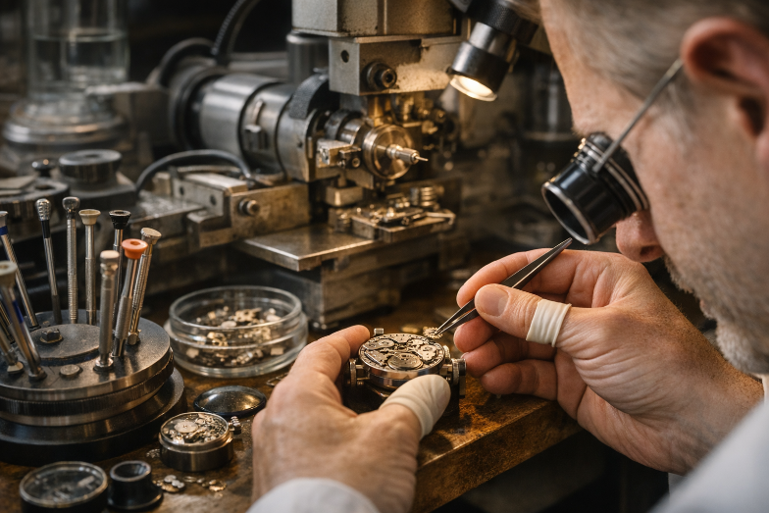
Figure 1. China Watchmaking Workshop and Precision Machinery.
Source: Adapted from Federation of the China Watch Industry (FH), 2025.

a. Global Swiss Watch Industry and China Market Context
The Swiss watch industry is internationally recognised as the pinnacle of luxury horology, characterised by high precision engineering and artisanal craftsmanship, and powerful brand legacy. Switzerland has established a dominant market in the world luxury watch market with brands like Rolex, Patek Philippe, and Omega dominating the global market (Federation of the Swiss Watch Industry, 2025).
China is currently one of the crucial export and consumption markets of Swiss luxury watches, despite the fact that the center of production is Switzerland. China has emerged as a leading contributor to the luxury consumption in the world in the last ten years thanks to the rapid urbanisation, increased income levels, and desire to consume prestige goods (Bain & Company, 2023). The Swiss watches are not only considered as useful timepieces but also as a symbol of success, wealth, and social standing in China.
The Swiss watch industry is hence globally connected: manufacturing is still based in Switzerland, whereas consumption is becoming more global with China, the United States, and Hong Kong being the key centres of demand.

b. Size, Scope, Economic Importance.
The Swiss watch business is a significant exporter of Switzerland. In 2023, the export of Swiss watches amounted to about CHF 26 billion, and the largest share of the export value is formed by luxury mechanical watches (Swiss Watch Industry Federation, 2024). Though the level of production is comparatively low as to mass-market producers, Switzerland is the world leader in luxury in the value, but not quantity.
China is an important component of this ecosystem because it is one of the biggest markets of Swiss luxury watches. In 2024, the Chinese luxury watch market was estimated to exceed USD 15-18 billion, with the market significantly growing with younger affluent consumers and the growing wealth of the middle-class (Daxue Consulting, 2025). The major cities, where luxury consumption is associated with lifestyle and status, like Shanghai, Beijing and Shenzhen are especially in high demand.
The Swiss watch industry also sustains a large economic network, which includes:
- precision component suppliers
- micro-engineering firms
- luxury retail networks
- design and innovation centres
This ecosystem pays a lot of contribution to jobs, innovations and export earnings in Switzerland. Also, Swiss watches are defined as investment luxury items, which have a tendency to increase in value over time, making it more resistant to economic changes worldwide (Deloitte, 2023).

c. Competitive Positioning and Major Firms.
The Swiss luxury watch market is very concentrated as there are few players in the world that play in various luxury segments. The major companies are Rolex, Patek Philippe and Omega, which are in different strategic positions.
- Rolex SA: Rolex is the leader in luxury watch category worldwide. Its positioning is based on exclusivity, limited supply and robust brand equity. The limited production by Rolex is intentional to preserve scarcity, a factor that drives demand and resale price (Morgan Stanley, 2024). It is generally priced between USD 5,000 and more than USD 75,000 and is marketed to the high-end global clients. Rolex possesses good distribution networks in more than 100 countries and is also generally considered to be the most recognisable brand of luxury watch in the world.
- Patek Philippe: Patek Philippe competes in the ultra-luxury market which is based on craftsmanship, rarity and heritage value. The brand was established in 1839 and manufactures watches with very limited production and usually is priced between USD 20,000 and more than USD 500,000. It focuses on exclusivity and not scale and targets collectors and ultra-high-net-worths. Patek Philippe watches are considered as generational assets, which solidifies their investment worth over time (Statista, 2024).
- Omega (Swatch Group): Omega is in the high end market and has a wider consumer base than Rolex and Patek Philippe. It is also associated with space exploration (Moonwatch) and the world sports like Olympics. The omega products are in the range of USD 3,000 and USD 50,000 and hence they are more affordable and yet retain good brand value (PwC, 2023). With more than 90 countries of international presence, Omega employs high-volume premium positioning to attract aspirational buyers.
Table 1.Comparative Positioning of Key Brands
Company | Segment | Price Range | Global Reach | Strategy
Rolex | Luxury | USD 5k–75k | 100+ countries | Scarcity, brand prestige, controlled supply
Patek Philippe | Ultra-luxury | USD 20k–500k | 50+ countries | Exclusivity, craftsmanship, heritage value
Omega | Premium luxury | USD 3k–50k | 90+ countries | Accessibility, innovation, sports marketing

Overall, the Swiss watch industry remains a global leader in luxury horology, driven by craftsmanship, innovation, and strong brand heritage. Switzerland dominates production, while China represents one of the fastest-growing and most strategically important consumption markets. Firms such as Rolex, Patek Philippe, and Omega illustrate different competitive strategies, ranging from mass luxury exclusivity to ultra-rare artisanal production. This diversified positioning ensures the long-term global competitiveness of the Swiss watch industry while reinforcing its dominance in the high-value luxury segment.

3. Global Competitiveness: Porter’s Diamond Model (Switzerland Watch Industry with Focus on China Market Demand)

The Diamond Model of Porter describes why some industries in a country can be internationally competitive due to interplay of four major determinants; factor conditions, demand conditions, related and supporting industries, and firm strategy, structure and rivalry (Porter, 1990). The model is applicable in the Swiss watch industry as it explains why Switzerland has been the world leader in luxury watch-making and China is a key demand market with high growth to companies like Rolex.
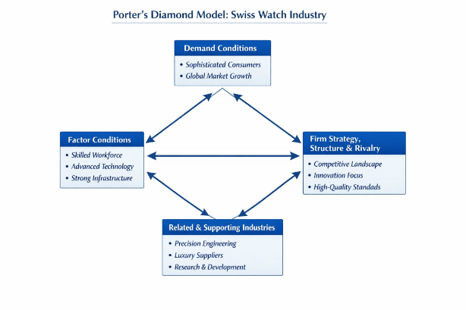
Figure 2. Porter’s Diamond Model applied to the China watch industry.
Source: Adapted from Porter (1990) and Federation of the China Watch Industry (FH), 2025.

1. Factor Conditions (High level of production in Switzerland)
The competition in the luxury watch industry in Switzerland is highly conditioned by the highly developed factor conditions. A tradition of precision engineering, micro-mechanics and horological craftsmanship has been long established in the country, and is backed by special education systems and vocational training schools, including watchmaking schools in Geneva and Le Local.
The Swiss labor force is very efficient in the assembly of complex mechanical movements in need of extreme precision and handicraft. Moreover, Switzerland enjoys a high level of technological infrastructure, political stability, and high level of protection of intellectual property, all of which are favourable to the innovation in luxury production (Deloitte, 2023).
In the case of Rolex, these conditions of factors are necessary in the preservation of the quality of products, mechanical accuracy and brand image. The fact that there are few trained watchmakers in the world further enhances the special position of Switzerland and makes it extremely difficult to imitate.

2. Demand Conditions (Strong Domestic Sophistication + China as Global Demand Driver)
The demand in Switzerland is very sophisticated and historically local consumers are sensitive to precision, quality and craftsmanship. Nevertheless, the biggest demand force of Swiss luxury watches today emanates from the foreign markets especially in China.
China is one of the most rapid luxury watch markets worldwide as the country experiences the increase of disposable income, urbanisation, and cultural ties to luxury items and their links to social status and prosperity (Bain & Company, 2023). Prestige of the brand, investment value and symbolic ownership are of great importance to Chinese customers, which is very much in line with the brand positioning of Rolex.
This demand structure presents a huge opportunity to Rolex since the Chinese tend to consider high-end watches as an investment, instead of an accessory. This high external demand supports the capacity of Swiss producers to retain high prices and regulated supply policies.

3. Supporting and Related Industry (Integrated Swiss Ecosystem)
A very well-networked ecosystem of related industries supports the Swiss watch industry: manufacturers of precision components, jewellery, micro-engineering companies, and sophisticated materials manufacturers.
Switzerland also enjoys good logistics, financial services and export infrastructure to facilitate world distribution. Moreover, the materials science technological partnerships (e.g., ceramic bezels, anti-scratch sapphire crystal, and precision tools) improve the product innovation and longevity.
In the case of Rolex, one of the strategies is that of vertical integration, meaning that most of the components are manufactured by the company to ensure that it can control the quality and minimize reliance on third parties (Morgan Stanley, 2024). Such strict control enhances effectiveness and preserves brand integrity in the international markets even in China.

4. Strategy, Structure and Rivalry Firm (Intense Swiss Competition Driving Global Excellence)
The high internal rivalry in the Swiss luxury watch industry is typified by the presence of globally renowned brands like Rolex, Patek Phillipe and Omega. This competition promotes constant invention, brand differentiation and standards of high quality production.
- Rolex emphasizes controlled scarcity, longevity and positioning of mass luxury prestige.
- Patek Philippe is oriented on ultra-luxury exclusivity and family legacy.
- Omega concentrates on high-quality accessibility and technology.
This competition model makes the firms strive to keep on improving design, craftsmanship and brand storytelling. Although both brands belong to one industry in the country, they serve various parts of the luxury market in the world, and this minimizes substitution, but the competition is high.
In the case of Rolex, this competition helps it to continue innovating and retain its brand leadership in the luxury market around the world, including China.
Table 2.Comparative Advantage: Switzerland vs Global Competitors
Dimension | Switzerland (Rolex Industry Base) | International Competitors
Skilled Workforce | Highly specialised horology expertise | More automation-focused production
Innovation | Mechanical precision + heritage innovation | Digital/tech-focused innovation
Brand Strength | Global luxury leadership (Rolex, Patek Philippe) | Strong but less heritage-driven
Production Quality | Artisanal + precision engineering | Mass production or hybrid models
Market Position | High-value luxury dominance | Mid to premium luxury competition

The Porters Diamond Model can reveal that the reason why Switzerland has managed to dominate the luxury watch industry is due to the good factor conditions, high-end global demand, integrated supporting industries, and stiff domestic competition. Whereas Switzerland gives the production and innovation platform, China is another important outside demand driver that gives a significant boost to the growth and profitability of the industry.
In the case of Rolex, the structure allows the business to continue to lead the world through a blend of Swiss artisanship and robust expansion to the world markets, especially in the high growth luxury markets like China. (PwC, 2023; Porter, 1990).

4. Rolex as a Multinational Enterprise in China

4.1 Company Overview
Founded in 1905, Rolex SA is one of the most luxurious brands of watch in the world that is based in Geneva, China. Globally, the company is known to focus on precision engineering, craftsmanship, and exclusivity and has an annual production of more than one million timepieces with a tight supply control, to maintain brand value (Morgan Stanley, 2024; LuxeConsult, 2024). Over the past years, Rolex has been the leader in the world of luxury watches, with revenues in the range of CHF 10 billion and the biggest market share among China watch manufacturers (Morgan Stanley, 2024).
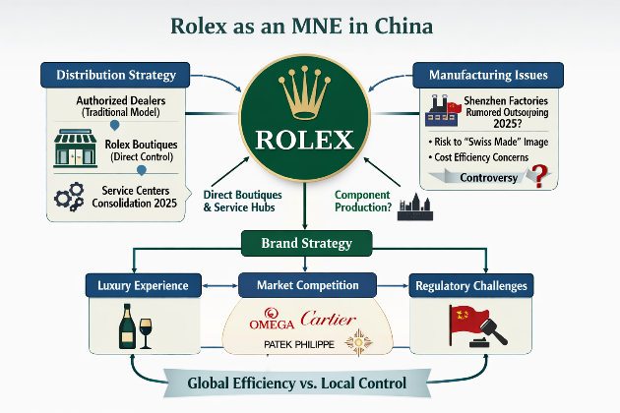
Figure 3. Rolex as a Multinational Enterprise in China. Adapted from corporate strategy literature and luxury market reports (2024–2025).
Rolex being a foreign multinational company in China operates in one of the fastest emerging luxury markets in the world. In 2024, the Chinese luxury watch was estimated at around USD 18 billion in the market, as the market has been growing steadily due to the growth in disposable incomes, as well as the demand of high-status products (Daxue Consulting, 2025).
The approach of Rolex in China is based on brand reputation, scarcity and cultural orientation as opposed to mass marketing. The firm has partnered with key people in China and also sponsors cultural and sports events to promote brand resonance. Although the luxury industry is subject to economic fluctuations, Rolex still enjoys its high brand equity and pricing power in China due to its brand reputation as a status symbol and a long-term value asset (Statista, 2024; Deloitte, 2023).

4.2 Market attractiveness (PESTEL Framework) China
The PESTEL framework that brings to the fore the external macro-environmental factors that affect international activities at Rolex can be used critically to assess the attractiveness of the China market to Rolex.
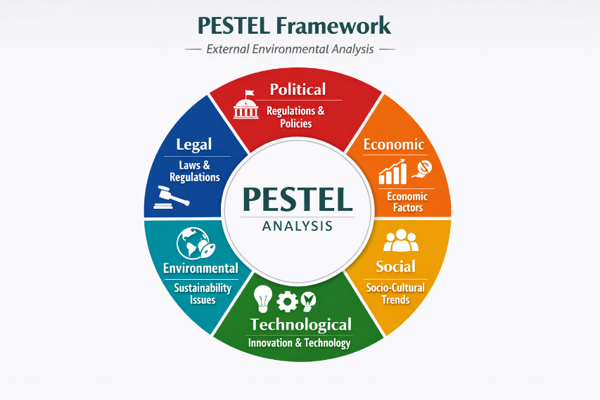
Figure 4. PESTEL Framework for External Environmental Analysis. Adapted from Johnson, Scholes & Whittington (2020) and corporate strategy literature.
- Political Factors: The political climate that has been in China is that of high levels of central government control and policy orientation that are very vital in determining business activities. The Chinese government has traditionally encouraged consumption and economic growth in the country, including the development of the luxury sector by urbanisation and income growth policies (World Bank, 2023).
- Economic Factors: China is one of the most promising economic regions of luxury brands because of the growing middle and upper classes. Its GDP growth, though slowing down in the recent past, is still substantial in comparison to the developed economies, which prove beneficial to increasing disposable incomes and consumption levels (IMF, 2024). Urbanisation and wealth accumulation are likely to lead to China taking a large portion of the luxury consumption in the world (Bain and Company, 2023).
- Sociocultural Factors: The sociocultural forces are important in determining the success of Rolex in China. In Chinese society, luxury products are frequently equated with social status, success, and personal accomplishments, and luxury watches are sought after by wealthy consumers (Kapferer & Bastien, 2022). In this instance, Rolex in its specifics is viewed as a symbol of prestige, reliability, and long-term value; which reflects well with Chinese cultural tendencies to associate their products with wealth and stability.
- Technological Factors: The highly developed digital environment in China offers opportunities and threats to Rolex. It is one of the nations with the highest rates of internet penetration in the world, as well as a high usage of e-commerce platforms and digital payment platforms like the Alipay and WeChat Pay (Statista, 2024). This offers luxury brands the chance to connect with consumers via online marketing, social media and internet shopping avenues.
- Environmental Factors: In China, environmental sustainability is increasingly becoming a major issue due to the government policies and the increasing consumer awareness. The Chinese authorities have introduced more stringent environmental policies and sustainability goals which make companies eco-friendlier (UNEP, 2023).
- Legal Factors: Rolex has both opportunities and threats in the legal environment in China. The protection of intellectual property (IP) has been enhanced over the past several years, and more robust enforcement methods are supposed to decrease counterfeiting (WIPO, 2023). Nevertheless, fake luxury products continue to be a significant threat, especially in the online shopping platforms, threatening brand recognition and sales.
On the whole, although the Chinese legal system is being adjusted to accommodate foreign business, the challenge posed by the regulations requires effective compliance measures.

4.3 SWOT Analysis Rolex in China
The SWOT analysis offers an organised approach to the analysis of the internal strengths and weaknesses of Rolex and external opportunities and threats that the company will be exposed to in the Chinese luxury watch market.
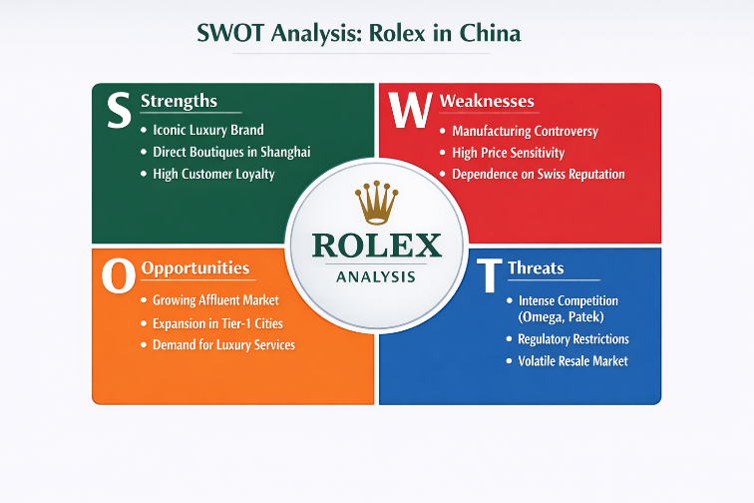
Figure 5. SWOT Analysis of Rolex in China. Adapted from corporate strategy literature and luxury market reports (2024–2025).
Strengths
The key competitive advantage that Rolex will have in China is its unmatched brand name and reputation of luxury, accuracy and exclusivity in the world. The brand is strongly viewed as a status and success symbol, which fits well with Chinese cultural values, which underline prestige and social acceptance (Kapferer and Bastien, 2022).
The other strength is that Rolex has tight control on the production and distribution. Rolex has achieved limited supply through its careful selection of authorised dealers, thereby creating a sense of scarcity, which contributes to its desirability and contributes to high resale prices (Morgan Stanley, 2024). This is a very effective strategy especially in china where luxury goods are usually considered as status symbols as well as an investment.
Weaknesses
In spite of its strong points, Rolex has a number of internal constraints in the Chinese market. Among the weaknesses is that it is relatively conservative in its digital transformation. Rolex has been slow to embrace e-commerce and direct online sales, unlike its competitors, as exclusivity and controlled distribution have been prioritised. This can restrict its capabilities of targeting younger consumers in a highly digitalised market such as China, where they depend on online platforms extensively (McKinsey, 2024).
The dependence of the brand on the high-end luxury segment is another weakness. The high prices of Rolex limit its market to those with high incomes, and thus more susceptible to economic forces and shifts in consumer spending patterns.
Opportunities
The fast growth of the middle and upper classes in China offers great growth opportunities to Rolex. The rising disposable income and urbanisation are boosting the demand of luxury products, such as luxury watches (Bain & Company, 2023). This can be exploited by Rolex since it would increase in the emerging cities where the luxury demand is increasing.
There is also a significant opportunity with digital engagement. Selective e-commerce, social media marketing, and virtual retail experience will help Rolex to engage customers more even as it preserves exclusivity. Digital channels that are popular in China might be tapped to enhance the brand awareness of the younger generation.
Threats
Counterfeits are one of the greatest threats to Rolex in China due to the prevalence of fake products. However, even with the development of intellectual property protection, the number of fake luxury brands has increased, especially on the Internet, which endangers the integrity of the brand and revenues (WIPO, 2023).
There is also a risk of economic uncertainty. Discretionary spending on luxury goods can be lowered due to fluctuations in economic growth and consumer confidence. Policies by the government to curb excessive consumption can also affect demand.
All in all, Rolex has a good competitive standing in China because of prestige of its brand, exclusivity and quality of its products. Nevertheless, to ensure long-term growth, the digital constraints and keeping up with the evolving consumer trends will be essential.

4.4 Five Forces Analysis (Porters Analysis)
The Five Forces model created by Porter offers a systematic analysis of the competitive forces that affect the operations of Rolex in the Chinese luxury watch industry. The analysis shows the degree of competitiveness and the drivers of profitability in the industry.
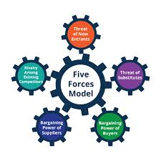
Figure 6. Porter’s Five Forces Analysis of Rolex in China. Adapted from Porter (1980) and luxury market strategy literature (2024–2025).
- Threat of New Entrants -Low to Moderate: Barriers to entry are very high and as a result, the threat of new entrants in the industry of luxury watches is also low. These are high minimum capital requirements, high technical skills and high brand heritage and reputation. Rolex enjoys more than 100 years of brand equity; which new entrants can hardly emulate. Nevertheless, there is the development of niche luxury brands and independent watchmakers, focused on a particular consumer niche, so the threat is moderately topical in specialised markets.
- Supplier Power- Moderate: The luxury watch industry suppliers include specialised parts that include movements, metals, and gemstones. Rolex alleviates supplier power by vertical integration, in which most of its components are made internally. Nevertheless, the company is vulnerable to fluctuations in prices and shortages of raw materials which are of high quality such as precious metals. This has a moderate supplier bargaining power.
- Bargaining Power of Buyers- Moderate-High: The bargaining power of Chinese consumers is increasing, as more consumers are getting access to information and a greater number of luxury brands. Consumers have the ability to compare products of different brands like Omega SA and Patek Philippe, which affects their purchases. Nonetheless, due to the high brand loyalty and exclusivity that Rolex is associated with, price sensitivity is minimized, which balances the buyer power to medium-high.
- Threat of Substitutes - Moderate: These substitutes can be other luxurious products like jewellery, and luxury watches such as smartwatches made by brands like Apple Inc.). Although the alternatives have various functional uses, they are competing over consumer expenditures. Emotional and symbolic value of Rolex watches makes the substitution risk lower, and switching of consumer preference makes this risk moderate.
- Industry Rivalry – High: The luxury watch industry is highly competitive as the established brands fight over quality, innovation and brand prestige. Rolex is under intense competition with other premium and ultra-luxury watch brands and so must continually innovate and market its products. The competitiveness is high due to the rivalry but it puts pressure on the firms to ensure that there is differentiation and brand value.
On the whole, the industry is very competitive with high barriers to entry to protect the established players such as Rolex, but growing buyer power and competition necessitate a sustained strategic adjustment.

4.5 Comparison with Competitors
Rolex also holds a good competitive edge in the Chinese luxury watch market, compared to its major competitors like Omega SA and Patek Philippe. The broad luxury segment is controlled by Rolex that balances exclusivity with somewhat broader availability to reach both established and new affluent buyers.
The competitive advantage of Rolex is an international brand awareness, tight distribution network, and resale value. Nonetheless, Omega is equally competitive based on innovation and sport associations whereas Patek Philippe thrives in exclusivity and legacy. This distinction guarantees a stiff competition, yet also enables every brand to maintain its own presence in the Chinese market.
Table 4: Rolex vs Competitors in China
Aspect | Rolex | Omega | Patek Philippe
Brand Recognition | Very High | High | Very High
Innovation | High | Medium | Medium
Global Distribution | 100+ countries | 90+ countries | 50+ countries
Market Segment | Luxury | Premium | Ultra-luxury

4.6 Strategic Recommendations
Rolex ought to embrace the balanced strategy that retains exclusivity and embraces selective innovation in order to enhance its presence in China. To begin with, the company needs to increase its online presence with regulated e-commerce platforms and immersive technologies like virtual showrooms. This would enable Rolex to tap younger and tech-savvy consumers without watering down its premium brand image.
Second, Rolex ought to increase its presence in the emerging cities in China where the luxury demand is rising. The company can also tap into new growth prospects by ensuring that it has chosen authorised dealers and boutique locations and brand control.
Third, there must be a focus on spending on sustainability. Ethical sourcing, open supply chains, and green production can also be promoted, which will increase brand awareness among consumers who are becoming more aware.
Lastly, Rolex must invest in product innovation, and maintain its tradition. The exclusivity and culturally-appropriate designs may further boost its popularity within the changing luxury environment in China.
Altogether, this case shows how a globally recognized luxury brand can effectively adapt to a dynamic emerging market by striking a balance between tradition and innovation. The implications of these insights extend to strategic concerns of multinational firms working in the competitive global settings.

5. Conclusion
The China watch industry remains a globally renowned benchmark for luxury, craftsmanship, and precision engineering. Its competitiveness is underpinned by high-quality production standards, skilled labour, strong innovation capabilities, and a rich heritage that dates back centuries. Domestic brands like Rolex, Pate Philippe, and Omega have successfully leveraged these factors, creating differentiated market positions through strategic pricing, brand positioning, and selective distribution. The Porter’s Diamond Model highlights China’s advantages in factor conditions, demand sophistication, related industries, and intense domestic rivalry, all of which drive global competitiveness and reinforce the country’s leadership in high-end watchmaking. For multinational corporations such as Rolex, success relies on sustaining brand heritage, investing in technological innovation, and adapting to evolving consumer preferences across diverse markets. A strong global distribution network, strategic marketing, and selective product scarcity further strengthen brand value. Additionally, leveraging cultural prestige and maintaining stringent quality controls are critical for preserving consumer trust and exclusivity. Companies entering foreign luxury markets must recognize the importance of local consumer behaviour, regulatory frameworks, and cultural perceptions of prestige. Strategic entry requires balancing global brand consistency with market-specific adaptation, particularly in emerging economies where luxury consumption is rising. By understanding these dynamics and emulating best practices from established China players, new entrants can navigate competitive pressures, establish brand credibility, and capitalize on the growing demand for high-quality luxury products.

Section 2

Reflective Account

Use Gibbs’ Reflective Cycle:
This narrative is a reflection based on Gibbs Reflective Cycle (1988), which is a systematic approach that allows a critical evaluation of experience, emotion, and learning. To compose the report about Rolex and the China watch industry, I adhered to the systematic research, implemented strategic frameworks, and gained different academic and analytical skills.
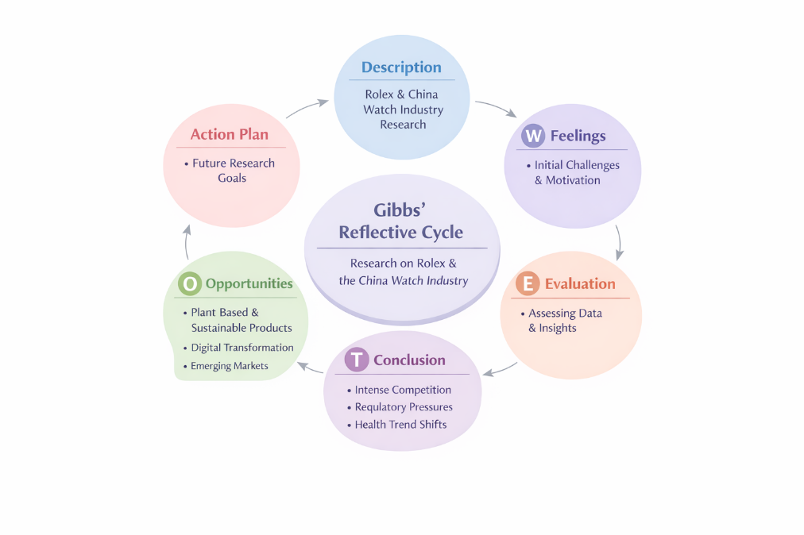
Figure 7.. Gibbs’ Reflective Cycle applied to research on Rolex and the China watch industry, illustrating systematic reflection on experience, emotion, evaluation, and learning (Gibbs, 1988).

Description
The assignment involved the analysis of the China watch market and assessment of Rolex as a multinational company. This included secondary data collection through credible sources such as industry reports, company disclosures, and scholarly literature in order to learn the market dynamics and positioning (Bryman and Bell, 2021). To determine the competitiveness of a country, I used the Diamond Model of Porter, to determine the internal and external environment of Rolex, I used SWOT analysis, and to determine the attractiveness of the market, I used the market attractiveness model based on political, economic, legal, and cultural factors (Porter, 1990; Kotler and Keller, 2016). Competitive tables and strategic suggestions were added to the analysis.
Comparative knowledge was also built through the analysis of competitors like Omega and Patek Philippe. This involved a need to interpret complicated quantitative and qualitative data, databases such as Statista and PwC, which offered recent data in the market and forecasts in the industry (Statista, 2024; PwC, 2023). This entailed synthesising information that was provided by various sources and appropriate academic referencing throughout.

Feelings
First, I was afraid of controlling the scope of the work since it presupposed incorporation of several analytical frameworks and a lot of secondary research. The difficulty in balancing between the theoretical models and actual data involved cognitive difficulties, especially attempting not to provide superficial descriptions but critical analysis, which is one of the main expectations at Level 7 (Creswell and Creswell, 2018).
Later on, I became sure of my ability to interpret industry data and implement strategic frameworks. I was happy to be able to connect abstract ideas, like Porters Diamond of national competitiveness, with the actual insights about an industry. On the other hand, I found it challenging to adjust conflicting information in sources, which made me question the credibility of the sources, which is a crucial research skill (Saunders, Lewis and Thornhill, 2019).

Evaluation
There were a number of elements of process which worked. The use of systematic structures brought uniformity and harmony, which helped me to systematise analysis. As an illustration, the Diamond created by Porter highlighted why the watch industry in China has a global advantage due to the factor conditions present in the country, including qualified labour force and innovation systems (Porter, 1990). SWOT analysis was also useful in converting theoretical concepts into real-life lessons regarding the strategic positioning, strengths and weaknesses of Rolex.
Researching in industry reports and professional sources (e.g. Statista, PwC) made sure that my analysis was based on up-to-date data. This boosted the report credibility and was in line with academic criteria of using current evidence (Oliver, 2012). Comparative tables, including one comparing Rolex, Omega and Patek Philippe, simplified complicated information.
The difficulties were, however, the consistency in data in various regions and the reconciliation of differences in reporting measures. Other sources were also reporting differently or defining issues, which needed to be interpreted and justified in the text. Another thing that I did concerning in-text citations and paraphrasing was to make sure that they comply with academic honesty criteria, which is critical to prevent unintentional plagiarism (Neville, 2016).

Analysis
Thinking about this project, the correlation of theoretical frameworks with empirical data helped me to deepen my knowledge. To give an example, Porters Diamond unveiled the impact of demand conditions, both local and global, on the capacity of the China watch industry to be innovative and to retain its premium status (Porter, 1990). The China and global customers have high standards of quality which promotes constant improvement and also strengthens the reputation.
The SWOT analysis further increased my respect of internal decision making variables including the need of Rolex to strike a balance between exclusivity and accessibility in the market. It also put in the limelight the external risks such as counterfeit and increasing competition that strategic recommendations tackled via innovation and brand protection initiatives.
The reflective practice identified such strengths related to my academic practice synthesis of data of diverse sources and systematic application of analytical frameworks. It also revealed certain areas that require enhancement - like synthesising contradictory information and incorporating more academic journal knowledge as well as industry reports.
This is in line with literature about postgraduate research skills, which focus on the skills of critically reviewing methodologies and interacting with literature on a higher level (Hart, 2018). I became familiar with higher-order skills, including critique, synthesis and systematic evaluation, which are important in Level 7 scholarship.

Conclusion
The reflective exercise has been enlightening. It strengthened the importance of planning of research, critical thinking and strategic analysis. I enhanced my skill in combining theoretical approaches with practical data of the industry to provide a consistent presentation of findings in a consistent scholarly manner. Further, my academic writing, source analysis, and data interpretation skills were enhanced, making my analysis credible and scholarly. This experience builds my confidence in approaching complicated business issues in a systematic way and prepares me to research on strategies in the future.

Action Plan
To further improve my research and analytical skills, I will carry out the following steps:
- Getting Better at Data Management: Reference management (e.g. Zotero, EndNote) tools and structured note-taking systems help to organise the sources and cite them in a consistent way (Booth, Colomb & Williams, 2016).
- Develop Academic Writing: Participate in academic writing workshops and get feedback to enhance coherence, synthesis, and clarity in composing complex arguments (Swales and Feak, 2012).
- Use Expanded Frameworks: Incorporate additional strategic tools such as PESTLE, VRIO, and scenario planning to provide multi‑dimensional analysis in future projects (Johnson, Scholes & Whittington, 2020).
- Keep abreast of Trends: The industry trends, academic journals, and market reports should be regularly examined to keep up with the changing business environments in the world (Saunders et al., 2019).
Such steps will enhance the quality of future research, academic rigour and strategic insight.

Reference
Accenture. (2023). Technology Vision Report. Available at: https://www.accenture.com/us-en/insights/technology/technology-trends
Audemars Piguet. (2024). Official Website. Available at: https://www.audemarspiguet.com
Adobe Inc. (2023). Adobe Annual Report. Available at: https://www.adobe.com/investor-relations.html
Amazon. (2024). Annual Report 2023. Available at: https://www.amazon.com/annualreport
Amazon Web Services. (2024). About AWS. Available at: https://aws.amazon.com/about-aws/
Booth, W.C., Colomb, G.G. & Williams, J.M. (2016). The Craft of Research. 4th ed. Chicago, IL: University of Chicago Press.
Bryman, A. & Bell, E. (2021). Business Research Methods. 5th ed. Oxford: Oxford University Press.
CNBC. (2024). Cloud Computing Market Competition. Available at: https://www.cnbc.com/technology/
Creswell, J.W. & Creswell, J.D. (2018). Research Design: Qualitative, Quantitative, and Mixed Methods Approaches. 5th ed. Thousand Oaks, CA: Sage.
Deloitte. (2022). International Cloud Adoption Report. Available at: https://www2.deloitte.com/us/en/insights/industry/technology.html
Deloitte. (2023). Technology Industry Outlook. Available at: https://www2.deloitte.com/us/en/insights/industry/technology/technology-industry-outlook.html
European Commission. (2023). General Data Protection Regulation (GDPR). Available at: https://commission.europa.eu/law/law-topic/data-protection_en
Financial Times. (2024). Big Tech Industry Analysis. Available at: https://www.ft.com/technology
Forbes. (2024). Cloud Computing Market Trends. Available at: https://www.forbes.com/sites/forbestechcouncil/
Gartner. (2023). Cloud Infrastructure Market Share Report. Available at: https://www.gartner.com/en/newsroom
Hart, C. (2018). Doing a Literature Review: Releasing the Research Imagination. 2nd ed. London: Sage.
IBM. (2023). IBM Annual Report. Available at: https://www.ibm.com/investor
IDC. (2024). Worldwide Cloud Market Forecast. Available at: https://www.idc.com
International Telecommunication Union. (2023). Global ICT Statistics. Available at: https://www.itu.int/en/ITU-D/Statistics
Japan Personal Information Protection Commission. (2023). APPI Guidelines. Available at: https://www.ppc.go.jp/en/
Johnson, G., Scholes, K. & Whittington, R. (2020). Exploring Corporate Strategy. 12th ed. Harlow: Pearson.
Kotler, P. & Keller, K.L. (2016). Marketing Management. 15th ed. London: Pearson.
KPMG. (2023). Technology Sector Analysis. Available at: https://kpmg.com/xx/en/home/industries/technology.html
McKinsey & Company. (2023). The Future of Cloud Computing. Available at: https://www.mckinsey.com/capabilities/mckinsey-digital
Ministry of Electronics & IT India. (2023). Digital Personal Data Protection Bill. Available at: https://www.meity.gov.in
MIT Technology Review. (2023). AI and Cloud Computing Trends. Available at: https://www.technologyreview.com
Neville, C. (2016). The Complete Guide to Referencing and Avoiding Plagiarism. 3rd ed. Maidenhead, UK: Open University Press.
Oliver, P. (2012). Succeeding with Your Literature Review. Maidenhead, UK: Open University Press.
Oracle Corporation. (2023). Oracle Investor Relations. Available at: https://investor.oracle.com
Patek Philippe. (2024). Official Website. Available at: https://www.patek.com
PwC. (2023). Global Technology Industry Report. Available at: https://www.pwc.com/gx/en/industries/technology.html
Porter, M.E. (1990). The Competitive Advantage of Nations. New York: Free Press.
Reuters. (2024). Technology Industry News. Available at: https://www.reuters.com/technology/
Rolex. (2023). Official Website. Available at: https://www.rolex.com
Rolex SA. (2024). Annual Report & Sustainability. Available at: https://www.rolex.org
Saunders, M., Lewis, P. & Thornhill, A. (2019). Research Methods for Business Students. 8th ed. Harlow: Pearson.
Statista. (2024). China Watch Industry and Cloud Market Analytics. Available at: https://www.statista.com
Swales, J.M. & Feak, C.B. (2012). Academic Writing for Graduate Students. Ann Arbor, MI: University of Michigan Press.
TechCrunch. (2024). Cloud Industry News. Available at: https://techcrunch.com/tag/cloud-computing/
U.S. Bureau of Labor Statistics. (2024). Employment in the Software Industry. Available at: https://www.bls.gov/ooh/computer-and-information-technology/
U.S. Census Bureau. (2023). Information and Technology Industry Data. Available at: https://www.census.gov/topics/business-economy/information.html
UK Government. (2023). UK GDPR Overview. Available at: https://www.gov.uk/data-protection
World Bank. (2023). Digital Development Overview. Available at: https://www.worldbank.org/en/topic/digitaldevelopment
WIPO – World Intellectual Property Organization. (2022). Intellectual Property Facts. Available at: https://www.wipo.int/about-ip/en/

