Final Year project proposal
Lowri Jones - 1801539
April 12, 2020
PROJECT MANAGEMENT
JOHN REES

Table of Contents
Introduction. 2
Working title. 2
Background 2
References. 2
Rationale. 3
Why is the research worth doing? 3
Is the research topical? 3
Is the research interesting? 3
Is the research controversial? 4
Have there been similar studies and is there a gap? 4
Aim and objectives. 4
Objective 1. 4
Objective 2 5
Objective 3 6
Outcomes and Deliverables. 6
Research and Development Methods. 7
Research Methods. 7
Data collection methods. 7
Development methods and techniques. 7
Analysing and Evaluating. 7
Resources and Planning. 7
Resources. 7
Project planning and Time management 8
References 9

Introduction.

Working title.
Before starting this project proposal, the author had to decide on a short title which is clear to understand what the whole project is about. The working title for this project is;
‘Reviewing and Comparing popular language apps for children, and project’
This title was chosen as Reviewing and Comparing popular language apps is going to be the main aspect of the project. After looking at the current language apps available, surveys will be handed out to both school age children and teachers in Primary schools, finding out what they feel are the best features on the apps that they currently use. With this information, a language teaching app will be designed and created.

Background
The subject area of the research is languages, which will be focussing on ways that children of school ages can learn Welsh from English as this is the National language in Wales, therefore it is highly beneficial to learn to speak Welsh at a young age. A lot of people believe that Welsh is an unnecessary language to learn, however most jobs in Wales will require you to speak Welsh as well as English. [1] The UK Curriculum states that schools should use different resources for learning languages that is suitable for both their ages and abilities. It is important that a vast wealth of different materials are used to engage the children in their language learning process. [2]

References.
Included below is a list of 5 reliable sources that will be used in this study.
- The UK Curriculum.
One of the references that will be beneficial to this study is the UK Curriculum. This will be used to find relevant information about how Welsh is to be taught in Wales. It is vital that this study keeps within the recommended teaching on the UK Curriculum.
- Language Pedagogy Reference.
https://ncelp.org/resources/modern-foreign-language-pedagogy/
One of the vital things needed to be included in the initial stage of the Research is Language Pedagogy. The above source contains valid and reliable information.
- Top apps.
http://www.appsinwelsh.com/all-apps/
The URL above takes you to a website which contains a list of apps available on the app store which focus on teaching Welsh. This list will allow the author to see the different features on each app and the reviews left by users of the apps.

- DuoLingo app.
https://www.duolingo.com/course/cy/en/Learn-Welsh
DuoLingo is a popular app for learning Welsh and it is commonly used in schools. It has been decided that this app would be beneficial to be included in this study.
- BBC News article on apps for Learning Welsh.
https://www.bbc.co.uk/news/uk-wales-50000586
The news article above focusses on the positives and negatives of learning welsh through apps. It is vital to be aware of these in order to know what to avoid and include in the development of this application.

Rationale.

Why is the research worth doing?
This research is worth doing as ICT and Apps are being used more and more in different education settings. It is said that on average every student has at least one education app on their devices if not more. [3] It has also been confirmed that currently there are over 62,000 apps focussing on education available in the multiple different app stores [3], the research that will be carried out will allow the author to see what currently works well in the different range of education apps and what doesn’t. Having this information puts the study at an advantage to develop a successful application for teaching languages.

Is the research topical?
This research study is very topical due to the amount of ICT that is currently being used in education. A study shows that 94% of educators questioned believe that using different forms of ICT in education can improve the overall engagement levels. [4] It is also predicted that the use of ICT and apps in education is going to have a major increase over the next few years. ‘The European broadband targets’ predict that by 2025 every school will have access to Gigabit Internet Connectivity as well as having access to up to date online learning platforms such as apps. [5]
A child born since the millennium has always been around Internet and Technology as there isn’t an escape! [6] It is very topical to be discussing using educational apps in school and reviewing them, as the majority of children are predicted to already be using apps at home.

Is the research interesting?
This research topic and app is very interesting for those who are looking into learning languages but are unsure on the best techniques and features on apps to look out for. Due to the rate that ICT and the use of apps is increasing in education, it is also a very interesting research report for schools looking into using new language apps, as the app will have been designed and created entirely from the research they will have submitted.

Is the research controversial?
This research topic could be looked at as ‘Controversial’ by many different groups of people. Teachers may argue that the best education comes from them teaching in a classroom as opposed to letting apps and ICT take over. However, having an app to teach a child languages allows for flexibility. The students can access the materials 24/7 and not be timetabled to a certain ‘class time’. [7] The different language apps out there are both stimulating and fun for the students, whilst teachers sometimes struggle to get all children in a classroom to pay attention they don’t have as much difficulty getting them to use a computer or an app. [6] It is very clear that a lot of students are more motivated and engaged whilst using Education apps than they are learning in a classroom. Apps also offer a variety of different ways to teach the same language topic which allows for a wider audience, gives the opportunity for children to learn more independently and makes it a more inclusive way of teaching languages.
Another point of view could come from parents who have worries about their child’s length of screen time. Although a child’s screen time is something that parents should watch, it isn’t all negative. Learning languages through the use of apps can give their children a learning boost whilst also helping them to develop new ICT skills. [8] When a child is using an education teaching app they are both engaging and creating oppose to passively observing a screen. Screen time for learning languages shouldn’t be limited whereas watching videos and playing video games should be, it is all about making their screen time ‘positive’.

Have there been similar studies and is there a gap?
There have been similar studies which will be referenced in the final report to strengthen the research. This also helps to show that there is a market for a project like this. There is always a market for learning languages. Learning the national language of your Country is not restricted by age. The Welsh Government included encouraging people of Wales to speak welsh into their plans and young people especially are targeted online through all types of social media. [9]

Aim and objectives.
The overarching aim of this study is;
‘to design and develop a successful language teaching app that is based on intensive research and findings‘.
The statement above has been chosen as the main aim of the study as it will be vital to obtain research and findings in order to create this app. It will also allow to look at the different aspects that a range of different people feel make a language teaching app ‘successful’, and then incorporate them into this app. Below are 3 objectives which specify how the overarching aim will be achieved;

Objective 1.
To research the current popular language teaching apps available.
Specific
The first thing to be looked at will be Language Pedagogy, reviewing the UK curriculum relating to teaching Welsh. Second, looking into detail and reviewing 3 top language apps teaching Welsh as this will give knowledge on different apps out there. In order to find the top 3 apps, Google will be used and books, reports and existing studies highlighting language teaching online will also be used. At the end of this objective there will be a clear list of the common features that appear on all of the apps that have been reviewed and on the different things that make a language teaching app successful.
Achievable
This project is achievable by setting a timetable of deadlines detailing when objectives have to be completed by. The deadline for reviewing the top 3 language teaching apps will be 1st September 2020, this objective will be met by using at least one IOS App Store.
Relevant
This objective is a vital stage of achieving the overarching aim. It is important that this is carried out as it will be the basis of the whole study. It will give an idea of the more popular features that the language apps contain, which will then be used when asking for the opinions of both students and teachers at a later stage in the study.
Time-Oriented
The objectives have been put in time order, with Objective 1 first and Objective 3 last. The reasoning behind putting this objective first is because it will give the foundation knowledge on the different apps that are available. It will also allow to include some of the feature names found from this objective, into the questionnaire / surveys.

Objective 2
To evaluate the opinions of teachers who specialise in teaching Welsh on language teaching apps.
Specific
A survey will be sent to a set of language teachers in the local area to find out what their opinions are on using apps for teaching children Welsh from English. They will also be asked about what features they feel make a successful teaching app. This objective will be achieved when all surveys are back and comparatives are made against findings from Objective 1. After Objective 1 and 2 are complete, views from both a teacher’s and learners perspective on the features that make a language app successful will be available to analyse and evaluate.
Achievable
There is confidence in the objectives being met with time spent on the initial detailed planning and Gantt chart and realistic dates set. Allowance has been made to ensure all surveys are returned in a timely fashion.
Relevant
This objective is another vital stage of achieving the aim as it will give the opinions of language teachers themselves. These teachers are currently teaching the National Curriculum and have a wealth of knowledge in teaching Welsh, making it beneficial to get their opinions.
Time-Oriented
The objectives are done in order, so completing Objective 1 first and Objective 3 last. The research collecting point of this Objective will be completed by October 15th, after this it will then take another 2 weeks analysing and comparing the results of the surveys.

Objective 3
To design and develop a successful language teaching app based on the evaluation of the findings from Objectives 1 and 2.
Specific
To complete Objective 3, Objectives 1 and 2 will need to be compared and contrasted with each other and a list of requirements will be compiled for this app. The requirements list will incorporate the features that have been reported to be successful and this will be a starting position to develop a Language Teaching app, focussing on teaching Welsh from English.
Measurable.
This goal will have been achieved when a successful and useable app has been created based on the research.
Achievable
After Objectives 1 and 2 have been completed and results compiled, this will give the necessary knowledge for the third and final objective to be done. This Objective needs to be completed by April 2021 therefore allowing from October 2020 to April 2021 for the remainder of the study to be completed. Specific time has been allocated for each objective and allows for the complete project to be finished in a timely fashion. A full detailed schedule can be seen below in the gantt chart.
Relevant
This Objective is the most significant as it provides the overall evaluation of the research and findings. This objective will help to create an app that is both effective and encouraging. The evaluation of the research from Objectives 1 and 2 will help to create the best application possible.
Time-Oriented
The objectives have been put in time order, completing Objective 1 first and Objective 3 last. This Objective will be finished by April 2021. This final objective will take the longest of the 3 objectives as it includes a significant piece of software.

Outcomes and Deliverables.
At the end of the study, a report will be submitted which will contain the research and findings from both objective 1 and 2. It will also cover Objective 3 where findings are compared from the previous objectives. From the research, a comprehensive list of requirements will have been made for the language teaching application along with a detailed design of what it will look like and the jobs to be executed. At the end of the overall project, an evaluation will be prepared evaluating the app that has been created, comparing against the requirements set at the initial planning stage and the detailed design. The final detail in the report will be an evaluation from an external user, detailing what they feel the app is like and how successful it is.
A significant piece of software will be submitted alongside. This software will be the application based on teaching children Welsh from English.

Research and Development Methods.

Research Methods.

To help expand the knowledge on language teaching apps and the benefits, primary and secondary research will be conducted. One of the research methods will be to include online research, in books and existing studies. The reason these types of secondary researches are done allows the report to obtain original and factual information about Language teaching apps and the UK Curriculum. Another research method will be to conduct a survey which will be sent to Welsh Language Teachers. The benefit of using this primary research will get opinions directly from those who teach the language and use these applications. Surveys allow for extensive research that ensures for a more accurate set of results to provide a better conclusion. [10]
Although conducting secondary research online will provide a set of data to help strengthen the study, it is vital that all sources are valid and reliable. In order to do this, it is vital that investigations into the authors of all sources have taken place to ensure the writer is employed by either a research institution or a university / college and observe the URL of the websites used to check if the sponsoring organisation is dependable and consistent. [11]

Data collection methods.
To complete Objective 2 a study needs to be conducted and sent to teachers in two primary schools. The two schools chosen are ‘Ysgol Glannau Gwaun’ and ‘Ysgol Wdig’.

Development methods and techniques.
Prior to developing the application, a detailed list of requirements will be created to ensure that everything necessary is included. A plan will also be drawn up detailing what the app will look like and outlining the main features. These steps are vital in the development of the app as they will help the author to remain on track and complete to the best of their ability.

Analysing and Evaluating.
In the study Objective 3 focuses on evaluating the research and findings, to do this their common aspects need to be studied. The focus will also be on the positive and negative features from both sets of results in order to produce a successful and usable app avoiding the negatives and including the positives.

Resources and Planning.

Resources.
For the development section, this study will be using ‘Unity’ to create the application. Unity has been chosen as this platform will make the process of creating and developing an app easy and simple to use compared to other platforms. Unity is also multi-platform which allows you to take your finished application from one platform, to all of them. [12] This will be beneficial for this app making it available to a wider audience once published. Unity also allows you to script in either Javascript or C#. For this application C# will be used.

Project planning and Time management
In order to keep on track and finish everything on time a Gantt Chart has been created which is shown below;
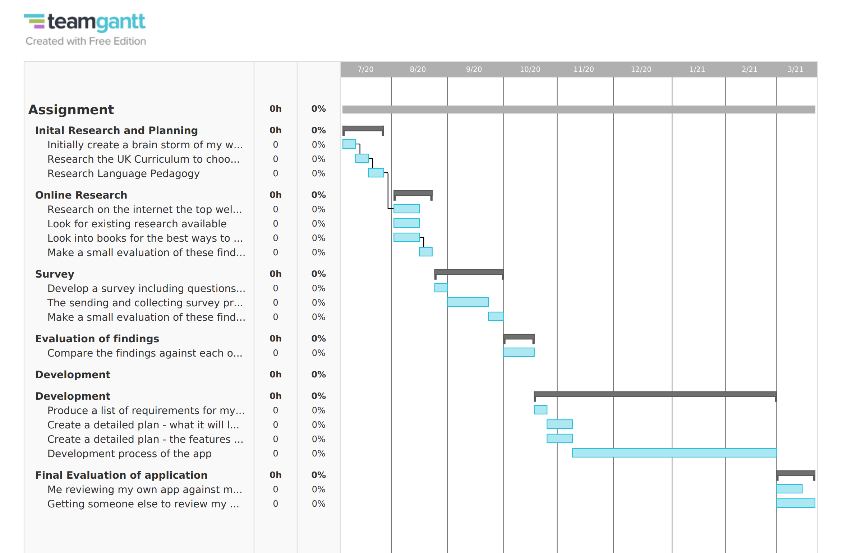

All of the below can be found on the Gantt chart.
The first section of the study is the ‘Initial Research and Planning’ stage. This stage includes initial planning of the overall project and choosing a small section of the Welsh Language within the UK Curriculum. This first stage of the Study starts 6th of July and finishes on the 27th of July.
The second section of the study is the ‘Online research’ section which is going to start on August 3rd and finish with a small evaluation of these findings on the 21st of August.
The third section of the study is the ‘Survey’ section which is going to start on the 25th of August and finish with a small evaluation of the findings on the 30th of September.
The fourth section of the study is the ‘Evaluation of the findings’ which is going to start on the 1st of October and finish two weeks later on the 16th of October. This stage is vital as it will provide the foundation for the application.
The next section is the ‘Development’ section. This section starts on the 19th of October and the development of the application will finish on February 26th. These 4 months will allow development of an application to the best of the authors ability.
The final section of the study is ‘Evaluation of the application’ which starts on the 1st of March with the authors review and finishes on the 19th of March with an External review.

References

[1] | A. Young-Powell, “Why Teaching Welsh is Important to Wales,” HUFFPOST, 28 October 2011. [Online]. Available: https://www.huffingtonpost.co.uk/abby-youngpowell/welsh-wales-teaching-important-to-wales_b_1063233.html?guccounter=1&guce_referrer=aHR0cHM6Ly93d3cuZ29vZ2xlLmNvbS8&guce_referrer_sig=AQAAAH1tZvx_3Rg82x94RjO1H2fFBmVEeIxgp61klffnlMOmvahhcwj8kucK8elbfdsthPPEr. [Accessed 12 April 2020].
[2] | D. o. Education, “Curriculum for Wales: revised Areas of Learning and programmes of study,” Department of Education, 2015.
[3] | Tanya, “10 Great Benefits of Using Mobile Apps in Education,” MobileAppDaily, 12 March 2020. [Online]. Available: https://www.mobileappdaily.com/benefits-of-using-mobile-apps-in-education. [Accessed 13 April 2020].
[4] | I. Curtis, “The State of Technology in Education Report,” Promethean, Europe, Africa, Australasia, 2018/19.
[5] | D. Connect, “2nd Survey of Schools: ICT in Education,” DG Connect, Europe, 2019.
[6] | B. Loveless, “Are Learning Apps Helping or Hurting Education?,” Education corner, [Online]. Available: https://www.educationcorner.com/learning-apps-helping-hurting-education.html. [Accessed 13 April 2020].
[7] | K. Ooi, “Online teaching vs classroom teaching – which one is better?,” hello teacher!, 6 March 2020. [Online]. Available: https://www.helloteacher.asia/blog/online-teaching-vs-classroom-teaching-which-one-is-better. [Accessed 13 April 2020].
[8] | “Positive screen time for children,” The school run, [Online]. Available: https://www.theschoolrun.com/positive-screen-time. [Accessed 13 April 2020].
[9] | BBC, “Language strategy to encourage everyday use of Welsh,” BBC News, 1 March 2012. [Online]. Available: https://www.bbc.co.uk/news/uk-wales-politics-17220657. [Accessed 13 April 2020].
[10] | S. E. DeFranzo, “4 Main Benefits of Survey Research,” Snap Surveys, 15 August 2012. [Online]. Available: https://www.snapsurveys.com/blog/4-main-benefits-survey-research/. [Accessed 18 April 2020].
[11] | G. Fleming, “How to Determine a Reliable Source on the Internet,” ThoughtCo., 26 January 2019. [Online]. Available: https://www.thoughtco.com/internet-research-tips-1857333. [Accessed 20 April 2020].
[12] | Brandon, “Top 10 Reasons to Choose Unity 3D for App and Game Development,” Studio Pepwuper, [Online]. Available: https://www.pepwuper.com/top-10-reasons-to-choose-unity-3d-for-app-and-game-development/. [Accessed 19 April 2020].

