EcoSIp Cafe Ltd – A Sustainable Plant - Based Cafe in Birmingham

Programme of Study: Enterprise and Entrepreneurship
Module Code: LCLM4006
Lecturer: Mohd Syafiq Bin Zolkeply
Student Name: Naheed Riaz

Student ID: 2434941
University Name: University of Wales Trinity Saint David

Executive Summary
EcoSip Café Ltd, a new sustainable, plant-based café, will be set up in the heart of Birmingham’s city centre. The business idea seeks to offer ethically sourced coffee, plant-based food, and zero-waste takeaway food to students and young professionals in the area. The idea has been informed by the growing need to address the issue of environmental sustainability, as well as the need to incorporate ethical consumption into the marketplace.
EcoSip Café Ltd seeks to establish itself not only as a café but also as a hub for the community to promote the concept of conscious living and consumption. The city of Birmingham is the second-largest city in the UK and has a very vibrant and diverse population. It is also home to the University of Birmingham and the Birmingham City University, making it an ideal place to set up the café since there is a ready market for the products and services to be offered. By locating the café in the city center, it would benefit from the high foot traffic and the strategic location to the universities and other key locations.
The hospitality industry in the UK has been a major contributor to the country’s economy over the years. The UK currently has over 5.5 million private sector businesses, as stated by the Department of Business and Trade (2024). Additionally, the demand for plant-based food has been on the increase, given the health and environmental concerns associated with the food industry.
Consumer trends have also shown that veganism, vegetarianism, and flexitarian diets are on the rise, especially among the younger generation of consumers. Environmental awareness campaigns and the media coverage of climate change have also impacted consumer behavior, with many consumers actively seeking to support businesses that show evidence of corporate social responsibility. EcoSip Café Ltd will be able to leverage this trend through the provision of a menu that is seasonal, locally sourced, and also environmentally friendly through the provision of compostable or reusable packaging options. By sourcing locally, the business will also be able to contribute to the local community and the economy.
EcoSip Café Ltd will be a private limited company, which will offer the business limited liability protection as well as increased credibility. The business’s USP will be its zero-waste policy as well as its affordability to students. The business will require £45,000 to set up, which will be raised through the owner’s investment as well as a loan from the bank.
The start-up capital will be directed to renting the premises, purchasing the necessary equipment like coffee machines and refrigeration units, designing the interior to suit the green concept, buying the initial stock, and marketing the business, among others. A major focus will be on cost management and the effective utilization of the limited resources to achieve sustainability in the first year of operation. Revenue will be realized through dine-in customers, takeaway customers, and possibly delivery customers, in addition to the prospects of offering catering services to the wider community in the future.

Executive Summary 1
Overview Of the Business Idea 4
Legal Format and Management Structure 6
PESTEL Analysis and Competition 7
Market Plan 9
Funding and Expenses 10
Conclusion 11
Reference List (Harvard Style) 13

Overview Of the Business Idea
EcoSip Café Ltd is a sustainable café offering specialty coffee and plant-based food to the people of Birmingham. The main objective is to capitalize on the increasing demand for environmentally friendly food services. Climate change and ethical sourcing have altered the purchasing behavior of consumers, especially among the youth.

EcoSip Café Ltd offers ethically sourced coffee and vegan food to the residents and visitors to the city. The café also offers vegan pastries and zero-waste packaging for customers taking food to go. The café offers a 10% discount to customers who use reusable cups.

Birmingham is the best location for this business due to the high population of students and the fact that the city center receives a lot of traffic. The business also taps into the current social trend towards sustainable and vegan food.

This is an entrepreneurial idea since it fills the gap between expensive vegan food and coffee shops offering non-sustainable food.

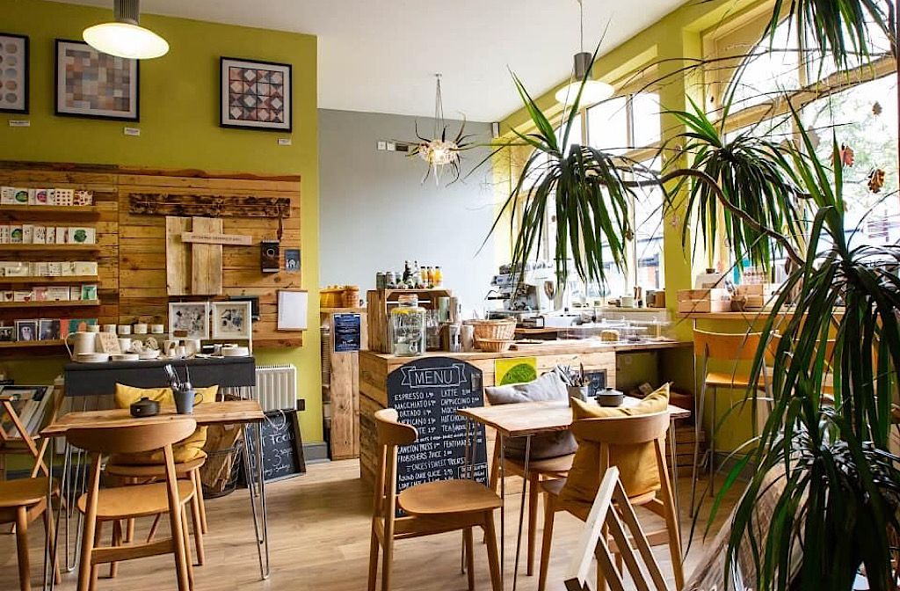

Figure 1: Example of possible settings for such cafe

Legal Format and Management Structure
EcoSip Café Limited will be a Private Limited Company (Ltd). This form of legal structure offers the benefit of limited liability, which means the liability of the members or the shareholders is limited to the extent of their investment.

This choice of legal form is informed by entrepreneurship literature, which indicates that limited companies are the best form of legal structure to adopt by growth-oriented ventures seeking finance.

Management Structure
- Managing Director (Founder) – Strategy, Finance
- Café Manager – Operations
- Baristas (Part-time) – Customer Service
- Marketing Assistant – Social Media, Promotions

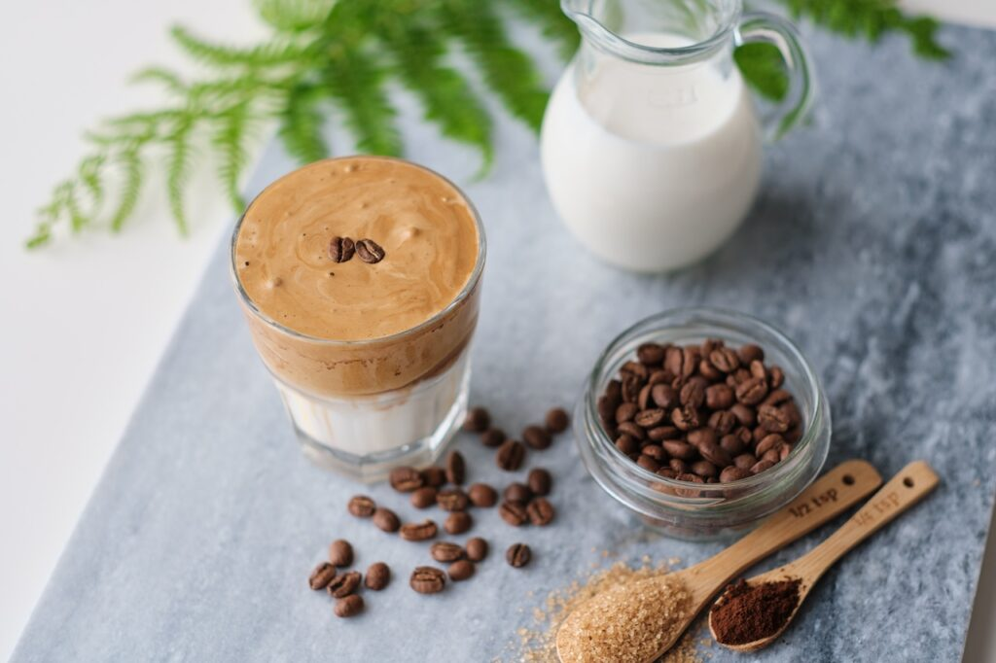
Figure 2: Example of Plant Based Cafe menu items

PESTEL Analysis and Competition

Political
Schemes provided by the government to support SMEs promote entrepreneurship. On the other hand, food safety regulations and environmental regulations add to the business operations.

Economic
Inflation and rising costs of energy may affect the business. On the other hand, the strong student population in the city of Birmingham guarantees consistent consumer demand.

Social
There is a growing awareness of veganism and the importance of going green. Consumers want to be associated with ethical products, which is good news for EcoSip.

Technological
EcoSip may leverage the benefits of digital payment options, social media marketing, and online ordering to promote the business cheaply.

Environmental
There is a growing awareness of the importance of environmental conservation, which translates to more people seeking to support businesses that promote the same. EcoSip offers a product that is environmentally friendly, given that it is a zero-waste product.

Legal
EcoSip will have to comply with various laws, including food hygiene laws, employment laws, and health and safety laws.

Competition
EcoSip will compete with other prominent players like Starbucks and Costa Coffee, as well as other cafes that operate independently. Large chains have the upper hand due to their popularity but lack the competitive edge of sustaining multiple branches in close proximity.

Market Plan

Target Market
• Age group: 18 to 25 years
• Young professionals: 22 to 35 years
• Environmentally concerned consumers

Marketing Strategy
Social media marketing: Instagram and TikTok will be used to market the visually appealing content and environmental awareness message. A simple website will also be created to allow customers to order online.
The café will partner with universities to offer discounted prices to students and create promotional events at the universities. A loyalty program will also be offered to customers to encourage repeated purchases.

Location Strategy
The café will be located in an area close to the universities or in the city center to have maximum exposure.

Funding and Expenses
Start-Up Funding Required: £45,000

Premises deposit: £10,000
Equipment: £15,000
Renovation: £8,000
Initial stock: £4,000
Marketing: £3,000
Working capital: £5,000

Funding Sources
Personal investment: £15,000
Bank loan: £30,000

First Month Operating Costs
Rent: £3,000
Staff wages: £6,000
Utilities: £1,000
Stock: £2,000
Marketing: £500

Estimated monthly operating costs: £12,500

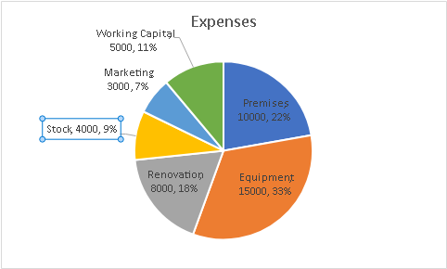
Figure 3: A pie chart displaying the different costs of the project

Conclusion
EcoSip Café Ltd is an entrepreneurial opportunity in the competitive hospitality industry in Birmingham. This business takes advantage of the increased demand for plant-based products and green living. Being a limited company minimizes the risk and maximizes the funding opportunities. Marketing and differentiation are key strengths in the sustainability of the business of EcoSip Café.

In conclusion, the positive market conditions, identification of the target audience, and the strong ethical branding proposition all enhance the feasibility of the proposed business venture. The dynamic city centre of Birmingham offers the opportunity for the café to access a wide range of customers, especially students and young professionals who may be more inclined towards the importance of affordability, sustainability, and ethics. By working in an environmentally friendly way, the EcoSip Café Ltd can differentiate itself from the competition, as many cafés may not share the same values.

The zero-waste commitment, the ethical sourcing of ingredients, and the price strategy all come together to form a strong value proposition for the business. This not only meets the demands of consumers but also makes a positive contribution towards the environmental goals that the business has set for itself. Additionally, the decision to become a private limited company will instill more confidence in the investors, thus helping the business grow more effectively in the long run.

In the long run, EcoSip Café Ltd could look for ways to expand the business, such as opening more stores, developing merchandise, or working with environmental groups in the area. This will ensure that the business is able to keep track of the latest trends while also being able to respond accordingly to the changes that occur in the market. With good financial management, effective marketing, and the sustainability mission, EcoSip Café Ltd is bound to make a good name for itself as the hospitality industry continues to grow in the city of Birmingham.

Reference List (Harvard Style)
Barringer, B. and Ireland, R. (2019) Entrepreneurship: Successfully Launching New Ventures. 6th edn. Pearson.
Burns, P. (2016) Entrepreneurship and Small Business. 4th edn. London: Palgrave.
Department for Business and Trade (2024) Business population estimates for the UK and regions 2024. Available at: https://www.gov.uk (Accessed: 1 March 2026).
Kotler, P. and Keller, K. (2016) Marketing Management. 15th edn. Harlow: Pearson.
Mintel (2023) UK Coffee Shop Market Report. London: Mintel.
ONS (2023) Consumer trends in the UK hospitality sector. London: Office for National Statistics.
Statista (2024) Plant-based food market value in the UK. Available at: www.statista.com
https://www.bedfordindependent.co.uk/outstanding-plant-based-bedford-cafe-given-unanimous-support-from-climate-change-committee/ - cafe image
https://lattini.com/recipes/plant-based-coffee-recipes-to-start-your-day-right/ - coffee image
Excel – Pie chart made personally

