UNIVERCITY OF WALES TRINITY SAINT DAVID

The Misdiagnosis of Hormonal Imbalances in Women:
Implications for Health and Social Care Practice in the UK

Name: Naznin Sumar
Student ID: 2529002
Module Code: LCHS4007
Module: Digital Skills and Research Methods
Lecturer: Markus Klingelfuss

Submitted on:

Table of Contents
Introduction…….…………………………………………………………………………………………….3
1.1 Selection of Research Topic………………..……………………………………………………….3
1.2 Evaluating Information Sources……..…………………………………………………………….4
1.3 Research Methodologies…………………………………………………………………………….7
1.4 Data Collection…..…………………………………………………………………………………….7
Conclusion……..…………………………………………………………………………………………….8
Reference List….…………………………………………………………………………………………….9

Introduction
This report analyses the misdiagnosis of hormonal imbalances in women within the UK health and Social Care system. Many women suffering from conditions such as PCOS, thyroid issues, endometriosis, and perimenopause, often have to wait years for the right diagnosis. Consequently, their health and well-being decline significantly. The report recognizes the issue, describes a research strategy that can be used to explore the problem more deeply, evaluates three relevant resources, and presents a research strategy that could be employed to examine this issue in greater detail.

  - Selection of Research Topic
The issue examined in this report is the misdiagnosis of hormonal imbalances in women who get care through the UK’s National Health Service (NHS). Hormonal imbalances often coexist with other conditions, including depression, anxiety, and chronic fatigue. Therefore, they are more difficult to diagnose, and many women are treated incorrectly for the wrong condition before the true cause is found.
The extent of the problem is considerable. According to Endometriosis UK (2023), women in the UK typically had to wait eight years to be diagnosed with endometriosis. According to a British Thyroid Foundation study from 2022, 35% of women with hypothyroidism had been previously diagnosed with a mental health condition. Based on the 2023 Wellbeing of Women foundation study, 84% of women said that doctors did not take their symptoms seriously. These numbers emphasize the seriousness of the issue and the need for quick action.
This issue affects women of all ages and backgrounds, especially those who work or provide care, because a delayed diagnosis can make it more difficult for them to handle their day-to-day tasks and work. Additionally, NHS Services end up incurring avoidable costs as a result ofj frequent appointments and inappropriate treatments. There is a noticeable lack of understanding in women’s hormonal health among caregivers that needs to be addresses (RCOG, 2022).
This topic was chosen because of a personal connection to the issue. It took a long time for someone close to me to get a proper hormonal diagnosis, and during that time, their symptoms were repeatedly brushed off or associated with stress and anxiety. After experiencing diagnostic delays myself, I became aware of their seriousness and impact, which piqued my interest in their causes. Therefore, exploring this subject is personally important as well as extremely pertinent to health and social care practices in the UK.

  - Evaluating Information Sources
Three reliable sources were selected to back this report. Every source was analysed using the CRAAP test, which evaluates whether it is Current, Relevant, Authoritative, Accurate and suitable for Purpose (Blakeslee, 2004).
The first source is a journal article published in the British Journal of General Practice by Whitney et al. (2021. It outlines qualitative interviews with PCOS-diagnosed women in the UK and explores how their symptoms were misinterpreted prior to getting a proper diagnosis. It was published in a reputable peer-reviewed publication, is up to date, and comes from original research with ethical approval. It is directly linked as it provides actual proof of misdiagnosis from the perspective of the patient. A limitation is that it might not fully capture the experiences of women with different hormonal issues since it focuses exclusively on PCOS.
The second source is the report from Endometriosis UK (2023) titles ‘Endometriosis is the UK: Time for Change’. This study, which surveyed over 10,000 women, found that the typical duration to receive an endometriosis diagnosis was eight years, and 58% had been diagnosed with a different condition beforehand. It is current, uses a large dataset, and was developed by a well-known charity in the UK. The data is reliable and commonly referenced in NHS policy debates, but the aim is somewhat advocacy-driven, indicating it might focus on negative outcomes. This source has a weakness in that it omits clinician perspectives on the causes of misdiagnosis. The rates of incorrect diagnoses and delayed diagnoses from this source are shown in Figures 1 and 2.

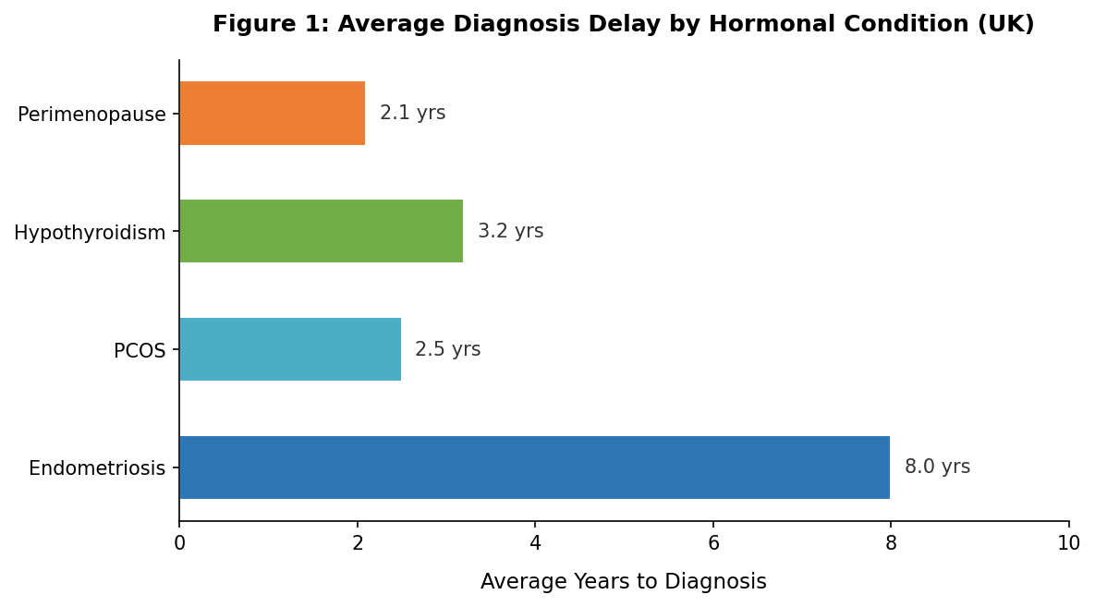

Figure 1: The UK’s average diagnosis delay by hormonal disorder (Endometriosis UK, 2023; British Thyroid Foundation, 2022; RCOG, 2022)

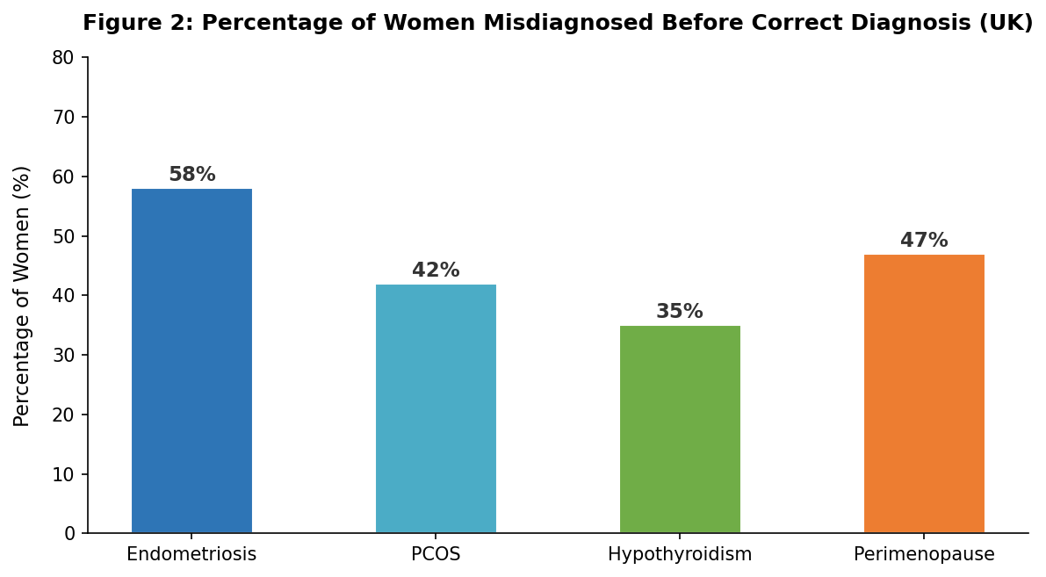

Figure 2: The proportion of women who were misdiagnosed before being properly diagnosed (Endometriosis UK, 2023; Whitney et al., 2021; RCOG, 2022)

The third source is “Women’s Voices: Enhancing Women’s Healthcare Experience”, a report published in 2022 by the Royal College of Obstetricians and Gynaecologists (RCOG, 2022). Using information from clinical audits, patient questionnaires, and policy evaluations, this study examines how gender affects clinical decision-making.
It found that rather than investigating hormonal factors, 47% of women experiencing perimenopausal symptoms were initially sent to mental health services. It is highly significant, credible, and up to date. One downside is its wide-ranging nature, resulting in hormonal misdiagnosis being mentioned briefly instead of thoroughly. Figure 3 shows the wider effects of misdiagnosis on the lives of women.

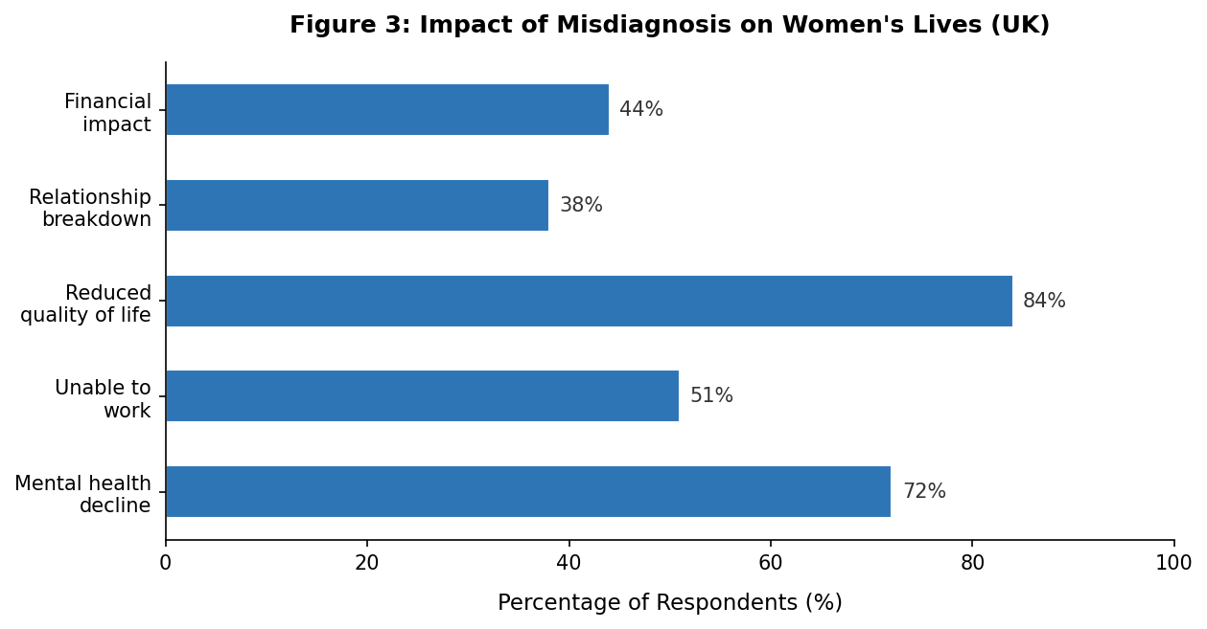

Figure 3: Misdiagnosis effects on UK women’s life (Wellbeing of Women, 2023; Endometriosis UK, 2023)

Significantly underrepresented in all three sources are women from Black, Asian and minority ethnic (BAME) backgrounds, who many have additional difficulties receiving a diagnosis (RCOG, 2022).
Women from Black, Asian, and minority ethnic (BAME) backgrounds, who might face extra challenges is getting diagnosed, are notably lacking in representation across all three sources (RCOG, 2022). Future studies need to look at this in great detail.

  - Research Methodologies
Research methodology refers to the technique used the gather and analyse data in order to address a research inquiry. Bryman (2016) identifies three major categories: qualitative, quantitative, and mixed-methods.
Quantitative research utilizes statistics and numbers to assess events and identify trends, for example, quantitative information could be gathered from a survey that inquired how many experienced a wait of over five years for a diagnosis. Qualitative research uses methods such as focus groups and interviews to explore in greater detail individuals’ viewpoints and experiences. Mixed-methods research provides a more in-depth understanding of the problem (Creswell and Creswell, 2018).
A mixed-methods technique would be the best choice for this study. Both quantitative data on the commonness of misdiagnosis and qualitative perspectives from women who have personally experienced it are needed for the study question. The materials examined in Task 1.2 demonstrate this combination: Endometriosis UK (2023) used substantial survey data, whereas Whiteley et al. (2021) carried out in-depth interviews. If a variety of techniques were used to cross-check and verify results from both data forms, the study would be more thorough and reliable.

  - Data Collection
The method of gathering information to answer a research question is referred to as data collection. The two main categories are primary and secondary data. The researcher collects primary data directly using techniques such as interviews and surveys. Secondary data, such as NHS reports, academic journals, or charity documents, is pre-existing information gathered by someone else (Bryman, 2016).
This research will utilize both types of data. Semi-structured interviews with women experiencing a delayed hormonal diagnosis, along with short questionnaires distributed to general practitioners to collect clinical perspectives, would be employed to obtain primary data. Interviews are well-suited for this topic as they allow women to convey their experiences in their own terms (Creswell and Creswell, 2018). Secondary data would originate from sources including published research, NHS Digital statistics, and the reports analysed in section 1.2.
There are several benefits to using primary data, including current, reliable data that is directly related to the research question. However, ethical consent is required, data collection takes time, and individuals might not always recall events correctly (Bowling, 2014). Secondary data may not necessarily align with the specific importance of the research, despite being more readily available and less expensive. Combining the two forms of data helps the overall findings and reduces drawbacks of depending only one source.

Conclusion
This research has shown that a major and widespread problem in health and social care in the UK is the incorrect diagnosis of hormonal imbalances in women. Studies show that women typically wait around 8 years for an endometriosis diagnosis, 3.2 years for hypothyroidism, 2.5 years for PCOS, and 2.1 years for perimenopause, and over 50% receive incorrect diagnosis, and many indicate a negative impact on their mental health and overall quality of life. Three trustworthy sources were evaluated, and each pointed to systemic and clinical shortcomings. A mixed-methods strategy applying both primary and secondary data was found to be the best way to investigate this issue in further detail. Further research is required, especially regarding the experiences of women from BAME backgrounds, to make sure that all women receive an accurate and timely diagnosis.

Reference List
Blackeslee, S. (2004) The CRAPP Test. LOEX Quarterly, 31(3), pp. 4-5.
Bowling, A. (2014) Research Methods in Health: Investigating Health and Health Services. 4th edn. Maidenhead: Open University Press.
British Thyroid Foundation (2002) Thyroid Disease and Women. Available at: https://www.btf-thyroid.org (Accessed: 1 March 2025).
Bryman, A. (2016) Social Research Methods. 5th edn. Oxford: Oxford University Press.
Creswell, J.W. and Creswell, J.D. (2018) Research Design: Qualitative, Quantitative, and Mixed Methods Approaches. 5th edn. London: SAGE Publications.
Endometriosis UK (2023) Endometriosis in the UK: Time for Change. London: Endometriosis UK. Available at: https://www.endometriosis-uk.org (Accessed: 1 March 2025).
NHS England (2019) The NHS Long Term Plan. London: NSH England. Available at: https://www.longtermplan.nhs.uk (Accessed: 1 March 2025)
Royal College of Obstetricians and Gynaecologists (2002) Women’s Voices: Improving Women’s Experience of healthcare. London: RCOG. Available at: https://www.rcog.org.uk (Accessed: 1 Marh 2025).
Wellbeing of Women (2023) Women’s health Survey: Patient Experiences Across the UK. London: Wellbeing of Women. Available at: https://www/wellbeingofwomen.org.uk (Accessed: 1 March 2025).
Whiteley, C., Mooney, R. and Bhatt, S. (2021) ‘Patient Experiences of Diagnosis and Management of Polycystic Ovary Syndrome in Primary Care’, British journal of General Practice, 71(712), pp. e872-e879.

