1702463
Introduction to Web Development
BSc Business Information Technology
Runa Bibi
10/01/2018

Table of Contents

Introduction 2
Requirements 2
Site Map 2
Wireframe Diagram 3
Implementation 4
Completed Website 4
Validation 9
Evaluation 9
Accessibility Evaluation 9
General Evaluation 10
Recommendations for Improvements 10
References 11

Introduction
This report will include the details of a website that the author has coded as pertaining to one of their interests, which in this case is their favourite band. It will contain details of its layout and how each page links to each other using a site map and wireframe diagram. The home page and main CSS page will be validated and the results of this will also be provided. Moreover, the completed website will be evaluated based on its accessibility and its general usability, design and content. Any recommendations to improve the website will also be included.

Requirements
The website’s purpose is to promote the girl group Little Mix. It will inform fans of any new updates about the group including new tour dates and news stories. Any new fans can also find out more about each member and new tours they have planned. There will also be products available to view and buy. The audience will be fans of the group and people interested in finding out more about them. It is relevant as a website as they are one of the biggest groups in the charts right now and influential to many young people.

Site Map
Below is a site map of the website showing how it is laid out and how each page links to each other [1].
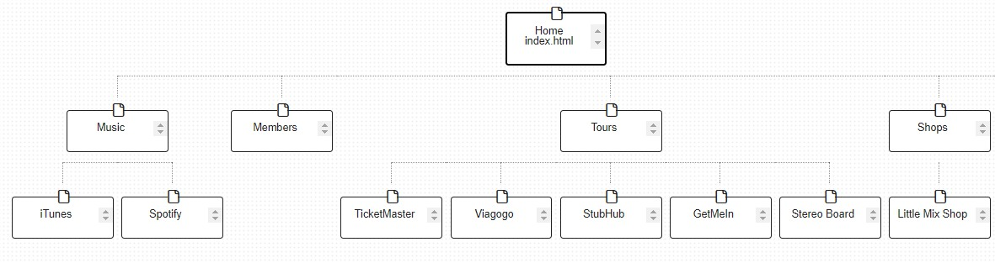

Wireframe Diagram
The following is a wireframe diagram of the home page which its grid layout and how its main elements are arranged [2].
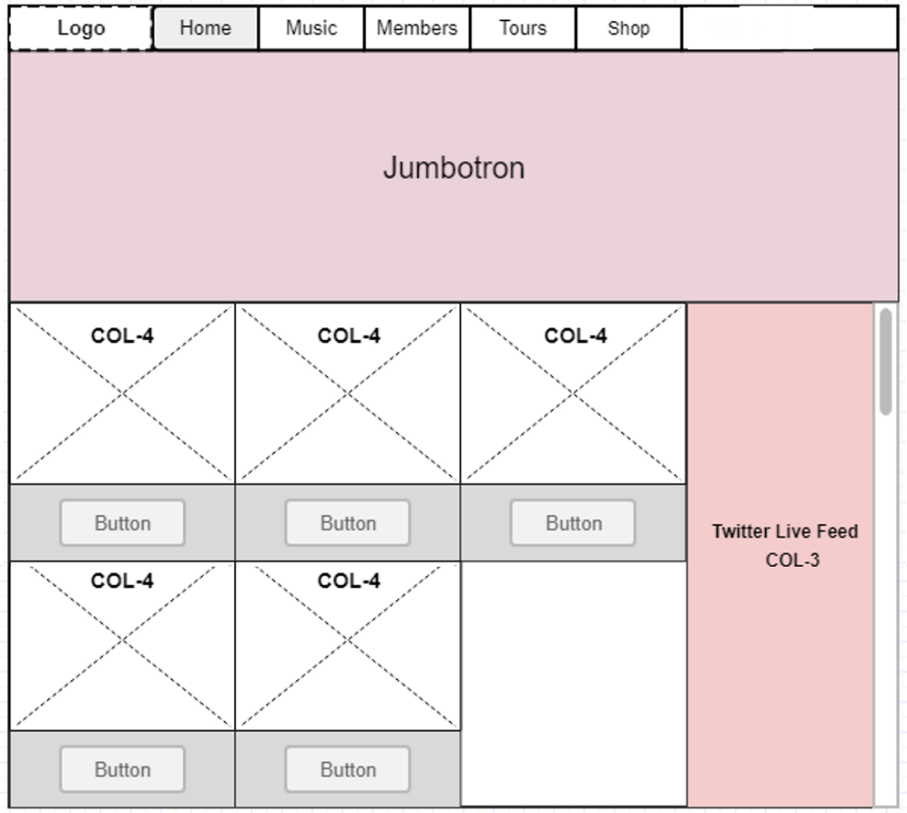

Implementation

Completed Website
Below are screenshots of the completed website.
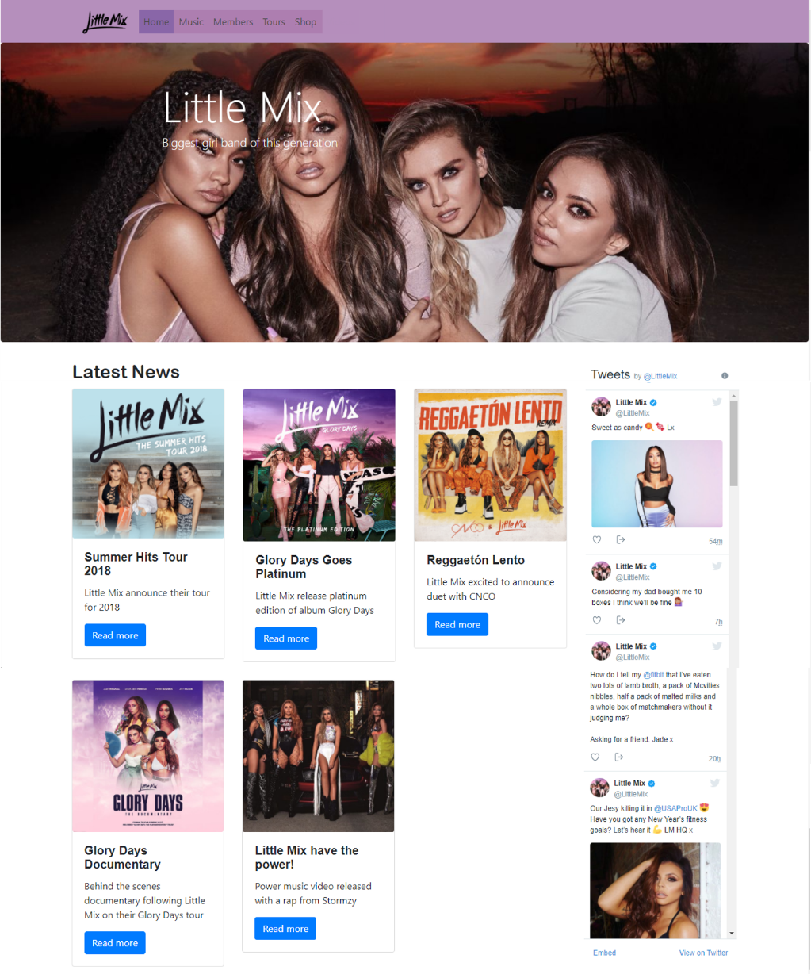
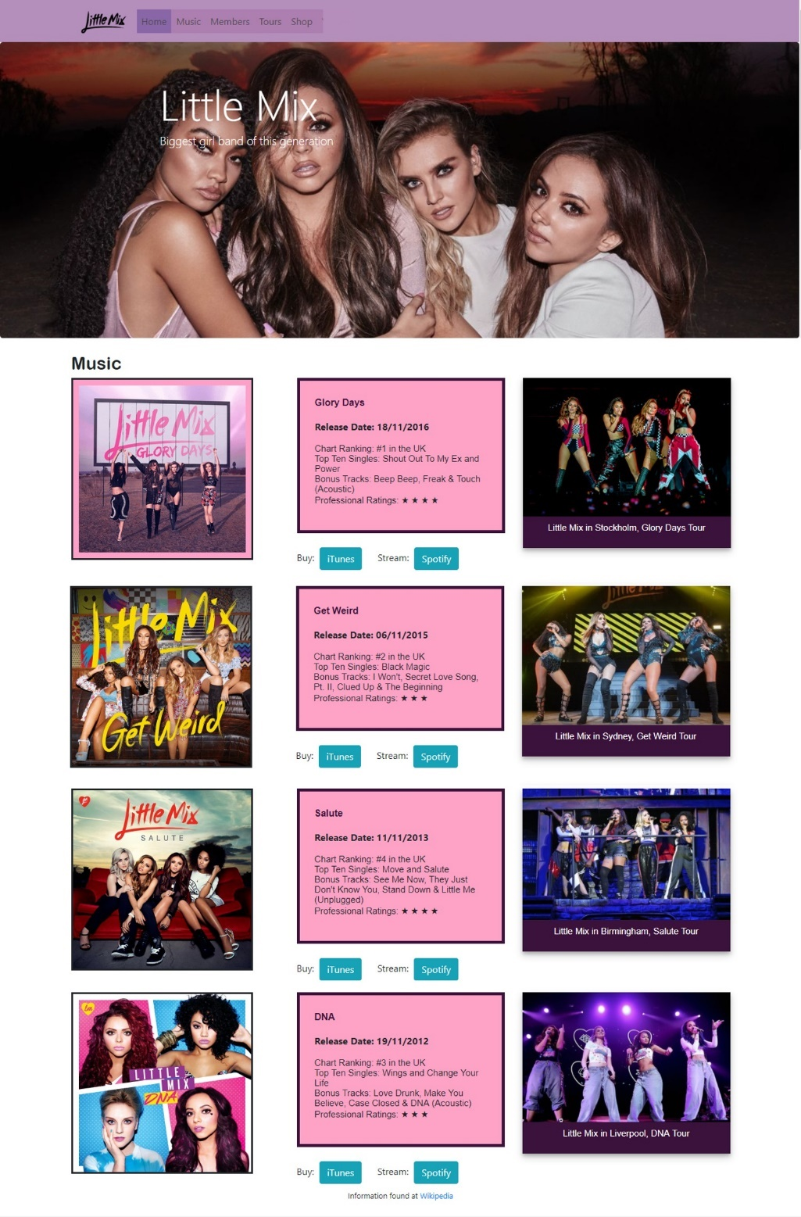
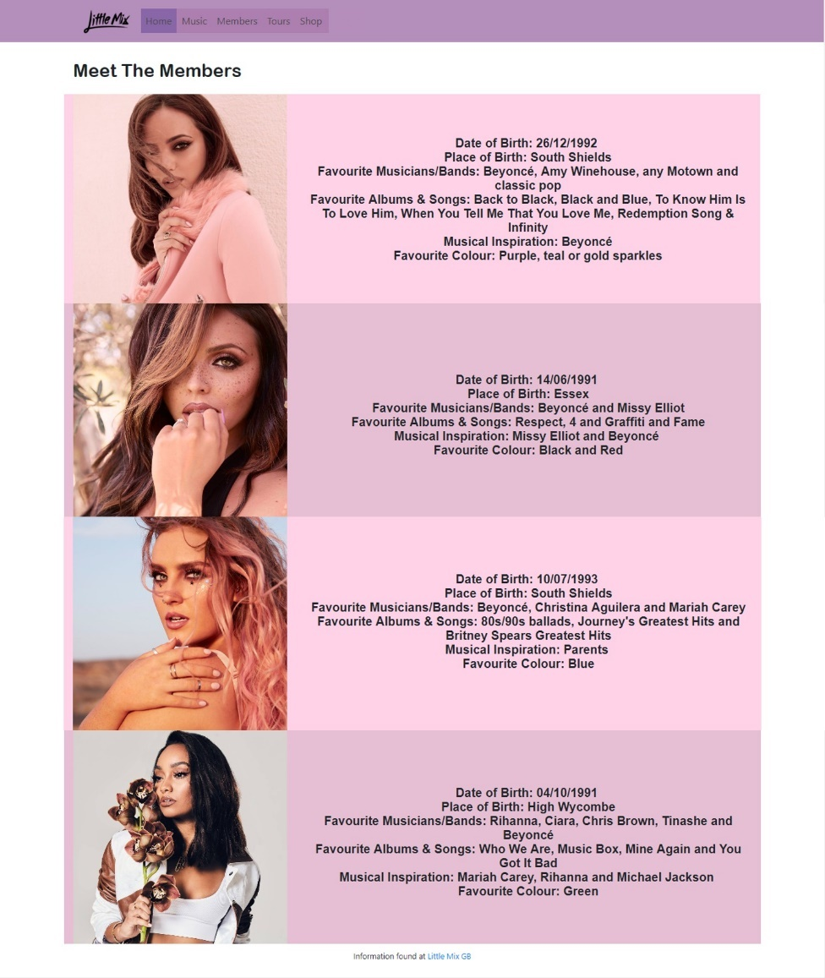
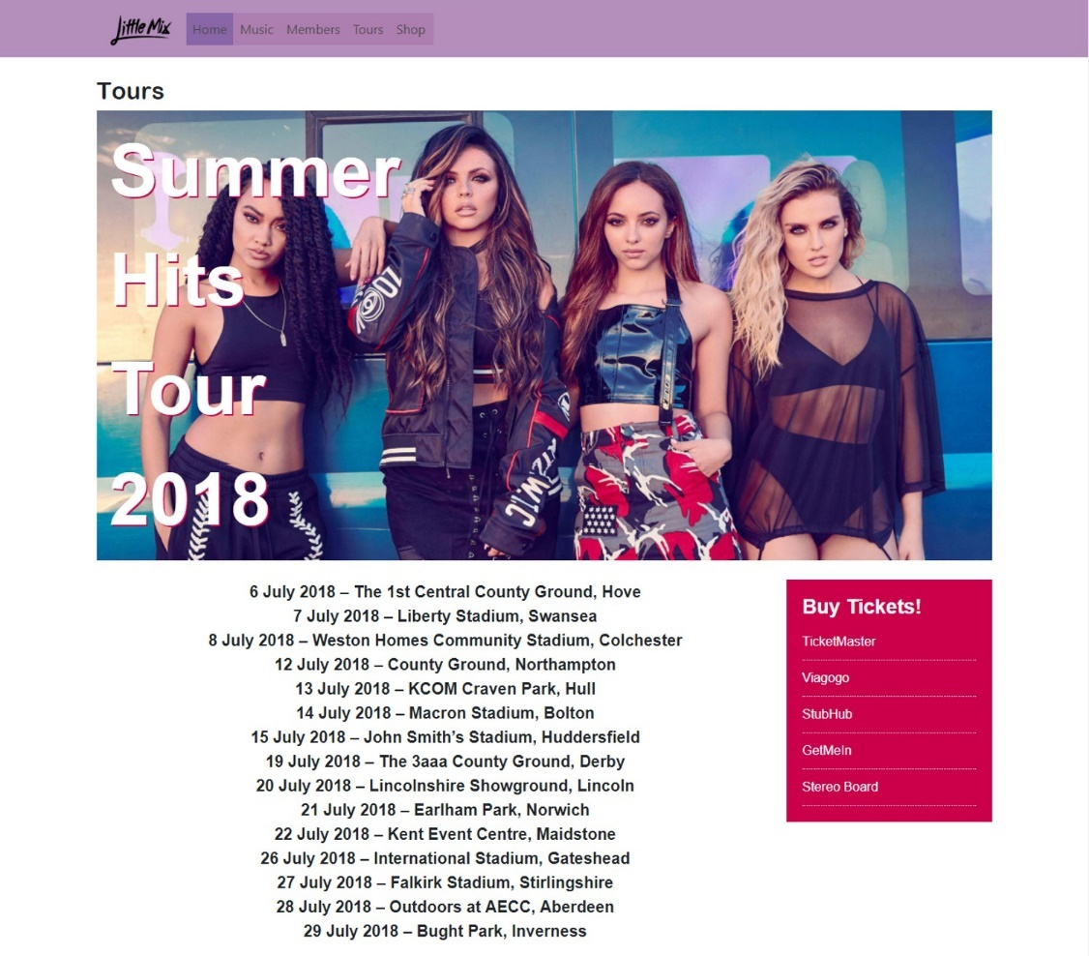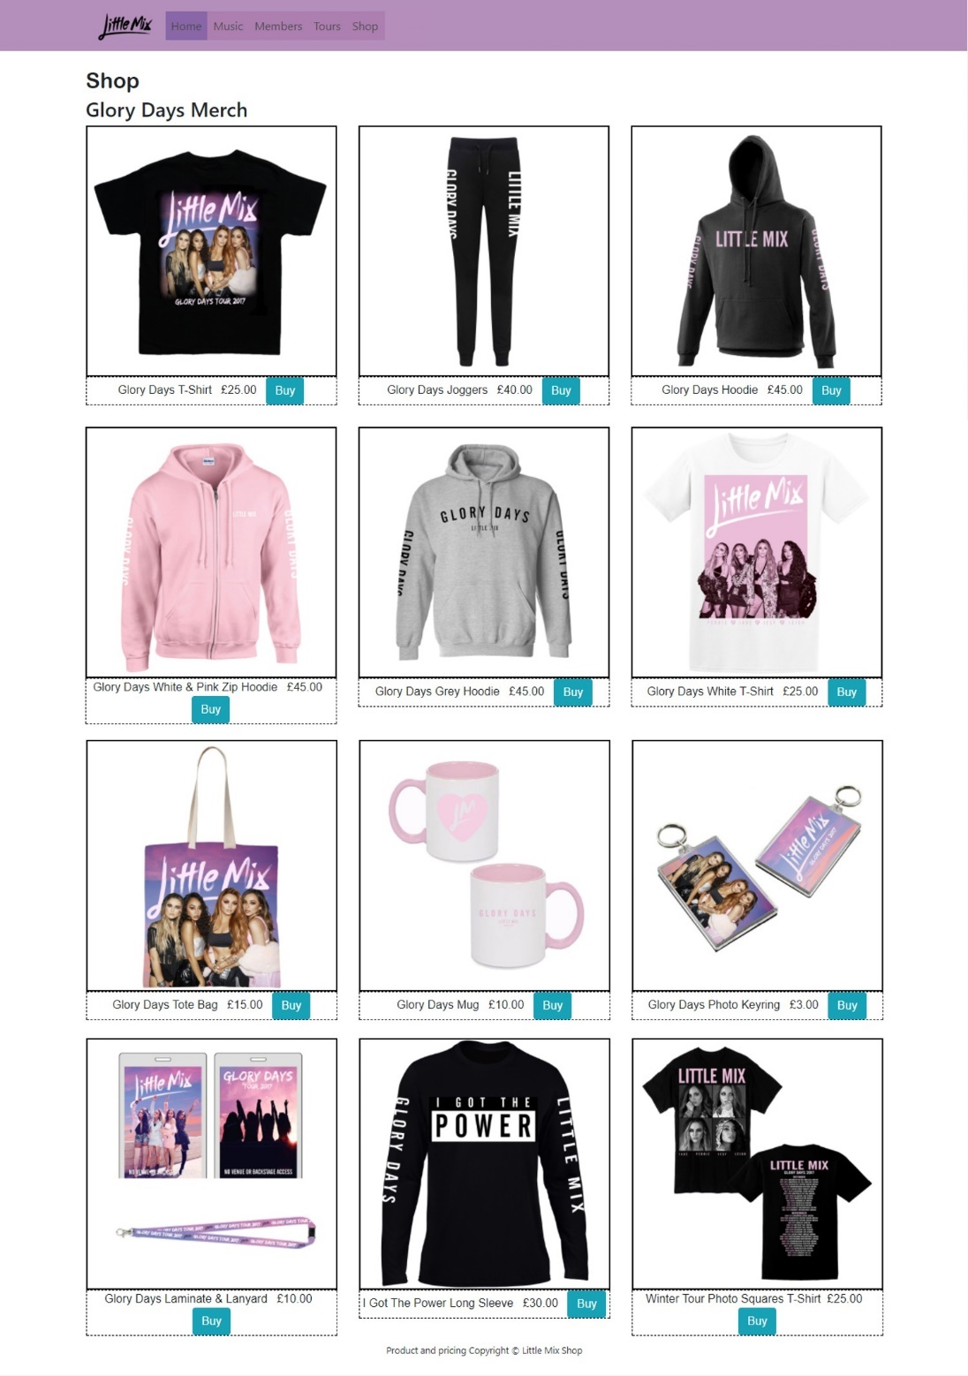
W3Schools was used for extra code to embellish images on the Music [3] and Members [4] pages. Twitter Publish [5] was used for the live Twitter feed on the Home page.

Validation
The author has validated the html of the home page [6] and their main CSS page [7]. The results are shown here.
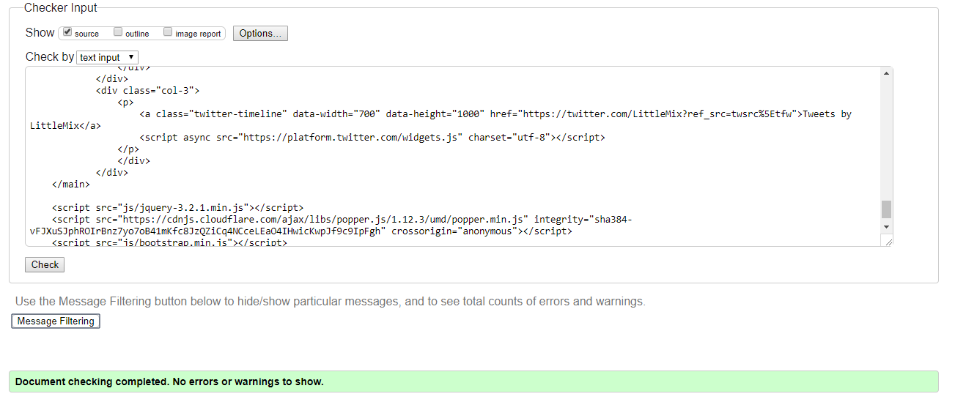
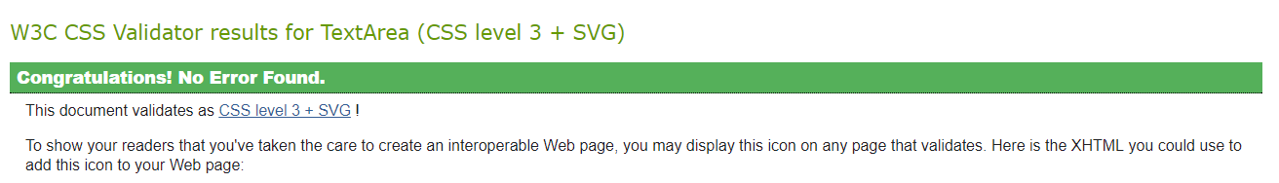
No errors were found in the code.

Evaluation

Accessibility Evaluation
The headings of the website all use the same font type, font size and colour to allow for consistency. All of the headings are black on a white background which is a high contrast and means it is fully colour compliant and easily readable for those with colour blindness [8]. The headings are all given their own style and a clear hierarchy, with Heading 2 being Arial rounded Mt and 30px and Heading 3 being Arial and 25px. All the text has been set to the font ‘Arial’ which is one of the best fonts to use for websites [9]. The navigation has the background #8966A8 with black text which is passed at Level AA for regular text and passed at Level AAA for large text which gives it a good contrast [10]. Some more basic accessibility checks include the page titles. This changes for each page that you are on which will make it more discernible if a user has a lot of tabs open [11]. For each image there is detailed alternative text provided for users who are blind and use screen readers, so they can hear the alt text read out. After resizing the text of the home page using Google’s developer tool, it is shown that only the main text within the cards increase in size which may make it difficult for blind users to read the rest of the text which remains its normal size. Each link is working and follows the same format for consistency and to avoid confusion. The navigation is clearly labelled at the top of each page. When the pages have been linearised the text becomes squashed and unreadable. Some people need to change how the pages are set out, so they are able to read it [11]. When using other browsers such as Internet Explorer and not Google Chrome, the home page becomes distorted.

General Evaluation
The website contains sufficient content on each page that is relevant to the page title. The style of the website is consistent, and it is clear where each link leads to on each page. The links are applicable to the website and fit their purpose [12]. They are also up to date [12]. The hover style on the images adds some vibrancy to the pages and makes the appearance more professional. All images that share the same type of information are in the same format such as the tour pictures on the music page. The website meets its purpose of promoting the band Little Mix and making it clear this is what it has set out to do. The website is also up to date with its content, particularly the home page as it displays the latest news and their official Twitter page feed which they update regularly themselves. While the site itself it informative, the byline in the Jumbotron “Biggest girl band of this generation” could be seen as biased. The website also credits where the information has been found and where the items shown are copyright to. It is also appropriate for its intended audience of fans and people who wish to know more about the band as it provides links to buy or listen to music, buy tickets for their latest tour and merchandise [13]. It is easy to use for novices as the navigation is clearly labelled so they can find anything they are looking for on the website. The balance of images to text is proportional as any text is related to the images [14]. All information used is accurate and based on research from external online sources [13]. The functionalities of the website are clear on each page, such as buying and reading more news [15]. The tone of the website is professional but the use of the colours make it more appealing to the target audience. The site logo follows convention and is in the top left-hand corner of the website and links to the home page no matter what page you are on [15]. The speed of loading each page is less than a second which is good as it means the user will not get frustrated while waiting for it to load and possibly leave the website. When first visiting the website, it is clear what it is going to provide and the use of ‘Read More’ buttons encourage the user if they are new to the band to learn more about them and then they may want to go back to the website and continue to learn about them. The user is able to reach their destination in one click so they do not have to search for a long time thus preventing them from becoming irritated and leaving the website [16]. Responses to external and internal links are immediate which will increase user satisfaction. It is clear what each page can provide the user.

Recommendations for Improvements
The website would be better if you could resize the content to fit in any browser. It should be able to be seen in one column for mobile users, so the text is still readable, and the images fit into one column. The author of the website has not been made clear and there are no contact details provided which is normal for websites [14]. It may have been better to use the Jumbotron on all pages or just the home page rather than two pages as it looks almost disjointed as you go from page to page. While it may be clear what the purpose of the website is, a short bit of text could be added on the home page clarifying this [17]. As the website is about a musical act it may have been improved by embedding music videos that they have made on another page. For the shop page, the author could have added all the sizes available for each clothing item as expected from any clothes store. Rather than single images for each tour, there could be a slideshow of pictures, with one from each venue for each tour for example. The colour scheme could use less colours and focus on a theme so the pages flow better together. To make it clearer what page users are on navigation bar could highlight the page link [15]. A search function could be added to help users find what they are looking for without having to click on each page. The music page could be more simple to provide professionalism.

References
[1] "WriteMaps," [Online]. Available: https://writemaps.com/wmaps. [Accessed 15 December 2017].
[2] Gliffy Inc., "Mock up Web Pages Quickly and Easily with Wireframes," [Online]. Available: https://www.gliffy.com/uses/wireframe-software/. [Accessed 15 December 2017].
[3] W3Schools, [Online]. Available: https://www.w3schools.com/howto/tryit.asp?filename=tryhow_css_image_overlay_slidetop. [Accessed 16 November 2017].
[4] W3Schools, [Online]. Available: https://www.w3schools.com/css/tryit.asp?filename=trycss_ex_images_card. [Accessed 16 November 2017].
[5] Twitter, [Online]. Available: https://publish.twitter.com/#. [Accessed 16 November 2017].
[6] W3C, "Markup Validation Service," [Online]. Available: https://validator.w3.org/. [Accessed December 16 2017].
[7] W3C, "CSS Validation Service," [Online]. Available: http://jigsaw.w3.org/css-validator/. [Accessed 16 December 2017].
[8] Acart Communications, "Contrast Checker," [Online]. Available: https://contrastchecker.com/. [Accessed 16 November 2017].
[9] R. Mening, "15 Best Web Safe Fonts," 7 March 2017. [Online]. Available: https://websitesetup.org/web-safe-fonts-html-css/. [Accessed 16 November 2017].
[10] JuicyStudio, "Luminosity Colour Contrast Ratio Analyser," [Online]. Available: http://juicystudio.com/services/luminositycontrastratio.php#specify. [Accessed 16 November 2017].
[11] W3C, "Easy Checks - A First Review of Web Accessibility," [Online]. Available: https://www.w3.org/WAI/eval/preliminary.html. [Accessed 16 November 2017].
[12] Dalhouse University, “6 Criteria for Websites,” [Online]. Available: https://cdn.dal.ca/content/dam/dalhousie/pdf/library/CoreSkills/6_Criteria_for_Websites.pdf. [Accessed 17 November 2017].
[13] University of Leicester, “Evaluating Websites,” [Online]. Available: https://www2.le.ac.uk/offices/ld/resources/study/eval-web. [Accessed 17 November 2017]
[14] CCCOnline, “Five Criteria for Evaluating Web Pages,” [Online]. Available: https://ccconline.libguides.com/c.php?g=242130&p=1609638. [Accessed 17 November 2017]
[15] The Visual Communication Guy, “How to Evaluate a Website,” [Online]. Available: http://thevisualcommunicationguy.com/2014/08/27/how-to-evaluate-a-website/. [Accessed 17 November 2017]
[16] SketchDeck, “How to evaluate the design of a website,” [Online]. Available: https://www.sketchdeck.com/blog/how-to-evaluate-the-design-of-a-website. [Accessed 17 November 2017]
[17] University of Reading, “Evaluating Tips,” [Online]. Available: https://www.reading.ac.uk/library/finding-info/guides/lib-evaluating-websites.aspx. [Accessed 17 November 2017]

