Daniel Jac Beynon Student no-2116579

Preliminary study for full site investigation
Course- HNC Quantity Surveying
Module- Fundamentals of construction technology
Lecturer- Alan Nantel

Contents page
- Assignment brief - Page 3
- Historical background – page 4-8
- Recommendations for site investigation/building regulations – page 9-10
- Foundation type – page 11
- Reference list – page 12

Assignment brief
In this assignment, I will be initiating a preliminary study for a full site investigation as a junior construction professional which will be undertaken by a specialist geotechnical contractor after my study has been complete. The area in which I will be completing the study is SA1 3SN which is between the Swansea county hall and the Marriot Hotel.
In this case study, I will be attempting to complete tasks such as,
- Describing the historical background of the area.
- Recommendations for the contents of a detailed site investigation.
- State the building regulations and codes of practice from my recommendations are derived.
- Select a suitable foundation detail for the building based on my preliminary observations and archival data.

Historical background
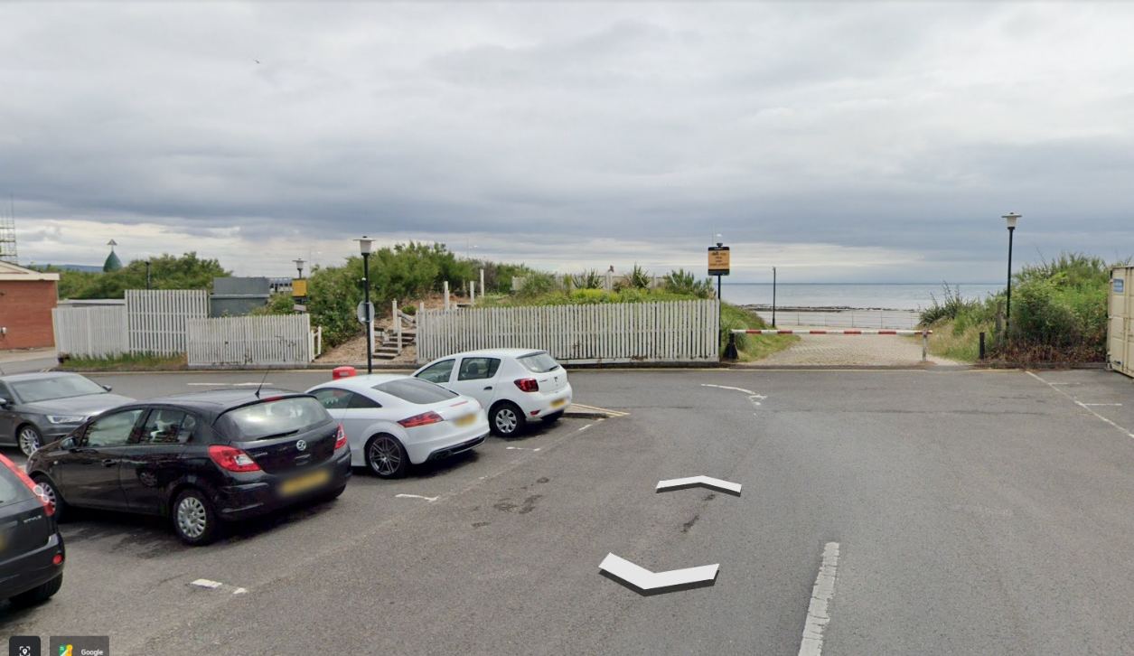

(Earth.google.com 2020)
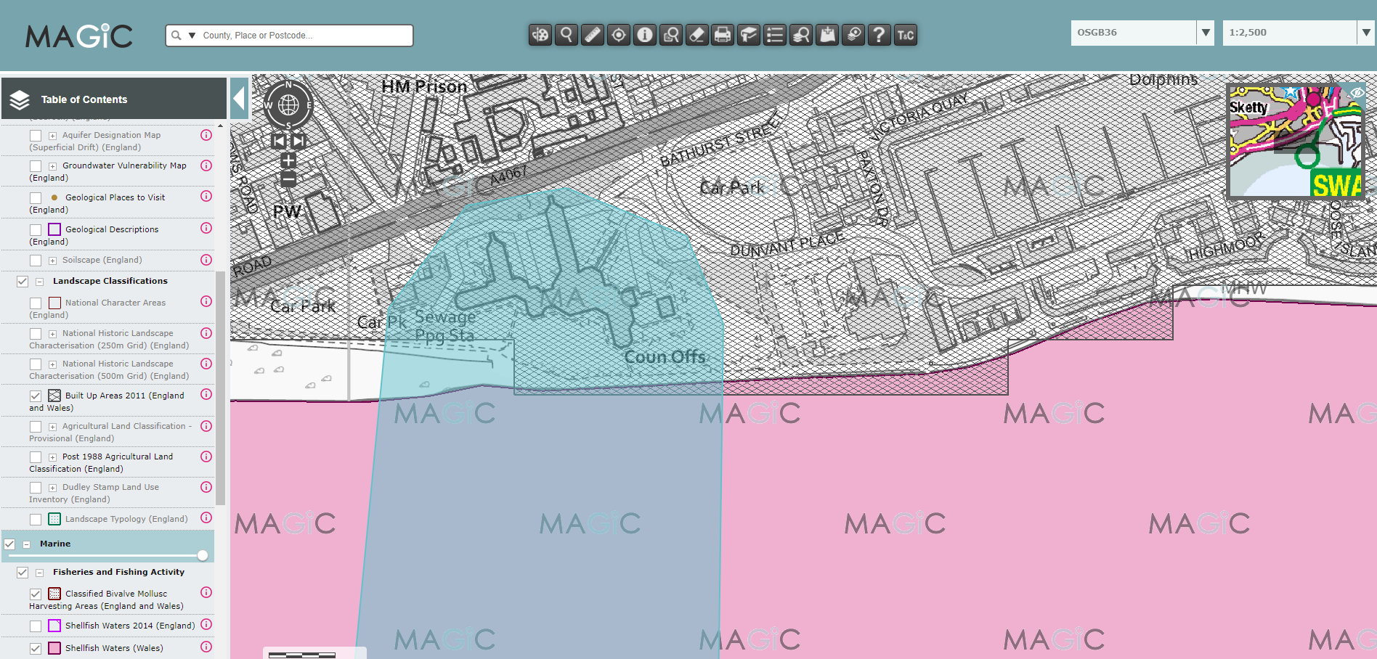
This image here from google maps which I captured shows the area which the proposed restaurant, ice cream parlour, and manager’s apartment at Swansea Foreshore. As you can see there are obstacles in the way such as a private patio for the hotel, this could be an issue if the hotel does not want to get rid of it but as it’s a joint agreement with the hotel there should not be any problem. This image does not show any other obstructions that might get in the way of building here. But National Resources Wales might have an issue with building near/on a beach therefore this might be an area you would want to look into more to get more clarification before stepping in the wrong direction.
(Defra, 2019)
This image is from https://magic.defra.gov.uk/MagicMap.aspx, it shows archeologically data from the UK. From this image you can see that from the filter selected which is built-up areas that the area that we want to build on is built up, this suggests that’s there could be any type of material underneath the footprint of the build.

Depending on the condition of the built-up ground there might be a need for finding a different foundations type from the traditional type as the built-up ground might not be suitable enough to hold the weight and provide the necessary strength.
Through investigation I found that this area of Swansea was exposed to the contaminative activity which was due to the area being associated with the dockyard and its activities, I found this information from a site called https://reports4planning.co.uk/contact-us/ where I emailed a member of staff from the site and they gave me the information I was looking for. From my knowledge and experience in the industry, this would allow me to say that if there was a building to be built here then a foundation design such as piling would have to be considered to get the building situated on the stable, strong ground which isn’t going to move which might be 5-8 meters down depending on the area, also as it is next to the beach you might have to take in to account the soft ground which could make the foundation have to be deeper. A more detailed assessment of the ground should be done in your full site investigation.
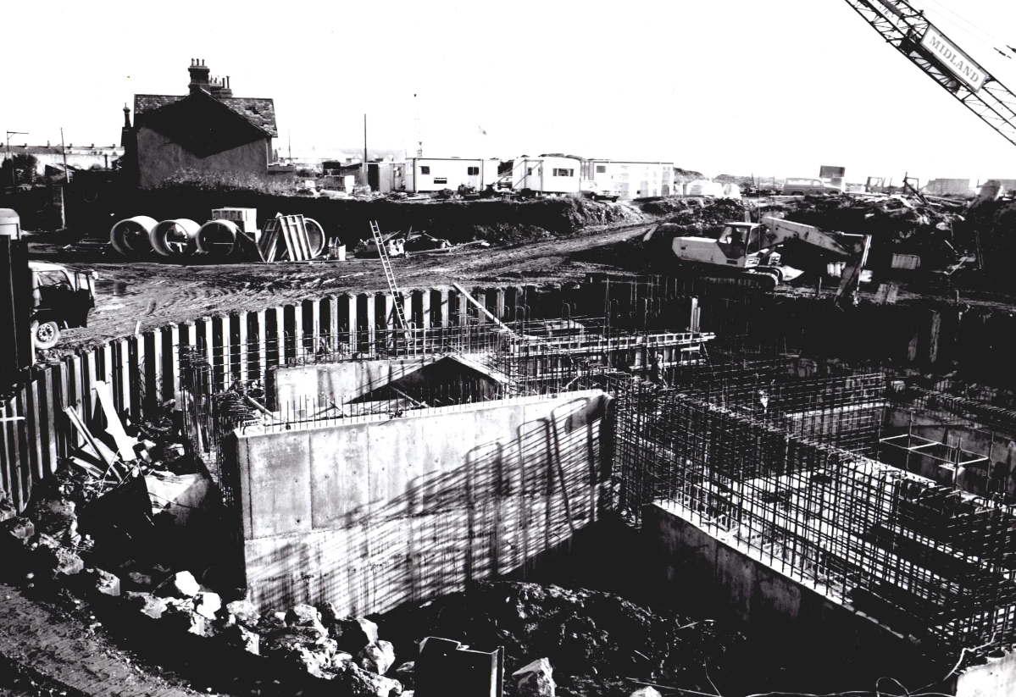

(Davies, 2011)
The image above shows the foundations of the County Hall which is near the area which this proposed building is going to go. As you can see the building has very deep foundations which could be the result of unstable ground closer to the surface which would not be suitable to build on, therefore they had to dig deeper to find stable, suitable ground for the building to stand on. This could be an area you look further into when a site investigation is done to see whether or not it would be necessary to have to pill the building.

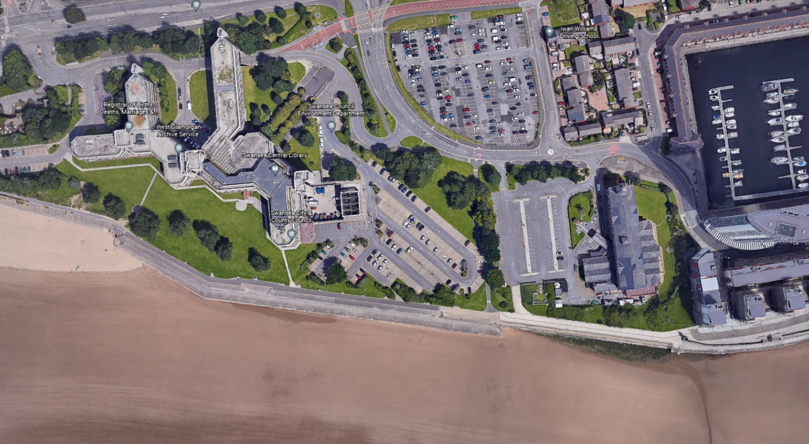
This red area shows the County hall/ West Glamorgan archives, and the blue area shows the area that is proposed to be built on. As you can see they are very close so the likely hood of the ground type being similar or even the same is very high therefore this would be an area that I would say to look into further to get more information.

(Earth.google.com, 2020)

The county Hall was opened in 1982 and several homes were demolished to make room for the mammoth structure, and the existing buildings were buried on-site and around to make room for the county hall, this could suggest that there are remains of the buildings buried in the ground and around the area.
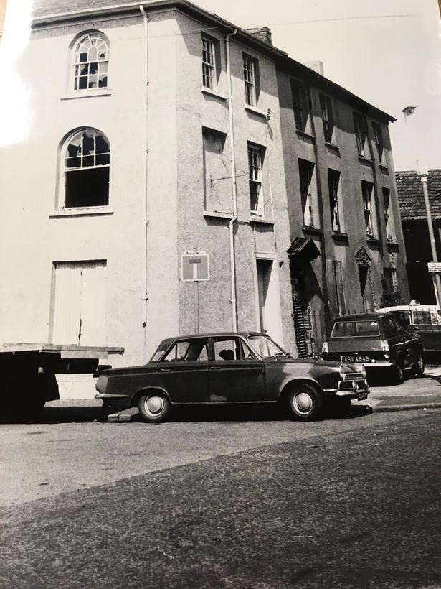
This image shows Buildings in Sloane Street and Dunant Place pictured in 1972 which made way for the county hall.

(Swansea Council archives/ West Glamorgan Archive Service)

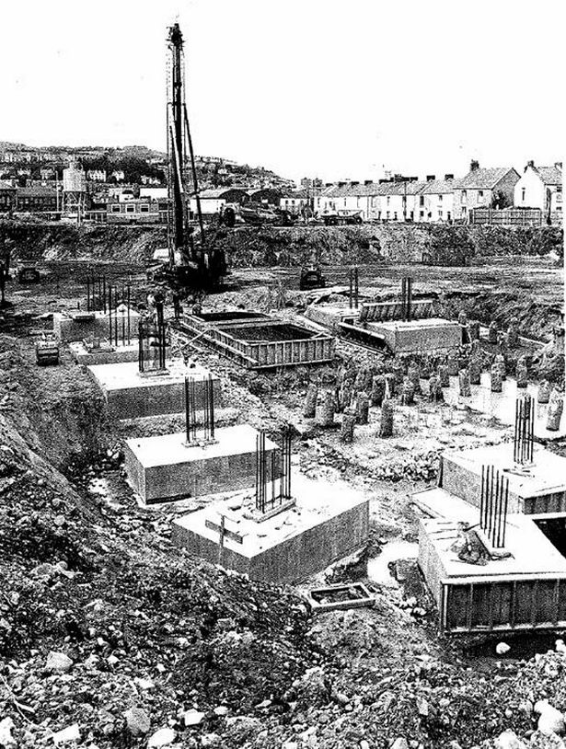

This image shows a piling rig in the background, and piles that have already been set, this leads me to think that a building going close to the county hall such as the proposed restaurant, café, and ice-cream parlour.
This would lead me to suggest to you to survey the ground more and maybe dig some test holes to see what type of material you are dealing with and see the suitability of it to build on.
(Dalling, 2019)

Geology of Swansea
Swansea is one of the main courses of industrial development in south Wales, with a long history of mineral extraction and processing (Water et al, n.d), this former industry has left a history of groundwater and land contamination in the area which does have an effect on building in the area and might have an effect on the area we are working with.
Also, with the area being close to the sea this could increase the groundwater and land water in the area, especially during the winter months when more rain and less precipitation is happening in the area. This is seen as in last couple years the main road that goes along the shore which is the A4067 gets flooded, this leads me to believe that the building nearest to this site just as the Marriott Hotel and County Hall get a lot of water damage too, and especially being that close to the sea.

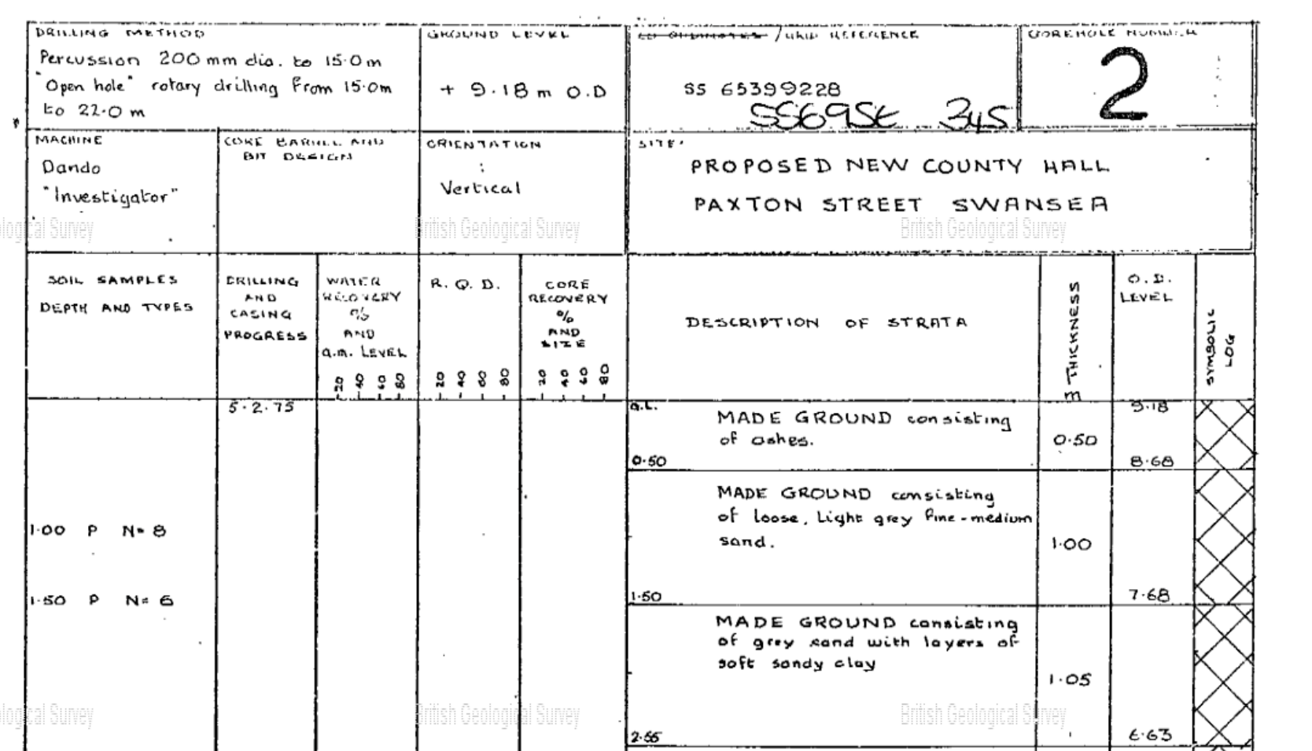

(Scans.bgs.ac.uk, n.d)
The image above shows information from a borehole that was dug before the county hall was built to evaluate what materials were beneath it. At a thickness of 0.5m there was made up ground from Ashes, then 1.0m of made up loose medium clay materials, then soft clay with grey sand. These materials are not suitable to build on which would suggest why they piled the footings to the building.
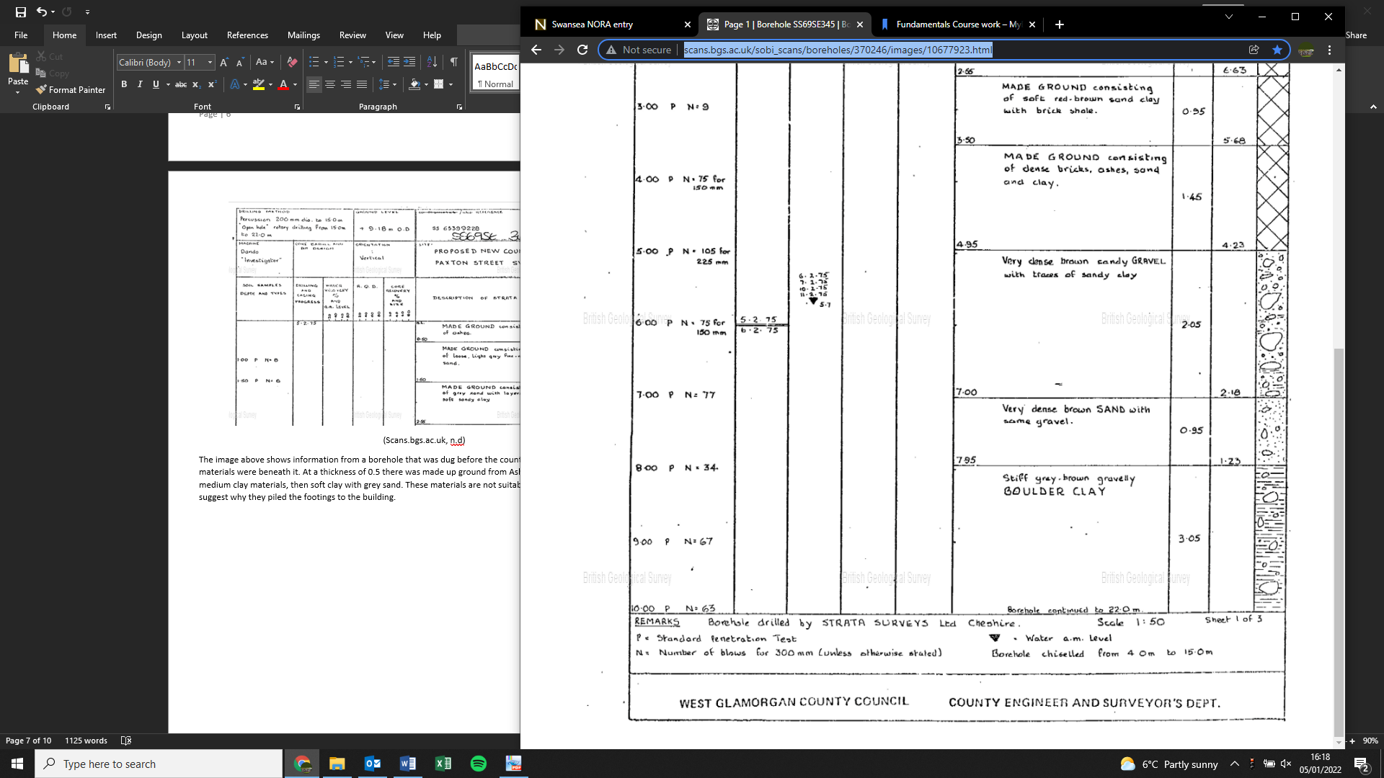

(Scans.bgs.ac.uk, n.d)

Further on down the assessment of the borehole bricks and boulder clay was found, this could be a result of the homes being demolished for the county hall to be built, which still isn’t a suitable material to build a large building with a GIA of 300 square meters.
The borehole carried on to a depth of 22.0 meters, with 10.45 meters of the borehole being unsuitable material which would not be safe to build on top off. This would suggest that the area we want to build on will be similar to this therefore a borehole test of your own could be productive to do as the results might help decide whether building here is a good idea or not.
Recommendations for site investigation
For the site investigation, I could consider looking at and surveying the groundwater flows and levels at the site, in this instance it could be important as the site is located very near to the sea which could mean that water comes over the area which the site is going when there is a high tide or a storm of some sort. I believe this might be a big risk to the development of this area, as the history in the area says that the likelihood of flooding and water affecting a build is very high. And from my experience in the industry groundwater always adds time to a project which means money therefore taking out a proper test into this will be worth it to know whether it is a good or bad idea to have a building in this area.
I would also advise taking a deeper look into the ground conditions on the site, as from the borehole assessment on the county hall sight you can tell that the ground doesn’t look like to be in a suitable condition (for the first 10-15m) therefore a borehole test on this site might be a good idea to get an up to date evaluation of the ground we are dealing with, as this is a major part of the building as getting the foundation wrong could end up ruining the job but also could end up injuring people and maybe damaging other building in the surrounding areas. The best idea might be doing a borehole test of your own to get up-to-date data on the materials which are beneath the proposed site.
It might also be important to take a look at the mechanical properties such as the strength of different soils and rock strata. This would be beneficial here as there are many different layers of soil on a nearby site it could well be the same here.
You could also have a survey to see if there are any special habitats in the area, I could not find any but there could be now if you could get up-to-date data.
Having a deeper look into these areas would give you a better conclusion on the area and the elements around it which would give you significant information on whether it is a good idea or not to build in this area.
Building Regulations
After my research, I found out that the ground under a nearby building (County Hall) was contaminated with ash with made up the soil, if this was found under our proposed area then you would have to send a contaminated land assessment along with the planning document, this will allow you to apply for planning permission on this contaminated ground. Having worked on a site as a trainee QS we found an area of knotweed which had to be treated before any further work was to be undertaken, therefore getting rid of the contaminated soil early on in the project will save money and time then if you were to deal with it after the project had started.
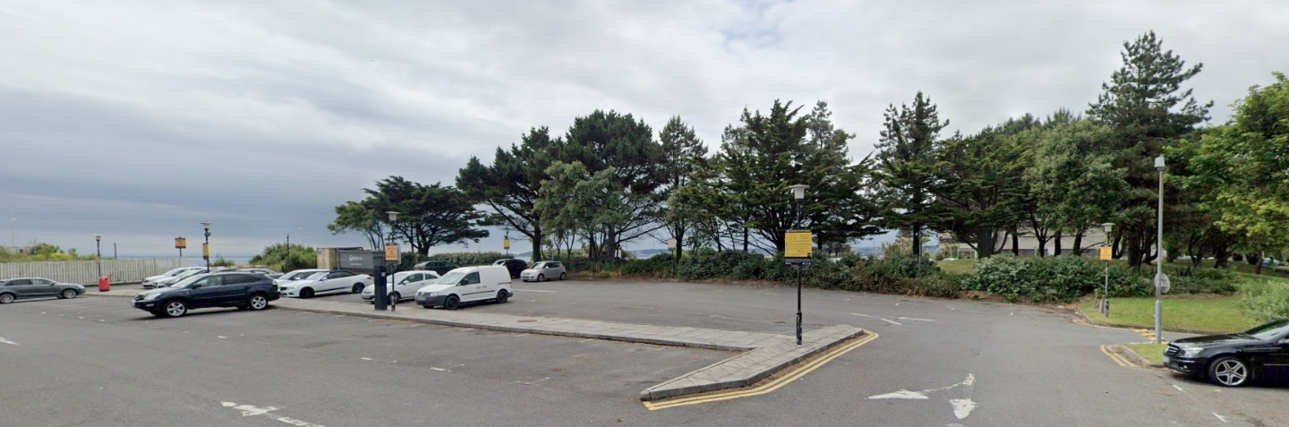

Another thing to consider would be to see if these trees are an invasive species because if they are there might be a problem with moving them, and if they were to be moved they would have to be moved along with the soil they are, which also would have to be done before any work is undertaken to save time once the project has started. any work If these trees were invasive and they got cut down then major fines could come the developer’s way therefore sorting it early on is the best way of dealing with the problem.

Foundation type
Following my preliminary investigation, I found out that the materials under the surrounding area were built up and not suitable to build on with a shallow foundation as it would not provide the strength which is needed for a building of this size that has a GIA of 300 square meters. Therefore, through my experience in the industry and being on several building sites where load-bearing soil is deep down, or if when a mine shaft was found after surveying the ground, I think a piled foundation will be best here as its normally the most economical solution for sites where loadbearing support is several meters into the ground. In this instance, I believe that the ground below is not suitable, but through my research, I could not find any activity of mining in the close proximity but it did happen in Swansea as a whole and therefore could mean it hasn’t been discovered yet if there is one in this area. Using a piled foundation has advantages such as high corrosion resistance, high load capacities (thearchitechesdesign.com, n.d), this should provide the necessary strength for this 300 m2 GIA building which is proposed to go in the area.
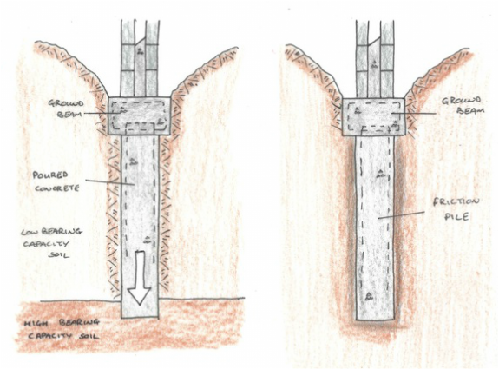

Reference list

Dalling, R. (2019). Forgotten houses and the birth of one of Swansea’s best known buildings. [online] WalesOnline. Available at: https://www.walesonline.co.uk/news/wales-news/forgotten-houses-birth-one-swanseas-15905059.

Davies, M. (2011). Foundations for WGCC County Hall in Swansea in the 1970s. [online] Swansea Recalled. Available at: https://ididitthisway.wordpress.com/swansea-old-picture-photos/20th-century/foundations-for-wgcc-county-hall/ [Accessed 5 Jan. 2022].

DEFRA (2019). Magic Map Application. [online] Defra.gov.uk. Available at: https://magic.defra.gov.uk/MagicMap.aspx.

earth.google.com. (2020). Google Earth. [online] Available at: https://earth.google.com/web/@51.61350732.

scans.bgs.ac.uk. (n.d.). Page 1 | Borehole SS69SE345 | Borehole Logs. [online] Available at: http://scans.bgs.ac.uk/sobi_scans/boreholes/370246/images/10677923.html.

thearchitecturedesigns.com. (n.d.). Advantages and Disadvantages of Pile Foundation [Complete guide] - The Architecture Designs. [online] Available at: https://thearchitecturedesigns.com/advantages-and-disadvantages-of-pile-foundation-complete-guide/#:~:text=Main%20advantages%20of%20pile%20foundation.

Waters, C., Tye, A., Brown, S. and Schofield (n.d.). Urban geology of Swansea and Port Talbot 1 2. Urban geology of Swansea and Port Talbot. [online] Available at: http://nora.nerc.ac.uk/id/eprint/504837/1/Swansea%20NORA%20entry.pdf [Accessed 5 Jan. 2022].

