What is the most effective diet plan to help people combat obesity?
Stacey Jones (2023)
Image(Washington Post,2015) 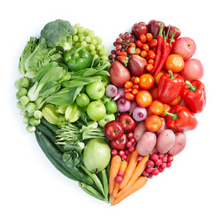
06 November 2023
2306691

Contents

Introduction 2
Background 3
Articles 6
Article 1 6
The British Medical Journal (BMJ) (2006) 6
Article 2 6
The European Journal of Clinical Nutrition (2017 6
Article 3 6
Liver International (2021) 6
Themes 8
Theme 1- Results from article 1 8
Theme 2 – Results from article 2 8
Theme 3 – Results from article 3 8
Conclusion 10
Reference list 11

Introduction

Being a healthy weight is considered a very important and effective way to tackle long term health problems, including obesity. In this day and age, healthy eating is a lot easier said than done. The conditions and surroundings in which we live, encourage our need for quick and easy access to foods. Combating obesity is not a task to be taken lightly (Gethin, 2023) (Welsh Government). There are many factors to be taken into consideration. Lifestyle and diet play a big part in eliminating obesity but there are society, global and individual needs to be taken in to consideration also (Welsh Government, 2023). Death and health issues linked to obesity have increasingly risen over the years at a very fast pace. Experts are at a pivotal point in time to take steps to help people live a better and more fulfilling life, not only for this generation but for future generations (Welsh Government, 2023).
The definition of what is considered healthy is constantly changing due to learning more and more about nutritional values of food and their benefits. The overall findings from a vast majority of research and trials shows that nutrient enriched foods are the most beneficial to promoting a healthy lifestyle (National Library of Medicine, 2020). But there is not one solution that suits all when it comes to healthy eating and diet plans (NHS, 2023). The aim of this report is talk about the best overall diet plan and the most effective plan that will combat obesity. This report will find the best way to help tackle obesity through healthy eating, the findings will be mainly concentrated on the issue in Wales with further readings and studies from all parts of the world.

Background information
Obesity in Wales has been a long standing battle throughout the years (The Welsh Health Survey, 2014)…
- More than half of the adult Welsh population are overweight (The Welsh Health Survey, 2014).
- More than 1 in 5 are obese (The Welsh Health Survey, 2014).
- The NHS spend over 86 million each year due to health problems associated with obesity (Welsh government, 2023).
- Welsh consumers regularly go over the recommended amount of saturated fat and salt (The National Diet and Nutrition Survey, 2015).
- Less than a third of people in Wales consume the recommended 5 a day advised for fruit and vegetables (Welsh government, 2023).
- Near 600,000 adults reported to be obese in 2019, (Public Health Wales, 2019).
- One in eight reception children in infant school are obese as reported in 2019. (Public Health Wales, 2019).
- In 2020, 23% of adults were overweight in Wales compared to 15% of adults in 1997. In Wales, infant aged children who suffer with obesity, has increased from 7% in 1997 to 21% in 2020 (Tagliaferro, 2023).

To tackle obesity it is important to know what healthy eating is considered to be. Healthy eating is about eating a good mixture of many types of nutrient enriched foods (NHS, 2022). Research has shown that low energy dense foods keep you fuller for longer which in turn prevents you from eating more fat in your diet (National Library of Medicine, 2018). Eating a wide range of foods from all food groups is important for tackling obesity. It helps you consume all the nutrients your body requires to be healthy (The Eat Well Guide, 2022).
Below are two images. They represent the healthy food groups advised by United States Department of Agriculture (USDA (2017), (2023).

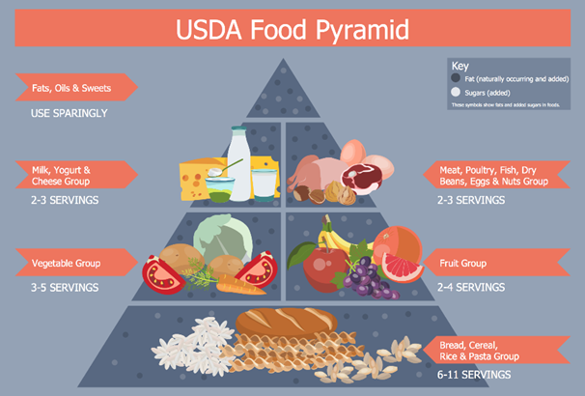
(Concept draw, 2023)
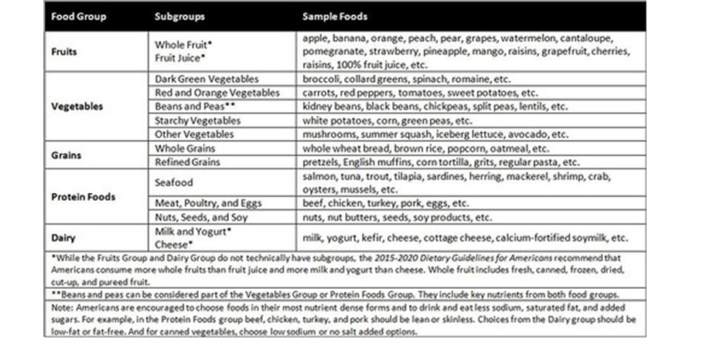(USDA, 2017)
Fruit and vegetables are considered part of your 5 A Day. Getting the recommended daily amount is not as difficult as many would think. More specifically 80g of all types of fruit counts as a portion of your five a day and most vegetables count as on portion of your five a Day, with the exception of potatoes (NHS, 2021). 30g of dried fruit go toward one portion of your five a Day. Dried fruit can also be eaten at meal times. 80g of beans or pulses. Fruit and vegetables don't have to be fresh to count (NHS, 2021). The World Health organisation (WHO) acknowledged that eating your 5 a day lowers the risk of becoming obese (Yasmin, 2022).
As previously stated from a different source (The Welsh Health Survey, 2014), tackling obesity is one of the biggest and longest serving problems we have in this country. Obesity has been linked to lowering your life expectancy (Department of Health and Social Care, 2020). It also poses a huge risk to developing other more serious health issues, including cardiovascular disease, type 2 diabetes and many more. Obesity has become a very real concern for anyone over the recommended body mass index (BMI). Furthermore, this also becomes a problem for our health and care services. 63% of adults are over a healthy weight, with 1 in 3 children leaving primary school already overweight. This is a major concern for future generations (Department of Health and Social Care, 2020).
Health promotion is very important. It is important to know that health promotion can be linked to disease prevention. Health promotion is the ability to help others master control over decisions that will improve their health (World Health Organisation, 2023). To do this it goes beyond tackling one person’s needs at a time, the aim is to educate groups of people in a more social setting (WHO, 2023). By choosing healthier eating on a daily basis you can prevent more specific health conditions and serious chronic conditions (Centres for Disease Control and Prevention, 2023) (CDC).
Lots of people who are overweight or obese want to lose weight but find it too hard and need help. (Department of Health and Social Care, 2020).

In 2022 the Welsh government reported a new initiative to tackle obesity through healthy eating. This was called ‘Healthy Food Environment’. There were three themes made in this report, (Healthy Food Environment, 2022)…
- Healthier Shopping Baskets (Healthy food Environment, 2022).
- Healthier Eating out of the Home (Healthy Food Environment, 2022).
- Healthier local food environments (Healthy Food Environment, 2022).
To know what is considered healthy eating, there have been numerous studies on what is the best diet to prevent and combat obesity. The following articles in this report will introduce the numerous studies and will discuss the findings to support this.

Articles

Article 1
The British Medical Journal (BMJ) (2006) produced an article titled ‘Randomised controlled trial of four commercial weight loss programmes in the UK: initial findings from the BBC "diet trials"’ . This trial spanned over a 6 month period, based on people healthily overweight and obese. The four weight loss programmes they studied were…
- Weight Watchers pure points programme
- The Atkins, new diet revolution
- Rosemary Conley's eat yourself slim diet and fitness plan
- Slim fast plan
As stated in the article this was an “unblinded randomised controlled trial” (BMJ,2006). Unblinded randomized controlled trials are when the group of people taking part and conducting the trial, are all conscious of all aspects of the trial. Unblinded trials make it less difficult to bias the outcome of the trial (BMJ, 2000).
It is possible to be ‘healthy overweight’, if a person weighs more than the recommended body weight but are still fit and healthy it is possible to be healthier than someone who is considered a healthy weight not is not active or healthy eating (Carr 2017).
It is important to take in to consideration that this trial is quite outdated, so the age of this trial may be considered as a weakness. The following articles are more up to date.

Article 2
The European Journal of Clinical Nutrition (2017) produced a study named ‘Effects of two diet techniques and delivery mode on weight loss, metabolic profile and food intake of obese adolescents: a fixed diet plan and a calorie-counting diet’, in which two different low calorie diets were used in contrast to study the weight loss in obese adolescents. The two diets used were…
- A fixed diet plan
- A calorie counting diet.
Metabolic Profile is a set of blood tests scale different points of the body’s chemical balance and process (National library of medicine, 2023).

Article 3
Liver International (2021) published an article called ‘Effects of two personalized dietary strategies during a 2-year intervention in subjects with non-alcoholic fatty liver disease: A randomized trial’. This trial comprised of ninety-eight people who were randomly chosen from a previous study called ‘Fatty Liver Obesity’. Liver International (2021) introduces that a reduction in calories plays an important part in the reducing body weight (Bertha et al 2021). Two different diets were used in this trial, both diets used a calorific reduction, the aim was to lose a maximum of 5% weight loss from their starting weight (Chalasani et al, 2018). This was to comply with the advice from the American Association for the Study of Liver Disease (AASLD) (Chalasani et al, 2018).
The aim of this study was to track the results of the two calorie restricted diet strategies on weight loss and other factors present with fatty liver disease over two years. The follow up was solely on the participants who were overweight and obese (Bertha et al,2021).
Randomised trials use groups of randomly selected participants (Webster, 2023).
Participants are the people involved in the trial (Cambridge Dictionary, 2023).

Themes

Theme 1- Results from article 1

The overall findings was, there is not one diet that fits all. In order to lose weight and keep it off there needs to be a higher energy expenditure than calories consumed. Therefore from this trial it is perceived that a low calorie diet is best for combating obesity (Truby et al, 2006).
The graph below shows the findings of the study and how close the weight loss was…
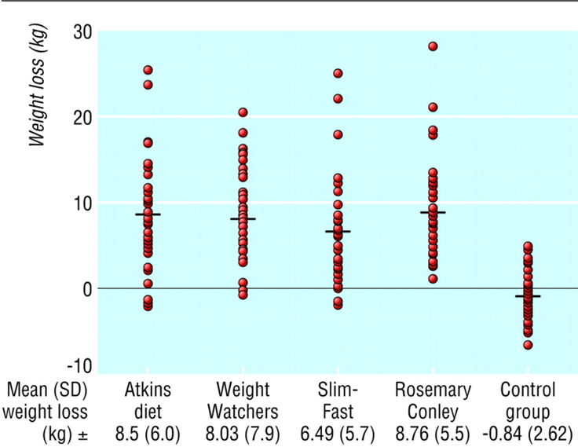

Theme 2 – Results from article 2

The findings were that both diets led to a similar reduction in BMI. As stated in the study “calorie-counting approaches have the strongest association with weight loss” (Mendes et al, 2017).

Theme 3 – Results from article 3

The findings after the two year check up showed that participants of both calorie reduced diets, reduced weight loss within the aim of 5%. Not only did this study have a positive effect on weight loss but it also had a profound effect on liver functions. This showed that a calorie reduced diet can also have a direct positive effect on certain health problems (Bertha et al, 2021). Below is a diagram to support the weight loss findings for both calorie reduced diets…

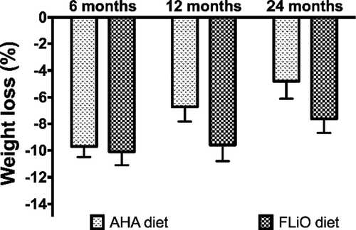
(Liver International, 2021)

From the studies, the common denominator is the importance to consume a low density, low calorie diet to control obesity.

Conclusion

The overall findings of this report conclude, there is an undeniable link between a low calorie eating plan and weight loss. Of the three trials studied, old and new, a reduction in calories has resulted in weight loss in each one. The third article exhibited a direct link between eating in a calorie deficit and not only weight loss but an improvement in liver function. This supports health promotion being linked to disease prevention (WHO, 2023).
To answer the question ‘What is the most effective diet plan to help people combat obesity?’
The results and findings of this report have proven that a low calorie diet is the most effective diet plan to help combat obesity.
This allows the understanding on how to implement the Welsh 2022 healthy eating initiative ‘Healthy Food Environment’ into daily routine. This reports gives an insight into how to have ‘Healthier shopping baskets’, how to be healthier eating out of the home and hoe to recognise healthier local food environments, (Healthy Food Environment, 2022).

Reference list

Bertha, A., Marin, A., Cantero,I., Perez-Diaz-del-Campo, N., Monreal, J. I., Elorz, M., Herrero, J. I., Benito-Boillos, A., Quiroga, J., Martinez-Echeverria, A., Uriz-Otano, J. I., Huarte-Muniesa, M. P., Josep, A., Martinez, J. A., Abete I. and Zulet, M. A. (2021) ‘Effects of two personalized dietary strategies during a 2-year intervention in subjects with non-alcoholic fatty liver disease: A randomized trial’. Available at: https://doi-org.ezproxy.uwtsd.ac.uk/10.1111/liv.14818.

Carr, R., (2023) ‘Can you be overweight and still healthy?’ Healthy Food Guide. Available at; https://www.healthyfood.com/advice/can-you-be-overweight-and-still-healthy/. (Accessed on13 November 2023).

CDC, (2023) ‘How you prevent Chronic Disease’. Available at: https://www.cdc.gov/chronicdisease/about/prevent/index. (Accessed on 11 November 2023).

Chalasani, N., Younossi, Z. and Lavine, J. E. (2018) ‘Diagnosis and management of non-alcoholic fatty liver disease: practice guidance from the American Association for the Study of Liver Diseases Hepatology’, 67, 328-357. (Accessed on 13 November 223).

Chang,S. MPH, RD, (2017) ‘Back to Basics: All About MyPlate Food Groups Nutritionist’, Center for Nutrition Policy and Promotion and Kristin Koegel, MBA, RD, Nutritionist. Available at: https://www.usda.gov/media/blog/2017/09/26/back-basics-all-about-myplate-food-groups.

ConceptDraw DIAGRAM 17 (2023) Available at: https://www.conceptdraw.com/How-To-Guide/healthy-foods. (Accessed on 13 November 2023)

Daya, J. S. and Altman, D. (2000) ‘Blinding in clinical trials and other studies’, Available at: https://doi.org/10.1136/bmj. (Accessed on 14 November 2023).

Department of Health and Social Care. (2020) ‘Tackling obesity: empowering adults and children to live healthier lives’. Available at: https://www.gov.uk/government/publications/tackling-obesity-government-strategy/tackling-obesity-empowering-adults-and-children-to-live-healthier-lives. (Accessed on 6 November 2023).

Gethin, V, (2023) Welsh Government, ‘Healthy Weight: Healthy Wales’. Available at: https://www.gov.wales/sites/default/files/publications/2019-10/healthy-weight-wales. (Accessed on 6 November 2023).

J. Rolls, Liane S. Roe, Amanda M. Beach, Penny M. Kris-Etherton. (2005) ‘Provision of Foods Differing in Energy Density Affects Long-Term Weight Loss’, Obesity society, Research Education Action. Vol 13 (6), Pages 1052-1060. Available at: https://doi-org.ezproxy.uwtsd.ac.uk/10.1038/oby.2005.123.

Mendes, M. D. S. D., De Melo, M. E., Fernandes, A. E., Fujiwara, C. T. H., Pioltine, M. B., Teixeira, A., Coelho, K., Galasso, M., Cercato, C. and Mancini, M. C. (2017) “Effects of two diet techniques and delivery mode on weight loss, metabolic profile and food intake of obese adolescents: a fixed diet plan and a calorie-counting diet”, European Journal of Clinical Nutrition, vol 71 (4), p.549-551. Available at: https://www.proquest.com/docview/1884071234?parentSessionId=5Us0uYu9PyNtZCrLL6P%2BzTZFEXv55w5EYX2JYSXDP3Y%3D&pq-origsite=primo&accountid=130472.

Meriam Webster (2023) Available at: https://www.merriam-webster.com/medical/randomized%20controlled%20trial. (Accessed on 13 November 2023).
National Library of Medicine, (2020) ‘Defining a Healthy Diet: Evidence for the Role of Contemporary Dietary Patterns in Health and Disease’. Available at: https://ncbi.nlm.nih.gov. (Accessed on 6 November 2023).

National Library of Medicine (2023) ‘Comprehensive metabolic panel’. Available at:https://medlineplus.gov/ency/article/003468.htm. (Accessed 11 November 2023).

NHS, 2023) ‘Obesity treatment’. Available at: https://nhs.uk/conditions/obesity/treatment. (Accessed on 6 November 2023).

NHS, (2022) ‘The Eat Well guide’. Available at: https://www.nhs.uk/live-well/eat-well/food-guidelines-and-food-labels/the-eatwell-guide/. (Accessed on 11 November 2023).

NHS, (2022) ‘Eating a balanced diet’. Available at: https://www.nhs.uk/live-well/eat-well/how-to-eat-a-balanced-diet/eating-a-balanced-diet/. (Accessed on 13 November 2023).

NHS, (2023) Available at: https://www.nhs.uk/live-well/eat-well/5-a-day/5-a-day-what-counts/. (Accessed on 7 November 2023).

Public Health Wales, (2019) ‘Obesity in Wales’, Available at: https://phw.nhs.wales/topics/obesity-in-wales-2019. (Accessed on 6 November 2023).

Tagliaferro, L. (2023) ‘40+ Essential obesity statistics and trends in the UK’, Available at: https://futurefit.co.uk. (Accessed on 6 November 2023).

The National Diet and Health Association, (2015). (Accessed on 6 November 2023).

The Welsh Health Survey, (2014) Available at: https://www.gov.uk/government/statistics/welsh-health-survey-2014-health-status-illness-and-other-conditions. (Accessed on 6 November 223).

Truby,H.,Baic,S.,Delooy,A.,Fox,K.R.,Livingstone, M.B.E. (2006) “Randomised controlled trial of four commercial weight loss programmes in the UK: initial findings from the BBC "diet trials"”, British Medical Journal, vol 332, (issue 7553). Available at: https://www.proquest.com/docview/1777635568?parentSessionId=AZup3LY768z9jnlUeQ0cU%2B4COVCF5S1Ic6eEm%2FVRsuw%3D&pq-origsite=primo&accountid=130472.

Welsh Government (2023) ‘Food and Drink Wales’. Available at : https://www.gov.wales/sites/default/files/publications/2021-02/food-for-the-future-report.pdf. (Accessed on 6 November 2023).

Welsh Government, (2022) ‘Healthy Food Environment’. Available at: https://www.gov.wales/healthy-food-environment. (Accessed on 6 November 2023).

World Health Organisation (2023) ‘How we work’. Available at: https://www.who.int/westernpacific/about/how-we-work/programmes/health-promotion. (Accessed on 10 November 223).

Yasmine, S, (2022) ’How to Prevent Obesity’. Available at: https://www.verywellhealth.com/obesity-prevention. (Accessed on 7 November 2023).

