Calum Case

Software development
Assignment 1

Contents
1 Introduction 2
2 Findings 2
2.1 Stages of Development 2
2.1.1 Problem 1 2
2.1.2 What was the first problem? 2
2.1.3 Development 2
2.2.1 Problem 2 3
2.2.2 What was the second problem? 3
2.2.3 Development 3
2.3.1 Problem 3 4
2.3.2 What was the third problem? 4
2.3.3 Development 4
2.4 Testing the Code 4
2.4.1 Problem 1 4
2.4.2 Problem 2 4
2.4.3 Problem 3 4
2.5 Errors Encountered - 400 5
2.5.1 Problem 1 5
2.5.1 Problem 2 5
2.5.1 Problem 3 5
3.1 Conclusion 5
4.1 Appendix 0
4.2 Appendix A: 0
4.3 Appendix B: 0
4.4 Appendix C: 0
4.5 Appendix D: 0
4.6 Appendix E: 0
4.7 Appendix F: 1
4.8 Appendix G: 1
4.9 Appendix H: 1
4.10 Appendix I: 1
4.11 Appendix J: 2
4.12 Appendix K: 2
4.13 Appendix L: 2
4.14 Appendix M: 2

1 Introduction
In this document, there will be a small amount of problems that will need to be solved via coding. This document will showcase the development of each problem, what problems appeared during the development and how each problem turned out at the end of development. All the coding problems will be developed in Visual studio showcasing various struggles to solving each problem. This document will cover the development of various problems that has been presented, this document will also cover the various development problems during the coding process.

2 Findings

2.1 Stages of Development
Below is the segment of the report that is documenting various parts of software development. There were three unique scenarios that have been presented that needed to be completed. Each scenario differs in difficulty as some problems were rather simple and others required complicated math and using techniques such as loops to complete the code. Below is an in-depth look at what each problem had to offer, how they were developed, the various testing that was required for each problem and a description of errors that occurred during the development.

2.1.1 Problem 1

2.1.2 What was the first problem?
The first problem that was presented was a rather simple one. The problem was trying to get certain variables to show in the code, for this specific example it was a book title, the length of the book and the number products inside the user’s cart. The problem was trying to get the user to input the name of the book, the length and the number of products inside the user’s cart, the code would then show back what the user had input when asked to confirm if the information was correct.

2.1.3 Development
The development of this problem started with adding in a string and two doubles. The string was added because there would be some text involved with this specific code and the two doubles were added because the code would need the user to input some numbers as requested by the user. The variables are shown in appendix A
Once those variables have been inserted into the code it was then time to crate the main code. This segment of the code is telling the user to input some data and then the code will then give the information back to the user. This was done by starting with a cout, this first cout line is telling the user to input the title of the book, that is why the cout line is saying “Enter the title of the book”. Once the user has input a book title the code will then take that data and give it back to the user via another line of cout that is saying “You entered: “ and then after that line the code will then give back the data the user had input into the code. The code is shown for this segment is seen in appendix B.
The second part of the code is universally the same thing as the first part talking about the book title but instead of asking for a book title the code is asking for a length. Another difference with this part of the code is that instead of using string it uses double, this is because a length is a number and thus using double instead of string would be essential for this part of the code. Like the first part of the code, this part will also use two different cout lines of code asking for an input from the user and another cout line showing what the user had input to the code. This segment of code can also be seen in appendix C.
The final part of this problem was asking about how many products was inside the user’s cart. This part is really like the second part talking about the length but instead of asking for a length it was asking for the number of products inside the user’s cart. This part of the code just like the previous two parts also had two different cout lines asking the user to input a number for the amount of products inside the user’s cart and second cout line is showing what the user had input to confirm that the number they had input is correct. This part of the code can be found on appendix D.

2.2.1 Problem 2

2.2.2 What was the second problem?
The second problem that was presented was a problem that was trying to figure out the width and height of a small box, alongside that small box there the radius of a circle also had the be solved out too, above those two problem is a bigger box, the biggest box was missing an area and the purpose of the code was to try and figure out the area of the bigger box, this can be helped by finding the area of the circle and the area of the smaller box.

2.2.3 Development
The first part of this code was working out the area of the circle out, this was done by setting a variable for the area being “r”, for the circle it was also necessary to add pie to work out the circle too. After the PI and the area had been made, a cout line was created to ask the user to input a radius for the circle. After the cout line had been made, to work out the radius of the circle the code used was “cin >> r;” this line of code alone has worked out how to find the radius of the circle no matter what number had been input before hand on the cout line. Once that line has been completed the next line is the code figuring out the area of the circle via the radius and PI. This was done to show that the code could figure out the area of the circle. Finally, the final line was a cout line showing the total area of the circle. This code can be seen in appendix E.
The next part of the code was to figure out the area of the small box on the original figure. This was done in a rather simple way as the code was just trying to figure out the area of the box thanks to the help of the box’s height and width. The first thing that was done was to establish the variables every variable used in this segment of the code was using double due to each of then being numbers have each potentially having decimal points. After the variables were pointed out the code was then a cout asking the user for the width of the box. After the cout line there is cin that will work out the width of the box. After the cin line there is another cout line asking the user to input the height of the box and just like the width before it, this line of code is followed by a cin line that will also work the height. Once the code has the box’s width and height it will then use those two final sums to get the area by timing them together to get the area of the box. Once the code has worked out the box’s area it will then show the user the box’s area via a cout line of code. This portion of the code can be seen under appendix F.
Finally, the last part of this problem was figuring out the area of the bigger box that has the circle and box inside (mentioned above). This part of the code is rather simple to figuring out the other box but there some new additions to this part of the code due to this box having both the circle and the smaller box inside this box. This part of the code started with setting the variables down, the variables needed for this box were the width, height and the area (like the other box). These variables are needed to figure out what the final area would total to. The code like the other parts of the code started with a cout asking the user to input a width for the box followed by a cin that will then figure out the width of the box. This is the same height as a cout line is also there asking the user for a height number and then the cin line that follows will work out the final height for the box. To work out the area for the bigger box the height for the smaller box and the circle are needed, this is shown in the code as “bigBoxArea = bigBoxWidth * bigBoxHeight –(boxArea +area);”. Once the code has gone through this line it will then show the user the final number for the box’s area via a cout line. The code for this part can be seen under appendix G.

2.3.1 Problem 3

2.3.2 What was the third problem?
This third problem was trying to figure out how to enter set prices of GPB and turn them into euros. This code will be using things such as arrays to figure out how to convert money from GBP into euros.

2.3.3 Development
This problem started with entering the variables, there are a few variables involved with this problem, these variables are a string for the value, a double for the prices that will be input (there is going to be 5 prices input for this problem and the other double variable is named “exchange” this variable will hold the current exchange rate between the GBP and euro. The rest of the code is now being executed in a for loop. This is because the code wants to input five different prices and change them all into euros. The code for this can be seen in appendix H Once all the prices have been input into the code, the code will then turn those numbers into money and then transfer them into the value of the euro thanks to the exchange variable. After the code has figured out the money and has changed it from GBP to euro it will then show the user that amount of money in euro via a cout line of code. This part of the code can be seen in appendix I.

2.4 Testing the Code
During the development of each problem, there was various tests that were made to make sure that the code works as intended. Below are some of the tests that were conducted to make sure that the code was working as they were originally intended to work.

2.4.1 Problem 1
There was not much testing done for the first problem as that problem was rather easy to complete and only needed a few tests. The tests made were just to see if the layout on the code was good to go and to see if the code was displaying the correct information that had been input by the user. After testing the code a few times, it was found that there wasn’t much wrong with the code as it was quite simple to write and complete. The image in appendix J shows what the tests looked like, there was not much that needed changing in terms of the code.

2.4.2 Problem 2
During the development of the second problem, there were many tests conducted to see if the corrects results came out. This was because there was a lot of math invented with this specific test. There was a test conducted for each shape as each shape needed to be prefect, if each shape was not correct the result would also be incorrect. Thus because of this realisation, it was required that each shape have at least three to five tests to ensure that the measurements were perfect and correct otherwise the result would fall apart. The final test conducted can be found under appendix K.

2.4.3 Problem 3
The testing for the final problem was quite problematic. This was due to some errors that had been made in the code and various amount of fixing to get the code fully operational again. But overall the testing was not that troublesome once the errors were fixed. The testing persisted of entering various amounts of numbers to ensure that each number would convert normally without any errors. After testing a big amount of numbers and ensuring that all the numbers calculate correctly the code was finally finished. The code can be seen in appendix L.

2.5 Errors Encountered - 400
Below are some of the errors that had appeared during the development of the code, while some code had little issues, other code has more issues than others. Below are some of the errors that was encountered during the development of each program.

2.5.1 Problem 1
During the first problem, there were minor errors with this problem, most of the errors made were formatting errors. Those errors were simply fixed by using the end line code to make the results a lot clearer and not on the same line as eachother. Appendix M shows what the original errors looked like during the development.

2.5.1 Problem 2
During the development of the second problem, there were many issues with the math that was involved. During the testing the numbers would always be incorrect when the code was trying to show the numbers of the shapes. This was then solved by adding in the PI. The PI in the code fixed the numbers and made the total number a lot more accurate for the circle. This circle error also made figuring out the final square area impossible due to the circle’s area not being accurate. As for the boxes and their measurements, there were not many errors during the development of those shapes. There was a small error with some typos, but those minor errors were quickly fixed.

2.5.1 Problem 3
There were many errors when it came to the third problem that had to be coded. There were many issues with the for loop and getting it to function. Each time the code would run it would not loop the for loop and stop after the time around. Another error that happened was the currency error, while it was a minor error the exchange rate is subject to change and getting the correct exchange rate was a minor problem to get working in the code.

3.1 Conclusion
To conclude this report, the problems given were quite challenging and each of them stood out in their own unique way. This report has covered three problems and how each of those problems were developed, this report went into detail on how each problem was completed. This report has also covered the various amount of testing that went into all the codes during the development.

4.1 Appendix

4.2 Appendix A:
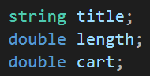

4.3 Appendix B:
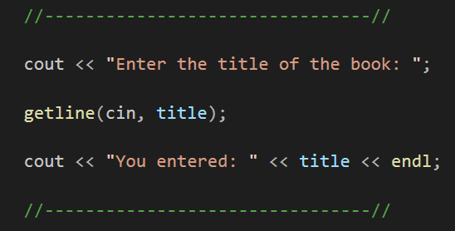

4.4 Appendix C:
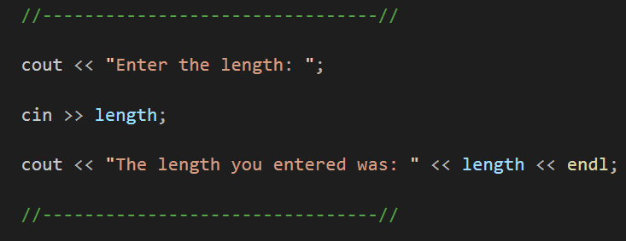

4.5 Appendix D:
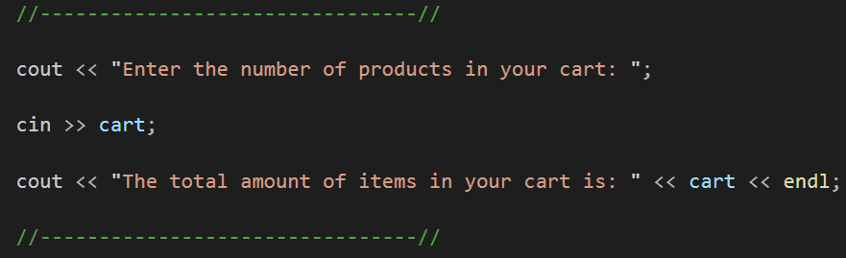
4.6 Appendix E:
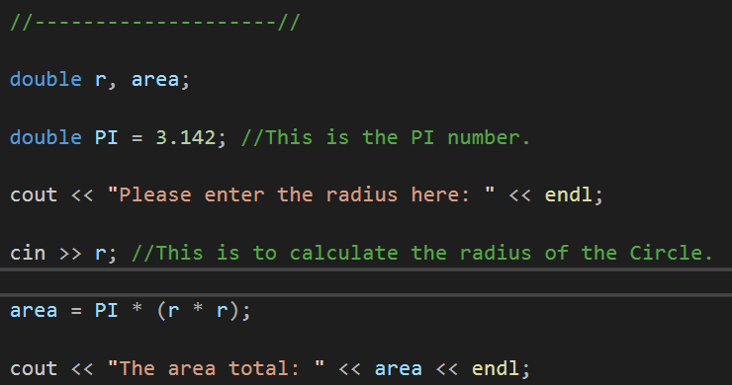

4.7 Appendix F:
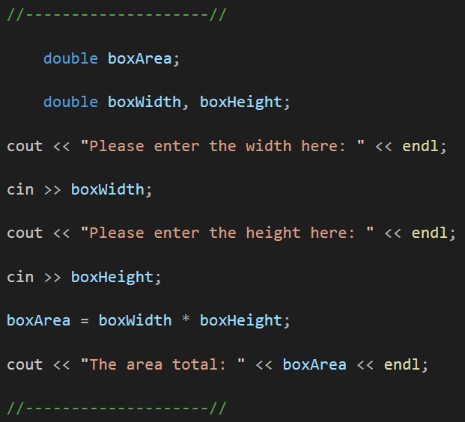

4.8 Appendix G:
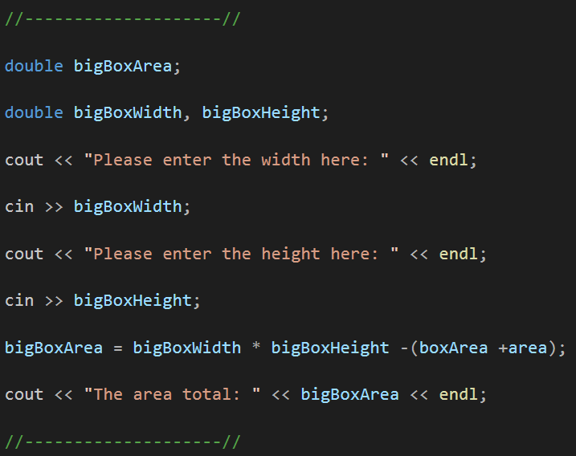

4.9 Appendix H:
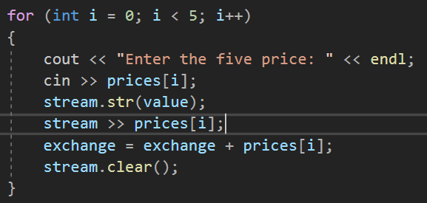

4.10 Appendix I:
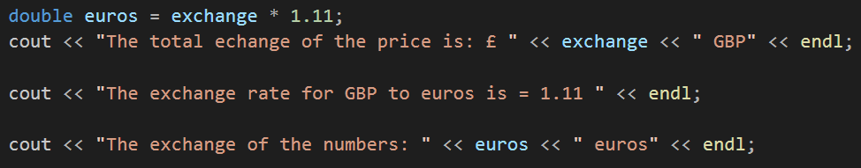

4.11 Appendix J:
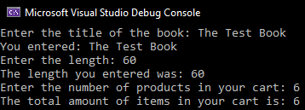

4.12 Appendix K:
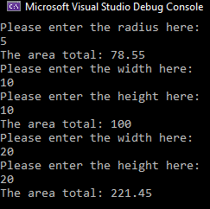

4.13 Appendix L:
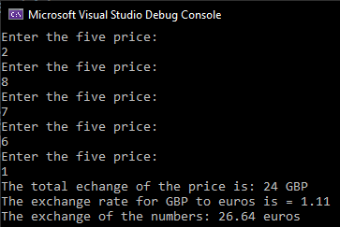

4.14 Appendix M:


