Advanced Stress Analysis & FEA

NDT Techniques

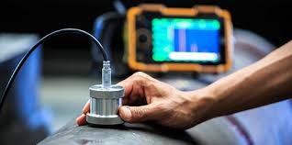
Matthew Parry
BEng Mechanical Engineering
P151377


Contents
Abstract 2
Introduction 3
Non-Destructive Testing vs Traditional Destructive testing methods 5
Acoustic Emission Testing 7
Principles of Acoustic Emission 7
Acoustic Emission Sensors 10
Advantages vs disadvantages 11
Applications 12
Ultrasonic testing 14
Pulse Echo Method 14
Pulse Transmission Method 16
Advantages vs disadvantages 16
Applications 17
Visual and Optical Testing 20
Principles of Visual and Optical Testing 20
Advantages vs disadvantages 21
Applications 22
Assumptions and Sources of Error 25
How NDT improve stress analysis 27
Conclusion 28
References 29

Abstract
This report looks at three non-destructive testing methods and discusses their impact on stress analysis. The assignment weighs up advantages and disadvantages of the three non-destructive test techniques and additionally discovers how their applications are being used in various industries to prevent failures which could have the potential to be catastrophic in nature. The report also explores the difference between non-destructive testing and destructive testing and draws conclusions between the two processes impact on stress analysis and how they can be used to help all industries better understand failure in materials and structures.

Introduction
NDT (Non-destructive testing) is a non-evasive technique that is used to analyse the functionality or integrity of a material or system (Blitz & Simpson, 1996). NDT has no obvious definite limitations. A visual inspection of a gear box, or a quick glance of a pump impeller is a form of NDT, as is the measurement of an ambiguous physical property such as Barkhausen noise (Halmshaw, 1991).
Initially there used to be five major methods of NDT which include radiographic, ultrasonic, magnetic, electrical, and penetrant. Though there are more recent methods such as acoustic emission methods, thermography, and holography (Halmshaw, 1991).
More recently there have been more specialised methods that have been investigated and found to have techniques in limited fields. These methods include proton annihilation, neutron scattering, proton radiography, microwaves, and nuclear magnetic resonance (Blitz & Simpson, 1996).
Much valuable data is obtained by carrying out standard tests such as tensile, shear, compression and impact properties of a material but these tests are destructive. Furthermore, the material properties in a standard destructive test will not always give a clear guide to the materials performance of a more complex and non-standard shaped component that would form part of a larger engineering assembly (Hull & Vernon, 1988). Defects of many types and sizes are born during the material or components manufacture and the extent and size of any defects will influence the following performance of the component. Further defects such as fatigue or corrosion could be produced within a material during its service. Therefore, it is crucial to have a reliable means for identifying the presence of defects at the manufacturing stage. But also, for identifying and monitoring the rate of progression of defects during the service life of a component or assembly (Hull & Vernon, 1988).
The first stage of an examination of any component or material is a visual inspection. However, a visual inspection is most likely not going to reveal much other than large defects that have developed through the surface. To carry out a true visual inspection a microscope can demonstrate what condition the materials surface is revealing (Halmshaw, 1991) (Hull & Vernon, 1988). Furthermore, optical inspection probes both rigid and flexible can be used to inspect internal surfaces, pipes, pumps, ducts and other more difficult to reach areas (Hull & Vernon, 1988).
Many methods of NDT have reached a stage where they can be used by a semi-skilled operative, following detailed technical directions, with safety measure built into the equipment. Microcomputers permit processes to be pre-programmed and validated, so that a competent operator does not need to know all the physics of the method being used (Halmshaw, 1991).

Non-Destructive Testing vs Traditional Destructive testing methods
Destructive testing is undertaken to understand a specimen’s performance or materials behaviour. Destructive testing methods include aggressive environment testing, corrosion testing, fracture and mechanical testing, fatigue testing, hydrogen testing, residual stress measurement. These procedures are carried out to test the specimen to failure which then reveals important structural analysis about the material. The results are then used to form part of engineering critical assessments and give designers the knowledge of the materials limitation so that it may be used correctly in its appropriate application (TWI, 2019).

Destructive testing is a reliable way to verifying the suitability of a material for its intended service. However, the destroyed material is no longer fit for service. Additionally, residual stresses can be measured using destructive testing methods. Destructive techniques such as drilling a hole or making an indentation can measure the dimensional changes in the material by using a strain gauge. Hooke’s law is then used to calculate the stresses from the measured strains. By their destructive character these can only be used in numerical quality management ideas (Campbell, 2015) (Mix, 2005).

NDT methods are preferred to destructive methods because the component or material is not destroyed. Nevertheless, NDT methods must be calibrated by using data from destructive techniques. It is essential to have reliable tests that do not involve destroying the material (Campbell, 2015) (TWI, 2019).

NDT evaluates the properties of a material, component, structure or system for characteristic differences, defects, and discontinuities without causing damage to the material. NDT can be used throughout all industry sectors including aerospace, transport, oil and gas, power generation and medical. The benefit of NDT vs traditional destructive testing is that it can be undertaken during production, post-production, in-service and following a repair. Also, NDT can be applied to both metallic and non-metallic materials such as polymer and composite components and structures. The result can provide test data as part of a fit for service report as well as a risk-based assessment inspection that can give the probability of failure of the material or component (TWI, 2019) (Mix, 2005) (Halmshaw, 1991) (Campbell, 2015).

Acoustic Emission Testing
Acoustic emission measurement is a system for detecting an elastic wave that is produced by the manifestation of microscale defects. Phenomena resulting from microscale defects can consequently be promptly detected by this application. Accidental failure of numerous types of structures, that result in disasters and injury to people have been caused by microscale defects in structural flaws and cracks of materials and structures (Enoki, et al., 2016).
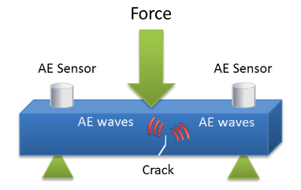
Figure 1. Acoustic emission wave generated in a solid material under stress (IDinspections, 2019)

Principles of Acoustic Emission
When an outside force is applied to a solid material, the material deforms. In the instance of a low stress due to a minute outside force, the deformed material elastically recovers to its initial shape upon unloading. This deformation is called elastic deformation. In the elastic range, the outside force leads to a build-up of energy inside the material known as strain energy. There is a limit for energy collection in the solid material. If the strain energy accumulated in the material due to the outside force reaches the limit, it is then released and results in plastic deformation. Even when the outside force is unloaded, the material will not return to its original shape (Enoki, et al., 2016).
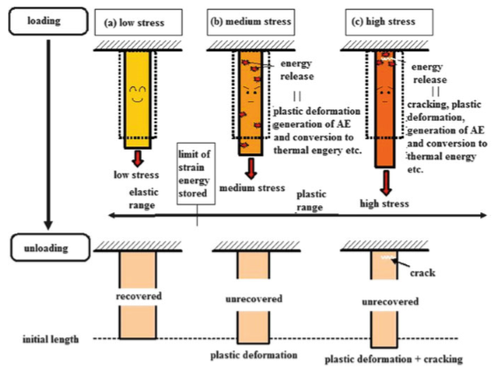
Figure 2. Generation of acoustic emission caused by strain energy release (Enoki, et al., 2016)

If an even larger outside force is applied, cracking would usually occur in the material. Owing to this the strain energy that has built-up inside the material is consumed by the generation and growth of cracks. Once the solid material is deformed or cracked, it consumes strain energy. Consequently, most of the strain energy is released. Simultaneously, the remaining is consumed to generate sound and heat. The sound that is released during this occurrence is referred to as acoustic emission, and it is sometimes referred to as the scream of a material under stress (Enoki, et al., 2016).
This phenomenon has the same principles and characteristics as an earthquake. This is because of cracking inside the material creates elastic waves that spread through the material. Hence acoustic emission has been referred to as a “mini-earthquake” in a solid material. The foundation mechanisms of acoustic emission phenomena as a comparison to an earthquake. A fault slip starts on a plate boundary between an oceanic plate and continental plate of the Earth’s crust. Consequently, a sliding failure or shear failure is created. However, acoustic emission phenomena can be referred to as cracks at the material surface (Enoki, et al., 2016).
A sliding or slip crack-motion relates to in-plane shear dislocation. Tensile dislocation is described to as opening dislocation (Enoki, et al., 2016). This is shown in FIG 3.
The fundamental difference between an earthquake and acoustic emission is the scale of defects and the connected frequency range. Earthquakes elastic wave frequencies are low and acoustic emission frequencies are high (Enoki, et al., 2016).
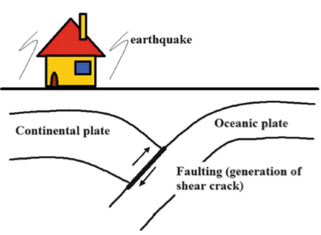
Figure 3. Overview of a plate earthquake (Enoki, et al., 2016)
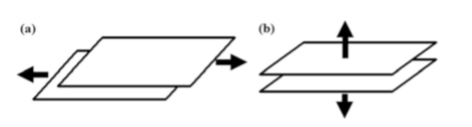
Figure 4. Types of crack actions at the surface. (a) In-plane shear dislocation. (b) Tensile dislocation. (Enoki, et al., 2016)

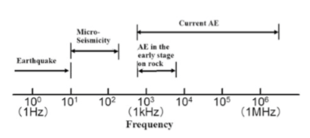
Figure 5. Frequency ranges of several elastic waves (Enoki, et al., 2016)

Acoustic emission is used as an NDT irrespective of the amount of strain energy that is released during the deformation and failure of materials and components. A material failure does not happen straightaway, and usually commences at microscopic level, leading to ﬁnal failure after the slow build-up of microscopic level cracks. Acoustic emission testing is a technique of observing and measuring this process up until the ﬁnal fracture. By detecting acoustic emission elastic waves during the early stages of the production and development of any crack we can stop ongoing operations and test materials to avoid crucial failure of the material, component or structure. Owing to this, Acoustic emission testing is an extremely vital NDT instrument (Enoki, et al., 2016).

Acoustic Emission Sensors
When an acoustic emission wave encroaches on to the surface of a test material and or application, very small movements of the surface molecules occur. A sensors function is to detect this mechanical movement and convert it into a specific, practical electric signal. Most sensors used in this form of NDT often utilise a piezoelectric transducer as the electrical to mechanical conversion devise (Miller & McIntire, 1987). The main considerations in sensor selection are
- Operating frequency.
- Sensitivity.
- Environmental and physical characteristics.
Nearly all modern acoustic emission systems are made up of a variety of amplifiers, hardware circuits and microcomputers. During the data recording the computer extracts the required data and translates it on to a graph or trend to allow the user to fully see and analyse the results (Miller & McIntire, 1987).

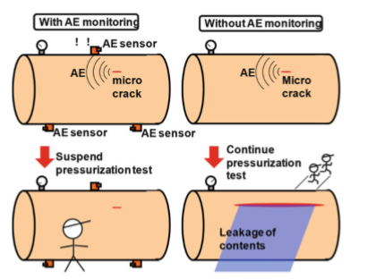
Figure 6. Acoustic emission sensor attached to a pressure vessel (Enoki, et al., 2016).

Advantages vs disadvantages

Advantages of Acoustic Emission Testing | Disadvantages of Acoustic Emission Testing
Acoustic emission sensors detect the source of developing damage in a loaded material (Grandt Jr, 2003). | There must be an applied stress or chemical action for emissions to occur. Owing to this stabilized damage is not detected (Grandt Jr, 2003).
Observing equipment is comparatively simple and reasonably inexpensive (Grandt Jr, 2003). | Not all damage will emit acoustic emissions, and the procedure is not applicable to all materials (Grandt Jr, 2003).
Acoustic emission waves can be observed in real time and recorded and stored for detailed analysis (Grandt Jr, 2003). | Although discontinuities can be located by acoustic emissions, crack sizes cannot be readily determined. Consequently, acoustic emission inspections are best used to supplement other NDT methods when damage size is required (Grandt Jr, 2003).
Acoustic emissions can detect internal discontinuities buried below the surface of materials (Grandt Jr, 2003). | While the acoustic emissions for each loading of the test object are unique, the method is not directly repeatable (Grandt Jr, 2003).
A comprehensive area coverage is feasible as the entire material can be observed at one time (Grandt Jr, 2003). | Electrical interference and ambient noise must be filtered for proper understanding of acoustic emission results (Grandt Jr, 2003).
Acoustic emission can be used for continuing material observation. Additionally, it can be used in harsh environments with remote sensing (Grandt Jr, 2003). | The lack of standard methods of data understanding has hindered development and acceptance of the method (Grandt Jr, 2003).
 | Numerous sound paths between the releasing damage and the sensor confuse signal identification in complex materials (Grandt Jr, 2003).
Table 1. Advantages and Disadvantages of Acoustic Emission Testing

Applications
Acoustic emission testing is an adaptable non-intrusive way to collect information about a material or structure. Acoustic emission testing can be applied to inspect and monitor pipelines, pressure vessels, storage tanks, bridges, aircraft, and a variety of composite and ceramic components (Enoki, et al., 2016).
Bridges contain countless welds, joints, connections. There are a combination of load and environmental factors such as corrosion that can seriously encourage damage processes such as fatigue cracking and metal thinning. Acoustic Emission testing is increasingly being used for bridge monitoring applications because it can constantly collect data and detect changes that may be detected. Furthermore, because this test is in real time and so non-intrusive the test can be carried out without the need for lane closures or a bridge shutdown (Enoki, et al., 2016).
Acoustic emission testing is also used in real time applications such as monitoring welding processes. During the welding process, temperature changes provoke stresses between the weld and the base metal. These stresses are often discharged by heat treating the weld. Despite this in some circumstances tempering the weld is not feasible resulting in minor cracking. Cracking can carry on for up to ten days after the weld has been finished (Enoki, et al., 2016).
Aerospace structures comprise of complex fabrications of components that have been designed to transport substantial loads. Many components can only tolerate a small amount of stress before becoming unserviceable. This makes discovery extremely important but components are often crammed closely together making access for examinations challenging. Acoustic emission testing can be used to monitor the condition of aerospace structures. This is achieved by installing sensors that can be attached to poorly accessible areas that are then remotely accessed. This data is then used to determine the life cycle of the component being tested (Enoki, et al., 2016) (Mix, 2005).

Ultrasonic testing
Ultrasonic waves are mechanical pulsations and have different wave lengths to that of electromagnetic radiation. Mechanical pulsations can be transmitted in liquids, gases, and solids. The particles of matter pulsate, and if the mechanical movements of the particles have regular flow the pulsations can be allocated a frequency in cycles per second, measured in hertz (Hz), where 1 Hz is 1 cycle per second. When the frequency is in the appropriate range of 10 to 20000 Hz, the sound is audible. However, if the range is above 20000Hz, the sound waves are represented as ultrasonic (Halmshaw, 1991) (Blitz & Simpson, 1996) (Mix, 2005).

Ultrasonic testing involves both directly and indirectly the measurement of time of transit of the pulsation including delay, path length, frequency, phase angle, amplitude, impedance and angle of the wave deflection. The system of measurements described above can either make use of pulsed and continuous waves. Pulse systems do however have the advantage of being able to offer promptly defined and accurately located reference points for transit times which can be detected on the display of a cathode-ray oscilloscope. They comprise of the pulse echo, and pulse transmission (Blitz & Simpson, 1996) (Halmshaw, 1991) (Mix, 2005).

Pulse Echo Method
The theory of this method is that an ultrasonic pulsed wave, usually in form of a damped oscillation, is produced by a transducer and transmits into a material with the ultrasonic velocity corresponding to the material being tested (Krautkramer & Krautkramer, 1990).

Some of the ultrasound will be reflected if it strikes an obstacle in the form of an inhomogeneity and, if this is not too large, the remainder will travel further to a boundary of the material and will be reflected to a receiver. The signal obtained from the test is displayed as a peak on a base line of a CR tube (Krautkramer & Krautkramer, 1990).

The horizontal sweep is proportional to the time, so that the transit times of the pulse to and from the reflector, and to and from the back wall, resemble respectively to the distances on the screen from the initial peak to the echo peaks conforming to reflector and back wall. To obtain an erect image the pulses and the sweep of the CR tube are coordinated at the pulse-repetition frequency (Krautkramer & Krautkramer, 1990).
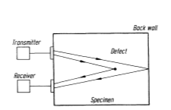
Figure 7. Principle of the pulse echo method (Krautkramer & Krautkramer, 1990)

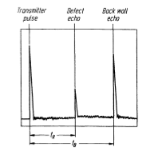
Figure 8. Results generated from test (Krautkramer & Krautkramer, 1990)

Pulse Transmission Method
The pulse transmission method uses two probes. The first probe is transmitting while the other is receiving the transmitted signal. They are in line with each other and positioned on opposite sides of the material being tested. The method involves observing the obtained peak and relating it to a standard, such as an electrical output signal from the transmission probe. This method is often used for testing highly weakened materials where the amplitude of any echo would be too low for any acceptable evaluation. It is useful for testing materials with uneven surfaces for which detected echoes are unclear but transmitted pluses would still contain useful information. Connection is achieved by submersing both samples and transducers into liquid. Alternatively, this can be achieved by applying jets of water (Blitz & Simpson, 1996).
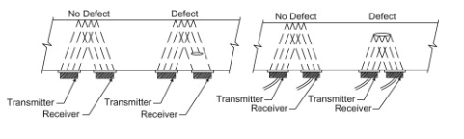
Figure 9. Pulse transmission method (Ebnesajjad & Landrock, 2015).

Advantages vs disadvantages

Advantages of Ultrasonic Testing | Disadvantages of Ultrasonic Testing
Both surfaces and subsurface irregularities may be detected in large dense materials (Grandt Jr, 2003). | At least one test surface must be available to the ultrasonic transducer (Grandt Jr, 2003)
An extensive choice of metallic and non-metallic materials and thicknesses may be examined (Grandt Jr, 2003). | Rough surfaces cause complications. Therefore, a gel is often used between the ultrasonic transducer and test object (Grandt Jr, 2003).
Detailed information may be obtained about fault size, orientation, and position. Specimen sizes and material properties can be measured (Grandt Jr, 2003). | Examinations are highly sensitive to the sound beam tight cracks may be difficult to detect (Grandt Jr, 2003).
There are a variety of methods for obtaining and producing the signal information that can be personalised to an application (Grandt Jr, 2003).  Transportable instrumentation is available for field level assessments (Grandt Jr, 2003). | A high level of skill and training are required to set up the equipment. Special knowledge is needed to interpret the results, increasing inspection costs (Grandt Jr, 2003).
Results are obtained in real time via electronic apparatus that may be adapted for automatic data recording that can be relayed on to graphs and trends for further analysis (Grandt Jr, 2003). | Although defect imaging is potential, these test processes can be fairly involved (Grandt Jr, 2003).
The method is sensitive to relatively small defects (Grandt Jr, 2003). | Special scanning systems may be required for inspecting large surface materials. Therefore, it may be unfeasible to inspect complex shapes (Grandt Jr, 2003).
Only single surface access is required (Grandt Jr, 2003).

Comparatively little part preparation is required. Surfaces do need to be cleaned of debris (Grandt Jr, 2003).

Table 2. Advantages and disadvantages of Ultrasonic testing

Applications
Ultrasonic techniques can be used to carry out the thickness of a material or component accurately. Digital display ultrasonic thickness gauges use the pulse echo method and do not require the same level of skill as a flaw detector. When the velocity of sound in a material is identified and the time of the ultrasonic pulse is measured, the thickness can be established. Thickness surveys can be aided with the use of data loggers. The results are then fed into a PLC system which interprets the results and displays the data as graphs and trends for operators and engineers to analyse. The ultrasonic measurement of a metals thickness is often used as a condition monitoring tool that can check for corrosion or erosion. The advantage of this is that internal corrosion of pipes and pressure vessels can be determined without internal access being necessary (Blitz & Simpson, 1996) (The British Institute of Non-destructive Testing, 2015) (Krautkramer & Krautkramer, 1990).

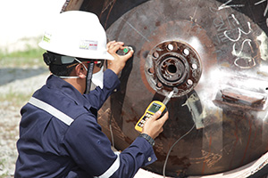
Figure 10. Ultrasonic testing of a components thickness (NUSATEK, 2019)

A further function of ultrasonic condition monitoring is live inspections that can detect cracks and crack propagation, including stress rupture cracks, thermal or mechanical fatigue cracks, stress corrosion and creep cracks. High-energy steam pipework and components such as steam valves are vital items in power stations and are subject to regular live inspection using ultrasonic methods. The failure of such components poses a significant health and safety risk, not including the commercial effect due to the loss of generation (Blitz & Simpson, 1996) (Krautkramer & Krautkramer, 1990) (The British Institute of Non-destructive Testing, 2015).
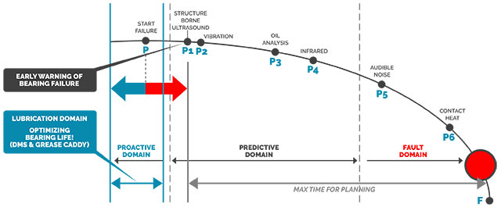
Figure 11. I-P-F curve of ultrasonic condition monitoring of bearing failure (Messer, 2017)

Microstructural irregularities such as cavitation due to hydrogen damage or creep in carbon steels, can be measured using the same measurement methods. These are specifically useful when combined with computer based ultrasonic imaging systems (Blitz & Simpson, 1996) (Krautkramer & Krautkramer, 1990) (The British Institute of Non-destructive Testing, 2015).

Stress measurement is a further purpose of ultrasonic inspection. The method is used to measure all velocity changes in a metal, which are produced by the occurrence of stress. An example of this applications is tensile loading of steel bolts and measuring residual stress in metal components (Blitz & Simpson, 1996) (Krautkramer & Krautkramer, 1990) (The British Institute of Non-destructive Testing, 2015).
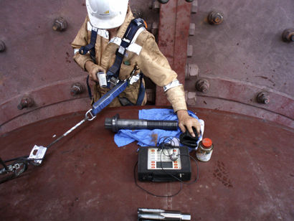
Figure 12. Ultrasonic stress measurement of steel bolts (Ritmindustry, 2019)

Visual and Optical Testing
Visual and optical inspection tests are one of the most necessary methods of NDT. Quality control inspectors follow techniques that range from simply looking at a part to see surface imperfections to implementing numerous gauging operations, which substantiate conformity with appropriate physical standards. Currently optical techniques can include special probes, spectrometers, and instantaneous imaging and analysis using notebook computers (Mix, 2005).

Principles of Visual and Optical Testing
Both aided and unaided visual inspection, and direct or remote are valuable NDT techniques. Visual assessment with suitable lighting is generally one of the first techniques employed for detecting suspected defect areas in materials and heavy equipment. Once discovered, the areas of significance can be more methodically examined and evaluated in detail. Ultimately there is still much to be learned by having the opportunity to look directly or remotely at the end of a heat exchanger or inside a large pressure vessel via an open manhole or inspection pot (Mix, 2005).

Physical measurements using micrometres and spring-loaded depth gauges can often afford inspectors with positive signs that corroborate eddy current and ultrasonic test results. The visual appearance and colour of a corroded pipe or pressure vessel can also provide useful understandings as to the cause and extent of corrosion, and ultimately assist in determining the remaining life of the test application (Mix, 2005).

All NDT methods are unique with their own advantages and disadvantages. Typically, visual inspections cannot be used to authenticate test results, nor can it be used to replace other NDT schemes. Nonetheless, when direct visual inspections cannot be made, complex optical instruments can often be used to deliver remote viewing of significant areas (Mix, 2005).

For castings, forgings, extrusions, and machined parts a methodical visual inspection is usually made after cleaning. For surface and subsurface defects, ultrasonic testing or a mixture of ultrasonic and eddy current testing can be used to test pipes (Mix, 2005).

Advantages vs disadvantages

Advantages of Visual Testing | Disadvantages of Visual Testing
Visual testing is a very straightforward but useful test to perform and often does not require high-priced equipment (The British Institute of Non-destructive Testing, 2015) (Grandt Jr, 2003). | Countless variables can lead to discontinuities being overlooked (The British Institute of Non-destructive Testing, 2015) (Grandt Jr, 2003).
Skilled operators and advanced equipment make it feasible for visual inspections to be very responsive (The British Institute of Non-destructive Testing, 2015) (Grandt Jr, 2003). | The process exclusively relies on the human accuracy and knowledge (The British Institute of Non-destructive Testing, 2015) (Grandt Jr, 2003).
Visual Inspection allows discontinuities to be physically seen and not be just a data on a screen (Grandt Jr, 2003) (The British Institute of Non-destructive Testing, 2015). | Some organisations do not focus their resources and give the operator the appropriate training (The British Institute of Non-destructive Testing, 2015) (Grandt Jr, 2003).
Numerous unusual surface fracturing discontinuities can be discovered (The British Institute of Non-destructive Testing, 2015) (Grandt Jr, 2003). | Sub surface discontinuities are not possible to be analysed (The British Institute of Non-destructive Testing, 2015) (Grandt Jr, 2003).
Virtually any structure can be inspected anywhere on its surface (The British Institute of Non-destructive Testing, 2015) (Grandt Jr, 2003).

Training and experience are relatively quick to gain (The British Institute of Non-destructive Testing, 2015) (Grandt Jr, 2003).

Table 3. Advantages and Disadvantages of Visual Inspection Testing

Applications
Video borescopes can be used for numerous applications that require remote visual testing. These include the aerospace and power generation industries, engine manufacturing and marine inspections. Video borescope techniques can be used to confirm disputed results of other NDT systems. For instance, an indication can be detected with ultrasonic inspection and then visualised with the video borescope. The main use of video borescopes is to permit several operators or engineers observe a screen at once. They are also very valuable for applications requiring a detailed assessment of measurements (The British Institute of Non-destructive Testing, 2015).
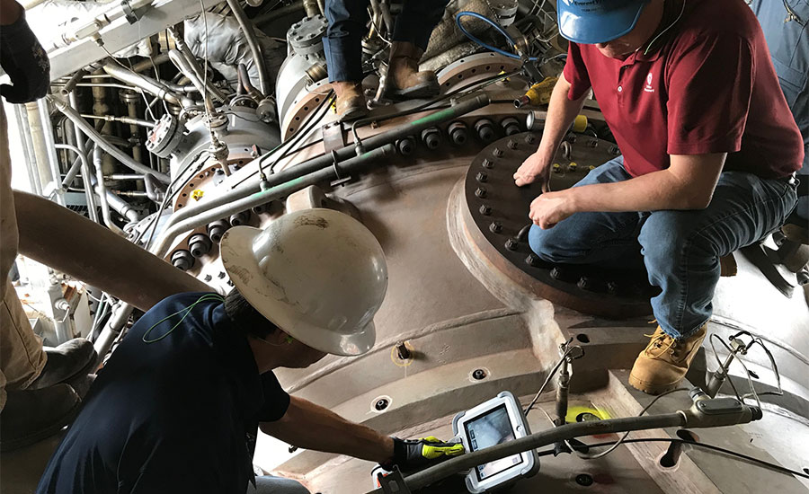
Figure 13. HD Video borescopes of a gas turbine (Fitzgerald, 2018)

A further significant area of visual inspection is in the aerospace industry. Remote visual inspection is completed on otherwise difficult to get to regions of the fuselage and engine of an aircraft. Operating problems such as fatigue cracks or corrosion can occur on aircraft integrity essential components such as pins joining the fuselage to the wings. Important visual inspections of hollow helicopter blades are carried out using video borescopes, in addition to the inner surfaces of jet engines and wings (The British Institute of Non-destructive Testing, 2015).
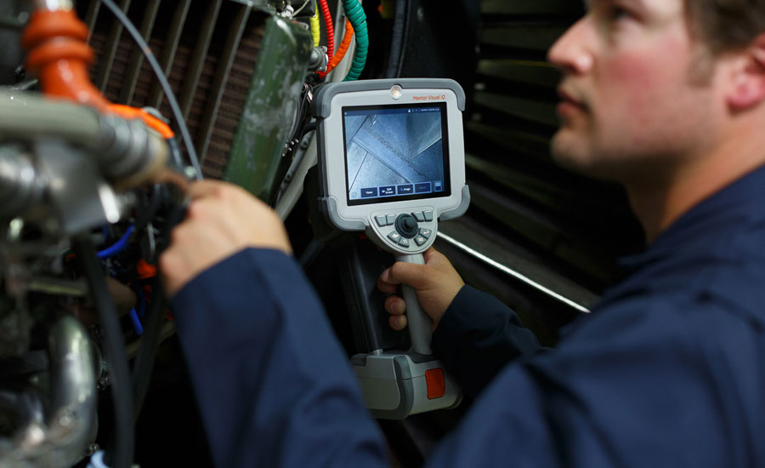
Figure 14. Technician performing visual NDT on an aircraft engine (McMenamin, 2015)

The chemical industry also relies on the use of visual inspection to test furnaces, combustion chambers, heat exchangers, pressure vessels and many other crucial areas within the process (The British Institute of Non-destructive Testing, 2015).
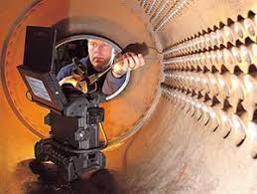
Figure 15. Visual NDT of a Heat Exchanger. (Olympus, 2019)

Remote inspection can be achieved in areas that would be hazardous to human operators. These include inside furnaces or high-radiation areas of nuclear power stations. During plant shutdowns meticulous use is made of visual testing to examination countless critical components under high-stress. (The British Institute of Non-destructive Testing, 2015).

Assumptions and Sources of Error
Source of error in NDT are usually born from human error. The eye is an amazingly complex instrument. However, it does not see everything. It is intended to focus light onto the retina, convert that light to nerve impulses and send them to the brain. The brain then manages this material and develops the images we see. However, what we thick see and what we physically see are not always the same, and this can be wholly dependent on a person’s own perception. People decipher incoming information from the eye in your own way. Therefore, we all see the same physical scene in a different manner (The British Institute of Non-destructive Testing, 2015).
The Müller-Lyer illusion below in FIG 9 makes evident the variation between perception and reality. The lines of the two arrows are the same length but look as if they are longer than one another. The difference of perception between two people heavily relies on the training, experience and the mental and physical state of the operator at the time the inspection is made (The British Institute of Non-destructive Testing, 2015).
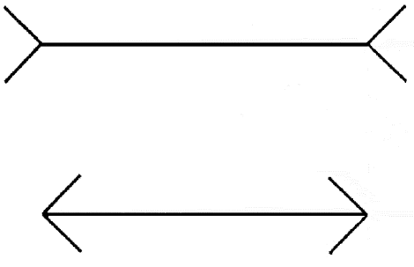
Figure 16. The Müller-Lyer illusion (The British Institute of Non-destructive Testing, 2015).

These should be used with caution, however, as the numeric information displayed does not allow a detailed interpretation of features such as laminations or inclusions, which could in turn lead to incorrect decisions being made.

Further assumptions and sources of error may possibly come from the level of training, and experience of the technician completing the test. NDT training consists of different levels of training which can only be completed after the technical has gain significant experience. The level starts at level one and continues to level three (IMechE Argyll Ruane , 2019).

How NDT improve stress analysis
NDT applications are used in a variety of functions in engineering. The use of NDT has provided further understanding of how defects form under certain loading conditions which can provide vital information to design engineers. This information can give an insight to the amount of stress applied to an application which can be transferred to different functions (Grandt Jr, 2003).
Both ultrasonic and acoustic emission testing provide information on how much residual stress are present after the applied load has been removed. This information gives an understanding of how much stress has been applied to the material and can be used to estimate the potential life cycle of a material. Though, this information is always referenced back to initial destructive testing analysis (Enoki, et al., 2016) (Blitz & Simpson, 1996).
FEA (Finite Element Analysis) is a modelling methodology that is used to explore the impact of stress effects on a material. The material is divided into a mesh containing a number of small elements. Equations are then solved for each element within the mesh, and the results are merged to calculate the behaviour of the material. FEA is used to predict displacement, mechanical stress, strains, heat transfer and fluid flow (The British Institute of Non-destructive testing , 2019).
NDT results can be used to verify and discuss FEA assumptions to see if the material properties from a FEA simulation have performed as expected. Also, by using FEA analysis at different stages of deformation could provide further signs or indications of when a failure may occur (Pedro, et al., 2016).

Conclusion
NDT is an indispensable mechanism that will continue to be used in all its applications. NDT has been used to reduce numerous possible disasters which could have had an immeasurable loss of life. As technology advances and more cutting-edge techniques are being developed, engineers and scientists have the opportunity to increase the safety records of all high-risk activities and process that much of society unknowingly depend on (Halmshaw, 1991).
NDT success is heavily reliant upon the results and research involved in destructive testing. Destructive testing analysis has provided NDT with the opportunity to examine materials to ensure that any defect that are found are discovered before they fail. NDT utilises the results from destructive testing to compare how a material under load is performing and if it is close to failure. Therefore, results from NDT processes such as acoustic emission and ultrasonic can only be analysed and understood by comparing destructive tests results that have previously been completed on a specimen material. The information gathered from the destructive test results at each stage prior to failure enables the analysis from NDT to be fully understood and used as a barrier to future failures and defects (The American Society for Non-destructive testing, 2019).

References
Anon., 2019. British Institute of Non-destructive Testing. [Online]
Available at: https://www.bindt.org/What-is-NDT/Index-of-acronyms/F/FEA/
[Accessed 31 10 2019].
Anon., 2019. StressTech. [Online]
Available at: https://www.stresstech.com/en/knowledge/articles/stresstech-bulletin-1-barkhausen-noise-analysis/
[Accessed 16 10 2019].
Blitz, J. & Simpson, G., 1996. Ultrasonic Methods of Non-destructive Testing. 1st ed. Cambridge: Chapman & Hall.
Campbell, J., 2015. Complete Casting Handbook. 2nd ed. London: Butterworth-Heinemann.
Deveci, M., 2019. Barkhausen Noise Analysis. [Online]
Available at: https://www.stresstech.com/en/knowledge/articles/stresstech-bulletin-1-barkhausen-noise-analysis/
[Accessed 29 10 2019].
Ebnesajjad, S. & Landrock, A. H., 2015. Adhesives Technology Handbook. 3rd ed. London: Elsevier.
Enoki, M. et al., 2016. Practical Acoustic Emission Testing. 1st ed. Tokyo: Springer.
Fitzgerald, P. C., 2018. Benefits of High Definition Video Borescopes. [Online]
Available at: https://www.qualitymag.com/articles/94883-benefits-of-high-definition-video-borescopes
[Accessed 31 10 2019].
Grandt Jr, A. F., 2003. Fundamentals of Structural Integrity. Damage tolerant design and non-destructive evaluation. 1st ed. New Jersey: Wiley.
Halmshaw, R., 1991. Non-destructive Testing. 2nd ed. Kent: Edward Arnold.
Hull, B. & Vernon, J., 1988. Non-destructive testing. 1st ed. London: Macmillan Education Ltd.
IDinspections, 2019. Introduction to Acoustic Emission. [Online]
Available at: http://www.idinspections.com/acoustic-emission-phenomenon/
[Accessed 31 10 2019].
IMechE Argyll Ruane , 2019. NDT Training. [Online]
Available at: https://argyllruane.imeche.org/course-category/ndt/
[Accessed 31 10 2019].
Krautkramer, J. & Krautkramer, H., 1990. The Pulse-Echo Method; Design and Perfomance of a Pulse-Echo Flaw Detector. 1st ed. Berlin: Springer.
McMenamin, E., 2015. Remote Visual Inspection: Video Borescopesto NDT Standards. [Online]
Available at: https://www.qualitymag.com/articles/92794-remote-visual-inspection-video-borescopesto-ndt-standards
[Accessed 31 10 2019].
Messer, A., 2017. Bearing Condition Monitoring Using Ultrasound. [Online]
Available at: https://www.maintworld.com/Cmms/Bearing-Condition-Monitoring-Using-Ultrasound
[Accessed 31 10 2019].
Miller, R. K. & McIntire, P., 1987. Non-Destructive Testing Handbook. 2nd ed. Columbus : American Society for Non-Destructive Testing.
Mix, P. E., 2005. Introduction to Nondestructive Testing A training Guide. 2nd ed. New Jersey: John Wiley & Sons .
NUSATEK, 2019. Ultrasonic Thickness Measurement. [Online]
Available at: http://www.nusatek.com/conventional-ndt/ultrasonic-testing/ultrasonic-thickness-measurement.html
[Accessed 31 10 2019].
Olympus, 2019. Videoscope Inspection of Heat Exchangers. [Online]
Available at: https://www.olympus-ims.com/en/applications/videoscope-inspection-of-heat-exchangers/
[Accessed 31 10 2019].
Pedro, F., Papaelias, M. & Zaman, N., 2016. Non-Destructive testing. 1st ed. Rijeka: Intech Open.
Ritmindustry, 2019. Ultrasonic bolt stress measurement device. [Online]
Available at: http://ritmindustry.com/catalog/other-material-characterization-instruments/ultrasonic-bolt-stress-measurement-device-2/
[Accessed 31 10 2019].
Taylor, T. & Nockemann, C., 1999. Summary of American-European Workshop on NDE Reliability. In: American-European Workshop on Non-destructive Inspection Reliability. Columbus: The American Society for Nondestructive Testing, pp. 7-8.
The American Society for Non-destructive testing, 2019. Introduction to Nondestructive Testing. [Online]
Available at: https://www.asnt.org/MinorSiteSections/AboutASNT/Intro-to-NDT
[Accessed 29 10 2019].
The British Institute of Non-destructive testing , 2019. What is NDT. [Online]
Available at: https://www.bindt.org/What-is-NDT/
[Accessed 29 10 2019].
The British Institute of Non-destructive Testing, 2015. Non-Destructive Testing (NDT) –. [Online]
Available at: https://www.bindt.org/admin/Downloads/Apprenticeship-Guidance-Document.pdf
[Accessed 2019 10 2019].
TWI , 2019. Non-Destructive Testing. [Online]
Available at: https://www.twi-global.com/what-we-do/services-and-support/asset-management/non-destructive-testing
[Accessed 19 October 2019].
TWI, 2019. What is destructive testing? - Methods, definition and examples. [Online]
Available at: https://www.twi-global.com/technical-knowledge/faqs/what-is-destructive-testing
[Accessed 19 October 2019].

Table 1. Advantages and Disadvantages of Acoustic Emission Testing 12
Table 2. Advantages and disadvantages of Ultrasonic testing 17
Table 3. Advantages and Disadvantages of Visual Inspection Testing 22

Figure 1. Acoustic emission wave generated in a solid material under stress (IDinspections, 2019) 7
Figure 2. Generation of acoustic emission caused by strain energy release (Enoki, et al., 2016) 8
Figure 3. Overview of a plate earthquake (Enoki, et al., 2016) 9
Figure 4. Types of crack actions at the surface. (a) In-plane shear dislocation. (b) Tensile dislocation. (Enoki, et al., 2016) 9
Figure 5. Frequency ranges of several elastic waves (Enoki, et al., 2016) 9
Figure 6. Acoustic emission sensor attached to a pressure vessel (Enoki, et al., 2016). 11
Figure 7. Principle of the pulse echo method (Krautkramer & Krautkramer, 1990) 15
Figure 8. Results generated from test (Krautkramer & Krautkramer, 1990) 15
Figure 9. Pulse transmission method (Ebnesajjad & Landrock, 2015). 16
Figure 10. Ultrasonic testing of a components thickness (NUSATEK, 2019) 18
Figure 11. I-P-F curve of ultrasonic condition monitoring of bearing failure (Messer, 2017) 18
Figure 12. Ultrasonic stress measurement of steel bolts (Ritmindustry, 2019) 19
Figure 13. HD Video borescopes of a gas turbine (Fitzgerald, 2018) 22
Figure 14. Technician performing visual NDT on an aircraft engine (McMenamin, 2015) 23
Figure 15. Visual NDT of a Heat Exchanger. (Olympus, 2019) 23
Figure 16. The Müller-Lyer illusion (The British Institute of Non-destructive Testing, 2015). 25

