Jacob Evans
2311160@student.uwtsd.ac.uk
Screenshots of the demonstration scripts.
ACCA5023-
Network Operating Systems and Service
Assignment PART 2
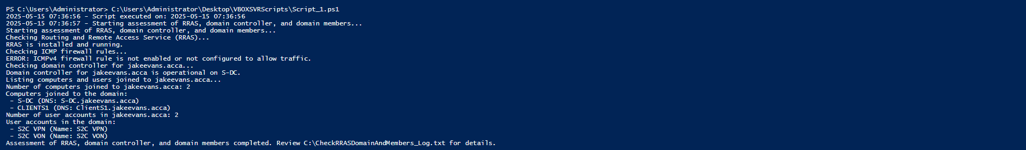
Script 1 Ran

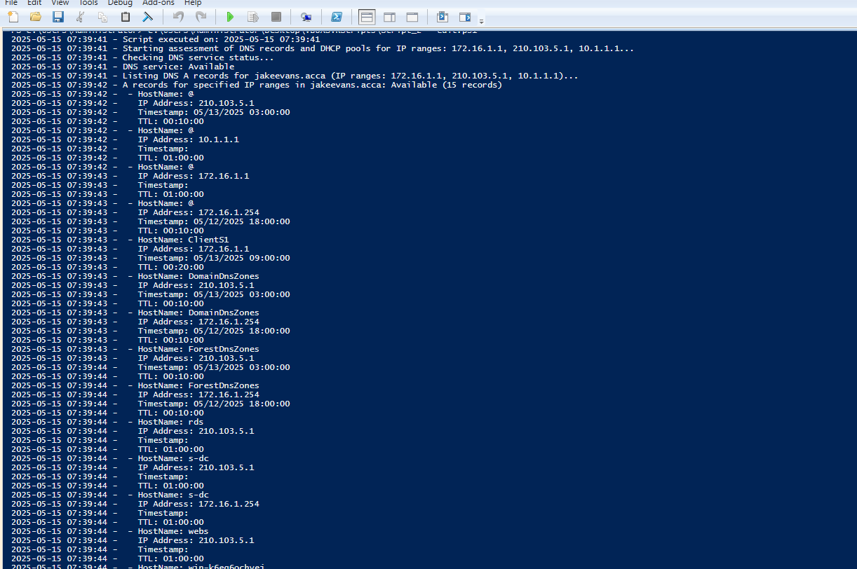
Script 2 – Part 1
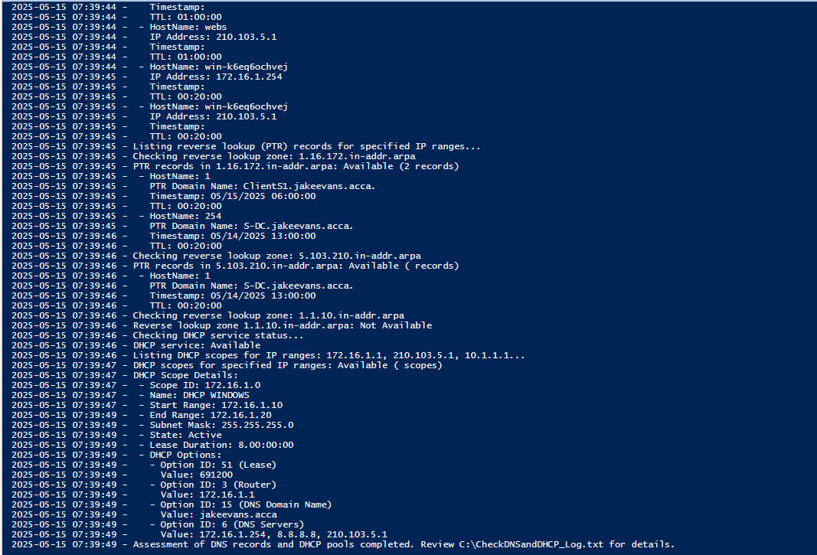
Sc
Script 2 – Part 2

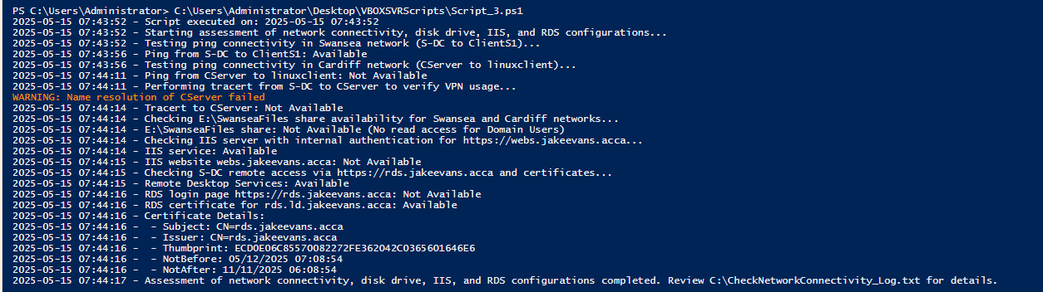
Script 3
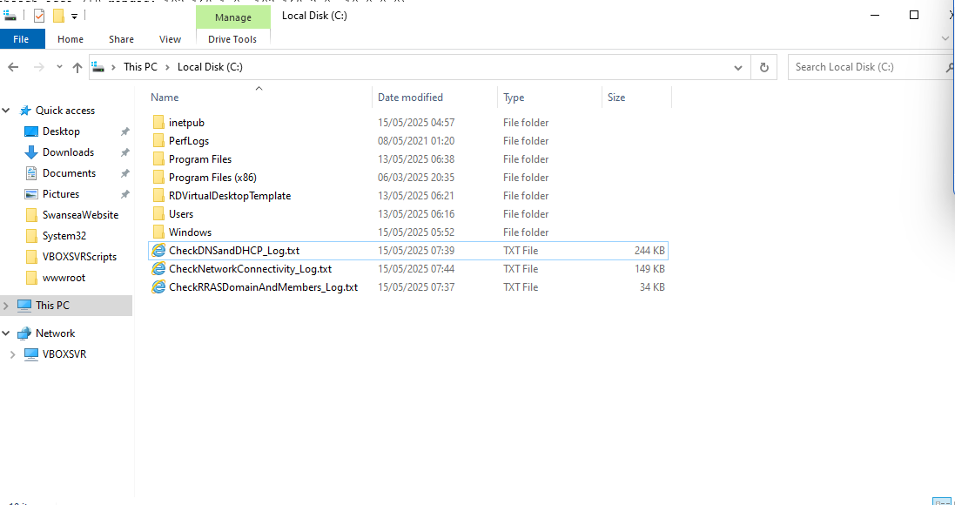
Screenshot of logs

