

A Study of Protocols to Enable and Secure Communications at the Network Edge in Restrictive Network Locations

by
Cameron Paul Fitze

Supervisor: Dr. Stephen Mosely
Second Marker: Jenifer Prince

Project submitted as part of the requirements for the award of (BEng Hons) Embedded Electronics Systems Engineering

DECLARATION

I, Cameron Paul Fitze, declare that I am the sole author of this Project; that all references cited have been consulted; that I have conducted all work of which this is a record, and that the finished work lies within the prescribed word limits.

This work has not previously been accepted as part of any other degree submission.

FORM OF CONSENT

I, Cameron Paul Fitze, hereby consent that my Project, submitted in candidature for the degree, BEng Hons Embedded Electronics Systems Engineering, if successful, may be made available for inter-library loan or photocopying (subject to the law of copyright), and that the title and abstract may be made available to outside organisations.

((BEng Hons) Embedded Electronics Systems Engineering)

Abstract

This report aims to identify and test protocol obfuscation methods in order to enable covert communications or obfuscated use of a protocol that is not permitted by network and firewall policies. The objective is to identify or develop and test a protocol using network simulator software, Network Simulator 3 (NS3), and observe on the terminal logs whether a layer of obfuscation has been achieved, or whether a chat message can be passed through an unbenign protocol (such as those described in the next paragraph).
An initially investigation into the Open Standards Interconnect (OSI) model revealed that there is not just one layer of the stack to concentrate on. Therefore, this investigation was conducted in order to focus efforts within the layers that are most likely to contain protocol that will facilitate the delivery of the desired outcomes for this research. This resulted in focusing on the network layer and transport layer. The network layer protocol of interest being Internet Control Message Protocol (ICMP) and the main transport layer protocols of interest being User Datagram Protocol (UDP) and Transport Layer Protocol (TCP).
Extensive research into ICMP and UDP discovered a variety of enhanced versions of these protocols that aim to offer covert communications such as ICMP tunneling, and obfuscated methods such as obfsTCP, and even ubiquitously used methods such as Quick UDP Internet Connections (QUIC).
The major findings within this research were that UDP and ICMP are easy protocol to recognise using the terminal logs, with the protocol, IP addressing information, and port numbers all visible. This will ensure network operators and firewalls can easily identify and implement any blocking policies.
Thereby proving the requirement for a more obfuscated method. Initial methods of adding ICMP header information to UDP payloads although compiled, did not give enough information to make a conclusion. The alternative method, to enable ICMP tunneling, involves extensive socket coding, which includes code for the server, client and main, to all work in unison to simply carry an obfuscated message. Within the NS3 environment, there were extra steps to ensure this ran.
Using a network simulator, such as NS3, is a good way to enable a test environment where testing of development protocol can ensue without risk of harm to real-world networks and device. Covert communications using ICMP tunneling is possible, but requires extensive coding, and obfuscation of protocol using UDP, TCP and ICMP is theoretically possible, and compiled successfully in this research, but was difficult to determine whether it actually achieved the desired outcomes.
Further research should continue to develop the code for covert communications using ICMP tunneling first, test it within the NS3 environment, then use a research test bed in order to test with firewalls, in an air gapped network, to avoid conflicts on real-world networks and third-party devices.

Table of Contents
1. Introduction 9
1.1. Problem statement 9
1.2. Existing solutions 9
1.3. Aim 10
1.4. Objectives 10
1.5. Objectives 10
2. Research and Literature Review 12
2.1. Existing work 12
2.1.1. Network Layer 12
2.1.1.1. Network Layer obfuscation techniques: 13
2.1.2. Transport Layer 13
2.1.3. Application Layer 16
2.2. Standards/Guidelines 17
2.2.1. Standards 17
2.2.2. Guidelines 17
3. Research and Development Methodology 19
3.1. Philosophy 19
3.2. Approach 19
3.3. Strategies 19
3.4. Hypothesis 19
4. Software 20
5. Design & Implementation 22
5.1. Requirements 22
5.2. Hardware, materials, and tools 22
5.3. Use case 23
5.4. Explain any system models that you have created to describe the system 23
5.4.1. NS3 system model 23
5.4.2. Creating a module 24
6. Testing 27
6.1. Phase 1: Unit testing 27
6.2. Phase 2: System testing 29
6.2.1. ICMP and UDP benchmark testing 30
6.3. Phase 3: Usability testing 36
6.4. Phase 4: Acceptance testing 36
7. Testing Analysis 37
7.1. Analysis of UDP 37
7.2. Analysis of ICMP 37
7.3. Analysis of Obfuscation of UDP within ICMP protocol 37
7.4. Analysis of QUIC in Wireshark 38
8. Conclusions 40
9. Recommendations 41
10. Reflection 42
10.1. Introduction 42
10.2. Skills developed 42
10.3. Learning curves 42
10.4. Proposed improvements 43
10.5. Reflections Conclusion 43
References 44

Table of Figures
Figure 1 - UDP connection 14
Figure 2 - TCP connection 14
Figure 3 - NS3 Model Architecture (Amewuda, Katsriku, & Abdulai, 2018) 21
Figure 4 - NS3 high-level file structure 25
Figure 5 - NS3 "Ping-test.cc" code 26
Figure 6 – NS3 Test.py completion output 28
Figure 7 - Two-node network with IP stack output 29
Figure 8 - ICMP two node test 31
Figure 9 - ICMP test with packet loss 31
Figure 10 - UDP point-to-point test 1 32
Figure 11 - Ping in UDP Echo code snippet 34
Figure 12 - Terminal log showing result from Ping in UDP Echo Test 34
Figure 13 - UDP with data string 38
Figure 14 - QUIC protocol packet capture in Wireshark 39
Figure 15 -Wireshark capture with no Google Chrome running 39

Introduction
The internet is a vast network of interconnected networks that connect to each other. Computers, servers, routers, computers, and cables, connect to one another within a network, and are able to send data to one another. The internet connects these networks, which are spread across the globe [1]. This enables the transfer of data between networks (hence inter-net), which enables devices connected to the Internet, to acquire services and applications from other networks.
Connections across the internet enabled by a suite of protocols that facilitate an internet user’s requests for services and applications that are delivered across the internet. These protocols have been developed over time to meet evolving requirements including security and compute requirements such as data rate and latency (delay/ “lag”).
As protocols have evolved, so have threat actors. In order to provide security against threat actors, Internet service Providers (ISPs) and network managers have evolved their security policies. This results in protocols being continuously developed as they may not meet the security policies of ISPs and network managers, in response to threat actor activity, leaving protocols, or protocol version that were once widely permitted, redundant. If an application or service, such as a website, have not update their protocols, then a network that is used to access that website may not permit its’ users to do so. Alternatively, if a website has updated its protocols or security policy, and an end user is using a protocol that is no longer permitted by that website, they will also be denied access.
This introductory section further delves into the problem statement, describes existing solutions, and outlines the aims and objectives of this research.

Problem statement
Networks managers and ISPs enact network security policies to protect their networks from malicious activity, but also against protocols that they do not permit. This could be for a variety of reasons.
Firstly, some locations can be restricted by local network infrastructure, which may limit their ability to host such protocols or applications that those protocols request, leading to a limited number of permitted protocols on any particular third-party Wireless Area Network (WAN).
These issues can result in end users losing the ability to accessing particular services or applications that they desire because of the ISP or local network’s policies, which will essentially block access to these services and applications, such as HyperText Transfer Protocol Secure (HTTPS), which is used for most internet activity such as accessing Netflix.

Existing solutions
Virtual Private Networks (VPN) have historically been a solution to this as they encrypt the data, thus the application is hidden from view. However, VPNs are increasingly blocked in certain locales, and Wide-area networks (WANs), leading to the requirement for a different approach to VPN-like networking over third-party networks.
Additionally, VPNs have some specific issues that this research aims to investigate. VPNs can be observed by a network analyser, and this research aims to research the validity of protocols that are obfuscated, so that a network analyser cannot identify them. Although VPNs can use proxy and thus afford a layer of obfuscation that way, this research is focused on light-weight protocols that can be implemented and illustrated on a two node point-to-point network. Introducing VPNs and VPN proxies complicates the network topology to an extent that is not in scope for this research.

Aim
This research aims to create a solution to enable the requirement for a communications protocol to operate in an obfuscated manor so that it can traverse ISPs, a variety of WANs, pass through firewalls, and access services with no issues. This aim could be particularly helpful for end users in locations with untrusted networks and restrictive network services policies, guided by ISPs or network policies.
This project looks to create and test a Network layer, Transport layer, or Application Layer protocol that can enable an end user to access a service or application over a network where it would usually be blocked due to the use of non-permitted protocols or using a VPN.

Objectives
The objectives of this research are as follows:
- Produce a literature study into existing obfuscation protocols.
- Test existing protocols using Network Simulator 3 (NS3).
- Determine the validity of these protocols against the aim of this research.
- Produce a custom obfuscated protocol if the existing protocols do not satisfy the aim of this research.
- Produce a brief on the applicability of using the NS3 environment to conduct this research.

Objectives
This report comprises of the following sections:
- Section 2: Research and Literature Review
- Section 3: Research and Development Methodology
- Section 4: Software
- Section 5: Design & Implementation
- Section 6: Testing
- Section 7:Testing Analysis
- Section 8: Conclusions
- Section 9: Recommendations
- Section 10: Reflection

Research and Literature Review
This section describes the background research that was conducted to lay the foundations for this research. It comprises of the following sections:
- 2.1. Existing Work (see section 2.1)
- 2.2. Standards and Guidelines (see section 2.2)

Existing work
It is necessary to understand the basics of protocols within the Open Standards Interconnect (OSI) Stack in order to lay the foundations for this research.
Before exploring OSI protocols, it is relevant to explain the connection types that are associated with most of these protocols.
The first is connectionless. This is where a protocol does not require receipt of a connection, e.g. a response to a request, in order to send data.
The second is connection orientated. This is where a protocol requires receipt of a connection, for examples, a response to a request, before sending the data.

Network Layer
Communications networks come in the form of Local Area Networks (LANs) and Wide-Area Networks (WANs). LANs are networks that do not connect with another LAN, and generally operate at Layer 2, with devices able to connect to one another via a switch. Connecting a LAN to another network such as the Internet requires a WAN. This elevates the network to Layer 3, as routing is required to transmit data from a device in the LAN to its intended destination. The data is formatted for transit as part of the payload within a packet. A packet is the format for which information is exchanged at the network layer. The packet contains the source and destination Internet Protocol (IP) address’.
When a packet transits from the source device, it is allocated a private IP address from the router. When it reaches the router, its private IP is mapped to a public IP through a process called Network Address Translation (NAT). It is at this stage that a tunnel is created for a VPN connection if that is being used.
The VPN obfuscates the underlying protocols and data being transmitted during the VPN session, from the point when the client and the VPN server exchange to the destination of the VPN tunnel. However, the VPN protocol will use other protocols, such as TCP, to build the tunnel. These protocols have port numbers associated with them, and thus, the analyser can reverse engineer and deduce what type of VPN protocol is being used based on the port allocation.
Examples of VPN protocols and their associated port numbers include [2]:
- OpenVPN (UDP) = 1194
- OpenVPN (TCP) = 443
This knowledge of VPN port numbers and protocol associations ensures that Internet Service Providers (ISOs) and network managers are able to target these specific ports in their network policies or firewall policies regarding traffic/ port blocking.
A potential work around to this is by utilizing an existing protocol, that is not a VPN, that data can be wrapped up in to afford a layer of obfuscation.

Network Layer obfuscation techniques:
Existing network-layer protocols that could be leveraged for obfuscation of data or protocols include:
- Internet Control Message Protocol (ICMP)
ICMP is a connectionless protocol that is used to test a network connection. It reports back with IP address information and network latency statistics. If a network is not reachable, then the Ping simply fails. It is not designed to carry data like other network protocols. However, it is possible to leverage ICMP for obfuscation of data, by manipulating the packet payload to encode your desired data to transmit. This will be practically evaluated in section 6.
ICMP has also been used for a basis of testing obfuscated and covert communications for many years. One example of this is ICMP being used as a protocol to enable a covert channel for file and message transfer, using a modified version of the File Transfer Protocol (FTP), called Hidden FTP (HFTP). This essentially offers a hidden message service for users simply using ICMP [3].
This method is a preferable method as it is light weight, which is part of the requirements of this research (see section 5.1 for requirements).

Juniper:
Juniper’s 128T software-defined WAN (SD-WAN) solution uses a NATing method (network layer) in order to achieve VPN abilities without any tunneling architecture. This comprises of manipulating the meta data in a way that enables the data to transit over the WAN without revealing the data or protocols used to that WAN. The destination router is able to repackage the data as an “instruction set” is added to the packet header, which tells the destination router how to repackage the data. This covers the area of packet design and NATing, under the network layer [4].

Transport Layer
Then, the packet needs a Transport Layer protocol. These include Transmission Control Protocol (TCP), a connection-orientated protocol, and User Datagram Protocol (UDP), a connectionless protocol. Both protocols use different methods to ensure packet delivery to its destination: UDP uses “fire-and-forget”, whereas TCP requires a response from the destination before securing the connection to send the data. Transport Layer protocols can be blocked at firewalls, due to port blocking or firewall security policies.
Figure 1 shows the UDP Request/ Response activity. As shown, there is simply a Request sent from the client to the server, and no acknowledgements or syncing is required as per the TCP protocol.
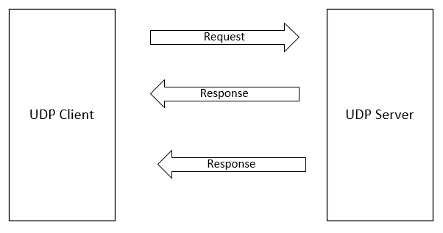
Figure 1 - UDP connection
Figure 2 shows a TCP connection. A shown, there are extra steps involved before data can be sent. There is the initial Synchronise (SYN) from the first node to the second, then the second responds to the SYN with an acknowledgment (ACK), to which the first node then responds with its own ACK.
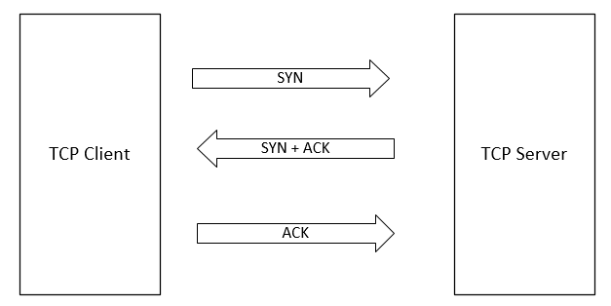
Figure 2 - TCP connection
Firewall security policies can block a specific Protocol, or they will block enact port blocking on a port that is associated with that protocol, for instance, TCP uses port 443.
An existing protocol will have to either be universally accepted, or obfuscated so that a network packet analyser will be unable to decipher the protocol being used based on the port, or associate that port with another protocol that is not the actual protocol being used, and therefore, unknowingly permit the protocol being obfuscated.

Transport Layer obfuscation techniques
Existing Transport-layer protocols that could be leveraged for obfuscation of data/ protocols include:
- Quick UDP Internet Connections (QUIC)
- TCP with crypt++ (tcpcrypt)
- ObsTCP (obfuscated TCP)

QUIC
QUIC is a Transport Layer protocol that forms part of HTTP/3, replacing TCP, as used in HHTP/1 and HTTP/2. QUIC is connectionless, as it is based on UDP, but employs extra methods to ensure packet delivery, such as forward-error-correction (FEC). This is particularly optimal in ensuring successful packet delivery in subpar channel conditions.
The principal aim of QUIC was to reduce the latency caused when a device returns to the server, so that there is zero round trip time (0-RTT). Resuming connections can then send data or requests without requiring a response from the first request. To a user who may be revisiting a recently opened web page this allows the webpage to load quicker as delays in the response time have been removed. Although, if a user contacts a server unfamiliar with the connection, it will require a TCP or QUIC handshake to take place. Once that handshake has taken place, and the server and client are able to use 0-RTT. Then the second request will take advantage of 0-RTT.
The Transport Layer protocol QUIC uses the Application Layer protocol HTTP/3. HTTP requests can be blocked by firewall policy, but also by way of its design.
HTTP/1 uses one data stream per TCP connection.
HTTP/2 built on this by enabling multiple data streams per TCP connection at the Application Layer. This increases the efficiency of the protocol, but did have one main issue: as one connection handles multiple streams, if one stream has an error, then all get blocked, which lead to Head-of-line blocking.
HTTP/3, which is what QUIC uses, has multiple data streams, like HTTP/2, but per UDP connection at Transport layer (not TCP connection as in HTTP/2). Security
Compared to HTTP/2 and TCP, HTTP/3 ensures more of the packet header is encrypted and thus offers more security against the underly networks, which may want to restrict access to the services/applications required. The parts of the packet that are unencrypted are protected by receiver authentication, so it can therefore be determined that QUIC offers a high level of obfuscation of the packet data and protocols being used.
As QUIC uses UDP, firewalls may have difficulty determining whether a packet is using the QUIC protocol or an unwanted or malicious UDP packet. Packet analysers, such as Wireshark, can determine the difference between QUIC and UDP, but only if the QUIC packets are originating from known ports ( usually port 80 and port 433), and if the Wireshark session captured the QUIC handshake when the connect was opened. Legacy network devices may be unable to make this determination and therefore block all UDP/QUIC traffic expect on port 53, which is used for Domain name server (DNS).
Firewalls will be able to inspect some header information if present for the handshake or has access to the application layer SSH Keys.

obsTCP
obsTCP was developed by google in the early 2000s but was never officially released. It was based on the principle of adding security to TCP connections. This was proposed by adding encryption to the TCP layer, specifically opportunistic encryption. Opportunistic encryption encrypts wherever possible, but tiers down toward unencrypted if encryption is not possible. This method prioiritises a reliable connection of the security of the encryption, which aligns with the aims of this research – the chance of a connection being blocked is more of a focus than having the information within the payload decrypted, for the purpose of this research.
A more modern example of opportunistic encryption is opportunistic TLS. This continually attempts to encrypt connections with the most secure TLS Cipher, before tiering down the TLS Cipher list until a connection is established [5].
ObstTCP never released, and appears to be archived as a nascent proposal within google rather than gaining any real traction. Despite this, it did elevate attention to the issues surrounding Internet Service Provider (ISP) restrictions at an early stage. It was during this time, the mid 2000s, that VPNs became available to private users, and as such, there will have been thought into alternative methods to rival that roll out.

tcpCrypt
Tcpcrypt is another transport layer protocol that proposes enhanced security via opportunistic encryption. It has an allocation with the IETF, RFC 8548, “Crpytographic Protection of TCP Streams (tcpcrypt)” [6].

Application Layer
These are used by Application Layer protocols. These include Hyper Text Transfer Protocol (HTTP), which is the standard format for transfer of data across the internet. An example of an application being blocked by the network is a website using HTTP instead of HTTP Secure (HTTPS).

Application Layer obfuscation techniques
Existing Application Layer protocols that could be leveraged for obfuscation of data/ protocols include:
- HTTPS - specifically using HTTP/2 to obfuscate HTTPS traffic
Various methods exist to potentially modify HTTPS in order to afford a layer of obfuscation. These could include:
- Dynamic port allocation
Dynamic port allocation would ensure that it is difficult for a network analyser to track the network traffic compared to the protocol using the same port for all communications.

Standards/Guidelines

Standards
Standards are of significance when referring to internet protocols. One of the main ones in this area of consideration regarding protocols is Request for Comments (RFCs). RFCs are used to publish innovative networking/internet-related technologies to the Internet Engineering Task Force (IETF). For instance, IPV4 is defined within RFC 791. A protocol having an RFC allocation demonstrates that it has met minimum standards as stipulated by the IETF to be formally documented.
The IETF is the body that produces standards that are adopted by internet users, vendors, and network operators [7]. As they are standards of protocols that are voluntarily adopted, network manager, internet users, and vendors are under no obligation to implement them, therefore, a protocol having an RFC does not guarantee it will be permitted by a network host. They are merely proposals that can be adopted, and show that they have met a threshold to be published by the IETF. Therefore, if within an RFC is stated that it must be adopted, it cannot be assumed that it has been. This shows the importance of continuously assessing protocols and developing methods to enable those protocols, assuming they are required and another cannot be used for the service or application, as network managers may not adopt them or might actively block them.

Guidelines
Various guidelines exist to ensure that protocol architecture meets certain requirements to be considered for use by various stakeholders. Guidelines are not rubber stamps like standards are, however, if a protocol is built as per specific guidelines, it will likely be considered for standardisation.
The UK Government Communications Headquarters (GCHQ) National Cyber Security Centre (NCSC) outlines the following high-level principles for a network protocol design, which are[1]:
- Prioritise the use case
- Keep it simple
- Think about the bigger picture
The United States (US) National Security Agency (NSA) and National Institute for Technology Standards (NIST) provide relevant country-specific standards for protocol adoption in the US.
This research aims to investigate and evaluate existing protocols that either have an IETF, but it is not a necessity due to the nascency of this work. An experimental protocol satisfies the remit for this research as this will not be a solution that will be produced with intent to be used suddenly, rather to observe the validity of obfuscating protocols, and reporting on it.

Research and Development Methodology
This research will follow particular research philosophies, approaches and strategies, as outlined below.

Philosophy
This research will be pursuing the positivism route as the knowledge will be based on real world phenomena. Positivistic research tends to produce experiments and includes the development of software, which will be the output of this research.

Approach
It therefore prudent that this research will pursue deductive reasoning, that is, to start with a theory, then make predictions, and experiment and simulate, as per the Sherlock theory.

Strategies
Appropriate strategies for this research will be experimentation, software development, document review, and straying into case studies as well. This strategy builds on experimental and is typical of development projects, which is more aligned with this research than other research strategies.

Hypothesis
Based on the aims of this research and the research identified in the literature study, the hypothesis is:
Using or modifying existing lightweight and generally permitted protocols from the network or transport layers of the OSI stack, obfuscation of protocol used or covert communications using an unbenign protocol should be possible and proven using a software simulation environment.

Software
This research will be requiring the use of a personal laptop that is able to access the internet and have free use of hardware interfaces. This work is primarily a network simulation task. Simulation is the art of simulating network behaviours in a synthetic environment. This is slightly different to Emulation, which provides a synthetic environment for plugging in and testing actual hardware or networks. Simulation is required as the complex nature of modern computer networks makes analytical methods of assessing protocols somewhat redundant, with simulation providing a better platform for analysing realistic network scenarios for modern computer networks [8].
The laptop will be require to host the software Network Simulator (NS)3. NS3 is a discrete-event network simulator used for network research. A discrete-event network simulator is a simulator where the computer’s state changes only when event happens at a discrete point in time.
It is appropriate for this project as it is primarily designed for network research, and therefore, enables a more granular level analysis into network performance. NS3 varies from NS2 as it uses C++ for scripting, whereas NS2 uses Tool Command Language (TCL).
Figure 3 shows the NS3 model Architecture. As shown, there are the Applications at the top of the model, much like in the OSI model. The next stage down in the implementation of the Internet Protocol Stack, which gets installed onto nodes. The next stage down is the NetDevice, which connects the nodes toe an adapter, which connects them to a channel. At this stage the node from one side can connect with another, so long as it also has at least a NetDevice.
When simulating in NS3, every code has a NetDevice, Internet Stack, and Applications Implementation. This is discussed further in section 5.4.2.2.
Figure 3 - NS3 Model Architecture [9]

The NS3 software is regularly updated. The latest version in 3.44, however, some modules that were required for this research, such as QUIC, were built initially for NS3 3.32. The issue with this version is it requires Python 3.4.0 or less, whereas the latest python is 3.13.0 (the Ubuntu version for this research was using 3.12.0). Although, a pull request to GitHub was made to make QUIC for NS3 compatible with version NS-3.41, it was decided that using the latest version of NS3, at the expense of not practically evaluating QUIC was preferable as it would increase the efficacy of this research, using a later version with more enhanced features, and security.

Design & Implementation

Requirements
Building on the background research in section 2.2, which outlined NCSC’s Protocol Design Principles, this section will focus on the requirements for this specific protocol.
The requirements for this protocol are as follows:
- Must be lightweight – so it can work over bandwidth-restricted networks and provides optimum network performance (high throughput, low latency)
  - However, must have a large enough payload to receive services/ applications from a host.
- Must obfuscate the initial protocol required to be used, but the primary protocol might be visible, as that is to be expected by a packet analyser, network manager, or firewall.
- Must obfuscate the protocol required for the intended use (service or application).
- Must not use tunneling architectures (as these contradict the aims of point 1) – although tunneling can be used to describe the act embedding one protocol within another, this is not tunneling in the traditional sense, such as VPN.
- The primary protocol being used by be widely permitted by networks, services and applications, and by firewalls. The concept of protocol obfuscation can still be proved with a protocol that does not meet this requirement, but it will not solve anything if implemented on real-world networks due to its high chance of being blocked.

Hardware, materials, and tools
This project will be developed and demonstrated in the NS3 emulation environment. Therefore, the materials required are:
- Laptop running a Ubuntu 24.04.01 within a virtual machine (VM) using Oracle’s Virtual Box application
- Laptop will have free and open internet access to ensure unimpeded downloads of required software to run and build NS3 and any required addons.
As there is no manufacturing element to this project, no tools will be required.

Use case
The use case is to enable unrestricted communications from a location to a server to acquire services, applications, or simply a chat message, that would require protocols that may not be supported on that network.
Each service required for this network will use its own protocol that is dependent on the information being exchanged. For instance, a Netflix request is conducted by the HTTPS Transport Layer protocol.
This research investigates the validity of using the following:
- An alternative protocol to obfuscate the transport or network layer protocol that is required
- An alternative method to tunnelling to achieve the same aims as VPN
One of the issues that this research will investigate is the required protocols are not available for the service that is being requested, is there a technological solution to ensure that the service can be provided to the node requesting it using different protocols, which could be managed on the digital agent.

Explain any system models that you have created to describe the system
The system model for this project comprises of the following model:
- NS3 system model
These will be discussed in the following sub sections.

NS3 system model
The NS3 model architecture comprises of the following components [10]:
- Node – The computing device that is connected to a network and is represented by the class node.
- Application – The process that is executed to complete tasks as requested by an end user, such as HTTPS in order to complete the task of downloading a webpage. Within NS3, Application is represented by the class application.
- Channel – This is the Physical Layer medium that data transmits across between nodes, such as Ethernet, and is represented in NS3 by the class channel. An example channel is CsmaChannel
- Net Device – This is the piece of hardware that connects the computing device to a network, such as a Network Interface Card (NIC). In NS3, NICs are known as net devices (owed to the fact that software drivers control the network device)
- Topology Helpers – provides an efficient way for creating a network that requires carious connection of NS3 components such as NetDevices to Nodes, NetDevices to Channels, and IP address management. Topology helper essentially creates the NetDevice, assigns a MAC address, installs this onto a Node, configure the protocol stack, and finally connect the NetDevice to a channel component.
The next stage down in the model is the module itself. Within the code files, there are a number of “#include” statements. These list a number of scripts that provide most of the dependencies that may be needed when producing custom modules/ applications. All of the include files within the NS3/ directory and within the build/NS3/ directory.
Once these have all been confirmed, the project can be configured and built – explained further in section 6.

Creating a module

File structure
It is necessary to understand the NS3 file structure in order to be aware of where the custom code for this research will be hosted, along with the locations of the dependencies for the code.
Figure 4 shows the high-level file structure of the NS3 model. The subfolders seen will be described below.
NS3 protocol file projects are known as modules. To create a custom module, there is a wizard within NS3’s utils/ directory that produces the module file structure and all required file templates within the subdirectories of that module. The command to execute this wizard is:
“./utils/create-module.py <module name>”.
This command will create the necessary files ready for custom code. The files include Helper, Model, Test, Doc, and CMakeLists.txt.
The src folder contains the modules inherent with NS3, but custom modules can also be run from there. Within modules in the src folder, there is a CMakeLists.txt file and three subdirectories: helper, model, test.
When the “./ns3 compile” command is initiated, ns3 queriers each project folder within src, identifying what .cc and .h files make up that project. The CMakeLists.txt file tells the compiler what files are used in the project and the subdirectories they can be found.

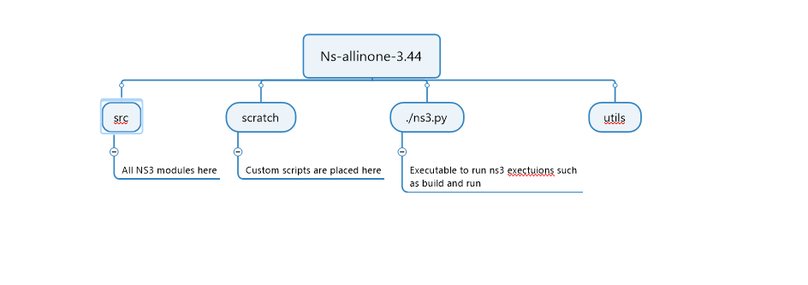
Figure 4 - NS3 high-level file structure

Code Structure
Interfaces within the NS3 code structure are used that use APIs to provide the C++ scripts within the NS3 environment with various abstract classes, available for the end user to instantiate custom code using those classes.
Next, the individual .cc and .h files need coding to implement the desired protocol that will be tested.
NS3 inherently has libraries full of source and header files that simulate a point-to-point network, with a protocol stack and ready to analyse. To enable aims of this research, these files can be modified to include custom code to implement the desired protocol for this research.
Figure 5 shows a code snippet from the NS3 “ping-test.cc” script. When executed, this script runs a simple 2 node ping test using the PingHelper class, which is used to implement ping applications. This outputs a simple ping echo and response to the terminal when executed within NS3, using the following command:
./ns3 run “ping-test.cc”
The code is explained further in this section.
To simulate a simple network with a protocol stack for analyses, the following steps are executed within the code:
- Build network topology with nodes (devices) [NodeContainer]
- Add the desired protocol stack to the devices [InternetStackHelper]
- Assign IP addresses to the devices [Ipv4AdressHelper]
- Add applications to generate traffic [ApplicationContainer]
Stage 1 is where the nodes (known as devices/ NetDevices in NS3 semantics) are instantiated from the NodeContainer class and added to a Channel, done by the PointToPointHelper class.
Stage 2 is where a protocol stack is installed onto each node. The internet stack is a typical one used as it contains TCP, UDP, IP, amongst other Internet protocols.
Stage 3 is where IP addresses are assigned to the nodes. Only one IP address needs to be stipulated as the code will incrementally add IP addresses there on to the rest of the nodes in the network.
Stage 4 adds applications to generate the traffic. This is done from the Application class ,which is also a module within the src/ directory of NS3.
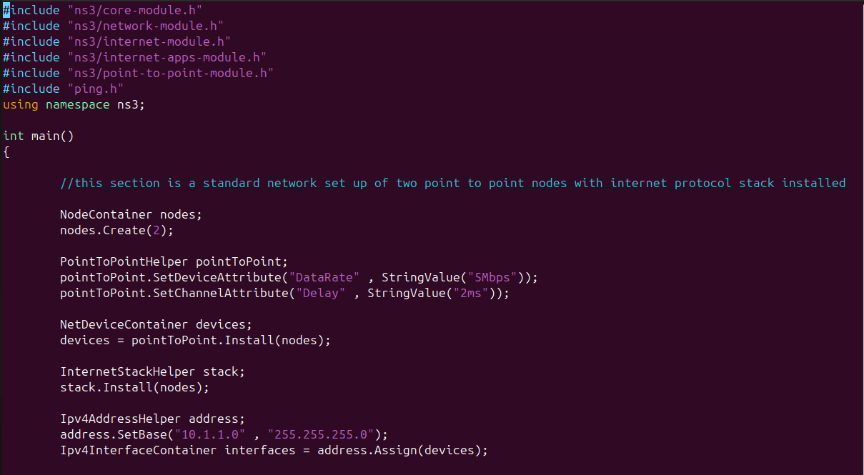
Figure 5 - NS3 "Ping-test.cc" code
As NS3 is a discrete-event simulator, it relies on events associated with an execution time to run throughout the life of the simulation. Once it has run all executions against their allotted time within the simulation, it should stop running.
Standard practice with running custom scripts is to allocate them to the scratch/ directory, and run them from there.

Testing
The testing phase comprised of the following phases:
- Phase 1: Unit testing (do the individual bits of code work?)
- Phase 2: System testing (does the system as a whole work?)
- Phase 3: Usability testing (does the interface work?)
- Phase 4: Acceptance testing (does the user believe that it does what it's supposed to do?)
These phases are discussed in the following sub sections.

Phase 1: Unit testing
This phase involves ensuring that the various sections of code compiled. An NS3 module usually comprises of Source (.cc) and Header(.h) files. To execute the testing required for this research, the modules have to be written, compiled and built.
Within the NS3 file tree, there is a folder named scratch. This is a folder where custom C++ files can be run from, and is where the test files for this research will be stored and run from. NS3 hosts a library of existing protocol C++ code within the src/ directory. NS3 documentation is hotsed within the Doxygen library, hosted on the internet. Doxygen contains all of the directory, files, class information required. When investigating the location of a particular protocol’s C++, files, and depencies, Doxygen is consulted to find these.
This section details the unit testing for each file.To test the module, NS3 has the following commands:
./ns3 configure –enable-examples –enable-tests
./ns3 build
./test.py
The first command assesses all of the example modules for their ability to be built. This assessment produces a results table that details which modules will build and which modules will not build. Based on this results table, the decision can be made whether to continue with the build or to address issues with modules that cannot be built if they are required.
The next command builds all of the ns3 modules.
The final command, as shown in runs all available tests, resulting in a report at the end detailing PASS, FAIL, CRASH, or SKIP against each test. This is always done after installing and building NS3 to ensure that the build has executed correctly. This is paramount before continuing on with any NS3 projects as an initial build failure could result in custom modules failing.

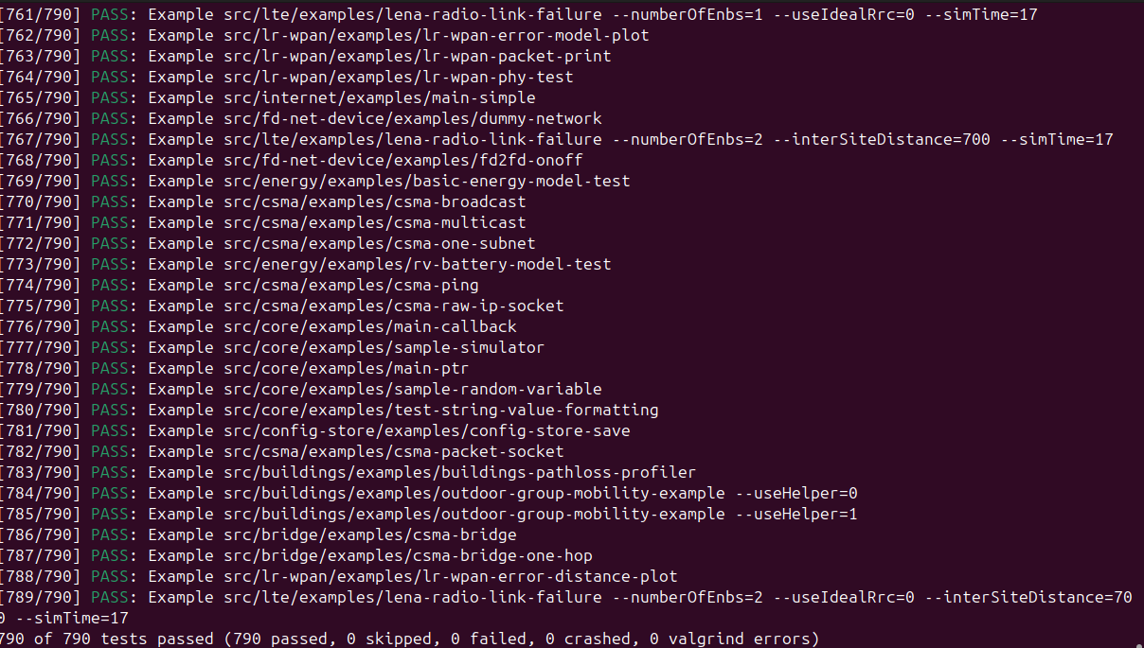
Figure 6 – NS3 Test.py completion output
The test.py program can also test individual source files, for instance:
./test.py –examples=quic-echo
All of the above tests were conducted on completion of the initially installation of NS3 to confirm that the download/installation had executed correctly with no errors. This ensures that at the next stage, which involved building the module for this task, any errors that occurred can be assumed to be related to the new custom module. This ensures easier debugging as only that module requires attention.
One of the standard files NS3 provide within the examples/ directory is called first.cc. This comprises of a two-node network running the IP stack, with an IP address, in the private range, starting from 10.1.1.1 255.255.255.0. The output can be seen in Figure 7.
As shown in Figure 7, the client node (10.1.1.1) sent a payload of 1024 bytes to the source node 10.1.1.2 via port 49153, a port associated with TCP/IP traffic. It was received on Port 9, a discard port also associated with TCP/IP traffic.
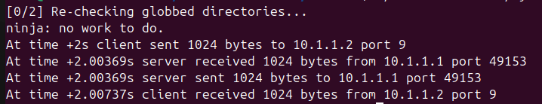
Figure 7 - Two-node network with IP stack output
This is the information that is of interest to this research. The topics discussed in section Error! Reference source not found. will be determined to be viable if at this stage, the protocols used are not observed, or the port number that are observed do not have known associations with the protocol used, and thus will prove a level of protocol/ application obfuscation.
Now that the code test environment is set up, the custom protocol implementations can be evaluated.

Phase 2: System testing
This phase involved testing that the end-to-end communications system utilising the protocol to evaluate its validity compared to protocols with no obfuscation.
Ultimately, the aim of this project is to test a protocol that offers obfuscation of the protocol being used. However, protocols should also offer good network performance if they can be considered for use, as a poor network performance translates to a poor end-user experience.
So, in addition to the observing whether protocols are identified at the network analysis stage, this phase will also observe performance statistics of the following parameters, which will display in the terminal log:
- Packet Loss
- Latency
- Throughput
The equations for each of the test metrics are as follows [11]:
- $Packet Loss \left(\%\right)=\left(\frac{Packets Lost}{Packets Sent}\right)*100 ADDIN EN.CITE <EndNote><Cite><Author>Fai</Author><Year>2021</Year><RecNum>0</RecNum><IDText>ns-3-project: Performance Analysis of TCP and UDP</IDText><DisplayText>[2]</DisplayText><record><ref-type name="Online Multimedia">48</ref-type><contributors><authors><author>Fai, Alfred Tso Chun</author></authors></contributors><titles><title>ns-3-project: Performance Analysis of TCP and UDP</title><secondary-title>GitHub</secondary-title></titles><dates><year>2021</year></dates><urls><related-urls><url>https://github.com/alfredtso/ns-3-project</url></related-urls></urls></record></Cite></EndNote>$
- $Latency \left(ms\right)= \frac{Totalend-to-end Delays for Received (Rx) Packets}{Rx Packets}$
- $Throughput (Mb/s)= \frac{Number of Received Packets }{Time of Last Rx Packets-Time of First Rx}$
The network performance analysis is enabled by the Flow Monitor. Flow Monitor is a module within NS3 that collects and analyses network performance statistics.
It should be noted that these test metrics are standard metrics within network testing software, so these values will be calculated by the software and displayed in the terminal.
To conduct a test within NS3, the C++ files within the examples folder are run, with the following command:
./ns3 run <filename>
e.g. ./ns3 run simple-routing-configuration
Once the test has completed, it will output various pcap (Packet Capture) files. This is the standard format for capturing network traffic data. The pcap files are opened in NS3 using the following command:
tcpdump -tt -r <filename.pcap>
The following subsections detail the testing of protocols of interest under this research, which are:
- ICMP (see section 6.2.1) -ICMP is under test as it meets the initial requirements of this task, especially given its lightweight nature, it is not a tunnelling protocol, and it is widely permitted on networks an by firewalls.
- UDP (see section 6.2.1) – UDP is a lightweight protocol that is not a tunnelling technology. It is therefore compatible for investigation against the requirements of this research.
- As UDP and ICMP are on different layers of the OSI stack, they will be tested separately, and then with one another, in an architecture where ICMP will sit within a UDP payload.
- Additionally, ICMP tunnelling will be investigated, which involved obfuscating one protocol, or even just a message, within an ICMP packet.

ICMP and UDP benchmark testing
ICMP
Figure 8 shows the terminal output when this script was run. As shows, various ICMP packets are sent, 28 to be exact, with a latency of 20ms, and 64 bytes of data was sent. This is a fairly low latency and shows a high-quality network connection. There is then a summary section further down detailing the following metrics:
- Number of packets transmitted
- Number of packets received
- Packet loss (%)
- Simulation time (ms)
As shown, 5 packets were transmitted and 5 were received, over a simulation time period of 4020ms (4.0 seconds). This is an example of a network connection that has 0% packet loss.
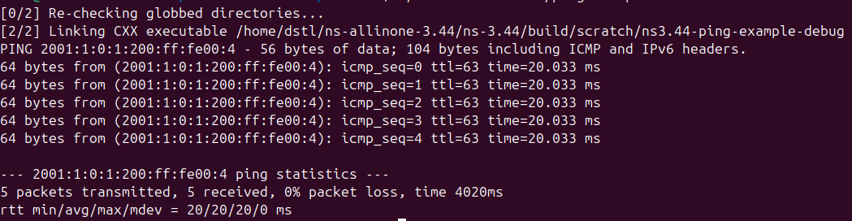
Figure 8 - ICMP two node test
This ICMP code has enable packet dropped packets, which should enable a simulation that represents a poor connection that leads to packet loss. Figure 9 shows the results when the ICMP code has been manipulated to enable packet loss.
As shown in Figure 9, 5 packets were transmitted, but only 3 were received, so 2 were lost. Plugging these numbers into equation 1 from earlier in this section, we get the following:
$$Packet Loss \left(\%\right)=\left(\frac{Packets Lost}{Packets Sent}\right)*100$$
$$Packet Loss \left(\%\right)=\left(\frac{2}{5}\right)*100=40\%$$
$$ADDIN EN.CITE <EndNote><Cite><Author>Fai</Author><Year>2021</Year><RecNum>0</RecNum><IDText>ns-3-project: Performance Analysis of TCP and UDP</IDText><DisplayText>[2]</DisplayText><record><ref-type name="Online Multimedia">48</ref-type><contributors><authors><author>Fai, Alfred Tso Chun</author></authors></contributors><titles><title>ns-3-project: Performance Analysis of TCP and UDP</title><secondary-title>GitHub</secondary-title></titles><dates><year>2021</year></dates><urls><related-urls><url>https://github.com/alfredtso/ns-3-project</url></related-urls></urls></record></Cite></EndNote>$$
The calculations above determined the packet loss to be 40% during this test. This correlates with the test results shown in Figure 9.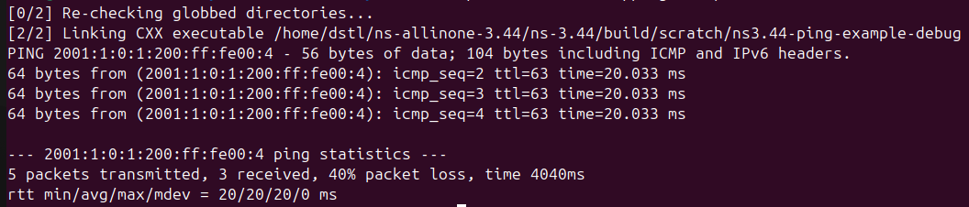
Figure 9 - ICMP test with packet loss
Now the benchmark testing for the ICMP protocol was complete, the next stage was to modify the code to see if other protocols could be encapsulated within the ICMP packet. This involved adding UdpEcho to the packet of the ICMP packet and then running a test.
UDP
It is necessary to test at least one other protocol before testing the “obfuscation” protocol to understand why obfuscation is required.
The first test conducted was using the UPD protocol on a simple point-to-point network. Figure 10 shows the output from the UDP test using the udp-echo example test script.
Node 1 (source) IP address = 10.1.1.1
Node 2 (destination) IP address = 10.1.1.2
The figure shows the various stages involved in point-to-point network communications using the UDP protocol, which are as follows:
- Identify link (interface) type – in this case, Ethernet.
- Address Resolution Protocol (ARP) Request from node 1 to node 2 – ARP is a protocol that maps the Medium Access Control (MAC) address – the hardware address that is unique to a piece of hardware – of a host to its IP address [12].
- ARP response from node 2 to node 1: “10.1.1.2 is at 00:00:00:00:00:02” – this is telling node 1 the MAC address of node 2, which it requires for communication
- “Discard” message. With UDP, when the destination node (in this case, node 2) received a datagram, it is thrown away, and no response is sent back to the source node (in this case node 1). This proves the “fire and forget” nature of UDP.
As shown, the UDP protocol is clearly stated, so this type of network communication will only be possible with networks and firewall that permit UDP packets.
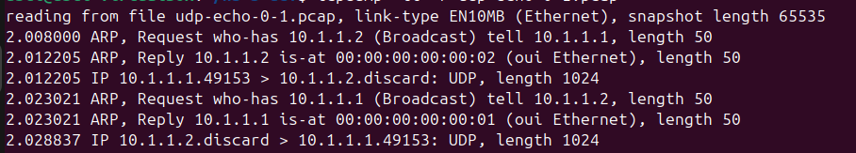
Figure 10 - UDP point-to-point test 1
Obfuscation test encapsulating UDP packet within the ICMP protocol
The ICMP test involved first writing a C++ script for an ICMP protocol test. This code involves all of the components as outlined earlier in this section. However, in addition to the use of UdpEcho within the code, the PingHelper class would also be invoked. This is the class that enables a ping test, and it is hoped this could be deployed within the UDP code.
The process to embed UDP within the payload of an ICMP packet involves the following:
- Create the UDP packet (using UdpHeader)
- Create the ICMP packet (using ICMPv4Header) and make the UDP packet created above part of the payload
- Create an IP packet (using Ipv4Header) and put the ICMP packet as part of its payload
  - Set source and destination IP addresses
- Simulate in NS3
Once the UDP information is created, this then need embedding within the ICMP code, specifically within the payload section.
The testing will be conducted to understand what affect, if any, this has on the ICMP protocol’s ability to transmit as per usual. The aim is to understand if it is still able to secure a connection with the modified code, and how this will appear during the execution stage. Will the protocol information be visible in the terminal log statistics.
Test 1:
This test involved adding the Ping code to the UDP Echo code in order to establish whether the ping application would work simply by adding it to the same code of the UDP Echo. Figure 11 shows a snippet from the code for this implementation.
As shown, the UdpEcho code is followed by the Ping implementation. This code has been compiled before the Ping implementation, and worked, as outlined in the UDP section of this phase. This code just adds the Ping implementation to that code.
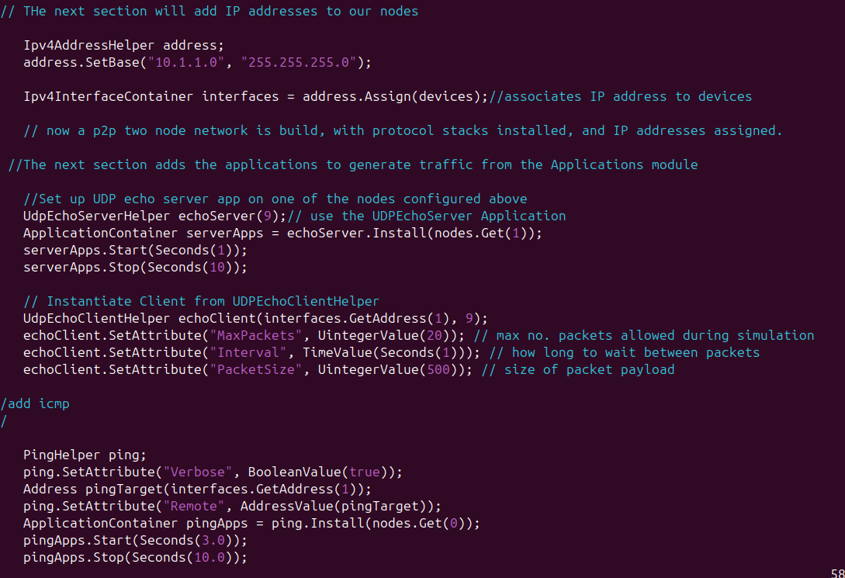
Figure 11 - Ping in UDP Echo code snippet
Figure 12 shows the terminal output from this test. As shown, the code did compile, with no errors, but did not produce the desired result – there is no log output showing network activity at all, where there was a log output without the ping implementation. So although there were no errors, it was not the desired output.
Figure 12 - Terminal log showing result from Ping in UDP Echo Test
Within the ICMP payload, there is the Ping echorequest, which is the request within ICMP that checks the connection to the destination address. If there is a connection, there will be a host response. It is here that the UDP implementation (UdpHeader) could potentially be obfuscated.
An ICMP packet is hosted within an IPv4 packet with ICMP header information. The payload size of the ICMP message can vary, but can be calculated as follows:
- IP header = 20bytes
- ICMP header = 8 bytes
- Datagram = 576 bytes
Data can be stored within the datagram, to be transmitted via the ICMP protocol. Usually, this will host the ICMP echo code. However, this test will implement an architecture that encapsulates a UDPEcho within the data payload of the ICMP packet. Therefore, the ICMP echo code will be replaced with the UDPEcho for the client and a UDPEcho for the server side.
As described in the list above, a typical ICMP data payload is 576 bytes. A typical UDP header is 8 bytes [13], so will be compatible with the size requirements of the ICMP payload.
The UDPEcho for the client side will be set to transmit packets that contain UDP data within the data payload of the ICMP echo request.
The UDPEcho for the server side will be set to receive packets that contain the ICMP echo request, which will contain the UDP data, which will be extracted, and then sent back to the client.
This method is essentially creating a tunnel-like behaviour without actually creating a tunnel, or using tunnelling technologies such as VPN. This ensures that the UDP request is not hindered by firewall VPN blocking policies by appearing on network analysing tools as a VPN protocol. Instead it will appear as a ICMP packet, which is a universally accepted protocol for network testing diagnostics.
The code adheres to the NS3 code design as outlined in section Error! Reference source not found.. It begins with the NodeContainer, the PointToPointHelper, NetDeviceContainer, and finally installs the internet stack protocol onto the nodes.
This is followed by the IP addressing information, before going onto the ICMP header code section. This is where usually the ICMP::ECHO_REQUEST code resides. With this test, the UDP_REQUEST code will also sit in that section, in the hope that the ICMP client will still transmit the packet, and the ICMP server will still receive, and respond to the packet.
ICMP tunnelling requires complex code to implement the following sections:
- ICMP Server
- ICMP Client
- ICMP main code
The ICMP server and client code are implemented as part of the ICMP main code. The aim is to add enhanced packet information to the server and client code. It is the client that will embed data within the ICMP Echo Request. This is akin to the earlier method where the UDP Echo Request was embedded where the ICMP Echo Request would usually be in the ICMP code.
The ICM Server then receives the ICMP Client payload and extracts the relevant information from the ICMP Echo Request. This is achieved without using UDP.
This test was difficult to implement within the NS3 system, and requires more thorough investigation into the reasons for this.

Phase 3: Usability testing
This phase will assess the end user experience when using this network protocol. The aim of this project was to enable the obfuscation of one protocol by one that is permitted on the underlying WAN. The end user does not care about this but does care whether or not they can access their desired applications and services, with satisfactory network performance.
The user experience will be determined by:
- Testing whether a ‘host’ protocol can facilitate successful connection between source and destination nodes whilst obfuscating a secondary protocol within its payload.
- Observing the latency, throughput, and jitter to see how it compares with the host protocol without the secondary protocol within its payload. If there is much degradation, then this will be noticeable to user and will not be acceptable. This may also be noticeable to the WAN, which may terminate a connection it believes to have been tampered with or behaving in a manner that is not expected or typical of that protocol.
As the protocols evaluated in Phase 2: System testing were not able to be judged to be operating in an obfuscated manor, usability testing will ensue on receipt of functioning code.

Phase 4: Acceptance testing
The final phase assessed the protocol’s performance at each of the first 3 phases of the testing process, and determine whether it meets the requirements set out in section 5.1, and whether the protocol obfuscation is observable or provable within the NS3 terminal or PCAP files.
As with Phase 3: Usability testing, the acceptance testing will ensue on receipt of fully functioning code. The acceptance is on the basis that the terminal logs are not providing detail of the protocol or data that is supposed to be obfuscated from view. The code is still within the Phase 2 testing until it can be determined to be functioning as per the desired aims and outcomes of this research.

Testing Analysis
This section provides an analysis of the protocols tested in section 6, and provides network traffic analysis into the QUIC protocol.
Analysis of protocols tested in NS3 can be conducted with two methods:
- Analysing PCAP files
- Anaysing terminal output
NS3 can generate pcap packet trace files, which as discussed in section 6.2, can be analysed within NS3 using the tcpdump command. PCAP files can also be analysed in Wireshark. Within the C++ code, there is a function that can be implemented, EnablePCAPAll, which will output PCAP files once the simulation has terminated. These can then be saved and opened in Wireshark for further analysis. This research is aiming to observe the output within NS3.
Depending on the test, the terminal may output the results as well. In this scenario, the terminal output can also be sent to a logfile, if specifically requested in the command to execute the test.

Analysis of UDP
The UDP test clearly shows that the UDP protocol is being used, as displayed in the terminal output in Figure 10.
As UDP is a connectionless protocol, it does not requires a response. This is a consideration when embedding it within the ICMP payload as it may not be obvious if it has been successful. In real-world networks, if the ICMP packet has been blocked, and it is embedded with UDP, then the source node will not know that it has been blocked. This is not a consideration within the scope of the analysis for this research as it is contained within a synthetic environment, and firewall and network security policies have not been enabled or configured.

Analysis of ICMP
The ICMP test compiled with variations of the code to demonstrate the effects of packet loss on the statistics in the terminal logs. This clearly shows the ICMP protocol is being used.

Analysis of Obfuscation of UDP within ICMP protocol
As shown in Figure 12, the obfuscation of UDP within the ICMP protocol test compiled succesfully in the first test, but did not produce any network activity. There would still be expected network activity to observe, which may involve Ping, but the most expected result would be to observe the UdpEcho activity, and not the Ping. This would prove that the Ping is still be carried within the UdpEcho.
One test that was attempted was to observe if it was possible to implement a data string within the UdpEcho, just to observe whether just a simple modification would execute and produce a desired output. Figure 13 shows the terminal logs from this code execution. As shown, there is clearly a string “hello world” being sent as part of the UdpEcho. This is sent as part of the data fill, which is the location where it was hoped that the earlier ICMP in UDP test was conducted.
Other metrics to note from the logs include the port number, in this case port 9, being visible. This can be changed in the code for this test, but is not necessary as changing the port not obfuscate the use of UDP in the terminal output.
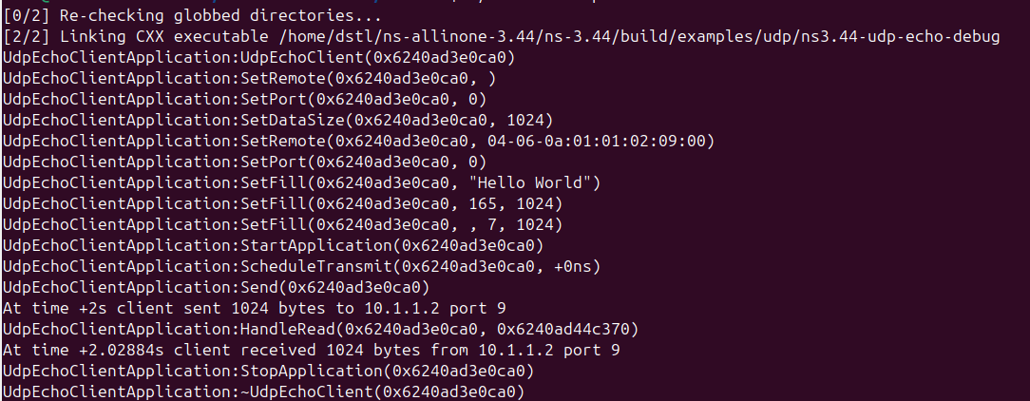
Figure 13 - UDP with data string
It has been established that it is possible to adapt the UDP code in order to carry some custom data. A simple string is fairly simple to test, but implementing with other protocols is more difficult.
It should be noted that some networks, firewalls or hosts may drop ICMP packets if they have reason to believe it has been tampered with. This enhances the reasons why this topic is such a difficult one to implement. Ultimately, firewalls only permit protocol they know and know to be genuine. If a protocol has been embedded within the payload to look like data that would be expected of that protocol, then the likelihood of that transmission being successful will be fairly high.
Simply obfuscating UDP within ICMP by implementing a UDP Echo instead of a ICMP echo appears to have difficulty implementing. This is likely due to a lack of packet header information, which is a whole section of code that should be implemented in addition the existing code for ICMP.
ICMP tunneling requires quite complex coding in order to work as desired in this research, which can be explored in the recommendations section (see section 9).

Analysis of QUIC in Wireshark
Although it was not possible to test QUIC within the NS3 environment, it was possible to observe QUIC activity using the packet analyser, Wireshark. It is necessary to show the power of the packet analyser in its ability to detect QUIC, where some websites or firewalls may fail to do so
Figure 14 shows the Wireshark capture displaying QUIC network traffic. This shows that QUIC is visible on packet analysers, especially Wireshark. Information is displayed within the capture as well, such as 0-RTT, which was described in the QUIC section of the literature review (see section 2.1.2.1.1).
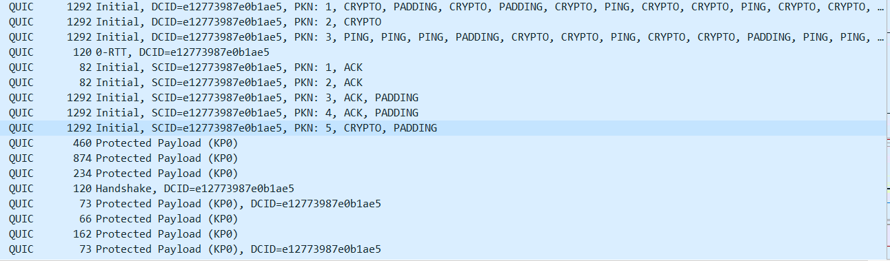
Figure 14 - QUIC protocol packet capture in Wireshark
This capture was taken once google was started. Before starting google, only TCP network activity was observed, as show in Figure 15. This show only TCP activity, which shows that QUIC is used by Google, and can be observed by a Wireshark.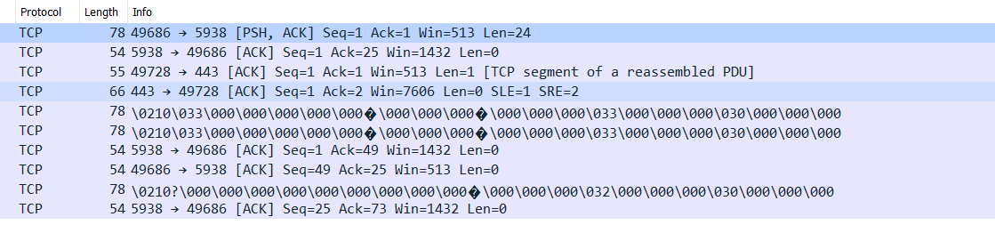
Figure 15 -Wireshark capture with no Google Chrome running

Conclusions
There are various conclusions from this research, which will be discussed in this section.
Firstly, NS3 is a good network simulator tool to test a variety of extant protocols and allows for custom modifications. NS3 has good documentation, Doxygen, to enable further knowledge of various modules that appear in the NS3 code, and to help resolve issues relating to NS3-specific C++ classes, and inheritance-related errors.
Most research in this area points references the utility of tunnelling technologies, such as VPNs, to achieve secure and reliable comms, relatively shielded from restrictive network policies and firewall port blocking and IP blocking policies
The extant transport layer protocol TCP has security enhancements made through a variety of additional security protocols such as Secure Socket Shell (SSL), TLS, and additionally, TcpCrpyt RFC 8545, and the proposed, but never released, obsTCP. Alternative methods that modify extant protocols such as obsTCP, are difficult to implement, and are used primarily for nefarious intentions
Simply integrating one protocol into another’s data payload does not always work. Whilst it has the correct syntax and thus successfully compiles, it does not produce the desired outcomes
Network security is a constantly evolving space, with network and firewall policies adapting to protect against evolving threats. This results in an increasing number of protocols experiencing blocking by certain websites, firewall, and networks, which historically have not been. This even includes protocols such as the ICMP (ping) network layer protocol, which is used for network diagnostics, so has historically been a universally permitted protocol. This is supported by RFC 1122, which outlines that ICMP Echo server request and response must be implemented on every host. Hosts must also facilitate Echo requests and receiving Echo replies implementation for the purpose of network diagnostics [14]. It also states that ICMP and IP, as ICMP is a datagram within the IP packet, must be implemented for every Internet-layer host.
It can be concluded that despite a protocol being universally accepted at the current time, this is not guaranteed in the future. Therefore, alternative protocols and methods must be continuously developed and evolved to meet the requirements of evolving network security policy.
Protocols that have been developed for the purpose of bypassing network and firewall blocking policies must be observed for any hijacking of use by network threat actors, who may exploit the merits of the protocol for nefarious reasons. If this use becomes detected and known to network managers, then these protocols will be blacklisted and therefore blocked. This is why continuous development of these protocols and methods is important, otherwise a website or application may well rely on a redundant protocol.

Recommendations
The recommendations from this research are as follows:
- As network security policy continuously evolves, alternative protocols and methods must be continuously developed and evolved to meet the requirements of evolving network security policy.
- This is a continuous task, as one protocol or method to enable a protocol that has received network security issue, cannot have guaranteed permitted status across all networks and firewalls.
Some suggestions of future work include:
- Explore alternative methods to obfuscation in order to avoid detection by network security and firewall policies, such as manipulating packet size. Manipulating packet size, for instance assigning it to a random sequence, will make the UDP request appear like normal network traffic rather than a UDP request, which has a static packet size.
- Test with an emulated network scenario, including firewalls. Testing with firewalls will test whether the protocol is actually bypassing firewall rules, instead of human observation of terminal logs.
- Due to the complexities surrounding the embedding of one protocol within another, future work should concentrate on creating a protocol stack for a specific implementation. This is important as implementing ICMP with UDP, for instance, is implementing two protocols on different layers of the OSI stack (ICMP being network layer, and UDP being transport layer).
- Implement this on commodity hardware with varying network topologies. Implementing a test bed, involving having computing devices on different networks, with firewalls between them, will increase the efficacy of this research.

Reflection

Introduction
This section describes the reflection from my personal perspective in delivering this project to the report stage.
This project has enabled me made me aware of all of the constituent parts that a research project comprises of and how each parts affects one another, and the outcome of the project. That is, if one of the theoretical strands of research do not produce a desired outcome, this can affect the project’s ability to address the hypothesis. I have learnt that at this stage it is acceptable to re-scope certain aspects of the aim of the research in order to attempt to address the hypothesis to the best of my ability.

Skills developed
During this project, I have developed a range of skills, which will certainly help in my future work.
Firstly, I have developed good writing skills. This is specifically regarding writing in a dissertation style. I have learnt to include a good amount of background to the topic of the dissertation, ensuring that I understand why I am doing this research, so producing a problem statement, from which I can accurately develop my hypothesis, and thus ensues the research to address it.
Secondly, I have developed good research skills. I have adapted my research skills during the tenure of this project, which include exploring a more academic sources of research. Interestingly with this research topic, open-source material, which forms the basis for a significant amount of software-related scientific research, is also widely leveraged by academic institutions. Therefore, during my use of open-source software material, such as code repositories, I was often able to identify high-quality sources with academic or professional institutions.
Thirdly, I have learnt that developing good requirements really help to bound the research. During the background research stage, I would identify protocols that seemed interesting, but when I referred to my project’s requirements, found that they do not meet those requirements, and so would not be worth investigating.

Learning curves
The main learning curve for me during this project was what appears to be a minor issue, a “quick fix”, can actually consume a significant amount of time, which is not necessarily accounted for in the project planning stage. This can be addressed by allowing for contingency at the project planning stage, being slightly more generous with the timing in the Gantt chart during the project’s early stages. I could also have addressed this by not spending a significant amount of time attempting to remediate the issue, and learn to identify when it is time to stop and move on, or try another method.

Proposed improvements
I propose a variety of steps I could have taken in order to improve the outcomes of this project.
Firstly is building contingency in the planning stage. This is important as I did not have enough time to address the issues with strands of the practical research within this project
Secondly, is planning appropriately to account for software version miss matches. This project was a software-based project. Software is usually available in a range of versions, with releases fairly common, especially if security issues are identified. This caused issues in this project when I was attempting to model some versions of protocols within the NS3 environment. I found that the NS3 environment could to new a version for the protocol modules, and in the earlier stages, I tried earlier versions to test specific protocols. I then had to revert back to the newest version to test the more custom protocols, and also increase the validity of my research. Having research on old software versions can raise issues regarding software security surrounding the work. If a protocol can only work on an old software, it will unlikely be valid for further investigation or exploitation, unless a patch, or a request, such as Pull Request in Git.

Reflections Conclusion
On reflection, I have experienced a great deal of skills obtained, but also experienced learning curves when parts of the project have provided me with issues. I will take these learning curves on board and along with my proposed improvements, use these to ensure that my next project can run as smoothly as possible.

References

[1] | Cloudflare, Inc, “How does the Internet work?,” Cloudflare, Inc, [Online]. Available: https://www.cloudflare.com/learning/network-layer/how-does-the-internet-work/.
[2] | S. Šimkevičiūtė, “Can you be tracked with a VPN?,” 19 June 2022. [Online]. Available: https://nordvpn.com/blog/can-you-be-tracked-with-a-vpn/#:~:text=Some%20VPN%20protocols%20use%20specific,Deep%20packet%20inspection..
[3] | Z. Trabelsi, W. El-Hajj and S. Hamdy, “Implementation of an ICMP-based covert channel for file and message transfer,” in 2008 15th IEEE International Conference on Electronics, Circuits and Systems, Saint Julian's, Malta, 2008.
[4] | Juniper Networks, Inc, “SESSION SMART NETWORKING –HOW IT WORKS,” Juniper Networks, Inc, Sunnyvale, CA, 2023.
[5] | KCCross and robmazz, “How Exchange Online uses TLS to secure email connections,” 27 11 2023. [Online]. Available: https://learn.microsoft.com/en-us/purview/exchange-online-uses-tls-to-secure-email-connections.
[6] | A. Bittau, D. Giffin, M. Handley, D. Mazieres, Q. Slack and E. Smith, “RFC8548,” 05 2019. [Online]. Available: https://datatracker.ietf.org/doc/html/rfc8548.
[7] | IETF LLC, “Introduction to the IETF,” [Online]. Available: https://www.ietf.org/about/introduction/.
[8] | K. S. P. G. F. R. Richard M. Fujimoto, Network Simulation, J. Walrand, Ed., Springer Series, 2022.
[9] | A. B. Amewuda, F. Katsriku and J.-D. Abdulai, “Implementation and Evaluation of WLAN 802.11ac for Residential Networks in NS-3,” Journal of Computer Networks and Communications, mARCH 2018.
[10] | ns-3 project, “ns-3 tutorial,” 09 March 2025. [Online]. Available: https://www.nsnam.org/docs/release/3.44/tutorial/singlehtml/index.html#document-conceptual-overview.
[11] | A. T. C. Fai, “ns-3-project: Performance Analysis of TCP and UDP,” 2021. [Online]. Available: https://github.com/alfredtso/ns-3-project.
[12] | Cisco, “ IP Addressing: ARP Configuration Guide, Cisco IOS XE Release 3S,” 2015.
[13] | G. Fairhurst, “The User Datagram Protocol (UDP),” 19 11 2008. [Online]. Available: https://www.erg.abdn.ac.uk/users/gorry/course/inet-pages/udp.html.
[14] | R. Braden, “Network Working Group Request for Comments: 1122,” Internet Engineering Task Force, October 1989. [Online]. Available: https://www.rfc-editor.org/rfc/rfc1122.txt.
[15] | NS3 Code, “How to Begin Implement Simple Network Protocol in NS3,” NS3 Code, [Online]. Available: https://ns3-code.com/how-to-begin-implement-simple-network-protocol-in-ns3/.
[16] | NCSC, “Protocol Design Principles,” 2020.

