

Module code: BMIH6005
Organisational Consultancy- Report
Student Name: Loredana Turner
Student ID: 2242724

I confirm that I have not used any Al tools in the research and creation of this assignment. I confirm that I have not presented any Al generated materials as my own work. I confirm I have copies of my drafts, notes, and other resources I used, which I may be asked to provide in evidence

Executive Summary:
The identified problems are a complex combination of internal inadequacies and external pressures, with the lack of sufficient investment in room renovations, high employee turnover, and inadequate training, particularly in the food and beverage department, leading to a significant decline in service quality; while external inspirations include rising guest expectations, high inflation, the emergence of emerging competitors such as boutique hotels and Airbnb, and the post-COVID workforce crisis. Furthermore, the hotel management's letdown to address negative reviews has resulted in noteworthy digital reputation damage.
An in-depth analysis was conducted, which included sentiment analysis, guest and employee interviews, as well as industry benchmarks (e.g. PwC, Deloitte, STR Global). Complex planned frameworks such as SWOT, TOWS, and STEEPLED were applied to identify both risks and chances. The hotel’s central location, spectacular Georgian architecture, and presence of loyal IHG One Rewards members continue to be key strengths.
This advisory report provides an in-depth analysis of the ongoing operations & reputation challenges of the five-star InterContinental Edinburgh The George hotel, where in spite of InterContinental Hotels Group (IHG)’s worldwide success, such as a 0.6 percentage point increase in occupancy in the first quarter of 2025 & a 14% RevPAR (Revenue per Available Room) increase in 2023, the Edinburgh-based property has become a major trouble (The4, 2025). As the hotel has failed to maintain the service standards expected of a luxury hotel, resulting in negative reviews on TripAdvisor, Google Reviews & Booking.com, such as outdated rooms, inconsistent service and poor communication during check-in/check-out, which is causing a lack of trust among customers & is damaging the hotel’s brand’s premium position in a aggressive market.
The report identified that the root reasons of these challenges stem from a combination of internal inefficiencies and external pressures. Internally, a lack of adequate investment in refurbishment, high staff revenue rates, and inadequate training, particularly within the F&B department, have led to a decline in service quality, which is largely responsible for the decline in service quality. Externally, rising guest expectations, inflation, competition from boutique hotels and Airbnb, & staff shortages in the post-COVID environment have exacerbated the situation (IHG, 2024). Online reputation plays a crucial role, as 88% of consumers trust reviews as much as personal recommendations, but The George’s management has failed to respond appropriately to negative feedback, which has further damaged their digital presence & perception among all.
Although InterContinental Hotels Group (IHG) has achieved significant success globally and achieved a 0.6% increase in guest occupancy rates and a 14% increase in revenue per available room (RevPAR) in 2023, the current operational and reputational issues at InterContinental Edinburgh The George Hotel are so glaring that they are seriously damaging the hotel's best brand image in a modest market; particularly in the negative reviews given on trusted platforms such as TripAdvisor, Google Reviews and Booking.com, guests have expressed their complaints that the hotel's rooms are old and unkempt, the quality of service is unpredictable and disorganized, and the lack of message during the check-in and check-out process is evidently causing tourist dissatisfaction, which is directly affecting the hotel's overall reputation and performance.
Despite facing various challenges, the hotel's financial performance is not fully aligned with the customer involvement, as reflected by its declining Net Promoter Score (NPS); to address this situation, a five-step integrated action plan has been proposed.
- Service Excellence & Staff Training – To elevate client service standards.
- Phased Room Renovations – Converging on areas with the most grumbles to meet brand expectations.
- Strategic Pricing Review – Ensuring value perception matches pricing to regain trust among price-sensitive guests.
- Wellness Partnerships – Collaborating with local providers to augment amenities without major capital expenditure.
- Digital Reputation Management – Assigning a dedicated team to engage with online reviews and improve digital presence.
InterContinental Edinburgh The George is able to rebuild its reputation, increase customer loyalty, and regain leadership in a competitive market, as each creativity includes clear timelines and cost estimates to ensure assessable progress; this process is further strengthened by strategic investments in service quality, infrastructure, and digital engagement.

Table of Contents
Introduction: 4
Analysis 6
Issue Identification and Impact on the Hotel 6
Root Causes and Contributing Factors 7
Role of Feedback and Reputation 8
Broader Scope and Methodology 10
Positive Performance Areas and Internal Strengths 11
Strategic Analysis and External Influences 12
STEEPLED Analysis 12
SWOT Analysis 13
TOWS Analysis 14
Recommendations and Change Management 15
Service Excellence and Staff Training Program 15
Pricing Review and Value Proposition Enhancement 16
‌Room Maintenance and Infrastructure Upgrade 18
‌Strategic Partnership for Wellness Amenities 18
‌Change Management Framework 19
Monitoring and Evaluation 19
‌Action Plan 21
Below is an example of an action plan presented in a table 22
Conclusion 23
Reference List 25

Introduction:
The following report identifies the internal and external multi-level factors affecting the performance of InterContinental Edinburgh The George Hotel, using modern and comprehensive tools such as STEEPLED and SWOT analysis, thereby proposing strategic options to improve service quality, digital engagement, and competitive capabilities. The final objective of the report is to provide contemporary actionable and relevant material and grow a specific change management plan that will accelerate the hotel’s recovery process in line with the IHG brand’s commitment to delivering a high-quality guest involvement and position the organisation in a strong competitive market through reintegration.
InterContinental Edinburgh The George is a luxury hotel located in the heart of Edinburgh, Scotland's capital, on George Street, a prestigious area known for its proximity to important cultural and commercial sites such as Princes Street Gardens and Edinburgh Castle. The hotel is a converted Georgian townhouse, combining the splendor of historic architecture with modern hospitality. The hotel has over 240 rooms & suites and multiple event spaces, making it a popular venue for weddings, business events, and luxury getaways for many years; however, based on feedback on platforms like TripAdvisor & Booking.com, it is clear that many guests currently find some of the hotel's rooms outdated due to a lack of modernity, find service inconsistent, and experience communication issues during check-in and check-out. These issues are particularly concerning, given the hotel’s premium pricing and five-star classification, which typically creates expectations of high-quality service & amenities; however, this report has been prepared by Vertex Hospitality Advisory, a specialist consultancy with a strong track record of success in operational change, digital reputation strategy & service innovation in the global hotel and sightseeing sector, where Vertex closely supports hotel sector clients across the UK, Europe and the Middle East, and uses data analytics, industry benchmarks and employee engagement insights to inform their strategy formulation process; our team of experts combines deep information of market dynamics with hands-on management experience, ensuring practical and sustainable improvements to meet the modern challenges of high-end hotels.
While InterContinental Hotel Group (IHG) continues to see its financial indicators improve post-pandemic with strong performance globally, InterContinental Edinburgh The George—recognized as IHG’s flagship five-star property is facing significant operational and reputational challenges that are not only negatively impacting the hotel’s overall performance and guest loyalty, but also deteriorating satisfaction, service quality and online reviews; while also risking IHG’s luxury position in an increasingly competitive hospitality market, where reliance on digital reviews and value propositions is increasing.
Located in the heart of Edinburgh city centre, on prestigious George Street, this luxury hotel, housed in a converted Georgian townhouse and combining historic architecture with modern amenities, has long been a favourite venue for weddings, business events, and luxury stays, with over 240 rooms and a range of event spaces. However, recent guest feedback on platforms such as TripAdvisor and Booking.com has tinted the dated condition of the rooms, inconsistent quality of service, and communication issues during check-in and check-out, which is predominantly concerning as the hotel’s high premium price and five-star status create high expectations for service quality and facilities.
Prepared by Vertex Hospitality Advisory, a renowned consultancy recognised for its expertise in driving effective change, digital standing strategies, and service innovation in the global friendliness industry, the report will assess the challenges facing hotels through a deep and integrated analytical framework. Vertex’s team of specialists, who have insightful market knowledge and extensive experience in real-world management, will get to the root of the problems and formulate and propose evidence-based and effective solutions.
The hotel's problems stem from a combination of inadequacies, service deficiencies, and infrastructure weaknesses, compounded and deepened by a lack of proactive reputation management; this makes it tremendously problematic for the hotel to compete with modern boutique hotels and platforms like Airbnb, which attract customers with modern amenities, personalised service, and more flexible pricing.

Analysis

Issue Identification and Impact on the Hotel
Although IHG's UK Guest Satisfaction Index (GSI) exceeded 100 in 2022 and they performed better than their competitors, the five-star InterContinental Edinburgh The George, located in the heart of the Scottish capital Edinburgh, has recently faced significant customer dissatisfaction, reflected in negative reviews and low scores published on various online platforms such as TripAdvisor, Google Reviews and Booking.com, which on the one hand is damaging the brand's reputation and on the other hand is negatively affecting digital review-based decision-making in a competitive market (Voegeli, 2021). As IHG’s hotels in Edinburgh are lagging slightly behind those in Glasgow and London, occupancy rates and ADR are declining, which is ultimately reducing revenue (de Haast et.al, 2025).

Root Causes and Contributing Factors
The decline in performance at InterContinental Edinburgh The George reflects the combined effect of internal inefficiencies and external pressures. A more in-depth and structured analysis will be applied using the 5 Whys approach, specifically meeting on the Food and Beverage (F&B) department, to analyse the root causes of the decline in service quality.
- Why has service quality declined?
High levels of staff turnover in the Food and Beverage (F&B) sector have been established as one of the main reasons for declining service quality.
- Why is there high turnover in the F&B department?
The main motives for high staff turnover are a lack of motivation and inadequate training, which have established more critical due to the lack of skilled workforces in the UK in the post-COVID period.
- Why is there insufficient employee motivation and inadequate training?
Lack of proper speculation in employee engagement and expansion programs, coupled with high employee turnover and irregular staffing levels, is causing serious problems, specially within the Food and Beverage (F&B) sector.
- Why is there a lack of investment in employee engagement and development?
Although the hotel prioritized other areas such as room facelifts and infrastructure enhancements, it overlooked the importance of retentive and inspiring its staff.
- Why has the hotel neglected investment in workforce development?
While financial resources are absorbed on short-term goals like renovation and digital reputation management, long-term strategies like cumulative employee morale and dipping employee turnover are not assumed due importance.
Internal vs. External Root Causes:
- Internal Causes:
  - High staff turnover and unpredictable service standards, mainly in the F&B department.
  - Lack of investment in employee motivation, training, and retention.
- External Causes:
  - Boutique hotels and platforms like Airbnb are facing cumulative competition as they offer modern amenities, flexible pricing, and personalized service.
  - As inflation and the increasing cost of living have increased guest potentials, the need for high-quality service has also amplified
‌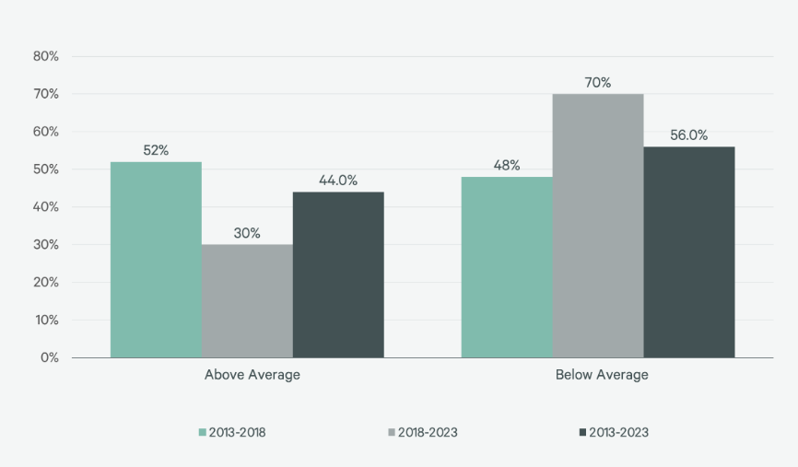
Figure 1: Percentage of 50 Selected Hotel Brands With Above- & Below-Average RevPAR Growth
(Source: Cbre, 2024)
As per the graph, RevPAR growth was 3.0% between 2013 and 2018, it halved to 1.5% between 2018 and 2023, indicating that while the share of short-term rentals doubled to 16%, only 30% of hotel brands were able to outperform the average, indicating increased competition and the increasing trend of price-conscious guests during this period (Cbre, 2024).

Role of Feedback and Reputation
In the digital age, guest feedback plays a key role in shaping public opinion of luxury hotels, such as the InterContinental Edinburgh The George, where infrastructure and cultural distance also influence strategic decisions about hotel placements, and governments as well as land developers have a role to play in determining the number of multinational hotel establishments (Chen, 2022). A 2024 study by ReviewTrackers revealed that 88% of consumers trust online reviews as much as personal recommendations when choosing a hotel, and that platforms such as TripAdvisor, Trustpilot and Google Reviews not only increase customer dissatisfaction, but also significantly influence search engine visibility and booking decisions (Kwan et.al, 2023).
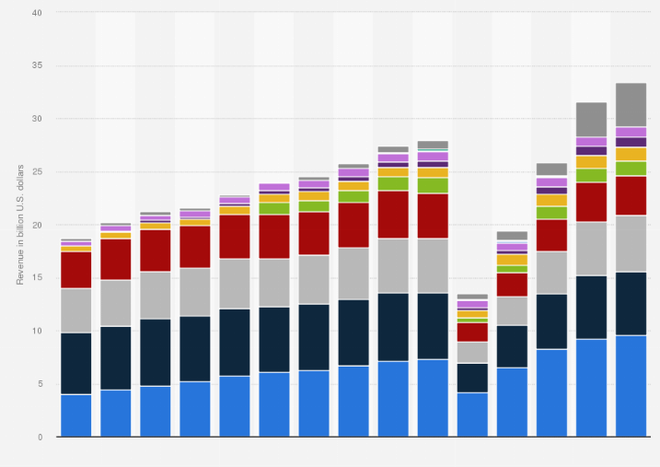
Figure 2: Gross revenue of the InterContinental Hotels Group 2010-2024, by brand
(Source: Statista, 2024)
As per the graph, Holiday Inn Express generated $9.6 billion in revenue in 2024, up from $9.2 billion in 2023, it is clear that the company has seen financial growth. Despite this growth, complaints against The George Hotel have increased and their Net Promoter Score (NPS) has declined, suggesting that IHG's overall financial improvement may be having a negative impact on its reputation (Statista, 2024).

Broader Scope and Methodology
In the third quarter of 2024, InterContinental Hotels Group (IHG) saw RevPAR in the UK grow by 2.2%, higher than the global average of 1.5%, according to Hotel Management Network, but lower than the 7.1% growth in Continental Europe, and in the first quarter of 2025, while RevPAR in the UK was virtually flat, there was significant growth in Continental Europe, the Middle East, East Asia and the Pacific (Morningstar, 2025). This report used mixed methods research, which included online review analysis, customer interviews, employee feedback, STIR performance index, RevPAR trends and social media sentiment analysis, and assessed underlying data using PwC and Deloitte’s Hospitality Outlook reports for 2024 (Antunes, 2023). The impact of the COVID-19 pandemic has brought profound changes to the global travel and tourism industry, creating a need to rebuild trust.

Positive Performance Areas and Internal Strengths
Although InterContinental Edinburgh The George faces a number of challenges, it is performing well in a number of key areas that are key to its overall success. Its location on George Street provides a convenient location that places it close to the city’s main cultural, commercial and shopping areas, ensuring ample visibility and regular footfall (Liberato et.al, 2023). The historic Georgian architecture and restored interior, which is considered a venue for a variety of high-end events and weddings, remains a significant revenue source. With over 6,300 hotels worldwide, including 362 in the UK, and a further 25 under construction, it is clear that the company has a huge impact on the travel market (Kipsu, 2024).
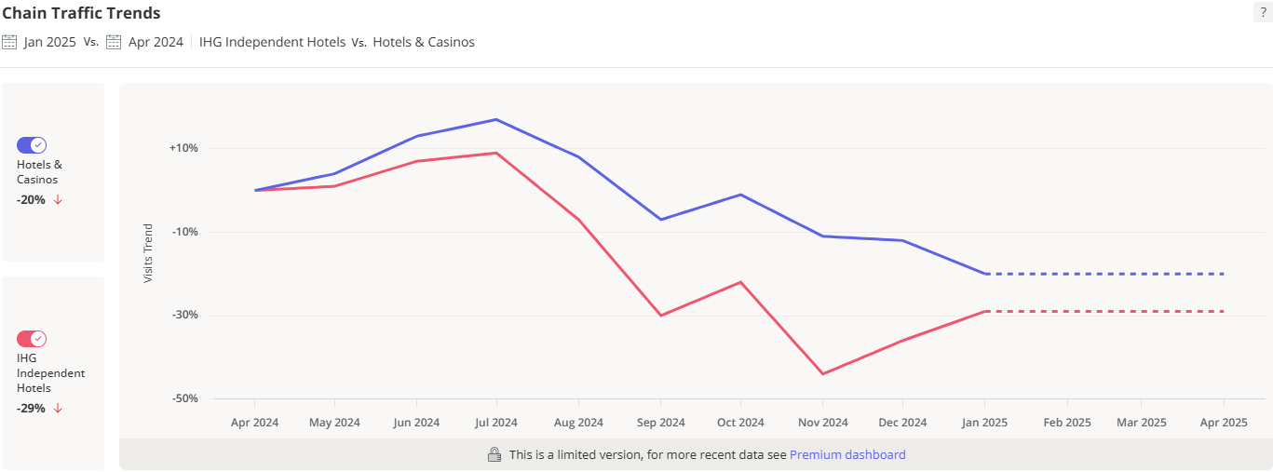
Figure 3: Nationwide Foot Traffic Visits for IHG Independent Hotels Stores Compared to 10 Months Ago
(Source: Labs, 2025)
As per the graph, a significant 29% decline in IHG's nationwide visitor numbers between April 2024 and January 2025, InterContinental Edinburgh The George has been able to consistently maintain high footfall and stable event revenue streams through its highly regarded location, heritage architecture and the unwavering support of its international loyal clientele (Labs, 2025). While specific figures for F&B revenue in 2024 were not released, total gross revenue increased 6% to $33.4 billion, suggesting that the company’s overall revenue, including F&B, has grown, consistent with local media praise for its restaurants and bars, and that it is creating a competitive advantage by combining tradition with modern luxury.

Strategic Analysis and External Influences
As chatbots can be applied to enhance the guest experience for IHG Hotels & Resorts, as demonstrated by a quantitative study conducted among 16-40 year olds, where data was analyzed using SEM and SmartPLS, the investment in digital check-in, smart room systems and CRM tools has become technologically essential; however, as economic pressures from rising energy and supply costs have created, and despite the growing demand for sustainable travel, the hotel still lacks a clear environmental policy (Richardson et.al, 2023).
STEEPLED Analysis
Factor | Analysis
Social | Changing guest expectations, rise of boutique hotels and Airbnb, and post-pandemic travel behavior lead to increased demand for personalized service, flexibility, and wellness offerings. Cultural and culinary inclusion is crucial in multicultural cities like Edinburgh (Anon, 2025).
Technological | The use of Property Management Systems (PMS), Customer Relationship Management (CRM) software, AI, and smart room technologies enhances personalized services. Guest feedback analysis via platforms like TripAdvisor helps improve service quality (Omoge et al., 2022).
Economic | Rising living costs and inflation increase demand for affordable accommodation, driving price sensitivity (Collings et.al, 2009). IHG faces competition from mid-range hotels and Airbnb, which offer more value. IHG's rapid expansion, especially in Greater China, indicates its growth trajectory (Fernandes, 2021).
Environmental | Guests demand eco-friendly features like energy-efficient facilities and waste reduction. The Minimum Energy Efficiency Standard (MEES) affects high-energy hotels. Sustainable tourism practices are becoming a necessity, especially in environmentally sensitive cities like Edinburgh (UWL, 2025).
Political | Health and safety regulations and employee welfare policies may raise costs for hotels. Edinburgh's tourism development policies aim to attract international tourists, while Brexit's long-term effects on labor supply and pricing remain a concern (THOUGHT, 2019).
Legal | Increased health and hygiene expectations post-pandemic lead to stricter protocols to avoid legal risks. Changes to employment laws may result in higher turnover in the food and beverage sector, requiring strategic management of employee retention (Tran, 2020).
Demographic | Millennials and Gen Z, who value modern amenities and sustainability, are increasingly influential in the luxury hotel market (Chodor, 2024). The elderly population also represents a growing tourist segment, requiring hotels to adapt to accessibility needs. Edinburgh’s cultural and linguistic diversity must also be addressed in the post-Brexit era (Camilleri, 2018).
SWOT Analysis
Factor | Analysis
Strengths | The hotel's central location on George Street provides high visibility and easy access to cultural and commercial hubs, enhancing its appeal. Its Georgian architecture and historical heritage offer a unique luxury experience, complemented by award-winning dining facilities that improve guest satisfaction (Alexios-Patapios, 2025).
Weaknesses | The irregularity in food and beverage service has led to lower guest satisfaction, emphasizing the need for staff training and consistency. Aging infrastructure, including the lack of smart room technology and wellness amenities, hinders the luxury experience, suggesting a need for modernization (Please, 2025). Psychological safety is also crucial for improving employee performance (Alexios-Patapios, 2025).
Opportunities | Renovating rooms and public areas to modern luxury standards can improve guest satisfaction and ensure long-term success. Implementing advanced marketing strategies targeting younger, international tourists can expand the customer base. Additionally, adopting sustainable initiatives like green energy will attract eco-conscious guests and enhance the hotel’s reputation (Hardy, 2021).
Threats | The competition from boutique hotels and short-term rental platforms such as Airbnb is intensifying, which can reduce the demand for traditional luxury hotels. Economic downturns, inflation, and the effects of COVID-19 and global instability pose threats to the luxury segment, while affordable alternatives gain popularity (Rafael, 2022).
TOWS Analysis
Strategy Type | Analysis
Threats & Strengths | The hotel's central location and rich historical heritage provide an opportunity to differentiate by offering unique experiences such as private tours of Edinburgh's historic sites and special cultural events. This strategy leverages the findings from the Edinburgh Authenticity Study (Harwood, 2021).
Opportunities & Strengths | By upgrading the hotel to modern luxury standards while preserving its historical charm, the hotel can attract guests interested in both history and modernity. This aligns with the growing demand for unique experiences, especially from international and young tourists (Lesh et al., 2023). Digital marketing strategies should highlight this mix.
Weaknesses & Threats | Investing in comprehensive training programs to maintain service quality, particularly in the food and beverage department, will address staff turnover and meet evolving workforce expectations (Proquest, 2023). Additionally, focusing on renovating old infrastructure will help mitigate competitive risks from modern boutique hotels.
Weaknesses & Opportunities | Incorporating green initiatives in the renovation, such as energy-efficient lighting and sustainable materials, will attract eco-conscious guests and improve the hotel’s environmental footprint. This aligns with the global need for sustainable building practices and helps the hotel remain competitive (Rotimi, 2018). Use of smart room tech can also enhance the guest experience.

Recommendations and Change Management
The analysis of the InterContinental Edinburgh The George Hotel clearly highlights some fundamental operational challenges that are having a significant impact on guest satisfaction, service continuity and overall financial performance (Jackson et.al, 2003).The hotel’s current decline is largely driven by a combination of internal inefficiencies and external pressures, with internal inefficiencies such as ageing substructure, inconsistent service standards and lack of effective staff training being key drivers, while external pressures include increased competition and higher guest expectations, as identified through SWOT and STEEPLED analyses (Genter, 2024). Although the Global Guest Satisfaction Index (GSI) stands at 78.6%, the lack of UK-specific data makes it difficult to identify specific and actionable areas for improvement in this market.
Applying Organisational Analysis and Change Management Models
To address the working and reputational issues at InterContinental Edinburgh The George, several analytic and strategic application models from consultancy theory are vital. Firstly, using the McKinsey 7S Framework (Week 2), numerous misalignments can be identified: Structure—ineffective delegation and lack of front management; Staff—high turnover and inadequate training; and Systems—inefficient communication processes during check-in/check-out. These internal rudiments are not aligned with the hotel’s strategic goal of bringing best guest involvements, important to universal letdowns in facility delivery (IHG, 2024).
Completing this, the Star Model (Galbraith) assistances exemplify that policy (luxury branding) is not adequately maintained by people (staff shortages), rewards (lack of recognition), or procedures (outdated tech and manual bookings) (Janse, 2019). This misalignment clarifies the gap between visitor outlooks and actual service, settling the root reasons spread beyond insincere indications.‌
Furthermore, the 5 Whys Technique uncovers the complexity of operative issues. For example, when diagnosing why guests are dissatisfied with check-in, the root cause leads to underinvestment in combined digital systems—an unnecessary problem curtailing from cost-saving decisions. This diagnostic tool confirms the standing of addressing foundational disorganizations rather than just customer-facing indicators (Richardson et.al, 2023).
From a strategic viewpoint, the TOWS Matrix (Week 3) provides criminal direction. The hotel’s inner strengths (location, heritage, loyal members) should be in time with external chances (rising demand for premium stays) by investing in room progresses and service training (Murphy, 2024). Meanwhile, internal weaknesses (service inconsistency) must be mitigated against external threats (boutique hotel race and review-based bookings) through digital appointment and adaptive assessing strategies (Hofstede, 1983).‌
In terms of implementation, Lewin’s Change Management Model (Week 4) is chiefly relevant. The ‘Unfreeze’ stage requires creating urgency by showcasing negative customer assessments and declining KPIs (Zendesk, 2020). ‘Change’ involves rolling out phased room refurbishments, digital check-in systems, and healthy training tactics. Finally, the ‘Refreeze’ phase can embed new practices through regular reaction loops and recital metrics.
Moreover, the ADKAR Model tourist attractions the human side of change. Staff need Consciousness of the urgency, Desire to participate in retrieval, Knowledge and Ability to bring developments, and Reinforcement to sustain behavioural change (Prosci, 2024). Advisors must safeguard stakeholder engagement across all levels—running, employees, and guests—to secure buy-in and long-term achievement (Hiatt, 2006).

Service Excellence and Staff Training Program
The inconsistencies in service delivery across IHG hotels, as widely reflected in online guest reviews and feedback surveys, are of great importance, especially for a company that operates over 6,300 hotels spread across 120+ countries and has been recognized by renowned organizations such as J.D. Power and Associates for guest satisfaction. In this context, there is a strong need to introduce a specialised training program for service improvement, which is tailored to the front desk, housekeeping and food and beverage departments and which will enhance their customer service skills, product knowledge and effective communication skills (Linkedin, 2024). As IHG has demonstrated in 2023, where more than 16,000 employees have completed a conscious and inclusive training programme, it is clear that training and employee engagement not only help improve service quality, but also play a crucial role in the long-term performance of an organisation (Statista, 2024).
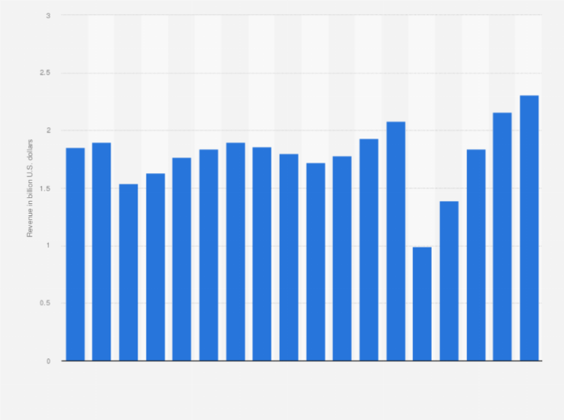
Figure 4: Revenue of the InterContinental Hotels Group (IHG) from 2007 to 2024
(Source: Statista, 2024)
This graph show that, as InterContinental Hotels Group, a UK-based multinational, achieved revenue of US$2.31 billion in 2024 compared to US$2.16 billion in 2023, it is clear that initiatives such as their Service Excellence and Staff Training Program, which improves the guest experience through skilled employees, have made significant contributions to financial success by increasing customer satisfaction (IHG, 2023).‌

Pricing Review and Value Proposition Enhancement
The hotel’s pricing and service concerns have had a significant impact on its reputation, with many guests commenting that room rates and food and beverage prices are not in line with the quality and range of services provided(Herriot et.al, 1997). To address this issue, the hotel should follow a detailed pricing and competitor analysis process, which will assess competitors’ pricing and create value packages for guests, such as additional benefits such as inclusive breakfast or late check-out (‌Avelar et.al, 2020). In addition, IHG’s total revenue grew by 3.78% in the past year, and their UK occupancy rate was 66.7% in the first quarter of 2025, up 0.6% from the previous year. In light of these changes, using dynamic pricing tools will allow the hotel to respond flexibly to changes in demand and maintain profitability (The4, 2025). Marketing campaigns will showcase the benefits of the new packages, eliminating any confusion or frustration among guests (Team, 2024).
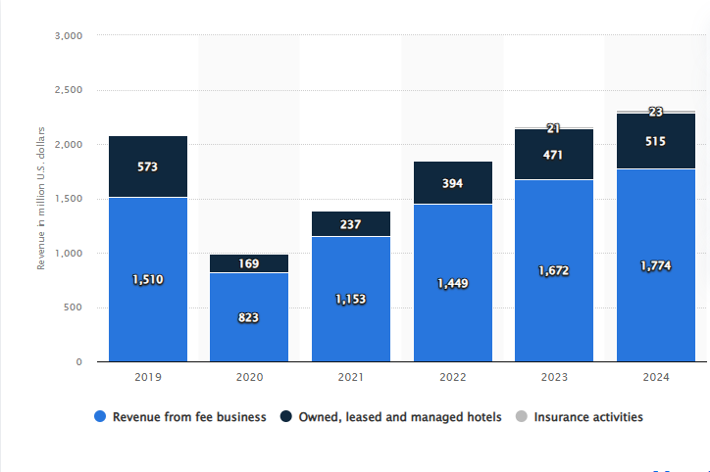
Figure 5: Revenue of the InterContinental Hotels Group (IHG) from 2007 to 2024
(Source: Statista, 2021)
As per the figure, As InterContinental Hotels Group generated revenue of US$515 million from its owned, leased and operated hotels and approximately US$1.77 billion from its fee-based business in 2024, it is clear that its strategic pricing review and value proposition development initiatives have optimized revenue streams as well as increased brand appeal among diverse customer segments (Statista, 2021).

‌Room Maintenance and Infrastructure Upgrade
Guest dissatisfaction with room size, layout, and bathroom amenities can pose a serious risk to a hotel’s brand image, which can have a detrimental impact on hotel quality and customer satisfaction. For this reason, a well-planned and phased renovation program is recommended, starting with the rooms that have received the most complaints. These renovations will focus primarily on bathroom functionality and modernization, with particular emphasis on improving water pressure, lighting upgrades, and furniture modernization (NerdWallet, 2025). After Iberostar hotels were included in the IHG system, the number of openings increased by 27% year-on-year in the fourth quarter and signings increased by 50%, marking one of the largest quarters for growth activity. If these changes can be made during low occupancy, operational disruptions will be minimal and operations will continue (Bbborg, 2024). In addition, it is important to provide staff with proper training on new room features and upgraded amenities so that they can communicate properly with guests, and provide specific scripts to inform guests about the renovations. Effective communication is essential for change management, as 303 of the 970 total complaints over the past three years have been resolved in the past 12 months, but the breakdown of complaints by room type or specific location is not presented. To accurately measure the impact of the renovation, it is essential that guest feedback is collected post-renovation and compared with previous room ratings (Bellrock, 2018).

‌Strategic Partnership for Wellness Amenities
The hotel’s service offering lacked a spa or pool, which was not particularly in line with its luxury branding. Rather than investing in high-priced amenities, InterContinental Hotels Group (IHG), which markets itself as IHG Hotels & Resorts, could offer wellness services to guests by forming a partnership with a reputable spa (Investorschronicle, 2025). The partnership would include negotiated rates for guests, a matching stay-and-spa package, and perhaps transportation to the spa location. This strategy would provide the hotel with multiple opportunities to enhance its value proposition, but would not require any capital expenditure to build new wellness infrastructure. Employees would need to be fully informed about the packages and be able to confidently promote them (IHG, 2019). IHG reported $2.312 billion in revenue in 2024, which came from reportable segments. This revenue includes a royalty fee of 5-6% of a hotel’s room revenue and a base fee of 1-3% of gross revenue in a typical franchise agreement. In addition, contributions to the system fund and valuations were $2.611 million in 2024. The initial marketing and support costs for this initiative will be approximately £1,500.

‌Change Management Framework
A well-structured and effective change management strategy is essential to ensure the smooth transition of change in an organisation. Through Lewin’s change management model, the hotel can manage this process of change in a way that ensures the overall effectiveness of the organisation and the long-term benefits for its employees. According to the 2017 UK Business Counts, micro-enterprises (0-9 employees) were 47.3%, and small companies (10-49 employees) were 38.8%, highlighting the expansion of business diversity and the need for strategic implementation at different levels (López-Andreu et.al, 2019). Lewin’s model precisely defines the three main pillars of the change process—preparation, implementation, and sustainability—which effectively play a role in accelerating and consolidating the internal change process of the organisation (Volberda et.al, 2014).
‌In the context of staff training, for example, the hotel can apply Lewin's three-step model as follows:
- Unfreeze: Before the hotel starts the employee training process, it will first create awareness about the importance of training and its benefits, so that the employees and the overall performance of the hotel can be improved (Antony et.al, 2021). The completed response rate was 29.4%, but according to the 20% survey, it is not possible to ensure the improvement of the skills of the employees at every level of the business without employee training, and this training is seen as essential.
- Change: When employees start participating in training, the training program can be launched; at this stage, training materials such as workshops, online courses or hands-on sessions will be provided, tailored to the specific needs of the hotel (Fernandes, 2021). For example, the hotel may introduce new technologies to improve customer service training or work to increase operational efficiency.
- Refreeze: After the experience is complete, the hotel will manage the reinstatement process by incorporating new behaviors and practices into daily routines (Maclean et.al, 2017). For example, managers can organize follow-up sessions to assess how well employees have mastered the training while providing ongoing support, which will further solidify the changes achieved.
IHG’s commitment to employee engagement, reflected in a score of 87% in the 2023 Colleague Heartbeat Survey, demonstrates how an organisation can prioritise employee development and address concerns about high turnover (Job, 2025). IHG initiatives such as the IHG Academy, which has trained more than 90,000 young people, including 43,000 in 2024, demonstrate the effectiveness of a strong training and engagement strategy.

Monitoring and Evaluation
Measuring the impact of each recommendation is crucial, as it provides an opportunity to assess the effectiveness of recommendations, which are dependent on various aspects of the business. IHG’s fastest growing premium hotel brand, voco hotels, launched in 2018 and has quickly become IHG’s fastest growing global brand; voco, known for its unique charm and distinctive experience, combines the charm of a stand-alone hotel with the quality of a global brand, and for this reason has been acclaimed worldwide. IHG says that voco was recognized as the world’s top premium hotel brand at the 2021 World Travel Awards, which is further testament to its popularity and reputation (InterContinental Hotels Group PLC, 2024). While the employee engagement rate is 82%, this may not be a direct reflection of turnover, as the company places a strong focus on employee career development and advancement, which helps ensure the satisfaction and retention of its employees (True Hospitality Good for Contents, 2025).
To assess the success of the proposals, a change success dashboard should track the following key performance indicators (KPIs) in depth, so that the results can be statistically and analytically evaluated:
- Net Promoter Score (NPS): This is an indicator of guest satisfaction and sentiment, which helps to evaluate the success of the whole guest involvement by gauging the guests' reactions to the service and their likelihood to recommend the hotel in the future (Shah et.al, 2014).
- Service Complaint Rate: This provides accurate nursing of the hotel's service quality, so that it is possible to review the presentation of service providers and propose recommendations for improvement in light of each complaint.
- Employee Turnover Rate: This is cooperative in determining the success of employee retention and organizational relatives, as it proves the long-term attractive environment and employment security for the organization's employees (Santos et.al, 2016).
- Training Participation Rate: This provides a measure of employee participation in training and development initiatives, which helps to analyze their attention and commitment in terms of employee engagement and better-quality performance.
- Room Occupancy Rate: This is a measure of operational success Key indicators, which help determine the potential for revenue growth or decline by calculating the overall efficiency of the hotel's room running and guest flow.

‌ Action Plan
As InterContinental Edinburgh The George Hotel faces a number of operational and reputational challenges, a targeted and realistic action plan has been adopted to address these issues sustainably, including initiatives such as the introduction of an extensive training programme for staff, a phased room refurbishment, a strategic review of pricing, the creation of wellness partnerships and the development of digital reputation management, with the aim of increasing guest satisfaction, aligning the brand’s luxury standards and ensuring customer loyalty through long-term revenue growth in a competitive market (IHG, 2023).

Below is an example of an action plan presented in a table
Problem | Solution | Desired Outcome | Time Scale | Estimated Cost
Inconsistent service quality | Launch Service Excellence & Staff Training Program | Improve guest satisfaction and review scores | 3–6 months | £75,000 for training programs and workshops
Outdated rooms and infrastructure | Phased renovation of high-complaint areas | Enhance comfort, align rooms with brand standards | 6–18 months | £1.2–1.5 million depending on scope
Misaligned pricing/value perception | Conduct strategic pricing review & redefine value proposition | Restore trust and attract price-sensitive guests | 2–3 months | £30,000 (consulting and analysis)
Lack of wellness amenities | Establish local spa/wellness partnerships | Improve guest experience without major CAPEX | 1–2 months | £10,000 (negotiation and branding integration)
Poor online reputation management | Assign a dedicated digital response team | Improve engagement, enhance digital visibility | Immediate to 3 months | £20,000 annually (staff and tools)

Conclusion
This advisory report provides a comprehensive analysis of the key challenges facing InterContinental Edinburgh The George, including the hotel’s service quality, ageing infrastructure and unbalanced operational standards impacting its inexpensive position, which are a major setback to IHG’s strong global performance. The most notable of these challenges are poor digital image management and high staff turnover, which have been exacerbated by rising industry costs and changing customer expectations in the post-COVID era.
The proposed action plan focuses on achieving service excellence, modernising infrastructure and improving digital image management, with success measured by restoring customer satisfaction, significant enhancements in service delivery and growth in financial performance. However, there are some risks related to potential implementation delays, staff confrontation and initial speculation requirements, which can be strategically overcome with the right leadership and long-term commitment, and will allow the hotel to be revitalised, while ensuring a sustainable growth path in line with IHG's luxury brand values.
This advisory report provides a comprehensive and in-depth analysis of the current challenges and strategic opportunities facing InterContinental Edinburgh The George, where multiple complex factors are interrelated. While InterContinental Hotels Group (IHG)’s overall performance is strong, particularly with increasing RevPAR, consistent profits growth and a loyal international customer base, Edinburgh The George’s performance is not in line with these global trends. The main findings outlined in this report highlight a number of interrelated issues that, if not addressed appropriately, could pose serious challenges to the hotel’s long term position in a highly competitive & challenging market.
However, InterContinental Edinburgh The George has some vital strengths that could help to change this situation, such as its location on George Street, a historically significant building, and the consistent presence of events and high-spending international guests. Furthermore, the strength of the IHG One Rewards loyalty program, the commitment of long-standing employees, and the support of a worldwide brand create a strong foundation for the future growth of the organization, which could serve as a solid step towards changing this situation.
A strategic action plan has been proposed to address the current challenges, emphasizing actions such as targeted worker training to achieve service excellence, phased infrastructure development, digital reputation management, wellness partnerships, and realignment of pricing strategies. These actions have been organized in a way that they are realistic, cost-effective, and achievable within a specified timeframe, ranging from short-term gains to long-term transformation goals. If all these activities are effectively implemented, The George will be able to rebuild its customers’ trust, improve service quality, & strengthen its brand identity consistent with InterContinental Hotels’ luxury positioning. Ultimately, it can be said that while the impact of the challenges faced by InterContinental Edinburgh The George is significant, they can be overcome with the right strategy and full focus.

Reference List
Alexios-Patapios Kontis and Ioannidis, K. (2025). Metaverse Tourism: An Overview of Early Adopters’ Drivers and Anticipated Value for End-Users. Tourism and Hospitality, 6(2), pp.86–86. doi:https://doi.org/10.3390/tourhosp6020086.
Anon, (2025). Equity Research on Intercontinental Hotels Group PLC- Enduring the Implications of Covid-19 - ProQuest. [online] Available at: https://www.proquest.com/openview/e210bfe3c3350a28aa95ff64e8718686/1?pq-origsite=gscholar&cbl=2026366&diss=y [Accessed 3 Aug. 2024].
Antony, J., Sony, M., McDermott, O., Jayaraman, R. and Flynn, D. (2021). An exploration of organizational readiness factors for Quality 4.0: an intercontinental study and future research directions. International Journal of Quality & Reliability Management. doi:https://doi.org/10.1108/ijqrm-10-2021-0357.
Antunes, M.T.B., 2023. How to Support a 5-star Hotel in Lisbon to Attract and Retain Talent? What Are the Key Factors That Hotels Should Take Into Consideration When Developing and Implementing Talent Retention Strategies to Match the Demands of Today’s Workforce? (Master's thesis, Universidade NOVA de Lisboa (Portugal)).
‌Avelar, P.A.S. and Martins, T.R., 2020. Hotel Industry Growth Trends–The Case of Intercontinental Hotels Group (Master's thesis, Universidade NOVA de Lisboa (Portugal)).
Bbb.org. (2024). InterContinental Hotels Group. [online] Available at: https://www.bbb.org/us/ga/atlanta/profile/hotels/intercontinental-hotels-group-0443-4567/complaints [Accessed 22 May 2025].
Bellrock (2018). Bellrock wins deal with InterContinental Hotels Group. [online] Bellrock Property & Facilities Management Limited. Available at: https://www.bellrockgroup.co.uk/bellrock-win-deal-intercontinental-hotels-group/ [Accessed 22 May 2025].‌
Camilleri, M.A. (2018). Travel Marketing, Tourism Economics and the Airline Product. [online] Tourism, Hospitality & Event Management. Cham: Springer International Publishing. doi:https://doi.org/10.1007/978-3-319-49849-2.
Cbre.com. (2024). Slowing RevPAR Growth Makes Hotel Brand Selection More Critical. [online] Available at: https://www.cbre.com/insights/reports/hotel-brand-performance-2024.
Chen, X., 2022. Location Strategies of Multinational Hotel Groups in China: An Application of Game Theory.
Chodor, D. (2024). Enhancing Well-Being in Transit - Epsilon Archive for Student Projects. Epsilon.slu.se. [online] doi:https://stud.epsilon.slu.se/20702/.
Collings, D. G., McDonnell, A., & Scullion, H. (2009). Global talent management: the law of the few. Poznan University of Economics Review, 9(2).
de Haast, A., Busquet, A. and Cescau, P., INTERCONTINENTAL HOTELS GROUP PLC. Policy, 112, pp.77-14.
Fernandes, F. (2021). Intercontinental Hotels Group - Time to Check-In - ProQuest. [online] Available at: https://www.proquest.com/openview/5c61b3410b66a714c863c054e647c987/1?pq-origsite=gscholar&cbl=2026366&diss=y.
Fernandes, F. (2021). Intercontinental Hotels Group - Time to Check-In - ProQuest. [online] Available at: https://www.proquest.com/openview/5c61b3410b66a714c863c054e647c987/1?pq-origsite=gscholar&cbl=2026366&diss=y.
Genter, K. (2024). IHG elite status: What it is and how to earn it - The Points Guy. [online] The Points Guy. Available at: https://thepointsguy.com/loyalty-programs/what-is-ihg-elite-status-worth/.
Hardy, J. (2021). Branded Content. The Fateful Merging of Media and Marketing. doi:https://doi.org/10.4324/9781315641065.
Harwood, S. (2021). An Audit of a UNESCO World Heritage site - the Royal Mile, Edinburgh: a preliminary search for authenticity: Three years later (2014). [online] University of Edinburgh Research Explorer. Available at: https://www.research.ed.ac.uk/en/publications/an-audit-of-a-unesco-world-heritage-site-the-royal-mile-edinburgh-4 [Accessed 23 Jul. 2025].
Herriot, P., Manning, W & Kidd, J. (1997). “The content of the psychological contract”. British Journal of Management. Iss 8, p51-62.
Hiatt, J. M. (2006). ADKAR: a model for change in business, government and our community. Prosci Learning Center.
Hofstede, G. (1983). “Cultural relativity of organizational practices and theories”. Journal of International Business Studies. Fall, p75-89.
IHG (2019). How our business works. [online] InterContinental Hotels Group PLC. Available at: https://www.ihgplc.com/en/about-us/how-our-business-works.
IHG (2023). How we’re creating Room to Belong PROGRESS REPORT. [online] Available at: https://www.ihgplc.com/~/media/Files/I/Ihg-Plc/responsible-business/reporting/2024/2023%20Progress%20Report.pdf.
IHG (2023). Provide True Hospitality for Good To be the hotel company of choice for guests and owners HOW WE MAKE IT HAPPEN AMBITIOUS DEDICATED COURAGEOUS RELENTLESS FOCUS ON GROWTH BRANDS GUESTS AND OWNERS LOVE LEADING COMMERCIAL ENGINE CARE FOR OUR PEOPLE, COMMUNITIES AND PLANET CARING OUR GROWTH BEHAVIOURS Our strategy Strategic Report. [online] Available at: https://www.ihgplc.com/~/media/Files/I/Ihg-Plc/investors/annual-report/2023/our-strategy-2023.pdf.
IHG (2024). About us. [online] InterContinental Hotels Group PLC. Available at: https://www.ihgplc.com/en/about-us.
IHG (2024). Annual Report. [online] InterContinental Hotels Group PLC. Available at: https://www.ihgplc.com/en/investors/annual-report.
IHG. (n.d.). IHG | Frequently Asked Questions. [online] Available at: https://www.ihg.com/content/us/en/customer-care/frequently-asked-questions [Accessed 11 Jul. 2021].
InterContinental Hotels Group PLC. (2024). Full Year Results for the year to 31 December 2024. [online] Available at: https://www.ihgplc.com/en/news-and-media/news-releases/2025/full-year-results-for-the-year-to-31-dec-2024.
InterContinental Hotels Group PLC. (2025). Q1 Trading Update to 31 March 2025. [online] Available at: https://www.ihgplc.com/en/news-and-media/news-releases/2025/first-quarter-trading-update-to-31-march-2025 [Accessed 11 May 2025].
Investorschronicle.co.uk. (2025). InterContinental Hotels Group PLC (IHG:LSE) Share price, analysis, charts, news, dividends, EPS forecasts, annual reports and RNS - Investors Chronicle. [online] Available at: https://markets.investorschronicle.co.uk/data/equities/tearsheet/forecasts?s=IHG:LSE [Accessed 22 May 2025].
Jackson, P. & Harris, L. (2003) “E-business and organizational change: Reconciliing traditional values with business transformation”. Journal of Organizational Change Management. Vol 16, Iss 5, p497.
Jaecker, C., 2023. Sustainability Certifications in the Hotel Industry: Characteristics, Motivations and Risks Case Study–InterContinental Lisbon and the Green Key Certification (Master's thesis, Universidade NOVA de Lisboa (Portugal)).
Janse, B. (2019). Jay Galbraith’s Star Model, a powerful strategy tool | toolshero. [online] toolshero. Available at: https://www.toolshero.com/management/jay-galbraiths-star-model/.
Job, R.T. (2025). Holiday Inn owner IHG confident US domestic demand will deliver profit growth . Reuters. [online] 9 May. Available at: https://www.reuters.com/business/intercontinental-hotels-global-room-revenue-rises-first-quarter-2025-05-08/.
Kipsu.com. (2024). TripAdvisor reviews show that IHG guests love guest messaging! | Kipsu. [online] Available at: https://www.kipsu.com/blog/tripadvisor-reviews-show-that-ihg-guests-love-guest-messaging [Accessed 22 May 2025].
Kwan, M. and Tong, L., 2023. EXEMPLARY SERVICES AND INSPIRING LEADERSHIP: CASE OF INTERCONTINENTAL ZHUHAI HOTEL, IHG. Gulf Journal of Advance Business Research, 1(2), pp.94-109.
Labs, P. (2025). IHG Independent Hotels IHG Chain Demographics and Foot Traffic Insights. [online] Placer.ai. Available at: https://www.placer.ai/chains/ihg-independent-hotels [Accessed 22 May 2025].
Lesh, J. and Nichols, D. (2023). Destruction, Development and Heritage in Melbourne. Routledge eBooks, pp.372–383. doi:https://doi.org/10.4324/9781003131069-33.
Liberato, D., Oliveira, M., Cardoso, R. and Liberato, P., 2023. An Approach to Revenue Management Strategies in the Hospitality Industry. In Advances in Tourism, Technology and Systems: Selected Papers from ICOTTS 2022, Volume 2 (pp. 639-650). Singapore: Springer Nature Singapore.
Linkedin.com. (2024). LinkedIn. [online] Available at: https://www.linkedin.com/company/ihghotels&resorts.
López-Andreu, M. and Hamedani, M. (2019). HOW HAS THE UK HOTELS SECTOR BEEN AFFECTED BY THE FISSURING OF THE WORKER- EMPLOYER RELATIONSHIP IN THE LAST 10 YEARS? Final Report.
Maclean, M., Harvey, C., Suddaby, R. and O’Gorman, K. (2017). Political ideology and the discursive construction of the multinational hotel industry. Human Relations, 71(6), pp.766–795. doi:https://doi.org/10.1177/0018726717718919.
momondo. (2025). Eden Andalou Aquapark & Spa. [online] Available at: https://www.momondo.co.uk/hotels/marrakesh [Accessed 22 May 2025].
Morningstar.co.uk. (2025). Available at: https://tools.morningstar.co.uk/uk/stockreport/newsItem.aspx?id=LSE20250508070008_5645302 [Accessed 22 May 2025].
Murphy, K. (2024). Using the TOWS Matrix for Strategy Formulation. [online] Kyle C. Murphy. Available at: https://kylemurphy.com/2024/02/15/using-the-tows-matrix-for-strategy-formulation/.
NerdWallet. (2025). IHG vs. Marriott: Which is Right For You? [online] Available at: https://www.nerdwallet.com/article/travel/ihg-vs-marriott.
Omoge, A.P., Gala, P. and Horky, A. (2022). Disruptive technology and AI in the banking industry of an emerging market. International Journal of Bank Marketing, 40(6). doi:https://doi.org/10.1108/ijbm-09-2021-0403.
Please cite the Published Version. (2025). Available at: https://e-space.mmu.ac.uk/623723/1/Sultan%20Alzyoud%20PhD%20Thesis%202019%20Psychological%20Safety%20and%20Employee%20Innovation%20in%20Four%20and%20Five%20Star%20Hotels.%20Updated.pdf [Accessed 3 Oct. 2023].
Proquest.com. (2023). How to Support a 5-star Hotel in Lisbon to Attract and Retain Talent? What Are the Key Factors That Hotels Should Take Into Consideration When Developing and Implementing Talent Retention Strategies to Match the Demands of Today’s Workforce? - ProQuest. [online] Available at: https://www.proquest.com/openview/70fb41e697ecae62829ca923d50167e5/1?pq-origsite=gscholar&cbl=2026366&diss=y [Accessed 23 Jul. 2025].
Prosci (2024). Use the ADKAR Model for Change Success. [online] Prosci.com. Available at: https://www.prosci.com/blog/adkar-model.
Rafael (2022). Equity research - InterContinental Hotels Group. Ulisboa.pt. [online] doi:http://hdl.handle.net/10400.5/26913.
Richardson, S., Jovanka, F., Zabrina, P.K., Adiati, M.P. and Rosman, D., 2023, July. The Consequences of Digital Concierge Chatbots Acceptance on Hotel Guest Experience and Satisfaction at IHG Hotel and Resort. In 2023 International Conference on Digital Applications, Transformation & Economy (ICDATE) (pp. 1-5). IEEE.
Rotimi, A. (2018). Impact of the uses of various technologies on the thermal performance and energy efficiency of UK hotel buildings: application to Hilton hotels in the UK - UWL Repository. Uwl.ac.uk. [online] doi:https://repository.uwl.ac.uk/id/eprint/6271/1/Abdulazeez_Rotimi_Final_Thesis_%28Oct_2018%29.pdf.
Santos, C. M., Passos, A. M., & Uitdewilligen, S. (2016). When shared cognition leads to closed minds: Temporal mental models, team learning, adaptation and perfor-mance. European Management Journal, 34(3), 258-268.
Shah, M. H. (2014). An application of ADKAR change model for the change management competencies of school heads in Pakistan. Journal of Managerial Sciences, 8(1).
ShareScope Articles. (2018). Stock Watch: InterContinental Hotels - ShareScope Articles. [online] Available at: https://knowledge.sharescope.co.uk/2018/05/09/stock-watch-intercontinental-hotels/ [Accessed 22 May 2025].
Statista (2024). IHG: gross revenue by brand 2019. [online] Statista. Available at: https://www.statista.com/statistics/298806/gross-revenue-of-intercontinental-hotels-group-by-brand/.‌
Statista (2024). IHG: revenue 2019. [online] Statista. Available at: https://www.statista.com/statistics/273254/revenue-of-the-intercontinental-hotels-group/.
Statista. (n.d.). IHG revenue by ownership type 2021. [online] Available at: https://www.statista.com/statistics/223419/intercontinental-hotels-group-revenue-by-segment/.
Team, D. (2024). Mission Statement, Vision, & Core Values (2024) of InterContinental Hotels Group PLC (IHG). [online] DCF, SWOT, CANVAS, PESTEL, BCG Editable Templates. Available at: https://dcfmodeling.com/blogs/vision/ihg-mission-vision.
The Caterer. (2024). IHG reports revpar boost amid ‘strong’ demand... [online] Available at: https://www.thecaterer.com/news/ihg-revpar-boost-full-year-results.
The4 (2025). InterContinental Hotels Group PLC (IHG): Marketing Mix [Jan-2025 Updated]. [online] DCF, SWOT, CANVAS, PESTEL, BCG Editable Templates. Available at: https://dcfmodeling.com/products/ihg-marketing-mix.
THOUGHT LEADERS. (2019). Available at: https://www.amcham.gr/wp-content/uploads/2019/09/BP103.pdf [Accessed 23 Jul. 2025].
Tran, N.H. (2020). Employee Motivation (Case: InterContinental Danang Sun Peninsula Resort, Vietnam). Theseus.fi. [online] doi:http://www.theseus.fi/handle/10024/340591.
True Hospitality Good for Contents. (n.d.). Available at: https://www.ihgplc.com/~/media/Files/I/Ihg-Plc/investors/annual-report/2024/ihg_rbr_24-25_interactive.pdf.
UWL REPOSITORY. (2025). Available at: https://repository.uwl.ac.uk/id/eprint/9212/1/Shiva%20Amirkhani%20thesis.pdf [Accessed 8 Apr. 2025].
Voegeli, C., 2021. A Case Study of Knowledge Management Practices at the Intercontinental Hotels’ Group. Available at SSRN 3819409.
Volberda, H. W., Van Den Bosch, F. A., & Mihalache, O. R. (2014). Advancing manage- ment innovation: Synthesizing processes, levels of analysis, and change agents. Organization Studies, 35(9), 1245-1264.
Zendesk. (2020). Organizational change management: 8 proven models to navigate change. [online] Available at: https://www.zendesk.com/in/blog/change-management-models/.

