Christmas Party Night 2022

TO BEGIN
Spiced carrot and Lentil Soup
Artisan Seasoned Bruschetta & a sprinkle of toasted spices (v, ve, gf)
Smoked Salmon Carpaccio
Beetroot, orange, and horseradish cream & Mixed Leaf Salad (gf, nut-free, egg-free)
Stuffed Portobello Mushrooms
Warming Nutmeg, tangy cranberry cheese & Salad (v, gf)
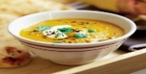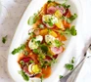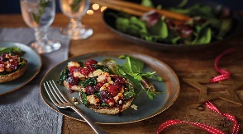
THE MAIN EVENT
Tasty Spiced Pork Loin with Asparagus
Black Pudding sauce & Spiced January King Cabbage (gf, lf, df)
Tender Roast Turkey Ballontine
with flavors of sage, pork, and chestnut stuffing (gf, lf, df)
Sweet Potato Roulade with Cajun Spices
Vegan Cream Cheese, red pepper & red onion chutney (v, ve, gf)
All main dishes are served with potatoes and Seasonal Vegetables
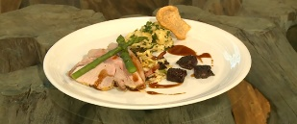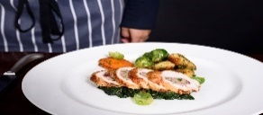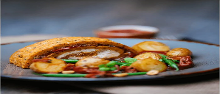
SWEET MOMENTS
Traditional Christmas Pudding with Brandy Sauce (gf, lf, v, ve)
Creamy Vanilla Cheesecake
Fresh blueberries & delicious homemade blueberry compote (gf)
Welsh cheesecakes
Filled with Blackcurrant Jam & Sprinkled with icing sugar (v)
Indulgent Dark Chocolate Delice
Chocolate Soil & Mint Icecream (gf, ve)
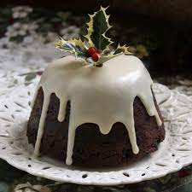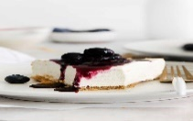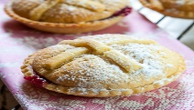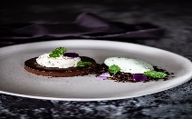
(DF: Dairy Free, GF: Gluten Free, LF: Lactose-Free, V: Vegetarian, VE: Vegan)

Christmas Kids Menu
Starters
Creamy Pumpkin Soup (french style bread roll and a garnish of crème freche – optional)
Rosette of Melon (mixed berry compote and a drizzle of mango coulis)
Mains
Christmas Platter (crispy chicken nuggets, salmon and leek mini parcels, pigs in blanket with a side of fries or mash potato)
Rich Tomato Spaghetti (topped lightly with cheese and served with a side of fresh salad)
Desserts
Mini Yule Logs (topped with chocolate icing and icing sugar)
Profiteroles (drizzled with a creamy chocolate sauce)
Ice cream & Mini Muffins (chocolate, vanilla, strawberry, mixed berry, bubblegum, and dairy-free ice cream)
Christmas Drinks Packages
Bronze | Sparkling | Gold | Beer Essentials
2 Bottles of Pinot Grigio | 3 Beer Buckets (15 Bottles) | 1 Bottle of Pinot Grigio | 12 Bottles of Peroni
2 Bottles of Merlot | 2 Bottles of Prosecco | 2 Bottles of Merlot | 12 Bottles of Corona
1 Bottle of Rose | 1 Bottle of Grey Goose | 1 Bottle of Rose
1 Bottle of Prosecco | 1 Bottle of Champagne | 2 Bottles of Champagne
 | 1 Bottle of Water | 15 Bottles of Corona
 |  | 2 Bottles of Water
£115 | £155 | £185 | £130
The all-inclusive Drinks Menu is available upon request.
A delicious traditional 3-course festive dinner accompanied by mince pies, freshly made tea, or filtered coffee.
£74.95 per adult | £24.95 per child 3-10 years (under 3` – free of charge)

Live entertainment is available. Photo Booth with Christmas & Party Props.
Arrive at 7.30 pm. Dinner served at 8 pm. Disco until 12.45 am
Only Smart Dress Code for the Event; No ripped jeans or Sneakers
Available dates in December: Friday 2nd, Saturday 3rd, Friday 9th, Saturday 10th, Friday 16th, Saturday 17th , Friday 23rd , Saturday 24th

A non-refundable reservation deposit applies - £10 per person. For Large Groups (over 30 people) a discount will be offered. Please enquire.
Enjoy a magical Christmas night with friends and family!
Bookings are now available. Please contact us at: christmas.reservations@hoteltrinity.co.uk
Wishing you a Merry Christmas!

POPA ANCA
2126967
Food & Beverage Operations (BMIH4002)
Tristan Hawkins

Reference List

Atwood, S. et al. (2020) Menu engineering to encourage sustainable food choices when dining out: An online trial of priced-based decoys, Vol. 149. Available at: https://www-sciencedirect-com.ezproxy.uwtsd.ac.uk/science/article/pii/S0195666319308335 (Accessed: 6 November 2022)
Boston, C. (2017) Roast Turkey Ballontine with Pork, Sage & Chestnut Stuffing by Adam Woolven at Island Grill, The Staff Canteen. Available at: https://www.thestaffcanteen.com/chefs-recipes/Roast-turkey-ballontine-with-pork--sage---chestnut-stuffing-by-Adam-Woolven-at-Island-Grill (Accessed: 9 November 2022)
Collins, E. (2022) Gluten-Free No-Bake Cheesecake, Meaningful Eats, 1st of July. Available at: https://meaningfuleats.com/gluten-free-no-bake-mini-cheesecakes/ (Accessed: 9 November 2022)
https://www.mountpleasant.co.uk/wp-content/uploads/2022/03/2022-Christmas-Brochure.pd Accessed 6 November 2022 (Accessed: 6 November 2022)
https://www.canva.com/templates/?query=christmas-menu (Accessed: 6 November 2022)
https://manage.wix.com/logo/maker/esh/brands/ee6adb94-dbd0-4af0-bed8-ce03013650b5/brands/studio?selectedWebsiteId=1 (Accessed: 8 November 2022)
https://www.template.net/editable/menus/printable (Accessed: 9 November 2022)
https://s3-eu-west-1.amazonaws.com/websites-wordpress-uploads/theearl.co.uk/wp-content/uploads/2022/07/Christmas_Brochure_2022_NEWDESIGN_v3_email_spreads.pdf (Accessed: 8 November 2022)
https://realfood.tesco.com/recipes/baked-mushrooms-with-festive-cheese.html
Linassi, R. et al. (2016) Menu engineering and activity-based costing: An improved method of menu planning, Vol.28. Available at: https://www.proquest.com/docview/1826443026/fulltextPDF/817BB5BA91244F43PQ/1?accountid=130472 (Accessed: 6 November 2022)
Moya (2012) Welsh Cheese Cakes, Food and Tools, 23rd June. Available at: https://foodandtools.com/2012/06/23/welsh-cheese-cakes/ (Accessed: 9 November 2022)
Walsh, C. (2016) Smoked salmon carpaccio, New Idea Food, 8th of February. Available at: https://www.newideafood.com.au/smoked-salmon-carpaccio (Accessed: 9 November 2022)

