
BEng. Motorcycle Motorsports Engineering
Integrating project – M3X01506

“The Secret V8 Project”

Abstract-

Our Goal was to design a Soap Box Racer (Gravity Racer) for use in competition at the Richards Castle event 2018. The intention of the team was to be competitive within the race given a very limited budget, together with factoring in our own talents to make it a ‘Team built’ exercise. The following pages will give insight into the teams plan to achieve this effectively.

Contents of this report

  - Intro to project
  - Intro to Team and specific job roles
  - Initial research into gravity racers and on other competitors
  - Research on Circuit
  - Body/Aero methodology
  - Frame design
  - Ergonomics
  - Steering
  - Tyres/wheels
  - Braking system
  - Suspension
  - Analysis
  - Conclusion

  - Introduction to project

Our aim from the start was to have a final product that was fully student built, and to have a competitive, reliable and efficient vehicle that could be built and maintained to a good standard for minimal budget, keeping in the theme of Soap Box racing.

  - Introduction to the team

Using our talents from past experiences along with our newly attained knowledge from UWTSD, We decided upon specific roles for one another.

NAME | ROLE
Connor Williams 1702252 | Team Leader / Researcher
Wayne Thomas 1704626 | Bodywork / Aerodynamics
Richard Green 1704571 | Wheels / Brakes / Fabrication Advisor
Mateusz Skoczylas 1704045 | Steering
Zack Church 1700054 | Suspension
Yahye Hussein 1703137 | Chassis

  - Our research into gravity racers

The research began by looking into the world record holder for gravity powered racing. We quickly discovered they look very different to the usual contenders due to mainly being designed for straight tracks rather than a typical soap box course as Fig.1 and 2 show. Fig.1 is the current fastest lap holder at Richards Castle, (Thomas, 2016) and his machine. (Thomas, 2016) Is also the owner of c12cfd, a composites engineering firm responsible for making prototype carbon wheels for (Dymag, n.d.) - And has experience in aerodynamics work for Group C prototype racing. We hoped to combine the technology of the world record contenders streamlined design with a more stereotypical soap box design to complete our target. (BodzRodz, 2017) were a company of extensive research and inspiration due to their extreme low drag streamlined designs achieving speeds of up to 100mph. Using an equation by (SCA, 2013) on MATLAB (fig.11) we played with frontal area, rolling resistance, mass, and other parameters that affect acceleration to see where the most improvement could be made. This confirmed the information we found by (SCA, 2013) on Fig.3 and Fig.4 about the effects of friction at varying speeds.

  - The Circuit

Plotting the course on Google maps allowed us to get the GPS coordinates to accurately recreate the track in a GPX file. This could then be used in free online software by (SCA, 2013) called CartieSim to gauge rates of acceleration, turning severity and areas where brakes were needed. This was found to be a great starting point for the areas of research by giving us theoretical figures to aim for. Fig.16 shows an aerial view of the track with colour indicating highest speed which also gave us braking zones, these matched perfectly with the footage we have seen of previous years racers, especially on red area on the long sweeping turn 3. This was an area we found to be very unstable for previous racers (Youtube, 2006) and an area of potential for us, keeping speed up in this area was a huge focus.

  - Aerodynamics and Bodywork

Using the data in Fig.11 we found an ideal compromise between frontal area (f.a) and driver seating angle, also using a specialist steering wheel (Fig.12) we found that we could achieve a very small f.a (fig.27) whilst still maintaining comfortable ergonomics (Fig.9) to help boost our rate of acceleration at speeds over 10MPH. An area we found to be beneficial considering our calculated speeds (fig.16). Fig.13 shows the effect of acceleration with an initial speed of 10mph with varying f.a’s plotted on the Y axis, it shows how much this affects acceleration. Fig.4 shows a simple hybrid design utilizing a small f.a and allowing our choice of wheels. This could be made in house using clay moulding followed by wet lay fibreglass. If needed a mould could be taken of the finished part to make spare bodywork readily available. This also allows for production of lightweight composite bodywork if found to be necessary and within budget and time constraints.

  - Frame Design

The initial frame design was based on a production circuit racing Go-Kart chassis with elongated ‘leg’ section, re-designed suspension mounts and added roll over protection as per the Rules and Regulations of the event. This could give similar results to the (BodzRodz, 2017) vehicles (Fig.7) and keep funds down that could be spent in other potential areas. We found that the modifications required would outweigh the cost saving benefits, and made our own design based on 30mm box section steel (Fig.8). Further simulation is required to fully understand the stress on sections of the material under load from braking and input from the suspension, but we feel it’s a good cost effective and most importantly simple design. Wheel base, track and frame length where decided and are shown on fig.26. This gave us the widest track possible taking inspiration from the racing success of the British Leyland Mini as put in an article by (Sports Car Digest, 2009), whilst still keeping within the guidelines set in the rulebook of overall vehicle length and width.

  - Ergonomics

Driver position isn’t normally considered a priority in such a specialised vehicle, as such it wasn’t very high on our list. It does however affect bodywork, steering, chassis and the overall dimensions of most elements of the vehicle and as such it should be considered. We choose an average height person to take measurements from and Fig.6 shows a rough overall length measurement being taken with the desired recline angle. We also took measurements for arm length and height to ensure we get the full range of steering approximately 30 degrees in either direction (Fig.9).

  - Steering

Driver input and gravity is the only thing getting us to the finish line. There is no throttle and little to no braking, the only input is steering. We went for an adjustable system to make it as precise as possible and to try and have some control of oversteer and understeer (fig.28). Narrowing down on actual figures will have to be done during testing, combined with toe, camber and caster during the initial phase. As 1.7 states we only have a small 30 degree window of steering movement so getting accurate control without ‘twitchy’ feel will be very important in the faster sections of the course. Our current design can adjust the angle of steering to driver feel. (fig.28)

1.9 Tyre & Wheels

The tyres were a talking point amongst the group because of the idea to go with a world record winning type design. In an ideal world we would have gone with a design similar to that of (Volvo, 2005) (fig.15), but a design that complex would be optimistic at best, for our budget and ability as a team. Unfortunately because of the low slope angle of the starting point in the race, the MATLAB acceleration figures with an initial speed of 0 MPH were so gradual, that when comparing the effect of rolling resistance on different types of tyres, that it made any change very insignificant (fig.14). For maximum acceleration we went for a design similar to that of a BMX bicycle wheel, with a low rolling resistance tyre. Although the side loading in corners will not allow for a spoke design, as research had shown in quite spectacular fashion that the wheel would fail. (Thomas, 2016) Used carbon composite wheels based on a 20” BMX wheel, this design seems to be a natural progression from a standard nylon wheel (fig.10) used by many others in the Soap Box Racing world. Wheel mass showed an impact on the rate of acceleration (fig11.1) so using a very light wheel is a place where easy speed can be gained, but also where catastrophic failure can easily occur if the desired strength is not obtained. To be confident in a design load simulations would have to be carried out prior to real world testing with production nylon wheels, unless funds allowed for a machined aluminium wheel of our own design.

1.10 Braking system

Our design for a braking system was mostly out of regulation rather than necessity, as we can’t add energy to the system so removing it seemed very wasteful. We firmly believe that you don’t win a race by going fast, you win by not going slow and with this philosophy we aim to make the kart agile enough that braking will be kept for emergencies only. The regulations state that there must be brakes on at least one axle, for stability we decided to go for both front and rear axles. A simple and commercially available hydraulic system would work nicely, combined with a bespoke foot brake and around a 70/30 bias to the front. Ideally with a proportioning valve to adjust whilst testing.

1.11 Suspension

Suspension was another highly debated subject, it could be a very time consuming and costly effort for a complex system. We looked at a lot of footage and found the track to be very bumpy in places with lots of surface gravel, as said with 1.9 the aim was to eliminate the need to brake so medium and slow speed corners would be taken without their use. For simplicity our research suggested a double wishbone design (fig.20). Combined with a suitable coil over shock suspension unit, this would give us complete adjustment of damping, compression adjustment on the spring, camber, toe and caster angle (fig.22). This design meant we could also ‘borrow’ the suspension units from the university’s other project in fig.21 in an attempt to keep costs down, or go with a more complex system to try and keep everything inboard, and have a more central mass as on fig.24. A more budget friendly option would be to have a simple single lower wishbone design with a rod that could have replaceable bushes at each end allowing for a simple way to change suspension rate (fig.25, fig.23), if at a much reduced level of optimisation during testing.

1.12 Analysis

Our numbers confirmed our initial research that data on fig.4 is correct. We feel that now our main goal would be to start testing. So far we only have theoretical numbers which we have faith in, but are yet to fully confirm with physical evidence. We have went with the most efficient wheels we can without compromising on strength and plan to go with ‘off the self’ options for an inner tube and tyre. This gives us the flexibility to choose from a few different options. An efficient and easy to manufacture body shell of our own design, which still maintains a good level of view for the driver and is also within regulation.

1.13 Conclusion

We believe we have done sufficient research and that our design is at a position for us to start construction on areas of the project. Some simulation and testing is needed in other areas but we think this can be done within budget and within the time frame allowed.

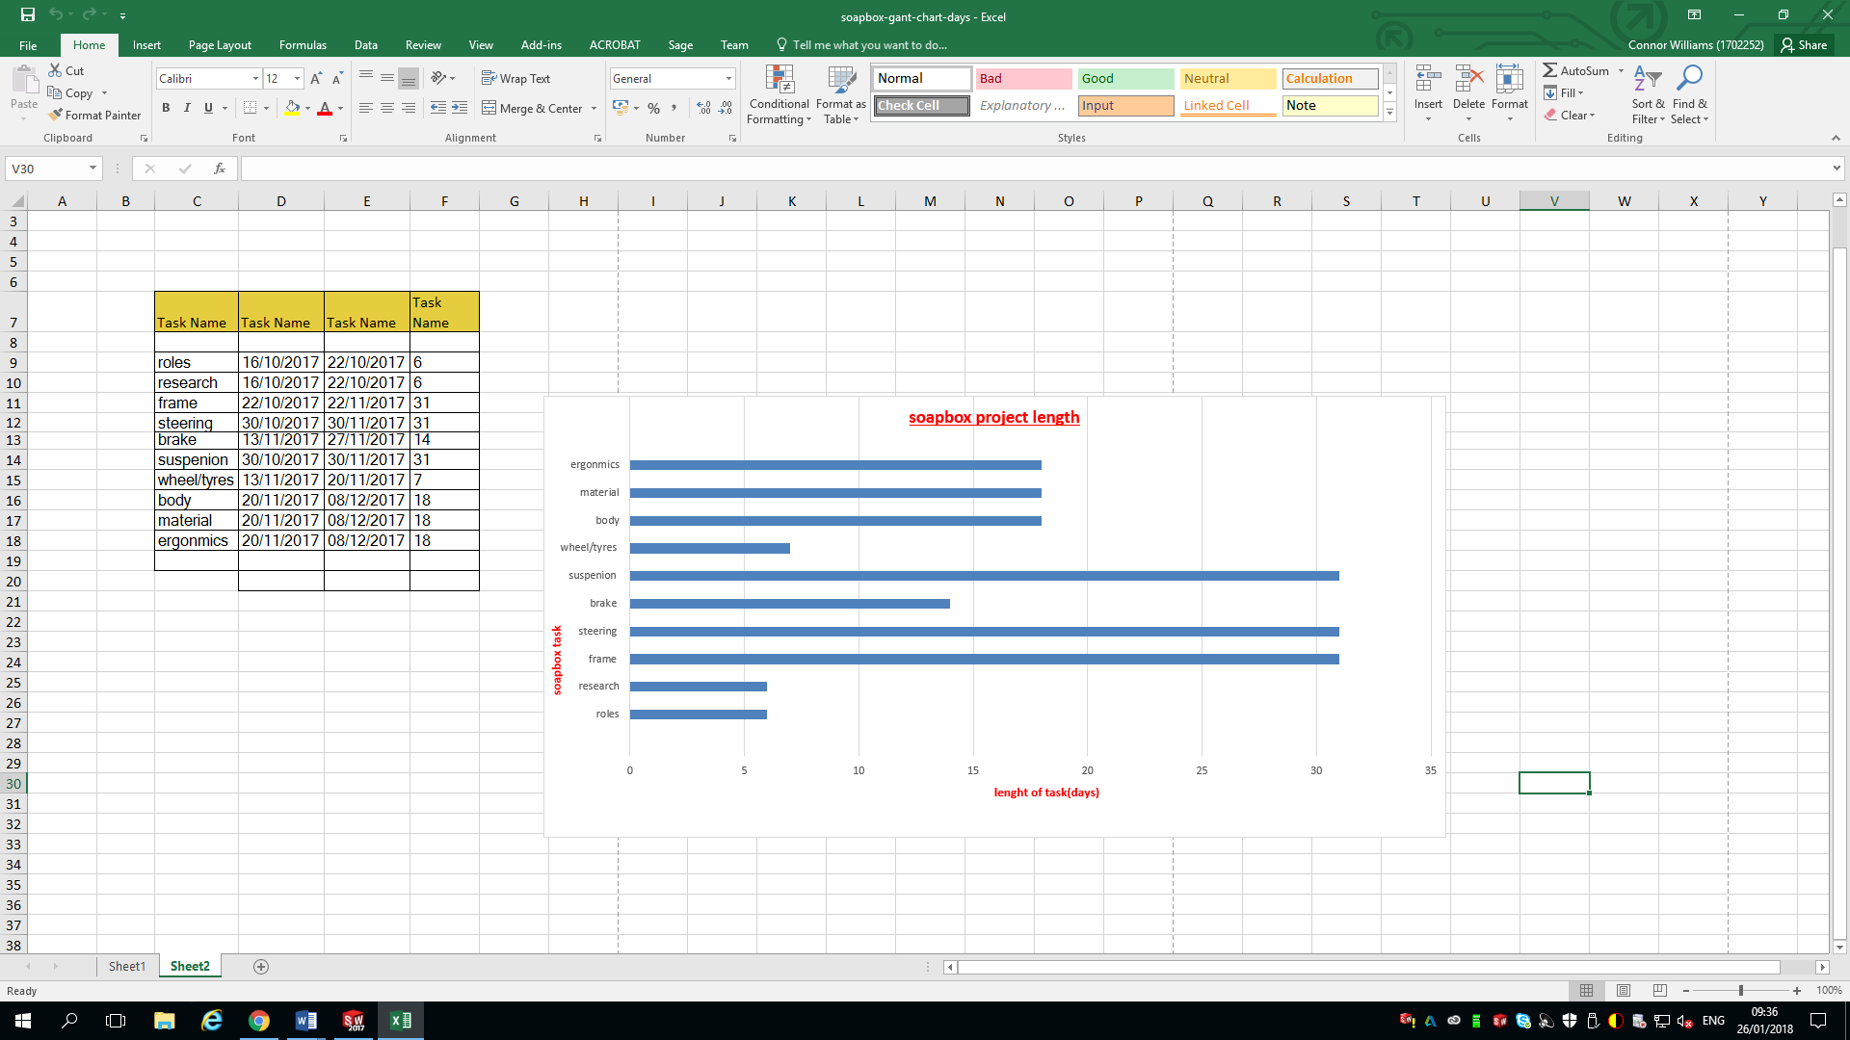

References
BodzRodz, 2017. [Online]
Available at: http://bodrodz.weebly.com/
Dymag, n.d. [Online]
Available at: www.dymag.com
SCA, 2013. Soap box racer physics. [Online]
Available at: http://scottishcarties.org.uk/resources/how_to_build_a_soapbox_racer/soapbox_racer_physics
[Accessed 2017].
Sports Car Digest, 2009. Mini Turns 50 – Racing History and Photo Gallery. [Online]
Available at: http://www.sportscardigest.com/mini-cooper-birthday-racing-history-photo-gallery/
[Accessed 2017].
Thomas, S., 2016. [Online]
Available at: http://www.c12cfd.co.uk/
Volvo, 2005. Volvo Takes Grand Prize for Fastest Car in 2005 Extreme Gravity Competition. [Online]
Available at: http://www.swedespeed.com/news/publish/Volvo_News/article_626.html
[Accessed 2017].
Youtube, 2006. Richards Castle Soap Box Crashes 2006. [Online]
Available at: https://www.youtube.com/watch?v=X72rUV4On3c
[Accessed 2017].

Researched figures & Sources

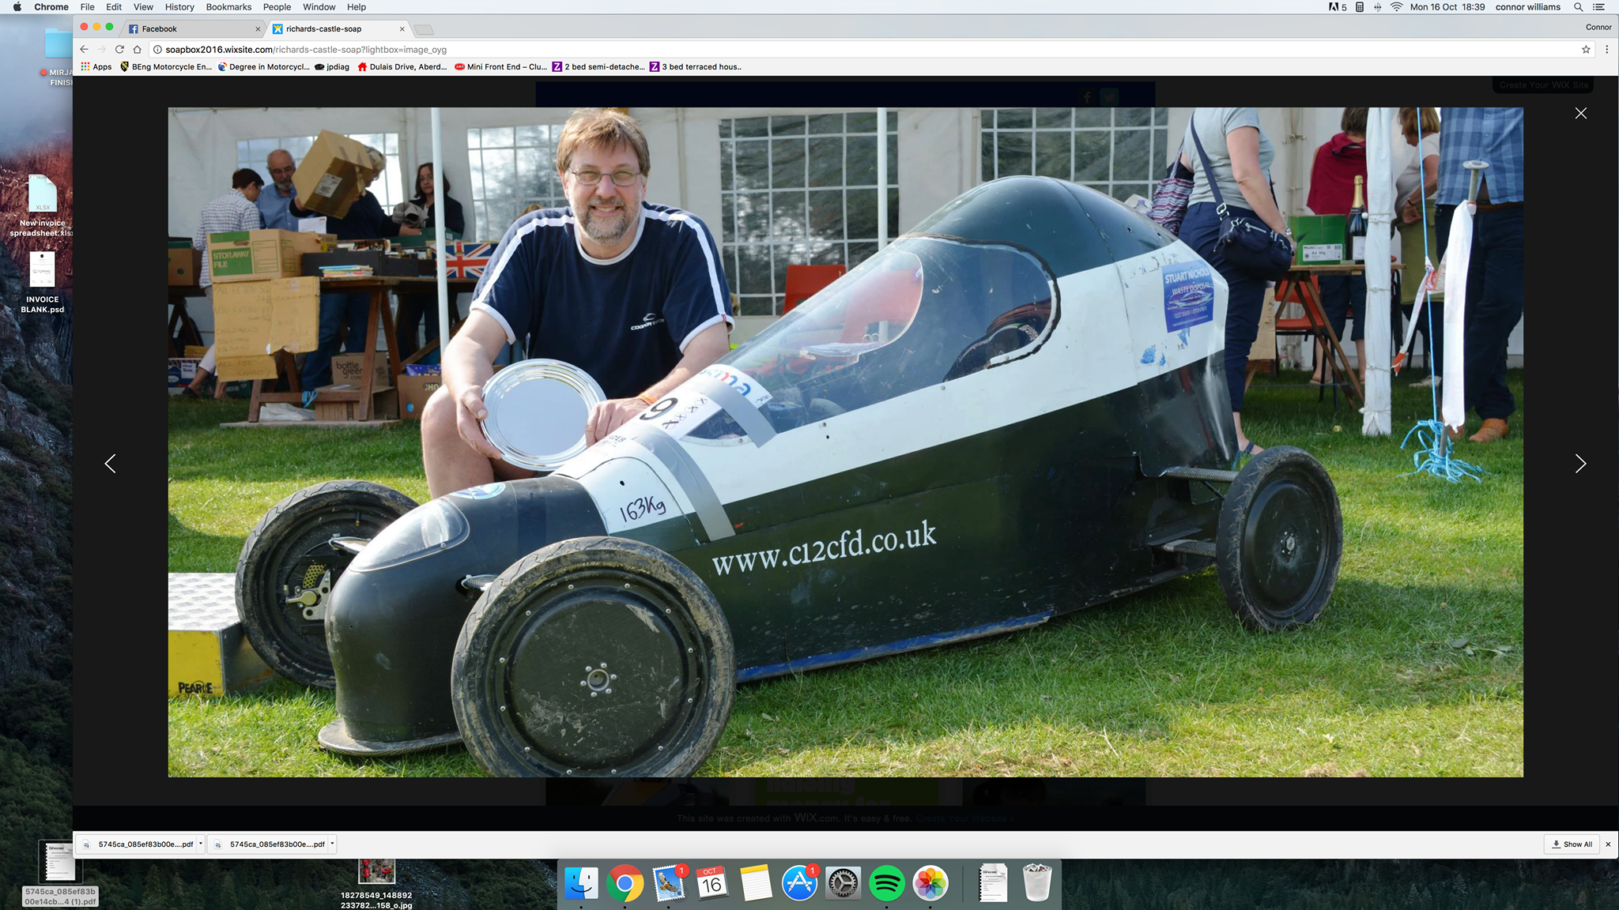fig.1 (Thomas, 2016) 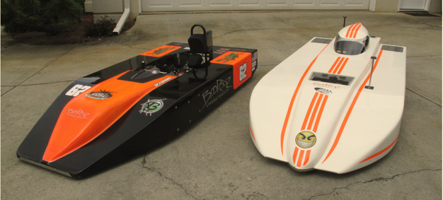fig.2 (BodzRodz, 2017)
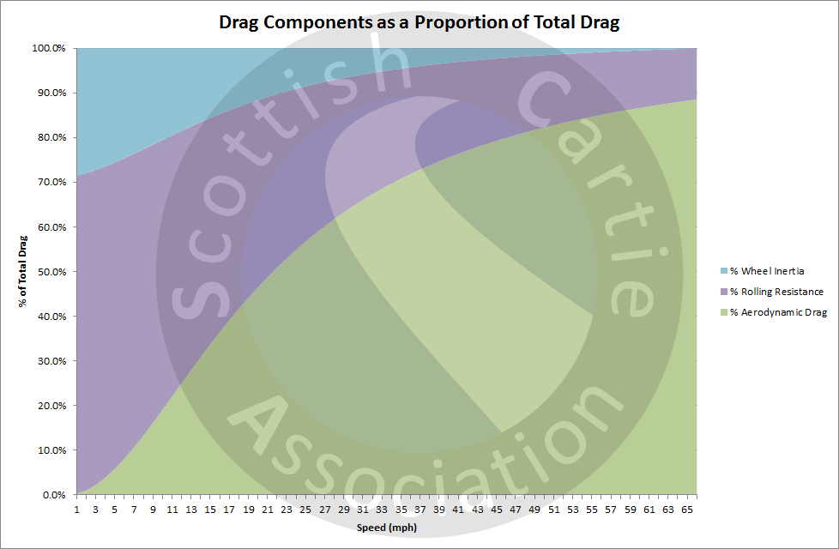fig.4 (SCA, 2013)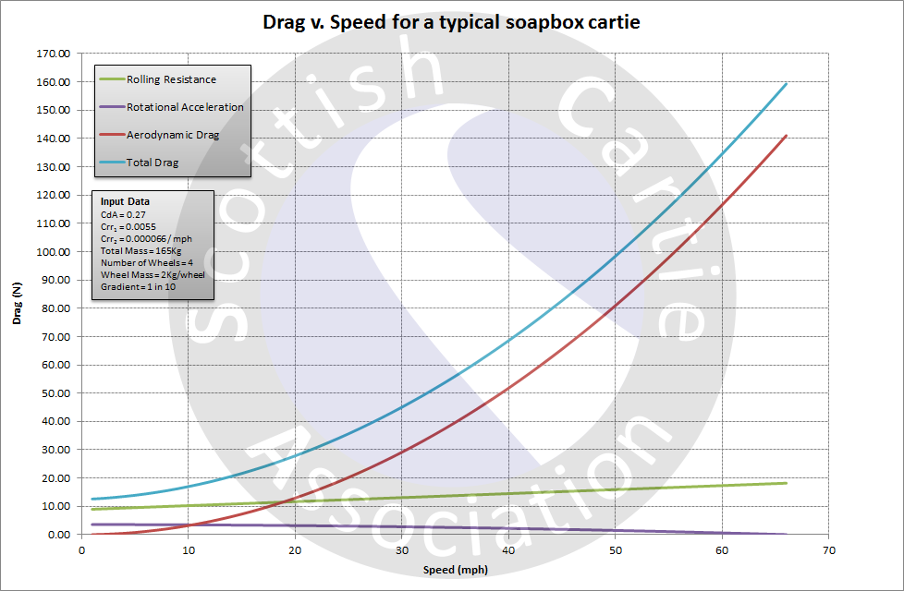fig.3 (SCA, 2013)
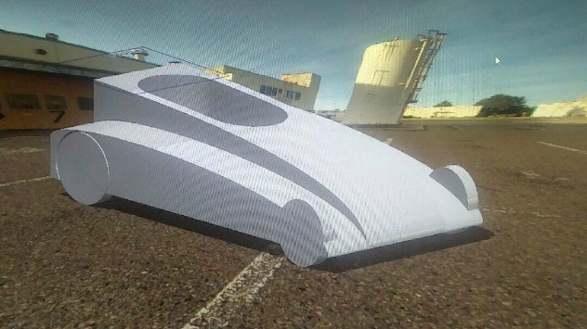fig.5- low drag Solidworks body prototype 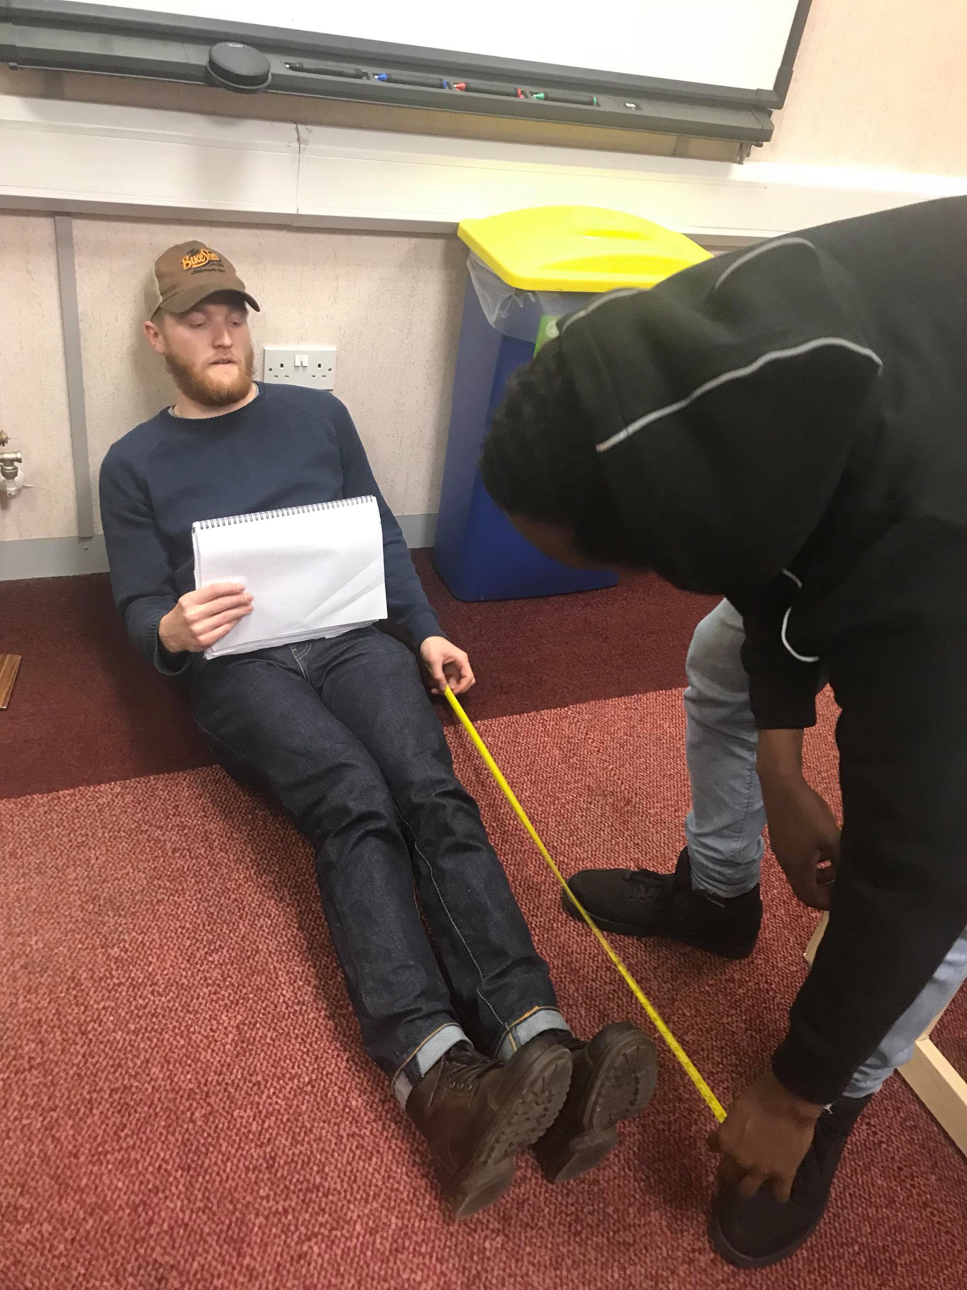fig.6 initial measurements
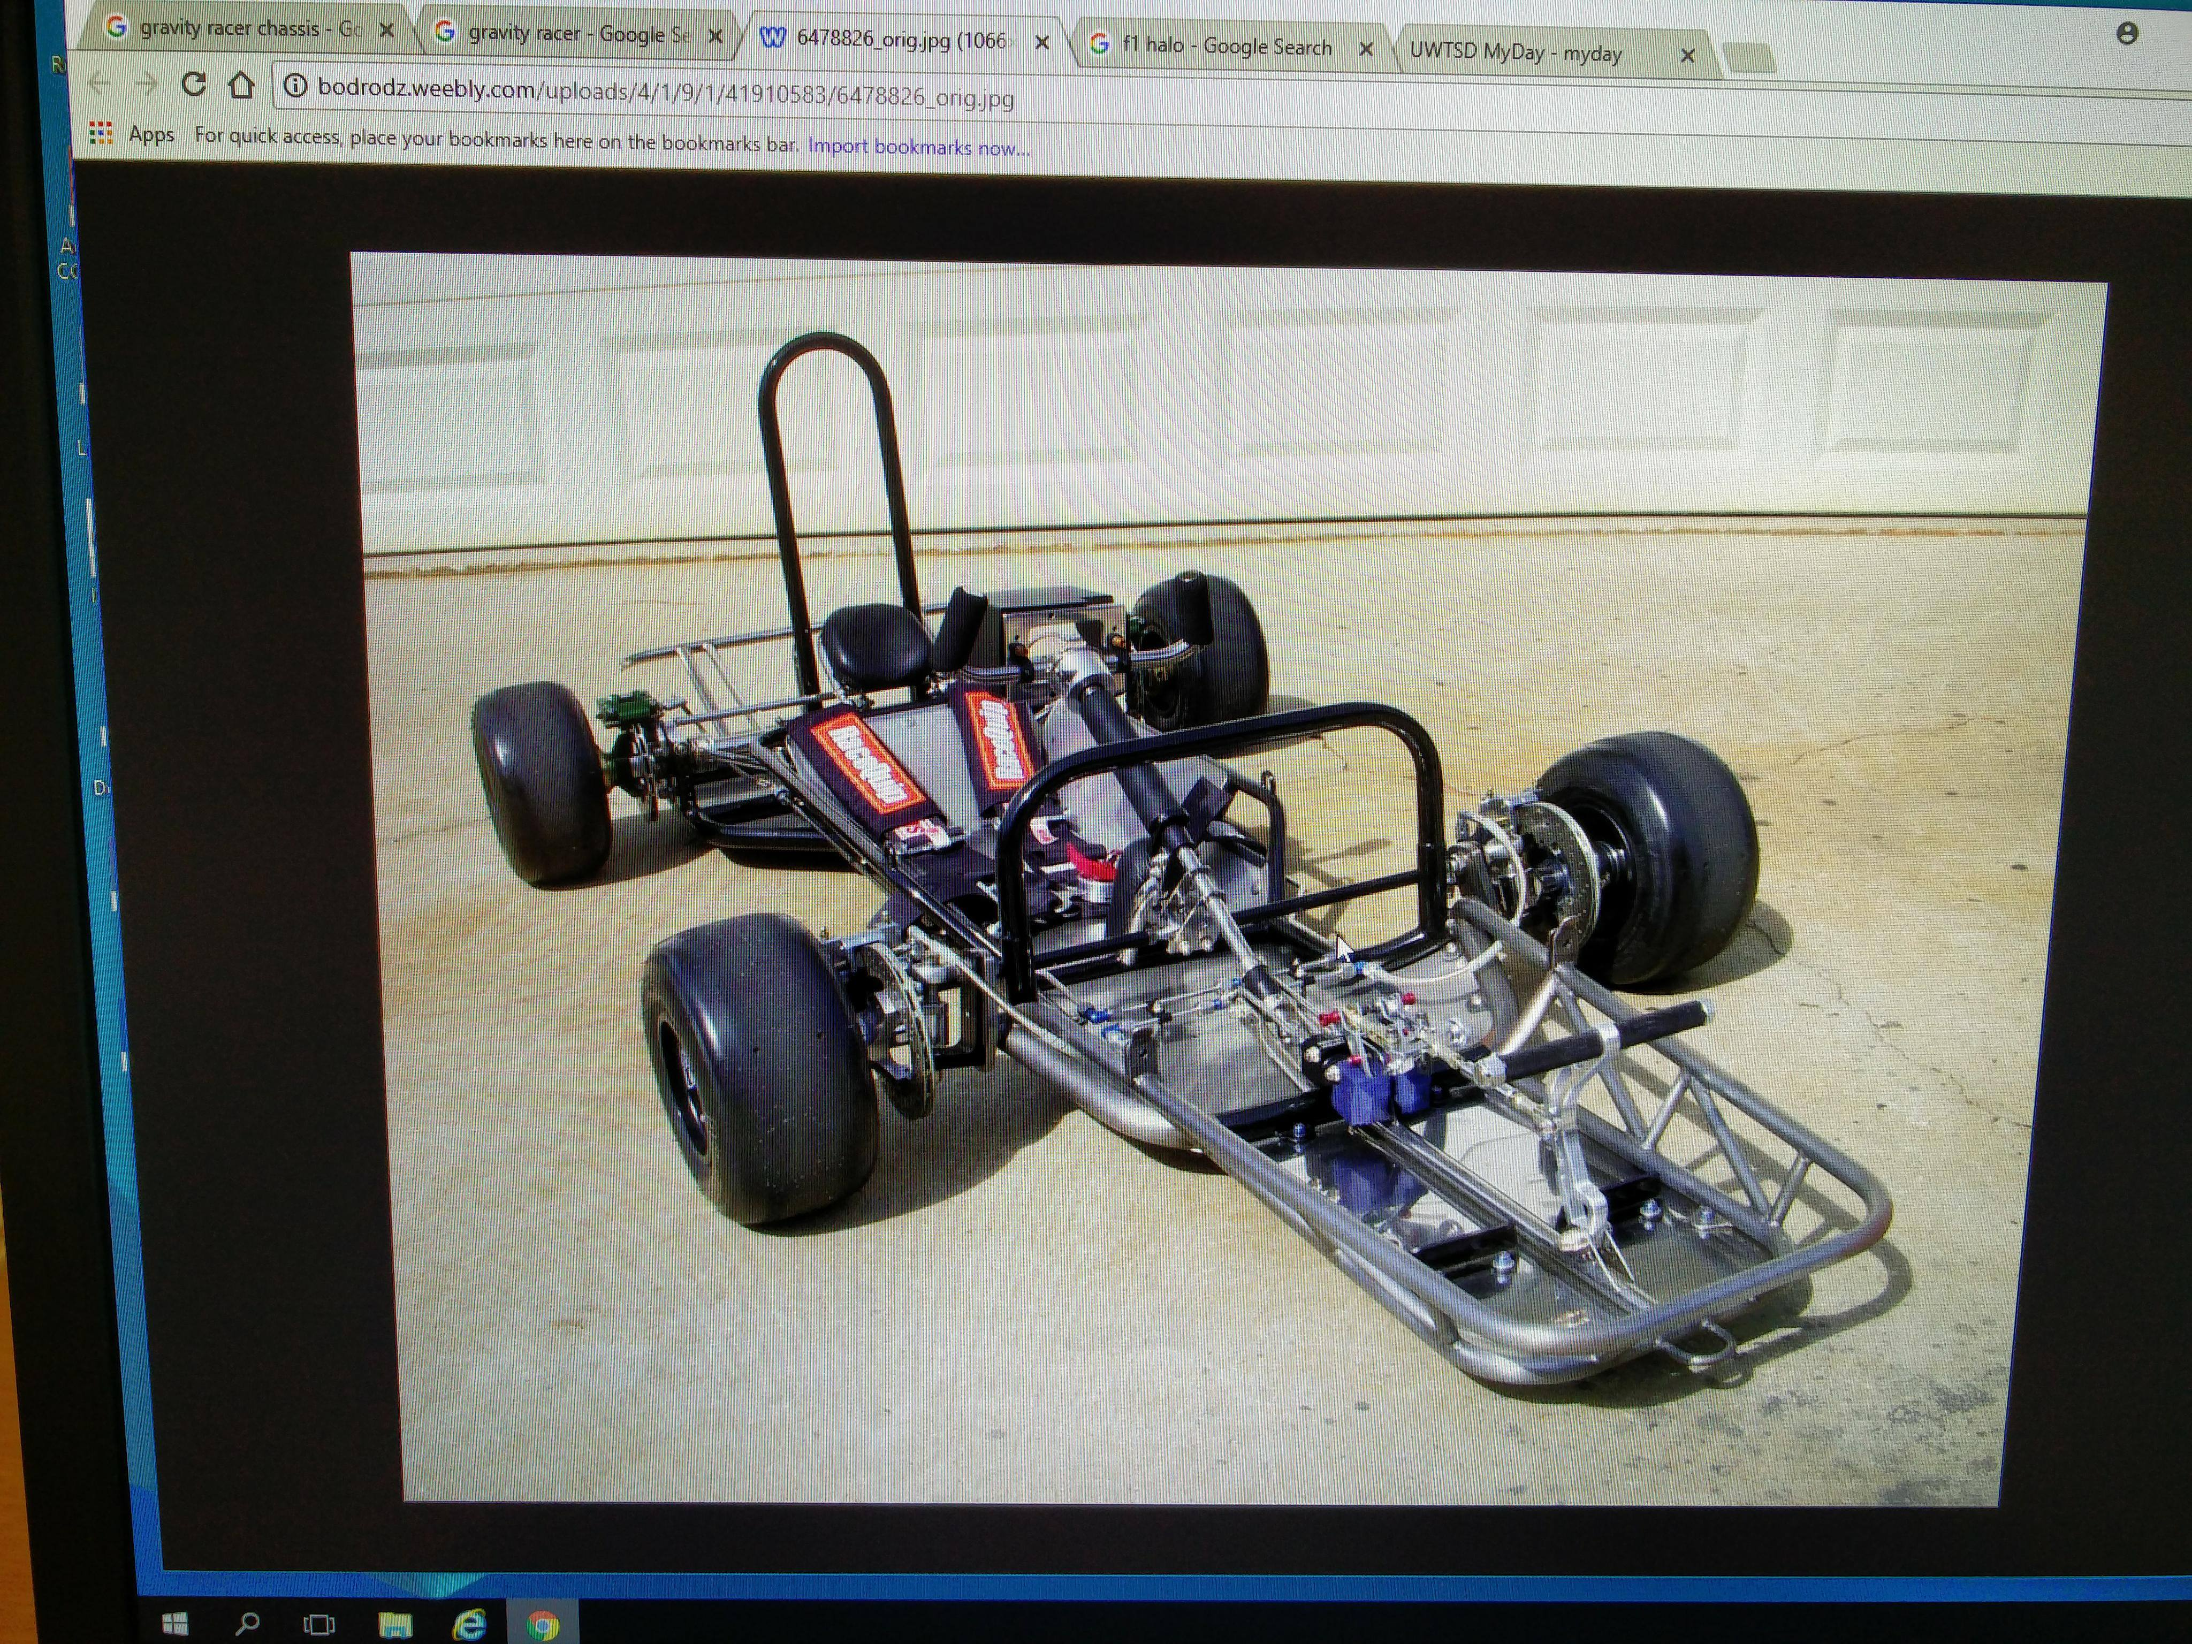fig.7 (BodzRodz, 2017)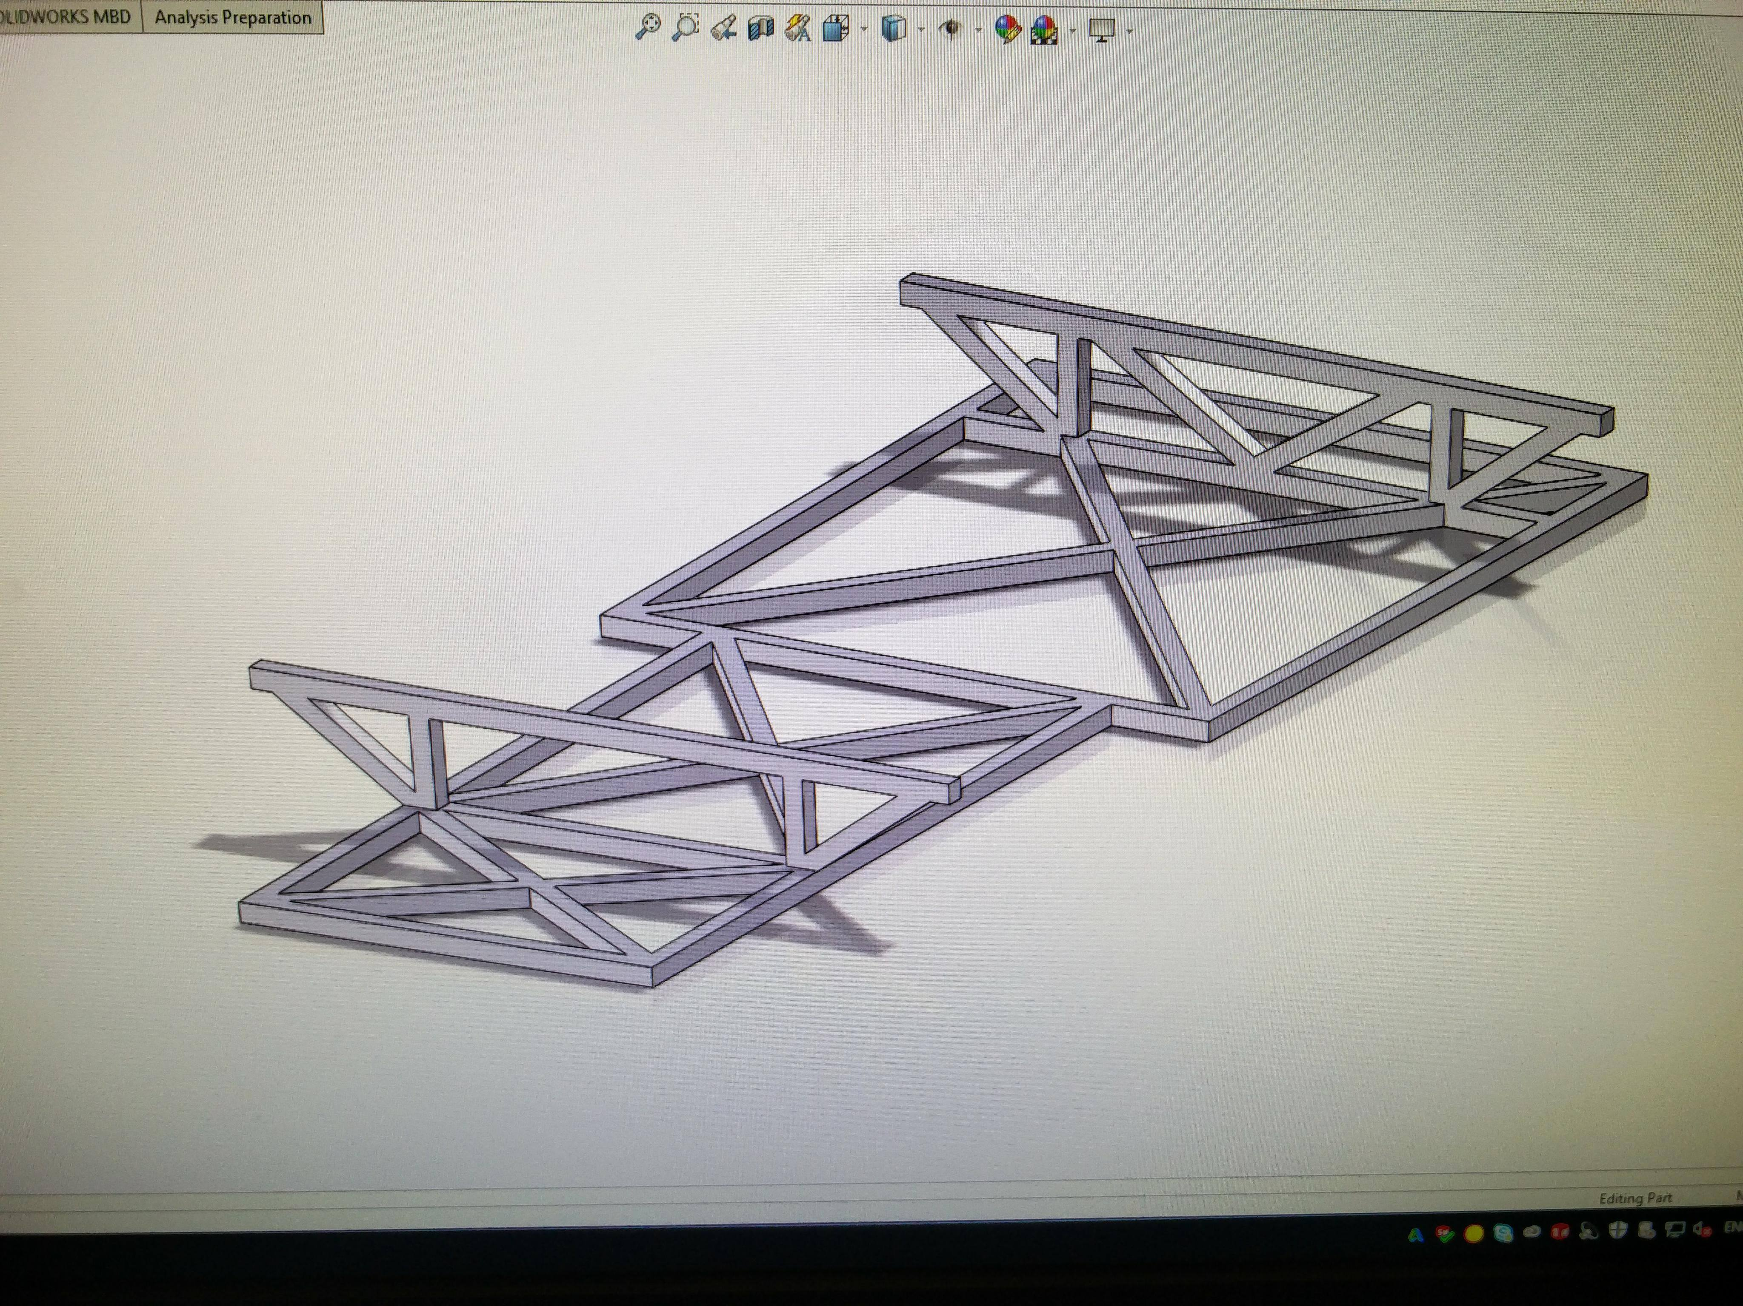fig.8 Solid works frame
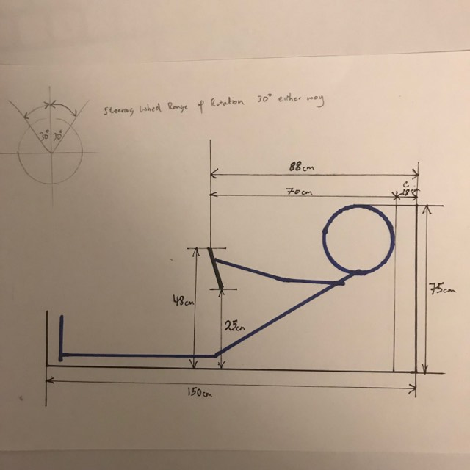fig.9 Ergonomics sketch
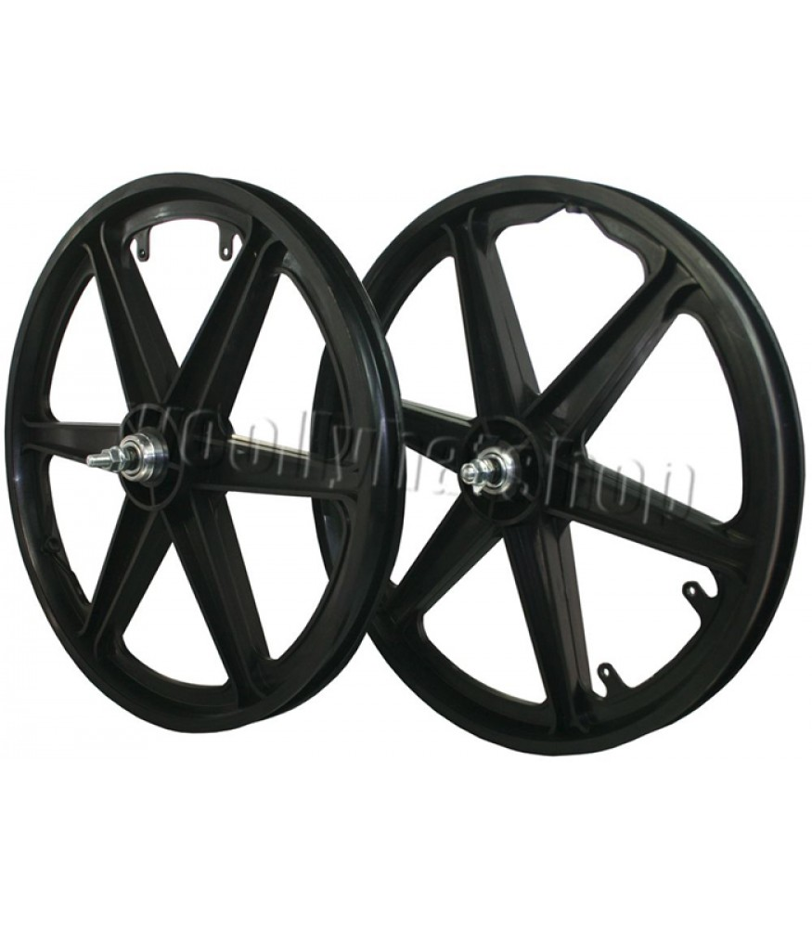fig.10 Generic image taken from - https://www.woollyhatshop.com/image-smp/20-bmx-mag-wheels-6-spoke-nylon-freestyle-pair-black20_3411_875x1000.jpg
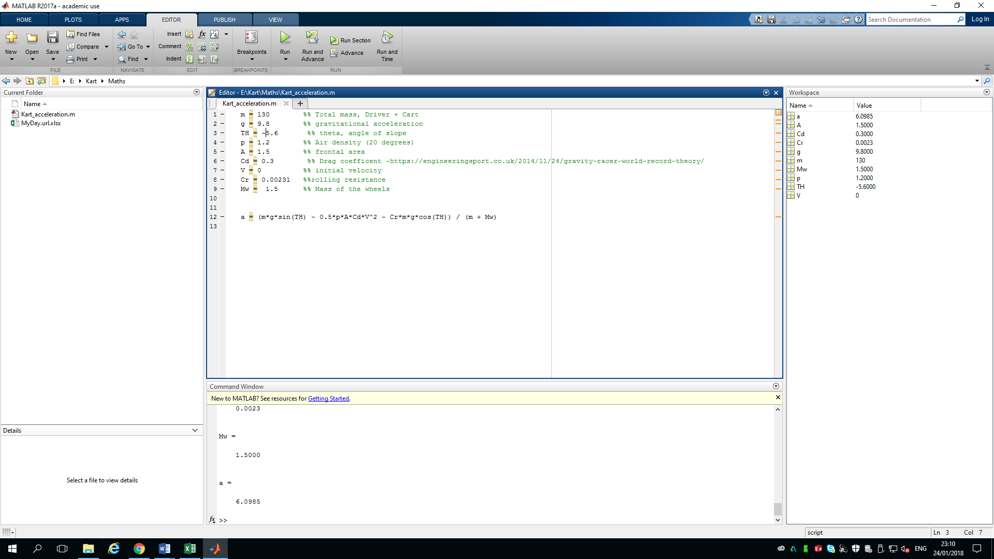fig.11- MATLAB figures from (SCA, 2013)
Fig11.1
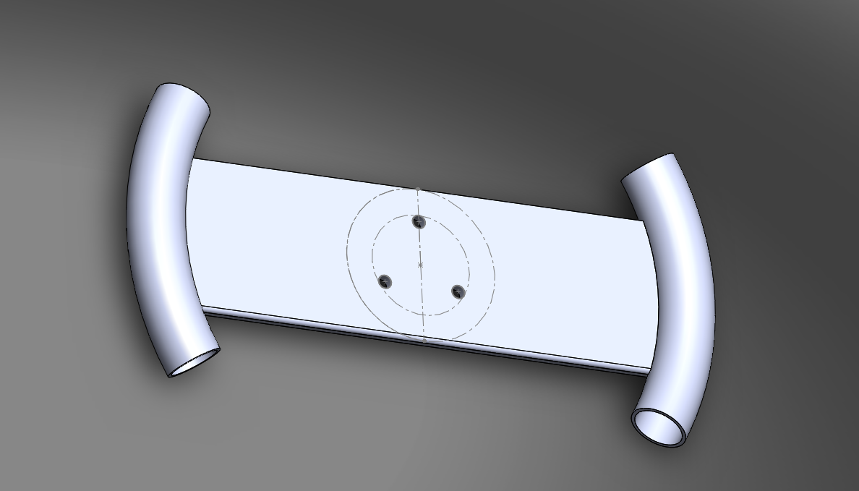fig.12 Steering wheel design

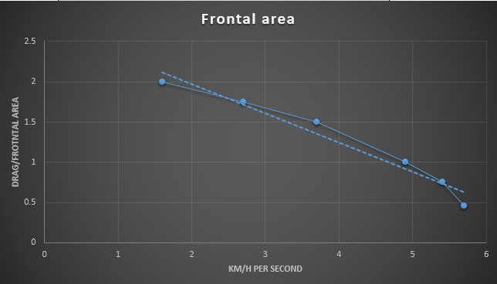
fig.13 Impact on Frontal area (Y) by Acceleration (X) at initial speed 10 MPH

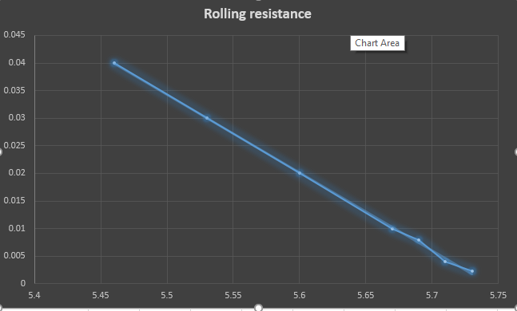
Fig.14 acceleration (X) by rolling resistance (Y) at 0 mph initial speed
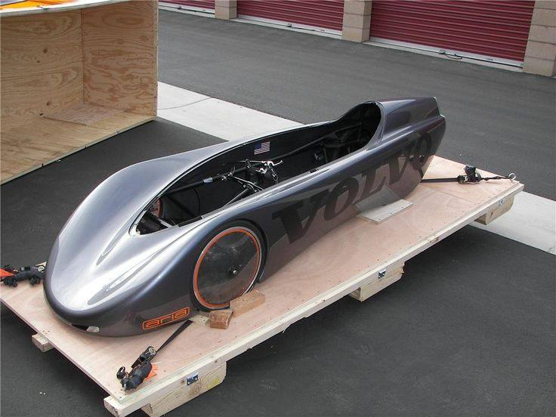fig.15 (Volvo, 2005)
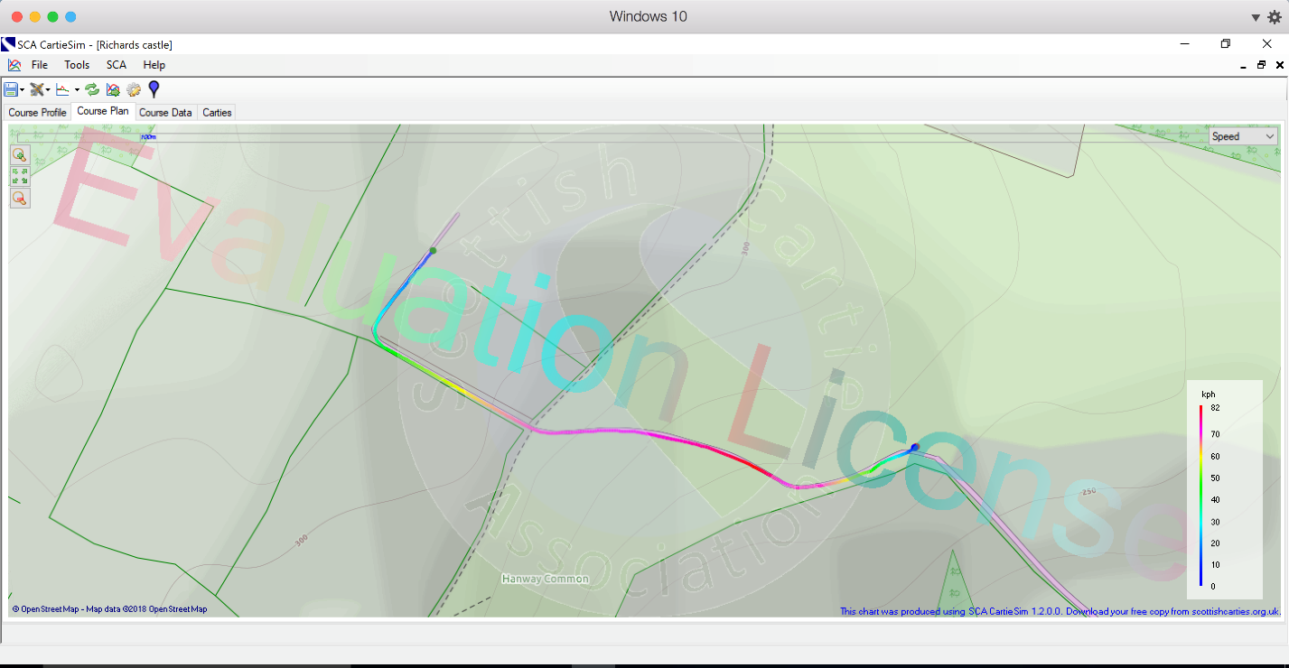Fig.16 Corner severity on CartieSim
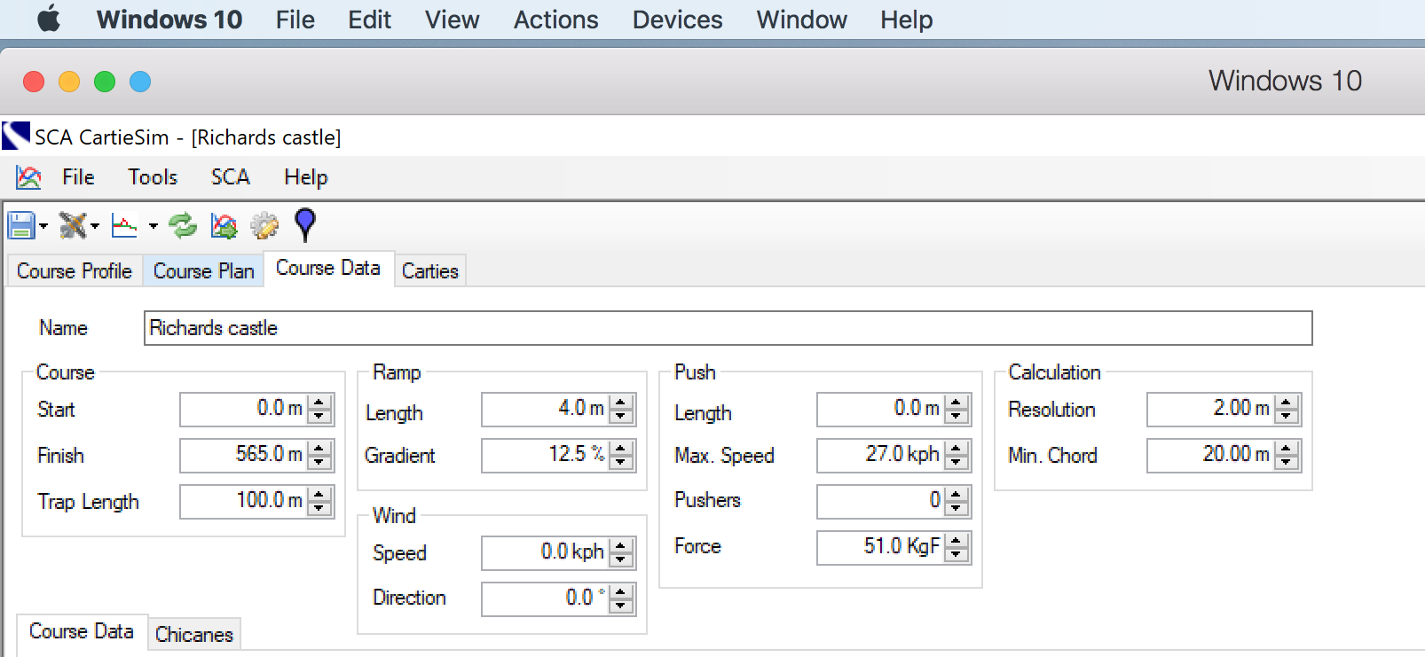
fig.17 Start slope adjustment on CartieSim
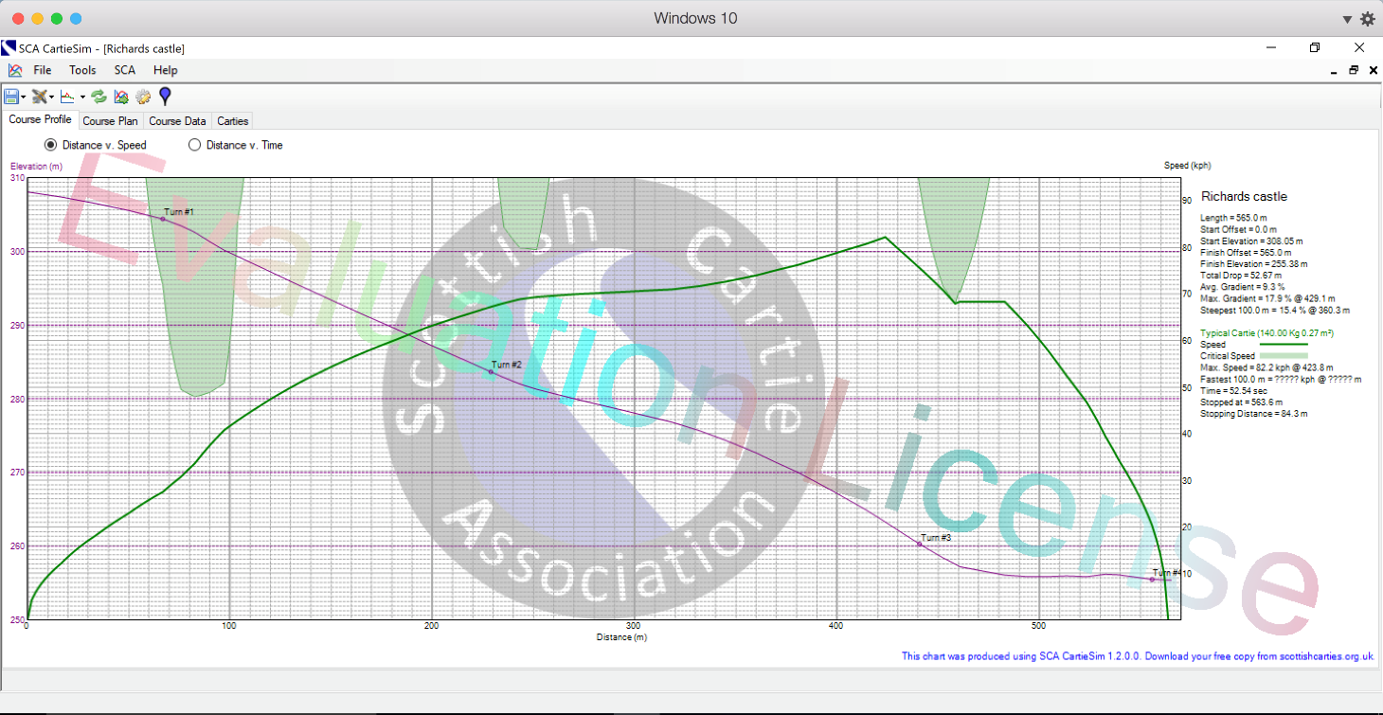
fig.18 speed graphs CartieSim 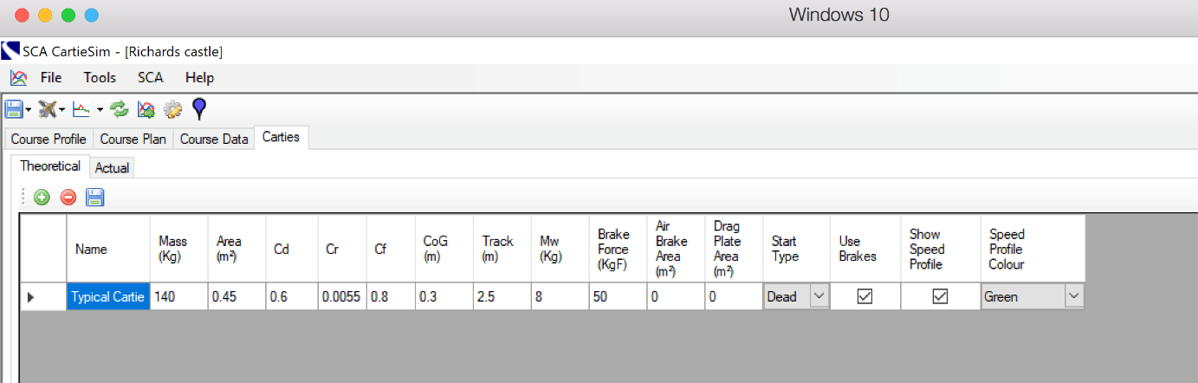
Fig.19 Cart parameters CartieSim
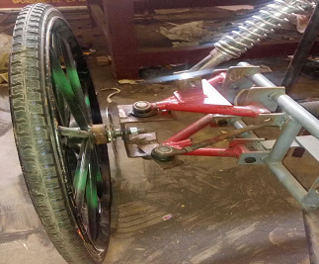fig.20 - simple double wishdone design - https://contest.techbriefs.com/2017/entries/automotive-transportation/8206
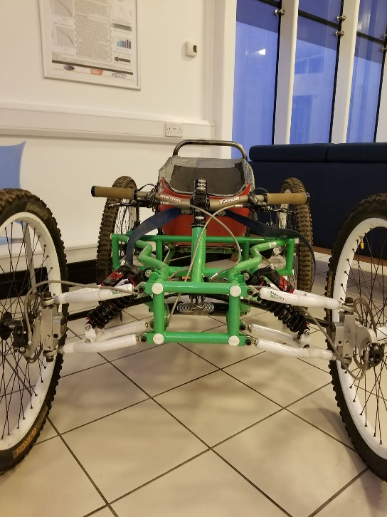fig.21- UWTSD project

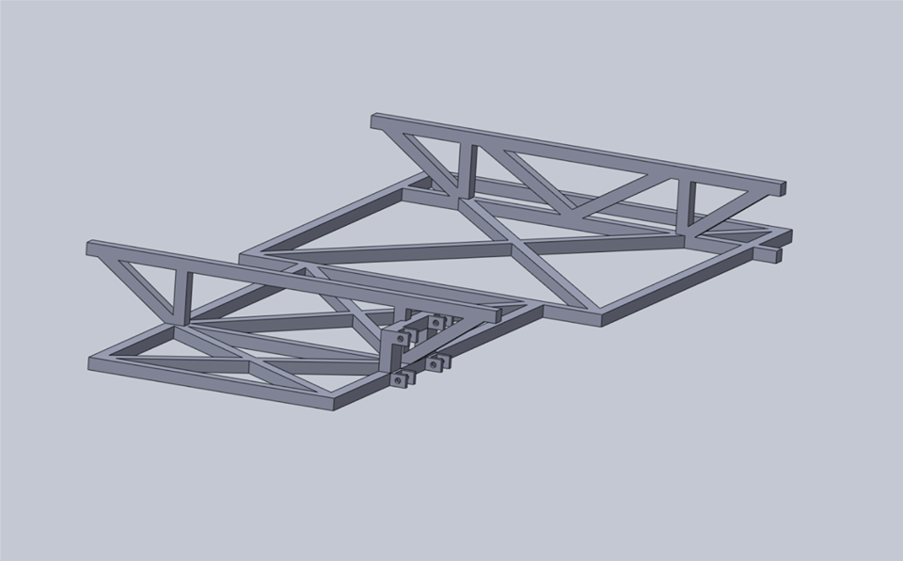
Fig.22 frame with mounts for suspension
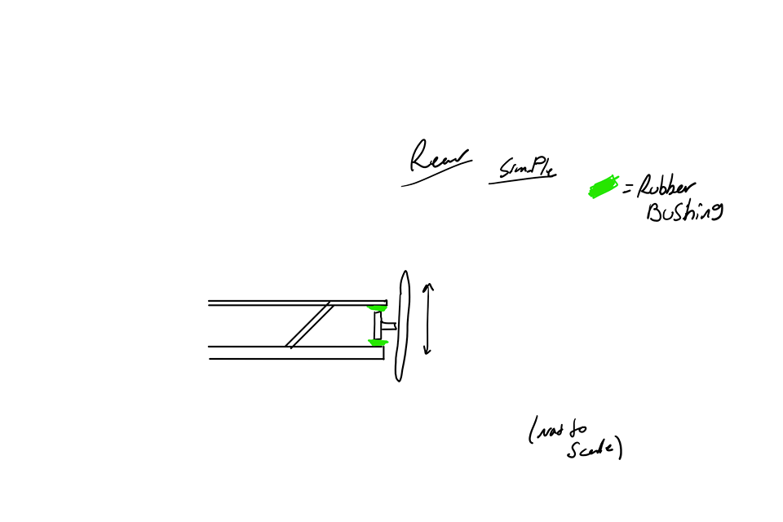fig.23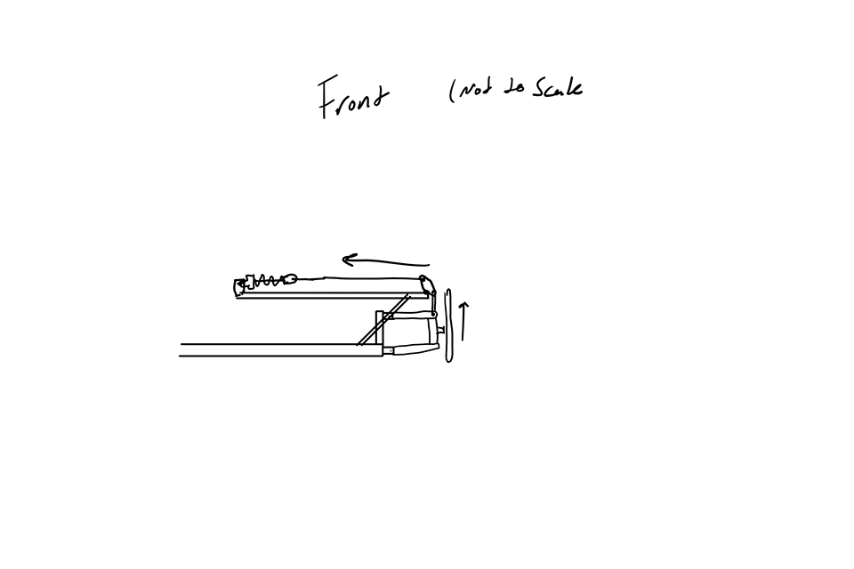fig.24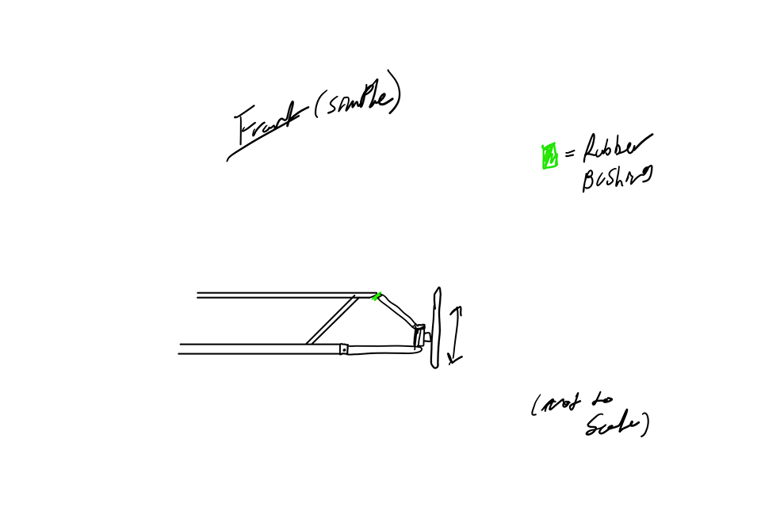fig.25
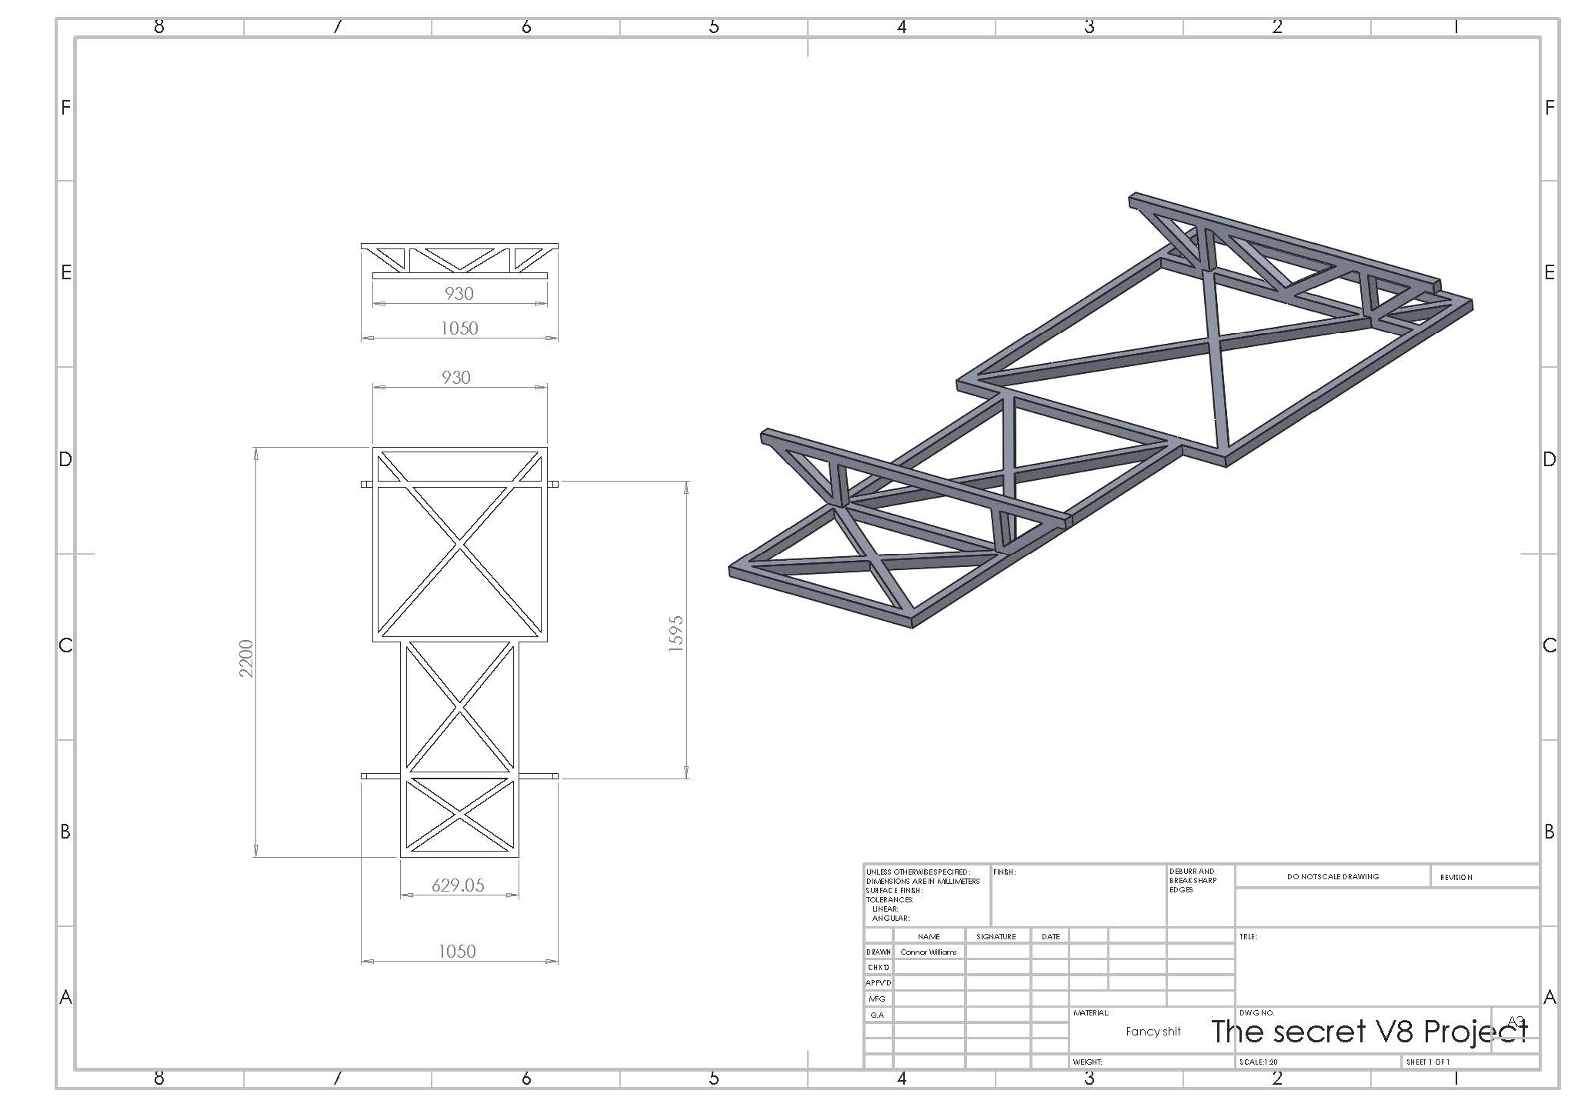fig.26 showing all dimensions of chassis
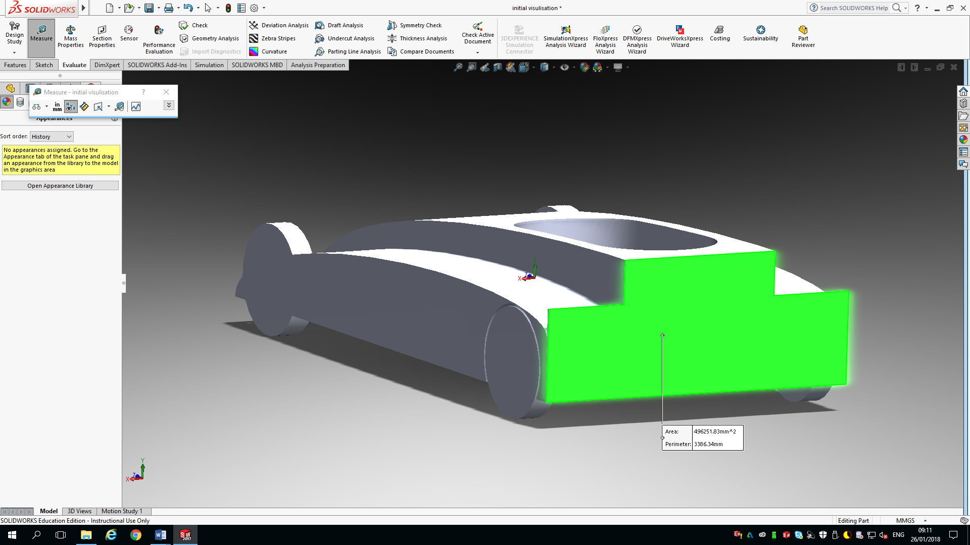
Fig.27 showing the most extreme low frontal area of around 0.5M^2
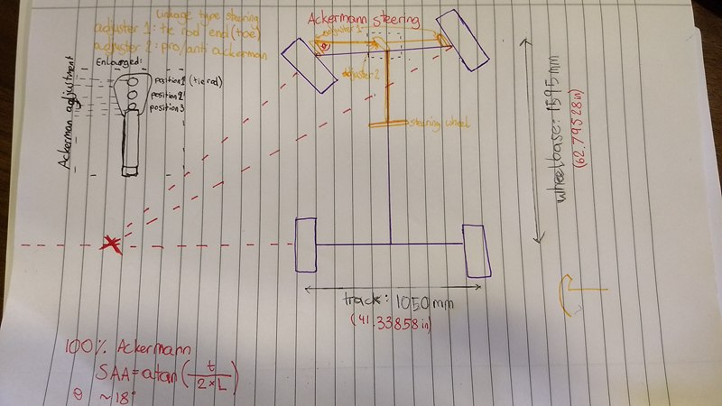
Fig.28 steering system with adjuster

