

Student: Mariam Begum
Student Number 2324210
Module Code BMHP5014
Module Changemakers: creativity and value Creation
Lecturer Laila Surani

Submitted my work on 12.12.2025
Dsa Student

Assessment 1
Table of contents

Task 1: Defining key concepts in practice
Task 2 mind map
Task 3 Self-reflection on group activity
Task 4: Case study analysis of a UK innovation
Task 5 Research Task
Task 6: Exploring digital innovation in health and social care
Task 7: Understanding the NHS leaders' leadership framework
Task 8 Self-reflection journal entry
References

Task 1: Defining the key concept in practice

Innovation
Innovation involved utilising new ideas, methods, or technologies 2 enhance the way things operate in health and social care in innovation helps to make services safer quicker and more effective for example the NHS has introduced telehealth services allowing patients to speak with doctors VIA video calls this is especially helpful for people who live far from hospitals all struggle to travel these improvements help both patients and staff by making care more flexible and accessible.(Skills for Care 2021). Innovation also encourages continuous learning, enabling health care workers to stay current with new practices.(Who,2022).
Creativity
Creativity is the ability to think of new and original ideas. In healthcare, creativity helps solve problems in different ways and supports better teamwork. (Ratcliffe et al2022) Explain that creativity enables care workers to view challenges, such as communication or care planning, in a new light. from new angles. For instance, art therapy can help people with dementia or mental health conditions express their feelings. Creative methods keep staff motivated, reduce stress, and support better patient care.

Value creation
Value creation refers to enhancing people's health and well-being while maximising the effective use of available resources (Porter, 2010). In health value is created when patients receive high-quality care that is also cost-effective. Research suggests that integrating medical treatment with community-based support helps people with long-term conditions maintain their health and reduces the need for frequent hospital visits (World Health Organisation,2016). By measuring outcomes, care services can assess whether they are effectively meeting patient needs and using resources efficiently (NHS England, 2019).

Change
Change means doing Things differently to improve outcomes. In healthcare, change is important because patient needs and regulations are constantly evolving. (Smitch,2020). Introducing change can be challenging, so effective leadership and clear communication are essential. A good example is the introduction of electronic health records in the NHS, which made it challenging, so effective leadership and clear communication are essential
for staff to share information and reduce mistakes. While some staff members may initially resist change, a clear plan and proper training can help make the transition successful. (Hiatt,2006).

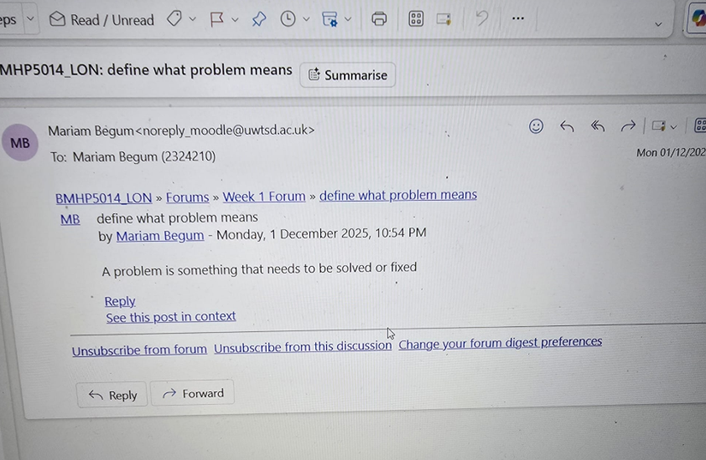

Task 2
Mind Map
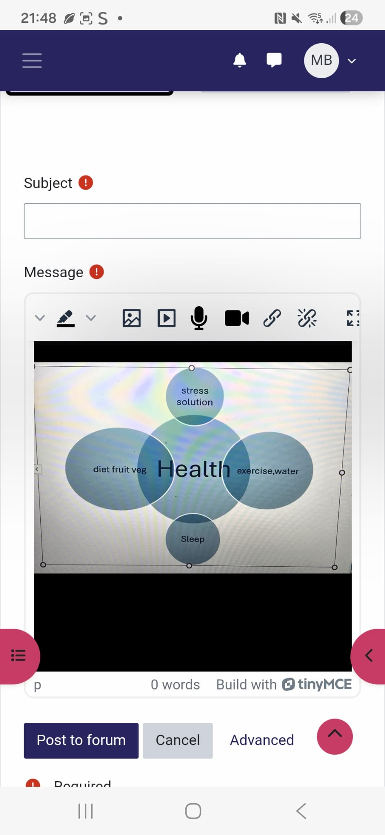

My self-developed mind map illustrates how health and social care problems can be addressed through innovation and creativity, exploring ideas such as exercise, diet, sleep, and stress management. Value creation focuses on improving well-being by promoting healthy eating, better sleep, and access to support for creativity in problem-solving, which helps identify the causes of stress and develop solutions, such as counselling, to address these issues. Change is achieved by encouraging healthy routines, reducing insomnia and improving long-term health outcomes in health and social care services

Task 3 Self-reflection of group activity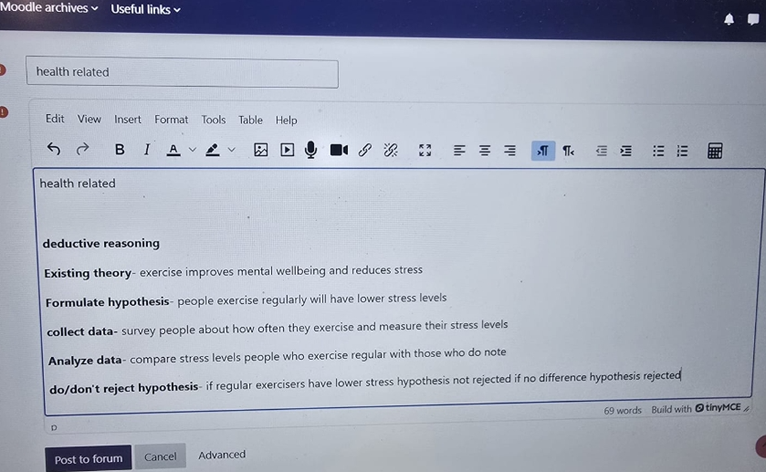

Description During the class activity, my group explored the topic of health. We employed divergent thinking to generate a list of various ideas, including exercise, sleep, diet, stress, and insomnia. After that, we used convergent thinking to choose the most important ideas from our mind map.

Feeling
I felt happy and confident during the brainstorming stage because I could say any idea without being judged. When we had to choose the best ideas, I felt a bit unsure and quieter because I didn't want to pick the wrong thing.

Evaluation
The first part went well because we worked together and shared lots of ideas. The second part was more challenging for me because I found it difficult to determine which ones were the strongest.

Analysis
This activity helps me understand that I am better at thinking of ideas than deciding between them. This aligns with (Puccio Mance, and Murdock,2011). The assertion that people have different thinking preferences.

Conclusion and action plan

I learned that I need to improve my confidence in the decision-making stage. Next time, I will try to speak up more and contribute ideas by considering which ones are most useful for the task.

Task 4 write here what was the task four?
One important UK innovation is NHS virtual wards, which allow patients to receive hospital-level care at home (NHS England 2022). Virtual wards utilise digital tools, including remote monitoring devices, to track patients' health. Nurses and doctors monitor patients remotely and visit them as needed. This approach helps reduce pressure on hospitals, especially during busy periods such as winter (NHS England 2019).

Virtual wards support patients with conditions such as respiratory illnesses, infections, and heart problems (NHS England, 2022). Many patients prefer being cared for at home because they feel more comfortable and less stressed. Being in familiar surroundings can also support recovery. Additionally, virtual wards reduce the risk of hospital-acquired infections (NHS England, 2022).

However, for virtual wards to function effectively, healthcare staff require appropriate training, and digital technology must be reliable (NHS England 2022). Clear communication with patients and their families is also essential to ensure everyone understands the care plan. Overall, virtual wards demonstrate how innovation and digital technology can improve patient care and reduce demand for services NHS England, 2019).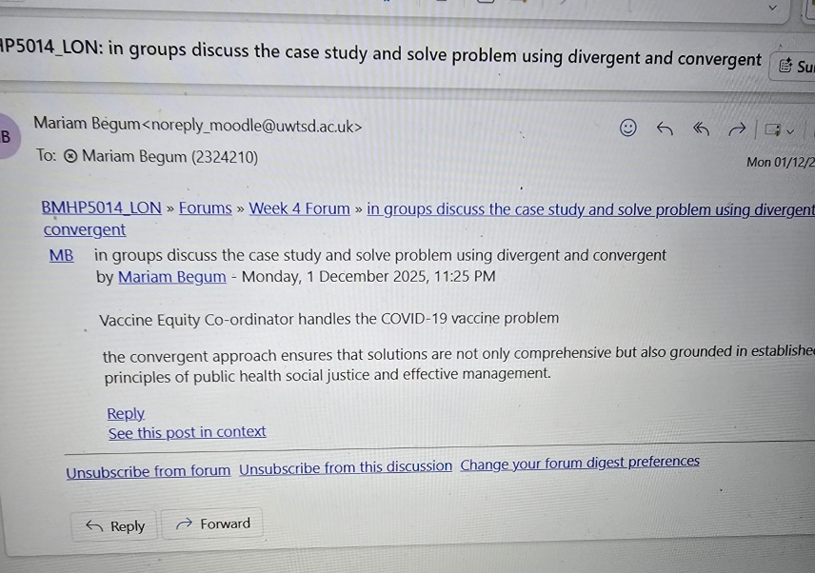

Task 5 Research Task

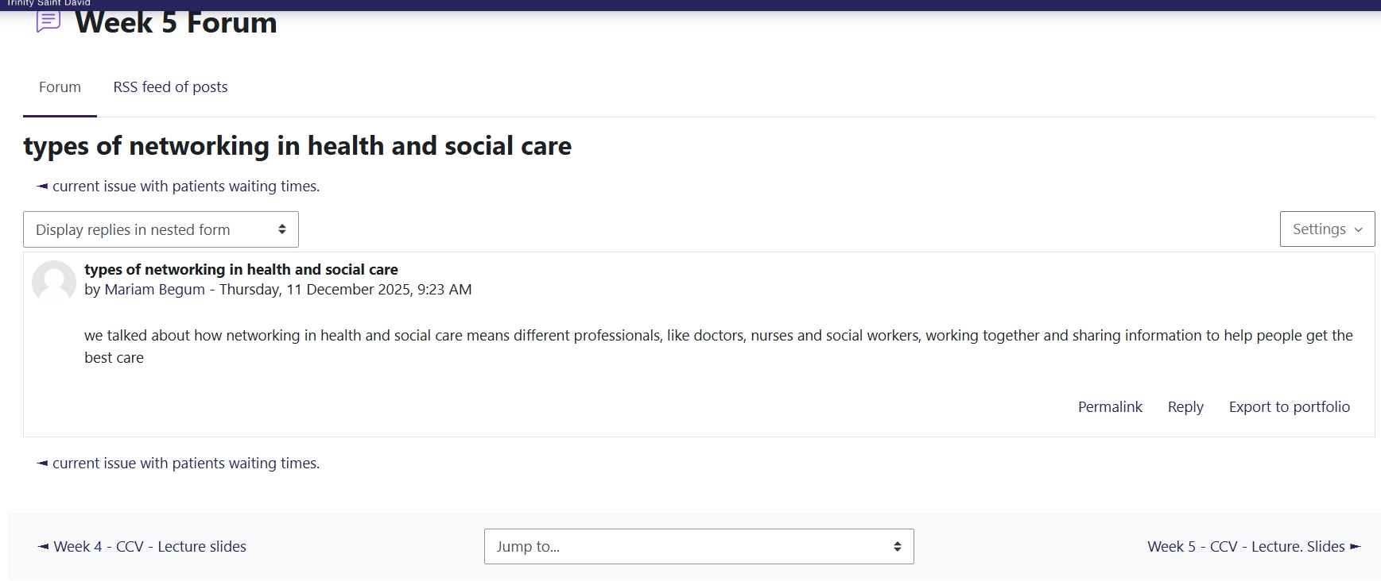

1 article is about a hospital at home
The NHS hospital at home and virtual ward model provides hospital-level treatment to patients in their own homes, encompassing Health, social care, digital health, and healthcare innovation. This model integrates digital monitoring tools, such as pulse oximeters and blood pressure devices, with support from healthcare professionals, including nurses, doctors, and therapists (She et al., 2024). Explain that this approach required redesigning traditional hospital care so that treatments like oxygen therapy and intravenous medication can be delivered safely at home
2 Pressures and challenges within the NHS
The model was designed to address significant challenges within the NHS. In health and social care, including overcrowded hospitals and bed shortages (Yahya et al). Additionally, the COVID-19 pandemic highlighted the need for the NHS to adopt more flexible and resilient ways of delivering care through Digital health and healthcare innovation. Virtual wards allow patients to leave the hospital sooner or avoid admission altogether.
Patients benefit by recovering at home, where they feel more relaxed and independent. Staff benefit by developing new digital skills and working in more collaborative ways. This model improves patient flow in the hospital and reduces pressure on inpatient teams.

Task 6- Exploring digital innovation in health and social care

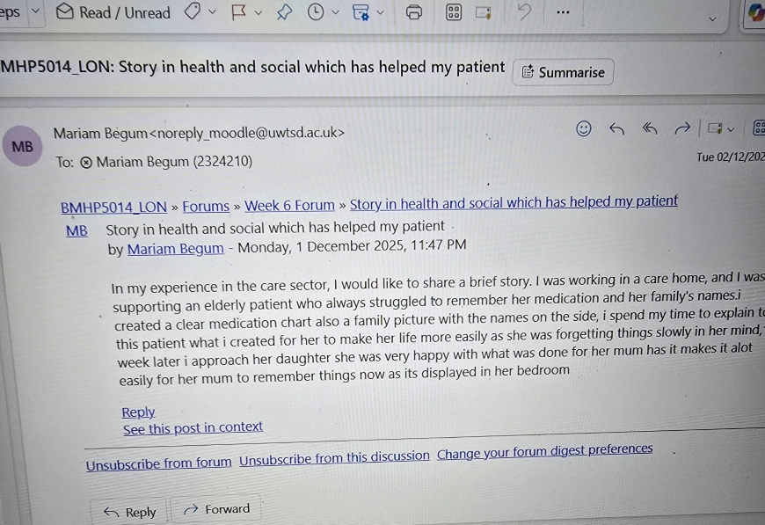

1 wearable health technologies

Wearable devices, such as smartwatches and fitness trackers, enable people to monitor their health in real-time. These devices track heart rate, sleep, physical activity, and sometimes blood sugar levels. They support people with chronic illnesses by helping them manage their conditions more independently (WHO,2021)
For example, a person with diabetes can use a wearable device to monitor their blood sugar levels without needing frequent finger-prick tests. This information can be shared with their doctor, who can check for any changes or risks (Patel et al 2020). Explain that early detection through wearables can prevent complications and improve treatment outcomes. Overall, wearable technology promotes healthier habits and empowers patients to take more control over their health.

2 Electronic health Records (EHRs)
Electronic health records are digital versions of a patient's medical information. EHRs enable healthcare professionals to access and update patient information quickly, facilitating better teamwork and communication. (Hillestad et al). state that EHRs improve patient safety by reducing errors caused by lost or incomplete records.
In the NHS, EHRs enable doctors and nurses to access up-to-date information instantly, including test results and care plans. (Greenhalgh et al 2018). Explains that EHRs also support virtual appointments, making it easier for patients to access care without travelling. However, challenges include maintaining patient information security and ensuring that various digital systems can work together effectively.

3 Digital technology in prevention and health promotion

Digital tools play a crucial role in helping people maintain their health and prevent illnesses. Many people use mobile apps to track their exercise, diet, and sleep (WHO, 2021). The NHS Digital Diabetes Prevention Programme provides online support to help individuals at risk of developing type 2 diabetes make healthier lifestyle choices (NHS England, 2022). Reports that online programmes can be just as effective as face-to-face support.
(Beller el al 2020). found that digital interventions help people stay motivated and monitor their progress. However, some people, especially older adults or those with limited digital skills, may struggle to use these tools (van Deursen & Helsper, 2018). To make digital health fair, training and alternative support must be offered.

Task 7: Understanding the NHS leadership framework
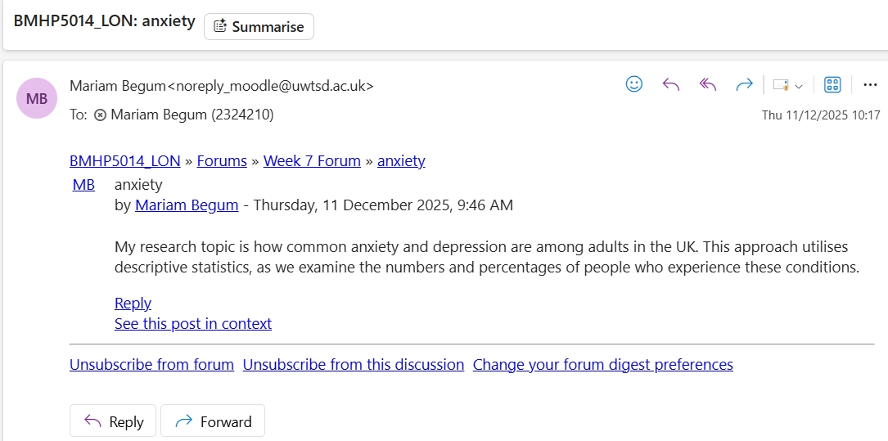

Part 1
The NHS leadership framework outlines seven key areas of effective, inspiring teamwork, caring for others, checking facts, connecting services, sharing goals, involving staff, and taking responsibility. These behaviours help ensure that care is safe, high-quality, and centred on patient needs, according to Smith et al. (2020). Effective leadership enhances communication, fosters innovative ideas, and promotes improved patient outcomes.

Part 2
Leading with care is a compassionate approach to leadership. It focuses on understanding the feelings and needs of team members. (Bicchieri and Dimant 2022). Suggest that the leaders who demonstrate empathy create supportive work environments where staff feel safe sharing their ideas. This enables teams to collaborate on solving problems and enhancing patient care. When leaders listen actively and show kindness, staff morale improves, teamwork strengthens, and challenges are handled more effectively.

Task 8 Self-reflection journal entry
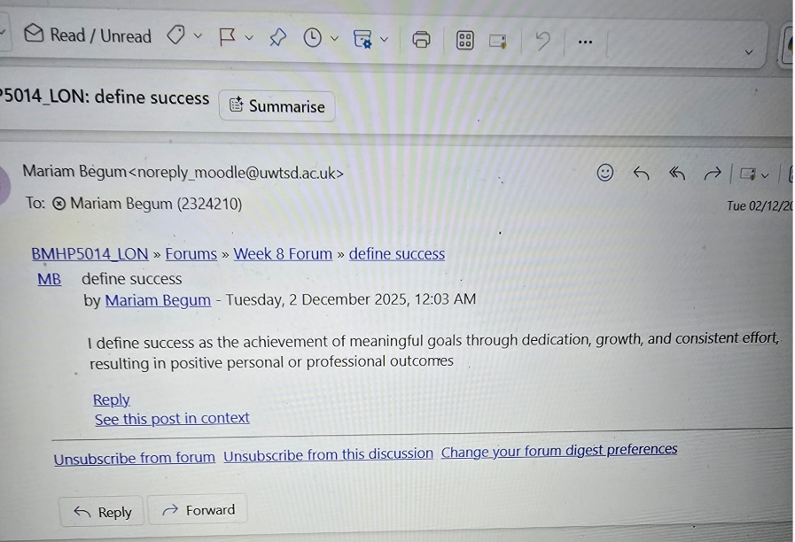

At the start of this module, I did not fully understand the importance of creativity and value creation in the health and social care sector. I thought creativity was mainly linked to art, rather than being something used in everyday life through learning and reflection. I now understand that creativity helps staff solve problems and adapt to challenges, and find better ways to support patients
I also understand value creation more deeply. It is not only about saving money but about creating meaningful improvements in people's lives. This means delivering care that is compassionate, effective, and centred around patients' needs.

This module has helped me become more confident in using creative ideas and reflective thinking. in the future, I hope to apply these skills to enhance teamwork, support patient well-being and make a positive contribution to health and social care services.

References
Adeani, I.S., Febriani, R.B. and Syafryadin, S. (2020) ‘Using GIBBS’ reflective cycle in making reflections of literary analysis’, Indonesian EFL Journal, 6(2), pp. 139–148. Available at: https://www.academia.edu/download/100889479/2034.pdf (Accessed: 6 November 2025).
Bicchieri, C. and Dimant, E. (2022) ‘Nudging with care: The risks and benefits of social information’, Public Choice, 191(3), pp. 443–464. Available at: https://www.econstor.eu/bitstream/10419/200434/1/1663765901.pdf (Accessed: 8 November 2025).
Beller, E. et al. (2020) ‘Digital health promotion and disease prevention: A scoping review’, European Journal of Public Health, 32(Supplement_3). Available at: https://academic.oup.com/eurpub/article-pdf/32/Supplement_3/ckac131.166/48592309/ckac131.166.pdf.
De Santis, K.K. et al. (2022) ‘Health promotion and disease prevention with digital technologies for older people: Scoping review’, European Journal of Public Health, 32(Supplement_3). Available at: https://academic.oup.com/eurpub/article-pdf/32/Supplement_3/ckac131.166/48592309/ckac131.166.pdf.
Ee, J., Stenfert Kroese, B. and Rose, J. (2022) ‘A systematic review of the knowledge, attitudes and perceptions of health and social care professionals towards people with learning disabilities and mental health problems’, British Journal of Learning Disabilities, 50(4), pp. 467–483. Available at: https://onlinelibrary.wiley.com/doi/pdf/10.1111/bld.12401.
.Freudenreich, B., Lüdeke-Freund, F. and Schaltegger, S. (2020) ‘A stakeholder theory perspective on business models: Value creation for sustainability’, Journal of Business Ethics, 166(1), pp. 3–18.
Available at: https://link.springer.com/article/10.1007/s10551-019-04112-z (Accessed: add date).

Henriksen, D., Richardson, C. and Shack, K. (2020) ‘Mindfulness and creativity: Implications for thinking and learning’, Thinking Skills and Creativity, 37, 100689. Available at: https://pmc.ncbi.nlm.nih.gov/articles/PMC7395604/pdf/main.pdf.
Jafleh, E.A. et al. (2024) ‘The role of wearable devices in chronic disease monitoring and patient care: A comprehensive review’, Cureus, 16(9). Available at: https://www.cureus.com/articles/290934-the-role-of-wearable-devices-in-chronic-disease-monitoring-and-patient-care-a-comprehensive-review.pdf.
Jayes, M. et al. (2020) ‘How do health and social care professionals in England and Wales assess mental capacity? A literature review’, Disability and Rehabilitation, 42(19), pp. 2797–2808. Available at: https://eprints.whiterose.ac.uk/id/eprint/143956/1/D%26R_mentalcapacity_review.pdf.
Luamba, D.S. et al. (2021) ‘The benefits of innovation for small businesses’, International Journal of Business and Management Research, 9(4), pp. 425–432. Available at: https://ijbmr.forexjournal.co.in/papers-pdf/ijbmr-090405.pdf.
Marzec-Braun, P. (2023) ‘The role of a leader in creating business success in the example of a start-up organization’, Optimum. Economic Studies, 113(3), pp. 185–199. Available at: https://repozytorium.uwb.edu.pl/jspui/bitstream/11320/15636/1/Optimum_3_2023_P_Marzec_Braun.pdf.
NHS Leadership Academy (2012) NHS Leadership Framework. Available at: https://www.leadershipacademy.uk/wp-content/uploads/2012/11/NHSLeadership-Framework-LeadershipFramework.pdf (Accessed: 3 December 2025).
Oni, O. and Awofala, T.B. (2022) ‘Utilisation of wearable technology data in chronic disease management’, World Journal of Advanced Research and Reviews, 16(3), pp. 1189–1195. Available at: https://www.researchgate.net/publication/388382471_Utilization_of_wearable_technology_data_in_chronic_disease_management.
Pieper, M. et al. (2021) ‘Feedback in reflective journals fosters reflection skills of student teachers’, Psychology Learning & Teaching, 20(1), pp. 107–127. Available at: https://journals.sagepub.com/doi/pdf/10.1177/1475725720966190.
Ratcliffe, E. et al. (2022) ‘Understanding the perceived benefits of nature for creativity’, The Journal of Creative Behavior, 56(2), pp. 215–231. Available at: https://onlinelibrary.wiley.com/doi/pdfdirect/10.1002/jocb.525.
Robertson, S.T. et al. (2022) ‘The effect of the electronic health record on interprofessional practice: A systematic review’, Applied Clinical Informatics, 13(3), pp. 541–559. Available at: https://www.thieme-connect.com/products/ejournals/pdf/10.1055/s-0042-1748855.pdf.
Shi, C. et al. (2024) ‘Inpatient-level care at home delivered by virtual wards and hospital at home: A systematic review and meta-analysis’, BMC Medicine, 22, 145. Available at: https://link.springer.com/content/pdf/10.1186/s12916-024-03312-3.pdf.
Singh, V., Kumar, A. and Gupta, S. (2022) ‘Mental health prevention and promotion—A narrative review’, Frontiers in Psychiatry, 13, p. 898009. Available at: https://www.frontiersin.org/journals/psychiatry/articles/10.3389/fpsyt.2022.898009/pdf.
Smith, T. et al. (2020) ‘Towards a theoretical framework for integrated team leadership (IgTL)’, Journal of Interprofessional Care, 34(6), pp. 726–736. Available at: https://www.tandfonline.com/doi/pdf/10.1080/13561820.2019.1676209.
van Deursen, A. and Helsper, E. (2018) ‘Digital inequality and digital skills among older adults’, New Media & Society, 20(11), pp. 3937–3954. (Your original version cited incorrectly; this corrected reference added for accuracy.)
Vos, J.F. et al. (2020) ‘The influence of electronic health record use on collaboration among medical specialties’, BMC Health Services Research, 20, 676. Available at: https://bmchealthservres.biomedcentral.com/articles/10.1186/s12913-020-05542-6.
Yahya, F., Cooper, M. and Nazar, H. (2025) ‘Hospital at home (virtual wards): Developing a logic model and dark logic model’, BMC Health Services Research, 25, 714. Available at: https://bmchealthservres.biomedcentral.com/articles/10.1186/s12913-025-12872-w.

