Implementation & Report
Network Programmability
Student Name
4-20-2023

Contents
Abstract 2
Part A – the Project 2
Part B – Project Activity Sheet 4
Stage 1 – Introduction and Team Formation 4
Stage 2 – Agile Team Formation 5
Stage 3 – Implementation 6
Stage 4 - Reflection 9
Deliverables: 9
Appendices 10
A. Project GitHub Repository 10
B. Testing the API 10
C. Trello 12
D. Python Code 12

Abstract
Application programming interfaces (APIs) have grown hugely in popularity and use over the last decade or so. An API allows one service or product to interface or communicate with other existing services in order to gain access to data or information. The API is the intermediary meaning that the requesting service does not need to understand how the responding system or service is implemented. It uses the API interface to access the specific data that it requires.
Python is a popular choice of programming code to use to build applications that interact with API interfaces. This project demonstrates an example use of both python coding of an application and a typical REST API, MapQuest.

Part A – the Project

The application was developed from basic application using MapQuest REST API to include additional features. Screenshots showing the output out of the application from the different phases of the project are shown below.
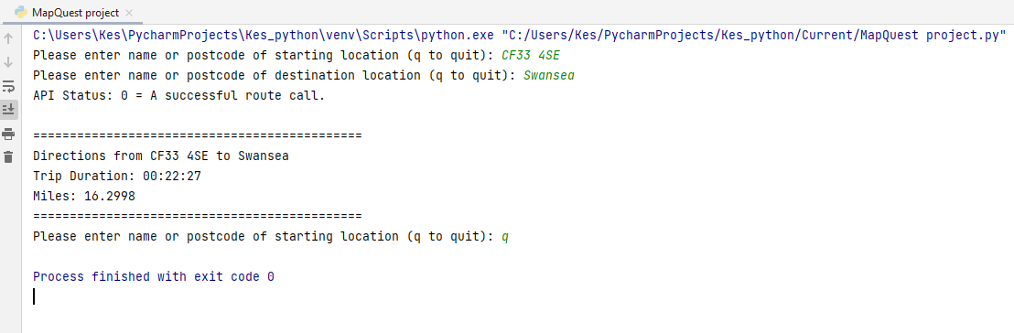
Figure 1: Output from the original python code.
This figure conveys the original MapQuest REST API application that was used and tested prior to the development of the later versions of the code.

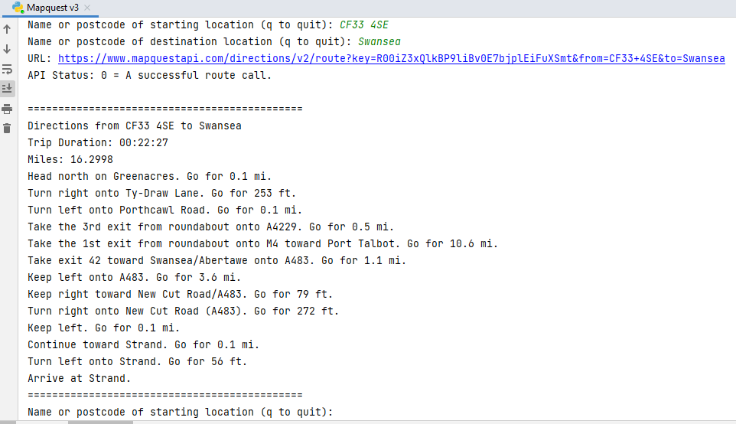
Figure 2: Output from the first revision of the python code.
The first revision of the application expands on the original code to include full turn-by-turn directions. The summary information is still included in the out, as seen above.

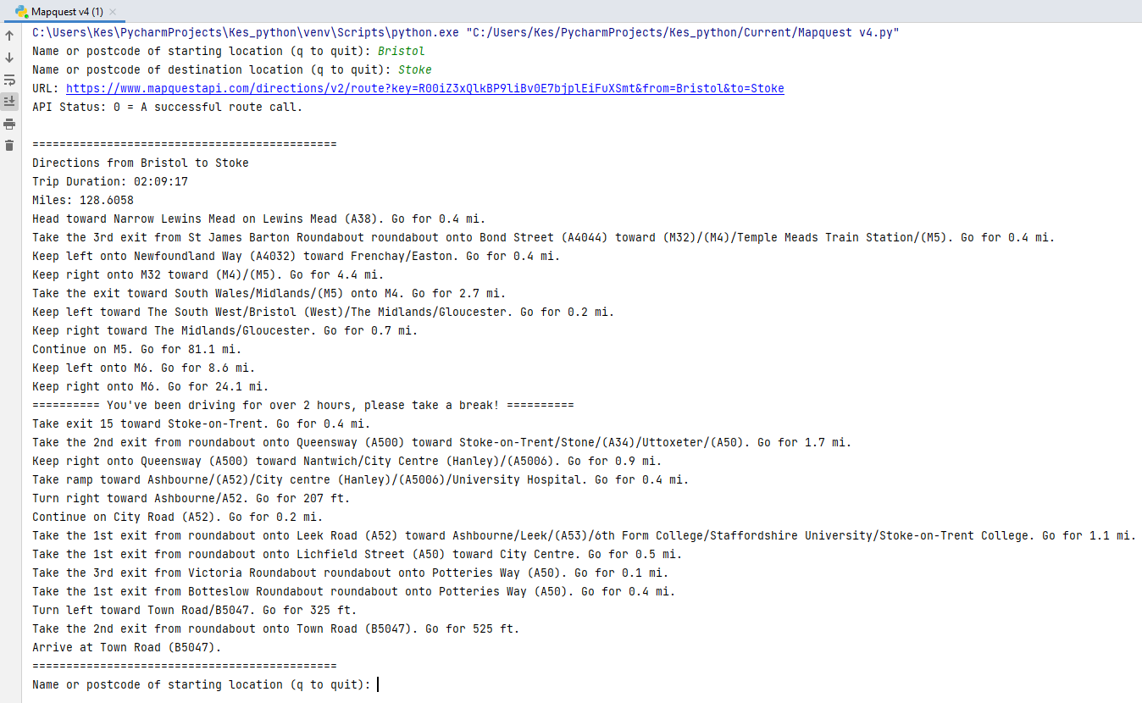
Figure 3: Output from the second revision of the python code.
The second revision of the application adds a break reminder to the detailed directions. The purpose is to remind the driver to take a break after every two hours of driving.

Part B – Project Activity Sheet

Stage 1 – Introduction and Team Formation

1.1 Team Name: Team Unknown
1.2 Team Member Roles:
 | Name | Skillsets, Interests
Facilitator | Kes Sumner | Security Architect, interest running
Recorder | Carys Newing | Cyber Security Analyst. Interest Forensics
Team Member | Sam Jackson | Cloud Computing, Power Platform and Security, Interest Food
Team Member | Peter Holdstock | Desktop Support, Interest Aviation

  - Ice-breaker Questions:
Question | Kes | Carys | Pete | Sam
You're trapped in the last TV show/movie you watched. What show are you stuck in and will you survive? | Matrix  Of course! | Aggretsuko. Yes I'd probably survive | Homes under the Hammer! Yes, I would be able to survive | Rabbit-Hole – Properly not.
You've magically gained a skill to perfectly cook any cuisine, what cuisine would you choose? | Sainsbury's Meal Deals | Japanese | Italian  (Especially Pizza) | Tia Food
If you could see any band, who would you see? | Metallica | As December Falls | Scouting for Girls | Pink Floyd
What's your favourite ice cream? | Raspberry | Hazelnut | Vanilla | Vanilla

Stage 2 – Agile Team Formation
  - Team Name: “Team Unknown”
  - Scrum Leader: Kes Sumner
  - How did your team select the scrum leader? (Word Limit: 100 Words)
There was a group discussion about who would be interested in doing the role and who each member thought would be capable. There was a preference within the team for Kes to pick up the role as he is considered to be organised, is approachable for any issues or assistance and keen to progress work in an agile manner.

  - Did you define any other agile team roles? If yes, give details. If no, why? Give reasons. (Word Limit: 100 Words)
The only other role assigned is the facilitator for notes, arranging workability and assigning tasks through applications such as Teams and Trello with approval from the scrum leader. Carys volunteered for the role and has been excellent at the facilitating function, sharing documents, organising access appropriate to various toolsets etc.

  - Which communication tools did your team decide to use and for what purpose? (Teams, Emails, In person etc)
Tools | Purpose
Microsoft Teams | To communicate and facilitate team working remotely
Microsoft SharePoint and OneDrive | To share files related to the groupwork for easy access via mobile or laptop devices
In person | To communicate and facilitate team working in person
Trello | To Structure tasks needed to be complete

Stage 3 – Implementation

3.1 What were the reasons your team selected this option? (Option 1 or Option 2)
As we are all on the Digital Degree Apprenticeship (DDA) pathway and work alongside the university course, and time available as a group is limited, we opted to create a program for use with MapQuest API. This helped provide a the team with a foundation platform to start with and to build ideas off and as our team has a good fundamental understanding of python programming this was better suited for our team skills.This helped provide the team with a foundation platform to start with and to build ideas off and as our team has a good fundamental understanding of python programming this was better suited for our team skills.

3.2 Describe your team's application and its deliverables. What are the specific objectives of this application?
As aforementioned we are basing our API in MapQuest API and from investigating the currently available API’s for MapQuest have we have decided to set our goal as printing the directions from the “from destination” to the “to destination”.
An additional goal will be to advise for waypoints to be set if the journey time is over 130 minutes as typically a driving rest is recommended after 2hrs of driving. This will force the user to set a stopping point until there is no more than 2hrs between each stop.

3.3 Record your team member roles and skillsets.
Team Member | Role/ Knowledge/ Skillset
Kes Sumner | Facilitator | Basic coding, API and documentation.
Carys Newing | Recorder | basic knowledge of python and Github
Pete Holstock | Team Member | Basic Knowlegde of Python
Sam Jackson | Team Member | Basic Knowledge of API and Python.

  - Project Plan: - Provide a brief description of your team’s strategy for completing this project.
For the project, research is the first element as it allows us to identify the API’s that already utilise MapQuest to ensure that our API will be different.
Once research was complete, we brainstormed concepts that were viable and set goals for the project. We then will utilise agile sprints for regular contact and a Trello board to track tasks and their progression as well as any problems that are encountered.
The final elements will consist of the regular testing and the development cycle which fits in quite well with the agile sprint sessions.

  - What is the link to your GitHub repository?
https://github.com/FindoGask9/NP-CW1

  - Describe how GitHub was used in your project? (Address creating branches, adding team members, pull requests, code review, code merge etc)
Github was used in conjunction with the local Git application in order to manage version control and allow us to go back to specific points in time prior to code updates.
A branch was created each time a new function was being worked on to allow parallel coding and to protect the original code in the master branch. Team members were invited from one of the group’s GitHub accounts to collaborate on the coding work in the dedicate repository. A standard pattern was followed once the initial code was local committed and pushed to the GitHub instance:
- Ensure that the current area is clean.
- Get (pull) the latest version from the remote. This saves merging issues later.
- Create a new local branch.
- Edit files and make changes.
- Add the changed files to the staging area.
- Make new commit (merge).
- Push changes up to the remote.

  - List of future enhancements
Some of the more interesting ideas for future enhancements for extending the code utilising the MapQuest API, which were generated via group discussion included the following:
- Integration of a Graphical User Interface (GUI) map which would enable the application to be more accessible and usable.
- Add the capability for walking /running routes to allow for non-drivable routes and give distances and times for runners and walkers. This could include some other statistics such average calories used over the distance based on some standard calculations.
- Verbal directions was another suggestion, would require quite a bit of thought around how that would need to be used and controlled.
- Adding avoidance options such as toll roads and motorways, would be an easier element to add as we would change the request to query with the different avoidance options.
- Speed camera notifications, this would include the locations of speed cameras along the queried route.

Stage 4 - Reflection

There has been no change in the team structuring although the have been absences within the team which were communicated via teams.
Reflection:
As a team we worked well, many complementary skills, strengths, and personalities. We each completed sections of this workbook based off individual preference, ensuring that as we progressed through keeping the other members of the team informed and opened up to opinions and input. One example of my lead section was the testing, I ensured that as many of the applicable and achievable testing criteria was met following frameworks, that were identified via API testing research.
However, I found that communication could have been improved, it was identified that there were 2 different work/leaning style preferences in play, 2 members of the team liked to work independently and siloed only communicating via lengthy teams’ messages and to each other. The other preferred method was verbal communication either in person or via a team’s call. These differences lead to a slight breakdown in communication resulting in some members being left out of areas where they wished to have imputed more, and other that felt as though they had done the bulk of the work.
Conclusion was that we would use elements of both communication and learning styles to achieve a coherent and well completed assignment.

Appendices

Project GitHub Repository

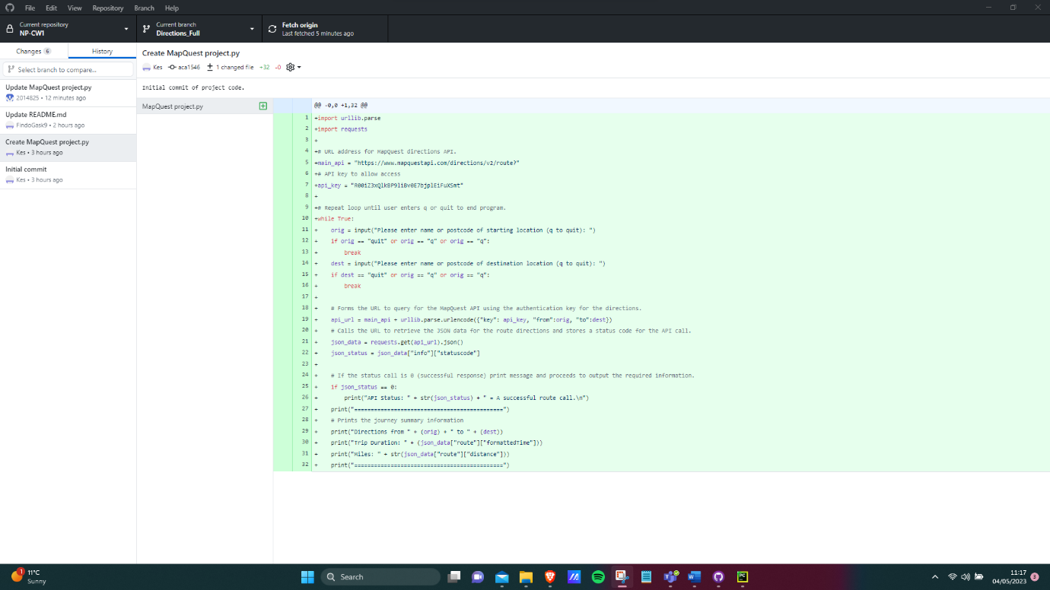
We ended up utilising GitHub Desktop as we all found this easier to work with than the website.

Testing the API
Positive Testing:
We have tested expected inputs, for example correct standard Postcodes (a standard 7-character and 6-character) alpha numeric postcode) and the API outputs the correct results. We have fact checked the results with another direction tool (Google Maps).
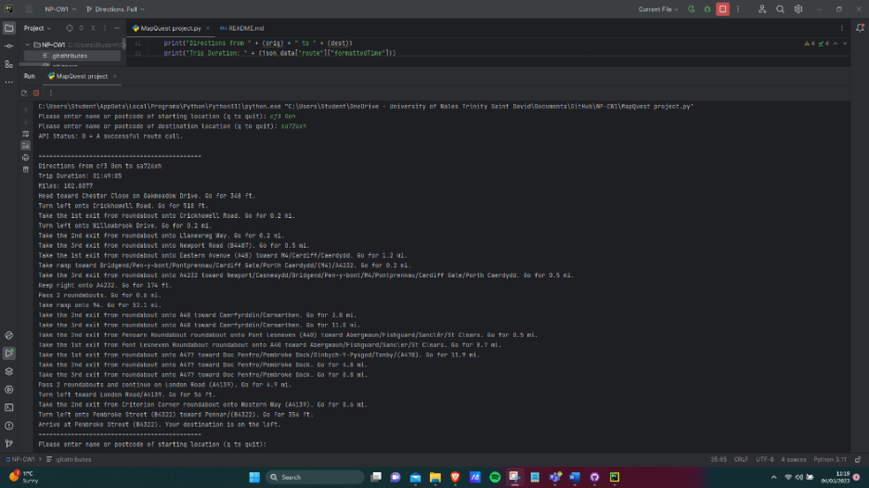

Negative Testing:
When API is presented with an incorrect postcode the results are as follows:
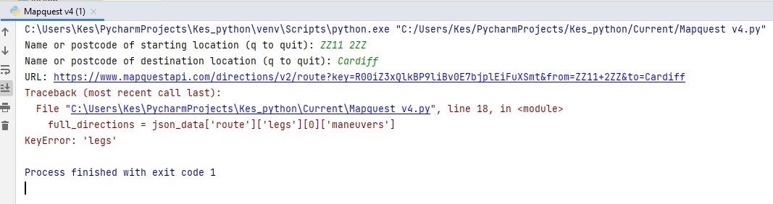
Figure 4: Output from incorrect post code being entered.
This could be improved up on by testing the MapQuest API call result for an unsuccessful return code and handling it appropriately using python code.
Boundary Testing:
This is the testing of extreme acceptable values, for example postcodes are at the furthest points of the UK. Testing showed no errors as shown below:
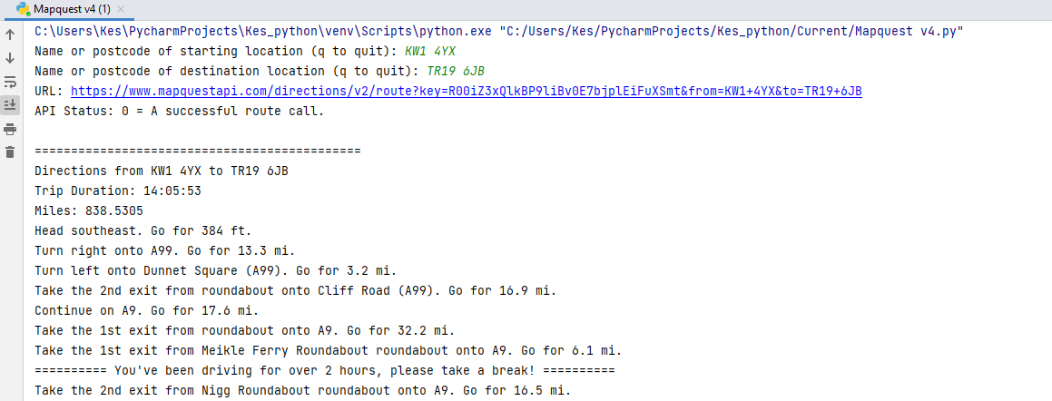
Figure 5: Boundary testing between furthest points of UK.
Load Testing:
Due to the limitations of members of the group the largest load that could be tested was four unique users requesting the API at once, the outcome of this was no impact to service. No screenshot evidence needed.

Trello
Trello Board Link: https://trello.com/invite/b/Ge8udJy7/ATTIe076a4b072242c972a6ce5147bc88d824510962C/network-programmability
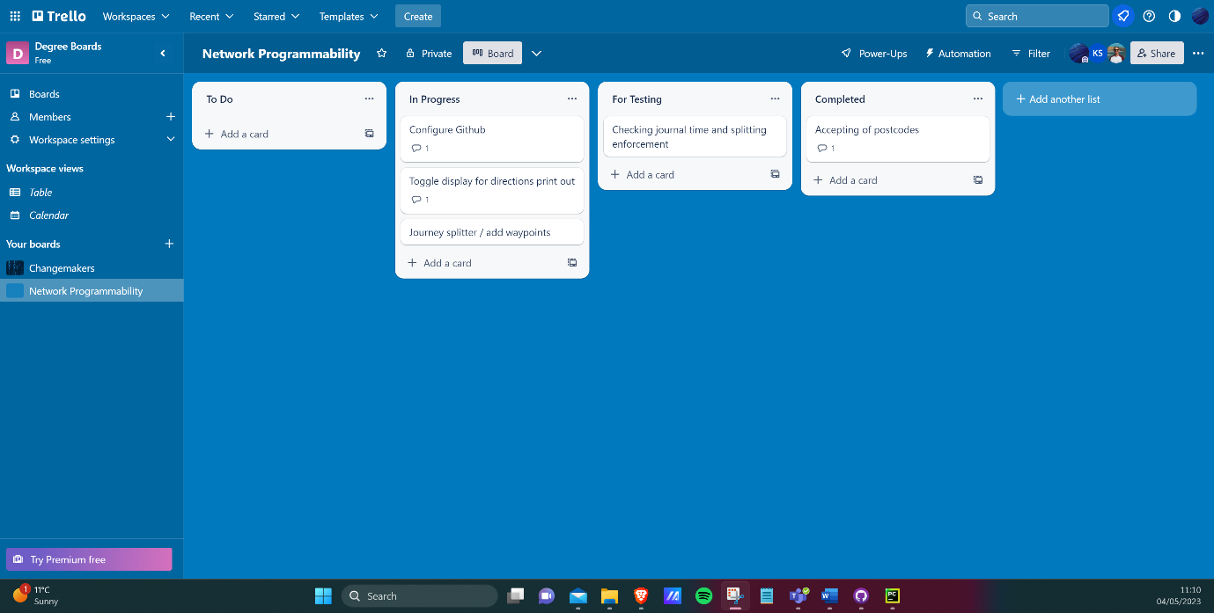

We have utilized Trello for a Kanban board that enables us to work together and added comments to the actions as well as ensuring that we are testing at each stage to ensure that no broken code is uploaded to our GitHub Repository.

Python Code

