How to maximise and minimise the different windows use Tabs on your screen
- Once logged in to your UWTSD account click on hwb for access to moodle/library

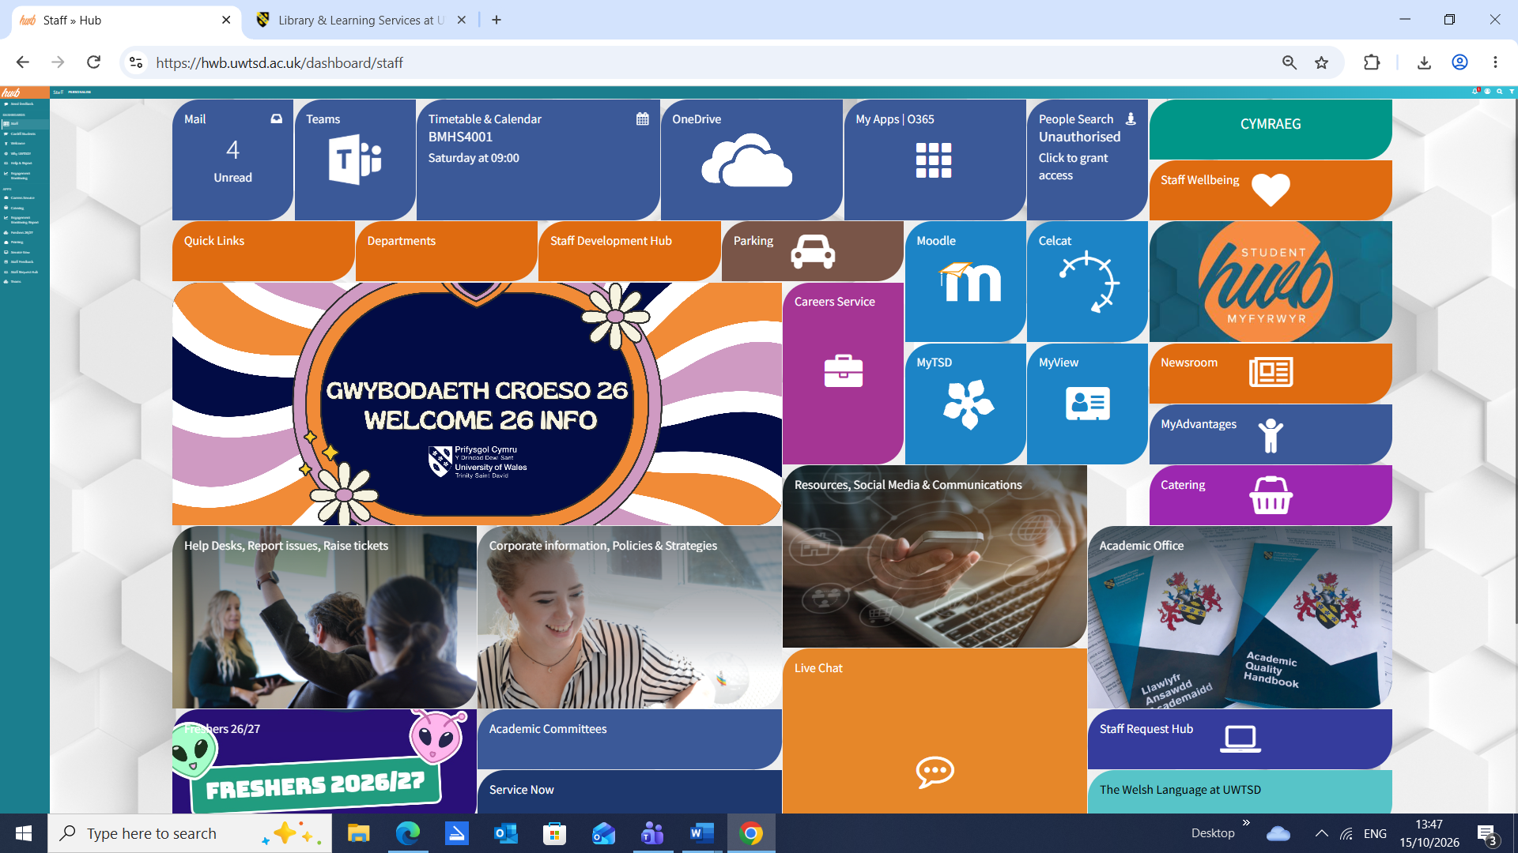

Here are Tabs for the pages you opened These 3 buttons change size/close current page
Click on Tab You want minimise Maximise Close
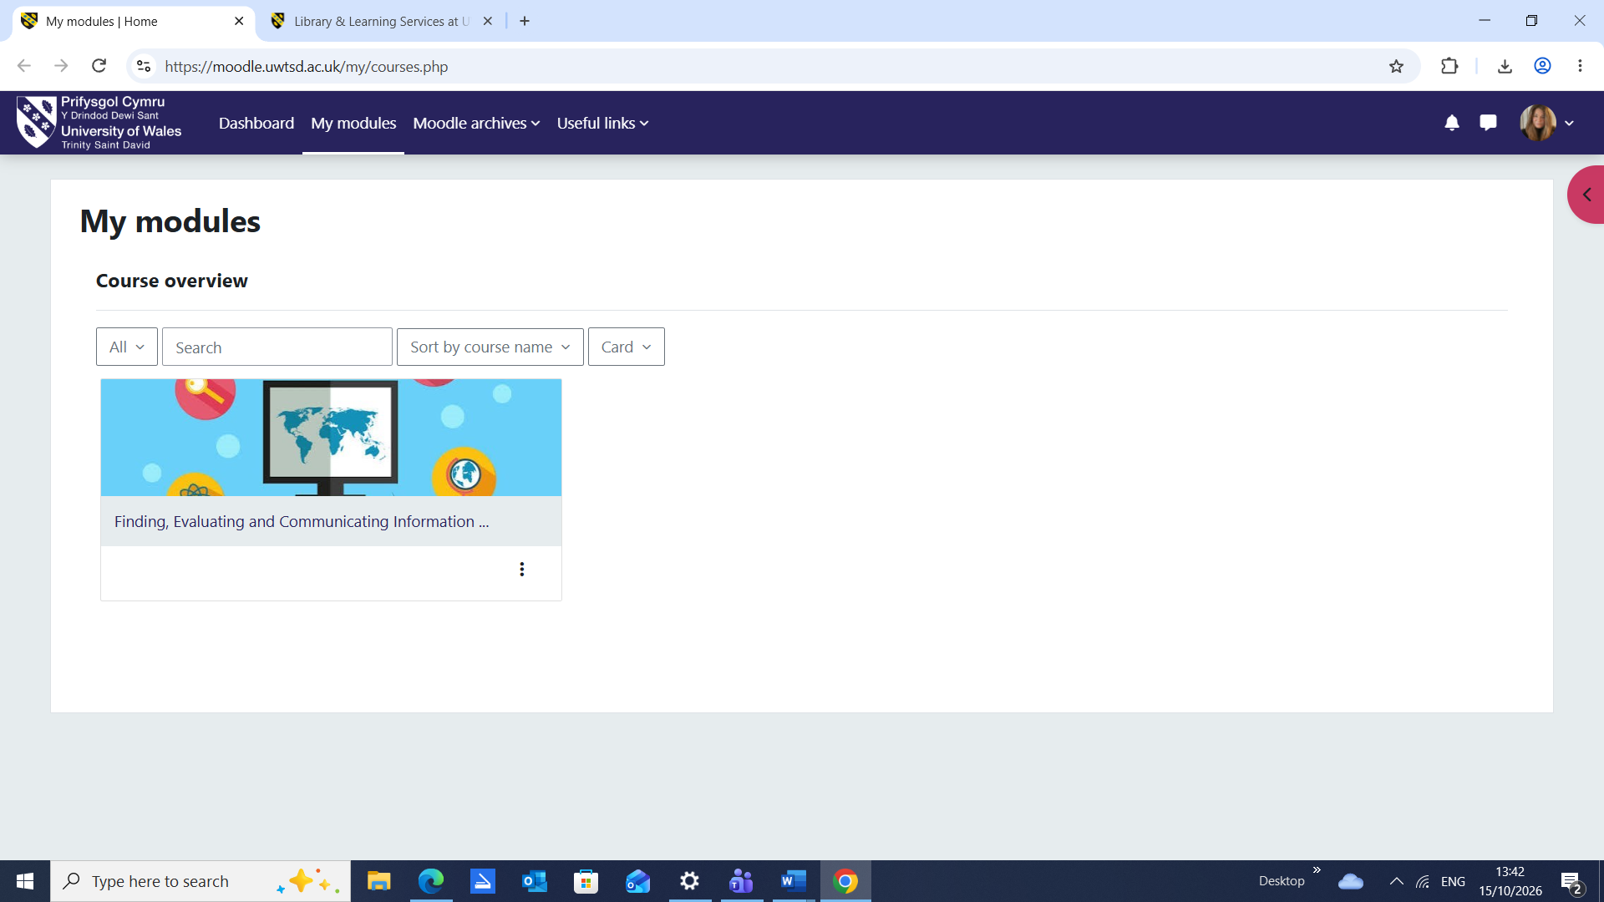
At the bottom is the Taskbar. Right click to open what you need
Right click on this file icon to open documents. Remember to name file and save to Desktop

