University of Wales Trinity Saint David
Wales Institute of Science & Art

Electronics Circuits Testing and Applications
Vehicle Electronics (ACHA4031)

Ollie Gooch
2501626
18/04/2026

Contents
1 Task 3 2
1.1 Scope Time Divisions Calculations 2
1.2 Function Output Generator Square Wave 2
1.3 Capacitor Charge and Discharge wave 3
1.4 Basic Capacitor Calculations 3
1.5 Capacitor Discharge Table 4
1.6 Plot log(V) Against Time 4
1.7 Gradient Calculations and Comparison 5
1.7.1 Gradient Calculations 5
1.7.2 Comparison Table 5
1.8 Capacitor Uses 5
1.9 Inaccuracies 5
1.10 Risk 6
2 References 7

Task 3

Scope Time Divisions Calculations
Frequency of the wave generator used $=250Hz$
$$Time Period (T)=\frac{1}{Frequency (f)}$$
$T=\frac{1}{250} T=0.004s$
The scope screen shows 10 time divisions so must divide original value of T by 10.
$\frac{0.004}{10}=0.0004s=400μs$
The nearest time division selected to show the wave $=500μs$.

Function Output Generator Square Wave
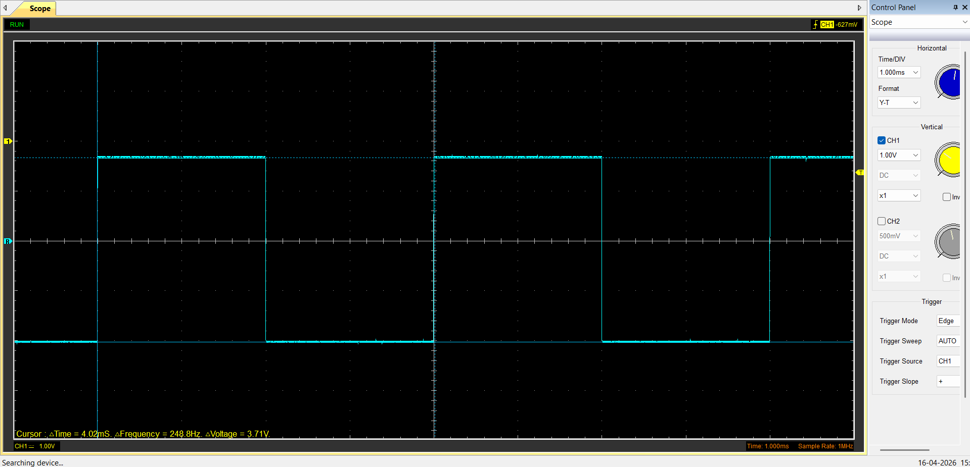
Figure 1.1

Capacitor Charge and Discharge wave
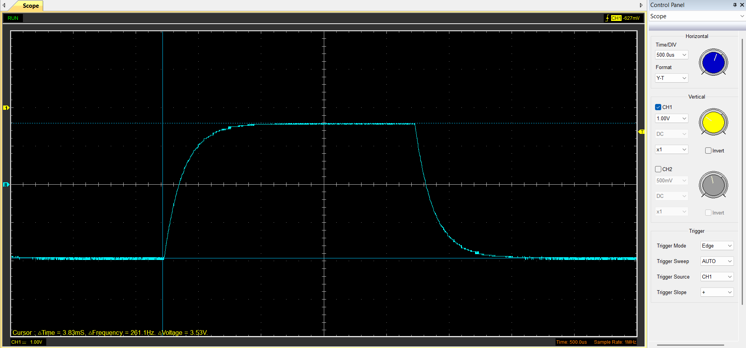
Figure 1.2

Basic Capacitor Calculations
Time constant is time taken for voltage to reach 63.2% of max voltage (for charging)
$V=3.5v 3.5×0.632=2.212$
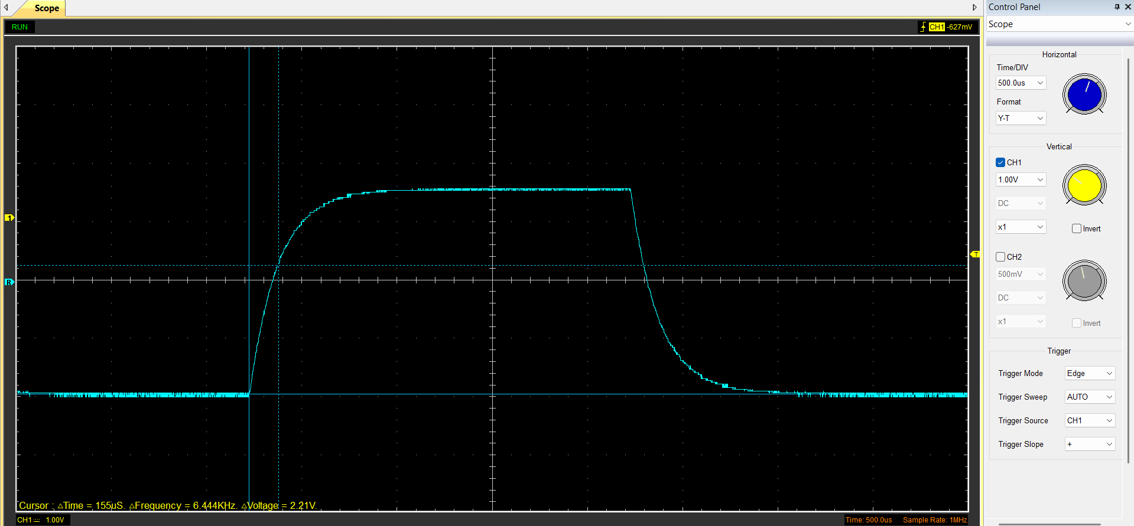
Figure 1.3
$τ=RC C=\frac{τ}{R}$
$R=100Ω$
$C=\frac{155e-6}{100}=1.55μF$

Capacitor Discharge Table
Time (s) | Voltage (V) | ln (V) | dy = y2 – y1 | dx = x2- x1 | dy/dx
Time (s) | Voltage (V) | ln (V) | dy = ln(V)2-ln(V)1 | dx = Time2 – Time1 | dy/dx
0.002394 | 3.3862 | 1.219708349 | x | x | x
0.002427 | 2.696 | 0.991769193 | -0.22793916 | 3.3E-05 | -6907.24714
0.00246 | 2.1941 | 0.78577194 | -0.20599725 | 3.3E-05 | -6242.34101
0.002493 | 1.7549 | 0.562411875 | -0.22336006 | 3.3E-05 | -6768.4868
0.002526 | 1.3784 | 0.320923406 | -0.24148847 | 3.3E-05 | -7317.83239
0.002559 | 1.1274 | 0.119914097 | -0.20100931 | 3.3E-05 | -6091.1912
0.002592 | 0.9078 | -0.09673119 | -0.21664529 | 3.3E-05 | -6565.00866
0.002625 | 0.7509 | -0.28648279 | -0.1897516 | 3.3E-05 | -5750.04857
0.002658 | 0.5941 | -0.52070762 | -0.23422483 | 3.3E-05 | -7097.72217
0.002691 | 0.5 | -0.69314718 | -0.17243956 | 3.3E-05 | -5225.44112
Table 1.1

Plot log(V) Against Time

Figure 1.4

Gradient Calculations and Comparison

Gradient Calculations
$τ=\frac{-1}{gradient}=\frac{-1}{-6490.9}=0.000154s$
$C=\frac{τ}{R}=\frac{0.000154}{100}=1.54μF$

Comparison Table
 | Capacitance | Delta | Percentage Difference
Actual | $1μF$ | x | x
Marker Calculation | $1.55μF$ | $+0.55μF$ | $+55\%$
Gradient Calculation | $1.54μF$ | $+0.54μF$ | $+54\%$
Table 1.2

Capacitor Uses
Uses for capacitors in electrical, automotive, and motorcycle applications:
- Smoothing DC output in power supplies (Poole, 2026)
- Protecting delicate components in PCBs by grounding high frequency AC (JLCPCB, 2025)
- Timing circuits using an RC circuit (Chaudhary, 2022)
- Improving power factor in AC circuits (Electrical4U, 2024)
- Stabilize voltage supplied to car audio amplifier (Matthews, 2026)
- Reduces flicker of lights under load (Matthews, 2026)
- Protects ignition circuits by preventing arching at the points (Markel, 2025)
- Absorb current ripple in EV powertrains (Rambow, 2024)
- In voltage regulator circuits to safeguard motorcycle electrical systems (Swagatam, 2026)
- Battery eliminator can replace battery for kick start and carburetted motorcycles

Inaccuracies
One source of inaccuracy comes from uncertainty in placing the oscilloscope markers, as shown in Figure 1.3. The waveform shown is not perfect, creating a small vertical spread of points that makes it difficult to identify the exact starting voltage. This affects the measured time constant, which directly affects the calculated capacitance.
Another source of inaccuracy could come from the Equivalent Series Resistance (ESR) of the capacitor, this is simply the internal resistance present in all capacitors (Gupta, 2019). This added resistance, using $τ=RC$, would increase the time constant of the capacitor which could explain why the measured values of the time constant were higher than the actual value.
Finally, any inaccuracies may be exaggerated by the tolerance of the capacitor used. For example, with the 1 microfarad capacitor used, it is very common for it to have a tolerance of $±10\%$ or even $±20\%$ (PCBSync, 2026). Knowing this, it is possible the measured values of the capacitance were more accurate than what was first observed. The same logic can be applied to resistors as well.

Risk
One way in which a vehicle's CANBUS systems are safeguarded is message authentication. As per ISO/SAE 21434, all communications through the vehicle must have cryptographic message authentication codes (MAC) to ensure the message is genuine (Voss, 2025). This protects the vehicles CANBUS systems from cybersecurity attacks such as spoofing and other kinds of unauthorised data access.
Another way in which a vehicle’s CANBUS systems are safeguarded is gateway ECUs. This involves separating and isolating the vehicle’s critical control systems (e.g. braking, steering, powertrain) from the non-critical systems (e.g. telematics and infotainment) (IEMA IEMLabs, 2025). This makes it more difficult for attackers to access critical systems and stops the attack coming from the more vulnerable infotainment systems such as Bluetooth or Wi-Fi.
An additional way in which a vehicle’s CANBUS systems are safeguarded is by revisiting and updating the security measures put in place. For example, in line with ISO/SAE 21434, incidents should be reported and reviewed, any vulnerabilities will be continuously monitored, and security patches should take place regularly (Voss, 2025). This will protect the vehicle’s CANBUS systems from newly emerging cybersecurity attacks.

References
Chaudhary, B. (2022), RC Charging Circuit : Example and Its Applications, https://www.semiconductorforu.com/rc-charging-circuit-example-and-its-applications/ (Accessed 17/04/2026)
Electrical4U (2024), Power Factor Correction: What is it? (Formula, Circuit And Capacitor Banks), https://www.electrical4u.com/power-factor-correction/ (Accessed 17/04/2026)
Gupta, S. (2019), Understanding ESR and ESL in Capacitors, https://circuitdigest.com/tutorial/understanding-esr-and-esl-in-capacitors (Accessed 17/04/2026)
IEMA IEMLabs (2025), Securing the CAN Bus: The Achilles’ Heel of Connected Vehicles, https://iemlabs.com/blogs/securing-the-can-bus-the-achilles-heel-of-connected-vehicles/ (Accessed 18/04/2026)
JLCPCB (2025), Decoupling vs Bypass Capacitor: What’s the Difference, https://jlcpcb.com/blog/decoupling-vs-bypass-capacitor (Accessed 17/04/2026)
Markel, A. (2025), How Capacitors Protect Ignition Circuits, https://www.tomorrowstechnician.com/how-capacitors-protect-ignition-circuits/ (Accessed 17/04/2026)
Matthews, J. (2026), Car Audio Capacitor What It Does How It Works Explained, https://carxplorer.com/what-does-a-car-stereo-capacitor-do/ (Accessed 17/04/2026)
PCBSync (2026), Capacitor Tolerance: Accuracy & Application Selection Every PCB Engineer Must Get Right, https://pcbsync.com/capacitor-tolerance/ (Accessed 17/04/2026)
Poole, I. (2026), Capacitor Smoothing Circuits & Calculations, https://www.electronics-notes.com/articles/analogue_circuits/power-supply-electronics/capacitor-smoothing-circuits.php (Accessed 17/04/2026)
Rambow, W. (2024), Calculating DC-Link Capacitance for xEV Powertrains, https://eepower.com/technical-articles/simplified-calculation-of-dc-link-capacitors-for-automotive-high-performance-xev-power-train-architecture/ (Accessed 17/04/2026)
Swagatam (2026), Motorcycle Voltage Regulator Circuits, https://www.homemade-circuits.com/3-phase-motorcycle-voltage-regulator/ (Accessed 17/04/2026)
Voss, W. (2025), Secure Your CAN-Bus: Implementing ISO/SAE 21434 in Embedded Systems, https://copperhilltech.com/blog/secure-your-canbus-implementing-isosae-21434-in-embedded-systems/ (Accessed 18/04/2026)

