Module: Global Business Challenges
Module code: BMMB7006
Assignment Title: Global Challenges
Word count: 4993

Executive summary
This report explains the challenge of control over data, the responsible application of AI, adherence to regulations, and the trust of customers in risk management at Unilever as the implementation of artificial intelligence is gaining momentum at a faster rate. For this report, Unilever is an ideal company example, as the firm has a global market in 190 nations, where its products under different brand names are being sold to 3.7 billion customers daily. Also, the company has made a significant amount of revenue amounting to €50.5 billion in the year 2025; thus, the case study is significant. The report shows that AI can both corporate value and risk to the company in the sense that it has massive market share that relies on the name of their brand. The report also states that AI could help Unilever in the areas of market forecasting, customer analytics, supply-chain planning, and productivity of operations. Artificial intelligence can make the market response faster, improve the decision-making process, and increase competitiveness on the global level. The report also explains that the rapid pace at which AI is evolving, is also among the major concerns in case the governance and management cannot keep pace with the innovations. These could lead to operational errors wrong prediction, data misuse, privacy, cybercrime, regulatory and compliance, ethical issues, leading to reputational loss, which may result in customer loss of confidence. While considering the operations of Unilever at Netherlands, AI risk must be taken into consideration at the regulatory and institutional level. This is because the UK laws are quite flexible and principles-focused whilst the Netherlands is more formal and EU-based and this means that the identical model of governance cannot be applied by Unilever in both countries. The report suggests that Unilever establish a governance structure of AI framework, enhance board and managers controls, enhance AI data security, conduct regular AI risk evaluation and monitoring, retain human decisions, assure consumer confidence through transparency in utilizing AI, regulate the compliance developments in the two nations, and train employees. In the report, it is concluded that AI can be used to benefit Unilever in the event that there is good governance, correct use of information, and successful implementation that facilitates innovation.

Table of Contents
1. Introduction 4
2. Main Findings 4
2.1 Unilever in the International Business Environment 4
2.1.1 Company Overview, International Operations and Market Presence 4
2.1.2 Macroeconomic (PESTLE Analysis) 5
2.2 The Growing Importance of Artificial Intelligence in International Business 7
2.3 The Impact of Artificial Intelligence on Risk Management in Unilever using Transaction Cost Economics (TCE) 8
2.4 Data Governance in Unilever using Corporate Governance Framework 300 words 10
2.5 Ethical Artificial Intelligence and Corporate Oversight 12
2.6 Regulatory Compliance in the UK and the Netherlands 13
2.6.1 The UK Regulatory Environment 13
2.6.2 The Netherlands Regulatory Environment 14
2.6.3 Comparative Analysis 15
2.6.4 Implications for Unilever and Theoretical Interpretation 15
2.7 Customer Trust and Stakeholder Expectations 16
2.8 Recommendations for Unilever and Implementation plan 18
3. Conclusion 23
4. Reflection 24
References 26

1. Introduction
AI is quickly becoming the operating, competitive, and decision-making tool of global companies using it to analyse customer behaviour, enhance prediction, assist in supply chain planning, and increase day-to-day efficiency. Unilever justifies this report since it markets the products in 190 countries to 3.7 billion people, and in 2025 the company turnover was €50.5 billion (Unilever, 2025a). It has over 128,000 employees in 100 countries proving its size and the challenges of risk management in the markets. AI can be used for understanding market, consumer behaviour, forecasting and supply chain management but bad governance can bring significant legal, ethical and reputational issues. The report discusses the challenges of the swift development of artificial intelligence in risk management at Unilever in terms of data governance, ethical use of AI, compliance with the law, and customer confidence. The report has compared the UK and Netherlands, examined hazards, and provided recommendations and implementation strategy.

2. Main Findings

2.1 Unilever in the International Business Environment

2.1.1 Company Overview, International Operations and Market Presence
Unilever is among the largest consumer goods firms in the world as it sells its products in 190 countries, and is consumed by 3.7 billion people every day. The company has a global presence as it reported a turnover of €50.5 billion in 2025. Unilever produces home care, personal care, beauty, wellbeing, and food products under many recognizable brands at global scale providing it with a fine organization to explore the role of AI in business decision-making, processes, and risk mitigation. Due to its market presence globally, it could impact many nations and enterprises with minor changes in technology or policy. The global supply chains, the effective supplier-retailer partnerships and the global market exposure are the results of the worldwide operation of Unilever. The corporation has presence in 100 countries and it relies on international demand and business performance by generating 59 percent of turnover in the new markets, which reveals the corporation heavily depends on new markets (Unilever PLC, 2026b). This wide market exposure positively impacts potential and risk as regional consumer demand, regulation, trade conditions, and technology, influencing corporate success. Unilever is an ideal case study to understand how AI can support global operations even as it provokes challenging legal, ethical and reputational challenges.
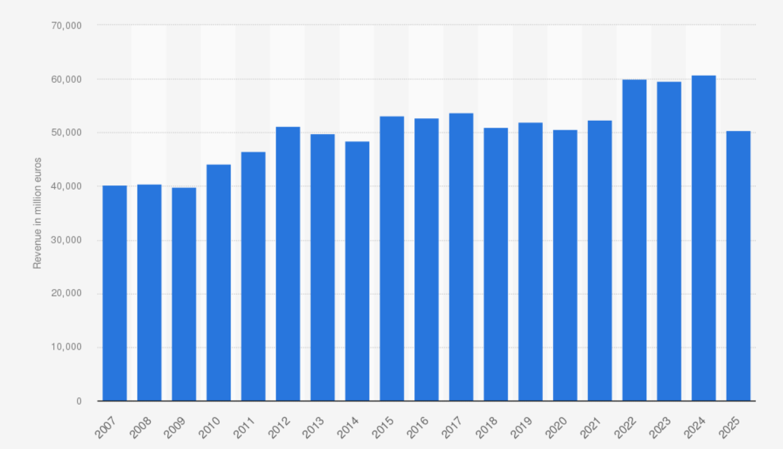
Figure 1: Unilever revenue in 2025
(Source: Unilever PLC, 2026b)

2.1.2 Macroeconomic (PESTLE Analysis)
The PESTLE model is important to understand the external factors that are affecting Unilever, as the company currently operates in 190 nations, with 3.7 billion daily customers and has a revenue of €50.5 billion, in the last quarter of 2025 (Badawy, 2025). From political aspect, Unilever needs to consider the difference in compliances in UK and Netherlands, when operating in both countries; whereas from economic perspective, the company must carefully allocate funds in AI for its future market predictions and to avoid excess cost. From technology perspective, Unilever is making progress, like its Personal Care AI Studio in four nations has become popular. From legal perspective, the company considers the difference between the compliance regulations of UK and EU, where UK has flexible structure; while, Netherlands has a formal EU compliance structure, with phased implementation of the EU AI act in 2026 and 2027 (Kerrigan et al. 2025).
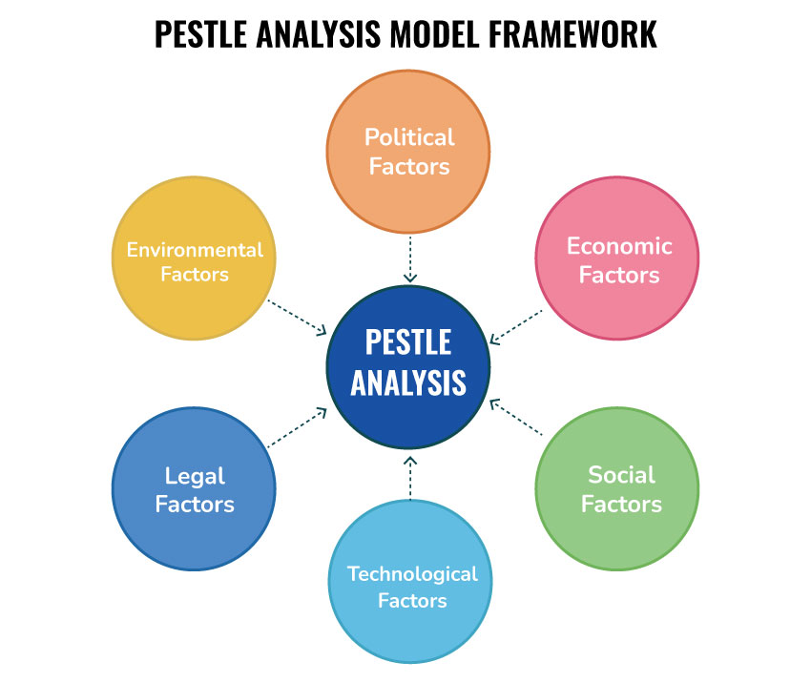
Figure 2: PESTLE Model
(Source: Badawy, 2025)
Irani et al. (2023) however assert that such PESTLE traits also make adoption of AI complicated as political and legal differences between the Netherlands and the UK do not allow one governance model to be applicable in both markets. The fast development of technology is capable of implementing AI use before internal controls are prepared. Rana et al. (2022) observe that social pressure may be counterproductive to Unilever where customers perceive that AI use is invasive, unequal, and economic pressure may encourage the firm to implement AI fast to save money, resulting in poor decision-making, privacy and compliance risk. Nevertheless, unethical AI applications can be minimised through the appropriate regulation, data management, and legal framework, so AI can still be of value to Unilever even in the face of these limitations. The report recommends that Unilever ought to apply AI as a business strategy instrument based on economic, political, legal, social, and technological influences and set up risk controls as quick as innovation.

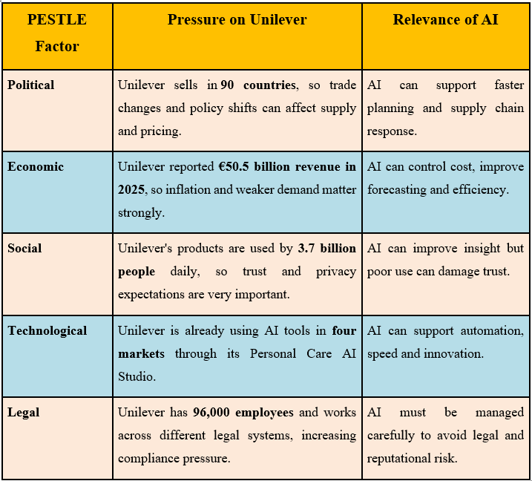
Table 1: PESTLE Analysis

2.2 The Growing Importance of Artificial Intelligence in International Business
According to Ashfaq et al. (2025), Resource-Based View (RBV) describes the rationale behind Unilever use of artificial intelligence since it believes that the company gains competitive benefits due to appreciate internal resources, capabilities, and systems. Unilever can benefit from this with its huge turnover and global presence, where the Personal Care AI Studio in four markets shows that AI is already accelerating the work of digital content and business efficiency (Unilever PLC, 2025b). Unilever is adopting AI due to business imperative rather than curiosity since Unilever reported 3.5% underlying sales growth in 2025, of which 1.5% was due to volume and 2.0% was due to price. 59% of turnover was driven by emerging regions with rapidly evolving demand. In such cases, markets, brands, and supply systems require more forecasting, consumer knowledge, expediency in planning and utilisation of data with greater caution.
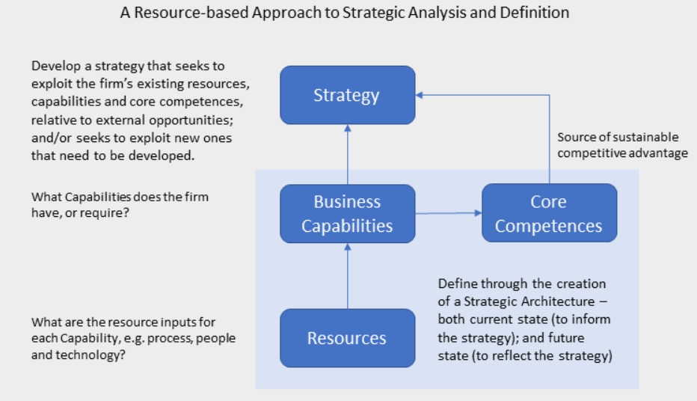
Figure 3: Resource-Based View (RBV) Theory
(Source: Ashfaq et al. 2025)
Day et al. (2025) however assert that RBV dictates that AI does not necessarily generate value, as firms need to deal with tools superiorly than their competitors to get performance. Inaccurate forecasts, marketing choices, and legal or reputational losses are possible because of poor quality of data, lack of personnel training, or speedy systems related to improper AI usage. The global reach of the company can result in the rapid spread of even small errors across other brands and even countries. Nevertheless, RBV states that organisations can develop pertinent capacity with help of appropriate internal management, and thus AI can also be useful to Unilever. Thus, Unilever will be able to leverage AI on the basis of digital solutions, its massive data base, research strength, global brand presence, and scale of its operations to turn AI into a strategic asset. In 2025, the corporation has spent €836 million on research and development, where Personal Care has yielded EUR 13.2 billion, which proves that AI can help the corporation to grow, accelerate, and make smarter decisions when properly linked to business objectives.

2.3 The Impact of Artificial Intelligence on Risk Management in Unilever using Transaction Cost Economics (TCE)
Nagle et al. (2025) note as per the Transaction Cost Economics (TCE), in case of increased uncertainty and difficult decisions-making, an organization requires a more effective control, closer supervision, and coordination. Unilever markets products in 190 countries, targets 3.7 billion individuals daily, and its turnover amounts to €50.5 billion in 2025, thus any minor AI error can be disseminated very quickly across brands, markets, and supply chains. The technology used by Unilever handles 240 TB of data each week and over 3 billion transactions, which can be dealt with the help of AI, as managers can work faster but more difficult to identify errors (Unilever, 2025d). AI can accelerate the process of forecasting, planning, marketing, and supply chain decisions in Unilever, where the company can ensure that the outcomes are precise, reasonable, and effective to actual business circumstances.
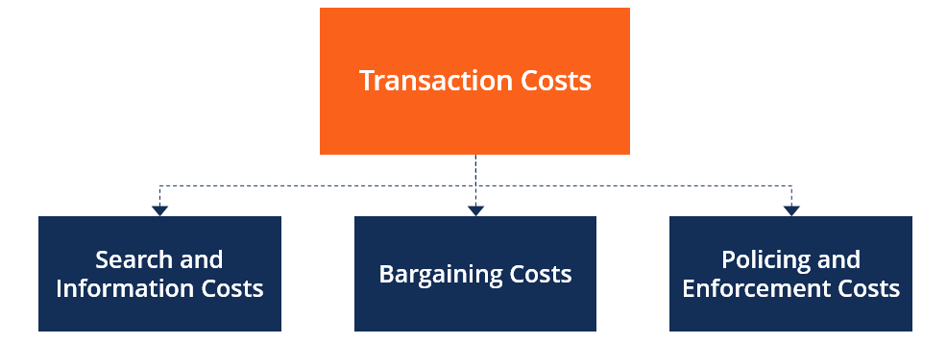
Figure 4: Transaction Cost Economics (TCE) Theory
(Source: Nagle et al. 2025)
However, in the opinion of Odedina (2023), overusing automated systems without proper verifications may cause Unilever to face a problem in risk management. A faulty prediction in operations could result in delivery of the wrong products to the wrong market, more wastage and stalling supply in different areas. The inadequate information or careless use of data may compromise the results and reveal confidential customer or employee information. With larger digital systems, cybercriminals have access to the connected data systems, cloud tools, and automated operations. Kilian et al. (2025) also observe that in the UK and Netherlands, where governance is given greater emphasis, Unilever will have to handle AI with considerable care since the EU AI act can only be implemented in phases until 2027. A single mismanaged AI application in targeting, profiling or communicating with consumers could destroy years of brand trust.
Nevertheless, TCE claims that Unilever ought to reinforce control when new technology introduces uncertainty, complicates monitoring or increases the cost of coordination within the teams and markets. Unilever claimed in 2025 that its business will be “simpler, sharper, and faster”, which implies that AI will improve everyday decisions (Unilever PLC, 2026b). To improve Unilever’s performance, better review mechanisms, monitoring data, clear reporting lines, and human approval in high-impact decisions can help the company achieve performance. Therefore, AI can help Unilever to perform accurate forecasting, planning, and faster processes, yet the managers should reinforce internal requirements for data collection, output testing, and response in case of system failure. TCE demonstrates that the basic problem lies in the expense of controlling, inspecting and integrating technology in a big global company. The application of AI will assist Unilever in its planning, supplying, and decision-making, as eradicating mistakes, preserving information, minimizing cyber exposure, and complying with the law helps retain the trust of the public. The company needs to take AI as one of the significant management issues, rather than technical equipment, since a lack of control in the current situation may have an adverse effect on its global competitiveness in the future.

2.4 Data Governance in Unilever using Corporate Governance Framework 300 words
Unilever’s artificial intelligence systems require strong, timely and steady data during operations to facilitate forecasting, demand organization, customer understanding, and supply chain decision. According to Emeka-Okoli et al. (2024), this is well explained under the Corporate Governance framework since it considers efficient oversight as a regulation, supervision, internal procedures, disclosure, and transparency and leaves the boards to guide goals, monitor controls, and manage risk. It is significant to Unilever since the company markets in 190 countries, accesses 3.7 billion individuals each day, and achieved €50.5 billion turnover by 2025, so, even minor data leak can go global. Guillen-Aguinaga et al. (2025) suggest that good quality of data, clear ownership, and restricted access is needed because erroneous data may hamper AI-based predictions, inventory organization, marketing choices, and brand, supplier, and market confidence. This is particularly critical for MNCs since AI regulation, data management, and platform responsibility vary among jurisdictions, increasing the cost of compliance and complicating the task of monitoring cross-border operations.
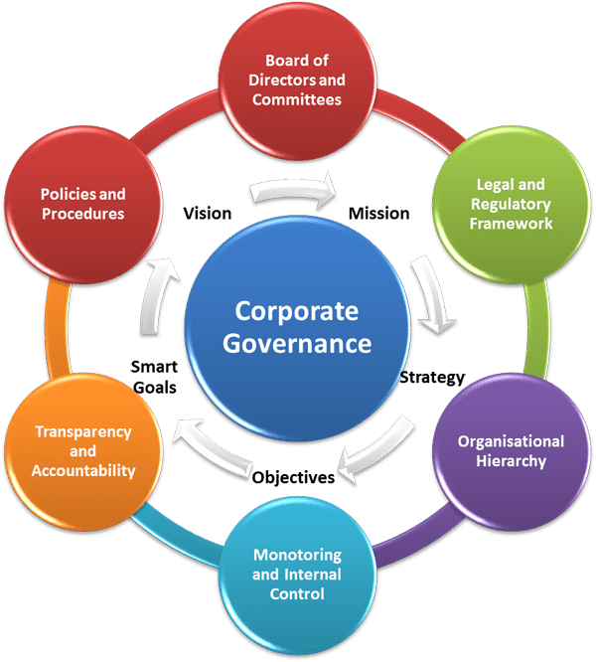
Figure 5: Corporate Governance framework
(Source: Emeka-Okoli et al. 2024)
However, Papagiannanidis et al. (2023) argue that limited managerial approach can see data governance as an IT department technical problem, as AI is often defined by speed, efficiency, and cost savings and not cautious control and accountable use. Nevertheless, the Corporate Governance structure demands boards to manage internal controls, adopt legally acceptable policies, guarantee good reporting, and deploy subsidiary structures of governance when risk arises. Critical interpretation reveals that data governance at Unilever should be viewed as a governance matter that incorporates power, authority, responsibility, and lawful administration in the UK and Netherlands rather than back-office support. Therefore, Unilever ought to enhance board-level disclosure, data ownership, transnational control, and AI implementation to avoid legal, operational, and reputational harm due to minute failures.

2.5 Ethical Artificial Intelligence and Corporate Oversight
Chang and Ke (2024) assert that the model of Triple Bottom Line is used to measure the profit, efficiency, influence on the planet and people, and trust by using ethical artificial intelligence in Unilever. The model by Elkington (1994) focuses more on people, the planet, and profit as opposed to financial performance in evaluating corporate success. The success of AI in Unilever must be assessed based on its impacts on the workers, consumers, and stakeholders and not the speed of operation enhancement. Arinze (2024) confirms that AI can raise the speed of services demanded, plan the needs, and enhance corporate success. However, Varona and Suarez (2022) imply that AI might create bias, unfair profiling, ineffective employment choice, abuse of personal data, and reduced trust when a person is unaware of the decision-making process. Yet, AI usage is beneficial for companies as it helps to understand stakeholder’s expectations and act responsibly towards the planet, people and environment. Also, it helps to understand that ethical AI usage is enhanced in companies when critical decision-making is aligned with human-made decisions.
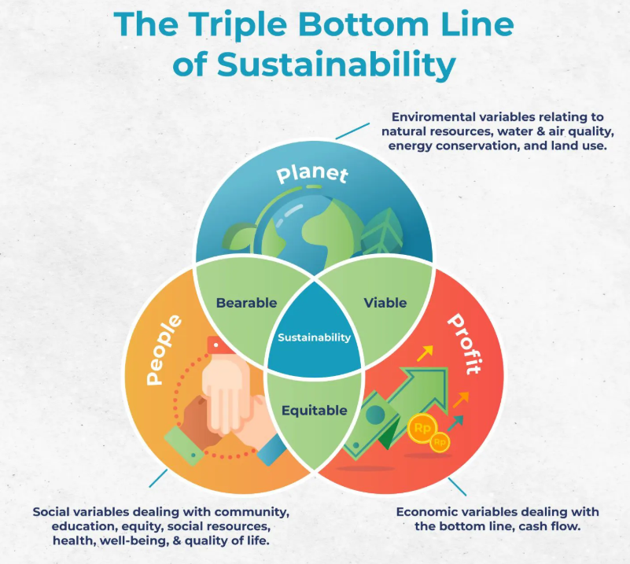
Figure 6: Triple Bottom Line Theory
(Source: Chang and Ke, 2024)
Bansal et al. (2023) report that AI has the potential to enhance the market predictions, fasten marketing process, supply chain planning, and utilization of data across a large multinational enterprise, which augments the profit component of the Triple Bottom Line. Unilever is complex due to its size, and AI can assist it in adjusting more quickly to the alterations on the market, demand, and cost pressure. Bahangulu and Owusu-Berko (2025) however indicate that ethical and governance costs that would hamper performance and public trust may be hidden by short-term benefits, hence the profit aspect still needs to be fully analysed. Nevertheless, the profit concept cannot be rejected due to the fact that the model doubts whether the financial gain is responsible and sustainable.
The planet aspect of the Triple Bottom Line should encourage responsible production, reduce wastage, and enhance sustainability decisions in the global supply chains of Unilever through ethical AI usage. According to Nweje and Taiwo (2025), AI is capable of enhancing accuracy of forecasts, minimising overproduction, enhanced inventory planning, and enhanced carbon-free transport and resource optimisation in the entire operations. However, Uddin et al. (2024) assume that this planet aspect of the model is more difficult to analyse, since environmental value is difficult to quantify, and corporations can exaggerate positive impact with no evidence. Nevertheless, the planet factor is applicable as it compels managers to focus on whether AI can help to ensure long-term sustainability or not only the improvement of operations.

2.6 Regulatory Compliance in the UK and the Netherlands

2.6.1 The UK Regulatory Environment
Galleli and Amaral (2026) assert that the UK’s business context can be explained with the help of the Institutional Theory due to the fact that it reveals that businesses are dependent on the rules, compliances, and policies of the environments, which they operate in. The UK government’s AI related law is flexible and supports pro-innovation behaviour, where five cross-sector principles, including safety, openness, fairness, accountability, and contestability, along with GDPR and Data Protection Act 2018 are applied. However, Unilever operates in 190 nations, means that it cannot follow a single governance structure in all nations, like Netherlands has a formal structure of EU AI Act. Hence, Unilever makes sure that company aims and global governance is maintained, but also adapts to the regulations according to different countries.

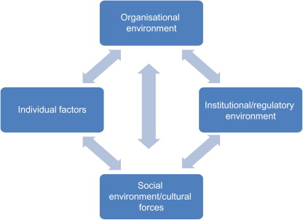
Figure 7: Institutional Theory
(Source: Galleli and Amaral, 2026)

2.6.2 The Netherlands Regulatory Environment
Netherland’s AI governance is institutionally different and informed by the EU AI Act. According to Butt (2024), the AI Act is the first ever risk-based paradigm based comprehensive AI law with responsibilities on high-risk systems, transparency, human control, data quality, accuracy, and cybersecurity set by the European Commission. Some important steps have been initiated since 2025, the greater part of the Act came into effect on 2 August 2026 and some of the duties persist until 2027, therefore compliance is still evolving. However, Busuioc (2022) adds that the Dutch Data Protection Authority organizes the supervision of algorithms and AI, where the Algorithm Register publicizes the algorithms used in the sector. Thus, Unilever understands the importance of a formal rule-based European compliance environment in the Netherlands, when considering it for marketing operations.
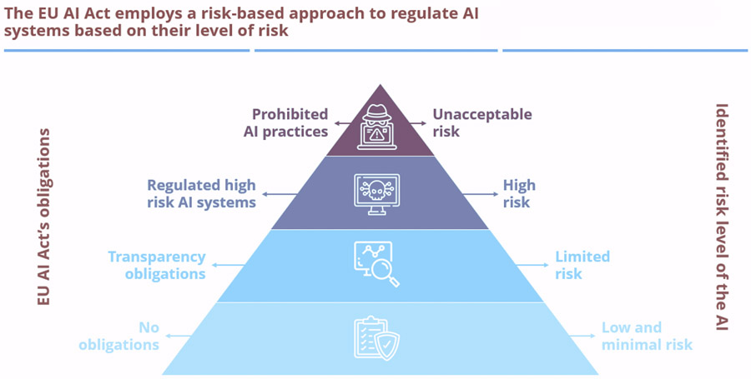
Figure 8: EU AI Act
(Source: Butt, 2024)

2.6.3 Comparative Analysis
The UK has greater flexibility of interpretation of the laws by regulators and the Netherlands follows the more formalised EU model. Popa (2025) states that the UK can provide Unilever with an enhanced chance to adjust AI governance according to the sector and the company operation, whereas the Dutch and EU have more severe legal requirements, schedules, and documentation. However, the UK and the Netherlands want corporations to rectify data prejudice, transparency, protection, responsibility, and authorized data use solemnly. The basic difference is that the same AI tool can be subject to further official classification and compliance requirements in the Netherlands than in the UK because of regulators, data law, and developing guidelines.

2.6.4 Implications for Unilever and Theoretical Interpretation
Unilever is a global brand and it markets its products in more than 190 countries, and the company has a turnover of €50.5 billion in 2025. Also, the company reaches 3.7 billion people every day with its FMCG products; hence, even the smallest governance errors can go viral among customers and this can lead to huge reputational loss for the company. According to the concept of Institutional Theory, the enterprises are required to conform to different legal and regulatory environments as opposed to the use of a single model across the board. Glynn and D'aunno (2023) suggest that Unilever must maintain a global governance system but introduce country-based legal controls, reporting, and compliance, like different kinds of AI governance in the UK and Netherlands. This implies that the risk of AI is technological and institutional and it should be maintained for operational success with proper governance frameworks.

2.7 Customer Trust and Stakeholder Expectations
The Corporate Social Responsibility theory shows that large companies must go beyond organisational profit that focuses only on increasing revenues, and also focus on society and all stakeholders, as only trust, fairness, and responsible behaviour is needed for companies to succeed on the long-term basis (Awa et al. 2024). Research indicates that CSR is able to enhance consumer confidence, commitment, satisfaction, and loyalty and it is useful for global companies like Unilever that deal with millions of customers. Unilever can be an effective example because it sells its products in 190 countries, they are used by 3.7 billion people every day, and the company shows a profit of €50.5 billion in 2025. Customer trust is essential to such a large firm since even minor concerns about justice related to data usage or privacy may circulate throughout brands and markets. Habbal et al. (2024) assert that AI is used by global companies like Unilever for client profiling while using that data for future predictions and targeting the customers intrusively for personalised marketing. However, client trust regarding transparency in data usage is important, as unethical usage of data can lead to misinterpretation of the results and thus cause reputational loss. Clients demand transparency in data usage, and Unilever must consider this aspect, as company reports show that it has increased 30% revenue once the company started implementing AI in their company operations. Thus, Unilever understands the importance of openness with customers regarding data usage, and hence the company has strong ethical governance regarding AI usage for maintaining customer trust.

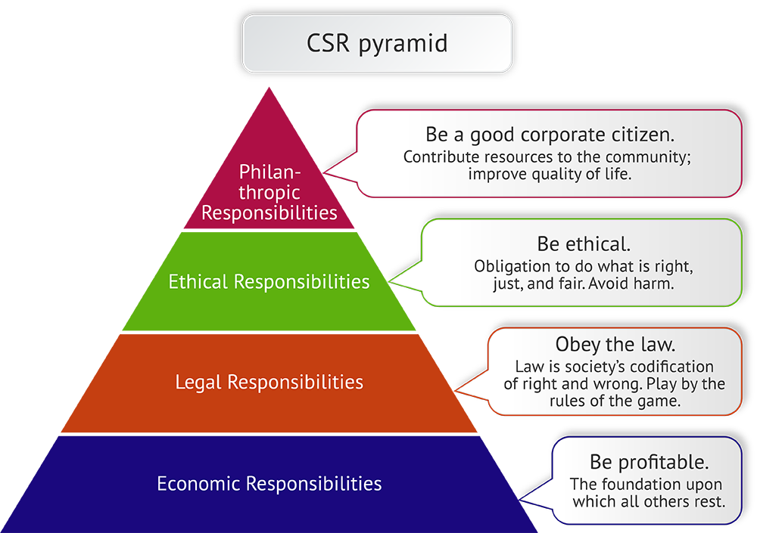
Figure 9: Corporate Social Responsibility Theory
(Source: Awa et al. 2024)
However, Akter et al. (2025) state that customers require convenience, reduced prices, and faster service, thus stricter AI regulations may inhibit marketing and reduce the gains of the companies. Unilever has boasted of faster content creation, greater campaign exposure, and a healthy engagement through AI assisted marketing. For instance, with the use of AI, within less than 30 days, the Dove Change the Compliment campaign had reached 700 million impressions and 94 percent positive sentiment, which has improved the brand image of Unilever at a global scale (Dove, 2025). Nevertheless, the theory of CSR states that the profitability generated in the short term is inadequate when customers may doubt the level of honesty, privacy, or fairness due to the fact that trust is the basis of reputation and repurchase. Responsible behaviour led to increased firm reputation and trust, which results in increased consumer trust, rather than sales as CSR and consumer trust studies reveal. Therefore, Unilever ought to prioritize customer trust as a strategic asset and assess AI in terms of responsibility and not speed, client reach, or cost-saving. Certain implications of responsible AI in Unilever are expected to be clear communication, cautious use of data, less intrusive profiling, and enhanced customer protection in the UK and Netherlands. The CSR theory purports that the stakeholders desire that brands should act fairly, explain their presence, and protect the trustworthiness since the value of the long term is based on trust rather than performance.

2.8 Recommendations for Unilever and Implementation plan
This section of the report will provide practical recommendations and a roadmap to responsible AI management for Unilever in the global market. These include governance, oversight, data control, risk assessment, human judgment to include AI-based decisions, customer trust, regulatory oversight, and employee competence in enhancing performance and mitigating the risks of legal, ethical and reputational risk.
Recommendation | Action | Responsible Team | Timeline | Expected Outcome
Establish an AI governance framework | Unilever needs to implement a holistic AI governance framework to implement responsible AI application across all its key business unit segments (Birkstedt et al. 2023). The business, risk, legal, and technical teams need to be connected by the definite roles in the design, approval, check, and review of AI systems. A central AI governing council must be used to prevent technical teams and local managers making key decisions. | Board, Executive Committee, Legal, Risk, Data and Technology Teams | Short term (0–3 months) | Clear control structure, better coordination, and stronger accountability across Unilever
Strengthen board and executive oversight | AI enhances the marketing, forecasting, supply chains, customer data, and business reputation in many industries and brands, and thus board and management oversight are to be enhanced for proper AI usage. To ensure the highest level of accountability, the senior leaders must receive periodic reports on the ethical AI use, risk exposure, compliance challenges and critical system failures (Frenette, 2023). This aspect of monitoring cannot be ignored since the AI decisions made by many teams with no obvious reporting lines or ownership undermine accountability. | Board, CEO, Senior Management, Risk and Compliance Teams | Short term (0–3 months) | Better senior-level accountability and faster response to emerging AI risks
Improve data governance | In an effort to enhance data governance in all systems and operating units, Unilever needs to enhance data quality, access, ownership, storage, and control policy (Adepoju et al. 2023). The absence of old, lost, copied, or mismanaged data within areas, departments, suppliers, and digital environments renders results of AI unreliable. Therefore, the organization is supposed to provide clear data to owners, restrict unnecessary access, and design regular data quality, accuracy and consistency audits. | Data Governance Team, IT, Legal, Business Unit Managers | Short to medium term (0–6 months) | More reliable AI outputs, lower data risk, and stronger legal compliance
Introduce AI risk assessment and auditing | The organization must implement a systematic AI risk assessment and auditing system to categorize systems according to risk prior to massive implementation in different markets (Giudici et al. 2024). Following the launch of a business, systems must be tested, approved and audited continuously, as compared to low-risk systems which might need minimal testing. It would assist Unilever to find the AI-led biases, privacy problems, underperformance, and control breaches before they become distributed across brands, functions, or countries. | Risk Team, Internal Audit, Data Team, Technology Team | Medium term (3–9 months) | Early identification of bias, privacy risk, weak controls, and system failure
Maintain human oversight in high-impact areas | Sensitive or high-risk decisions should not be controlled solely by AI particularly when it can be detrimental to human lives such as consumers, employees, suppliers, or crucial business results (Bamigbade et al. 2024). AI in such fields must complement human judgement and not surpass it, since human beings are required to assess outputs, add context, and prevent adverse consequences, thus enhancing responsibility in challenging decisions. | Senior Management, HR, Marketing, Supply Chain, AI Teams | Medium term (3–9 months) | Better judgement, fewer harmful automated decisions, and stronger accountability
Protect customer trust through transparent AI use | Transparency in AI communications, equitable data usage while customer profiling, targeting, and genuine engagement with customers must contribute to building customer trust in Unilever (Banerjee et al. 2024). In the sector of consumer products, trust plays an essential role since consumers hope that massive brands, in turn, can be fair, maintain their privacy, and engage honestly in business. Thus, building clear communication with customers regarding their data usage during critical AI communication would eradicate mistrust and maintain reputation. | Marketing, Legal, Customer Experience, Communications Teams | Medium term (3–9 months) | Stronger customer trust, better brand protection, and lower reputational risk
Monitor UK and Netherlands regulatory developments | Unilever needs to constantly consider legal and regulatory changes in the UK and Netherlands since a single governance model might not be applicable to both of the countries (Kashefi et al. 2024). This is critical because AI laws, enforcement practices, and compliance levels may evolve particularly in national and regional institutions. One of the benefits of regular legal review would be to prepare the organization and decrease compliance risk. | Legal Team, Compliance Team, Public Affairs, Country Managers | Ongoing, with formal review every 6 months | Better readiness for regulatory change and lower cross-border compliance risk
Build employee capability and awareness | Last but not least, employees of Unilever need to be trained about the threat of AI, the responsibility of data, ethics, and internal controls. The use of AI is affected by managers, marketers, supply chain employees, and top leaders, and thus they should be trained, as they must know how to use AI properly (Al Astal et al. 2024). There would be improved business awareness that can enhance decision-making and governance. | HR, Learning and Development, Legal, Risk, Technology Teams | Short to long term (0–12 months) | Improved staff awareness, safer AI use, and stronger governance culture
Track outcomes and monitor performance | The company can also establish key performance indicators in compliance, data quality, audit results, employee training, and issues concerning trust. These KPI metrics will help managers to understand the impact of their monitoring systems and also assess how AI affects clients in real-time. | Risk Team, Internal Audit, Data Team, HR, Customer Insights Team | Ongoing after implementation begins | Measurable progress, better monitoring, and continuous improvement across AI governance
Table 2: Recommendations and implementation plan

3. Conclusion
In conclusion, the report highlighted main points of advantages and disadvantages regarding the use of Artificial Intelligence for operational matters at Unilever, a FMCG company that operates worldwide. As the industry reports show, Unilever has a huge market globally with 3.7 million daily customers in 190 nations, who use their products daily. Also, the company revenue has reached a value of €50.5 billion in the last quarter of 2025, which indicates global success. Thus, Unilever has applied AI in its global operations for the purpose of marketing predictions, maintaining effective supply-chain and speed up the decision-making process. However, as the report shows, AI usage should be properly aligned with ethical implementation of AI, specially when data of customers are involved in AI-based decision-makings. However, if AI is not managed properly, and as most managers treat it, as a technological tool, it could lead to client mistrust and loss of company reputation. Thus, ethical AI usage is very important to consider a strategic business tool that has been involved in company governance, data quality, accountability towards clients and consumer trust. Hence, strong data governance is necessary since unjust, ambiguous, or violating AI laws will destroy trust in the system of large corporations. The UK and the Netherlands compliance law comparison indicates that Unilever has to cope with different regulatory and institutional settings. Unilever can use AI when it is backed by robust governance, proper regulatory compliance, proper use of data, and implementation of ethical AI usage on the business-wide level.

4. Reflection
This report taught me that artificial intelligence is a technical and cross-border business issue because prior to this assignment I thought that AI only assisted companies in saving time, increasing speed, and making decisions. After completion, I understood that AI is used by international organisations such as Unilever to improve efficiency and make profits, along with the responsible use of data, legal considerations, ethics, customer trust, and reputation (Zaborek, 2025). Companies should understand the impact of AI on individuals, markets, and the future corporate performance, and this demonstrated to me how AI influences the global strategy of the company and mitigates risks.
The other significant lesson from this report was the need to use theory to structure business analysis. The PESTLE framework demonstrated to me the impact of political, economic, social, technical, legal, and environmental issues on business decisions (Qadri and Tariq, 2025). This demonstrated the impact of regulation, consumer expectations, and global market pressure on the AI implementation of Unilever. The Resource-Based View concept taught me that AI could be a competitive edge of a company with good data, infrastructure, and internal capabilities. The most helpful ideas that I incorporated in my report were Corporate Governance, which demonstrated that AI requires accountability, oversight, and clear responsibility at senior level, and the Institutional Theory, which demonstrated that businesses should adapt to different national environments rather than employ a single approach globally (Ahmed et al. 2025). The Triple Bottom Line also taught me that AI has to be quantified with regard to its effects on trust, people and stakeholders rather than profit.
This report enhanced my academic and professional skills as it helped me to enhance my critical thinking since I could not provide one opinion but rather evaluate the advantages and disadvantages of AI. The second benefit that I got was, I was able to use theory on a global company situation and improve my analytical skills in business. Third, it enhanced my skills on writing recommendations since I was informed that a good recommendation needs to be practical, realistic, and related to the issues in the report. Implementation plan was also an important teaching and it reinforces recommendations to demonstrate how to implement them. This report, therefore, enhanced my knowledge of AI in global business and my confidence in the use of theory to address business issues.

References
Adepoju, A.H., Austin-Gabriel, B., Eweje, A. and Hamza, O., 2023. A data governance framework for high-impact programs: Reducing redundancy and enhancing data quality at scale. International Journal of Multidisciplinary Research and Growth Evaluation, 4(6), pp.1141-1154. https://www.allmultidisciplinaryjournal.com/uploads/archives/20250116173709_MGE-2025-1-077.1.pdf
Ahmed, F.A., Gul, S. and Shahzad, S., 2025. Ensuring accountability and transparency in AI-driven corporate governance. International Journal of Social Sciences Bulletin, 3(5), pp.330-341. https://socialsciencesbulletin.com/index.php/IJSSB/article/download/661/843
Akter, S., Akhter, S.R., Rahman, M.B. and Naidu, P., 2025. AI-driven business analytics for competitive advantage in service-oriented enterprises: CUSTOMER experience and efficiency. International Journal of Business and Economics Insights, 5(3), pp.389-423. https://ijbei-journal.org/index.php/ijbei/article/download/25/25
Al Astal, A.Y.M., Ateeq, A., Milhem, M. and Shafie, D.I., 2024. Corporate governance and internal control Mechanisms: Developing a strategic framework. In Business Sustainability with Artificial Intelligence (AI): Challenges and Opportunities: Volume 2 (pp. 551-564). Cham: Springer Nature Switzerland. https://www.researchgate.net/profile/Ahmad-Alastal-2/publication/385171190_Corporate_Governance_and_Internal_Control_Mechanisms_Developing_a_Strategic_Framework/links/67608a93996d2552c3ed1bff/Corporate-Governance-and-Internal-Control-Mechanisms-Developing-a-Strategic-Framework.pdf
Arinze, E.D., 2024. Artificial intelligence (AI) in customer service: Revolutionising support and engagement. IAA Journal of Scientific Research, 11(2), pp.33-39. https://smartie.kiu.ac.ug/public/assets/publications/d66bb149a003927f8b7bf2d8d036e17b90e1c1ac.pdf
Ashfaq, K., Abbas, N., Akram, A. and Shahazdi, I., 2025. The strategic impact of artificial intelligence on business innovation and firm performance: A resource-based view approach. Journal of Management & Social Science, 2(4), pp.868-891. http://www.rjmssjournal.com/index.php/7/article/download/228/207
Awa, H.O., Etim, W. and Ogbonda, E., 2024. Stakeholders, stakeholder theory and corporate social responsibility (CSR). International Journal of Corporate Social Responsibility, 9(1), p.11. https://link.springer.com/content/pdf/10.1186/s40991-024-00094-y.pdf
Badawy, W., 2025. Data-driven framework for evaluating digitization and artificial intelligence risk: a comprehensive analysis. AI and Ethics, 5(1), pp.453-478. https://www.researchgate.net/profile/Wael-Badawy-2/publication/375774151_Data-driven_framework_for_evaluating_digitization_and_artificial_intelligence_risk_a_comprehensive_analysis/links/655f63e5b86a1d521b02eb9f/Data-driven-framework-for-evaluating-digitization-and-artificial-intelligence-risk-a-comprehensive-analysis.pdf
Bahangulu, J.K. and Owusu-Berko, L., 2025. Algorithmic bias, data ethics, and governance: Ensuring fairness, transparency and compliance in AI-powered business analytics applications. World Journal of Advanced Research and Reviews, 25(2), pp.1746-1763. https://www.researchgate.net/profile/Louis-Owusu-Berko-2/publication/389397603_Algorithmic_bias_data_ethics_and_governance_Ensuring_fairness_transparency_and_compliance_in_AI-powered_business_analytics_applications/links/67c1200e207c0c20fa9ab59e/Algorithmic-bias-data-ethics-and-governance-Ensuring-fairness-transparency-and-compliance-in-AI-powered-business-analytics-applications.pdf
Bamigbade, O., Adeshina, Y.T. and Kemisola, K., 2024. Ethical and explainable AI in data science for transparent decision-making across critical business operations. International Journal of Engineering Technology Research & Management, 8(11), pp.734-753. https://ijetrm.com/issues/files/Jun-2024-16-1750047941-NOV202434.pdf
Banerjee, S., Whig, P. and Parisa, S.K., 2024. Leveraging AI for Personalization and Cybersecurity in Retail Chains: Balancing Customer Experience and Data Protection. Transactions on Recent Developments in Artificial Intelligence and Machine Learning, 16, p.16. https://www.researchgate.net/profile/Somnath-Banerjee-13/publication/391460557_Leveraging_AI_for_Personalization_and_Cybersecurity_in_Retail_Chains_Balancing_Customer_Experience_and_Data_Protection/links/681979cedf0e3f544f5210cf/Leveraging-AI-for-Personalization-and-Cybersecurity-in-Retail-Chains-Balancing-Customer-Experience-and-Data-Protection.pdf
Bansal, C., Pandey, K.K., Goel, R., Sharma, A. and Jangirala, S., 2023. Artificial intelligence (AI) bias impacts: Classification framework for effective mitigation. Issues in Information Systems, 24(4), pp.367-389. https://pure.jgu.edu.in/id/eprint/6745/1/Artificial%20intelligence%20%28AI%29%20bias%20impacts%20classification%20framework%20for%20effective%20mitigation.pdf
Birkstedt, T., Minkkinen, M., Tandon, A. and Mäntymäki, M., 2023. AI governance: themes, knowledge gaps and future agendas. Internet Research, 33(7), pp.133-167. https://www.emerald.com/intr/article-pdf/33/7/133/1214024/intr-01-2022-0042.pdf
Busuioc, M., 2022. AI algorithmic oversight: new frontiers in regulation. In Handbook of regulatory authorities (pp. 470-486). Edward Elgar Publishing. https://www.elgaronline.com/downloadpdf/edcollchap-oa/book/9781839108990/book-part-9781839108990-43.pdf
Butt, J., 2024. Analytical study of the world's first EU Artificial Intelligence (AI) Act. International Journal of Research Publication and Reviews, 5(3), pp.7343-7364. https://www.researchgate.net/profile/Junaid-Butt-6/publication/384675254_Analytical_Study_of_the_World's_First_EU_Artificial_Intelligence_AI_Act_2024/links/670269189e6e82486f055c9d/Analytical-Study-of-the-Worlds-First-EU-Artificial-Intelligence-AI-Act-2024.pdf
Chang, Y.L. and Ke, J., 2024. Socially responsible artificial intelligence empowered people analytics: a novel framework towards sustainability. Human Resource Development Review, 23(1), pp.88-120. https://journals.sagepub.com/doi/pdf/10.1177/15344843231200930
‌Day, S.W., Jean-Denis, H. and Karanja, E., 2025. Extending the resource-based view of social entrepreneurship: the role of artificial intelligence in scaling impact. Journal of Risk and Financial Management, 18(7), p.341. https://www.mdpi.com/1911-8074/18/7/341
Dove. (2025). Dove #ChangeTheCompliment: Confidence Beyond Looks | Dove UK. [online] Available at: https://www.dove.com/uk/dove-self-esteem-project/changethecompliment.html.
Emeka-Okoli, S., Nwankwo, T.C., Otonnah, C.A. and Nwankwo, E.E., 2024. Corporate governance and CSR for sustainability in oil and gas: Trends, challenges, and best practices: A review. World Journal of Advanced Research and Reviews, 21(3), pp.78-90. https://pdfs.semanticscholar.org/72f5/8cfb315436fa0e7506cf6cab296e5559a78e.pdf
Frenette, J., 2023. Ensuring human oversight in high-performance AI systems: A framework for control and accountability. World Journal of Advanced Research and Reviews, 20(2), pp.1507-1516. https://www.academia.edu/download/124100264/Ensuring_Human_Oversight_in_High_Performance_AI_Systems_A_Framework_for_Control_and_Accountability.pdf
Galleli, B. and Amaral, L., 2026. Bridging institutional theory and social and environmental efforts in management: A review and research agenda. Journal of Management, 52(1), pp.42-93. https://papers.ssrn.com/sol3/Delivery.cfm?abstractid=5520959
Giudici, P., Centurelli, M. and Turchetta, S., 2024. Artificial Intelligence risk measurement. Expert Systems with Applications, 235, p.121220. https://www.sciencedirect.com/science/article/pii/S0957417423017220
Glynn, M.A. and D’aunno, T., 2023. An intellectual history of institutional theory: Looking back to move forward. Academy of Management Annals, 17(1), pp.301-330. https://www.researchgate.net/profile/Thomas-Daunno/publication/364565100_An_Intellectual_History_of_Institutional_Theory_Looking_Back_to_Move_Forward/links/6395e33711e9f00cda39a73a/An-Intellectual-History-of-Institutional-Theory-Looking-Back-to-Move-Forward.pdf?origin=journalDetail&_tp=eyJwYWdlIjoiam91cm5hbERldGFpbCJ9
Guillen-Aguinaga, M., Aguinaga-Ontoso, E., Guillen-Aguinaga, L., Guillen-Grima, F. and Aguinaga-Ontoso, I., 2025. Data quality in the age of AI: A review of governance, ethics, and the FAIR principles. Data, 10(12), p.201. https://www.mdpi.com/2306-5729/10/12/201
Habbal, A., Ali, M.K. and Abuzaraida, M.A., 2024. Artificial Intelligence Trust, risk and security management (AI trism): Frameworks, applications, challenges and future research directions. Expert Systems with Applications, 240, p.122442. https://www.academia.edu/download/107426902/1_s2.0_S0957417423029445_main.pdf
Irani, Z., Abril, R.M., Weerakkody, V., Omar, A. and Sivarajah, U., 2023. The impact of legacy systems on digital transformation in European public administration: Lesson learned from a multi case analysis. Government Information Quarterly, 40(1), p.101784. https://www.sciencedirect.com/science/article/pii/S0740624X22001204
Kashefi, P., Kashefi, Y. and Ghafouri Mirsaraei, A., 2024. Shaping the future of AI: balancing innovation and ethics in global regulation. Uniform Law Review, 29(3), pp.524-548. https://academic.oup.com/ulr/article-pdf/29/3/524/60750550/unae040.pdf
Kerrigan, C., Musch, S. and Borrelli, M., 2025. The EU AI Act. In Artificial Intelligence (pp. 178-239). Edward Elgar Publishing. https://italcert.it/NEWS%20ISO%2042001_%20L'implementazione%20della%20IA%20vs%20EU%20AI%20Act.pdf
Kilian, R., Jäck, L. and Ebel, D., 2025. European ai standards–technical standardisation and implementation challenges under the eu ai act. European Journal of Risk Regulation, 16(3), pp.1038-1062. https://www.cambridge.org/core/services/aop-cambridge-core/content/view/E5157BA0391FFA9E1A3233E636005192/S1867299X25100329a.pdf/div-class-title-european-ai-standards-technical-standardisation-and-implementation-challenges-under-the-eu-ai-act-div.pdf
Nagle, F., Seamans, R. and Tadelis, S., 2025. Transaction cost economics in the digital economy: A research agenda. Strategic Organization, 23(2), pp.351-365. https://papers.ssrn.com/sol3/Delivery.cfm?abstractid=3661856
Nweje, U. and Taiwo, M., 2025. Leveraging Artificial Intelligence for predictive supply chain management, focus on how AI-driven tools are revolutionizing demand forecasting and inventory optimization. International Journal of Science and Research Archive, 14(1), pp.230-250. https://www.researchgate.net/profile/Uche-Nweje/publication/387903364_Leveraging_Artificial_Intelligence_for_predictive_supply_chain_management_focus_on_how_AI-driven_tools_are_revolutionizing_demand_forecasting_and_inventory_optimization/links/6781b0ef3e33dd0be9f72b59/Leveraging-Artificial-Intelligence-for-predictive-supply-chain-management-focus-on-how-AI-driven-tools-are-revolutionizing-demand-forecasting-and-inventory-optimization.pdf
‌Odedina, E.A., 2023. Redefining governance, risk, and compliance (GRC) in the digital age: integrating AI-Driven risk management frameworks. World Journal of Advanced Engineering Technology and Sciences, 10(1), pp.264-282. https://www.researchgate.net/profile/Eniola-Odedina/publication/392194337_Redefining_Governance_Risk_and_Compliance_GRC_in_the_Digital_Age_Integrating_AI-Driven_Risk_Management_Frameworks/links/683852b36a754f72b58d1d32/Redefining-Governance-Risk-and-Compliance-GRC-in-the-Digital-Age-Integrating-AI-Driven-Risk-Management-Frameworks.pdf
Papagiannidis, E., Enholm, I.M., Dremel, C., Mikalef, P. and Krogstie, J., 2023. Toward AI governance: Identifying best practices and potential barriers and outcomes. Information Systems Frontiers, 25(1), pp.123-141. https://link.springer.com/content/pdf/10.1007/s10796-022-10251-y.pdf
Popa, D.M., 2025. Frontrunner model for responsible AI governance in the public sector: The Dutch perspective. AI and Ethics, 5(3), pp.2789-2799. https://link.springer.com/content/pdf/10.1007/s43681-024-00596-2.pdf
Qadri, A.U. and Tariq, M., 2025. SWOT and PESTLE Analyses in Strategic Business Planning. International Journal of Modern Research in Management, 2(01), pp.34-44. https://www.ijournalmrm.com/index.php/IJMRM/article/download/15/15
Rana, N.P., Chatterjee, S., Dwivedi, Y.K. and Akter, S., 2022. Understanding dark side of artificial intelligence (AI) integrated business analytics: assessing firm’s operational inefficiency and competitiveness. European Journal of Information Systems, 31(3), pp.364-387. https://www.tandfonline.com/doi/pdf/10.1080/0960085X.2021.1955628
Uddin, M.S., Mohamed, O.E.B. and Ebert, J., 2024. Artificial intelligence-powered carbon emissions forecasting: implications for sustainable supply chains and green finance. Energy, Environment, and Economy, 2, pp.1-13. https://hal.science/hal-04972904/document
Unilever (2025a). Our Company. [online] Unilever. Available at: https://www.unilever.com/our-company/.
Unilever (2025d). How Unilever’s digital transformation is driving operational excellence. [online] Unilever. Available at: https://www.unilever.com/news/news-search/2025/how-unilevers-digital-transformation-is-driving-operational-excellence/.
Unilever PLC (2025b). How AI is transforming Unilever’s Personal Care business. [online] Unilever. Available at: https://www.unilever.com/news/news-search/2025/how-ai-is-transforming-unilevers-personal-care-business/.
‌Unilever PLC (2025c). How AI is helping drive Desire at Scale across Unilever. [online] Unilever. Available at: https://www.unilever.com/news/news-search/2025/how-ai-is-helping-drive-desire-at-scale-across-unilever/.
Unilever PLC (2026a). Overview q4-2025. [online] Unilever. Available at: https://www.unilever.com/investors/results-events/results-events-webcasts/overview-q4-2025/.
‌Unilever PLC (2026b). Sharper focus and disciplined execution driving competitive performance. [online] Unilever. Available at: https://www.unilever.com/news/press-and-media/press-releases/2026/sharper-focus-and-disciplined-execution-driving-competitive-performance/.
Varona, D. and Suárez, J.L., 2022. Discrimination, bias, fairness, and trustworthy AI. Applied Sciences, 12(12), p.5826. https://www.mdpi.com/2076-3417/12/12/5826
Zaborek, P., 2025. Artificial intelligence and big data analytics in international marketing: Navigating opportunities and challenges. Digital Internationalisation of Firms, pp.179-200. https://api.taylorfrancis.com/content/chapters/oa-edit/download?identifierName=doi&identifierValue=10.4324/9781003617396-11&type=chapterpdf

