  Component One:  What are the key skills required when working in the housekeeping team? 750 words (+/- 10%)  Contribution to Overall Module Assessment: 25% | Student No: | 2234243
 | Module Code: | BMIH4006
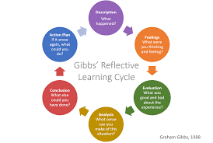
Each member of any housekeeping team needs to possess different skills like cleanliness skills, time management skills, communication skills, situation handle ability, customer service skills, flexibility, and so on (Anthonisz, 2014). I have many skills and qualities that make me confident to be a member of any housekeeping team in any prominent hotel industry. I think Gibbs reflective cycle will be effective to measure and justify my housekeeping skills and qualities.
Gibbs reflective cycle
Abraham Gibbs introduced this reflective cycle to justify the previous performances and experiences of individuals. This model has six stages like- description, analysis, feeling, evaluation, conclusion and action plan.
Description: In this time, individuals generally describe different necessary instruments of any fact or activities. For housekeeping professionals, each team member needs to possess communication skill, time management ability situation handle quality, cleanliness ability, customer service skills and so on (Pongsiri, 2012). Without having these skills and qualities, any team member of a housekeeping professional cannot perform desired action procedures in the workplace. I have those skills and qualities that encourage me to be a member of the housekeeping team of any multinational hotel industry. I think I will possible to apply those skills and qualities to perform outstanding action procedures as a member of the housekeeping team. I will show high passionate and dedication to conduct effective roles in any tough situation.
Feeling: I feel well and confident for having different skills and experiences about a housekeeping professional. My communication skills make me confident to communicate and interact in my workplace as a housekeeping professional. My customer service skills and approaches will be supportive of fulfilling customers' demand and expectations in the workplace. My adaptive thinking quality will be supportive to cope with any changing or dynamic workplace environment of housekeeping professionals. My time management quality also be effective in managing time and performing satisfactory actions in any complex workplace environment (Luka and et al, 2015). My flexibility and good behaviour quality will improve the relations with colleagues, customers and other individuals in the workplace. I have some weakness sides that me disappointed to reach my professional goals and objectives.
Analysis: This is the third step of Gibbs' reflective model that analyses the strengths and weakness sides of any factors. I think, my skills, qualities, and experiences will have a big role in performing my duties and responsibilities as team member of housekeeping professionals. In my workplace, I can face many problems and critical obstacles, but I have to rationally handle those to meet customers demand and achieve organizational goals. I need to improve my theoretical knowledge and practical skills to perform better operations as a housekeeping professional.
Evaluation: This step focuses on the good and bad factors about any activity. I have many theoretical and professional skills that will be supportive of conducting operations as a housekeeping professional. My high dedication and passion will improve overall approaches and activities in the workplace (Yasmin and et al, 2016). I have some lacking areas that can play a negative role to activities in the workplace. I have to be emotionally intelligent and practical to show a good personality in my area of the workplace. I have to be more active to reduce laziness and perform satisfactory action procedures in the workplace. Thus, I need to highlight my strengths sides and improve weak areas to perform better operations as a housekeeping professional.
Conclusion: In this step, individuals try to conclude about the overall action procedures. I think, my skills and capabilities are satisfactory for performing operations as a housekeeping professional. But I have to be serious and passionate to perform my duties and responsibilities in any supportive and tough situation. I need to utilize my skills and qualities to manage obstacles and perform satisfactory operations in any haphazard situation (Purwanti and et al, 2019).
Action plan: This is the last step of Gibb's reflective model, where individuals make effective plans to develop different areas of lacking. I will improve my adaptive thinking skills in the next two months. I will improve my emotional intelligence quality within the next three months. I will progress in my situation-handling ability in the next four months.
I think Gibb's reflective cycle is very relevant and effective to measure and justify my skills and capabilities for being a housekeeping professional. I want to work hard on my improvement of the required skills. I will try to design a good personal and professional development plan so that I can easily identify my weaknesses and can design the activities catalogue to go forward by following them. I want my all the efforts will be time bounded so that all the required things can be done and my goal can be achieved in proper manner.

Word Count | 789

Component Two:
Contribution to Overall Module Assessment: 25%

Problem | Why did it happen? | What are you going to do? | How will you prevent this from happening in the future? | What measures would you introduce to improve team effectiveness?
Uncleanness of bedroom | It happens for the activities of previous customers in the room. They did it for their unconscious attitudes and personality. | Immediately, I will inform the housekeeping department to clear the bedroom and ensure and healthy environment so current customers can stay the room happily. | From now, I will inform each customer to maintain the cleanliness of the bedroom. Besides, I will encourage the housekeeping department to clean the room after departing any customer. | I will encourage housekeeping department to show high effort and excellence to improve the atmosphere in the bedroom (Shin and et al, 2012). Sometimes, I will observe their performance to detect strengths and weaknesses areas.
Wi-Fi problem | It happened for the problem of router and poor speed of internet. | I will change the router as soon as possible. Besides, I will encourage Wi-Fi authority to increase the speed of internet. | I will keep available good quality router to solve the Wi-Fi problem. Besides, I will discuss the Wi-Fi authority to maintain the speed of internet in any supportive and complex business environment. | I will guide the housekeeping department to improve technological skills and knowledge so they can solve various problems facing in the dynamic workplace (Singh and Jaykumar, 2019). I will arrange different training and learning programs to progress the technological skills and experiences of employees.
Dirty washroom and toilet | The previous customers made this. | Immediately, I will inform the housekeeping department to clean the washroom and toilet. I will guide them to keep hand wash, tissue, and sanitizer in the basin of the washroom. | I will inform the customers to ensure the right use of toilet and washroom (Ndiuini and Baum, 2021). Besides, I will encourage the housekeeping department to ensure the cleanliness of the washroom and toilet after departing the customers. | I will make the housekeeping department more responsible and dutiful to make sure the cleanliness and hygienic environment in the toilet and washroom.
Problems of Air conditioner | It happened for the technological errors and unconscious activities of the electric department. | Immediately, I will inform the electric department to solve the problems of air-condition. | I will encourage the electric department to regularly check each air-conditioner. I will direct them to be serious and responsible for managing obstacles and ensuring a fruitful environment in the hotel industry. | I will recruit talented and skilled employees to electric department so they can perform outstanding functions and also solve any critical problem immediately.
Poor services of customers | Irresponsible activities of different employees existing in the hotel industry. | I will send responsible and dutiful employees to offer desired services and facilies to customers. I will guide them to focus on high services and satisfaction of customers | I will recruit skilled, experienced and responsible employees so they can play effective role to meet customers demand and improve their satisfaction in the hotel industry (Lloyd and et al, 2013). | I will observe the activities and approaches of employees during their customer service procedures in the hotel industry. I will guide them to improve their lacking sides to increase their professional value in any complex business environment.

Component Three:
Contribution to Overall Module Assessment: 50%

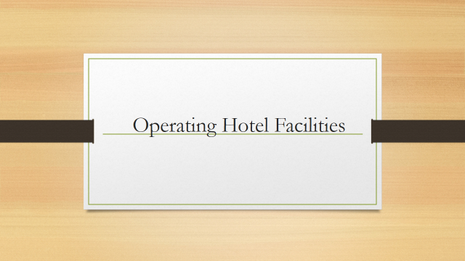

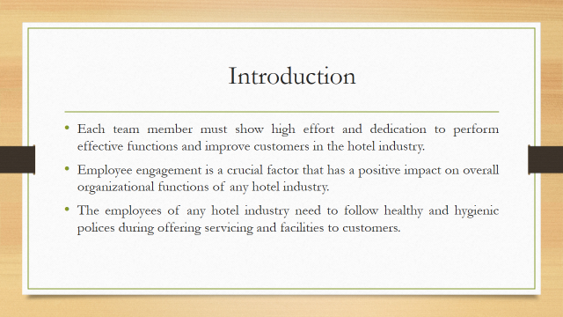

Training Notes:

The members of housekeeping team need to possess various skills and qualities to perform outstanding action procedures in the workplace. Each team member must show high effort and dedication to perform effective functions and improve customers in the hotel industry. Employee engagement is a crucial factor that has a positive impact on overall organizational functions of any hotel industry. The employees of any hotel industry need to follow healthy and hygienic polices during offering servicing and facilities to customers.

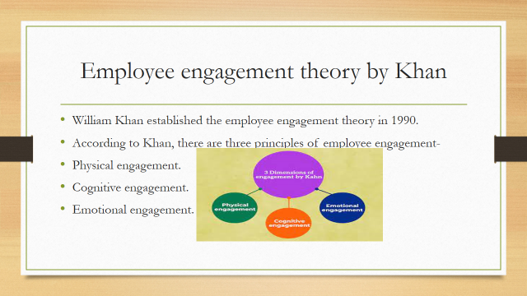

Training Notes:
William Khan established the employee engagement theory in 1990. According to Khan, there are three principles of employee engagement like physical engagement, cognitive engagement and emotional engagement (Lee and Kim, 2014). The employees engagement of housekeeping is very important factor. In physical engagement, the manager of housekeeping need to encourage employees to improve mental and physical communication in the workplace. In cognitive engagement, employees need to engage about organizational vision, mission and strategy in the workplace. In emotional engagement, employee must improve emotional relations to perform outstanding actions in the workplace.

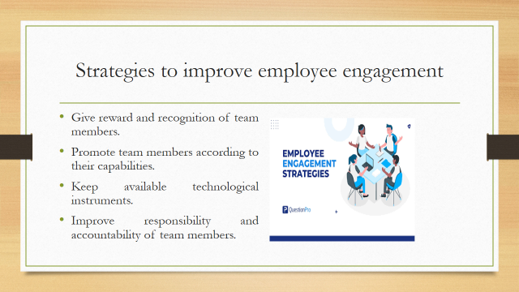

Training Notes:
Each hotel industry can practice different strategies to improve employee engagement in the workplace. Some key strategies are described in below to improve the engagement among the team members of housekeeping-
- Give reward and recognition of team members.
- Promote team members according to their capabilities (Bhardwaj and Kalia., 2021).
- Keep available technological instruments.
- Improve responsibility and accountability of team members.

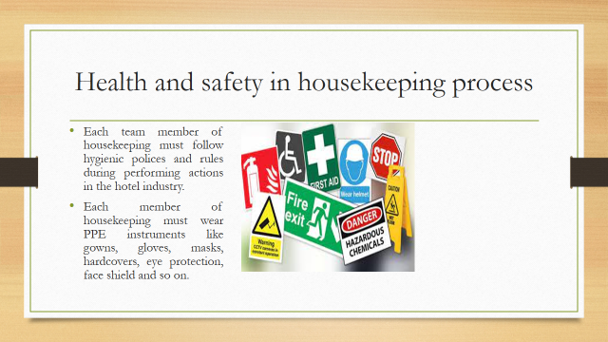

Training Notes:
Each team member of housekeeping must follow hygienic polices and rules during performing actions in the hotel industry. The manager of housekeeping must encourage employees to abide by healthy regulations during offering services and facilities to customers. The managers of housekeeping can arrange different learning program to improve the consciousness of employees about the health and safety in the services procedures and other activities in the hotel industry (Zientara and Zamojska, 2018). Each member of housekeeping must wear PPE instruments like gowns, gloves, masks, hardcovers, eye protection, face shield and so on.

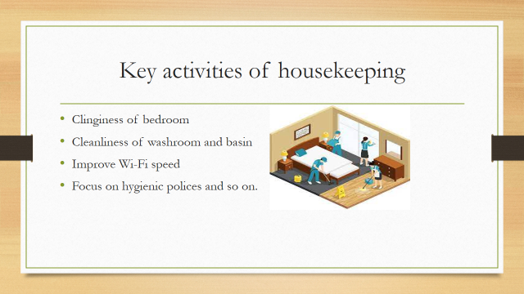

Training Notes:
The housekeeping department of any hotel industry need to focus on various key factors like- clinginess of bedroom, cleanliness of washroom and basin, improve Wi-Fi speed, focus on hygienic polices and so on. The housekeeping department of Premier Inn need to focuses these key factors to perform desired actions, offer better services to customers and increase organizational reputation in the competitive marketplace. Each member of housekeeping department must try to fulfill the dynamic demand and expectation of customers in the hotel industry (AbuKhalifeh and Som, 2013). Besides, they will offer additional services to attract and satisfy customers in the marketplace.

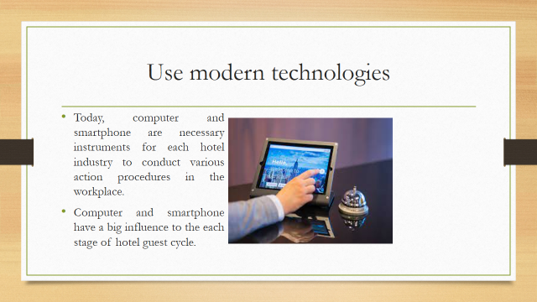

Training Notes: The housekeeping department of Premier Inn, St Albans need to use modern technologies and emerging tools to improve functions and offer better services to customers in the hotel industry. The manager of housekeeping must encourage team members to ensure the right use those technological infrastructures in any complex business (Karatepe, 2014). Today, computer and smartphone are necessary instruments for each hotel industry to conduct various action procedures in the workplace. Computer and smartphone have a big influence to the each stage of hotel guest cycle.

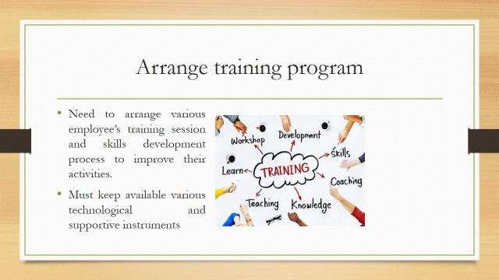

Training Notes:
The housekeeping department of Premier Inn, St Albans need to arrange various employee’s training session and skills development process to improve their activities. This hotel industry must arrange various trainers who will teach employees to their skills, performances and approaches in the hotel industry. The housekeeping department must keep available various technological and supportive instruments so employees get desired facilities to improve qualities and perform better activities in customer’s services procedures (Wihuda and et al, 2018). Thus, training and learning session can improve the skills, capabilities and performances of the team members of housekeeping. Training programs can help the employees to make themselves skilled in respect of their role playing in the workplace arena. Trainer can learn them the importance of quick response to the guests, how the quick response can create positive impression. In addition to, training programs most often incorporate new updates and trends which must be maintained in the particular hospital arena in order to retain more customers and survive in this competitive arena. So, the training programs are necessary to make the staff aware about the current business environment and thus they can realize the reality and lead their job life.

q

Training Notes:
The members of housekeeping team need to possess various skills and qualities to perform outstanding action procedures in the workplace. Each team member must show high effort and dedication to perform effective functions and improve customers in the hotel industry. Employee engagement is a crucial factor that has a positive impact on overall organizational functions of any hotel industry. The employees of any hotel industry need to follow healthy and hygienic polices during offering servicing and facilities to customers. Each hotel industry should establish employee engagement to improve activities and services procedures. The manger of hotel industry must encourage team members to show high dedication to give satisfactory services to customers. Hotel industry must keep technological availability so employees and managers can conduct outstanding action procedures in any complex business environment.

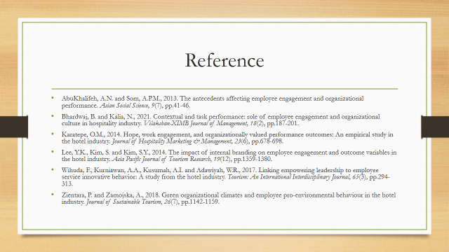

Training Notes: AbuKhalifeh, A.N. and Som, A.P.M., 2013. The antecedents affecting employee engagement and organizational performance. Asian Social Science, 9(7), pp.41-46.

Bhardwaj, B. and Kalia, N., 2021. Contextual and task performance: role of employee engagement and organizational culture in hospitality industry. Vilakshan-XIMB Journal of Management, 18(2), pp.187-201.

Karatepe, O.M., 2014. Hope, work engagement, and organizationally valued performance outcomes: An empirical study in the hotel industry. Journal of Hospitality Marketing & Management, 23(6), pp.678-698.

Lee, Y.K., Kim, S. and Kim, S.Y., 2014. The impact of internal branding on employee engagement and outcome variables in the hotel industry. Asia Pacific Journal of Tourism Research, 19(12), pp.1359-1380.

Wihuda, F., Kurniawan, A.A., Kusumah, A.I. and Adawiyah, W.R., 2017. Linking empowering leadership to employee service innovative behavior: A study from the hotel industry. Tourism: An International Interdisciplinary Journal, 65(3), pp.294-313.

Zientara, P. and Zamojska, A., 2018. Green organizational climates and employee pro-environmental behaviour in the hotel industry. Journal of Sustainable Tourism, 26(7), pp.1142-1159.

References

Anthonisz, A., 2014. Assessing the future of housekeeping operations in Dubai’s five-star hotel industry–room for innovation?. Worldwide hospitality and tourism themes, 6(4), pp.352-361.

Pongsiri, K., 2012. Housekeeping, Human Resources: Competency ServiceStandard Management for Hotel Business in ASEAN. International Journal of e-Education, e-Business, e-Management and e-Learning, 2(5), p.343.

Luka, I., 2015. Enhancing employability skills for tourism and hospitality industry employees in Europe. Journal of Turiba University Acta Prosperitatis, 6, pp.75-94.

Yasmin, M., Sarkar, M. and Sohail, A., 2016. Exploring English language needs in the hotel industry in Pakistan: An evaluation of existing teaching material. Journal of Hospitality & Tourism Education, 28(4), pp.202-213.

Purwanti, A.R., 2019. Evaluation on an ESP course book: Get along with English for the hotel industry. JEES (Journal of English Educators Society), 4(2), pp.107-116.

Suh, E., West, J.J. and Shin, J., 2012. Important competency requirements for managers in the hospitality industry. Journal of hospitality, leisure, sport & tourism education, 11(2), pp.101-112.

Lloyd, C., Warhurst, C. and Dutton, E., 2013. The weakest link? Product market strategies, skill and pay in the hotel industry. Work, Employment and Society, 27(2), pp.254-271.

Singh, A. and Jaykumar, P., 2019. On the road to consensus: key soft skills required for youth employment in the service sector. Worldwide Hospitality and Tourism Themes, 11(1), pp.10-24.

Ndiuini, A. and Baum, T., 2021. Underemployment and lived experiences of migrant workers in the hotel industry: policy and industry implications. Journal of Policy Research in Tourism, Leisure and Events, 13(1), pp.36-58.

