David Appleby 0250045
0250045@student.uwtsd.ac.uk
Introduction to Web and Database Concepts Assignment
HTML & CSS Web Development

Table of Contents
Introduction 2
Requirements 2
Implementation 3
My Website 3
Home Page: 3
Process Page: 3
Details Page: 4
Gallery Page: 4
Contact Page: 5
Validation 6
Evaluation 7
Website usability. 7
Website Accessibility. 7
Website Search Engine Optimisation 8
My Website Usefulness (usability and utility): 8
My Website Search Engine Optimisation 9
My Website Accessibility 10
References 11

Introduction
This report explains how I built a simple website using HTML and CSS code. It looks at the requirements of a website based on target audience and subject and then demonstrated the working website with evidence of how I validated the code.
The report then evaluates the website looking at usefulness, search engine optimisation and accessibility.

Requirements
The website is to be an info-site and learning resource that will explain to people what a cold rolling mill in a steel plant is and does.
The purpose of the site is to showcase the process in the port talbot cold rolled products part of the steelworks and guide someone who is unfamiliar with the plant through the process of cold rolling steel. It will give a basic understand of what a cold mill is and does and the process involved. It will also show some of the products that are manufactured from cold rolled steel.
The target audience is the public, visitors and students, or those with an interest in learning about steel manufacturing. So, the site needs to be clear, engaging and have good use of images but must be kept simple.

Implementation

My Website

Home Page:


Process Page:
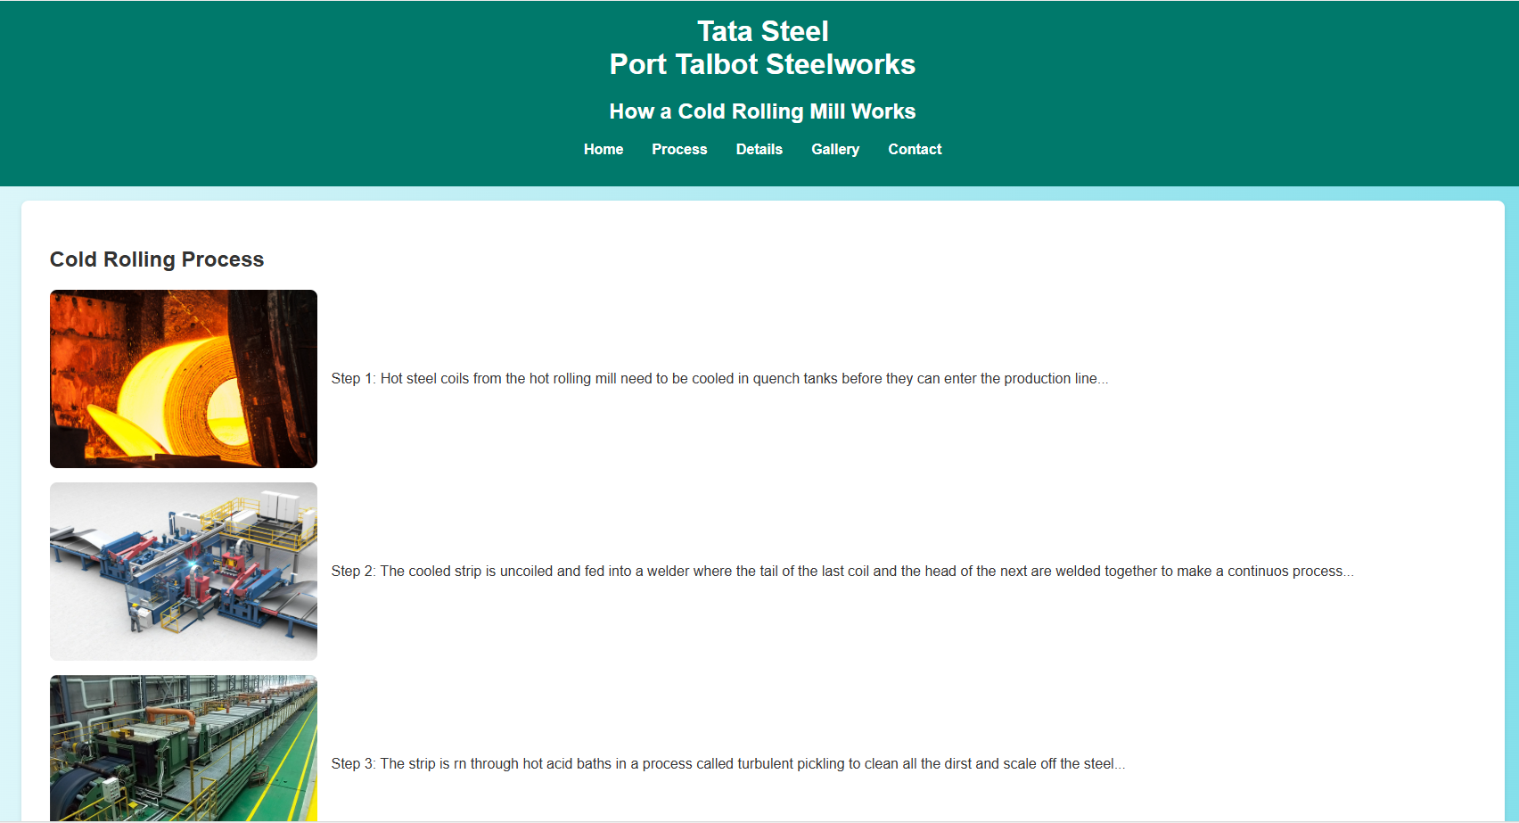

Details Page:
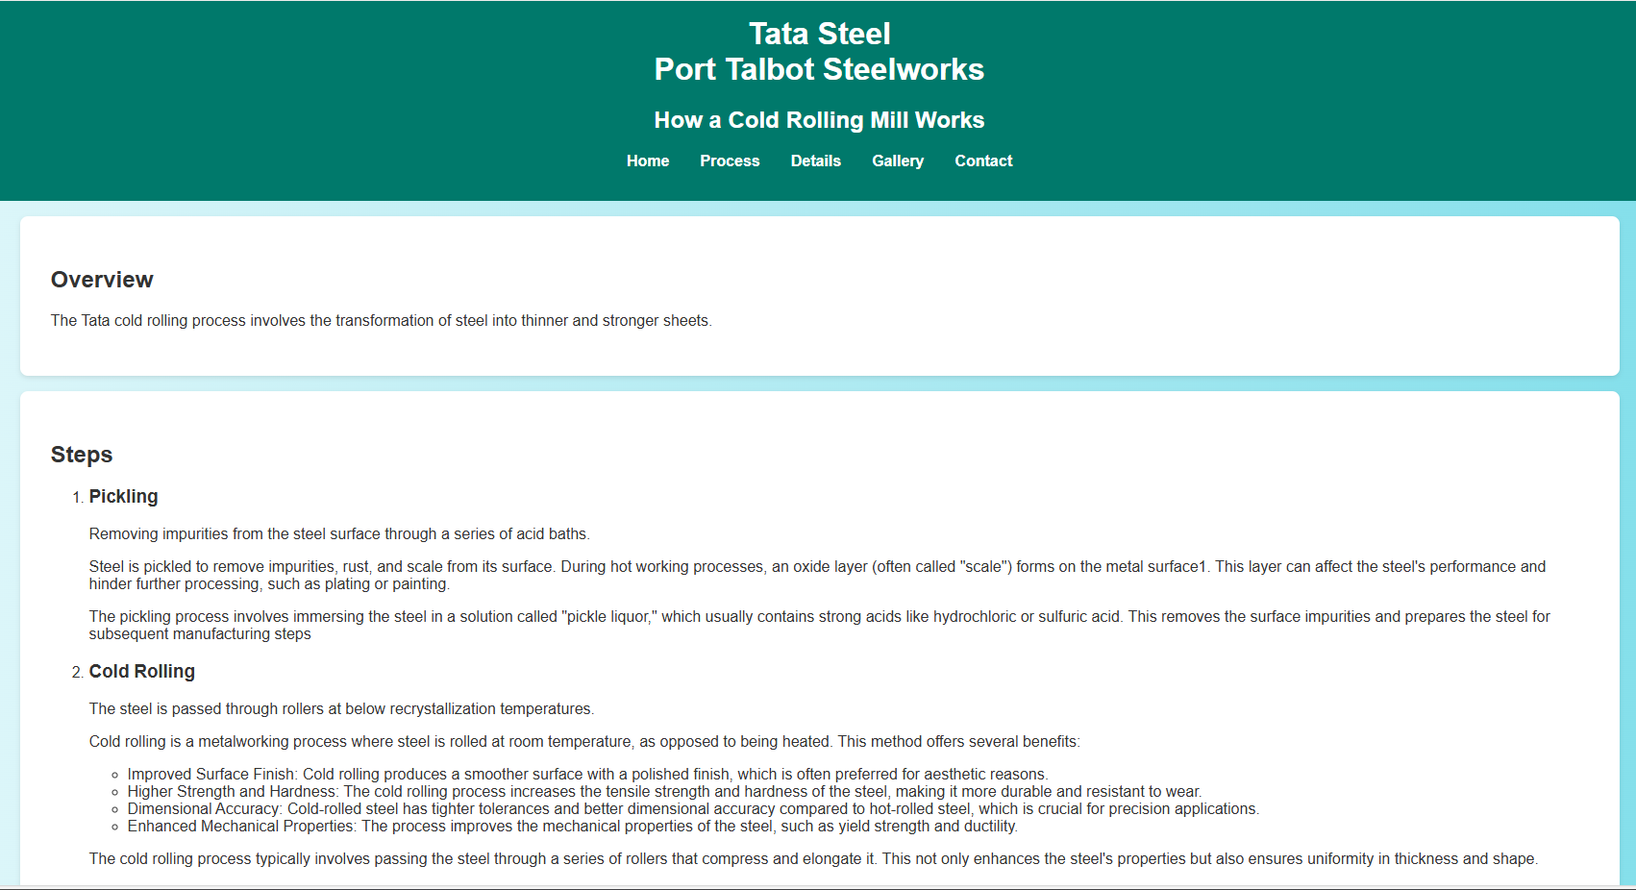

Gallery Page:
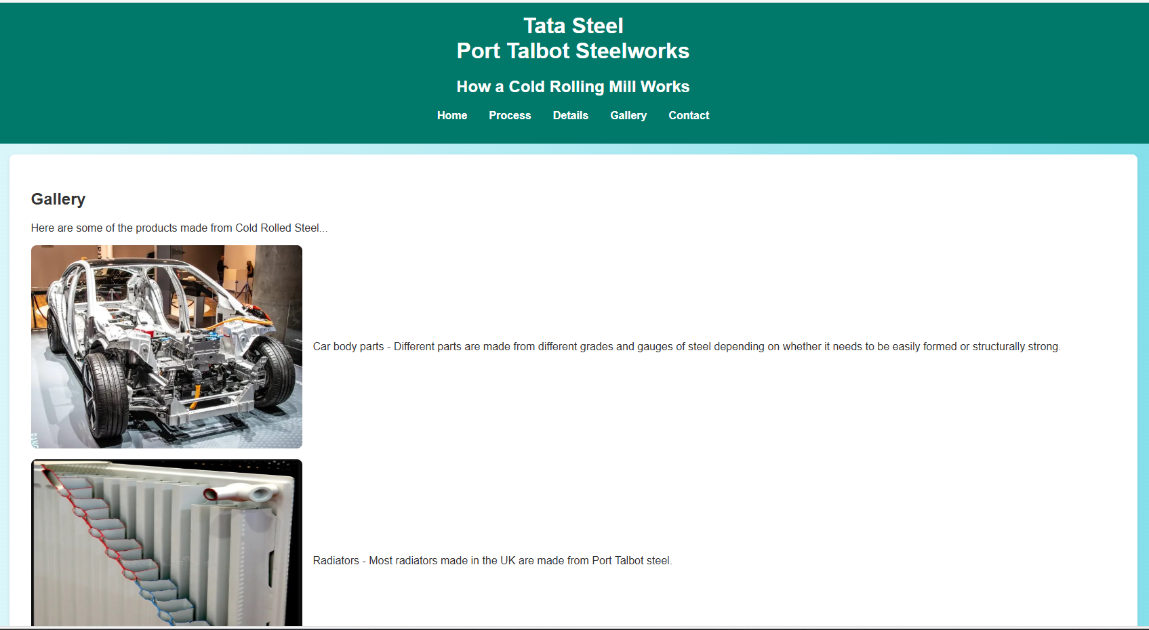

Contact Page:


Validation
To check the HTML and CSS coding of my website I used https://validator.w3.org This is an online code checking service to look for errors in the code.
The HTML code showed one error because I had put a space in my name of the folder where my files were stored, and a space is an illegal character. To rectify this, I created another folder and then retested my code. See images below:
Checked HTML code with illegal character:
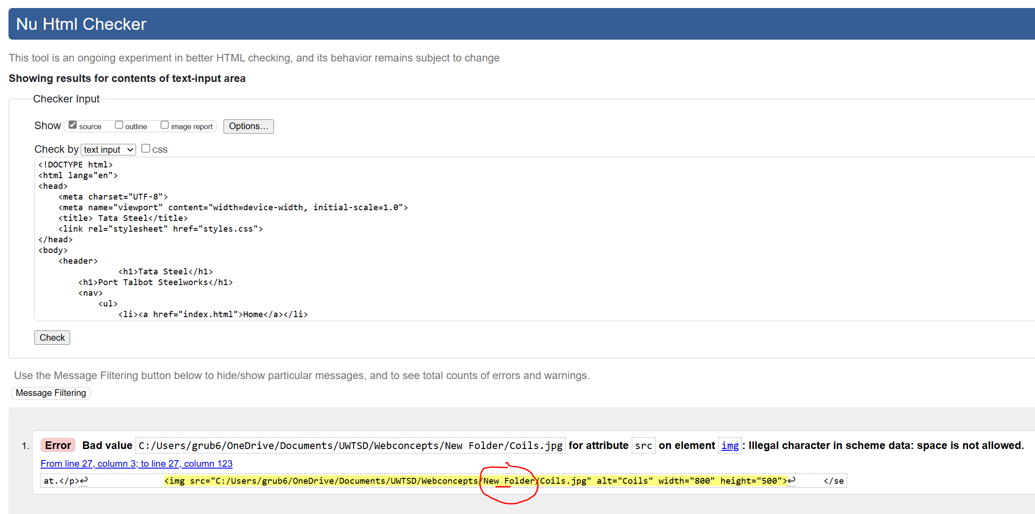
Checked HTML code after illegal character removed (folder renamed):
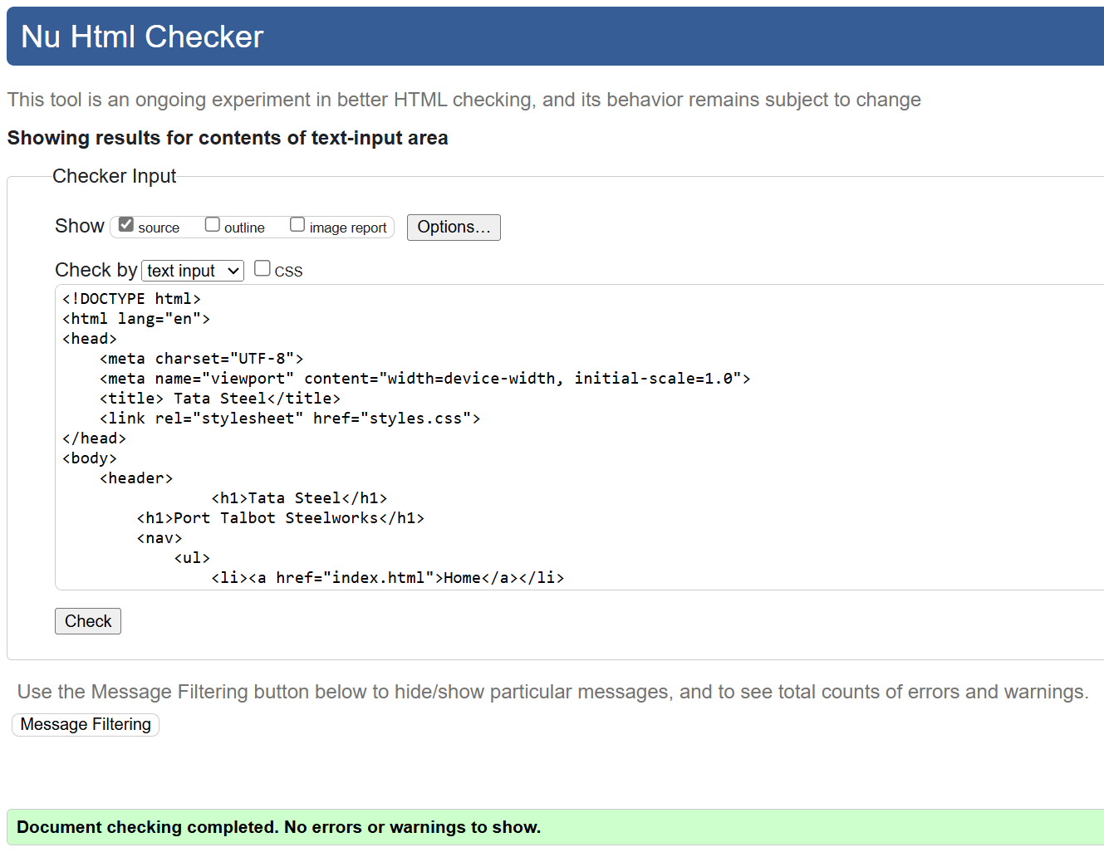
I used the same online service to check the CSS code and no errors were found. The results are shown below:
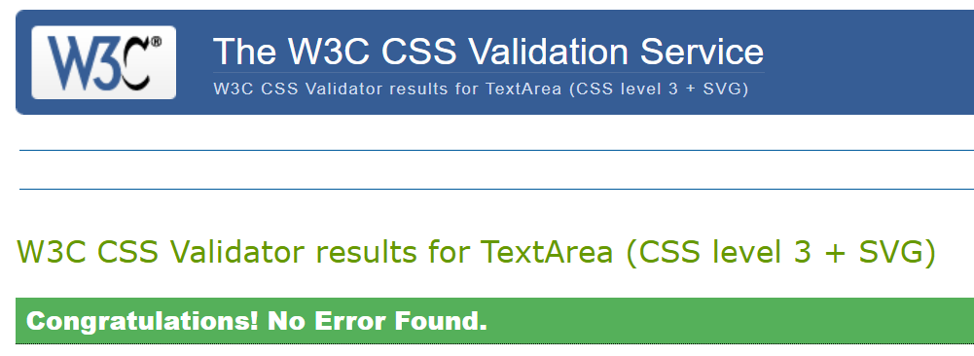

Evaluation

Website usability.
Website usability is crucial for ensuring that users can effectively and efficiently achieve their goals on a website. Usability encompasses various factors such as ease of navigation, intuitive design, and accessibility, which collectively contribute to a positive user experience. The IEEE define usability as "the extent to which a product can be used by specified users to achieve specified goals with effectiveness, efficiency, and satisfaction in a specified context of use" [1]. Enhancing website usability improves user satisfaction and increases the likelihood of achieving business objectives, as users are more likely to return to a website that is easy to use and meets their needs. Studies have shown that usability is a key determinant of web success, with well-designed websites leading to higher user engagement and retention. [1]

Website Accessibility.
Website accessibility ensures all users, including those with any impairments can still effectively interact with and benefit from web content. The IEEE state that accessibility refers to how easily people with impairments can perceive, understand, navigate, interact with, and contribute to the web. [1] Ensuring accessibility not only promotes inclusivity but also expands the reach of a website to a broader audience. The IEEE emphasises the importance of adhering to Web Content Accessibility Guidelines (WCAG) to make digital properties more accessible. By implementing accessible design practices, websites can provide a better user experience for everyone, including older adults and those with temporary impairments. [2]
The four main principles of web accessibility are often referred to as the acronym “P.O.U.R.” (Perceivable, Operable, Understandable, and Robust). These terms are widely recognised in the field of web development. These principles are outlined in the Web Content Accessibility Guidelines (WCAG) by the Web Accessibility Initiative (WAI) of the World Wide Web Consortium (W3C). [3]
- Perceivable: Information and user interface components must be presentable to users in ways they can perceive. This means providing text alternatives to images and finding ways to make it easier for users with visual impairments to understand the subject. [3]
- Operable: User interface components and the navigation must be operable. This includes making functionality available from a keyboard and providing users enough time to read and use the content. [3]
- Understandable: Information and the operation of the user interface must be understandable. The developer must make text readable and understandable. They must make sure that a web page operates in predictable way. [3]
- Robust: Content must be robust enough to be interpreted reliably by a wide variety of users, including assistive technologies. This means ensuring compatibility with current and future user tools. [3]
These principles ensure that websites are accessible to people with a wide range of disabilities, thereby promoting inclusivity and equal access to information.

Website Search Engine Optimisation
Search Engine Optimisation (SEO) is critical for enhancing a website's visibility and driving traffic. According to IEEE resources, SEO involves optimising both on-page and off-page elements to improve a website's ranking on search engine results pages (SERPs). Effective SEO practices, such as using relevant keywords, ensuring mobile-friendliness, and building quality backlinks, can significantly increase a website's discoverability and user engagement. By adhering to SEO best practices, websites can achieve higher search rankings, attract more visitors, and ultimately achieve their business goals. [3]

My Website Usefulness (usability and utility):
Based on the usability research above, I can evaluate the functionality and usability of my website as very good. The website is simple and clear and displays the information that it is designed to. The site is easy to navigate and with simple links in a prime location to switch between pages.
The content is limited, and this is where significant improvement could be made. The site would have benefited from some video or animated explanations of the processes and the ability to drill down for more detailed information on each part of the process.

My Website Search Engine Optimisation
To optimise my site for search engines (SEO), I ensured that the HTML code included a unique and descriptive title tag. This describes the page’s content and will appear in search engine results.
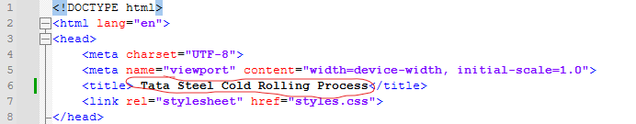

In addition to the title tags I also used header tags. By using the HTML header structure of <H1> and <H2> etc. and ensuring that my headers were clear and concise, and used keywords that people may search for will help search engines find and display my site in the listings.
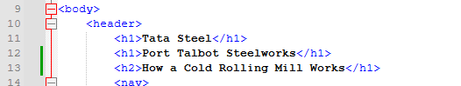

An additional and key SEO technique that I missed and should be added to my site to significantly improve SEO is the inclusion of a “Meta Description”. A meta description is a short summary of the website purpose or content that appears below the title in search results. It should include keywords and be enticing to encourage click-throughs.
To add a meta description, I would add the code below under the title in my HTML document:
<meta name="description" content="Basics of a cold steel rolling process within a steelworks. What products come from the cold rolled steel.">

My Website Accessibility
Using the four main accessibility principles described above, I can assess my website for accessibility.
Perceivable - My website uses clear pictures as well as text to aid in the understanding of the content however this could be improved with some clearer diagrams or animations.
Operable - The website is very basic but the navigation buttons work and remain in the same place to allow the user to easily go back and forth between the pages.
Understandable - Text on my website is of a suitable size and contract to the background to ensure it is readable. I have also used a clear and common font. A simple explanation of how to navigate the site may be helpful on the home page.
Robust – The site is simple enough for assisted technologies to read and to prevent errors or users getting lost or stuck.
In addition to the above, I used a contrast checker to check my that choice of colours was suitable.
My choices scored well, and the only failure was the contrast for font sizes less than 18 points so I ensured my site did not have fonts less than 18 points in this colour scheme.
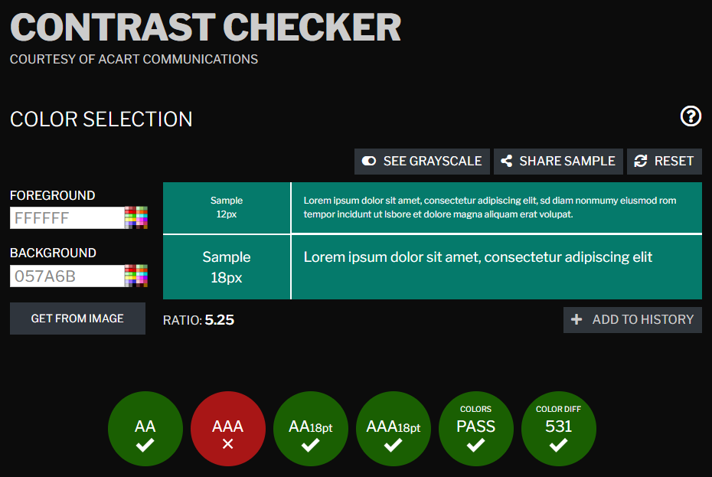 [5]

References

[1] | M. P. D. B. Priyanka Tripathi, “Towards the identification of usability metrics for academic Web-sites,” International Conference on Computer and Automation Engineering, ICCAE, vol. 5, no. DOI: 10.1109/ICCAE16361.2010, 2010.
[2] | IEEE, “IEEE Commits to Ensuring Digital Properties Are Accessible,” IEEE, 17 02 2022. [Online]. Available: https://www.ieee.org/about/diversity-index/articles/accessibility.html. [Accessed January 2025].
[3] | S. A. Zahra, “Accessibility Principles,” Education and Outreach Working Group (EOWG), 15th July 2024. [Online]. Available: https://www.w3.org/WAI/fundamentals/accessibility-principles/. [Accessed January 2025].
[4] | Y. L. Fuxue Wang, “An empirical study on the search engine optimization technique and its outcomes,” International Conference on Artificial Intelligence, Management Science and Electronic Commerce (AIMSEC), vol. 1, no. DOI: 10.1109/AIMSEC19209.2011, 2011.
[5] | Acart Communications, “Contrast Checker,” Acart Communications, 2017. [Online]. Available: https://contrastchecker.com/. [Accessed January 2025].
[6] | Interaction Design Foundation, “What is Usability?,” The Interaction Design Foundation, 1st June 2016. [Online]. Available: https://www.interaction-design.org/literature/topics/usability. [Accessed January 2025].

