University Of Wales Trinity Saint David
School of Engineering

Application of automation in wastewater treatment
ACMA5001

Aled Thomas
2206212
7th April 2025

Table of Contents
1 Glossary of terms 1
3 Introduction 2
4 History 1
5 ICA in wastewater treatment 2
6 Supervisory Control and Automation (SCADA) 5
7 Advancements in ICA for wastewater treatment 8
8 Conclusions and reflections 10
9 References 11

Figure 1 - Timeline of sanitation (Lofrano & Brown, 2010) 1
Figure 2- process control loop (Dunn, 2019) 2
Figure 3 - Generic SCADA system structure (Prochaska, 2021) 5
Figure 4- SCADA human-machine interface (Energenecs, diddyddiad) 6

Table 1 - Key measurements in WWTPs (Mannina, et al., 2018) 3

Glossary of terms
Abbreviation | Definition
ICA | Instrumentation, Control, and Automation
WWTP | Wastewater Treatment Plant
PLC | Programmable Logic Controllers
AI | Artificial Intelligence
ML | Machine Learning
DO | Dissolved oxygen
PID | Proportional Integral Derivative
SCADA | Supervisory Control and Automation
HMI | Human-Machine Interface
CMS | Central Monitoring Station
RTU | Remote Terminal Units
CI | Communication Infrastructure
VPN | Virtual Private Network
IoT | Internet of Things

Introduction
As populations of major cities continue to grow and industrial waste intensifies, the demand for efficient, sustainable, and intelligent wastewater treatment systems, a vital process for both public health and the environment, becomes increasingly important. This report explores how Instrumentation, Control, and Automation (ICA) is used in Wastewater Treatment Plants (WWTP) (Olsson, 2012).
As the population density of human settlements has increased from the first ancient settlers to modern-day cities, so as our understanding of sanitation and how it affects the health of the population. Technological advances (from basic drainage, to filtration, to chemicals and micro-organisms) have allowed us to reduce environmental harm, keeping cities clean and safe. This report will also consider the history of wastewater treatment and how it was controlled, considering the technological leaps that make our current day living standards possible (Angelakis & Rose, 2014).
This report will show how modern-day ICA is able to take measurements, then automate a response using a suite of sensors, Programmable Logic Controllers (PLC), with Artificial Intelligence (AI), Machine Learning (ML), or basic logic. These systems are crucial to keeping balance of the chemicals and ensuring processes run efficiently and safely.
Lastly, the report aims to examine how the rapid nature of technological advancement in Industry 4.0 creates automation process improvements in every sector. With recent developments in AI, automation has become more efficient, intelligent, and more accurate. This report aims to discover how AI and ML are being integrated into WWTP systems and the results in case studies (Garg, 2024).

History
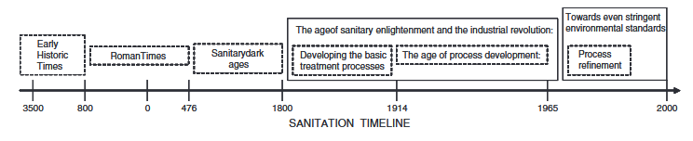
Figure 1 - Timeline of sanitation (Lofrano & Brown, 2010)
The first known civilisation to understand that a permanent settlement needed solutions to remove wastewater away from the community were the ancient Mesopotamian Empire around 3500-2500 BC. The ruins of the settlements Ur and Babylonia show that houses had drainage systems leading to cesspits. However, nothing was done to clean this wastewater, the first known urban sanitation systems were built by the Indus valley civilization. These were built in multiple settlements; Harappa, Mohenjo-Daro, and Rakhigarhi. Houses had drainage channels to underground tapered terracotta pipes. A small collection sump allowed solids to settle. Overflow drainage was added to the sumps, with inspection covers for maintenance and cleaning (Lofrano & Brown, 2010). The Indus valley people had the first known main drainage system connected to every dwelling, with almost every house having a private bathroom (Angelakis & Rose, 2014).
Next to improve upon these systems were the Egyptians and the Greeks, more complexity to underground networks and flushing toilets were developed. The Greeks attributed clean water to religious cleanliness, which advancement wastewater treatment. A big advancement came when Athens created a system of sewers diverting wastewater to a collection basin outside of the population area, from there, further diverted to crop fields and orchards to fertilize the grounds (Angelakis & Rose, 2014).
The Romans brought a huge leap to urban sewer systems. They had good understanding of clean water, discovered that spring water was safer to drink than surface water. They built aqueducts, and large underground sewers. Their population growth was unprecedented at the time and so had to create large complex systems in major cities such as Rome and Alexandria to keep up with the demand for such a high population density (Lofrano & Brown, 2010). When Rome fell, there was a devastating regression of technology in regard to clean water.
Progress to wastewater treatment mostly stalled between 300 AD and the mid-19th century (Angelakis & Rose, 2014). This was until the industrial revolution, where Britain, Germany, and France started construction on large new underground sewers. These mostly drained straight into the nearby rivers, causing what was referred to as ‘The Great Stench’ on the river Thames.
At the turn of the 20th century, a revolution in wastewater treatment occurred, the British Royal Commission of Sewage Disposal introduced a discovery in the ‘Eighth Report of 1912’ for biochemical oxygen demand (BOD) (THE ROYAL COMMISSION ON SEWAGE DISPOSAL, 1912), which is vital for micro-organisms in the wastewater to breakdown organic matter and treat the water (Olsson, 2012). After this discovery, governments began to regulate wastewater treatment. WWTPs were constructed in main cities all around Europe before and after the first world war (Angelakis & Rose, 2014).

ICA in wastewater treatment
Today, Instrumentation, Control, and Automation are techniques to remove manual intervention from a process. To achieve this, sensors/actuators, process controllers, and algorithms are employed allowing for self-correction of a system without the need for human control. These systems range in complexity, from simple ‘if’ logic with single sensor/actuator to large scale AI decision making with many variables being accounted for.
These systems self-correct, using a feedback loop/path. The set point, which is the initiating value is sent to the actuator causing an action that changes the system, this change is measured by the sensor and sent to the controller, which then decides if the initial value was too high, or too low. The difference between the initial value and the measured value is called the error. The controller adjusts the signal being sent to the actuator to attempt to correct the error. It will repeat this until the measurement from the sensor sends the expected signal through the controller (Dunn, 2019).
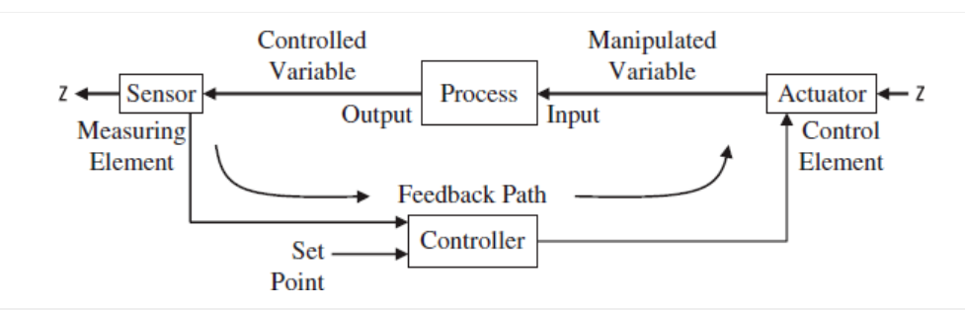
Figure 2- process control loop (Dunn, 2019)
WWTPs have become more complex over the last few decades and running them manually would be impossible without ICA continuously monitoring the variables and correcting them when they deviate from their safe/efficient values. This increases the efficiency and safety of the process, as the water is being treated to return to natural ecosystems or back into the population’s drinking water.
There are two types of plant parameters: physical, and analytical. Physical parameters are properties of the water itself, such as location, speed, pressure, temperature, level, and flow. The latter are chemical/biological variables such as dissolved oxygen, pH, chlorine, ORP, suspended solids, and nutrients (ammonia, nitrates, phosphorus).

Table 1 - Key measurements in WWTPs (Mannina, et al., 2018)
Type | Variable
Physical properties | Flow rates (liquid and air flow)  Water levels and pressure
Drinking water quality (analytical properties) | Turbidity  Free chlorine  pH  Contents of organic matter  Oxidation/reduction potential  Conductivity  Temperature  Colour  Ozone
Wastewater treatment (analytical properties) | Dissolved oxygen  Total suspended solids  Ammonia  Nitrite and nitrate  Phosphate  Organic content  Sludge level  Respirometry

Dissolved oxygen (DO) is one of the critical parameters to control in wastewater treatment and has a high priority for improvement since the 1970s (Olsson, 2012). Microbes in the water use the oxygen to break down organic pollutants from human, food, and industrial waste. If the levels of oxygen are too low, it can slow down the process or even cause anaerobic conditions causing gas build-ups. If the levels are too high, the process would be inefficient and would use more energy than is required. So, it is optimal for costs and safety to keep the values of oxygen in the water at a stable value (The World Economic Forum (WEF), 2022).
ICA systems are used to control this to ensure the levels of oxygen stay within the stable margin, keeping costs down while ensuring organic pollutants are broken down to an acceptable level. Sensors are used to measure the value of oxygen dissolved in the water in real time. There are two types, electrochemical and optical. Both types involve the use of a membrane. The electrochemical type allows the dissolved oxygen to pass through for measurement. The optical membrane doesn’t allow any oxygen to pass through, instead it’s coated with a dye that interacts with oxygen to take a reading (The World Economic Forum (WEF), 2022).
Control strategies for oxygen levels vary from simple to-use Proportional Integral Derivative (PID) controllers, to more complex model-based predictive controllers such as artificial intelligence (AI) or machine learning (ML) algorithms. PID is still the most commonly used due to its simplicity. These regulate aeration using DO set-points (Li, et al., 2022), which is typically guided by nitrogen removal monitored with ammonia sensors (Mannina, et al., 2018). If the level of DO drops below the measured allowable range, the controller sends the signal to the actuator (usually a blower, valve, or fine-bubble diffuser) to increase aeration. If the DO levels exceed this range, the aeration intensity is reduced, therefore saving energy. The system will keep measuring every cycle and will adjust the intensity of these actuators until the measured value is within the allowable threshold (Li, et al., 2022).

Supervisory Control and Automation (SCADA)
Supervisory Control and Automation (SCADA) systems enable real-time monitoring and supervision by human operators of the heavily automated wastewater treatment processes, while allowing adjustment of process parameters. Achieving a higher degree of regulatory compliance and enabling data collection and storage to analyse trends over time (Ranjith, et al., 2023). SCADA systems are specialised control systems consisting of computers, networks, programmable logic controllers (PLC), sensors, actuators, and interfacing control units (Prochaska, 2021). The network-based structure of SCADA enables remote access to multiple SCADA systems, which lowers operational costs (Tokos, et al., 2021).
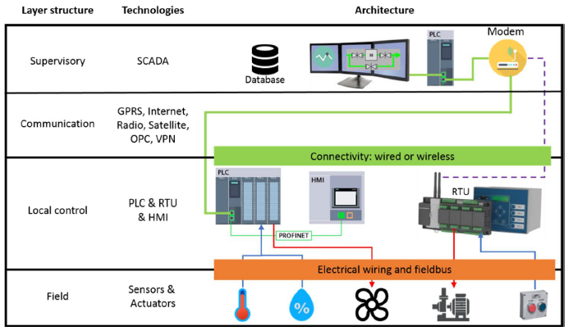
Figure 3 - Generic SCADA system structure (Prochaska, 2021)
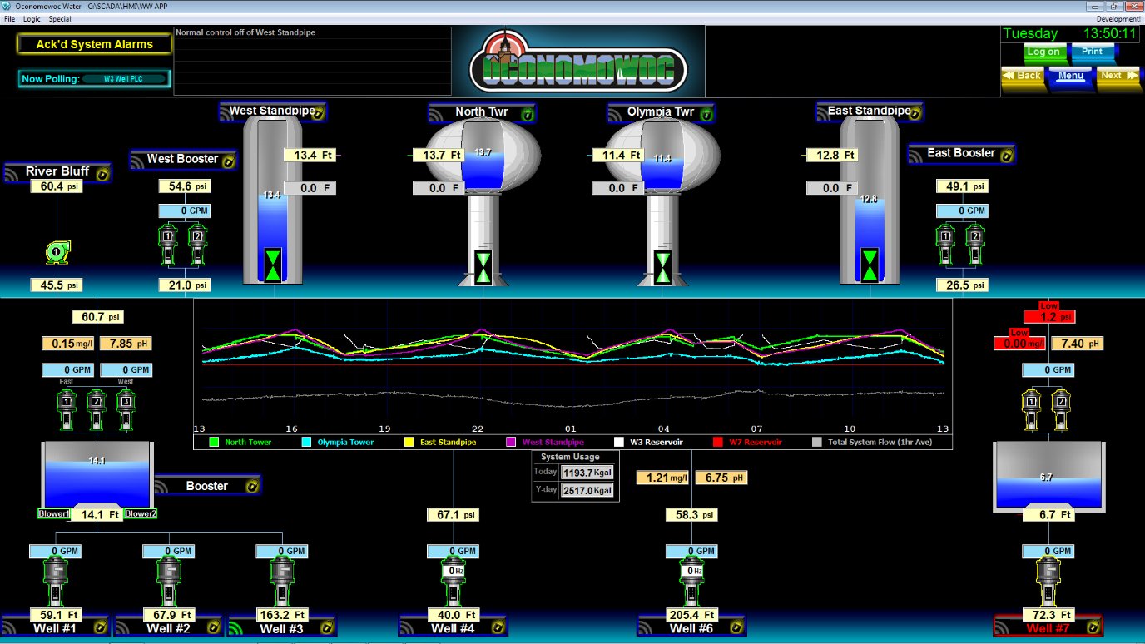
Figure 4- SCADA human-machine interface (Energenecs, diddyddiad)
SCADA systems start with a Human-Machine Interface (HMI), this program displays all the data to the operator. It shows states of variables, alarms, and charts and graphs (see figure 4). The operator uses this to monitor and tweak the processes. The data is acquired from the Central Monitoring Station (CMS), which also has the ability to produce an action when an event occurs, such as abnormal process conditions, malfunctions and failures, security, and safety alerts. This translates into an error alarm on the HMI terminals. The CMS gathers all the data from the Remote Terminal Units (RTU) in the field. Each RTU is set up to gather data directly from different processes within the plant. They act as secondary to the CMS which is the primary device. Programmable logic controllers (PLC) use inputs and logic programming to initiate an output, these are industrial boards with the ability to control multiple inputs and outputs simultaneously. The Communication Infrastructure (CI) connects both the RTUs and PLCs to the CMS and HMI, this is what allows data to transfer upward through the chain. At the very bottom of the chain, are the field instrumentation. This includes all the sensors and actuators at each of the processes and stages of wastewater treatment. (Humoreanu, 2012).
The HMI is where alarms are mainly displayed, this could be due to a fault, or a reading detected outside of allowable parameters. Physical alarms within the facility would also sound based on the severity of the issue, and the system can be set up to send SMS or email notifications to appropriate personnel (Ranjith, et al., 2023).
A good SCADA system relies on wireless connectivity with reliable uptime. Using a network solution without a security defence would enable hackers to access the system of critical infrastructure and potentially cause irreparable damage. A Virtual Private Network (VPN) is installed as part of the firewall to enable authentication of users entering the SCADA network. If, for any reason, the network goes down, the CMS would usually have a local HMI that would still function without network connectivity (Humoreanu, 2012).

Advancements in ICA for wastewater treatment
Sometime after the 2010s, the term Industry 4.0 was coined in Germany to describe the ongoing 4th industrial revolution kickstarted by advances in artificial intelligence (AI), machine learning (ML), and the Internet of Things (IoT) (Ortiz, 2020). These technologies allow data to be gathered and processed in much larger scales and quantities. This revolution is driving efficiency, reducing operating costs, and allowing companies to comply with increasingly strict regulations (Zong & Guan, 2024). Industry 4.0 in wastewater treatment allows a multitude of new developments, which will result in increasingly more efficient operations. Less consumables and energy, lower operational costs, increased equipment life, less costly maintenance. This is all due to the rise of data collection and smart control infrastructure already in place at these plants (Cairone, et al., 2024).
Such algorithms have predictive abilities far beyond a human operator. They can process all the historic data from the plant and use it to detect similarities in real time data. It can also consider current weather patterns, and humidity; accounting for these reduces water loss. AI models can create simulations for local challenges, such as climate change and population growth to ensure the facility will be able to meet the growing needs of the community it provides for effectively (Garg, 2024).
Energy costs are the biggest drivers for effective reduction in operating costs for WWTPs, as on average this accounts for 50-60% of total operating costs for energy intensive industrial consumers. The various pumps are the most energy intensive parts of WWTPs specifically. The less they are used, the better, both in terms of equipment life and energy costs. This is where predictive modelling excels. The previous generation of systems relying on basic logic and human monitoring would react to real time alarms with the expected delays and limited responses. However, predictive ML algorithms are able to react much quicker to changes in real time conditions. The reaction to these changes would be less intensive, due to it being noticed much earlier. It’s able to react so quick because it uses the historical data to predict what will happen next and decide how much of a reaction is required to not overreact or underreact. Bringing the system back to stability in the most efficient and safest way possible (Filipe, et al., 2019)
There are a multitude of case studies from the last few years, when these algorithms started outperforming traditional methods, they show a clear conclusion on the benefits of employing AI in conjunction with SCADA to control the processes. One of which was a study conducted at Fábrica da Água de Alcântara (ETAR), which is a WWTP in Lisbon Portugal in 2019. They integrated an ML control policy trained using a reinforcement learning (RL) algorithm called proximal policy optimisation (PPO). The study concluded with two possible options, either to mitigate alarms, or prioritise energy efficiency. When mitigating alarms, it reduced them by 99%, and reduced energy consumption by 3%. During the second option, the alarms reduced by 97% but improved energy consumption by 17%. Concluding that purely mitigating alarms leads to the system overreacting to changes, but not as much as the previous traditional system of SCADA and simple logic (Filipe, et al., 2019).
Another study conducted by Singapore’s National Water Agency at Ulu Pandan Water Reclamation Plant’s test site in 2020 concluded with a 15% higher efficiency in aeration control (Icke, et al., 2020).

Conclusions and reflections
This report set out to outline the efficacy of ICA in supporting, and optimising wastewater treatment systems, and how it evolved from the primitive systems of our ancestors. As a species, it was clear we had An instinctual understanding of our waste becoming hazardous. With the first known drainage systems dating back to 3500 BC. Despite a regression for our respect for clean water after the fall of the Roman Empire, the resurgence facilitated by the first industrial revolution in the 1800s propelled our societies to where we are today.
ICA has allowed human population density to grow to where it is now whilst keeping our drinking water safe. Without ICA, WWTPs would be inefficient, unsafe, and in extreme population densities, even more difficult to control and possibly overwhelmed. These systems range from simple PLC feedback systems, to integrating SCADA monitoring, to AI and ML controlled environments. Each of these systems gain valuable measurements from instruments, to cause a reactionary response from actuators to stabilise the measurements to an optimal value.
WWTPs have become increasingly connected to the IoT to allow cloud data storage, remote connections, and more intelligent control algorithms. Predictive modelling can control energy intensive pumps, valves, and other actuators more efficiently, thus reducing costs. Using the cloud data storage, historical data can be used to understand when items need maintenance, or to be replaced.
AI and ML algorithms are being given increasing control with each iteration on the models. Tests and case studies are discovering energy savings. As much as 17% at a site in Portugal, and another at 15% in Singapore. This 4th industrial revolution is still in exponential growth, with new robots and even smarter AI being released continuously. The future for automation in industry continues accelerating, as regulations and environmental constraints become more complicated, so will the need for more intelligent control and prediction models for controlling chemical balances and process variables. Industry 4.0 is still developing, trending to relinquishing more control over to AI as the training data and methods become more robust. These WWTPs, one day may even become dark factories, operating purely on automated controllers, with only the occasional maintenance person in sight.

References
Angelakis, A. N. & Rose, J. B., 2014. Evolution of Sanitation and Wastewater Technologies Through the Centuries. 1st ed. London: IWA Publishing.
Cairone, S. et al., 2024. Revolutionizing wastewater treatment toward circular economy and carbon neutrality goals: Pioneering sustainable and efficient solutions for automation and advanced process control with smart and cutting-edge technologies. Journal of Water Process Engineering, Volume 63.
Dunn, W. C., 2019. Fundamentals of Industrial Instrumentation and Process Control. 2nd ed. New York: McGraw-Hill Education.
Energenecs, n.d. SCADA Systems. [Online]
Available at: https://energenecs.com/controls/scada/
[Accessed 01 04 2025].
Filipe, J. et al., 2019. Data-driven predictive energy optimization in a wastewater pumping station. Applied Energy, Volume 252.
Garg, M. C., 2024. The AI Cleanse: Transforming Wastewater Treatment Through Artificial Intelligence. 1st ed. Cham: Springer Cham.
Humoreanu, B., 2012. Wastewater treatment plant SCADA Application. London, IEEE International Conference on Automation.
Icke, O. et al., 2020. Performance improvement of wastewater treatment processes by application of machine learning. Water Science & Technology, 82(12), p. 2671–2680.
Li, D., Zou, M. & Jianga, L., 2022. Dissolved oxygen control strategies for water treatment: a review. Water Science & Technology, 86(6), pp. 1445-1466.
Lofrano, G. & Brown, J., 2010. Wastewater management through the ages: A history of mankind. Science of The Total Environment, 408(22), pp. 5254-5264.
Mannina, G., Ekama, G. A. & Ødegaard, H., 2018. Advances in Wastewater Treatment. 1st ed. London: IWA Publishing.
Olsson, G., 2012. ICA and me – A subjective review. Water Research, 46(6), pp. 1585-1624.
Ortiz, J. H., 2020. Industry 4.0 Current Status and Future Trends. London: IntechOpen.
Prochaska, C., 2021. Municipal Wastewater Management. Basel: MDPI.
Ranjith, A. et al., 2023. Smart IoT-based water treatment with a Supervisory Control and Data Acquisition. Water Reuse, 13(3).
THE ROYAL COMMISSION ON SEWAGE DISPOSAL, 1912. THE EIGHTH REPORT OF THE ROYAL COMMISSION ON SEWAGE DISPOSAL. The Lancet, 180(4657), pp. 1530-1531.
The World Economic Forum (WEF), 2022. Wastewater Treatment Fundamentals III - Advanced Treatment. Cologny: The World Economic Forum (WEF).
Tokos, A. et al., 2021. SCADA Systems for Wastewater Treatment Plants. ELECTROTEHNICĂ, ELECTRONICĂ, AUTOMATICĂ (EEA), Volume 3, pp. 39-45.
Zong, Z. & Guan, Y., 2024. AI-Driven Intelligent Data Analytics and Predictive Analysis in Industry 4.0: Transforming Knowledge, Innovation, and Efficiency. Knowledge Economy.

