ANCIENT EGYPTIAN TIMELINE
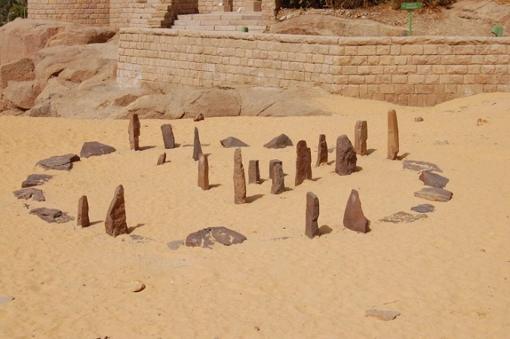
10,000 – 4,000 BCE
The Egyptian Neolithic Period
Sites of importance for this period; Nabta Playa; el-Badari; el-Omari
During this period there was both mobile and semisedentary (nomadic) communities and domestication of cattle, plants and other animals was happening. Ritual behaviours were taking place (Jennifer.C.Ross & Steadman , 2017).
(Varadzinová-Suková, 2009)

4,000 -3,000 BCE
The Predynastic (Naqada, I, II, III [Dynasty 0]
The sites within this period include; Hierakonpolis; Naqada; Abydas; Maadi.
Within this period happened the emergence of the eliets, the early start of urbanisation and sate development, the first kings of a unified Egypt; the beginning of hieroglyphics and the development of royal iconography (Jennifer.C.Ross & Steadman , 2017).

3,000 – 2520 BCE
The Early Dynasty (Dynasties I, III).
The relevant sites include; Abydos, Memphis; Saqqara and Hierakonpolis
This was the time of monumental funerary architecture, human sacrifice and the first stages of early administrative organisation (Jennifer.C.Ross & Steadman , 2017).
Key Dates:
- 3100 BC: King Naemer founded the first Egyptian dynasty by unifying upper and lower Egypt (Alchin, 2018).
- 3100 BC: Hieroglyphic script is developed (Alchin, 2018).
- 2950 BC: Hor – Aha is the I dynasty king
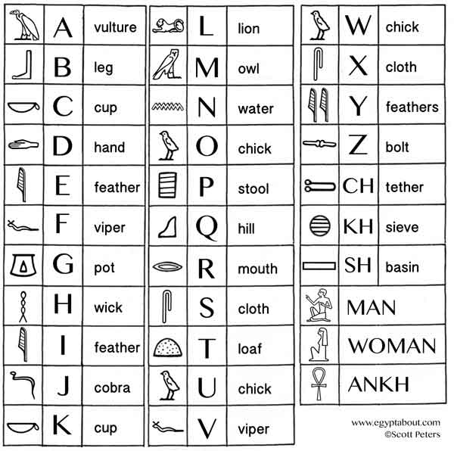
- 2950 BC: Memphis of Lower Egypt is established as the capital (Alchin, 2018).
- 2700 BC: The first step pyramid was built at Saqaea for King Zoser (Djoser), king of the III dynasty.
- 2600 BC: The Great pyramids are built at Dahshur and Giza
(Peters, n.d.)

2520 – 2100 BCE
The Old Kingdom (Dynasties IV, VIII)
Important sites include Saqqara; Giza, Memphis. ‘
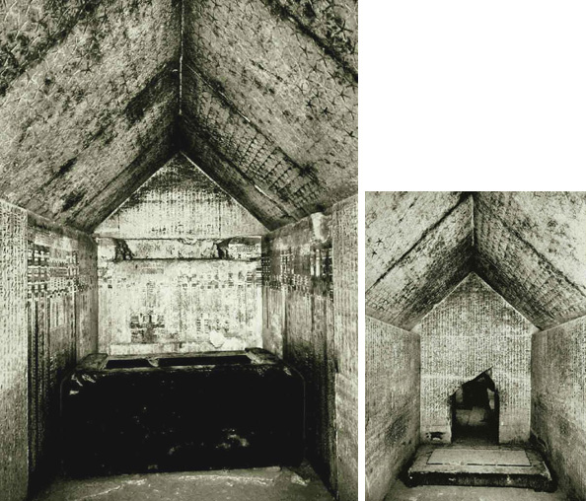
This is the ear of pyramid building, provincial administration organisation and the solar cult (Jennifer.C.Ross & Steadman , 2017).
(Piankoff, 1968.)
Key Dates:
- 2150 BC: King Unas (the last ruler of the V dynasty) had his burial chamber inscribed with spell for the afterlife – this was referred to as the Pyramid texts (Alchin, 2018).
- 1975 BC: The breakdown of the central government

2100 – 2010 BCE
First Intermediate Period (Dynasties IX – XI)
The sites include Herakleopolis and Thebes.
The state organisation dissolved within this period and the provincial government formed (Jennifer.C.Ross & Steadman , 2017).
Key dates:
- 2055 BC: Mentuhotep II gained control of the whole country (Alchin, 2018).

2010 – 1660 BCE
The Middle Kingdom (Dynasties XI – XIII)
The sites of Itj – tawy; Thebes; Deirel – Bahri; Avaris are important for this period.
The Middle Kingdom saw the reunification of Egypt and the formation of a stable military force. This was also a time of large literary development (Jennifer.C.Ross & Steadman , 2017).
- 1975 BC: Amenemhet overthrew Mentuhotep III.
- 1850 BC: Agriculture development of the Faiyum (Alchin, 2018).
- 1850 BC: Earliest parts of the Temple of Karnak was built (Alchin, 2018).
- 1800 BC: Egyptians control Nubia (Alchin, 2018).
1680 – 1549 BCE
The Second Intermediate Period (Dynasties XIV – XVII)
The sites include Auris and Thebes
Egypt was under the Hyksos rule and was affected by political fragmentation (Jennifer.C.Ross & Steadman , 2017).
Key dates:
- 1650 BC: Ahmose unified the country (Alchin, 2018).
- 1630 – 1520 BC: Hykos raiders from Asia moved into the delta and introduced the chariot. Ahmose expelled the Hykos from Egypt (Alchin, 2018).
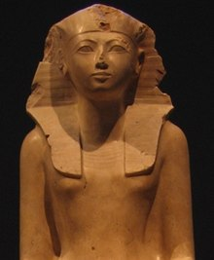
- 1500 BC: Hatshepsut becomes Pharaoh.

1549 – 1073 BCE
The New Kingdom (Dynasties VXIII – XX)
Memphis; Thebes; Deir el- Medina; Akhetaten (Tell el – Amarna) are the significant monuments for this time frame.
The New Kingdom was known as the international Age, where imperialism expanded the country. There was religious reforms and eventual stagnation (Jennifer.C.Ross & Steadman , 2017).
(Postdlf, 2005)
- 1539 – 1075 BC: The building of the tombs of the Valley of the Kings (Jennifer.C.Ross & Steadman , 2017).
- 1539 BC: There is a permanent army (Alchin, 2018).
- 1400 BC: King Thutmose III in the height of his power and military operations brought about the eastern coast of the Mediterranean Sea under Egyptian rule (Alchin, 2018).
- 1400 BC: Akhenten changed Egyptian religion (Alchin, 2018).
- 1450 BC: Tutankhamun became Pharaoh (Alchin, 2018).
- 1470 BC: Traditional religion returned (Alchin, 2018).
- 1300 BC: Hypostyle hall built at Karnak (Alchin, 2018).
- 1274 BC: Ramassess II fought in the battle of Kadesh (Alchin, 2018).
- 1100 BC: Upper and Lower Egypt split (Alchin, 2018).
- 1075 BC: Ramassess XI is the last ruler of the New Kingdom (Alchin, 2018).

1073 – 664 BCE
The Third Intermediate Period (Dynasties XXI XXV)
The sites include Tanis and Sais.
Imperialism was continuing resulting in Libyan and Kushite kings of Egypt (Jennifer.C.Ross & Steadman , 2017).
Key dates:
- 728 BC: Nubian King Piy, conquered Egypt (Alchin, 2018).
- 669 BC: Assyrians from Mesopotamia conquer and rule Egypt (Alchin, 2018).

664 – 332 BCE
The Late Period (Dynasties XXVI – XXXI)
The main site is Memphis
Egypt was rules from abroad with neo – Assyrian and Persian kings (Jennifer.C.Ross & Steadman , 2017).
Key Dates:
- 525 BC: Persians conquer Egypt lead by the Persian king Cambyses II (Alchin, 2018).
- 332 BC: Alexander the Great conquer Egypt and his general, Ptolemy, becomes king. As a result, Greek culture spread through the land and the city of Alexandria was founded. The Great library and the great lighthouse are the well-known monuments constructed in the city (Alchin, 2018).

305 – 30 BCE
Ptolemaic Dynasty
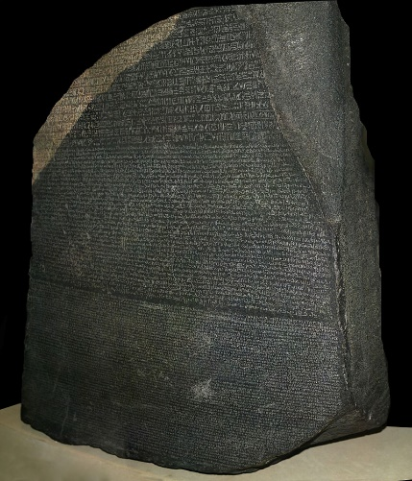
The site of Alexandria is important within the Hellenistic rule.
Key dates:
- 196 BC: The Rosetta Stone was carved (Alchin, 2018).
- 51 BC: Cleopatra VII becomes pharaoh (Alchin, 2018).
- 37 BC: Cleopatra becomes Marc Antonys mistress (Alchin, 2018).
- 31 BC: Octavian defeated Antony and Cleopatra in the sea battle of Actium. They then after, committed suicide leaving Egypt under the rule of the Roman general, Octavian (Alchin, 2018).
(Hillewaert, n.d.)

Common Era dates
- 33 AD: Christianity comes to Egypt and by the fourth century,
it has largely displaced traditional Egyptian religion (Alchin, 2018).
- 384 AD: Theodosius ordered the faithfulness to Christianity (Alchin, 2018).
- 395 AD: The Roman Empire splits into West and East leaving Egypt becoming apart of the Byzantine Empire (Alchin, 2018).
- 642 AD: The Arabs capture Alexandria and Egypt becomes an important part of the Islamic Empire (Alchin, 2018).
- 868 0 969 AD: The Tulunid and the Ikhshidid dynasty rule Egypt (Alchin, 2018).
- 969 AD: Fatmid rulers seize Egypt and founded the Egyptian city, Al-Qahirah (Cairo).

Bibliography
Alchin, L., 2018. Ancient Egyptian Timeline. [Online]
Available at: http://www.datesandevents.org/places-timelines/17-ancient-egyptian-timeline.htm
[Accessed 10 01 2019].
Hillewaert, H., n.d. Rosetta Stone. [Art] (The Britsih Museum ).
Jennifer.C.Ross & Steadman , S. R., 2017. Ancient Complet Societies. New York: Routledge.
Peters, S., n.d. Hieroglyphics. [Art].
Piankoff, A., 1968.. The Pyramid of Unas. [Art] (Princeton University Press - Princeton).
Postdlf, 2005. Hatshepsut. [Art] (Metropolitan Museum of Art).
Varadzinová-Suková, e., 2009. Nabta Playa. [Art].

