
PEOPLE MANAGEMENT
[A report regarding the roles and skills required by managers to successfully manage people and organization by using the performance of workforce]

[10/11/2022]
University of Wales Trinity Saint David

Executive Summary
The main purpose of this report is to develop the knowledge and skills required to effectively manage and develop people to contribute to sustainable organizational performance by using relevant theories and models.
People management is an ongoing process that involves recruiting, developing and retaining skilled workers. Skilled human resource is the highest achievement of an organization whose effective management is one of the most important tasks of the organization. One of the main tasks of People management is to create efficient and necessary manpower for the organization. Through People management, optimal utilization of all material and immaterial resources of the organization can be ensured. By taking the right measures at the right time, the desired utilization of material resources can increase production and improve service quality.
This report provide details about critically evaluating the roles and skills needed by managers as effective leadership, effective team working, motivation of employees, the flexible working and treating staff equally. Also, discussing the theories, models used by managers. In addition to this, evaluating how organizations successfully manages the performance of their workforce. The report will provide a detailed understanding in context with importance of effective management and leadership within the organization which can help in efficient evaluation of employees’ performance and guide them towards attainment of business goals and objectives.
The main findings of the report are: how managers or leaders in organizations motivate employees with their quality and expertise to create effective teams, treat employees equally and provide flexibility in their work to help increase performance.
Finally, from all the discussions in this report, it is evident that the practice of leadership quality, team development, motivation, work flexibility, diversity of work, performance management, effective communication, etc. is important for managers to increase their skills. And in this way the manager can work for the betterment of an organization and its employees.

Table of Contents

Executive Summary 1
Introduction 3
Main Findings 4
Effective leadership 5
Effective teamwork 6
Motivation of employees 7
Flexible working and treating staff equally 9
Performance management 10
Training and development 11
Conclusion 13
Bibliography 14

Introduction

People management is mainly defined as the process of lading, hiring, making teams for supporting the organizational goals and objectives. People management is a part of human resource management. This includes: training & development, recruitment, compansation, benefits etc. Effectively managing the people in the business mainly engages working with teams towards achieving the shared goals. Certain roles and skills required by the manager for supporting effective people management. There is a difference between managers and leaders which is being reflected in the report in order to develop a detailed understanding about the effective leadership. Leaders must have leadership skills which can enable them in guiding its followers towards accomplishment of business goals of objectives. Along with this it is their responsibility to encourage employees and build effective team who can coordinate with each other for attainment of common goals. There is an evaluation on development of effective team and its importance for achievement of business success. Leaders also plays a vital role in motivating their employees which can boost confidence and morale of employees leading to improvement in their performance. There are various motivational theories which are implemented by leaders that will also discussed in the report.

Main Findings

The role of managers is to effectively manage the resources to enable an organization to achieve its goals and objectives (Macke and Genari, 2019). The management of the business entity are organized by various functions which includes operations, marketing, finance and human resource. The effective management of human resource are known as human resource management who have various roles and skills. According to Stone and et.al. (2020) the roles of managers in effective management of workforce are:
- Development of HR policies and practices in accordance with organizations overall strategies and procedures,
- Development of effective workplace through encouraging equality and diversity,
- Hiring and retention of efficient and skilled employees,
- Building and maintaining a strong relationship between employees and managers by responding to their requests and resolving grievances,
- Proving with training and development opportunities for career growth and development of employees,
- Ensuring compliance of all laws and rules related to human resource,
According to Piopiunik and et.al. (2020) there are various skills which are required in HR managers:
- Business management and leadership skills,
- Interpersonal and communication skills,
- Strategic thinking and planning skills,
- Time management and multi tasking skills,
- Workplace culture development skills,
- Critical thinking and problem solving skills ,

Managers must be competent and also perform an effective role to prove their competence. The manager has to simultaneously work for the improvement of the organization, the employees and himself. For example: Sir Alexander Chapman Ferguson. Everyone knows him very well as the efficient manager of Manchester United Club. He is one of the greatest football managers of all the time. His skills and important roles make him an outstanding manager.

Effective leadership

Every manager of the company must be an efficient leader but it is not necessary that every leader to be managers (Isa and et.al., 2019). Managers will be able to become leader if they have leadership qualities which include effective communication, inspiring and guiding ability, motivating employees etc. The role and responsibility of leaders are:
- Setting of direction: Creation of strategies for future which can help in growth and development of organization.
- Alignment of people: Communicating with employees of organization regarding their roles and responsibilities and empowering them towards accomplishment of their duties (Tourish, 2019).
- Motivating employees: Motivating employees through rewarding them with incentives on the basis of their performance which can boost their morale and commitment towards entity.
Effective leadership can be defined as redefining company's vision and setting a culture for attainment of vision and mission (Leithwood, 2019). According to Leithwood (2019) there are various skills which are required for effective leadership:
- Effective communication skills,
- Flexible to change,
- Self awareness,
- Lead by example,
- Good motivators,

There are various leadership styles which are followed by managers of the organization to ensure effective management of workforce.
Democratic leadership: In this leadership style, the managers involves their employees in the decision making process.
Autocratic leadership: In this leadership style the directions comes from the top level mangers and middle and lower level managers and employees are required to follow the same (Sacavém and et.al., 2019).
Laissez- faire leadership: The leaders of the organization provides complete freedom to its employees in taking decisions.
Transformational leadership: Under this leadership style the employees of entity are encouraged to transform and adapt the changes.

Effective teamwork
Team refers to the group of individuals who perform interdependently towards accomplishment of common goals and objectives. Group and team are two different terms which are used interchangeably (Scholl, 2018). Group can be termed as collection of people who coordinate their efforts while team is a group of individual who share common vision and goals. In an organization to achieve success teamwork plays an important role. Teamwork helps in finding solution for any problem effectively and quickly as it involves multiple sharing of ideas for dealing with problems (Yakubu, 2018). As teamwork is the backbone of effective communication as it promotes sharing of experience and views which help in overall development of both organization and employees. It also helps in timely completion of work and employees are able to learn new skills from their team members. It improves efficiency of employees and provide more learning opportunities.

There are various principles or elements which ensures development of effective team within the organization which helps in enhancement of performance and productivity (AlArafat and Doblas, 2022). Some of the principles are:
- Common goals and objectives,
- Develop trust and support relationship,
- Respect and value diversity and multicultural,
- Resolving conflicts and disputes,
- Establishment of rules and policies,
- Specified and appropriate skills which are required for common project (Tripathy, 2018).
- Coordination and interaction with each other,
- Effective communication,
- Well defined decision making process and involvement of each member,

Motivation of employees

Motivation refers to the steps taken by managers or leaders of organization to inspire employees to put all their efforts towards achieve of business success. Motivation is of two types intrinsic which comes from within and extrinsic which arises from outside. Performance in context with employees can be defined as how employees meet their duties and responsibilities which is being segregated to them.

Motivation and performance is related with each other as motivation is the force which leads to excellent performance of employees within the organization. There are various factors which motivates employees of the organization in enhancing their performance (Haryanto, 2021). Each and every individual within the business entity have different needs and it is responsibility of managers and leaders to identify those needs and work towards fulfilment of employees needs. The motivation can be in quantitative as well as qualitative. Quantitative motivation is in terms of bonus or increment in salary whereas qualitative motivation is in terms of promotion. There are different theories of motivation followed by leaders of companies to ensure meeting of employees needs to effectively motivate and satisfy them.

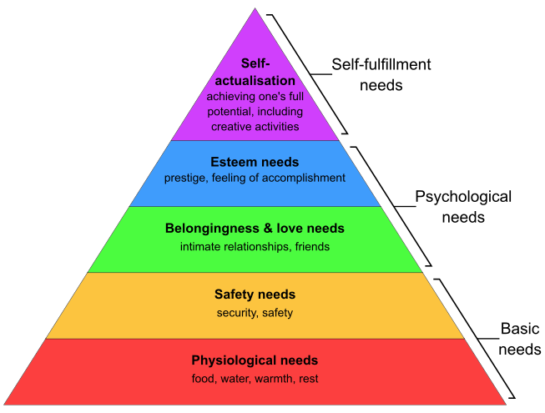
Maslow's hierarchy of needs

Source: https://simple.wikipedia.org/wiki/Maslow%27s_hierarchy_of_needs

There are five categories of human needs in accordance to their behaviour which can motivate them in effective performance. These needs are reflected in pyramid shape which includes physiological needs, esteem needs, love and belongingness, safety and self actualization (Lee, 2019). According to Maslow (1943), individual moves towards next stage when then attain formal needs. It is the responsibility of leaders to identify employees requirements in accordance to these categories and try to meet them step by step. For example, the prior need of employees is appropriate salary and providing salary in accordance to employees and job position can ensure higher motivation and performance enhancement along with this, employees will be committed towards company.

Along with this, there are several other motivational theories which are followed by organizations in order to ensure higher employees motivation and retention. Motivation theories includes Herzberg's hygiene theory, Vroom theory of motivation, Porter and Lawler expectancy theory, etc. Herzberg’s hygiene theory includes both motivation as well as hygiene it is beyond Maslow hierarchy theory.

Flexible working and treating staff equally
Flexible working: Flexible working refers to way or manner of working which suits the employees and their needs. For instance, working from home, working for a fixed time as per employment law, etc (Yunus and Mostafa, 2022).

Advantage and disadvantage of Flexible working :
 | Advantage | Disadvantage
Employer | - Increase productivity,  - Reduces tardiness and absenteeism, etc | - Lack of control,  - Compressed work weeks may mean client availability suffers, etc
Employee | - More control over time,  - Reduce stress and anxiety, etc | - Lead to reduce earnings,  - Lack of career progression, etc

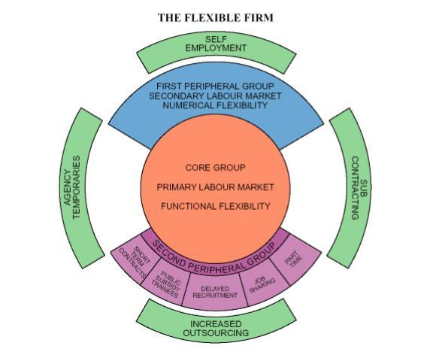
Flexible firm model (Atkinson theory, 1984)
Source : https://www.researchgate.net/figure/The-flexible-firm-Source-Atkinson-1984_fig1_319187614

According to flexible firm model, the employees of the organization must be provided by effective working arrangements and hours which is convenient for them (Yunus and Mostafa, 2022). There are three different forms of flexibility within organization: Functional flexibility, numerical flexibility and financial flexibility. Along with this, there are two dimensions of flexibility which includes flexibility in employment and flexibility in work.
Equality and diversity:
Equality: According to Mousa and et. al. (2020) Equality at workplace refers to providing equal and fair job opportunities to employees according to their qualification and skills.
Diversity: Diversity at workplace refers to multicultural environment where employees are hired from different culture and backgrounds, age groups, gender, etc.

Importance of equality and diversity within workplace
- Equality and diversity enables in effective motivation and encouragement to employees so that they can meet their roles and responsibilities (Saleem and et.al., 2020).
- Employing employees from different culture can enable business in building a strong and effective team with diverse specialization (Khan and et. al., 2019).
- It helps in encouraging employee loyalty and retention.
- Encouragement of equality and diversity develops a positive work culture within organization.
- The employee turnover cost can be reduced if employees develop trust and respect for each other and their culture.

Performance management

Performance management refers to an ongoing process which helps in continuous evaluation of employees performance and development of plan and strategy for enhancement of performance (Murtazoqulov and et. al., 2022). Performance management is essential as it enables organization in retaining talents, keeping employee engaged and identifying leaders. Accoding to Helmold (2019) the aim of performance management are:
- To take corrective measures to improve performance,
- To sustain effective performance (Helmold, 2019),
- Motivate employees by rewarding them according to their performance,
- To communicate organization strategies, goals and expectations from employees,

Performance management process
The managers of the business entity follows steps in order to ensure accomplishment of aim of performance management. The steps of performance management are: Identifying and defining business goals and objectives, performance planning, delivering and monitoring of performance, assessing and providing rewards (Tweedie and et.al., 2019). HR management of companies have adapted various performance evaluation software and technologies which helps in effective management and evaluation of performance of employees and motivating them to enhance their performance (Tseng and Levy, 2019). Employees are also providing with training and development programs which enables in generating new skills and knowledge which is essential in overall development of employees. Managers of companies set KPIs and benchmarks which helps in evaluation of employees performance and filling of any gaps.

Performance Apprisal
Performance appraisal refers to the rational evaluation of an individual's performance based on pre-determined standards. It is essential and necessary to give constructive performance appraisal feedback to employees, which helps to improve high-quality work performance and achieve long-term organizational goals.

Training and development

Training is a planned activity. As a result of receiving the training, the required knowledge, skills and attitudes of the trainees are changed. Development is a desired change or transition of something.
Training is essential to achieve good results in any area of work. New recruits are made fit for work through training and old ones are also made more efficient through training. Training is of immense importance for proper management of an organization. Training improves employee skills. As a result, wastage and losses in the organization are reduced. Increased efficiency results in reduced worker time and financial wastage. As a result, the company's production cost is reduced and more profit can be achieved.

Conclusion

From the above report it can be concluded that it is significant to develop mangers skills which can help in effective management of human resource leading to overall enhancement in productivity and profitability of organizations. Every organization is required to set KPIs or benchmarks which can help in effective evaluation of employees' performance and identifying areas for improvement. Performance evaluation and management can help business entities in gaining competitive advantages and ensure reduction of employee turnover (Lee, 2019). There was a discussion regarding the importance of equity and diversity within organization which is the responsibility of HR to encourage multiculturism within organization which can ensure equity and diversity. The report also provided an outline regarding importance of motivation and different motivation theories which are being implemented by managers to assure high employee satisfaction. There was also highlight on effective leadership and teamwork which plays a vital role in achievement of business success. Lastly, there was discussion on performance management of employees which also included importance of it within organization and in growth and development of employees.

Bibliography
Books and Journals
AlArafat, M. and Doblas, M. (2022), Impact of Effective Teamwork on Employee Performance: The Case of the Telecommunication Companies in the Kingdom of Bahrain. iKSP Journal of Innovative Writings. 2(2). pp.07-19.
Haryanto, B., (2021). Coaching for Performance Management: The Role of Motivation and Commitment in the Workplace. International Journal of Social and Management Studies. 2(4). pp.36-42.
Helmold, M., (2022). Performance Management as Part of the Corporate Strategy. In Strategic Performance Management (pp. 1-23). Springer, Cham.
Isa, K., Tenah, S. S., Atim, A. and Jam, N.A.M., (2019). Leading Happiness: Leadership and Happiness at a Workplace. International Journal of Recent Technology and Engineering. 8(3). pp.6551-6553.
Khan, N., Korac‐Kakabadse, N., Skouloudis, A. and Dimopoulos, A., (2019). Diversity in the Workplace: An overview of Disability Employment Disclosures among UK Firms. Corporate Social Responsibility and Environmental Management. 26(1). pp.170-185.
Lee, H. W., (2019). Moderators of the Motivational Effects of Performance Management: A Comprehensive Exploration Based on Expectancy Theory. Public Personnel Management. 48(1). pp.27-55.
Leithwood, K., 2019. Characteristics of Effective Leadership Networks: A Replication and Extension. School Leadership & Management. 39(2). pp.175-197.
Macke, J. and Genari, D., (2019). Systematic Literature Review on Sustainable Human Resource Management. Journal of cleaner production. 208. pp.806-815.
Mousa, M., Massoud, H. K. and Ayoubi, R. M., (2020). Gender, Diversity Management Perceptions, Workplace Happiness and Organisational Citizenship Behaviour. Employee Relations: The International Journal. 42(6). pp.1249-1269.
Murtazoqulov, O. R., Ubaydullayev, B. S. and Khalimov, Sh. Kh., (2022). Workplace Performance Management. European Journal of Life Safety and Stability (2660-9630). 17. pp.183-187.
Piopiunik, M., Schwerdt, G., Simon, L. and Woessmann, L., (2020). Skills, Signals, and Employability: An Experimental Investigation. European Economic Review. 123. p.103374.
Sacavém, A., Cruz, R. V., Sousa, M., Rosário, A. and Gomes, J. S., (2019). An Integrative Literature Review on Leadership Models for Innovative Organizations. An Integrative Literature Review on Leadership Models for Innovative Organizations. pp.1741-1751.
Saleem, Z., Shenbei, Z. and Hanif, A.M., (2020). Workplace Violence and Employee Engaement: The Mediating Role of Work Environment and Organizational Culture. SAGE Open. 10(2). p.2158244020935885.
Scholl, W., (2018). Effective Teamwork—A Theoretical Model and A Test in the Field. In Understanding Group Behavior (pp. 127-146). Psychology Press.
Stone, R. J., Cox, A. and Gavin, M., (2020). Human Resource Management. John Wiley & Sons.
Tourish, D., 2019. Is Complexity Leadership Theory Complex Enough? A Critical Appraisal, Some Modifications and Suggestions for Further Research. Organization Studies. 40(2). pp.219-238.
Tripathy, M., (2018). Building Quality Teamwork to Achieve Excellence in Business Organizations. International research journal of management, IT and social sciences. 5(3). pp.1-7.
Tseng, S. T. and Levy, P. E., 2019. A Multilevel Leadership Process Framework of Performance Management. Human Resource Management Review. 29(4). p.100668.
Tweedie, D., Wild, D., Rhodes, C. and Martinov‐Bennie, N., (2019). How Does Performance Management Affect Workers? Beyond Human Resource Management and its Critique. International Journal of Management Reviews. 21(1). pp.76-96.
Yakubu, Y., (2018). Intregation and Disintregation in Organization: Role of Human Relations Management Theory. 4th Social Sciences. p.146.
Yunus, S. and Mostafa, A. M. S., (2022). Flexible Working Practices and Job-related Anxiety: Examining the Roles of Trust in Management and Job Autonomy. Economic and Industrial Democracy. 43(3). pp.1340-1368.

