5/13/2025
Aliu Djalo

University of Wales Trinity Saint David
Network Operating Systems and Services

Configure, and manage Virtualised network
Table of Contents
I. Introduction: 2
II. Swansea Network. 2
1. Creating roles 2
2. Creating forest 2
3. Creating users: 4
4. Routing and remote access services: 5
5. Promoting the S-DC server to act as a router 8
6. Configuring Site-to-Site VPN 10
7. Creating DNS Records. 22
8. Mounting Second Disk Drive. 24
9. Configuring DHCP Services. 25
10. Joining ClientS1 to Domain 26
III. Cardiff Network 28
11. Modifying Firewall Rules in Cardiff Network. 28
12. Configuring DHCP Services in Cardiff Network. 34
IV. Conclusion: 34

Introduction:
In this coursework, the author has undertaken the task of configuring and managing network services across two distinct networks: Swansea and Cardiff. The primary objectives include setting up Routing and Remote Access Services, configuring Site-to-Site VPNs, creating domains and user accounts, managing DNS and DHCP services, and ensuring network connectivity and security. This document provides a detailed account of the steps taken to achieve these objectives, along with screenshots to illustrate the process.

Swansea Network.

Creating roles
Description: This screenshot demonstrates the initial setup of roles required for the network configuration. The roles include Routing and Remote Access, DNS, DHCP, and Active Directory Domain Services.
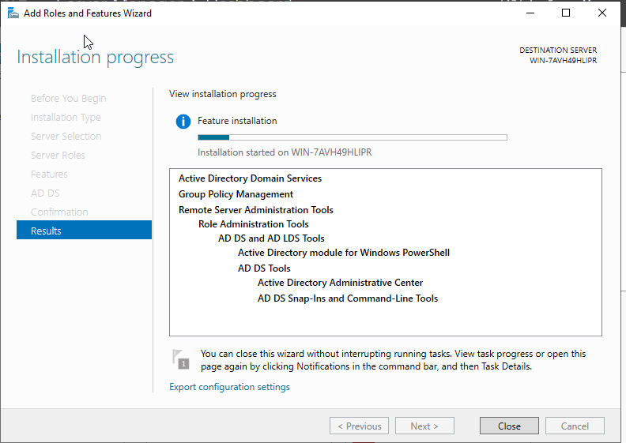

Creating forest
Description: Here, the author created a new forest named aliu.acca to establish the domain structure for the Swansea network. This involved configuring the domain controller and setting up the necessary DNS records.
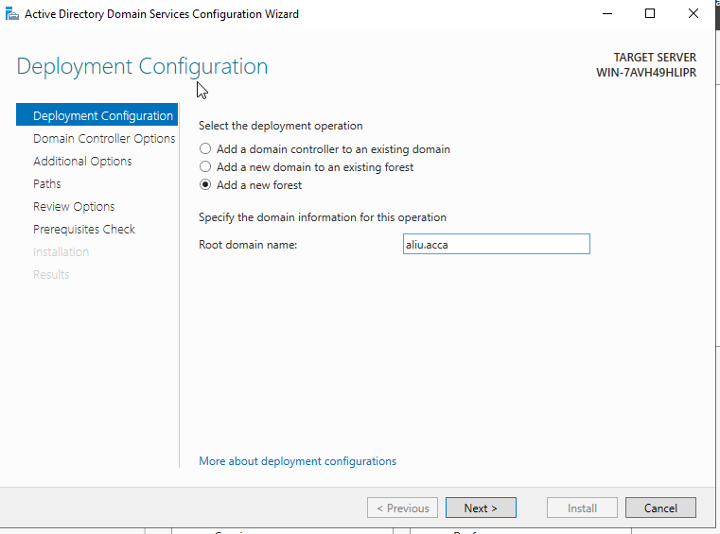

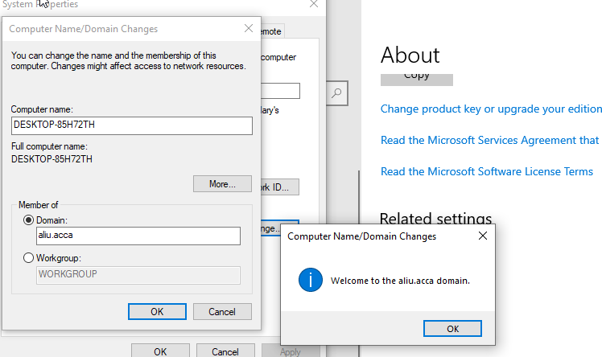

Creating users:
Description: This screenshot shows the creation of user accounts within the aliu.acca domain. The SAM Account Names were generated using the first letter of the first name followed by a dot and the last name, as specified.

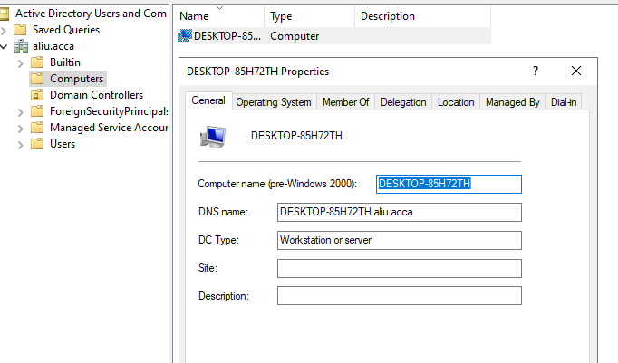

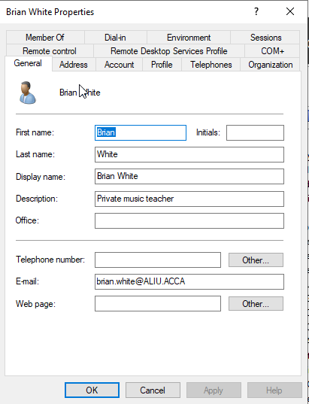
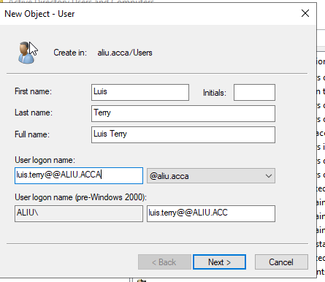
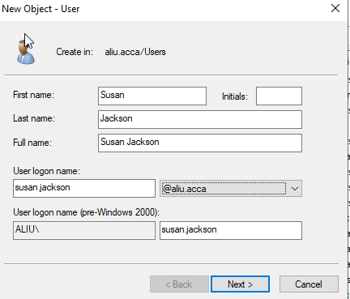

Routing and remote access services:
Description: This image illustrates the installation and configuration of Routing and Remote Access Services on the S-DC server, including the modification of firewall rules to allow ICMP traffic.
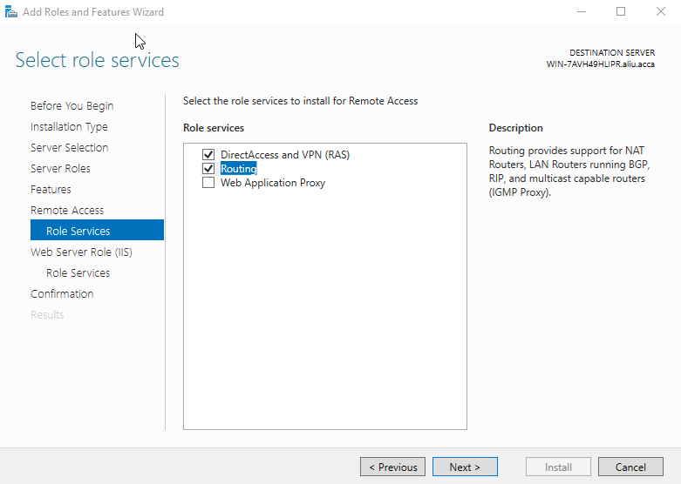
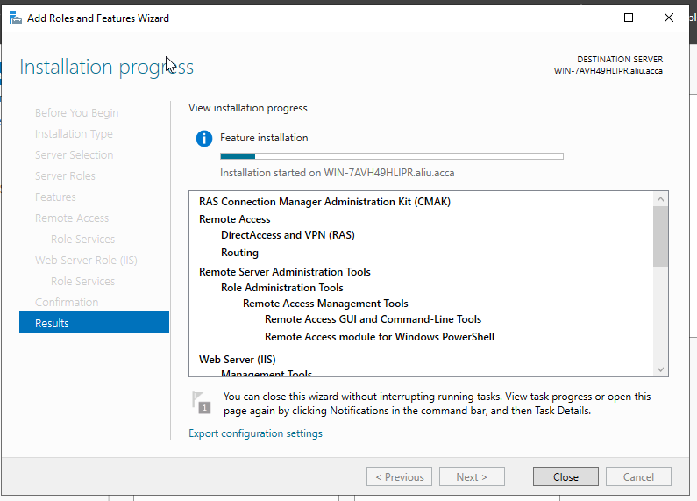
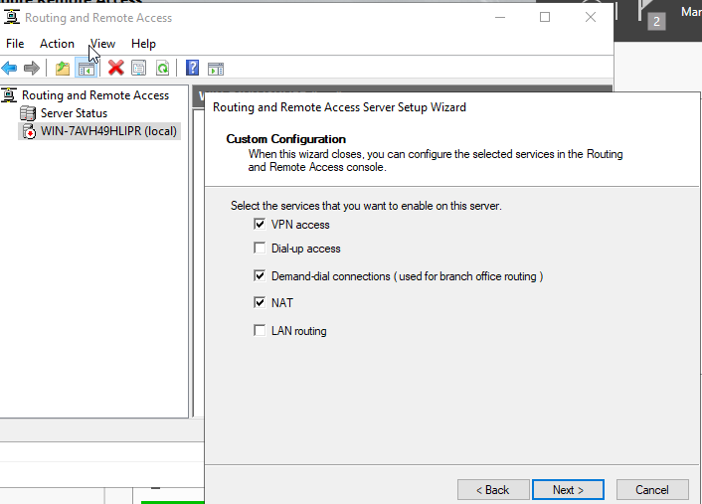
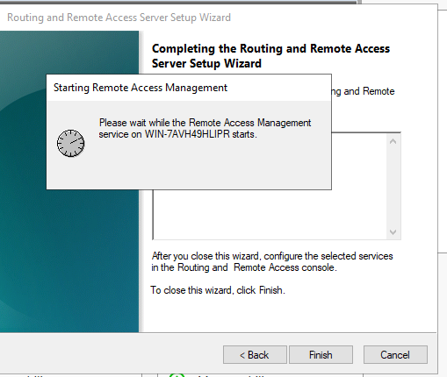
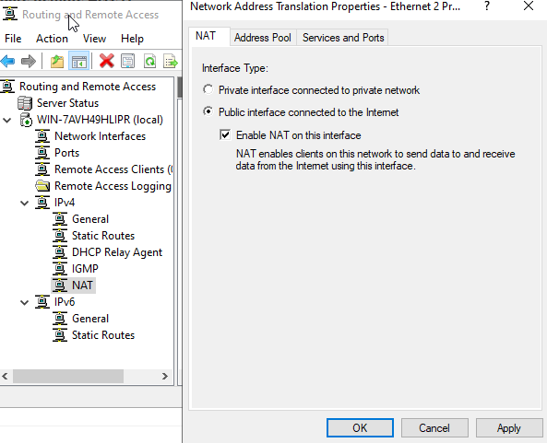

Promoting the S-DC server to act as a router
Description: The screenshot shows the promotion of the S-DC server to act as a router, with NAT interfaces configured for internal and external traffic.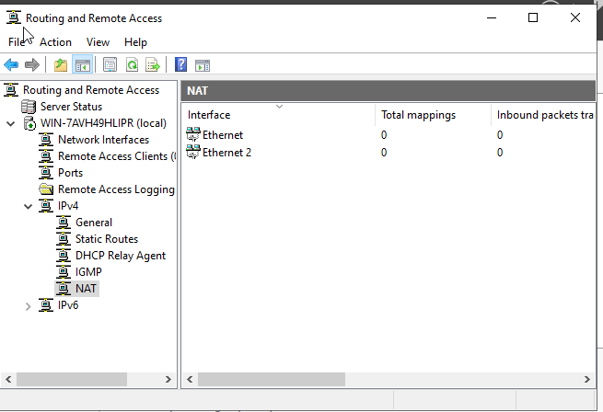
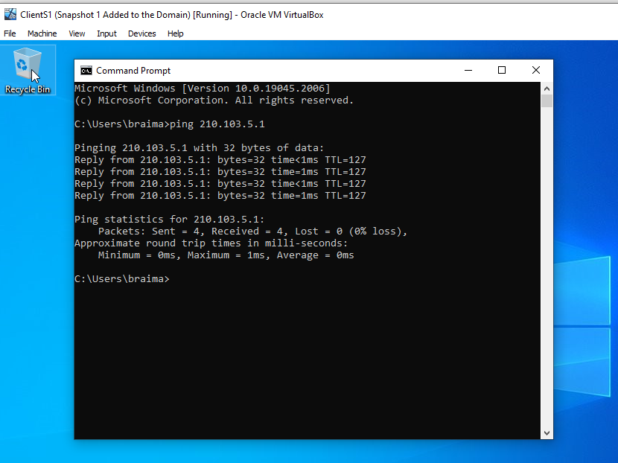

- New interface for the VPN Swansea and Cardiff
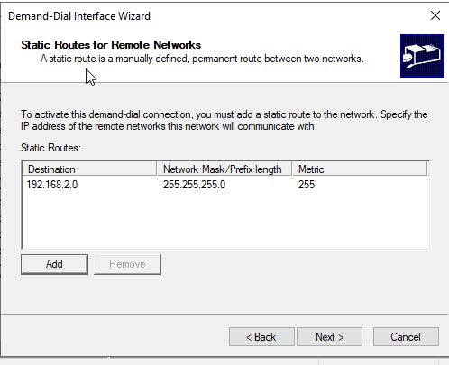
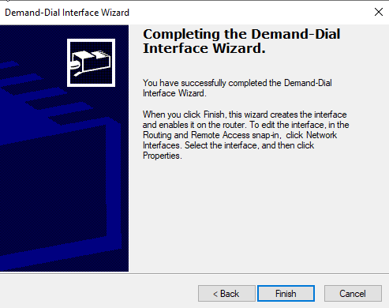
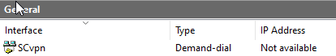

Configuring Site-to-Site VPN
This image captures the setup of a Site-to-Site VPN between Swansea and Cardiff networks using WireGuard for enhanced security and simplicity.
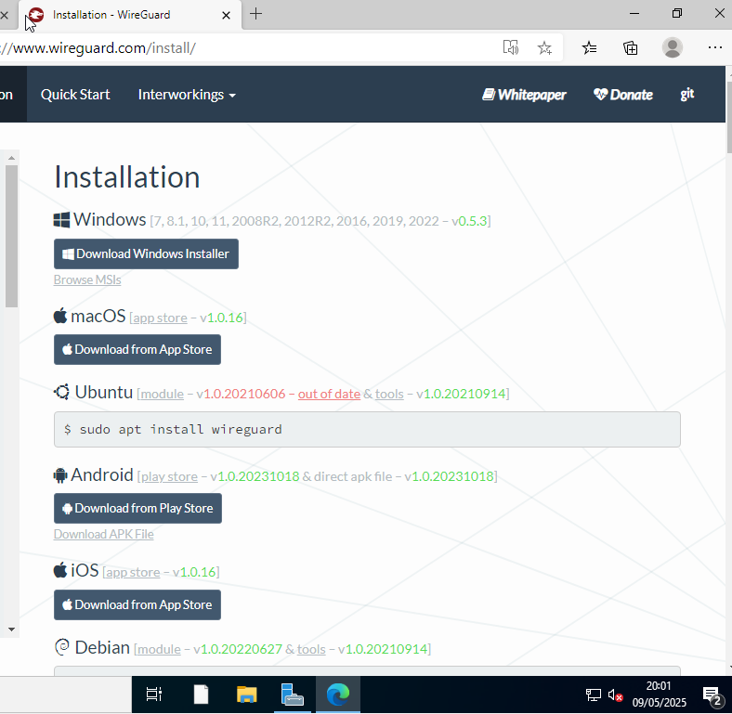

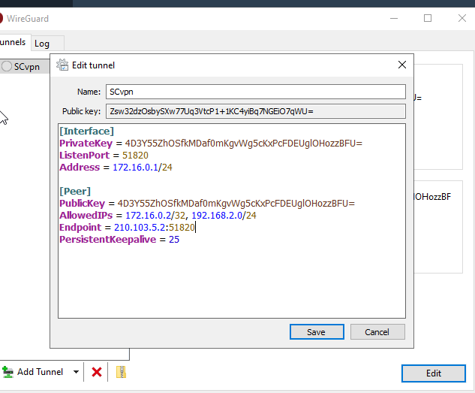

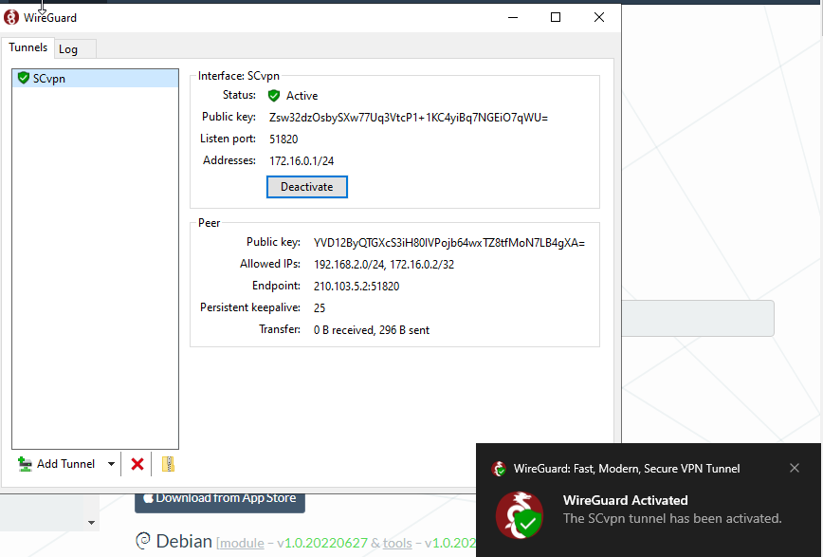

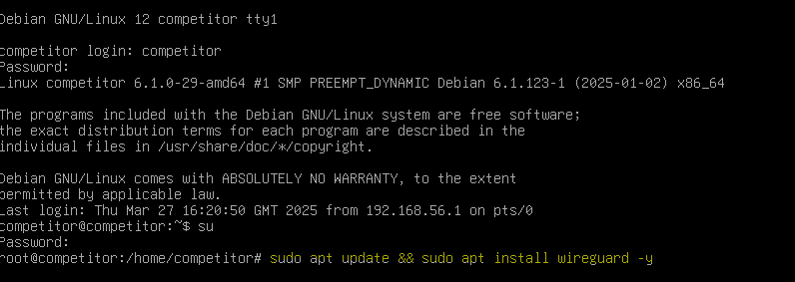

- Wire guard fail to install because system clock is behind the server’s timestamp.
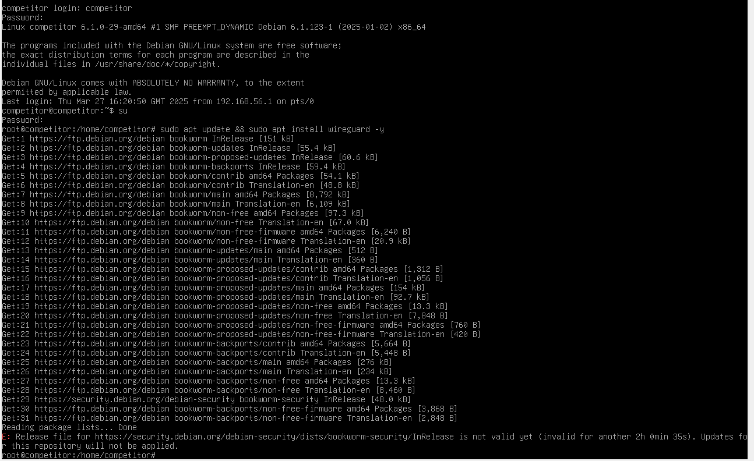
- Current system time will be checked and synced using NPT (network time protocol)
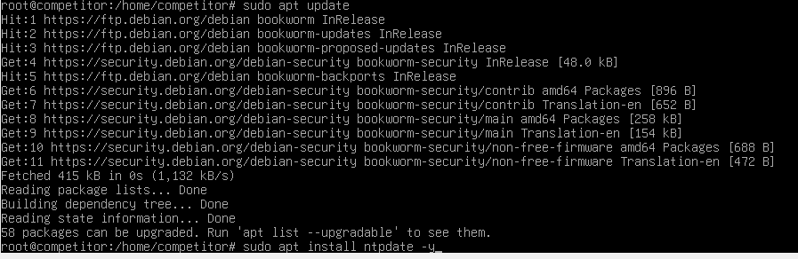
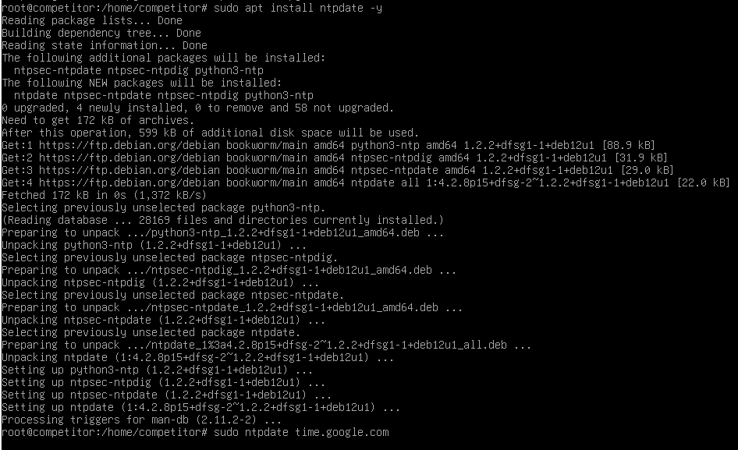
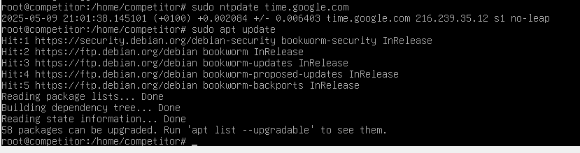
- Wire guard has been installed now.
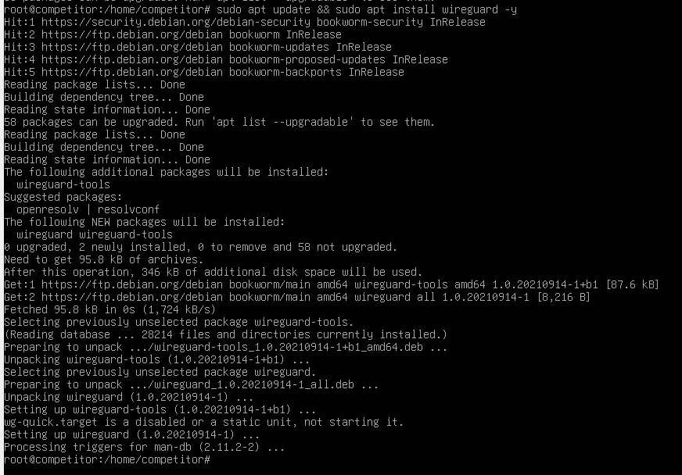

- Wire guard config on Debian
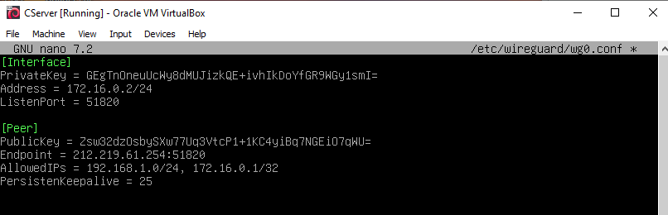

- Wire guard is not up and running on Debian, troubleshooting steps:
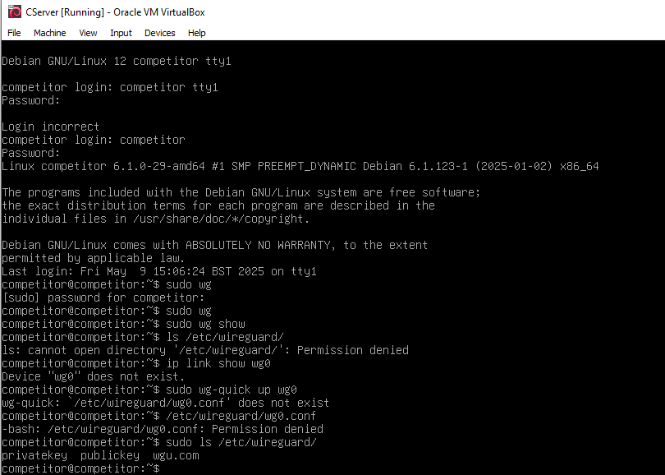

- It is working now.
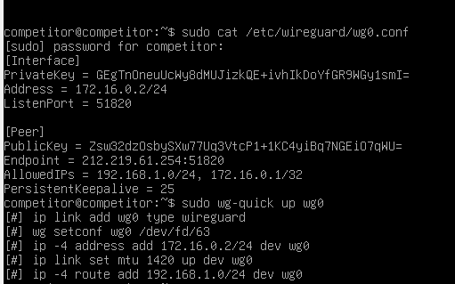

- Allowing UDP on windows server
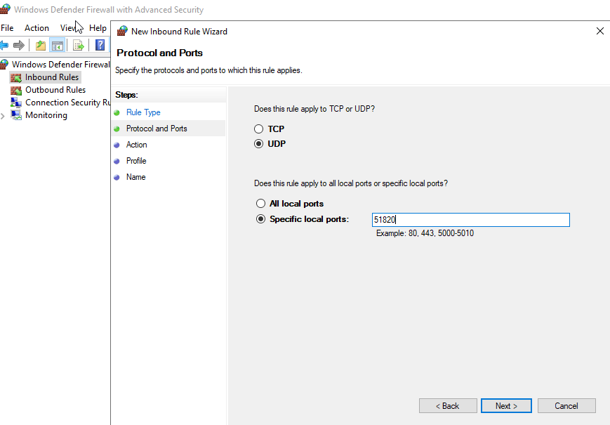
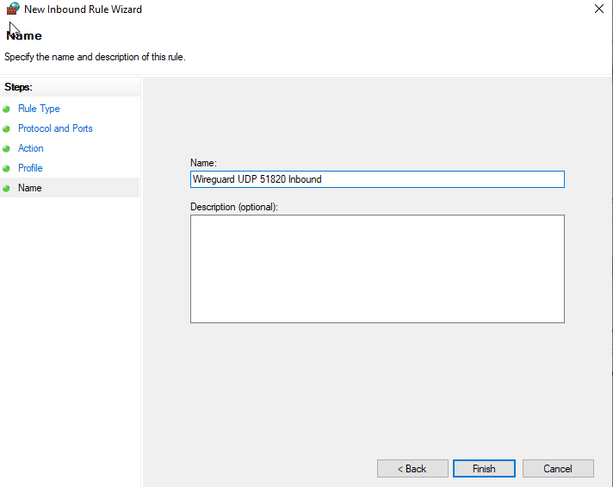

- Same for the outbound rules
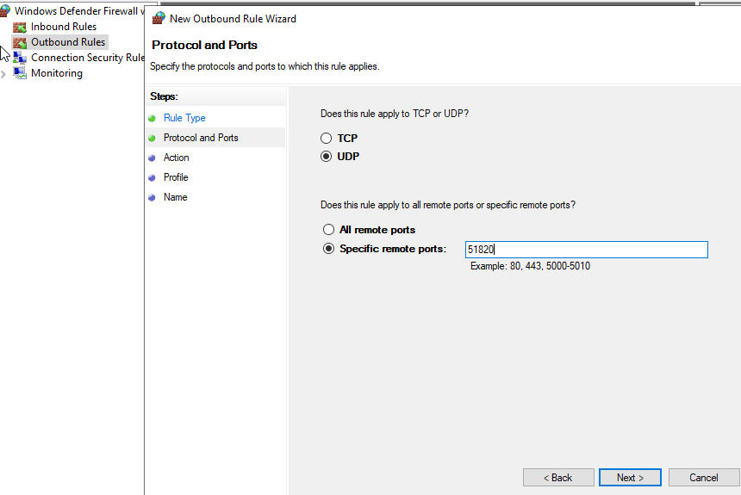
- Allowing ICMPv4
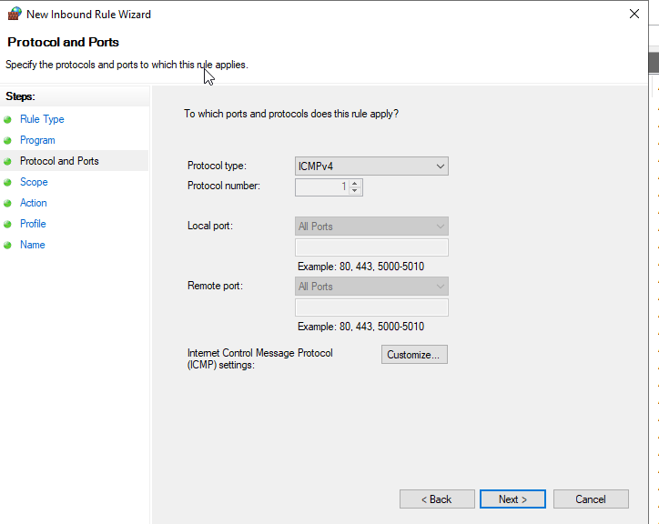
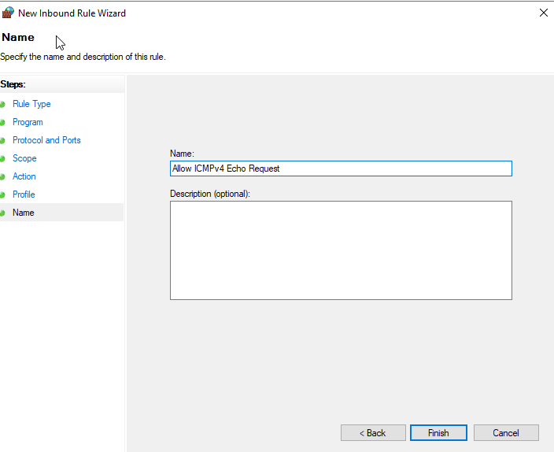

- Wire guard is all set and pinging
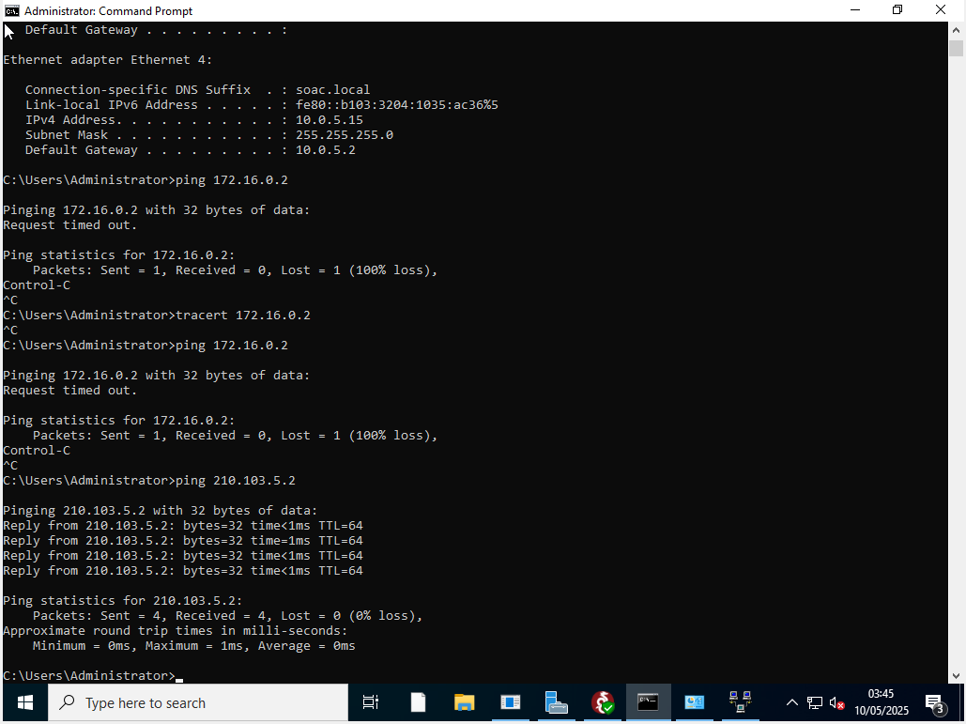
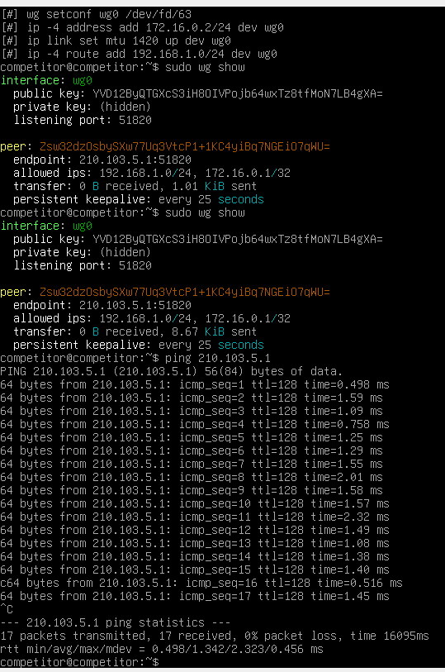

- Reverse lookup zone will be created first for Servers and clients
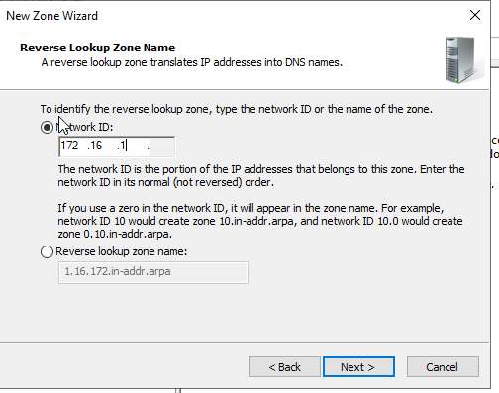
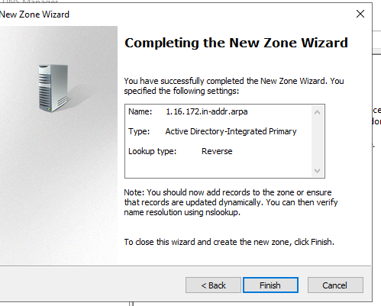
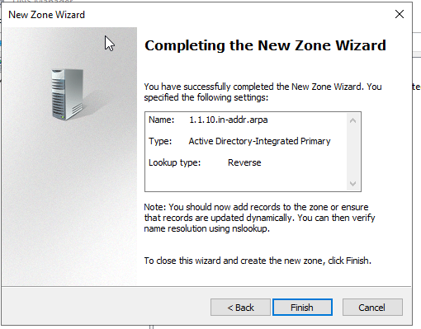
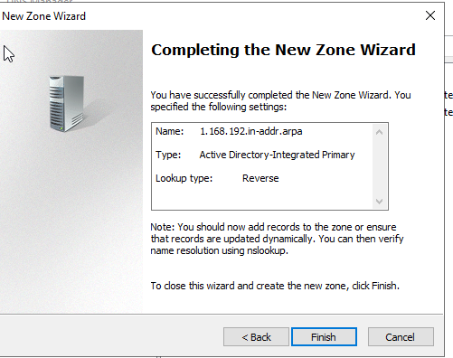

Creating DNS Records.
Description: The screenshot demonstrates the creation of A records and PTR records for all servers and clients within the specified IP ranges.
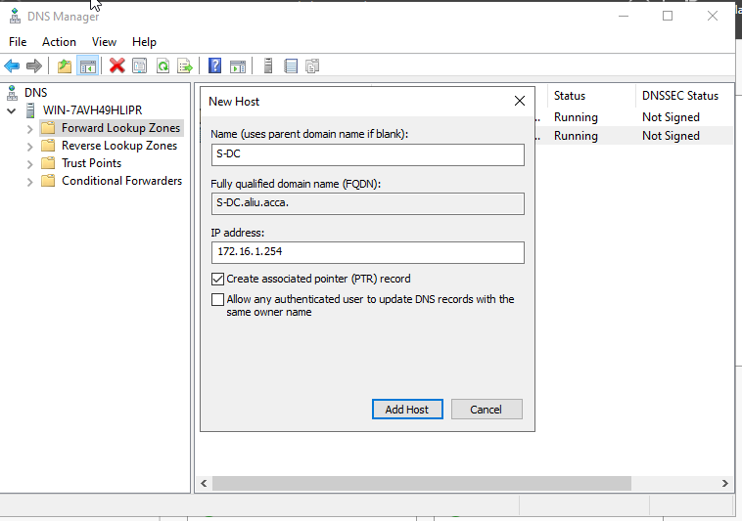
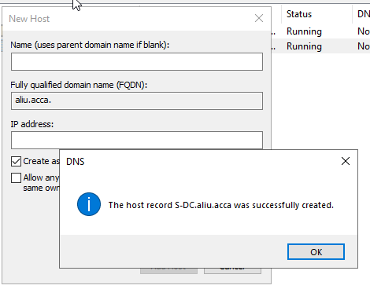
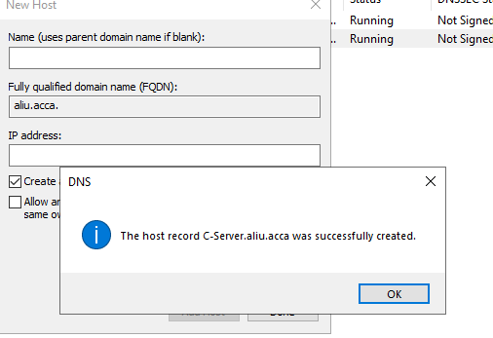

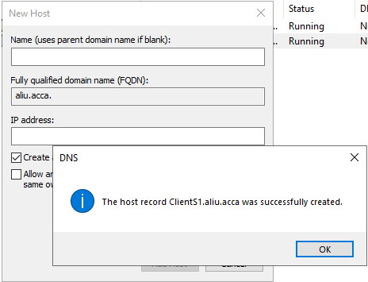

Mounting Second Disk Drive.
Description: This image shows the mounting of a second disk drive to D:\SwanseaFiles for file storage and sharing.
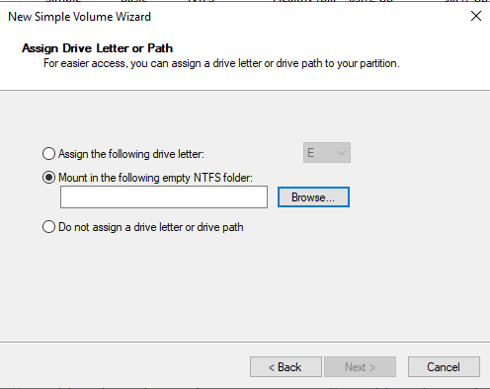
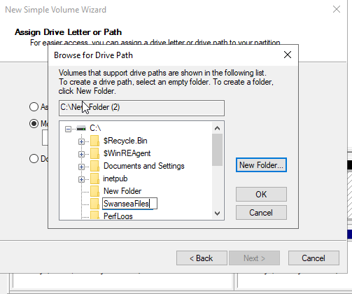

Configuring DHCP Services.
Description: The screenshot illustrates the configuration of DHCP services, including the setup of IP address ranges and other DHCP options.

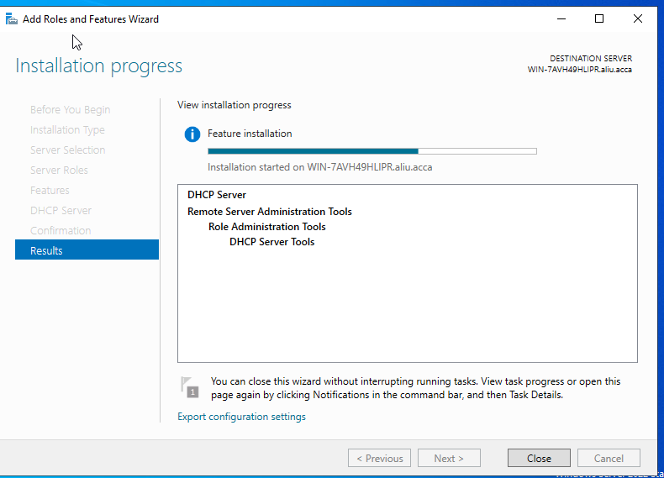

- Scope config
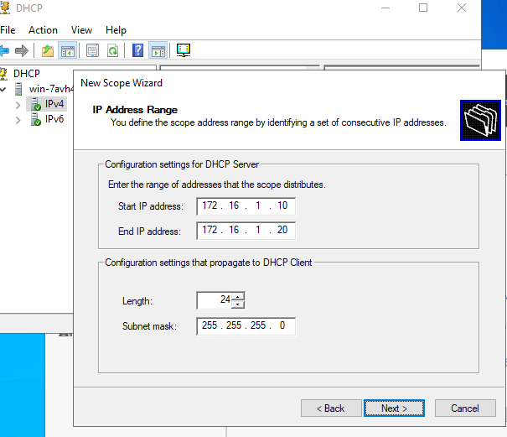

Joining ClientS1 to Domain
Description: This image captures the process of joining ClientS1 to the aliu.acca domain and assigning it a DHCP IP address.
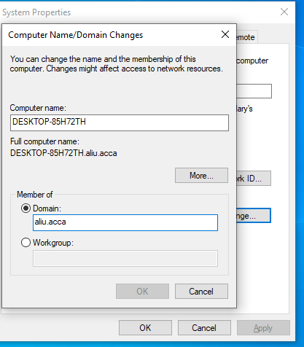

- Assigning clients1 with DHCP IP address.
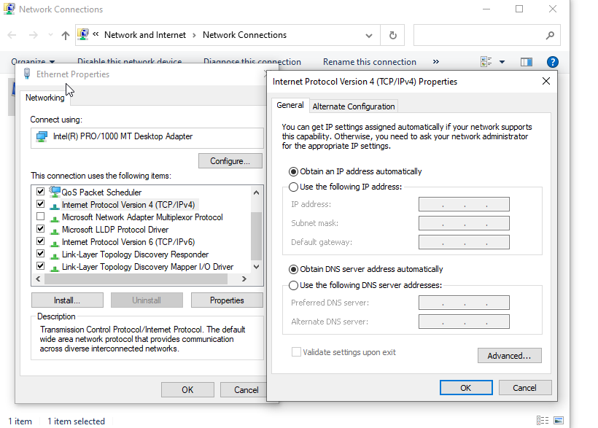
- ClientS1 is not getting IP address from the S-DC server
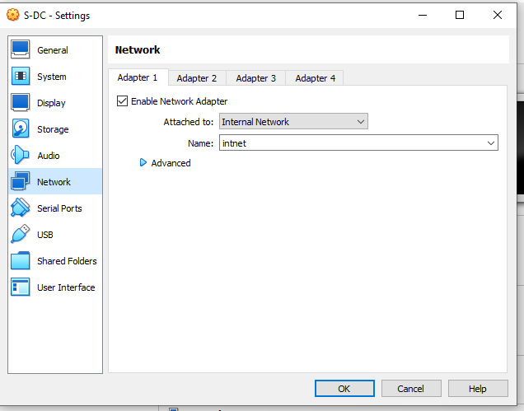

- ClientS1`is now getting its IP, DNS and gateway from the DHCP successfully.
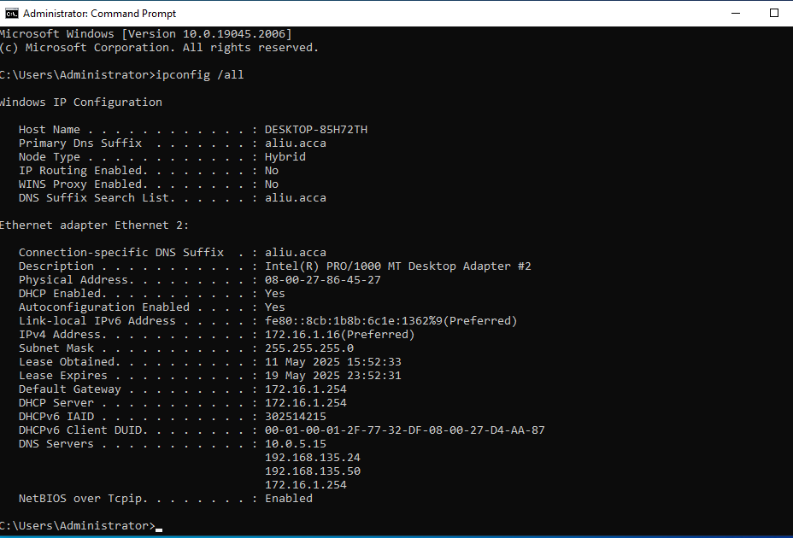

Cardiff Network

Modifying Firewall Rules in Cardiff Network.
Description: The screenshot shows the modification of firewall rules in the Cardiff network to allow ICMP traffic and enable IPv4 forwarding.
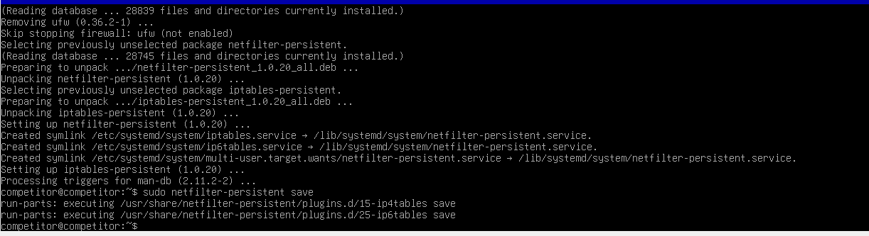

Servers can ping each other
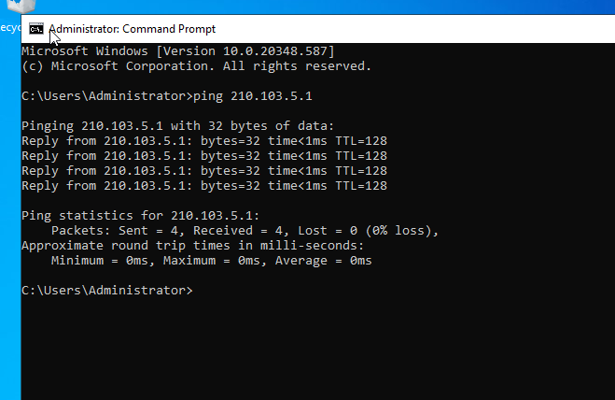
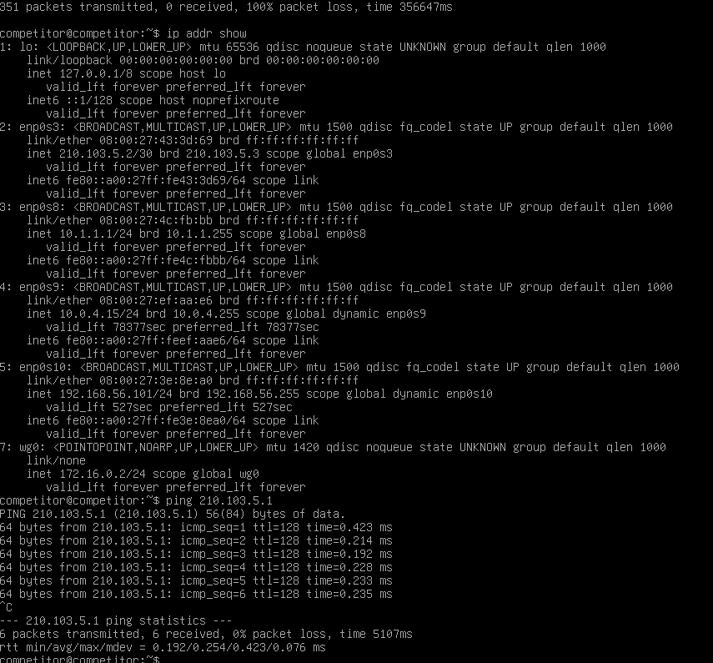

- Clients1 to Clientc1 are not pinging, so the IP address of the wireguard have been changed.
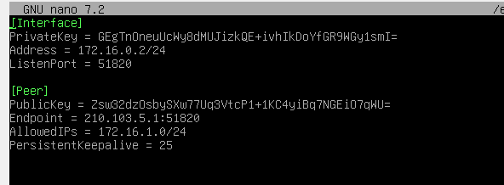
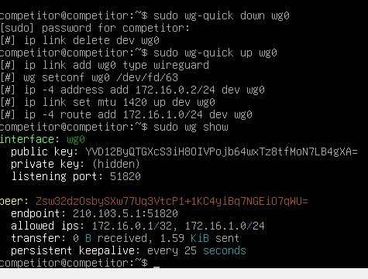

- The external Ips are reachable but routing to internal is not fully working yet
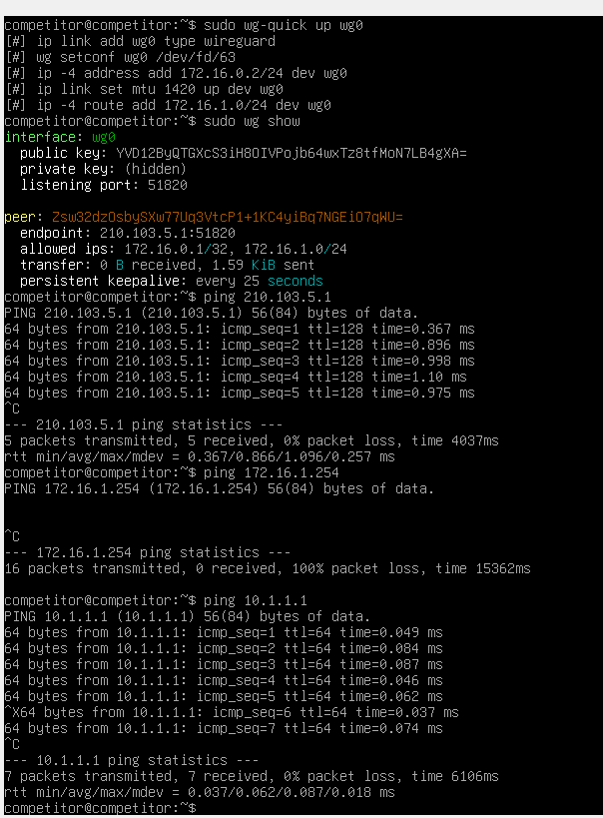
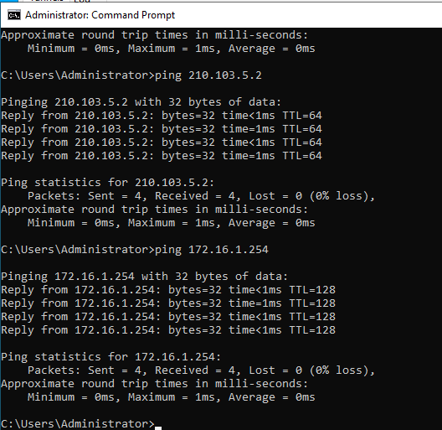
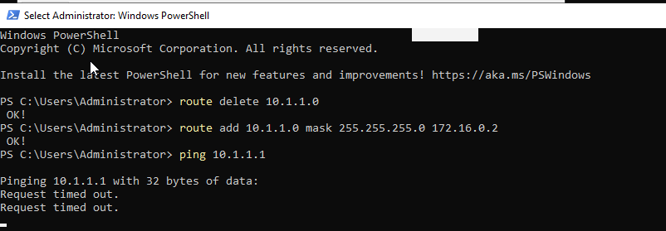

- Will enable IP forwarding on S-Dc
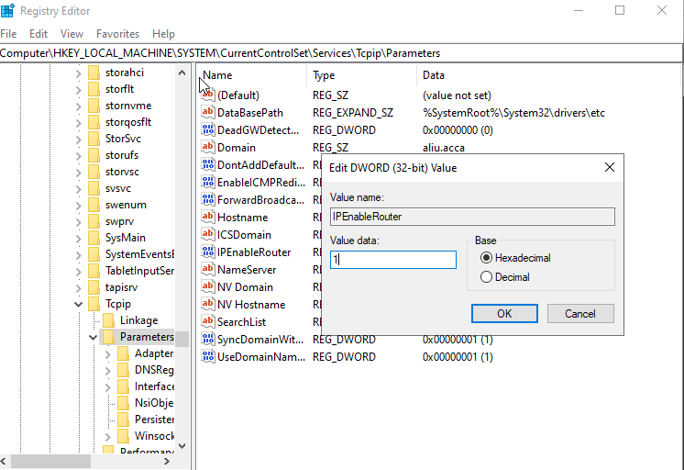
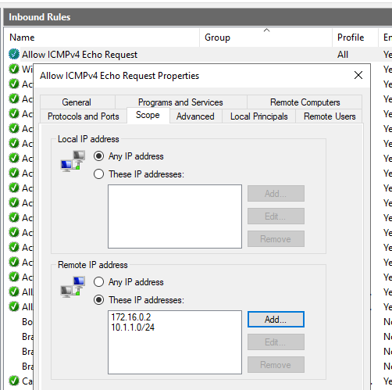
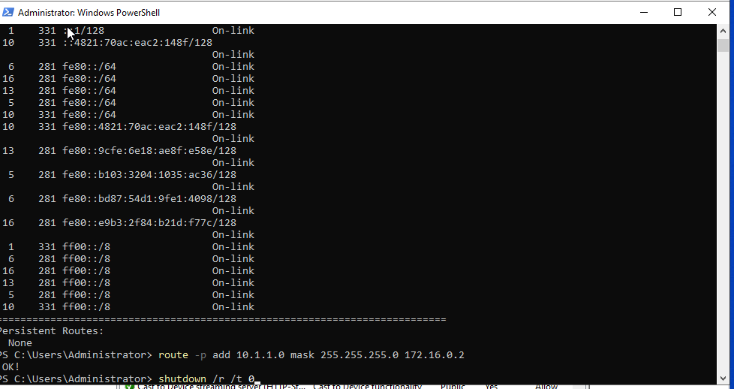

2.3 Debian client is not fully connected to the network or internet, so it can't join the domain or complete further tasks.
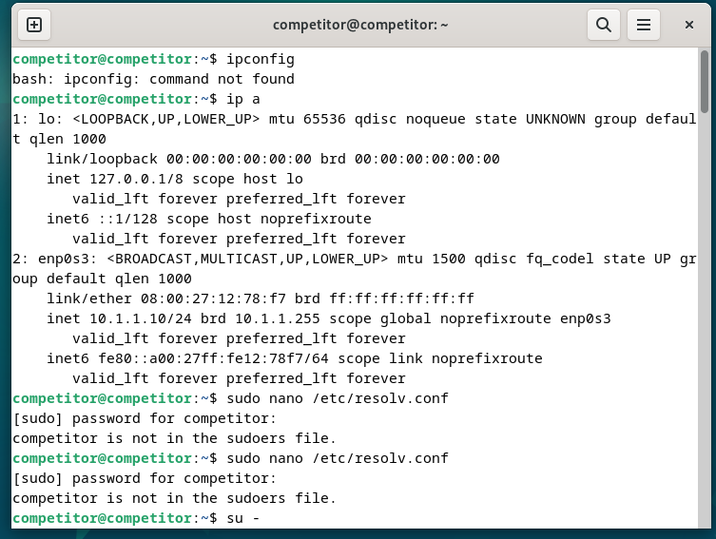

Configuring DHCP Services in Cardiff Network.
Description: This image illustrates the configuration of DHCP services in the Cardiff network, including the setup of IP address ranges and other DHCP options.
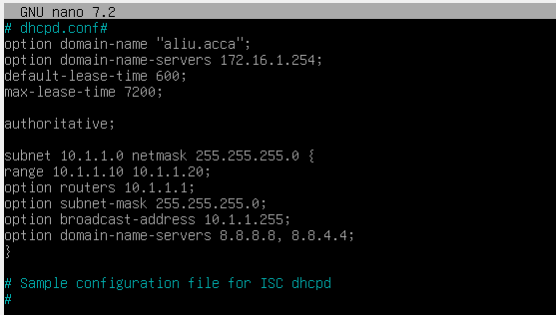
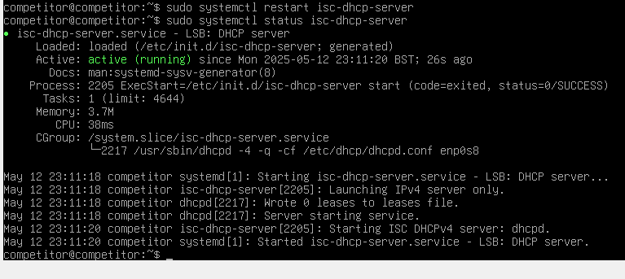

Conclusion:
This coursework involved comprehensive network configuration and management tasks across Swansea and Cardiff networks. By following the outlined steps, the author successfully installed and configured essential services, established secure VPN connections, managed DNS and DHCP settings, and ensured seamless network connectivity. The screenshots provided offer a visual representation of each step, highlighting the practical implementation of theoretical concepts.

