University of Wales Trinity St David
Module Name: Digital Skills
Module Code: LCLM 4002
Student Name: Maria Bogdan
Student Number: 2542723

Digital Skills Portfolio & Reflection

​Date: August 2026
Artifact 1: University Moodle VLE Page
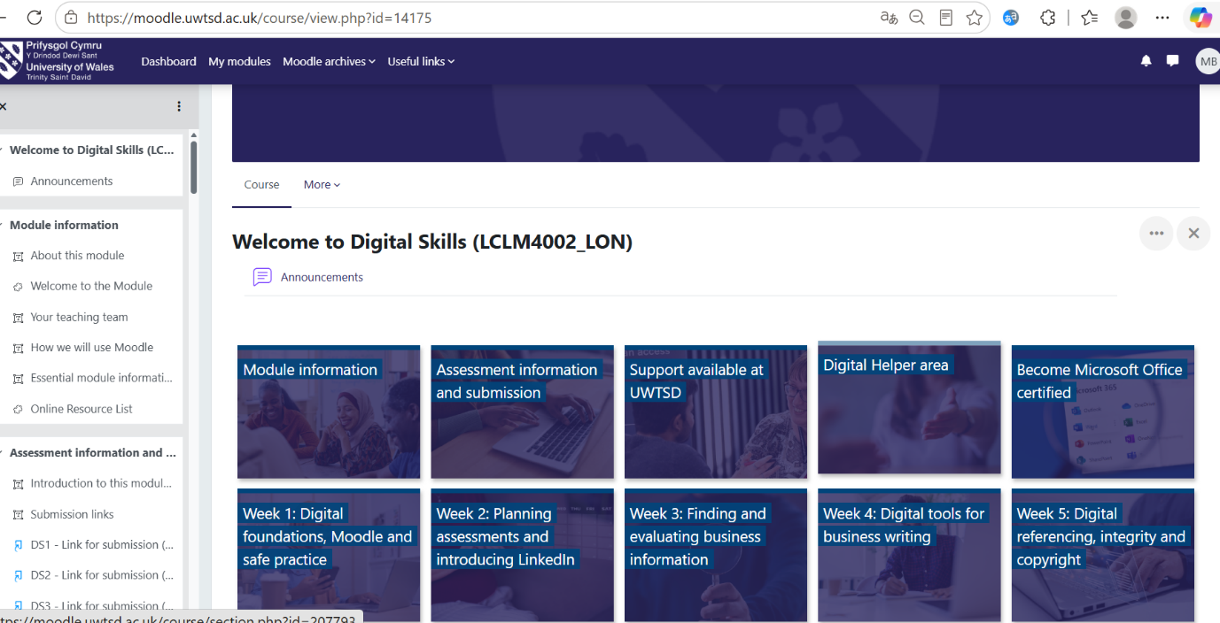
Moodle New Digital Skill.
What the work is: A direct screenshot of my main dashboard on the UWTSD Moodle Virtual Learning Environment for the Digital Skills module.

What skill it shows: Digital platform navigation, independent course management, and academic organization.

What I learned: How to navigate module tiles, locate weekly learning materials, access assessment briefs, and track submission requirements independently.

Artifact 2: Source Evaluation via CRAAP Test

​ 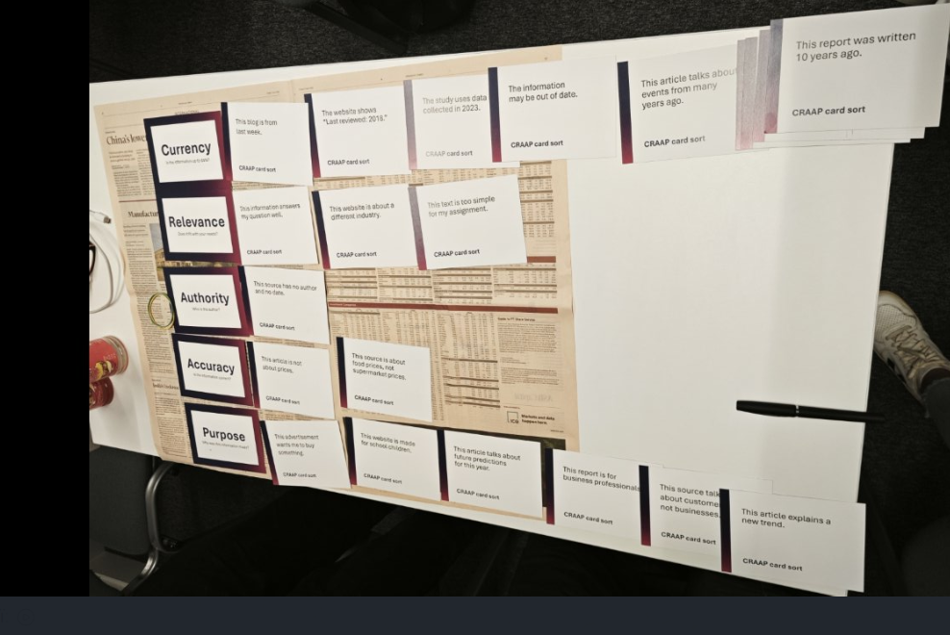
CRAAP test Week3.

What the work is: An interactive card-sorting exercise where I categorized research statements using Currency, Relevance, Authority, Accuracy, and Purpose.

What skill it shows: Critical information evaluation, academic integrity, and analytical filtering of web sources.

What I learned: How to filter out outdated, unreliable, or biased online information when researching business topics to ensure my academic work relies on credible data.

Artifact 3: Data Analysis in Microsoft Excel

​ 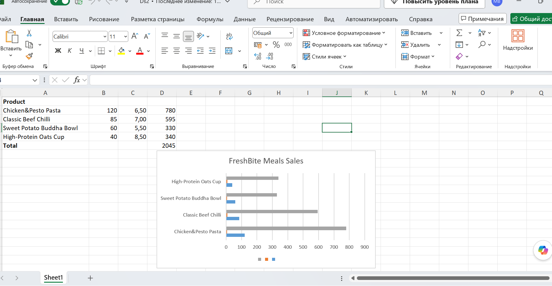
Excel (Sales Date) Week 4-6.

​What the work is: A structured business sales spreadsheet for "FreshBite Meals" containing product quantities, unit prices, automated total revenue formulas, and a horizontal bar chart.

​What skill it shows: Quantitative data organization, basic formula application, spreadsheet formatting, and visual data representation.

​What I learned: How to structure numerical data logically, apply basic functions to calculate totals, and convert raw figures into a clear bar chart for quick decision-making.

​

Artifact 4: PowerPoint & Digital Safety
​ 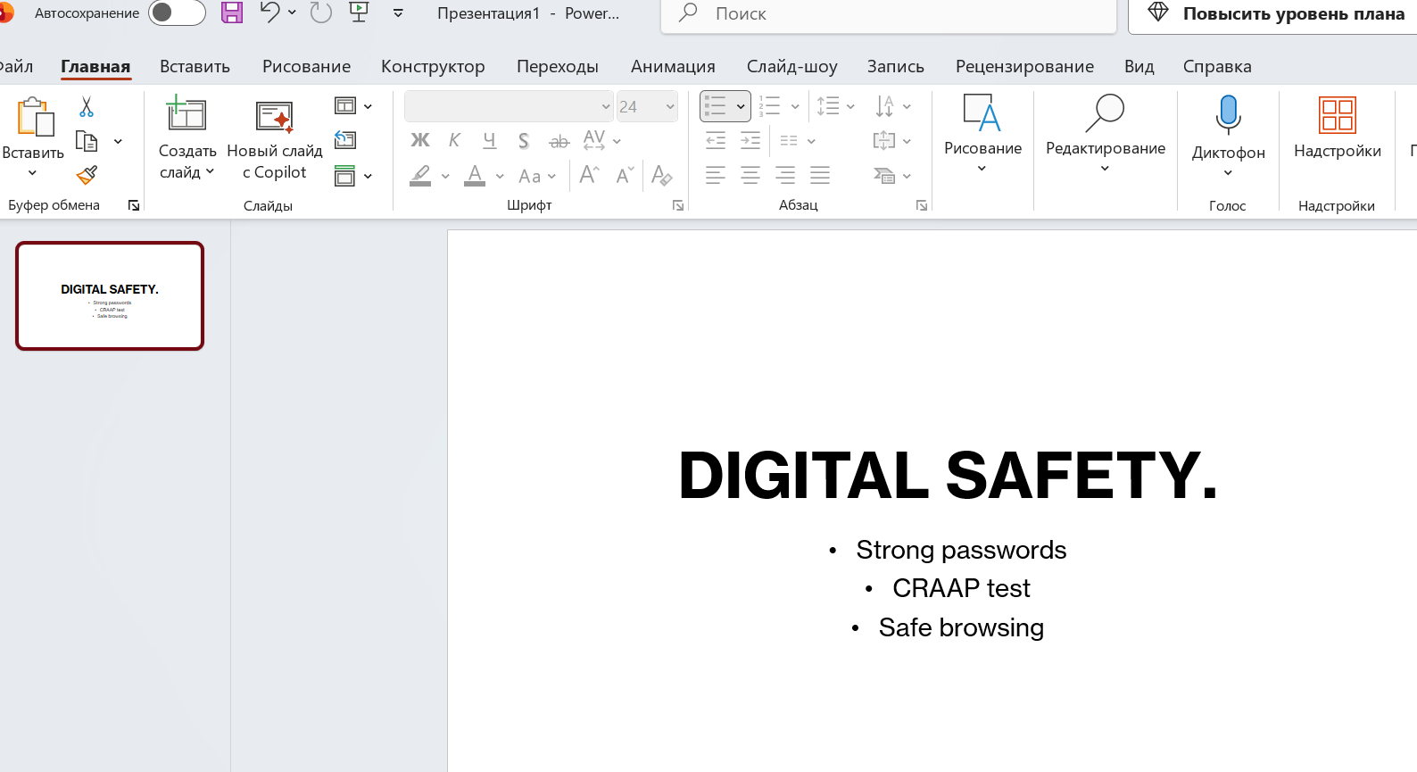
PowerPoint (Digital Safety) Week 8.
What the work is: A visually structured presentation slide built in Microsoft PowerPoint covering essential cybersecurity rules (strong passwords, safe browsing, source verification).
What skill it shows: Visual presentation design, concise layout structuring, and practical digital security awareness.
​What I learned: How to combine clean visual design with clear, actionable safety rules to communicate technical guidelines effectively to an audience.

​Personal Development & Reflection
​
What was difficult at first:
At the start of the course, Excel spreadsheets and formulas felt a bit overwhelming, especially making charts. I also wasn't sure how to check if information on websites was accurate and reliable.

​

What improved:
By practising every week in seminars, taking on feedback, and trying things step-by-step, I got much more comfortable with organising data, using Excel formulas, and setting up clean slides.

​What I can now do confidently:
Now I can easily find my way around Moodle, analyse data and build charts in Excel, put together clear PowerPoint slides, and check online sources using the CRAAP test.

References
Blakeslee, S. (2004) 'The CRAAP Test', LOEX Quarterly, 31(3), pp. 4–7.
Microsoft (2024) Microsoft Office Support and Training. Available at: https://support.microsoft.com/ (Accessed: 12 August 2026).
University of Wales Trinity Saint David (2026) LCLM4002 Digital Skills: Module VLE Page and Assessment Brief. London: UWTSD.

